Student Name: Thomas Wolfe

P number: 2302542

Programme of study: Graphic Design

Module: Ways of perceiving (ADDA4023/C)

Essay: Curating an imaginary exhibition

Curating an imaginary exhibition

Educating Today’s Youth

For centuries being different has been an ongoing battle throughout history. Supressed voices of vulnerable youth, forced into silence by the hands of uneducated minds, McCormack (2013) sheds light on the power given to people who meet the expectations pushed onto young minds across the world. Although discrimination is still an active culture, there are greater accessible resources of information to help diminish the patriarchal mindset. “Pride is celebration of diversity, equality, unity, and freedom” (Tandon and Rao, 2021), Acknowledging the confusion between equality and equity fought by the community. An upsetting example of the consequences from existing discrimination is the death of a black American, gay teen Nigel Shelby who was one of many to take their own life due to homophobia in 2019, (Mayo, Jr, 2019), sparking numerous riots and protests to not allow the thousands of losses of young LGBTQ+ lives go unnoticed.

For an exhibition to make an impact, it needs to have a clear and heartfelt message to the audience by “conceptualizing ways in which art and it’s contexts are understood” (O'Neill, 2016, p.1), as the intention for this curation is to provoke the audience to put themselves in the shoes of people who have been discriminated against in past and present times. “Hidden Histories was the first international historical survey of its kind to examine the lives and work of male artists in the 20th century who were same sex lovers” (Petry, 2007, para 5), this curatorial project that took place in The University of Wolverhampton held a discretion submission method for queer artists to showcase their talents in order not to ‘out’ anyone, giving a platform to those who aren’t ready to live the life that they desire because of the fear that has been instilled in them due to being raised in an injustice society.

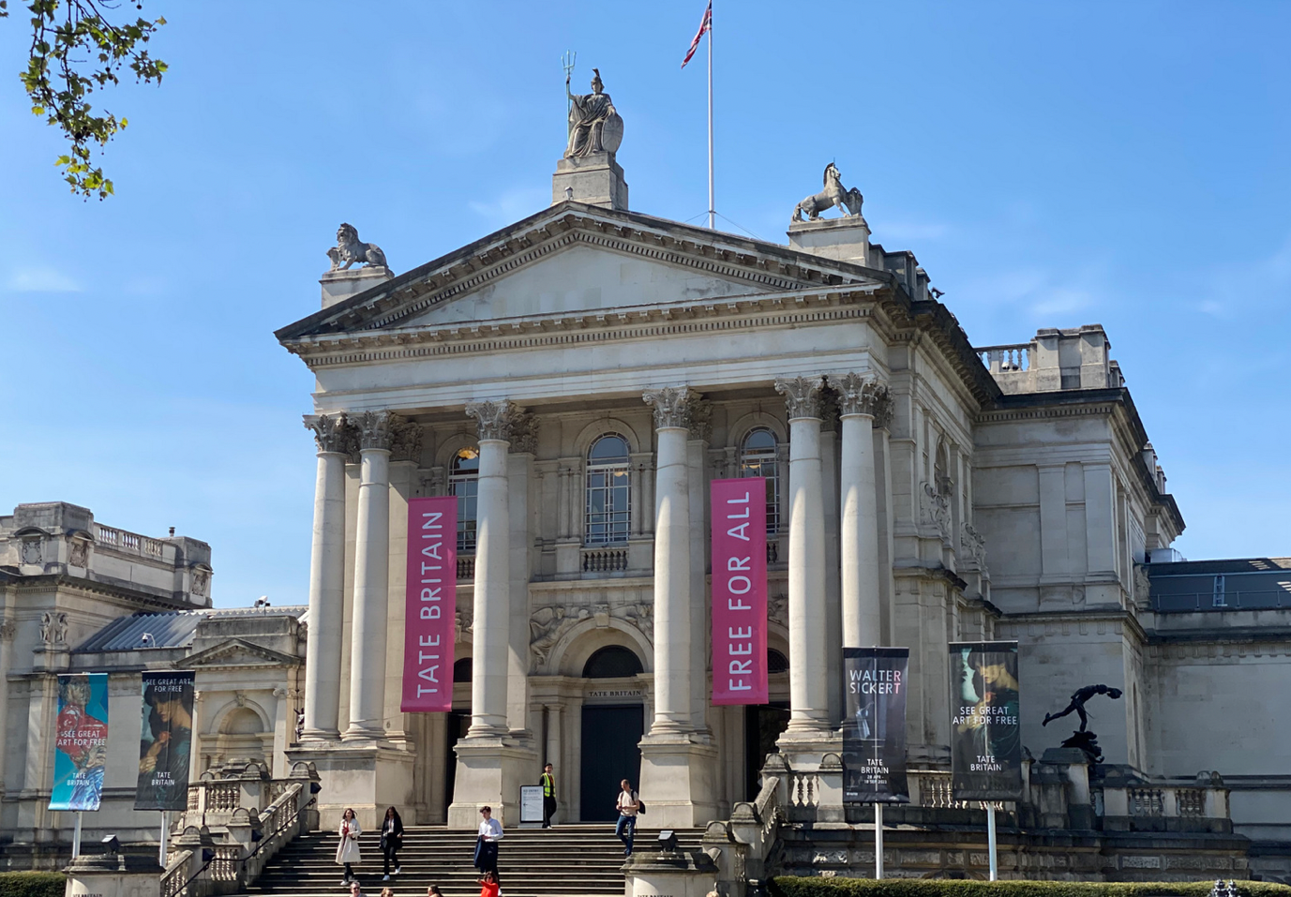
A generalised consensus around the LGBT+ community is how creative and outstanding their minds can be as there are countless artists and historical figures within the community who are often discredited due to the fact of them being queer, hence why it is crucial to curate an exhibition to celebrate gay culture and highlight a large aspect of creativity that is often overlooked.
Fig 1. Tate Museum, London.
Source: C. Emma Creese

The Tate Modern, a bastion of artistic expression in the heart of London is where the exhibition is to be held. London has come a long way over the last few decades when it comes to accepting diversity, however, it still has a long way to go. There was a study funded by London’s Metropolitan police service to show the amount of LGBT+ hate crimes reported between January and June 2001, showing that “1,554 homophobic incidents were reported to MPS which represents over one-third of all such incidents in the United Kingdom that year.” (Moran, 2007, p.41), Although the number of hate crimes has dropped dramatically in the UK since 2001, London is still considered one of the most intimidating places for people of the LGBT+ community in Britain, this is why it is important to hold the exhibition at the Tate Museum as it will educate today’s youth in this area on the lives of queer people.

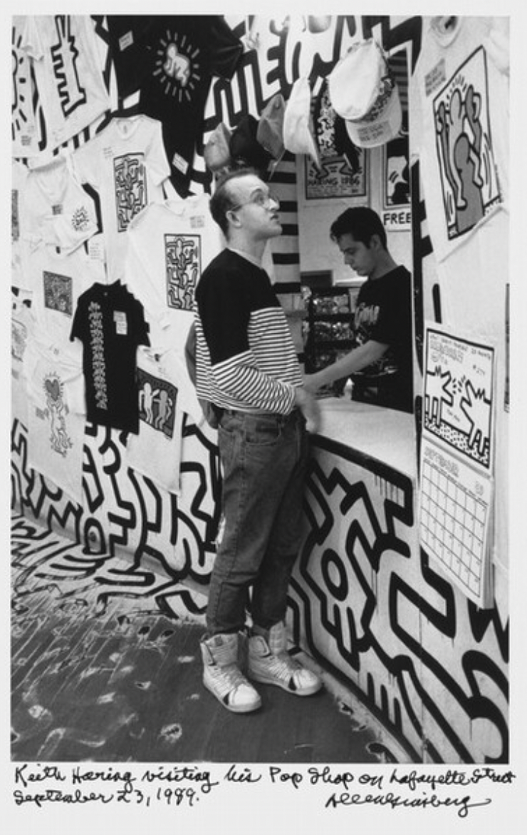
Keith Haring visiting his Pop Shop on Lafayette Street, (1989)

Fig 2, Allen Ginsberg, Keith Haring visiting his Pop Shop on Lafayette Street, (1989)
Source: https://www.nga.gov/collection/art-object-page.213310.html

Keith Haring was a pioneering artist known for his distinctive style characterized by bold lines, vibrant colours, and iconic symbols. Emerging from the New York City Street art scene of the 1980s, Haring's work often conveyed social and political messages, addressing issues such as AIDS awareness, drug addiction, and apartheid. His art was accessible and inclusive, appearing on subway walls, in galleries, and even on merchandise.

In 1989, Haring expanded his reach by opening a pop-up shop in New York City, where he brought his art directly to the people. During this time, it was the height of the AIDS crisis and people were often misinformed about the disease (Bell, 2020, p.159), hence Haring’s infamous pattern he used in a lot of his artwork such as Figure.2 to spread awareness.

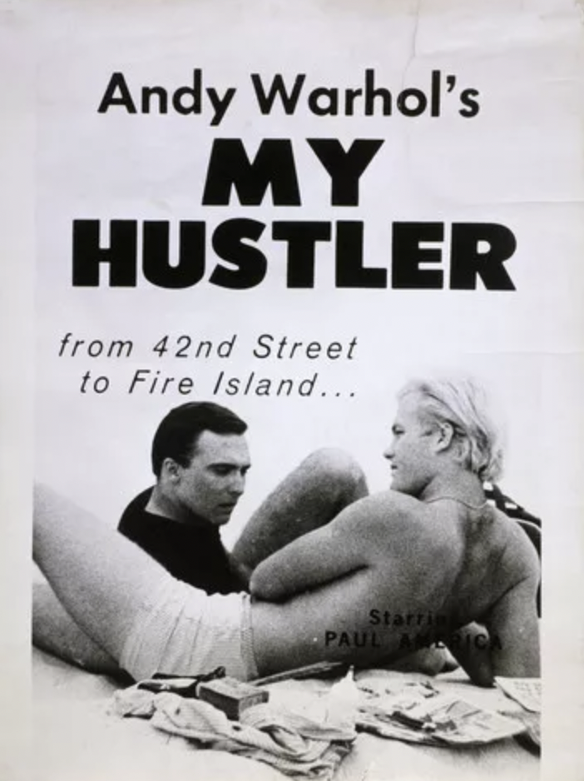
Andy Warhol, Film Poster “My Hustler”, (1965)

Fig 3. Andy Warhol, My Hustler, (1965)
Source: https://www.warhol.org/lgbtq/

Andy Warhol was an extraordinary figure in the 20th-century art world, known for his distinctive approach to art, celebrity culture, and mass production. Born in 1928 in Pittsburgh, Pennsylvania. He became renowned for his iconic works such as the Campbell's Soup Cans and Marilyn Monroe portraits, which explored themes of consumerism, fame, and media saturation. (Honnef and Warhol, 2000, P1-16)

Warhol's "My Hustler" offers a raw and unfiltered glimpse into the world of male prostitution and desire. Shot in Warhol's signature style of long, unedited takes, the film immerses viewers in the lives of its characters, capturing the tension and longing that pervades their interactions. This image shows a normality towards gay culture, diminishing the general consensus around LGBT+ people and intimacy, which is why this piece and Warhol, himself, are such relevant figures for the community.

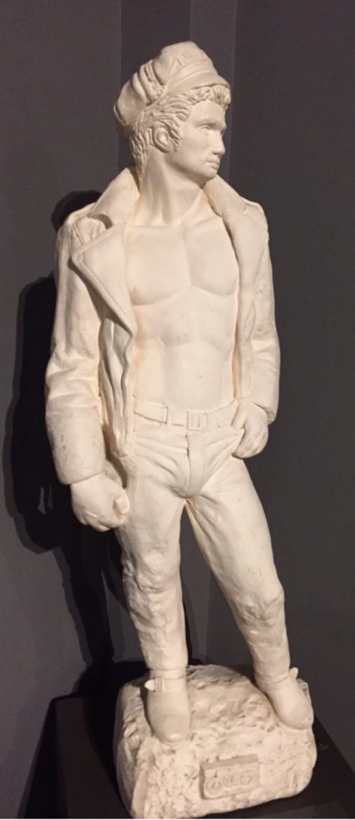
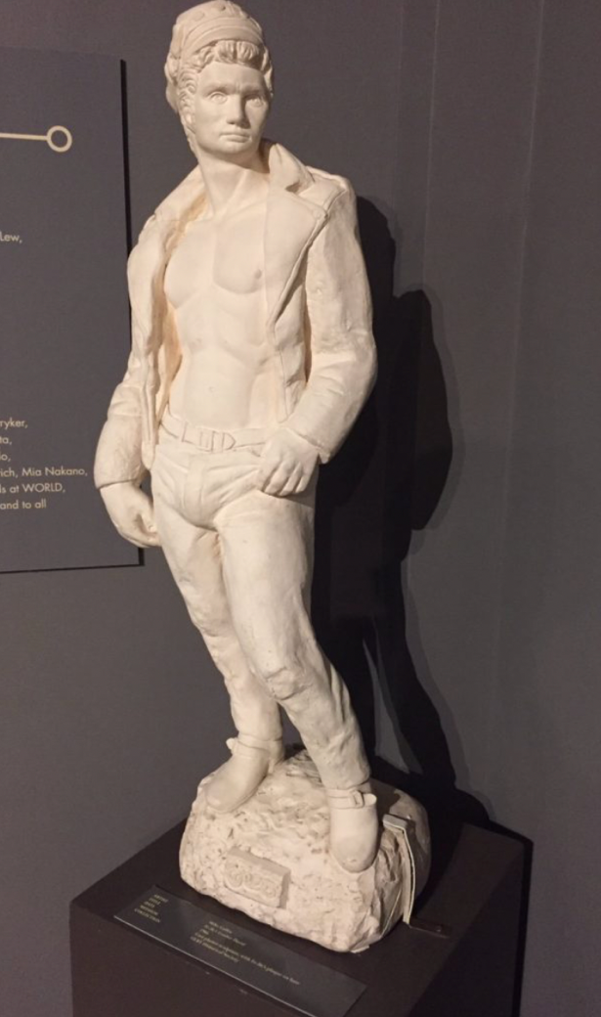
Fe-Be, Leather David, (1966)
Fig 4. Fe-Be, Leather David, (1965)
Source: https://www.queerarthistory.com/tag/sculpture/
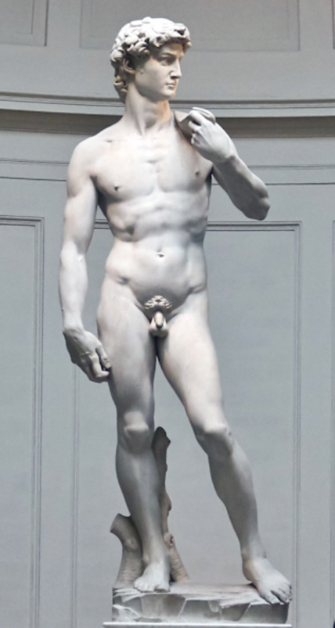

For Reference
Fig 5. Michelangelo, David, (1501-1504)
Source: https://www.accademia.org/explore-museum/artworks/michelangelos-david/
Fe-Be, also known as Félix Bélanger, is a Canadian artist renowned for his expertise in leather craftsmanship and his contributions to the LGBT+ leather community. As a skilled artisan, Fe-Be has created intricate leather designs, including harnesses, clothing, and accessories, which blend traditional techniques with modern aesthetics. One of his notable creations is the leather sculpture of David, inspired by Michelangelo's iconic statue. Fe-Be's interpretation infuses the classical form with a contemporary twist, celebrating the beauty of the male form while adding layers of symbolism and meaning reflective of the LGBTQ experience. His work embodies a fusion of artistry, craftsmanship, and queer identity. Michelangelo’s “David was originally commissioned on 16th August 1501 for one of the buttresses surrounding the tribuna of the cathedral of S.” (Keizer, 2008, p.664), Exampling Fe-be’s intentions when creating this sculpture, as turning something historically
religious in a time of mass homophobia, into an outstanding expression of queer art.

Henry Scott Tuke, The Critics, (1927)
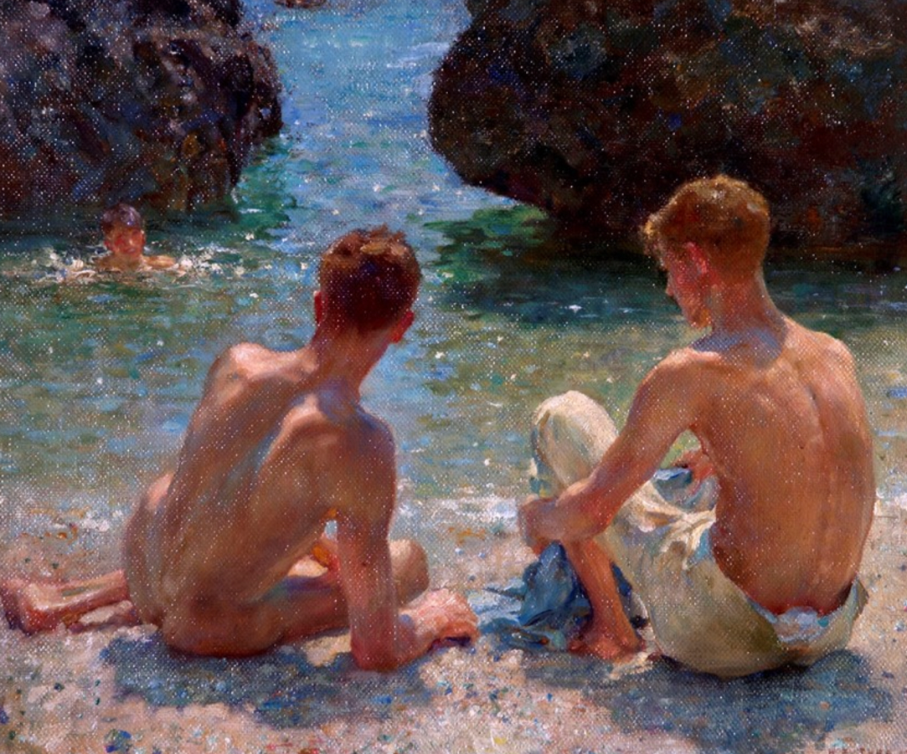
Fig 6. Henry Scott Tuke, The Critics, (1927)
Source: https://www.anothermag.com/art-photography/9694/ten-pioneering-works-of-queer-art-that-changed-history
Top of Form
Bottom of Form
"The Critics" by Henry Scott Tuke is a celebrated LGBT+ painting depicting a pair of young men lounging on a rocky shore, gazing at a nude swimmer emerging from the sea. Painted in 1927, the work captures a moment of quiet contemplation and homoerotic desire. As a prominent member of the Newlyn School of artists, Tuke often depicted themes of male beauty and camaraderie, challenging Victorian-era norms and celebrating same-sex desire in his art (Robinson, 2021, p.16). This piece portrays the LGBT+ community in a more sexual standpoint, showing the audience the stigma around same sex relationships.

According to Tin Louis-Georges' book "The Dictionary of Homophobia: A Global History of Gay & Lesbian Experience," (2008) being homosexual was still viewed more as a mental illness or fetish in the early 1900s than as a sexual orientation. This is the reason that Figure 6, which expresses the desire for liberation from this period, would have a significant influence.

Nan Goldin, Misty and Jimmy Paulette in a taxi, NYC (1991). From the series The Other Side.
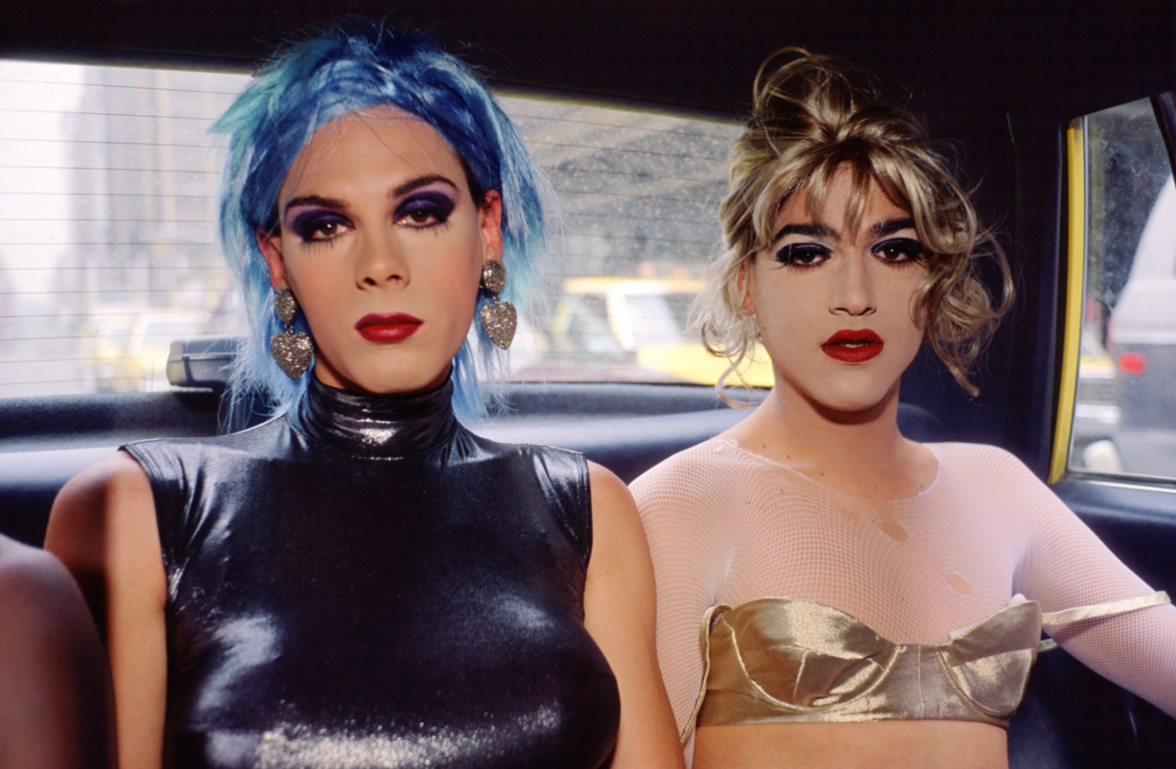

Fig 7. Nan Goldin, Misty and Jimmy Paulette in a taxi, NYC (1991)
Source : https://kunstkritikk.com/oh-snap/

Goldin's Misty and Jimmy Paulette in a Taxi, NYC (1991), encapsulates the LGBT+ standpoint with subtle yet profound significance. The photograph not only captures the tender intimacy between Misty and Jimmy Paulette but also serves as a testament to the resilience and authenticity of LGBTQ relationships. In a time when societal norms often marginalized or invalidated queer love. Goldin's portrayal celebrates the beauty and humanity of same-sex affection. By depicting Misty and Jimmy Paulette's connection with empathy and honesty, the image challenges heteronormative narratives and affirms the validity of LGBT+ experiences, making it a poignant symbol of queer visibility and acceptance.
“Goldin’s photography reveals her community to the gaze of others, disclosing her safe, domestic space to the viewer.” (Emilie Morin and James Boaden, 2016, p.15), This helps us understand Goldin's objectives for creating this work and offers the audience an option between being uncomfortable and embracing the image's glare. It also evokes a strong reaction in the spectator and compels them to face their own perceptions about the LGBT+ community.

Educating today’s Youth: Exhibition plan.

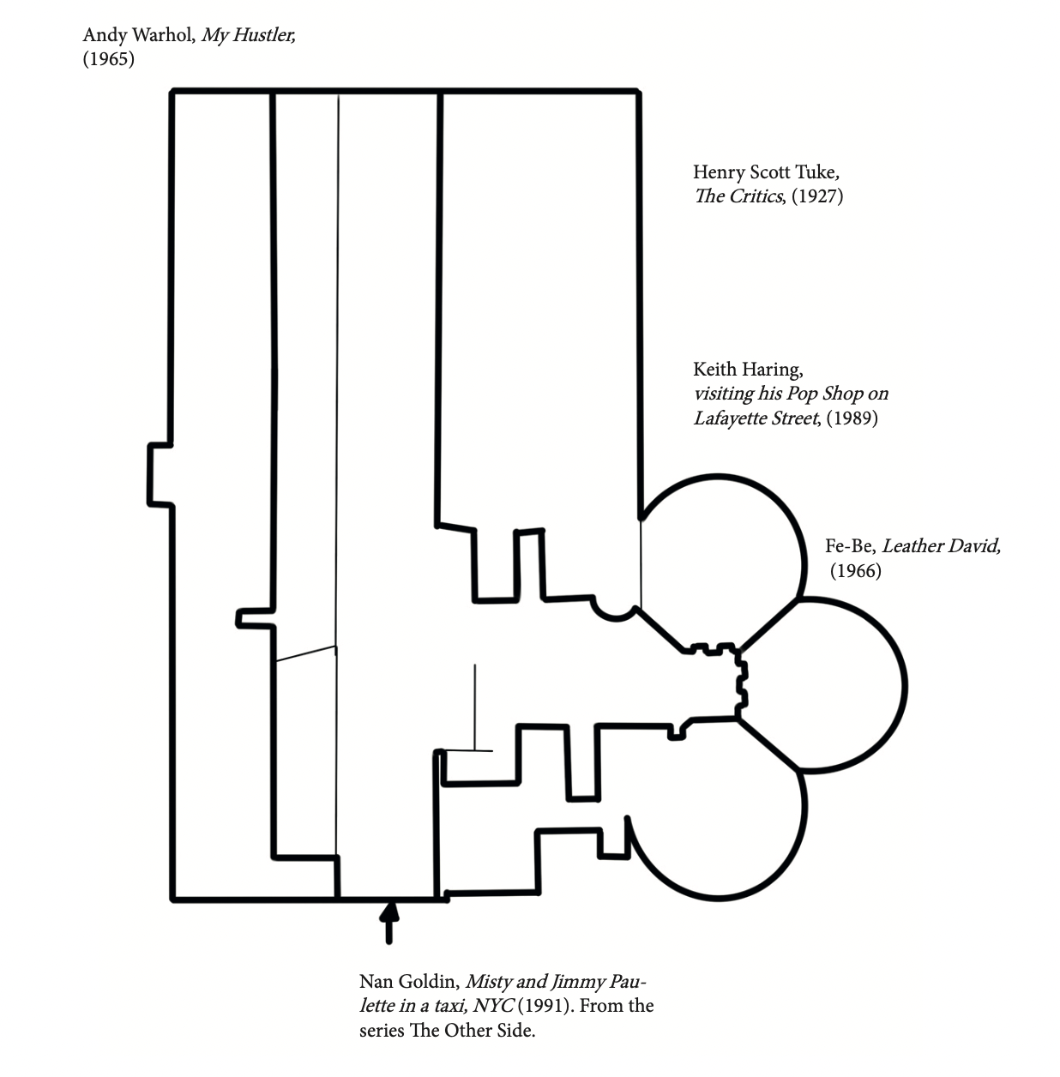

Bibliography
Bell, J., 2020. Between private and public: AIDS, health care capitalism, and the politics of respectability in 1980s America. Journal of American Studies, 54(1), pp.159-183.Available at: https://www.cambridge.org/core/journals/journal-of-american-studies/article/abs/between-private-and-public-aids-health-care-capitalism-and-the-politics-of-respectability-in-1980s-america/5DFDF1E4749ED89329A47ADF5E7E795F (Accessed on 22nd April 2024)
Honnef, K. and Warhol, A., 2000. Andy Warhol, 1928-1987: commerce into art. Taschen. Available at: https://books.google.co.uk/books?hl=en&lr=&id=YXxtLVKi7FEC&oi=fnd&pg=PA5&dq=Honnef,+K.+and+Warhol,+A.,+2000.+Andy+Warhol,+1928-1987:+commerce+into+art.+Taschen.&ots=MChZ3nNX4m&sig=Zqv6bozjyk3yxhhcdKDdl6o0Da8&redir_esc=y#v=onepage&q&f=false (Accessed on 22nd April 2024)
Keizer, J., 2008. Giuliano Salviati, Michelangelo and the'David'. The Burlington Magazine, 150(1267), pp.664-668. Available at: https://www.jstor.org/stable/40479899 (Accessed on 26th April 2024)
Morin, E. and Boaden, J., Bringing AIDS Home: Urban and Domestic Queer Spaces in the work of Nan Goldin and David Wojnarowicz. Available at: https://d1wqtxts1xzle7.cloudfront.net/53175532/Final_Dissertation-libre.pdf?1495105311=&response-content-disposition=inline%3B+filename%3DBringing_AIDS_Home_Urban_and_Domestic_Qu.pdf&Expires=1714359112&Signature=UrKo1uPDgRaxi91foPd6CcPShM8iScNSXVIC33wI7bOlunWE9VXzoLTccpLDE4dTc0geWksbkic90XgAuAbD27pSfq1IJq-~3pQnamg3o8nWsp8aBiIFkf1e8BQifxtJRc~Qt1CmJ7pl6gZtp4lENMQib0IBgJAE0~Qpr6rPQZWla-1k7G1WVKp39zFbblpcFmRIHdJUBvRs-X4RD69wiEDLVXZI3~j6YQyGBYXGFgTJYIpKDrwaTQGyPvgdvgnohpZkGCPo8oDTIFoeKXRjEa1ybElQ1S1YNhoc2rbtDkmnu4NUwy-qgrwvtkQAwi2keeaawg6C1OllAU0YjtOrjQ__&Key-Pair-Id=APKAJLOHF5GGSLRBV4ZA (Accessed on 27th April 2024)
Mayo Jr, J.B., 2019. ENGAGING TWO SPIRIT KNOWLEDGE AS A MEANS TO DECONSTRUCT THE GENDER BINARY. Editor: Jessica B. Schocker Associate Editor: Sarah B. Brooks, 39(1), p.6. Available at: https://d1wqtxts1xzle7.cloudfront.net/63637359/SSJSpring2019-120200615-127422-1juo9n4-libre.pdf?1592260364=&response-content-disposition=inline%3B+filename%3DWhat_should_I_teach_Supporting_social_st.pdf&Expires=1714359244&Signature=TI20IAuziou1qfyl-OKBsgSbsKmhZvcSgkN4IgRLcpYO7q3dpcOeZJvrz5Mghpcx4x5pPf4BA6gZOsLN4S9eLyjdTZ9CDu2AEIWFzMlEeT8ZOT97SJNXG7mDFra-ycystYDoko4mT879oFDq65VxWly5Rc3ru-sFo1bNpSWIEJiPGSZ7FVqXAq7sBAYn~XNqAkA4kGGlrMNOM3x650HY4kUhWAKCP~Ea4snLtba~cb5EJUPaZ6i4RTPlDwdZjrwpOo0Oah7uJUtG55JqdtAqBIClyZ6SDTQfoZI7stTCTA55WVjSZWn~zRLpYD0qG9e7H4y2XDiZ4CCoA-IHy3gM4A__&Key-Pair-Id=APKAJLOHF5GGSLRBV4ZA#page=6 (Accessed on 19th April 2024)
Moran, L.J., 2007. Homophobic violence in London: challenging assumptions about strangers, dangers and safety in the city. In Law and the City (pp. 77-95). Routledge-Cavendish. Available at: https://www.taylorfrancis.com/chapters/edit/10.4324/9780203945155-7/homophobic-violence-london-leslie-moran (Accessed on 22nd April 2024)
McCormack, M., 2013. The declining significance of homophobia. Oxford University Press, USA. Available at: https://books.google.co.uk/books?hl=en&lr=&id=aQZFW3DrKSYC&oi=fnd&pg=PP1&dq=McCormack,+M.,+2013.+The+declining+significance+of+homophobia.+Oxford+University+Press,+USA.&ots=f2kv330Rfl&sig=Asc6plZrYP0TnzNtLgYZP9ooe3U&redir_esc=y#v=onepage&q=McCormack%2C%20M.%2C%202013.%20The%20declining%20significance%20of%20homophobia.%20Oxford%20University%20Press%2C%20USA.&f=false (Accessed on 19th April 2024)
O'Neill, P., 2016. The Culture of Curating and the Curating of Culture (s). Mit Press Available at: https://books.google.co.uk/books?hl=en&lr=&id=EFT5DwAAQBAJ&oi=fnd&pg=PR9&dq=O%27Neill,+P.,+2016.+The+Culture+of+Curating+and+the+Curating+of+Culture+(s).+Mit+Press&ots=5620Gfi5Gi&sig=15KmTASwVV2N6RtcYzXKlzlKeng&redir_esc=y#v=onepage&q=O'Neill%2C%20P.%2C%202016.%20The%20Culture%20of%20Curating%20and%20the%20Curating%20of%20Culture%20(s).%20Mit%20Press&f=false (Accessed on 19th April 2024)
Petry, M., 2007. Hidden histories: The experience of curating a male same sex exhibition and the problems encountered. International Journal of Art & Design Education, 26(1), pp.119-128. Available at: https://onlinelibrary.wiley.com/doi/abs/10.1111/j.1476-8070.2007.00516.x (Accessed on 21st April 2024)
Robinson, C. ed., 2021. Henry Scott Tuke. Yale University Press. Available at: https://books.google.co.uk/books?hl=en&lr=&id=AgkrEAAAQBAJ&oi=fnd&pg=PP18&dq=Robinson,+C.+ed.,+2021.+Henry+Scott+Tuke.+Yale+University+Press&ots=Ny5wGlXjIe&sig=DCY3iHBvalLtwObuO6EvjHLVpmA&redir_esc=y#v=onepage&q=Robinson%2C%20C.%20ed.%2C%202021.%20Henry%20Scott%20Tuke.%20Yale%20University%20Press&f=false (Accessed on 27th April 2024)
Tandon, A. and Rao, T.S., 2021. Pride parades. Journal of Psychosexual Health, 3(3), pp.209-211. Available at: https://journals.sagepub.com/doi/full/10.1177/26318318211038118 (Accessed on 19th April 2024)
Tin, L.G. ed., 2008. The dictionary of homophobia: a global history of gay & lesbian experience. arsenal pulp press. Available at: https://books.google.co.uk/books?hl=en&lr=&id=aK02DwAAQBAJ&oi=fnd&pg=PT7&dq=Tin,+L.G.+ed.,+2008.+The+dictionary+of+homophobia:+a+global+history+of+gay+%26+lesbian+experience.+arsenal+pulp+press.&ots=h58BmOhulM&sig=fv4rgQVvwCXVa68XQmqV5IH9Nug&redir_esc=y#v=onepage&q&f=false (Accessed on 27th April 2024)

List of figures
Figure 1: Tate Museum, London. Accessed:
https://adventuresofalondonkiwi.com/2022/04/free-things-to-do-in-london-the-tate-britain-a-walk-through-art-history/
Figure 2: Allen Ginsberg, Keith Haring visiting his Pop Shop on Lafayette Street, 1989. Accessed: https://www.nga.gov/collection/art-object-page.213310.html
Figure 3: Andy Warhol, My Hustler, 1965. Accessed: https://www.warhol.org/lgbtq/
Figure 4: Fe-Be, Leather David, 1965. Accessed: https://www.queerarthistory.com/tag/sculpture/
Figure 5: Michelangelo, David, 1501-1504. Accessed: https://www.accademia.org/explore-museum/artworks/michelangelos-david/
Figure 6: Henry Scott Tuke, The Criticts, 1927. Accessed: https://www.anothermag.com/art-photography/9694/ten-pioneering-works-of-queer-art-that-changed-history
Figure 7: Nan Goldin, Misty and Jimmy Paulette in a taxi NYC, 1991. Available at: https://kunstkritikk.com/oh-snap/

