Malcolm Griffith-thomas
(1704210

Rural business and Diversification
(BMSP5009)

Jessica Shore

Assignment 2

Are small villages missing out? Have they lost their appeal? Do they have the footfall they used to? Are rural businesses being left behind? Is it time for diversity to transform these rural areas and change the forecast for rural business owners?

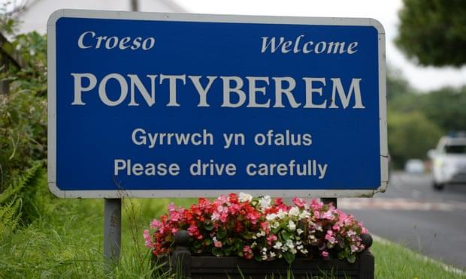
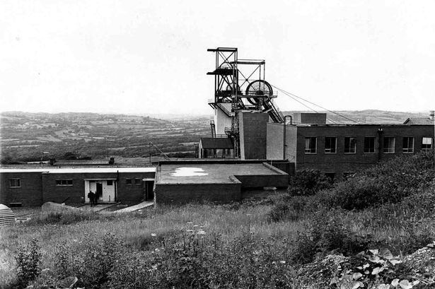
Pontyberem is a small village based in the hear of the Gwendraeth valley. Once known for it mining community and transport links to the two local mines, Glynebog and Cynheidre collieries. Pontyberem was a popular place to live between 1896 and 1989., with the mines working in full swing it was a conveniently based village for miners to live, with a train link heading in both directions. Ponthyberem thrived during this period with businesses booming and foot flow at an all time high, there were shops, bakeries, butchers, pubs, clubs, churches and two schools in the village alone. The collieries employed over one thousand four hundred and seventy two people in 1972, the reason rural business was at the top of its game. So, what happened to this once thriving village? The mine closed, people were made redundant and mov/ed to other locations in search of work, most miners has worked underground from a very young age, with no trade, no experience in any other field, they were left with no choice but to relocate where collieries were still running. This had a huge impact on the local economy, with money in short supply businesses struggled, with a reduced footfall things began to decline. “while miners depend on the mine, so too may an entire town. Many small businesses close along with mines, and a town can lose almost all of its economic activity.” (Five lessons from past mining closures | SEI, 2021) it was clear that the village suffered after the closure of the mines, derelict buildings could be seen where businesses once stood, Pontyberem used to be known for its minning community, everyone knew everyone, and most of the population were elderly. It is proven that the elderly tend to shop local “older shoppers show a preference for buying local-only” (Wells, 2021) supporting local business, however as the older population passed on they were replaced with a younger community. Young people tend to not have a preference on where the product comes from, they focus their decision purely on price and brand names “it is young millennials aged 18-24 who are more inclined to buy international brands, which they perceive to be more innovative and affordable.” (Wells, 2021) this costing the rural business owners their livelihoods, and the community spirit once known in the popular village slowly disappears.
(Sit-in at BBC Welsh studios – archive, 30 November 1968, 2021)
(2021)

So, what does Pontyberem consist of now?
Pontyberem has three clubs, two pubs, three takeaways, a carpet shop, a village hall, a flower shop, an undertaker, a chemist, a doctor’s surgery, several places of worship, a rugby ground, a cricket ground, a football pitch, a park, a tennis court, a primary school, several woodlands, hairdressers, a café, and two car dealerships. Having all these businesses in a village with “two thousand seven hundred and sixty eight people” (Kingdom, 2021) is good going, but how can more people be encouraged to visit the village, how can visitors be encouraged to spend in the village ensuring the rural business owners remain open and sustainable? The answer is Diversity, the need for change to ensure a sustainable future for both the business owners and community itself. The days of the locals spending all their hard earned cash locally are gone. The only way that the village will survive is by moving with the times and using what is on their doorstep to entice future custom into the village.

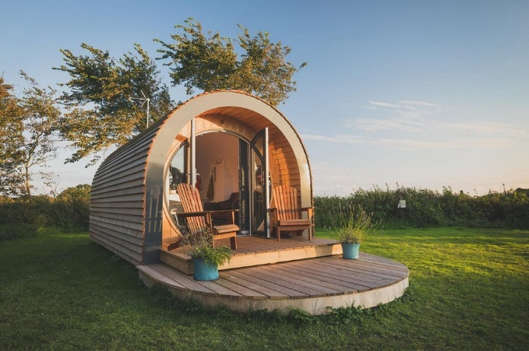
Glamping
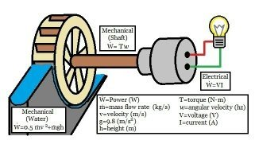
Looking at the landscape of the village and surrounding area there are several different woodlands. Beautiful scenery with a river runner through both the village and the forestry. This could be one very creative and effective way to encourage tourist to the area to see what the village has to offer. Glamping is a low cost holiday let which are usually located in woodland or fields in quiet rural areas. Glamping is very popular in the Uk “Glamping and camping is more popular that ever in the UK – with four in every 10 people having enjoyed a trip in the last year.” (2021) This could create income for the village through tourism, a cheap investment building some log cabins in the luxurious woodland surrounding the village park would encourage people to visit and potentially spend some of their income in the rural businesses whilst visiting, the good thing about glamping is the fact it can be done twelve months of the year unlike camping which tourists only tend to do in the summer months. Some on site activities could be offered such as, nature trails, fishing, forestry education, teaching visitors the difference between trees, plants, and wildlife, and possibly even a treetops trial and zip line. The opportunities are endless with a huge positive impact on rural business. However, for the glamping site to encourage customers into the area it must be different, it has to offer something that others do not, hot tubs are regularly available with a glamping pod. One thing that would fit in with the current battle on climate change would be to make the site one hundred percent carbon neutral. The first in the Gwendraeth valley and the first in the village. How could this be achieved? As mentioned earlier there is a river flowing through the heart of the woodland, a water wheel to produce of grid electricity could be installed. This would crate a hundred percent carbon neutral electricity when the river is in full flow, what about the summer months when the river is low? The answer to that question is without a doubt solar panels, solar power is created all year round and could be used alongside the water wheel to ensure that the site has a reliable electricity supply all year around. To make things even more sustainable they could include a large veg patch on the site where members of the local community and visitors could plant, grow, and purchase on site produce. Educating visitors and the local community on how to grow their own vegetables at home and reduce the pollution of transporting and packaging fruit bought from local supermarkets. The produce can be sold as an extra income stream for the site ensuring that they remain sustainable. All onsite waste could be recycled, and food waste composted for the vegetable patch. the glamping site could also have a small log building with pictures and information of Pontyberem in the past educating visitors of the history of a small village in years gone by.
(2021)
(2021)
Creating a glamping site however may have its flaws, increased littering and development of the woodland would be the two main contributing factors when deciding whether glamping would diversify the village. Some of the residents may complain that the site will increase traffic flow through the village and cause some congestion on the roads during busy periods. However, the benefits of having the site do severely outweigh the impact of having it. For example, if one pod holds four people, and the site has 10 pods, there is the potential of having fourty visitors at any one time. These visitors will require somewhere to eat, benefiting the local café, pubs and take away. They will require somewhere to purchase goods, benefiting the local shop, and there is always the possibility that they would like to have something alcoholic to drink benefiting the pubs and clubs. For a low investment development, it seems the possibilities are endless, and expansion is always an option if the development is a success. The development could also be community run, regaining the community feeling of belonging from years gone by, Pontyberem used to be a closed knit community during the mining era and with residents coming together to create and maintain the site could become an even stronger community. the development of this site will not only increase revenue for businesses in a rural area, but increase the sustainability of the area, bring the community closer and create a sustainable future for the village. Possibly putting the village back on the map.

Derelict railway line
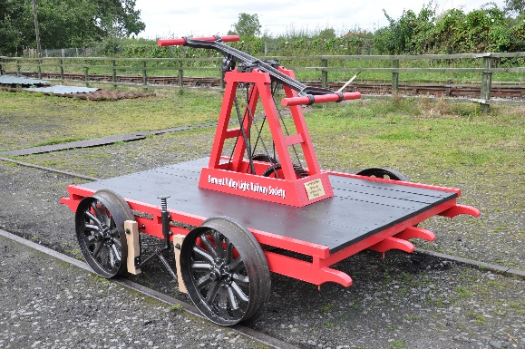
Pontyberem has a railway line running through the centre of the village, used years ago for the transportation of coal, which ceased in the late nineteen eighties when the col industry came to an end. The railway line has been left to overgrow. One way to encourage visitors to an attraction in the village would be to clear the line and open it for pump truck use, visitors get to hire a pump truck and travel through the village and neighbouring villages using a pump truck. This is a carbon friendly form of transport as well as an attraction and involves exercise. This could also be used by local youth clubs and fitness clubs as a form of training. Running costs would be low and the form of transport could be beneficial to those who do not drive. The rail line would look tidy again and it would put a rail line with a long standing history back in use again. A one of a kind attraction to encourage visitors and increase potential spend in the village. Stops could be incorporated outside local businesses to encourage people to stop. Or at least educate them of the local produce and services available.
(rail pump cart - Google Search, 2021)
Is community important?

Yes, community is important according to Healthoholics”It allows us to support one another, interact, share experiences and our modern life struggles. Having this open bond with others is what builds valuable relationships, and gives us a deeper sense of belonging. Communities are also rich in resources”. (The Importance of Community - Healthoholics, 2021) Community is essential in modern day life, this is something that Pontyberem has accomplished. The local park is run by a community group. The community group oversee maintenance and management of the park. Bringing the whole community together and ensuring that everyone is heard. The village can listen to the resident’s request and put them into action without having to put their plans forward to the council. The park is independent and that is thanks to the community. the community lead group arrange activities and organise events such as the carnival and buggy race, a yearly event that gets the whole village out, mixing and communicating helping each other in day to day life. the community group even have their own Facebook page for communication.
(Facebook, 2021)

Community is also essential especially in rural business, without the community behind you it is very unlikely a business will succeed, unlike urban business that is usually located in a town or city centre, and rely on passing trade, impulse buying, a rural business has much less passing trade and relies on the local community for recommendations and custom.

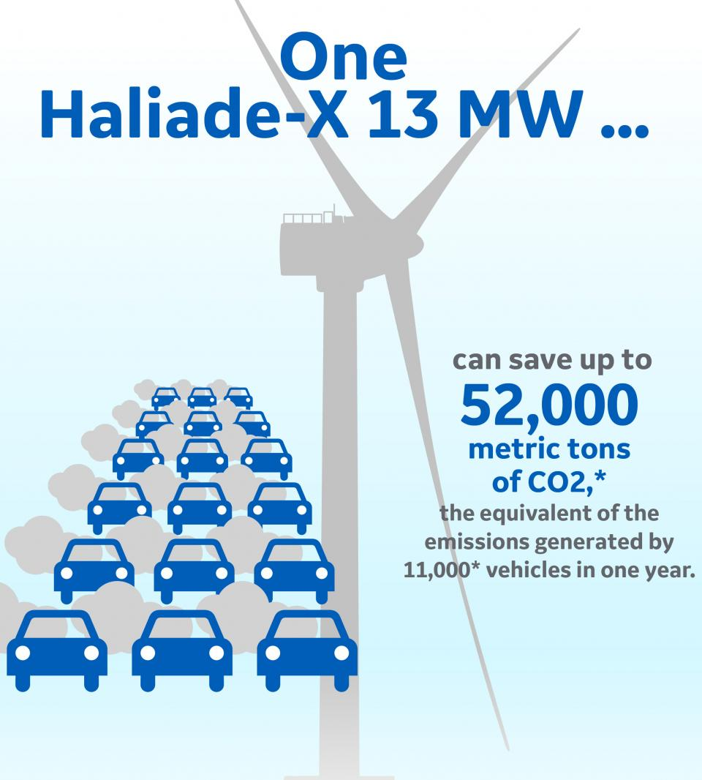
How sustainable is Pontyberem as a village?
There is very little evidence to show that the village is sustainable, with the fight against climate change looming, there is essential need for the village to increase its sustainable eco friendly production of electricity. The landscape in the area allows for several different types of renewable energy, the village is in a valley surrounded by hills, perfect for the installation of wind turbines. This could supply the village with a totally carbon neutral supply of electricity. One wind turbine can save up to 52,00o metric tons of co2 a year. Reducing the villages carbon foot print significantly. In turn this will reduce running costs for rural businesses and the community.
(2021)
Another form of sustainable energy production the village could use to their advantage is hydro power, hydro power is using the current of a river to power a turbine and create electrictity. This would be effective as the village have a large river, that runs from one end of the village to the other, with this wide spread water available more than one hydro power unit could be installed to produce a bigger amount of carbon free electricity. If the village of Pontyberem were to install both types of renewable energy sources there would be enough electricity produced for the village to reduce their carbon footprint significantly, helping combat climate change. Making the village sustainable and ensuring that the future of electricity production remains sustainable.

Throughout this article several different ideas have been identified to diversify this rural village, should the village decide to take these ideas on board, they will benefit from them, the Glamping experience will attract tourists to the area and increase revenue for businesses. Being self sufficient and growing their own produce both to consume and sell, will ensure that all income into the glamping site itself is profit, ensuring that the business can continue to grow and invest. Installing some wind powered turbines will lower the villages carbon footprint and increase the community’s sustainability. The main objectives identified are to improve the sustainability of the village now and in the future by increasing their renewable energy sources and attracting consumers to the area to spend the money. Ensuring that the village is sustainable. Without taking some sort of action the village will be left behind and in time business will be effected, be it the closure of businesses or relocation. The village has all the facilities it needs to create something spectacular sitting on the doorstep, all it needs is someone to put something into action and the benefits will show immediately benefiting the community by ensuring their shops and services remain open, and possibly making Pontyberem a popular village as it was in the mining era.

References

2021. [online] Available at: <https://newmanu.edu/top-5-skills-employers-look-for> [Accessed 24 May 2021].

2021. [online] Available at: <https://www.glampingbusiness.com/2017/01/06/glamping-popular-ever-uk/> [Accessed 25 May 2021].

Alchetron.com. 2021. Cynheidre Colliery - Alchetron, The Free Social Encyclopedia. [online] Available at: <https://alchetron.com/Cynheidre-Colliery> [Accessed 25 May 2021].

Cool Camping, C., 2021. The best coastal glamping sites in the UK. [online] Standard.co.uk. Available at: <https://www.standard.co.uk/escapist/travel/best-seaside-glamping-breaks-from-cool-camping-a3903451.html> [Accessed 25 May 2021].

Facebook. 2021. Log in to Facebook | Facebook. [online] Available at: <https://www.facebook.com/pontyberemcommunityparkassociation/> [Accessed 25 May 2021].

Ge.com. 2021. [online] Available at: <https://www.ge.com/news/sites/default/files/2020-09/GE%20Haliade%20X%20vertical%209_21_2020.pdf> [Accessed 25 May 2021].

Ge.com. 2021. [online] Available at: <https://www.ge.com/news/sites/default/files/2020-09/GE%20Haliade%20X%20vertical%209_21_2020.pdf> [Accessed 25 May 2021].

Google.com. 2021. rail pump cart - Google Search. [online] Available at: <https://www.google.com/search?q=rail+pump+cart&source=lnms&tbm=isch&sa=X&ved=2ahUKEwjgnpbLquXwAhWGOcAKHe9sAysQ_AUoAXoECAEQAw&biw=1366&bih=600#imgrc=zZA0nl2AunMf_M> [Accessed 25 May 2021].

Healthoholics. 2021. The Importance of Community - Healthoholics. [online] Available at: <http://healthoholics.com/the-importance-of-community/> [Accessed 25 May 2021].

Kingdom, U., 2021. Pontyberem (Community, United Kingdom) - Population Statistics, Charts, Map and Location. [online] Citypopulation.de. Available at: <https://www.citypopulation.de/en/uk/wales/admin/carmarthenshire/W04000553__pontyberem/> [Accessed 25 May 2021].
the Guardian. 2021. Sit-in at BBC Welsh studios – archive, 30 November 1968. [online] Available at: <https://www.theguardian.com/uk-news/2016/nov/30/welsh-bbc-studios-protest-sit-in-language-1968> [Accessed 25 May 2021].

Wells, L., 2021. Half of UK shoppers prefer to buy local. [online] Talking Retail. Available at: <https://www.talkingretail.com/news/industry-news/half-uk-shoppers-buy-local-support-small-producers-12-11-2018/> [Accessed 25 May 2021].

Wells, L., 2021. Half of UK shoppers prefer to buy local. [online] Talking Retail. Available at: <https://www.talkingretail.com/news/industry-news/half-uk-shoppers-buy-local-support-small-producers-12-11-2018/> [Accessed 25 May 2021].

