`
ASSIGNMENT

Database Systems (ACCA7002)

BY
WENXUAN ZENG

Student ID: 2200378

CONTENTS
Abstract 3
1 Requirements analysis 4
2 Create PostgreSQL database 4
2.1 Design Entity Relationship Diagram 4
2.2 Construct Tables 5
2.3 Create table 5
2.4 Foreign key constraint settings 5
2.5 Constraint settings 6
2.6 Populating tables in the database 7
3 Performance Tuning 8
3.1 The importance of indexing 9
3.2 Add Indexing 9
4 Database transactions and related operations 10
4.1 The importance of database transactions 10
4.2 The importance of rollback 11
4.3 The importance of submission 11
4.4 Adding transactions 11
4.4.1 Setting up the rollback 11
4.3.1 Setting up the submission 12
5 Evaluation of Design and Implementation 13
5.1 The importance of function 13
5.2 The importance of Triggers 13
5.3 The importance of Procedures 14
5.4 Design and Implementation 14
Reference 19

Abstract
This essay focuses on the analysis of existing problems with ALC. Completed the design of the Entity Relationship Diagram to meet the requirements of ALC. Completed the setting of each entity property and entity relationship through business grooming. The creation of database tables and the implementation of functions such as Rollback, Commit, Function, Triggers, Procedures, Transactions and Indexing are completed. In addition, the importance of these functions will be analysed. Finally complete the evaluation of the database design and implementation.

1 Requirements analysis
According to a survey of Abertawe Leisure Centre's (ALU) current operations, business systems and existing databases, it was found that the existing database provision was no longer adequate for the Centre's operations. The main deficiencies are.
(1) Staff supervision of membership status, for example, joining, renewal, termination, and course bookings.
(2) Database administrators' control over stored procedures, which enable the creation of insert, update, delete, commit, and rollback operations to the database
(3) Database administrator review of membership table operations in the database, including insertion, update and deletion

2 Create PostgreSQL database

2.1 Design Entity Relationship Diagram

2.2 Construct Tables
(1)Membership
Membership(Membership_Id, Membership_Type, Fee)
- Classes
Classes(Class_Id, Membership_Id, Class_Type, Join_Number, Status)
- Room
Room(Room_Id, Class_Id, Start_Time, End_Time, Start_Date, End_Date)
- Members
Members(Member_Id, Membership_Id, First_Name, Last_Name, Address, Telephone, Date_join, Until_Date, Last_Renewal)
- Instructor
Instructor(Instructor_Id, Membership_Id, First_Name, Last_Name, Address, Telephone)
- Instructor_Room
Instructor_Room(Room_Id, Instructor_Id)
(7)Member_Class
Member_Room(Class_Id, Member_Id)

2.3 Create table
Use the CREATE TABLE statement to create a database table, adding the attributes of the fields in the table at creation time.
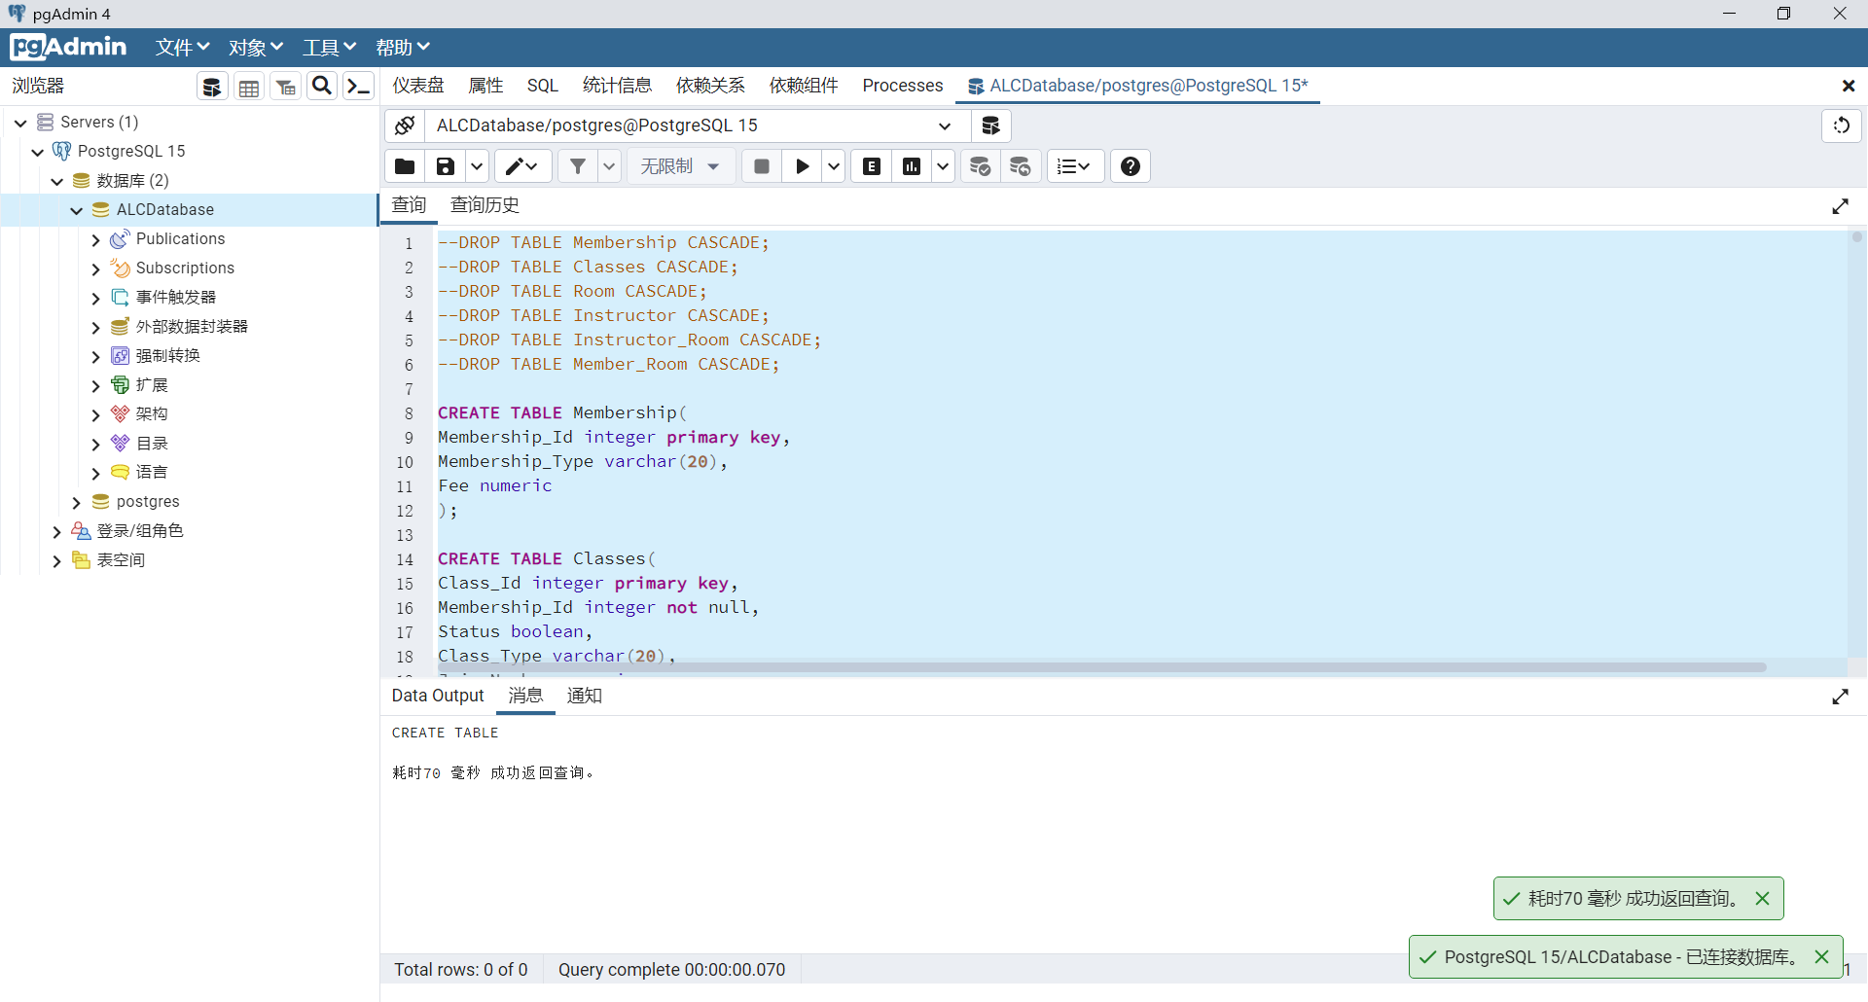

2.4 Foreign key constraint settings
The foreign keys for each table are set as follows：
Classes--Membership_Id
Room--Class_Id
Members--Membership_Id
Instructor_Room--Room_Id
Instructor_Room--Instructor_Id
Member_Class--Class_Id
Member_Class--Member_Id
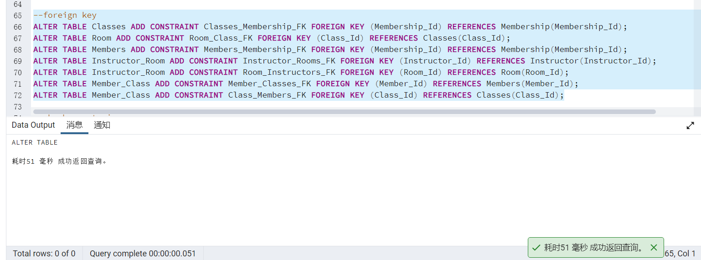

2.5 Constraint settings
(1) The number of participants in the class should be at least 0
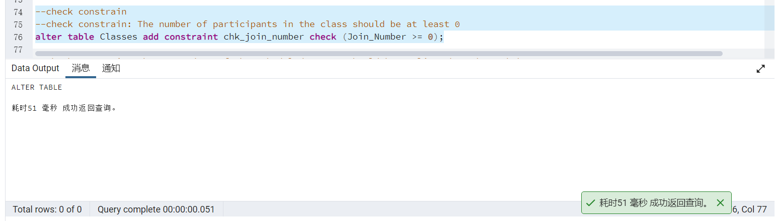
- The start date of the scheduled course should be earlier than the end date
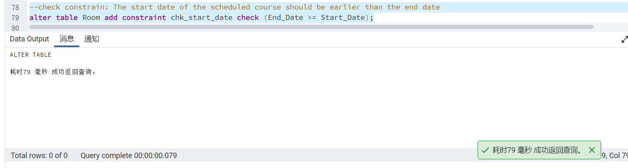
- Membership fees are only available at £550 pa, £800 pa and £1200 pa.
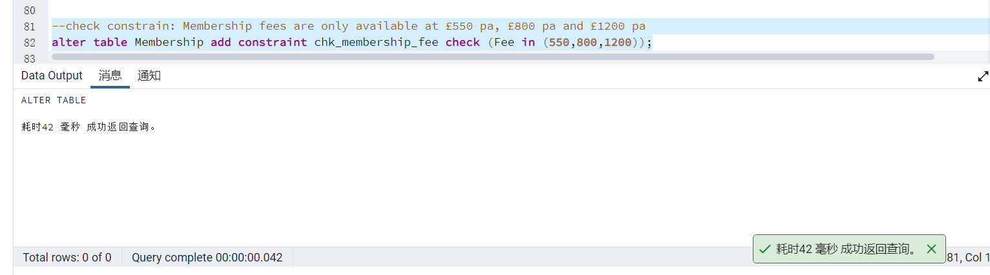
- Each member's membership number is unique
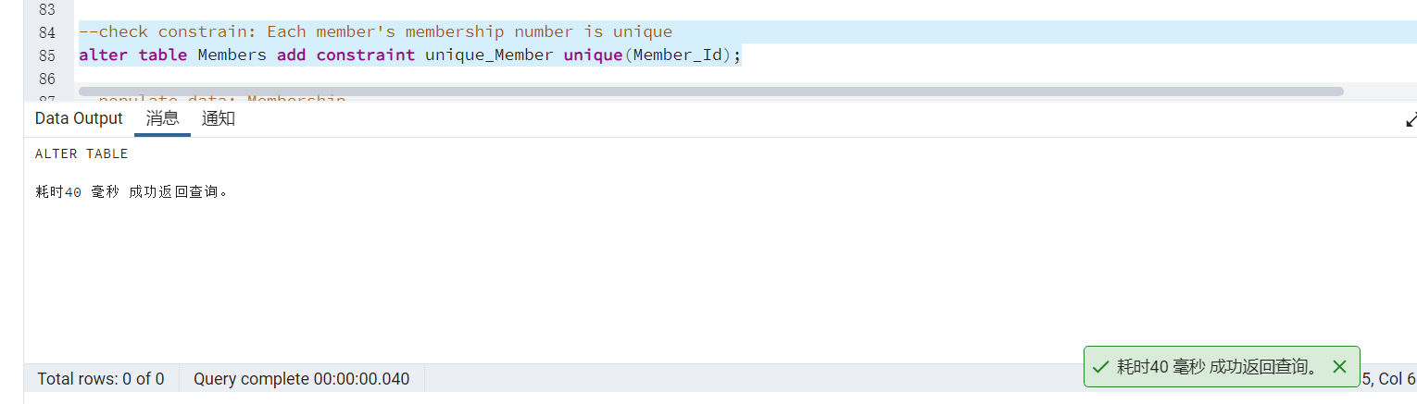

2.6 Populating tables in the database
Use the INSERT INTO statement to insert a new row into a table.
(1) Membership
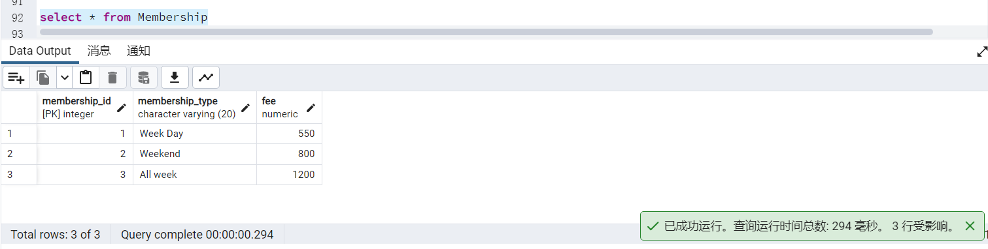
- Classes
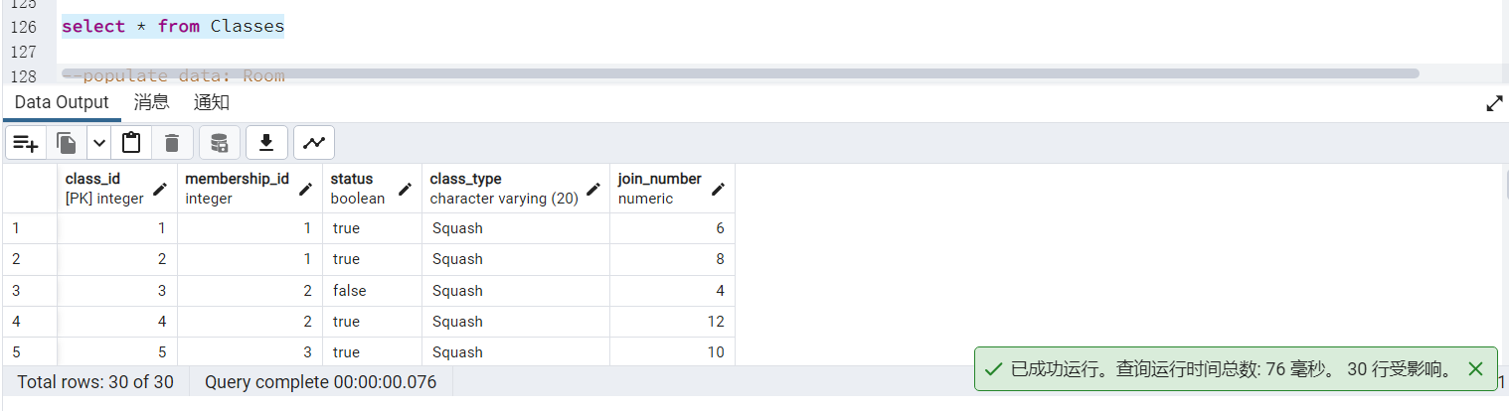
- Room
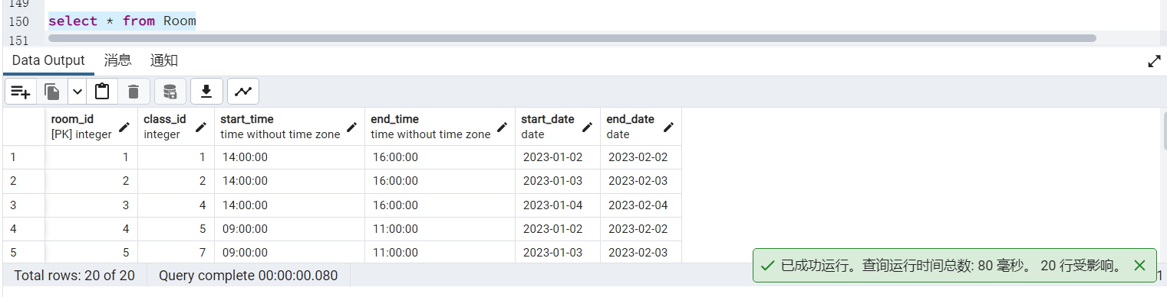
- Members
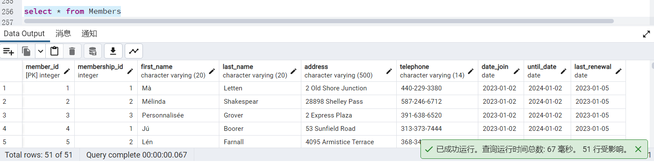
- Instructor
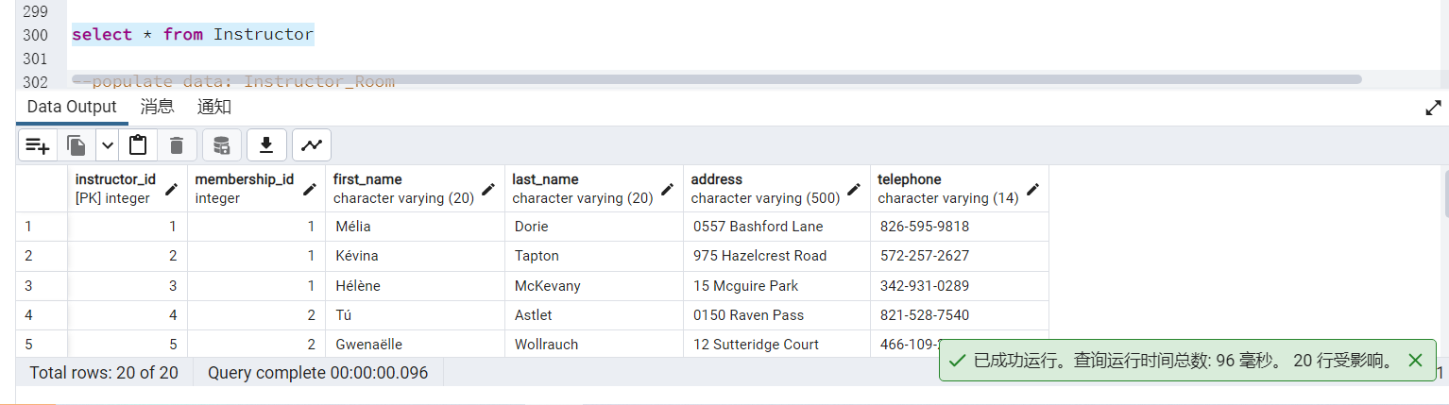
- Instructor_Room
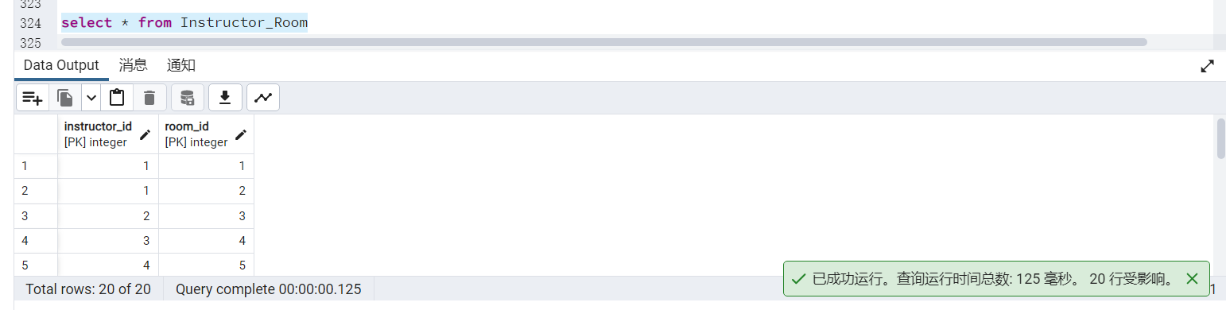
- Member_Class
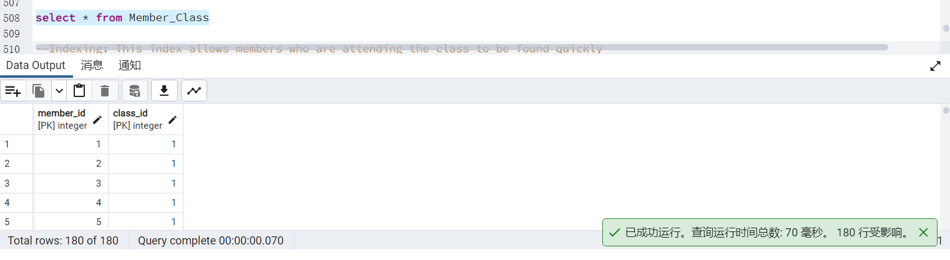

3 Performance Tuning
The Data Query Language is used to query the records of tables in the database, the longer used keywords are: select, where and so on. The query statement allows the user to quickly find the required data in the database.

3.1 The importance of indexing
Indexing is a method of speeding up the retrieval of data from a table, which means an auxiliary data structure that can help find the record ID that satisfies a condition.^{[1]}Each index has an associated search code and any subset of fields can be a search code. An index is seen as a collection of data catalogue items which provides efficient support for the ordering of all data catalogue items for a given search code value K.^{[2]}
The creation of indexes can greatly increase the speed with which data can be accessed and processed in the database.^{[3]}
(1) The ability to create a one-to-one mapped correspondence between the index and the information when designing a database by creating a unique index, increasing the uniqueness characteristics of the data.
(2) It can greatly speed up the retrieval of data, which is the primary reason for creating indexes.
(3) It can accelerate joins between tables, which is particularly relevant in achieving referential integrity of data.
(4) The time spent grouping and sorting in queries can likewise be significantly reduced when using grouping and sorting clauses for data retrieval.
(5) By using indexes, optimisation hiders can be used to improve the performance of the system during queries.

3.2 Add Indexing
(1) Create a secondary index on the Class_Id of Member_Class
Staff can use this index to quickly find the members who are attending the class
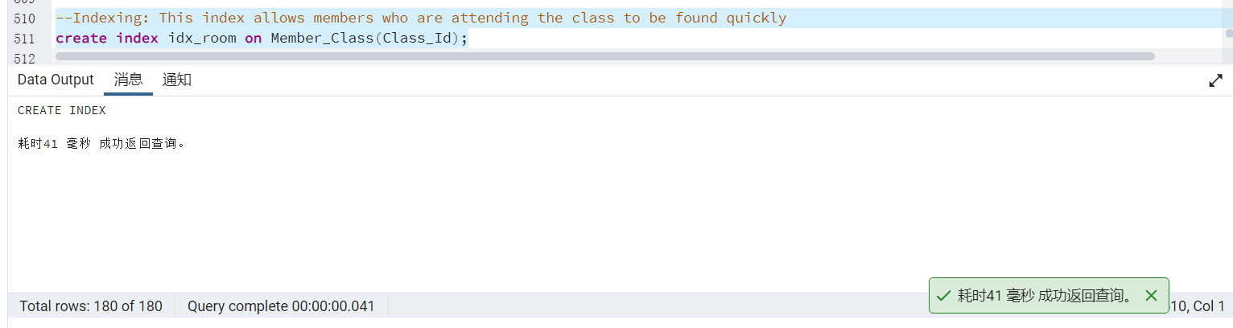
(2) Create a secondary index on the status of Classes
This index allows staff to quickly find classes with less than 6 members where they can make course booking recommendations for members who need to book a course.
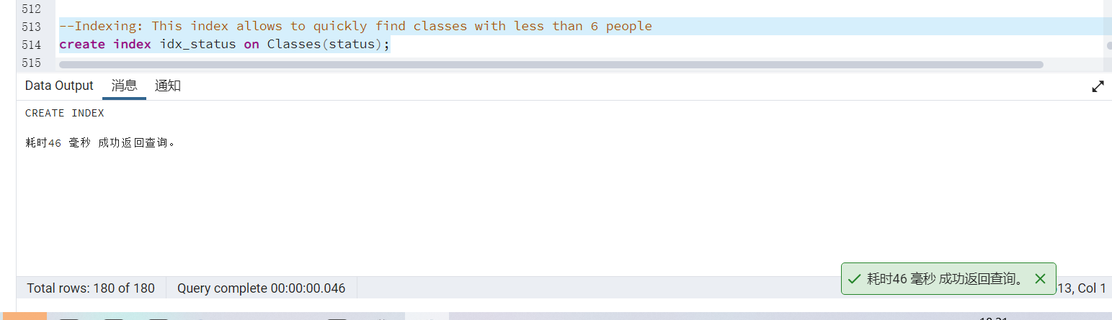
(3) Create a secondary index on Members' Until_Date
This index allows staff to quickly locate members who are approaching their expiry date. After locating a member who is close to expiry, staff could ask the member over the phone if they want to renew their membership.
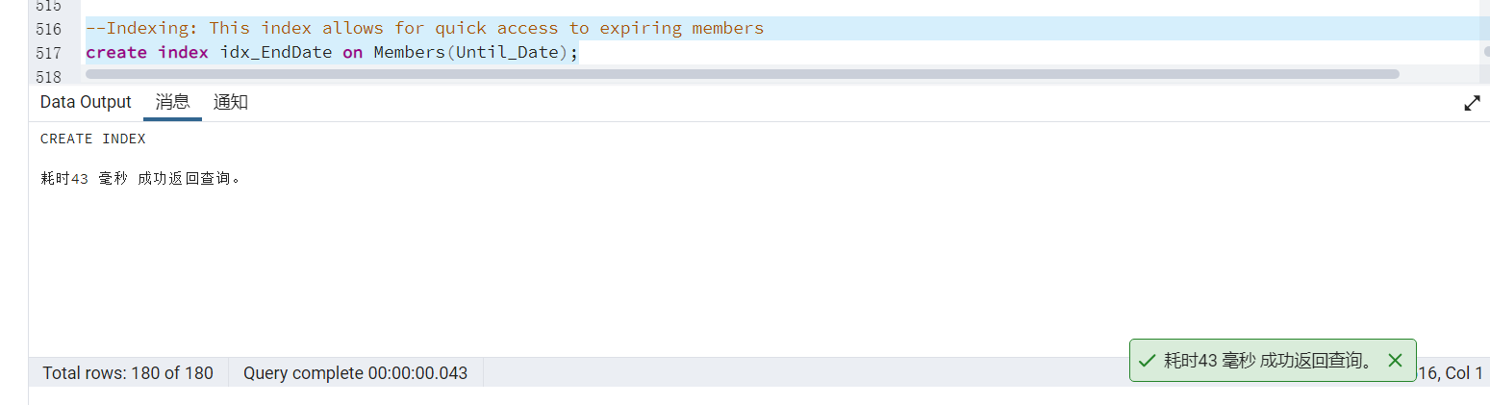

4 Database transactions and related operations

4.1 The importance of database transactions
Transactions are a unit of program execution that accesses and possibly updates various data items, and are generally considered to be an indivisible unit of work consisting of a sequence of all operations performed between the start of a transaction and the end of the transaction, which either do all or none of them.^{[4]}The start and end of a transaction could be controlled by the user display, or if the user does not define the transaction displayably, there is a DBMS to automate the sub-transaction by default.^{[5]}
A database transaction usually contains one sequence of read and write operations to the database. Its existence contains the following two purposes：
(1) To provide a means for a sequence of database operations to recover from failure to a normal state, and to provide a means for the database to remain consistent even in an abnormal state.
(2) To provide a method of isolation between multiple applications when they are accessing the database concurrently, to prevent their operations from interfering with each other.

4.2 The importance of rollback
Rollback of a transaction is when a failure occurs in the course of a transaction and the transaction cannot continue, the system undoes all the operations performed on the database in the transaction and rolls it back to the start of the transaction.^{[6]}
When operating with the data in the database, if an error is reported in the data, for example, if one of the data cannot be inserted during a bulk insert, then the operation will be considered invalid and the database will be rolled back to ensure the integrity of the data. In the program development, it is atomic operation with transaction, this may be due to a business operation to add, delete and change multiple tables in the database, if there is a problem in the middle, then the data of the operated part can be rolled back to restore the integrity of the database.^{[7]}

4.3 The importance of submission
COMMIT command is used to save the changes made by the transaction to the database. It saves all transactions since the last COMMIT or ROLLBACK command to the database.
The use of COMMIT has the following advantages:
(1) Using COMMIT to commit the current transaction makes changes performed in the transaction permanent, all changes to the transaction will be visible to other transactions, and sustainability is guaranteed when a crash occurs.
(2) The ability to view any changes made during the transaction through the table that was modified, but other users cannot see the changes made.
(3) The ability to roll back the ROLLBACK statement with any changes made during the transaction.
(4) This statement can be used to manually commit queries on a distributed transaction.
(5) This statement can be used to terminate a read-only transaction with the SET TRANSACTION statement

4.4 Adding transactions

4.4.1 Setting up the rollback
Maëlle Maplesden has chosen a squash class, and in order to do the selection operation, the whole transaction requires two steps: firstly, fill in Maëlle Maplesden's membership number of 51 and the squash class code of 1 in the Member_Classes table, and secondly, add 1 to the number of tennis selections in Classes. Classes table with Naéva Littell's membership number and squash class code, but when executing action 2, the program runs with an error and needs to be rolled back.
START TRANSACTION;
INSERT INTO Member_Class (Member_Id, Class_Id) VALUES (51, 1);
UPDATE Classes set Join_Number= Join_Number+1 WHERE Class_Id=100;
rollback ;
select * from Member_Class;
select * from Classes;
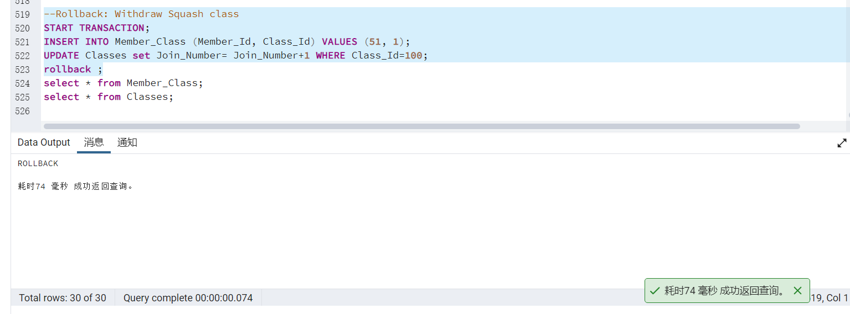

4.3.1 Setting up the submission
Naéva Littell signed up for a weekend membership, which will expire tomorrow, therefore Naéva Littell wants to continue his weekend membership for one more year.
START TRANSACTION;
INSERT INTO Members (Member_Id, Membership_Id, First_Name, Last_Name, Address, Telephone, Date_Join, Until_Date, Last_Renewal)
VALUES (52, 2, 'Naéva', 'Littell', '357 Heath Road', '693-680-0066', '2022-01-02', '2023-01-02', '2023-01-01');
UPDATE Members set Until_Date= '2024-01-02' WHERE Member_Id=52;
commit ;
select * from Members;
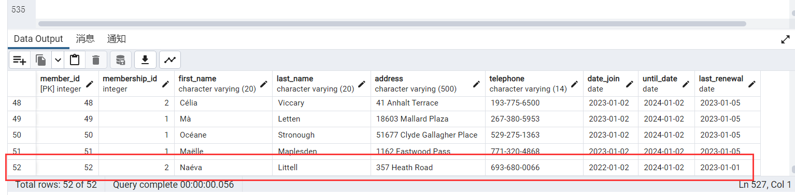

5 Evaluation of Design and Implementation

5.1 The importance of function
Functions are subroutines defined within the database. They are program structures provided by SQL that are similar to high-level languages, such as branch structures (if statements), loops (while, for statements, etc.) that perform complex "business logic" and are stored in the database and then called in SQL.
The use of functions can.
(1) Enhance the functionality and flexibility of SQL
(2) Increase the speed of operation
(3) Reduce the amount of network traffic
(4) Reduce the amount of programming effort
(5) Indirectly implement security control functions

5.2 The importance of Triggers
Trigger is a method provided by SQL server for programmers and data analysts to ensure data integrity. It is a special stored procedure associated with table events, whose execution is not called by a program or initiated manually, but is triggered by an event, such as when an operation is performed on a table (insert, delete, update).^{[8]}
Triggers are often used to reinforce data integrity constraints, business rules and so on. In typical circumstances, triggers can be used in the following ways:
1) Cascading updates to relevant tables in the database. For example: synchronous update of code values, data redundancy implementation, synchronous update of calculation tables and so on;
2) Rejection of operations that break integrity. For example: rejection of insertion of unmatched external code values;
3) Implementing more complex business rules that cannot be achieved by the database definition itself. For example: time limits on update operations, limits on the extent of data updates and so on;^{[9]}
4} Implement simple logical reasoning. Such as: "if .... then" reasoning analysis and so on.

5.3 The importance of Procedures
Procedures are a set of SQL statements designed to perform a specific function in a large database system.^{[10]} They are stored in the database, which is compiled once and is valid forever, in order to be executed when the user specifies the name of the procedure and gives parameters (if the procedure has parameters). A stored procedure is an important object in a database.
Using stored procedures enables:
1. Stored procedures are only compiled at the time of creation and do not need to be recompiled each time a stored procedure is executed later, while general SQL statements are compiled once per execution, therefore the use of stored procedures can improve the speed of database execution.
2. When complex operations on the database (such as Update, Insert, Query, Delete on multiple tables), this complex operation could be encapsulated in a stored procedure and used in conjunction with the transaction processing provided by the database.^{[11]}
3. Stored procedures could be reused, which can reduce the workload of database developers
4. The security is high, and only certain users can be given access to the specified procedure. Parameterised stored procedures are protected against SQL injection attacks, and Grant, Deny and Revoke permissions can be applied to stored procedures.

5.4 Design and Implementation
(1) Update membership information
Members' information in the database will be updated by the staff after the client has paid the fee to become an ALC member at the staff office. Membership is valid for 12 months, so the expiry date of membership will automatically be updated to one year after the last registration end date.
--Function
CREATE OR REPLACE FUNCTION Update_Member()
RETURNS TRIGGER
LANGUAGE PLPGSQL AS $$
DECLARE MembershipId integer;
BEGIN
UPDATE Members SET Until_Date=Until_Date()::timestamp + '1 year';
UPDATE Members SET Last_Renewal=Current_Date;
COMMIT;
END;
$$;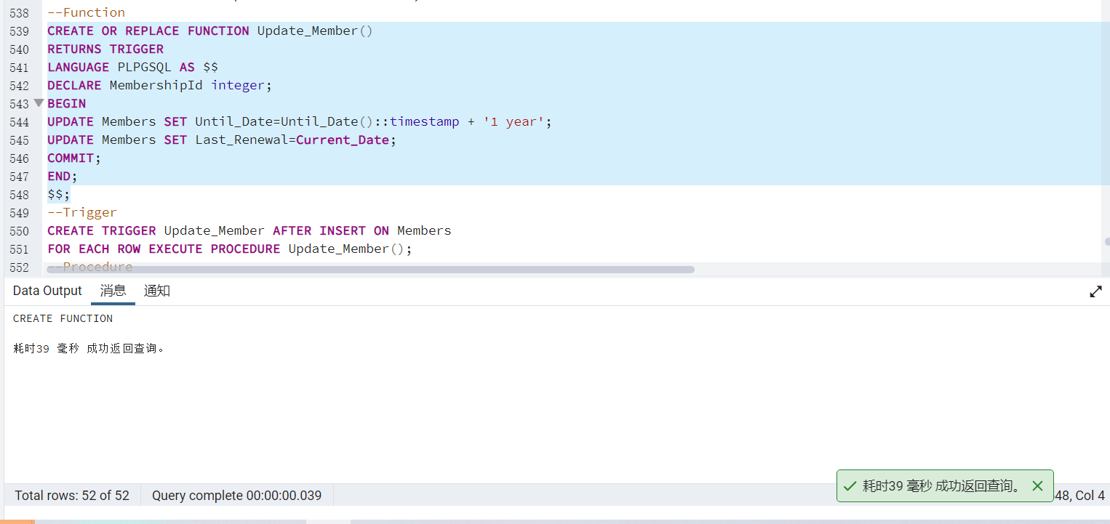
--Trigger
CREATE TRIGGER Update_Member AFTER INSERT ON Members
FOR EACH ROW EXECUTE PROCEDURE Update_Member();
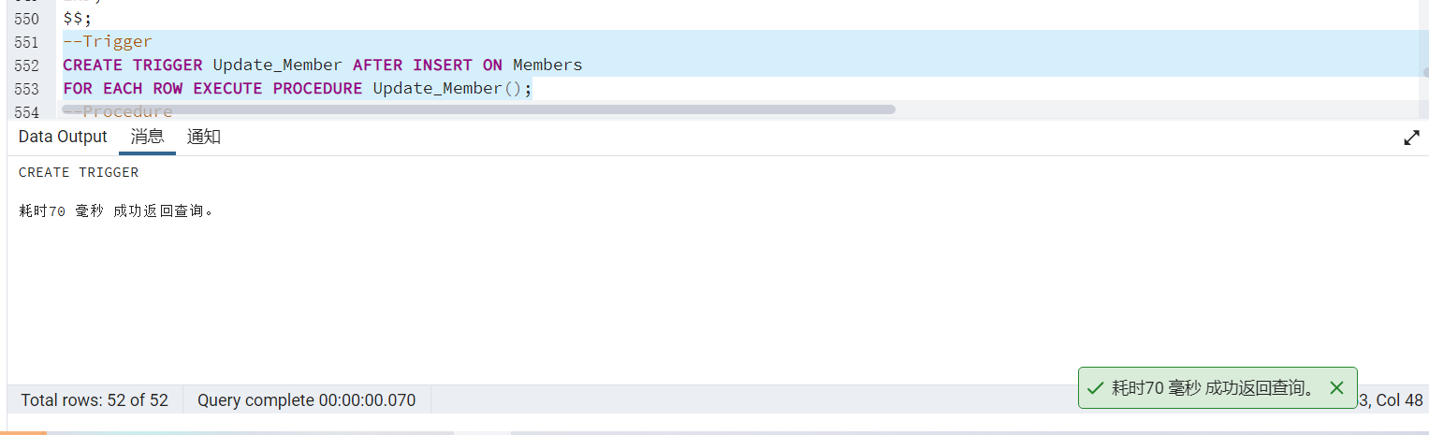
--Procedure
CREATE OR REPLACE PROCEDURE Insert_Member(Member_Id integer,Membership_Id integer,First_Name varchar(20),Last_Name varchar(20),Address varchar(500),Telephone varchar(14),Date_Join date,Until_Date date,Last_Renewal date)
LANGUAGE PLPGSQL
AS $$
DECLARE
MemberId integer;
BEGIN
SELECT Member_Id into MemberId FROM Members WHERE First_Name=FirstName AND Last_Name=LastName;
IF NOT FOUND THEN RAISE EXCEPTION 'Invalid member %', FirstName ||''|| LastName;
ROLLBACK;
END IF;
COMMIT;
END;
$$;
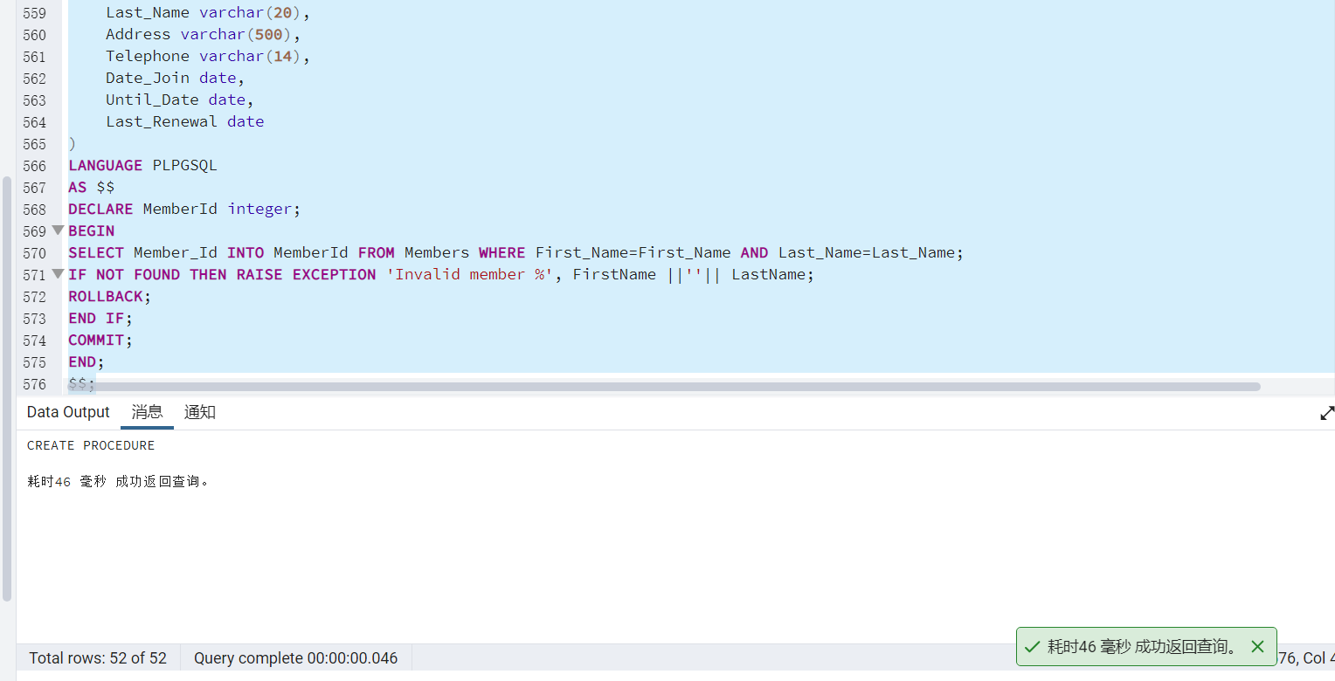
--Test
CALL Insert_Member('Mà', 'Letten', '2 Old Shore Junction', '440-229-3380', '2023-01-02', '2024-01-02', '2023-01-05');
CALL Insert_Member('Mélinda', 'Shakespear', '28898 Shelley Pass', '587-246-6712', '2023-01-02', '2024-01-02', '2023-01-05');
CALL Insert_Member('Personnalisée', 'Grover', '2 Express Plaza', '391-638-6520','2023-01-02', '2024-01-02', '2023-01-05');
CALL Insert_Member('Jú', 'Boorer', '53 Sunfield Road', '313-373-7444','2023-01-02', '2024-01-02', '2023-01-05');
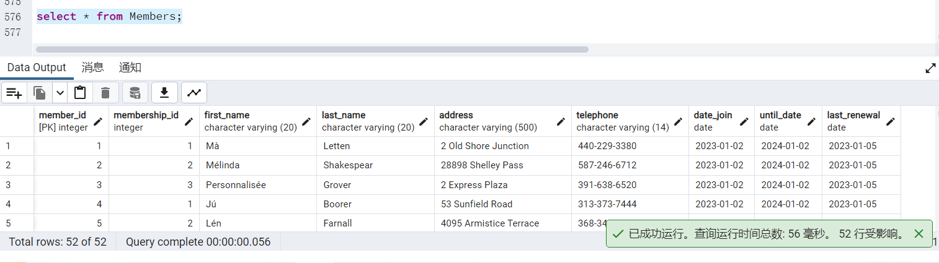
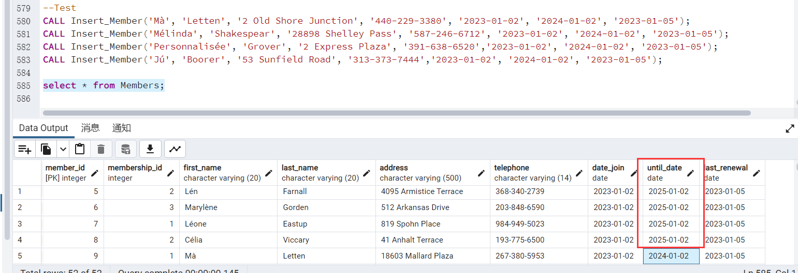
(2) Class Booking
Members can book a class by selecting the class type. After a successful booking, the number of members who have booked the course will be added to one and when the number is greater than 6, the course will be offered in the respective room.
--Function
CREATE OR REPLACE FUNCTION Class_Change()
RETURNS TRIGGER
LANGUAGE PLPGSQL
AS $$
DECLARE
BookNO numeric;
ClassNext integer;
ClassId integer;
RoomId int:=0;
rec Classes;
BEGIN
SELECT Join_Number INTO BookNO FROM Classes WHERE Class_Type = new.Class_Type;
SELECT Class_Id INTO ClassId FROM Classes WHERE Status=True;
IF NOT FOUND THEN RAISE NOTICE 'ROLLBACK, THERE IS NO EMPTY ROOM';
RETURN new;
ROLLBACK;
END IF;
SELECT CASE WHEN MAX(Class_Id) IS NULL THEN 1 ELSE MAX(Class_Id)+1 END INTO ClassNext FROM Classes;
IF NOT FOUND THEN RoomId:=0;
END IF;
IF BookNO<6 THEN RAISE NOTICE 'ROLLBACK, NOT ENOUGHE SIX';
RETURN new;
ROLLBACK;
END IF;
IF ClassId=0 AND BookNO>=6
THEN INSERT INTO Room VALUES(ClassNext, new.Class_Id, new.Start_Time, new.End_Time, new.Start_Date, new.End_Date);
INSERT INTO Member_Class VALUES(ClassNext, rec.Member_Id);
END IF;
RETURN NEW;
COMMIT;
END;
$$;
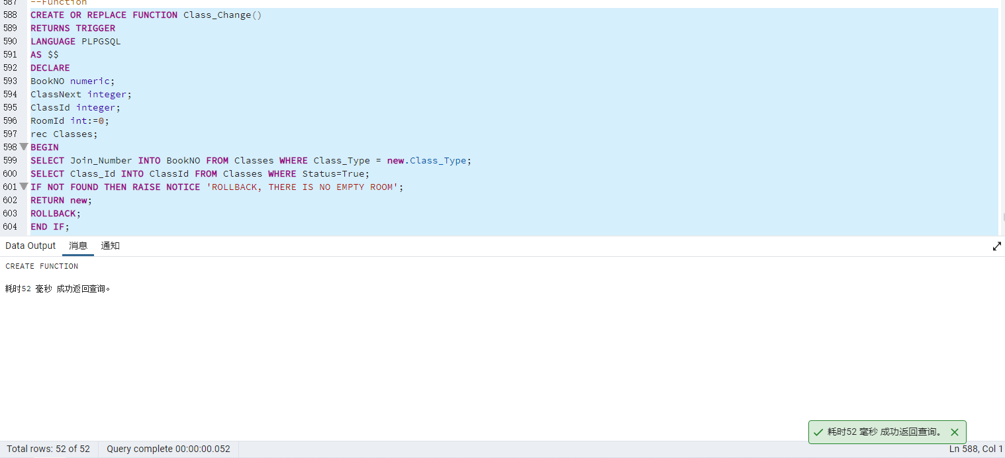
--Trigger
CREATE TRIGGER Class_Book AFTER INSERT ON Classes
FOR EACH ROW EXECUTE PROCEDURE Class_Change();
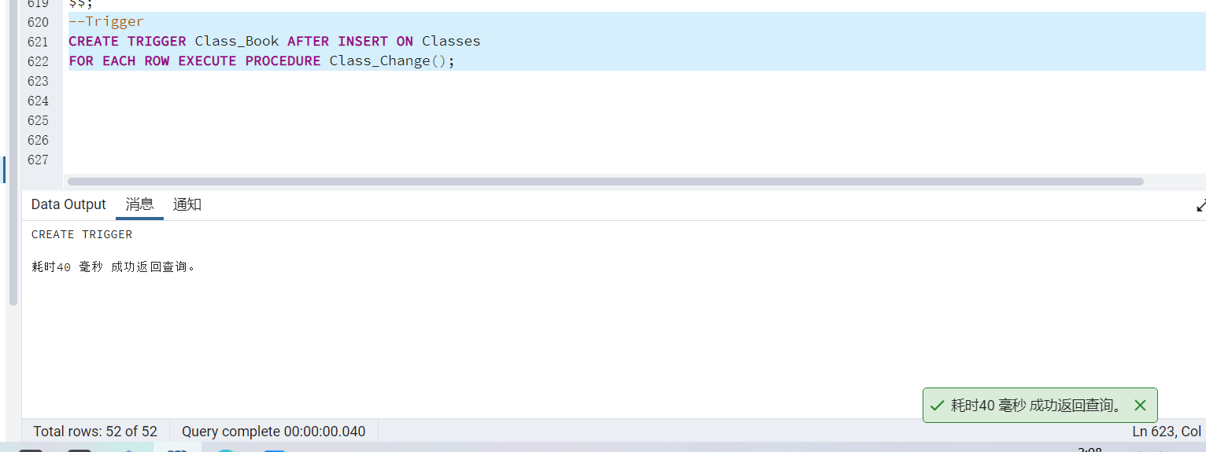
--Procedure
DROP PROCEDURE IF EXISTS Insert_Classes;
CREATE OR REPLACE PROCEDURE Insert_Class(
FirstName varchar(20),
LastName varchar(20),
ClassType varchar(20),
JoinNumber numeric,
Status boolean
)
LANGUAGE PLPGSQL AS $$
DECLARE
MemberId integer;
ClassId varchar(20);
BookNext integer;
BEGIN
SELECT Member_Id INTO MemberId FROM Members WHERE First_Name=FirstName AND Last_Name=LastName;
IF NOT FOUND THEN ROLLBACK;
END IF;
SELECT CASE WHEN MAX(Class_Id) IS NULL THEN 1 ELSE MAX(Class_Id)+1 END INTO BookNext FROM Classes;
INSERT INTO Classes VALUES(BookNext, MemberId, ClassType, JoinNumber, Status);
COMMIT;
END;
$$;
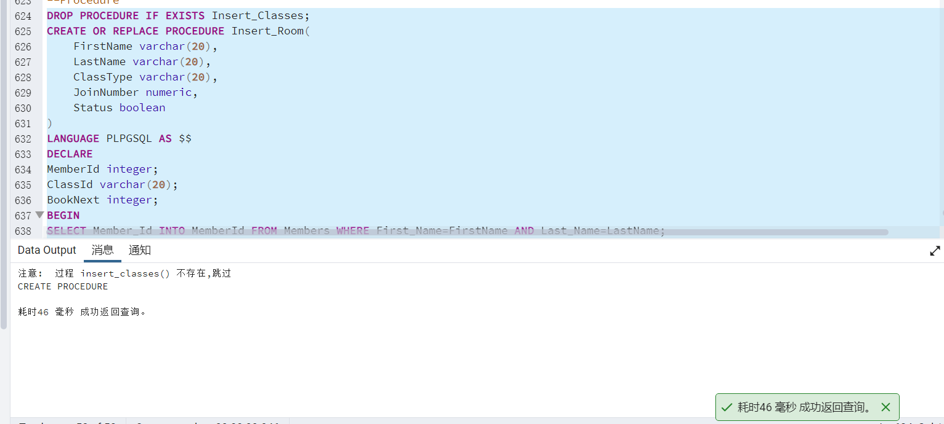

Reference
- Wang Hongbo. Exploring relational databases[J]. China Technology Investment. 2019,(6)
- Hunt E, Atkinson M P, Irving R W. A database index to large biological sequences[J]. work, 2001, 26: 27.
- Ou, P.. Database indexing technology applications [J]. Electronic Science and Technology. 2011,(9). doi:10.3969/j.issn.1007-7820.2011.09.044.
- Dr．Subrahmanyam Atlamamju, Nuts and Bolts of Transaction Processing, Subbu Allamaraju Homepage, http://www.subrahmanyam.com/articles/transactions/NutsAndBoltsOfTP.html, 1999
- Philip M．Lewis，Michael Kifer, Arthur J．Bemstein.Database and Transaction Processing. Addison-Wesley,2002.
- Cui Peng, Li Xiaosong, Bian Shenglin. A study of ORACLE database rollback segments[J]. Talent, 2009(1):2.
- Dynamic database recovery in a networked environment[J]. Journal of computer science& echnology, 2010.
- Yao Yuchun, Pan Linsen, Wang Fan. Database triggers and their applications[J]. Journal of Chongqing University of Architecture, 2003, 25(5): 128-131.
- Liu Xiaoping. The application of triggers in databases[J]. Journal of Shaoguan College, 2007, 28(3): 35-38.
- Wang H, Zhu R. Database stored procedure design and application[J]. Database stored procedure design and application [J]. Electronic information countermeasures technology, 2009, 24(2):6.
- YAN Ailan, LU Jiangchun. A study of database stored procedure applications [J]. Journal of South China University: Natural Science Edition, 2006, 20(2):3.

