Module | ACADEMIC & EMPLOYABILITY SKILLS
Module code | BMSK4001_BIRM
Student Name
Student ID
Lecturer

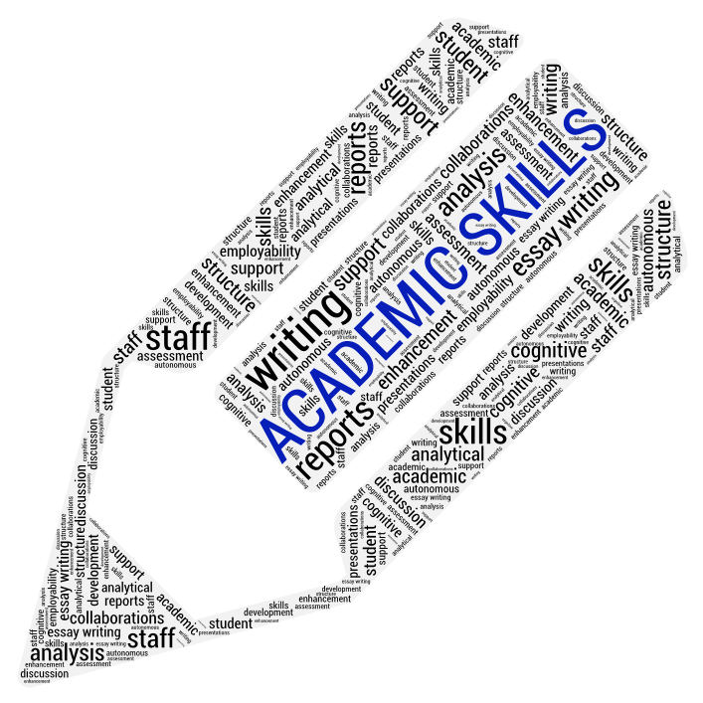
The importance of Academic Skills to higher education students
TABLE OF CONTENT:
INTRODUCTION: 2
The intention 2
Top Academic Skills: 2
TIME MANAGEMENT: 3
Frequent problems: 3
Example on how time management is significant to me and others: 4
Recommendations: 5
ACADEMIC WRITING 6
Categories: 7
Structure: 7
Importance of the topic to me and other students: 8
Recommendation: 8
NOTE TAKING: 9
Different methods for note taking: 9
The importance that note taking has to me and other scholars: 11
Recommendations: 11
CONCLUSION: 12
REFERENCES: 13
BIBLIOGRAPHY: 15
APPENDICES: 16

INTRODUCTION:
The intention of the following paper is to explain the importance of academic skills to higher education students highlighting some of them by explaining their meaning and making some examples on how they are used by students.
Academic skills are a set of routines of study, ways of learning and time management that allow students to understand and learn what is explained to them in school and nowadays, for many of them, learning is not only a way of accessing information, but it is also a tool that can help in many career paths (wiseGEEK, n.d.).

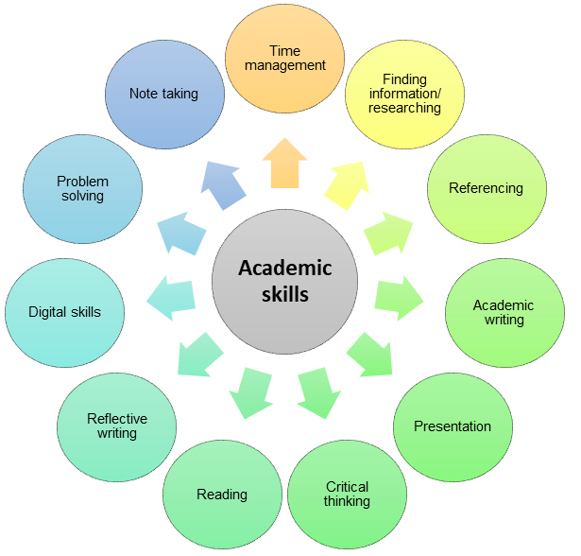
Top Academic Skills:
Source: Author
Some of the main skills necessary to the students in higher education, among the other, are time management, academic writing and note taking.

TIME MANAGEMENT:
Efficient time management is an indispensable instrument that a student is supposed to have in UK higher instruction.
Inability to coordinate time when it comes to creation or submission of an assignment brings to failures and can be a considerable cause of stress and nervousness.
According to Collins Dictionary (2020) time management is “the examination of how time is used and the ability to rank the important assignments with the aim to be efficient in the work”.
The signification of it can be applied even in higher education implying that for a student it is vital to perceive how to administrate the hours at disposition and an organized way to manage it, is essential to have control of the work in order to be able to face all the academic deadlines.
As Claessens, Eerde and Rutte, (2005) reported “time management is conceivable just through self-motivation and planning”, meaning that in order to be able to achieve the proposed purposes, a student should make a list of the important things and activities and prepare a ‘to do list’ with a plan of action considering the time stealers such as social media, work, romance, work and friends that can slow the way to success.

Frequent problems:
Not planning and separating the work over the time at disposition but leaving everything for the last minute is an usual mistake that a lot of students make that leads to failure and this can be caused by the involvement in extra-curricular labours, charities, partnerships and part-time jobs that can bring to over-commission, creating another obstacle to a successful time management.
The lack of academic skills as note taking, finding information and academic writing is another factor that slows down the students because instead of spending time on the requested task they lose time in trying to find shortcuts and most of the time, they postpone the work day by day till the last minute.

Example on how time management is significant to me and others:
This skill is significant to me for the reason that it helped me to organize and prioritize the points of the project/work by setting the goals to achieve.
I planed the day and the important tasks and delegated and postponed some secondary tasks, asking for help when necessary.
The most important thing is to stay motivated and focused on the project because having a good plan will help to reduce the stress and think clearly.
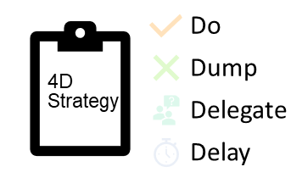
One of the tools that helped me on developing a plan was the 4D Strategy:
Source: Author
- Do a list of the important points and activities necessary for the completion of the task.
- Dump all the unnecessary activities and information.
- Delegate somebody for secondary, less important duty.
- Delay appointments and meetings that can be rescheduled.

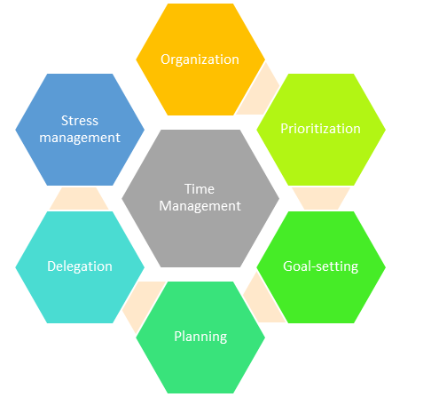
Recommendations:
Source: Author

As Hosking, (2014) said “complicated approaches for organization of the tasks will lead to distraction from the work”, making understandable that a too elaborate plan is not always the best way to act because it can take time from the main target and complicate the thoughts.
In order to be efficacious in time management a student should:
- Separate every day an hour or two to study, research and complete the assignments turning off the mobile phone and the social media that will distract from the work.
- Prepare a clear and easy to-do list with the main points, a mind map can be helpful for it.
- Become familiar with the tools used (internet browser, word, online library, etc.), this will prevent get stuck and lose time.
- Find a place where feel comfortable to study, not every student has the same criteria and ways of acting.
In conclusion to this paragraph it is important to remember that in order to manage the skill described, the key point is self-motivation and planning.

ACADEMIC WRITING
Academic writing is used from scholastic assessments, teacher’s materials, researches to newspaper articles and books.
Valdes, (2019) defines academic writing as “a tool used by the high education body in all the disciplines to bring ideas together and make scholar conversation”.
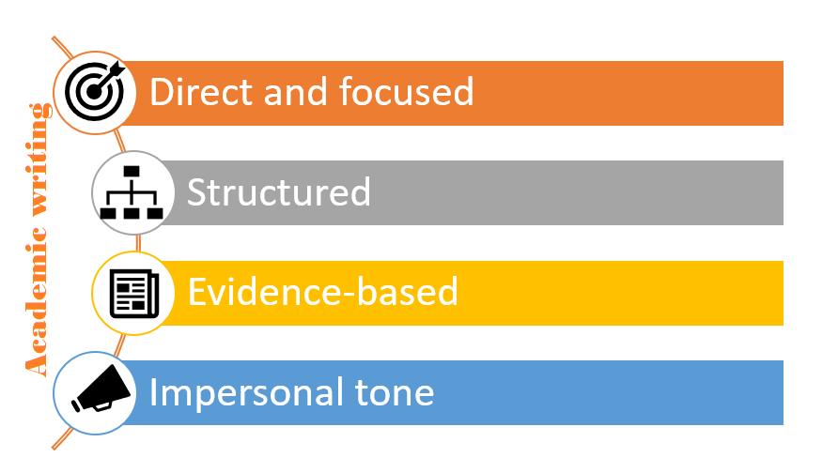
A good academic writing has the function to benefit the reader’s assimilation and is outlined by the following criteria:
Source: Author
- Direct and focused: shows the perception of the subject answering the examination.
- Structured: is logical, comprehensible and written in systematic order gathering pertinent material and points together.
- Evidence-based: shows understanding of the case field reinforcing the argument with proves and references.
- Impersonal tone: adopt fitting language, is understandable, compact and uniform.

Categories of academic writing:
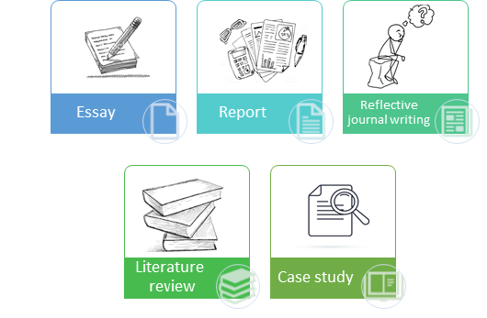
As mentioned earlier, academic writing has the purpose to give information to the reader that will help him understand better a topic/argument and it can be divided in 5 different categories:
Source: Author
- Essay: an essay is, according to Dictionary.com (2020), “a concise abstract piece on a specific topic or subject, most of the time in prose and typically analytic, theoretical, or interpretative”.
- Report: is a transmission of information that debate diverse points of view landing to conclusion and giving references.
- Reflective journal writing: is a reflection on the learning experience of the student with personal thoughts and usually is written in 1st person.
- Literature review: demonstrate the knowledge of an area of interest based on the reading of books highlighting sources, structure and critics.
- Case study: as PressAcademia (2018), defines it, “as an expressive and exploratory examination of an individual, a group or event”.

Structure of the academic writing:
Academic writing, generally, is composed by an introduction, a body and a conclusion and each part has basis that needs to be followed:
Introduction: describe the aim/purpose of the topic given background information.
Body: is divided in different paragraphs where every point is displayed, researched and evolved.
Conclusion: summarize the main points of the work and emphasize the key points.

Why is academic writing important to me and other students?
For a student, especially if new to higher education, the first assignment that has to prepare and deliver can be stressful and very difficult if does not have the necessary skills and knowledges to complete it.
Academic writing is important to me because I learned how to compose, like in this case, a report for the course that I’m following at UWTSD and I understood that there is no necessity for too complicated and unnecessary words (for example use “because” instead “do to the fact that”).

Recommendation on how higher education students can develop academic writing:
The better way to develop a skill, in this case academic writing, is to practice but there are some tips that can make easier the process:
- Adopt active voice.
- Learn when and where to use the punctuation (example: semi-colon (;) is used to divide two complete sentences that are correlated).
- Avoid writing small sentences and repetitions.
- Be concise.
- Use synonymous avoiding to adopt too complex words.
Carini, (2002) said: "Write to express, not to impress”, this is something that a student should always have in mind while being in the school environment.

NOTE TAKING:
It is almost unimaginable, no matter how good memory a student can have, to remember everything from a lesson, a speech or while reading a book and that is why note taking is one of the most efficient way to understand and recall all the important information and besides not all of them are equally important and necessary.
Taking notes can help to collect the important data for a longer period and can help to develop the relevant points between some topics.
As Macdonald (2014), wrote that "scholars write less than one word per second while lecturers usually deliver two or three times faster" meaning that, for a student, it is impossible to keep up with the teacher's speech and understand at the same time if unable to take notes correctly.

Different methods for note taking:
There are a lot ways to take notes depending on the contest they are in and for what are used for; three of the main methods are: mind maps, system diagram and tabular note taking.
- Mind map: has a central topic in the middle from which ideas and secondary points, all correlated to the main topic, are joined creating a like-web structure design that has the aim of a visual association of data.
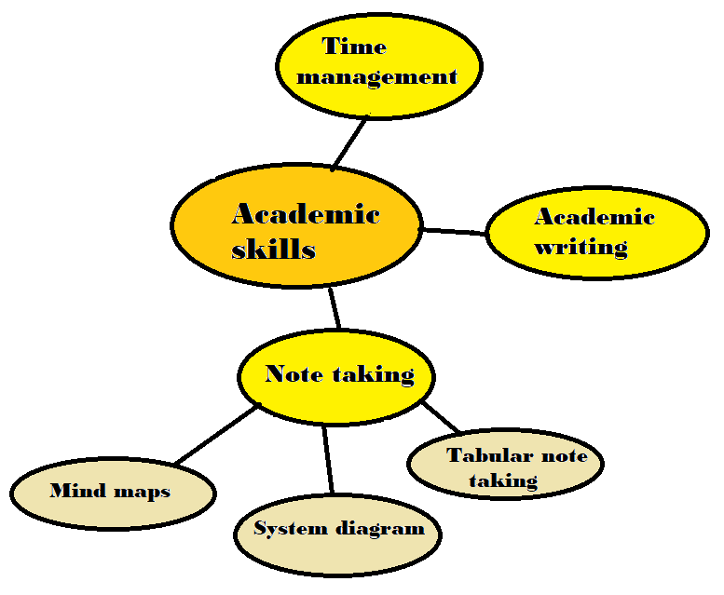
Chong (2014), reported that “mind mapping is said to be 15%-20% progressively viable in upgrading consciousness and developing study” because it helps to process the information when it comes to study and storage of data.
Source: Author

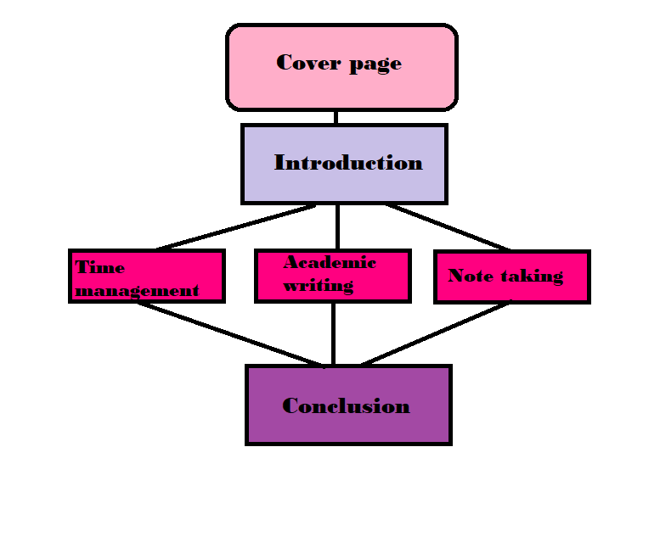
- System diagram: is used to show phases in a process without displaying the details and is another visual method that can help a student to develop a plan of study step by step.
Source: Author

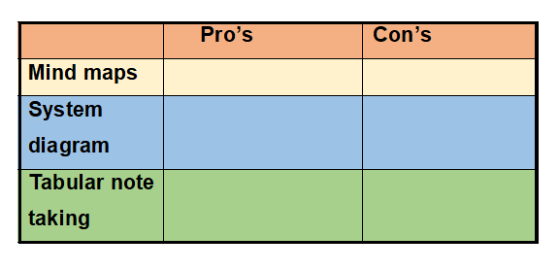
- Tabular note taking: helps to outline and compare information, showing different points of view.
Source: Author

The importance that note taking has to me and other scholars:
Note taking is an helpful skill to me and to others because it showed me how to prioritize the information that I get from my lecturers enabling me to develop a plan of study and decreasing the anxiety that an assignment can cause and because it can be applied even out of school, in every day life and activities making easier to focus on the important things and creating a strategy for the future.
A tool that helped me with the process of taking note during the lessons was the mind mapping because I was able to listen and in the same time grab, writing in my notebook, the important information of the lesson I was attending.

Recommendations:
Note taking is a great tool that can facilitate the life of a student if used correctly and here are some tips to succeed in it:
- Choose the appropriate method of takin notes for the task that needs to be done.
- Be clear and concise when picking the evidence.
- Use your own words and abbreviation but keep technical expressions and data.
- Use colours to differentiate the importance of each fact.
- Review the taken notes after class.

CONCLUSION:
Merriam-Webster (n.d.), defines skills as “the capability to practise the owned knowledges in practice” and as already mentioned before, academic skills are parts of conduct that students learn that are necessary in order to be successful in higher education and as shown, all of them are indispensable for the development of a rewarding result.
After researching and reporting about time management, academic writing and note taking, three of the main academic skills, it can be concluded that all of them are related to each:
being able to take notes during a lesson will reduce the time spent on reading and trying to understand alone what the important information are needed for an academic writing and academic writing becomes easier if note taking is a developed skill.

REFERENCES:
Carini, A. (2002). Nine Basic Ways to Improve Your Style in Academic Writing | Student Learning Center. [online] Slc.berkeley.edu. Available at: https://slc.berkeley.edu/writing-worksheets-and-other-writing-resources/nine-basic-ways-improve-your-style-academic-writing [Accessed 14 Feb. 2020].
Chong, Y. (2014). Mind Mapping: Step-by-Step Beginner’s Guide in Creating Mind Maps!. Miami, FL 33166: Yap Kee Chong, p.7.
Claessens, B., Eerde, W. and Rutte, C. (2005). [online] Citeseerx.ist.psu.edu. Available at: http://citeseerx.ist.psu.edu/viewdoc/download?doi=10.1.1.466.4966&rep=rep1&type=pdf [Accessed 6 Feb. 2020].
Collinsdictionary.com. (2020). Time management definition and meaning | Collins English Dictionary. [online] Available at: https://www.collinsdictionary.com/dictionary/english/time-management [Accessed 6 Feb. 2020].
Dictionary.com. (2020). Definition of essay | Dictionary.com. [online] Available at: https://www.dictionary.com/browse/essay?s=t [Accessed 12 Feb. 2020].
Hosking, R. (2014). Time management tips. [online] Search-proquest-com.ezproxy.uwtsd.ac.uk. Available at: https://search-proquest-com.ezproxy.uwtsd.ac.uk/docview/1567548055?rfr_id=info%3Axri%2Fsid%3Aprimo [Accessed 10 Feb. 2020].
Indeed.com. (2018). Time Management Skills: Definition and Examples. [online] Available at: https://www.indeed.com/career-advice/career-development/time-management-skills [Accessed 8 Feb. 2020].
Library.leeds.ac.uk. (2020). Academic writing. [online] Available at: https://library.leeds.ac.uk/info/14011/writing/106/academic_writing/3 [Accessed 13 Feb. 2020].
Library.leeds.ac.uk. (2020). Time management. [online] Available at: https://library.leeds.ac.uk/info/1401/academic_skills/84/time_management [Accessed 5 Feb. 2020].
Loveless, B. (2020). Study Skills Guide: Note Taking Strategies, Techniques and Methods. [online] Educationcorner.com. Available at: https://www.educationcorner.com/note-taking.html [Accessed 18 Feb. 2020].
Macdonald, V. (2014). Note Taking Skills For Everyone: Learn The Strategies Of Effective Note Taking In Order To Earn Maximum Grades Today!. Martin Knowles, pp.6, 9.
Merriam-webster (n.d.). Definition of SKILL. [online] Available at: https://www.merriam-webster.com/dictionary/skill [Accessed 18 Feb. 2020].
PressAcademia. (2018). Definition of Case Study. [online] Available at: https://www.pressacademia.org/definition-of-case-study/ [Accessed 13 Feb. 2020].
Shahabudin, K., Taylor, A., Turner, J. and Reid, M. (2010). Managing time at university: a learning development perspective on issues and effective interventions. [online] Archive.learnhigher.ac.uk. Available at: http://archive.learnhigher.ac.uk/resources/files/Time%20management/time_staff_research_overview.pdf [Accessed 5 Feb. 2020].
Valdes, O. (2019). What Is Academic Writing?. [online] ThoughtCo. Available at: https://www.thoughtco.com/what-is-academic-writing-1689052 [Accessed 12 Feb. 2020].
Warwick.ac.uk. (2015). What is a reflective journal?. [online] Available at: https://warwick.ac.uk/fac/cross_fac/iatl/study/ugmodules/humananimalstudies/assessment/reflectivejournal [Accessed 13 Feb. 2020].
wiseGEEK. (n.d.). What are Academic Skills?. [online] Available at: https://www.wisegeek.com/what-are-academic-skills.htm [Accessed 5 Feb. 2020].

BIBLIOGRAPHY:
Andrews, G. (2017). Research Proposal: Academic Writing Guide for Graduate Students. Grant Andrews.
Campbell, R. (2017). 7 Time Management Tips for Students. [online] Top Universities. Available at: https://www.topuniversities.com/blog/7-time-management-tips-students [Accessed 8 Feb. 2020].
Maldonato, G. (2017). Academic Skills 2 - Teachers Book | Vocabulary | Reading (Process). [online] Scribd. Available at: https://www.scribd.com/document/348462482/Academic-Skills-2-Teachers-Book [Accessed 5 Feb. 2020].
McPherson, F. (2014). Effective Notetaking (3rd ed). 3rd ed. Fiona McPherson.
Mindtools.com. (n.d.). What Is Time Management?: Working Smarter to Enhance Productivity. [online] Available at: https://www.mindtools.com/pages/article/newHTE_00.htm [Accessed 6 Feb. 2020].
Moyla, D. (2015). IELTS Academic Writing: Important tips & high scoring sample answers!. Sanbrook Publishing.
Nasrullah, S. and Saqib Khan, M. (2015). [online] Iiste.org. Available at: https://iiste.org/Journals/index.php/JLLL/article/viewFile/23538/23819 [Accessed 6 Feb. 2020].

APPENDICES:

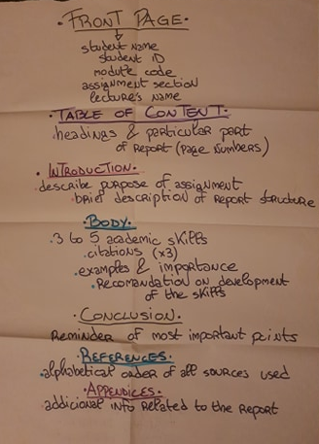
Appendix 1:
Source: Author
- Group activity done to show how to structure an academic writing.

Source: Author

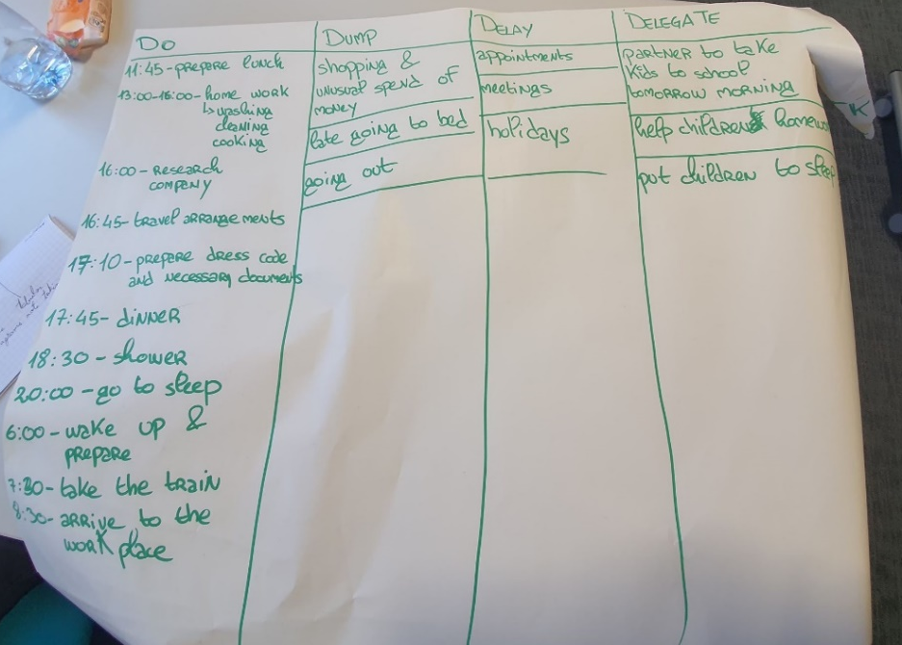
Appendix 2:
Source: Author
2.Time management group activity.
4D strategy: Do, Dump, Delay, Delegate

Source: Author

