Managing Enterprise in 21st Century
Task 1

STUDENT NR : 2025237
MODULE CODE : BMSW 4006
MODULE LEADER : DR OLUWASEUM ADEGBITE
Table of Contents
Introduction 2
Necessary things for setting up of new business 3
Conclusion 5
References 6

Introduction
This report will provide a brief reflective discussion on the various things that have been learnt about setting up a successful business. This report will also provide reflection on how the knowledge can be used in future and the explanation will be provided using “Gib Reflective Cycle.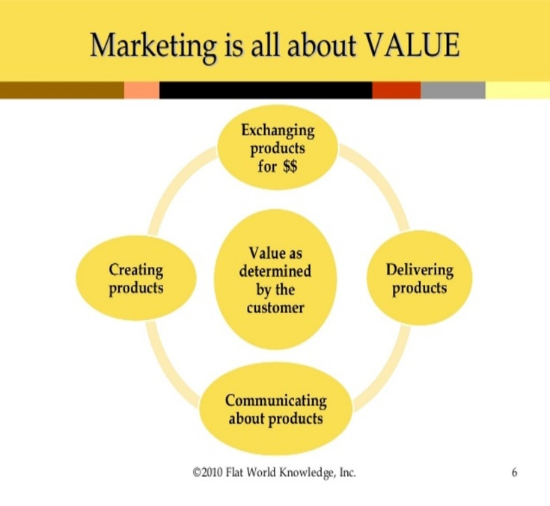
What Is Marketing?
Marketing refers to activities a company undertakes to promote the buying or selling of a product or service. Marketing includes advertising, selling, and delivering products to consumers or other businesses. Some marketing is done by affiliates on behalf of a company.

Professionals who work in a corporation's marketing and promotion departments seek to get the attention of key potential audiences through advertising. Promotions are targeted to certain audiences and may involve celebrity
Marketing as a discipline involves all the actions a company undertakes to draw in customers and maintain relationships with them.
and may include writing thank you emails, playing golf with prospective clients, returning calls and emails quickly, and meeting with clients for coffee or a meal. At its most basic level, marketing seeks to match a company's products and services to customers who want access to those products. Product, price, place, and promotion are the Four Ps of marketing. The Four Ps collectively make up the essential mix a company needs to market a product or service.
Product
Product refers to an item or items the business plans to offer to customersBefore they can prepare an appropriate campaign, marketers need to understand what product is being sold, how it stands out from its competitors, whether the product can also be paired with a secondary product or Price
Price

Price refers to how much the company will sell the product for. When establishing a price, companies must consider the unit cost price, marketing costs, and distribution expenses. Companies must also consider the price of competing products in the marketplace and whether their proposed price point is sufficient to represent a reasonable alternative for consumers.
product line, and whether there are substitute products in the market.
Place
Place refers to the distribution of the product. Key considerations include whether the company will sell the product through a physical storefront, online, or through both distribution channels, what kind of physical product placement does it get? When it's sold online, what kind of digital product placement does it get?
Promotion
Promotion, the fourth P, is the integrated marketing communications campaign. Promotion includes a variety of activities such as advertising, selling, sales promotions, public relations, direct marketing, sponsorship, and guerrilla marketing.Marketing refers to any activities undertaken by a company to promote the buying or selling of a service.

Taking these statistics into consideration, online marketing is a critical element of a complete marketing strategy. Considering an appropriate distribution channel for products purchased online is also an important step.
BUSINESS PLAN
Business plans are important documents used for the external audience as well as the internal audience of the company. They are also a good way for companies' executive teams to be on the same page about strategic action items and to keep themselves on target towards the set goals. Every company should have a business plan. Ideally, the plan is reviewed and updated periodically to see if goals have been met or have changed and evolved. A good business plan should outline all the projected costs and possible pitfalls of each decision a company makes.
FINANCE
In other words, if you want a slice of the financing pie, you need to work your cash projections hard and know your bottom line down to the penny. If you are thinking of becoming an entrepreneur, consider the following tips for successfully building your business in a challenging economy, It is important to know upfront how much money you need to put into the business, how much you need to charge to meet your operating costs, and what to do to turn a profit.
- You can successfully start a small business during times of economic uncertainty.
- Ask friends, other business owners, or professionals to review your business plan before you seek financing.
- Consider and develop your marketing strategy using search engine optimization and social media to drive potential customers to your business.
- Start small from hiring to inventory and then expand when things start to pick up.
- Some businesses thrive during times of economic uncertainty. If you’re considering starting a business, make sure you do your research before you spend your money.

Present Unique Legal Risk to Buyers and Sellers
Have been fraught with legal issues from the time they began, as investors have struggled with companies that don't follow through on their promises, and the potential for hacks and fraud.
According to a report by Coin Desk, "buyers can sue sellers privately under the federal securities laws" which govern similar types of transactions. A great deal of the legal details concerning ICOs comes down to the question of whether or not a coin can be considered a security.



Description
There are many things that are necessary for the setting up of a successful business and I have learnt about many things and there are many things that I still need to learn. At the start, I felt that there are many things that need to be learnt before the start of the course for setting up the business in a successful manner. The first necessary thing was the business model which is sound enough for the setting of the business. Another important thing for the setting of the business is experience and so on.
Feelings
During the situation, I felt that the process will be very long and I will be required to do a lot of hard work to successfully achieve my desired objective. But with every day passing, I was successful in gaining experience and also various new and creative learning opportunities. I was able to learn about various methods that can be used for marketing of the product which is necessary for success and so on. I started to feel confident and started to believe that I will be able to learn every necessary thing within the limited period of time.
Evaluation
There were many things that went well and also many things that didn't go as I wanted them to be. I was able to learn the processes of marketing in a quick period of time and it is necessary for a successful setting of the business. I was also able to gain the necessary experience that is required for a successful setting of the business. I also learnt about various resources that are necessary for the success of the business (Sekarwinahyu et al., 2019). But I was unable to learn about the processes that are involved in making an effective business model and that is the thing that did not go well for me.
Analysis
The major reason for the aforementioned factors to go well is that I already had a fair amount of ideas regarding the topic and was able to have proper guidance from the teachers. But I was unable to find proper guidance in the topic of Business model.
Conclusion
Many factors went well and some did not go well but it can be said that it was a fruitful time for me. I was able to gain necessary experience and knowledge for setting up the business in a successful manner.
Action Plan
I have learnt many necessary things for the success of the business and also for doing it in an effective manner. I will be applying all the factors in my business practices and also for a successful setting of the business. I will also join various courses for developing in many things that I feel that I need to improve.

Conclusion
This report has provided a brief reflective discussion on the various things that have been learnt about setting up a successful business. This report has also provided reflection on how the knowledge can be used in future and the explanation has been provided using “Gibbs Reflective Cycle”.

