Qualification: CIPD Diploma in Applied Human Resources

Module Name: Understanding Coaching and Mentoring in the Organisation

On the Job Training

Word Count: 1213

Student Name: Maria Mellen Jimenez
Student Number: 2005457
CIPD Membership Number: 57501591

By signing below, I confirm that the work/evidence presented is my own, unaided work. I understand the regulations pertaining to candidate malpractice and the action that may be taken as a result.

Signed: 
Date: 16/05/21

INTRODUCTION

I have been recently promoted to the role of Deputy Store Manager as maternity cover, for a multinational clothes retailer. Previously, I have worked for the same company as a Section Manager since 2009, but my career in the company started in 2008 as Cashier, being promoted to Visual Merchandiser six months after I started. Unfortunately, for this assignment, I am not allowed to disclose any information regarding the organisation I work for, including its name, as it is detailed in the Company’s Learning and Development Policy.

- ORGANISATION’S APPROACH TO COACHING AND MENTORING

One of my organisation’s values is ‘Our commitment to our people: our employees’, as we can find on the group’s website, unable to disclose, but I have attached screenshots of their website.

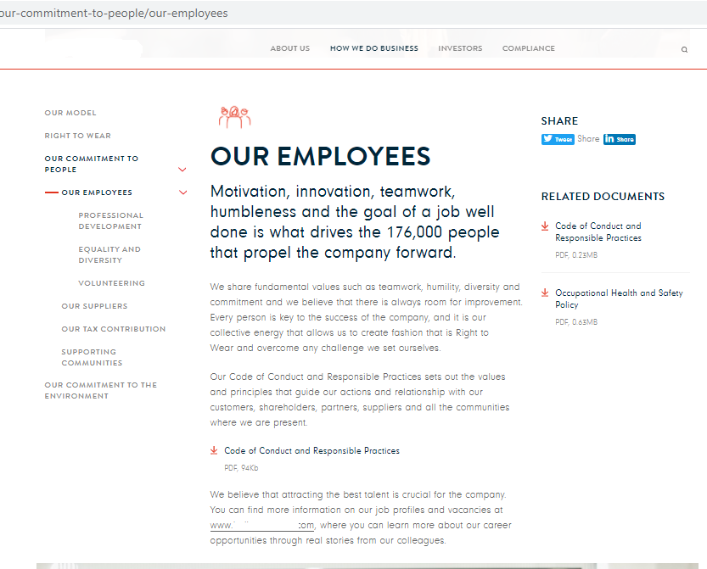

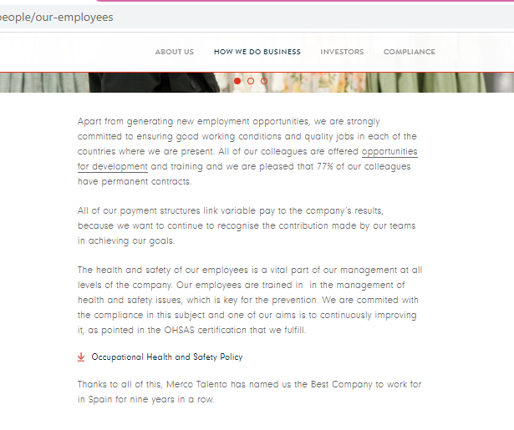

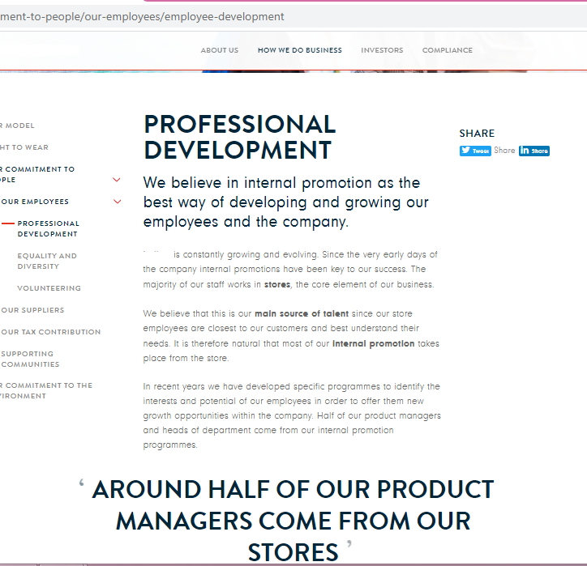

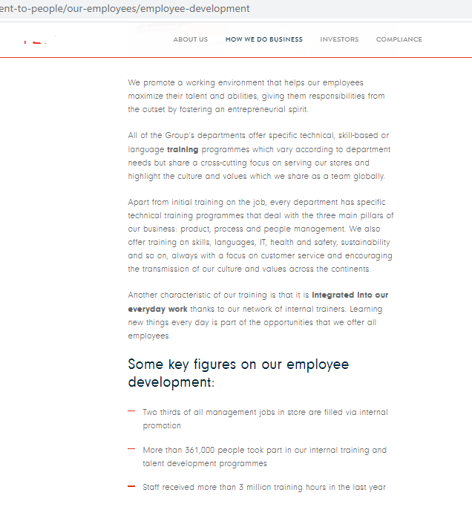

Clutterbuck et al (2016) establish that if the organisation has a highly supportive climate for a coaching culture there are higher chances to succeed with its creation. This climate is composed of four dimensions:

- Incitement to take initiative.
- Trust and skills to have open conversations.
- Diversity and beneficial challenge.
- Growth and learning orientated.

From the information we may obtain from the company’s website attached above, it is clear that the organisation is orientated towards learning and internal growth, and I am proof that with the right training and guidance, but also with the personal desire to work as hard as possible to learn and grow, any member of staff may get development opportunities within the company.

In terms of induction for new starters, the company provides us with an extensive document that we should follow with the topics we must cover in the stores in four hours. As we can read below, one of the key messages is to make the new members feel comfortable. But the reality is completely different, especially in small stores like mine. The induction process usually feels rushed as the manager has to carry on with his/her daily duties. They are supposed to be assigned a buddy for the first few days to show them basic tasks that they must learn, but the truth is that in small stores there is not enough support in terms of additional training hours, so the new starters spend a lot of time on their own.

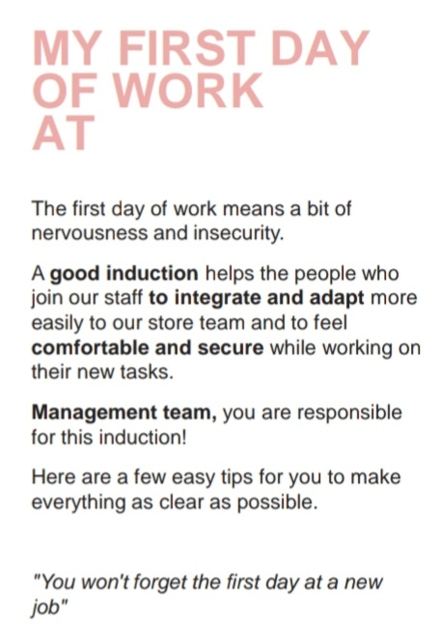
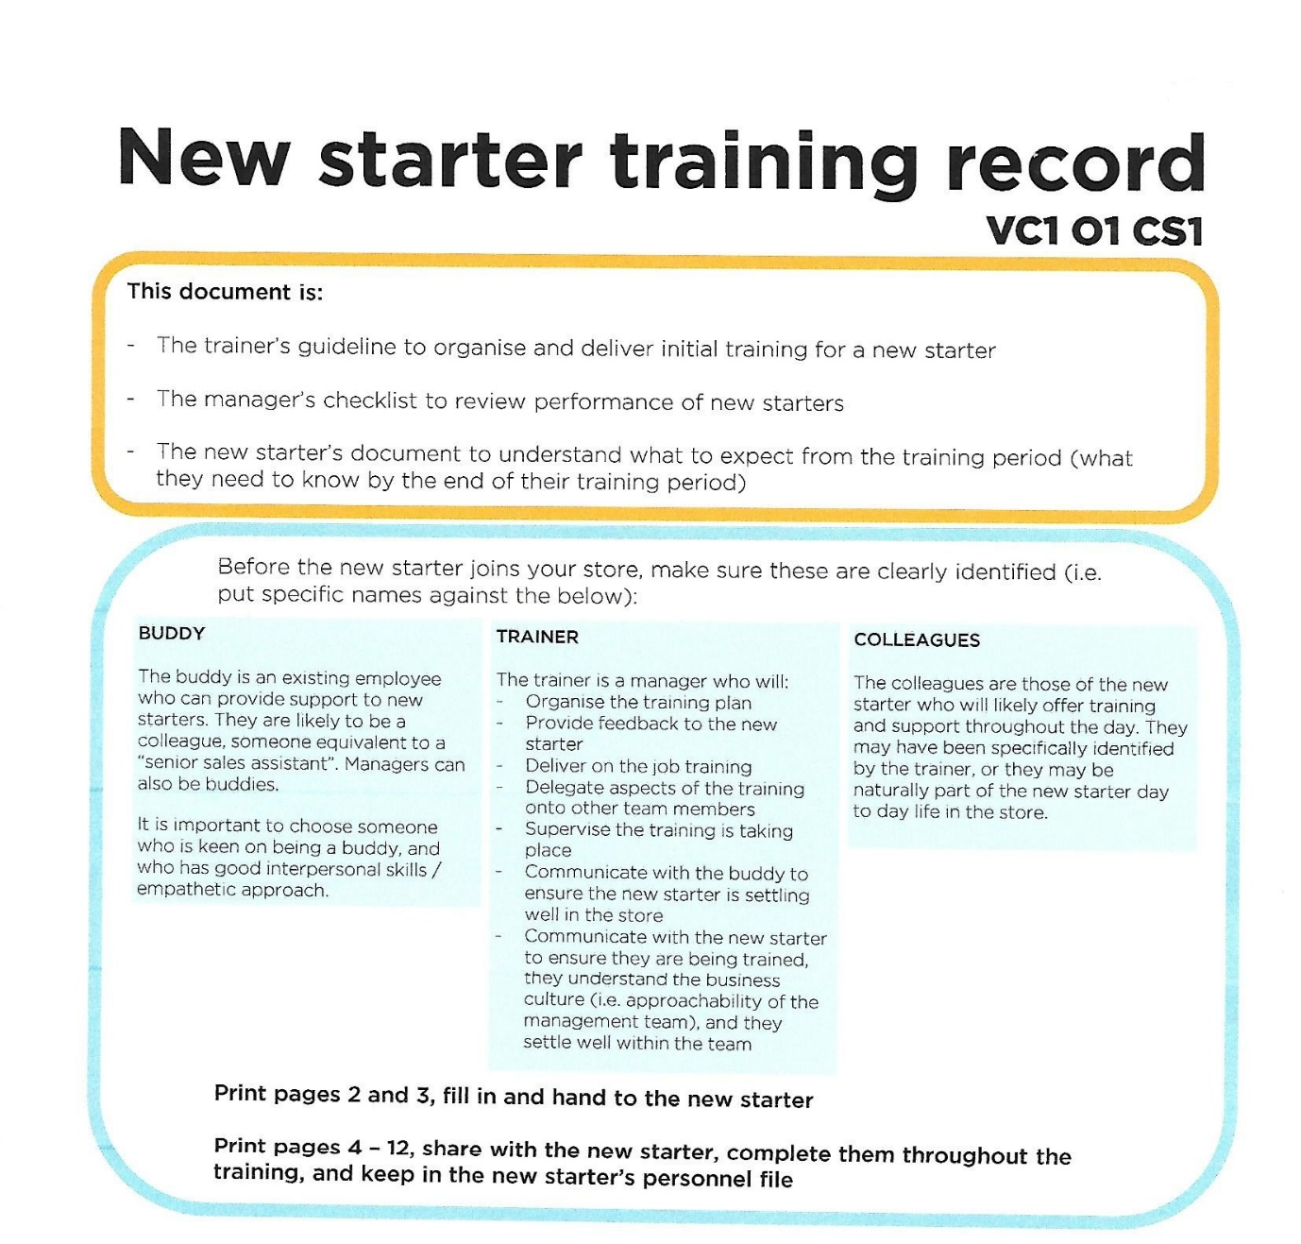

Talking about the role of the line manager as a coach, the position of my company reflects Downey’s concept (2003), where the line manager has three functions: manager, leader, and coach. In my organisation, there is no mention of coaching in any of the training documentation, but the managers are expected to set up objectives for their staff, give them constructive feedback, suggest ideas, also asking the employee for their feedback and initiatives. On the document below, the 121 record that we employ in the stores, we may see it has been inspired in the GROW model by Alexander, Fine and Whitmore, and OSCAR, by Whittleworth and Gilbert (2002).

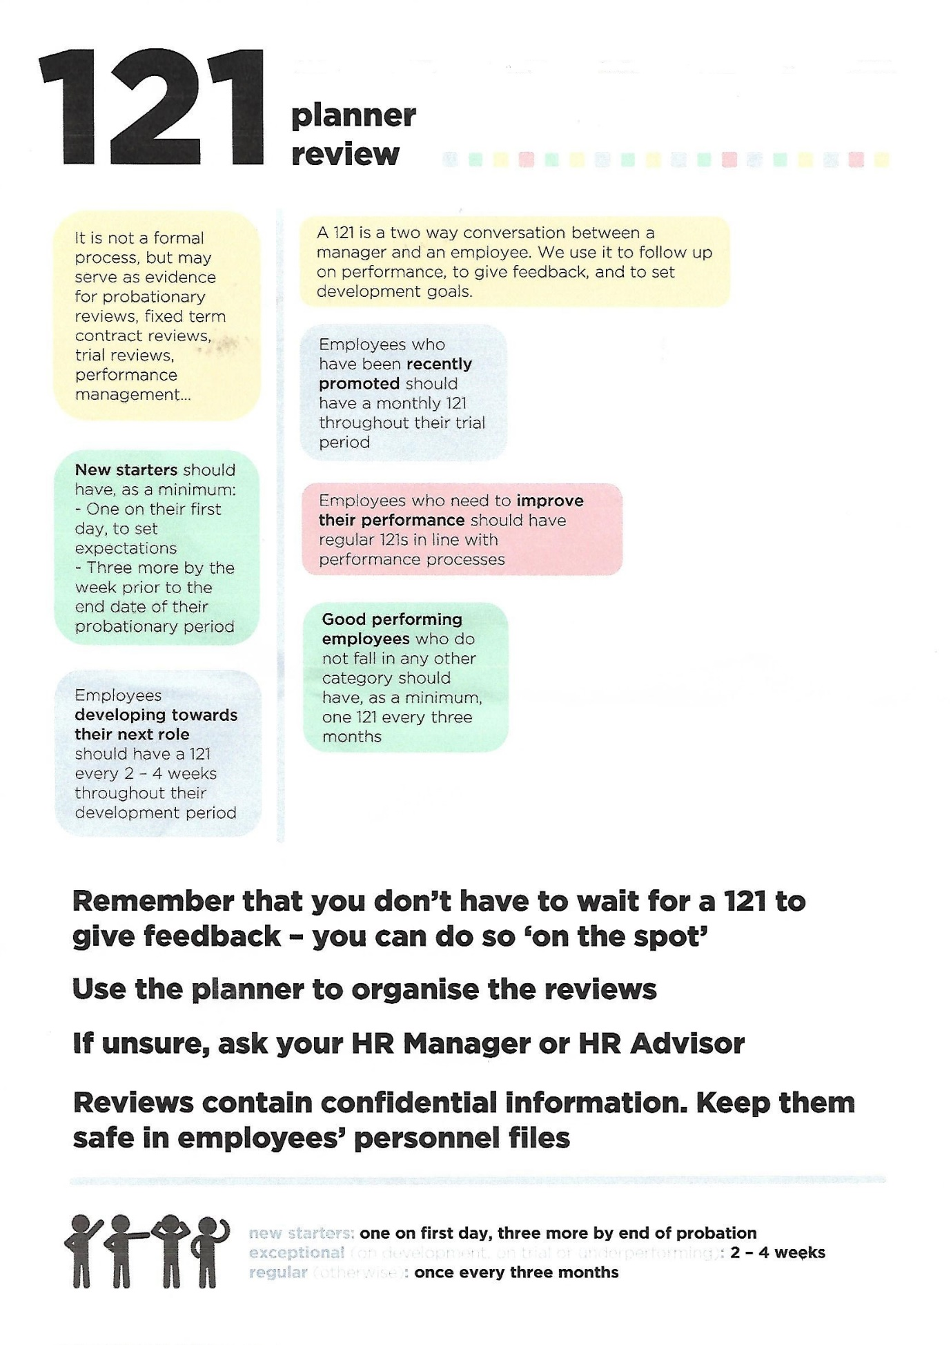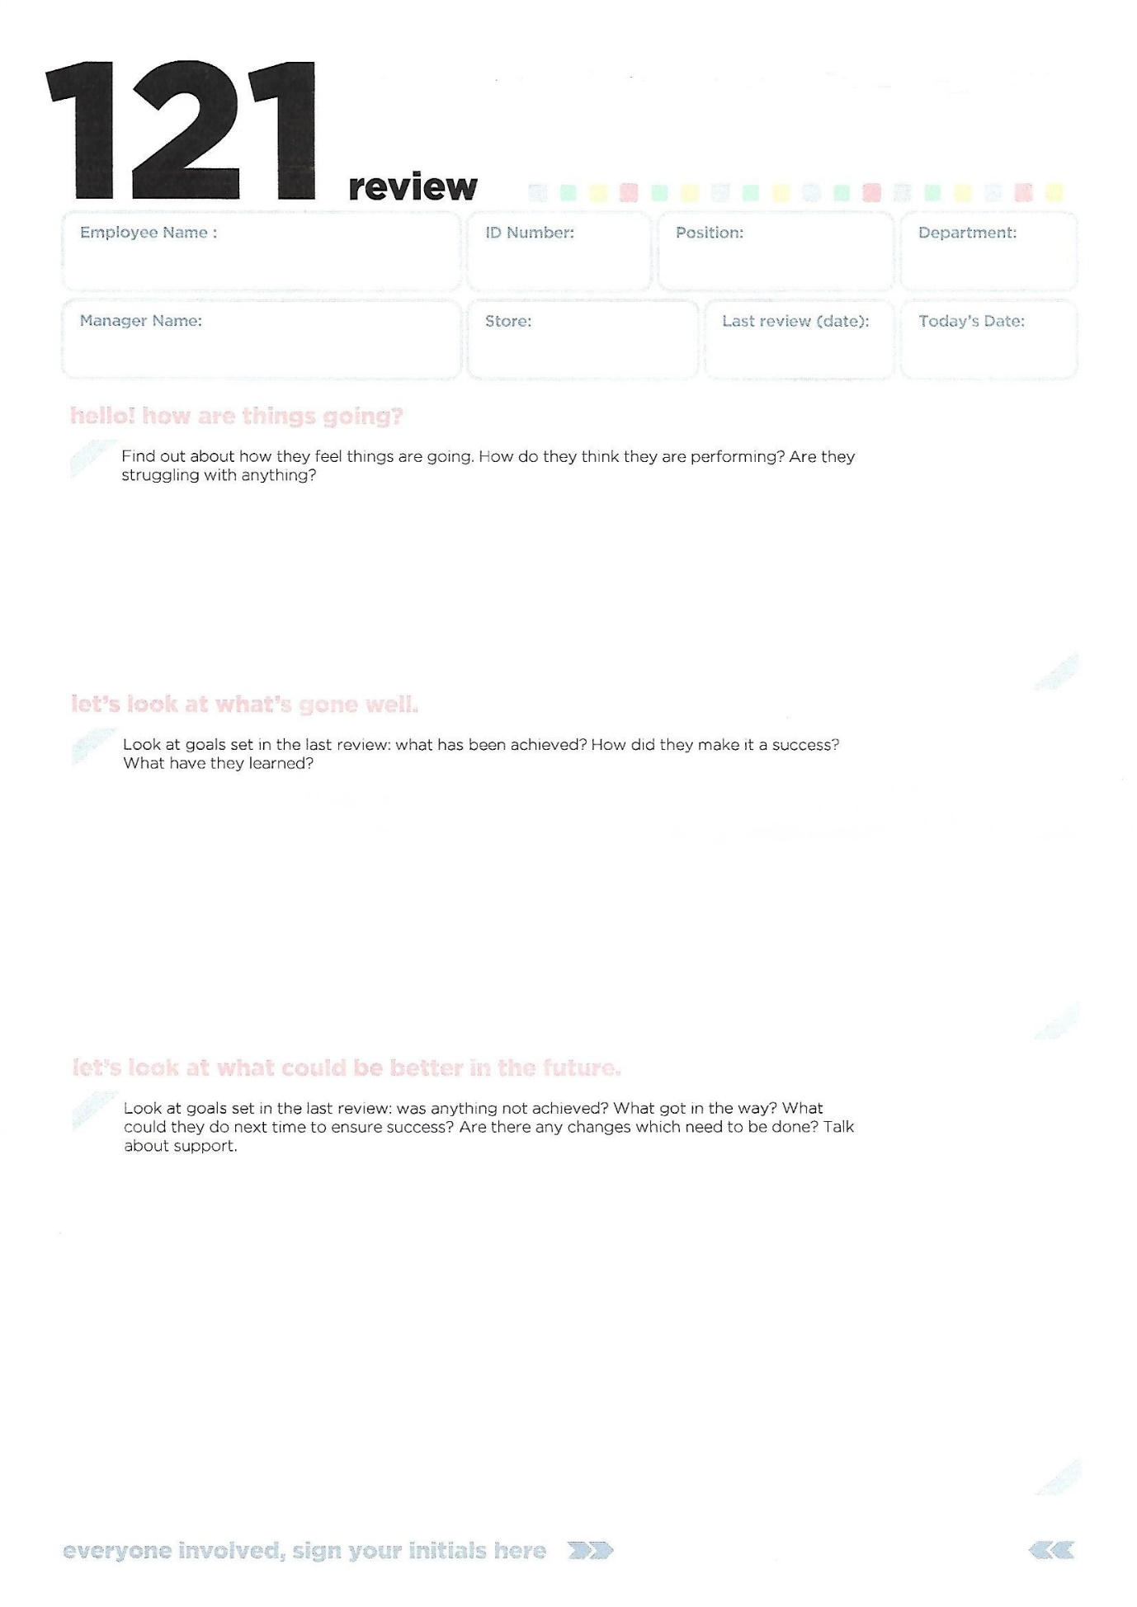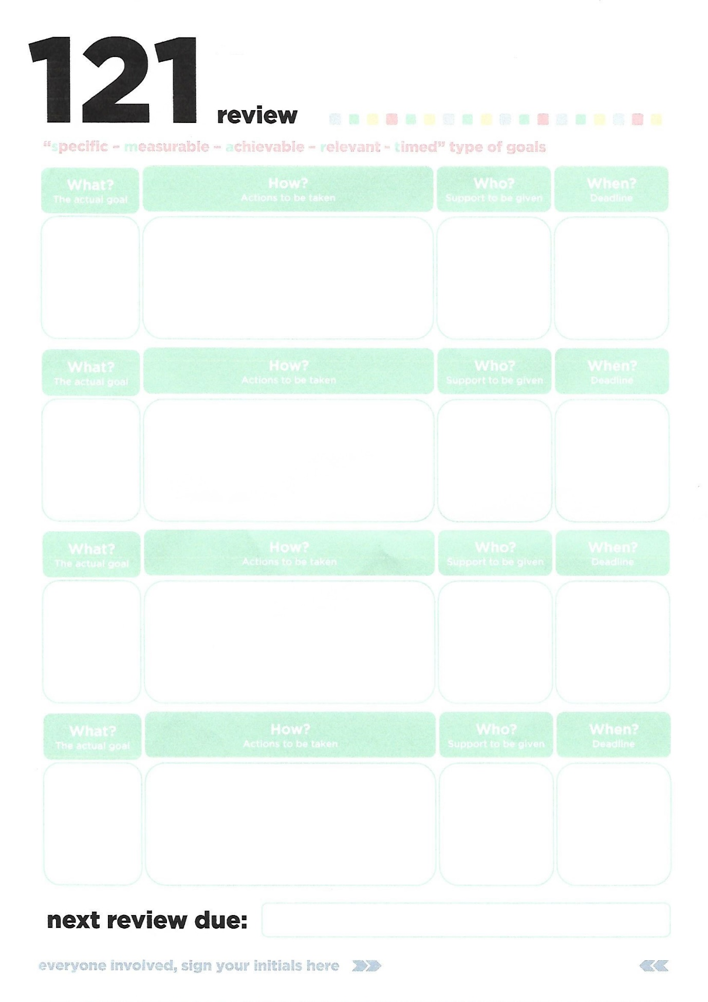

Prior to an employee being promoted as manager, they have to be successful in the training process, which usually happens in the store. Knowledge is passed on from senior managers to the sales assistants involved in a career development plan, using a blended approach between directive and non-directive styles (Bigrock, 2021). In the organisation’s training materials that refer to communication, we also find a reference to Covey’s 7 habits of highly effective people (see image below).

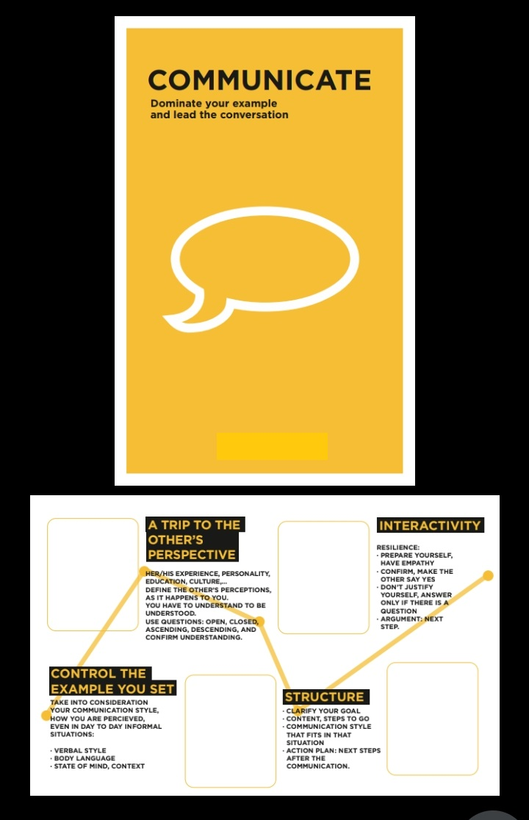

In conclusion, my organisation agrees with the CIPD (2020) statement which expresses that companies apply coaching as a daily management activity, embedding it into one-to-one meetings. However, there is no mention of any coaching or mentoring in any on the training documentation, managers are expected to act as coaches when they have not had any formal training. I believe the organisation should review introduce the concepts of coaching and mentoring, instead of covering all the activities in the process as ‘training’. Also, some formal coaching training should be delivered to them as part of the process of becoming a manager.

- ANALYSIS OF THE LEARNING AND DEVELOPMENT POLICY

Our Learning and Development policy’s purpose is to outline responsibilities and expectations, providing information and guidance to all the employees. However, it makes no mention to any coaching and mentoring training.

All employees are responsible for driving their own development by identifying their development needs, seeking opportunities to learn and discuss them with their line managers.

Managers are responsible for training and developing their teams, by monitoring performance, discussing, and agreeing learning and developing needs and goals and assisting their team in looking for solutions for those developmental needs, and support them, helping this way achieve also organisational goals.

The Learning and Development team has other responsibilities too, such as appointing suitable trainers, providing opportunities for growth, and supporting business objectives and values, which is based on the CIPD (2020) statement that affirms that coaching is linked to L&D strategies, confirming that it is the best way of supporting employees potential and providing career support.

One of the main points of this policy is about accessing funding for a course or qualification, which eligibility criteria is outlined below:

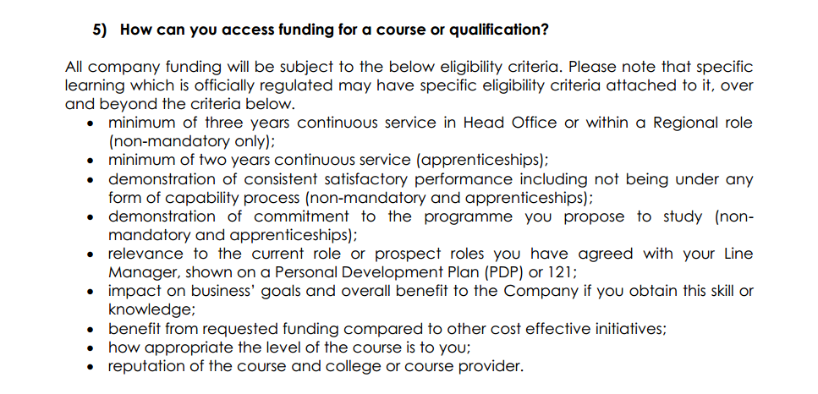

Conversely, reality is far from what it is stated in the policy. When I applied for this qualification, after having worked in the company since 2008, and as a manager for twelve years, I was denied any support from my regional managers and the Learning and Development team, which means very little or no access at all to any company information. For instance, when I approached my People Manager about how coaching and mentoring takes place in the organisation, he sustained that we do not have any coaching programmes, but after analysing some of our internal documentation, somehow it is implemented. Luckily, I have gained a lot of experience prior to this course, and I have always had the support of my line manager, offering any help ‘off the record’.

- MY DEVELOPMENT NEEDS AGAINST THE CIPD PROFESSION MAP

After having an understanding of what coaching and mentoring means, and looking at the People practice standards on the CIPD Profession Map, I can confirm the training tools which I use to develop my staff are linked to coaching and mentoring methods, although I have not received any formal training which refers to C&M.

When it comes to training employees working full time, we meet every two weeks. Usually, this employee would like to progress in the company, so the first thing we do is to have an informal conversation about which career path he/she would like to follow (commercial, cash desk, Head Office). As a manager, from my own experience and after analysing their skills, I can suggest which path would be more suitable for them, but always leaving for them to choose what they would like to do next. When the employee starts a development programme, we also meet every two weeks, to discuss the achievements and the issues the individual has encountered that prevent him/her from achieving other goals. My job here is not only to give them feedback, but also ensure that they receive the right training.

I believe an organisation like mine, whose main purpose is the professional development of its staff through internal promotion, should adopt a more clear strategy in coaching and mentoring in the development programmes for their staff, so line managers would know which method would be more suitable depending on the issue they have to overcome or the changes they would like to implement.

REFERENCE LIST

- Bigrock (2021) Why Coach? Exploring the Effectiveness of Coaching & Different Coaching Styles. Available at: https://www.bigrockhq.com/the-effectiveness-of-different-coaching-styles/#:~:text=In%20directive%20coaching%2C%20the%20coach,a%20coachee's%20own%20learning%20journey. Accessed 29/04/21.

- CIPD (2020) Coaching and mentoring. Available at: https://www.cipd.co.uk/knowledge/fundamentals/people/development/coaching-mentoring-factsheet. Accessed 18/04/21.

- Clutterbuck, D.; Megginson, D. and Bajer, A. (2016) Building and Sustaining a Coaching Culture. CIPD: London. Accessed on 13/05/21.

- Downey, M. (2003) Effective coaching: lessons from the coach's coach. Cengage Learning. Accessed on 09/05/21.

