Appendix A – Letter of consent for participation in research
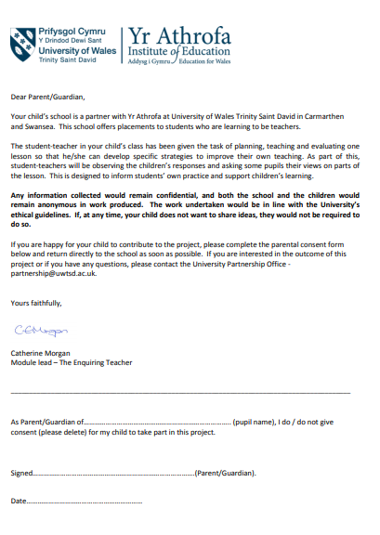

Appendix B - Leauven Scale of Involvement (Leavers, 1994)
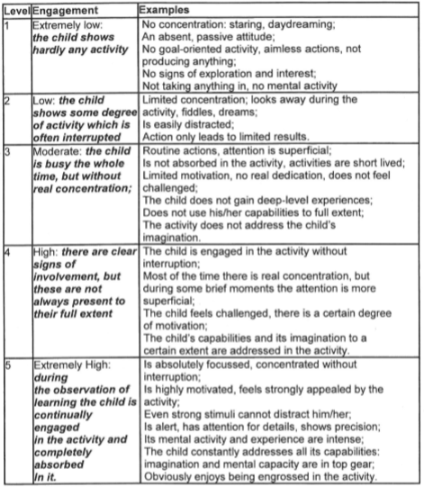

Appendix C – Adapted Leuven scale of involvement for involvement and engagement with technology
Level | Engagement/Involvement | Examples
1 | Extremely Low:  The child shows hardly any use/involvement and learning objectives are likely to not be met at all | Child cannot understand how to use the technology relevant to the lesson  Child refuses to use technology or employs different strategies to complete work  Child shows zero enjoyment during the lesson; no active learning takes place  Child cannot/will not make reconstructions about technology based on instruction from teacher or staff  Child not meeting success criteria based on technological aspects of the lesson
2 | Low:  The child shows some degree of use/involvement which is often interrupted. Learning objectives and/or success criteria may possibly begin to be understood on a small level | Child displays very basic understanding of how to use technology relevant to the lesson  Child is slightly unwilling to use technology or employs different strategies to complete work  Child shows minimal/very few moments of enjoyment during the lesson; zero – low levels of active learning  Child occasionally makes reconstructions regarding misconceptions but struggles to apply them practically.  Child unlikely to meet success criteria based on technological aspects of task but shows a basic understanding of the concept
3 | Moderate:  The child is involved with the technology but the use may be inconsistent and not working towards meeting learning objectives and/or success criteria | Child displays reasonable understanding of how to use technology relevant to the lesson and has task oriented ability in relation to the lesson  Child is willing to use technology and employs the required technological strategies to complete work  Child shows moments of enjoyment during the lesson; signs of active learning  Child makes reconstructions regarding misconceptions but struggles to apply them practically.  Child begins to work towards to meeting success criteria based on technological aspects of task but shows a basic understanding of the concept
4 | High:  There are clear signs of involvement and use but there are occasionally moments that require improvement | Child displays a good level of understanding of how to use technology relevant to the lesson, has task oriented ability in relation to the lesson and occasionally uses creative initiative to employ other relevant strategies  Child is eager to use technology, employs the required technological strategies to complete work and discusses in depth  Child shows frequent moments of enjoyment during the lesson and consistent levels of active learning  Child makes reconstructions regarding misconceptions (if any) and applies them practically.  Child meeting success criteria based on technological aspects of task but shows a basic understanding of the concept
5 | Extremely High:  The child displays a consistent level of involvement and use with the technology and is on course toward meeting learning objectives and/or success criteria | Child displays a very good level of understanding of how to use technology relevant to the lesson, has task oriented ability in relation to the lesson and uses creative initiative/flair to employ other relevant strategies  Child is eager and motivated to use technology, employs the required technological strategies to complete work and discusses in depth  Child shows consistent moments of high enjoyment during the lesson and; active learning clearly taking place  Child makes reconstructions regarding misconceptions (if any), applies them practically and assists others with enthusiasm  Child meets/surpasses success criteria based on technological aspects of task but shows a basic understanding of the concept

Appendix D – Reflective model adapted from Brookfield’s four lenses (1995) & Gibbs’ Reflective cycle (1988).

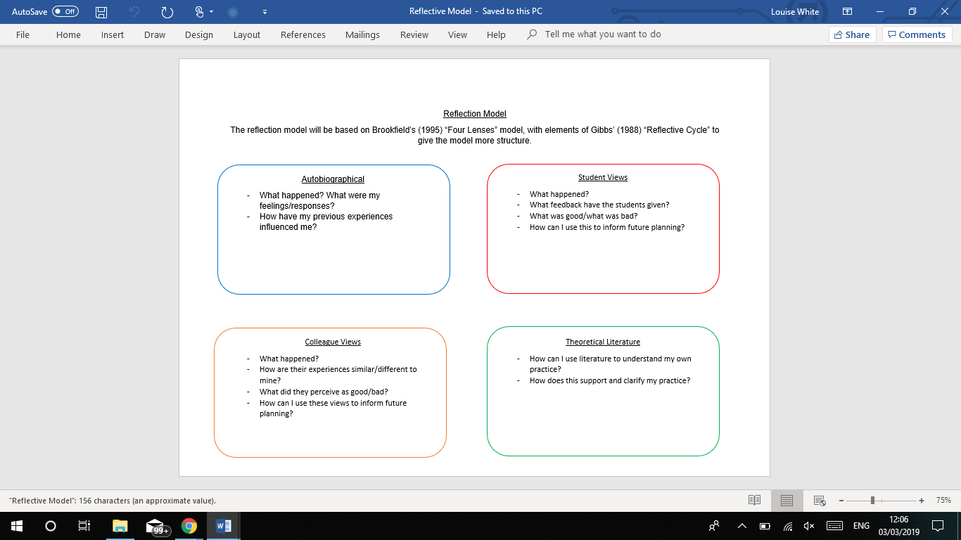

Appendix E – Process of gaining assent from potential participants

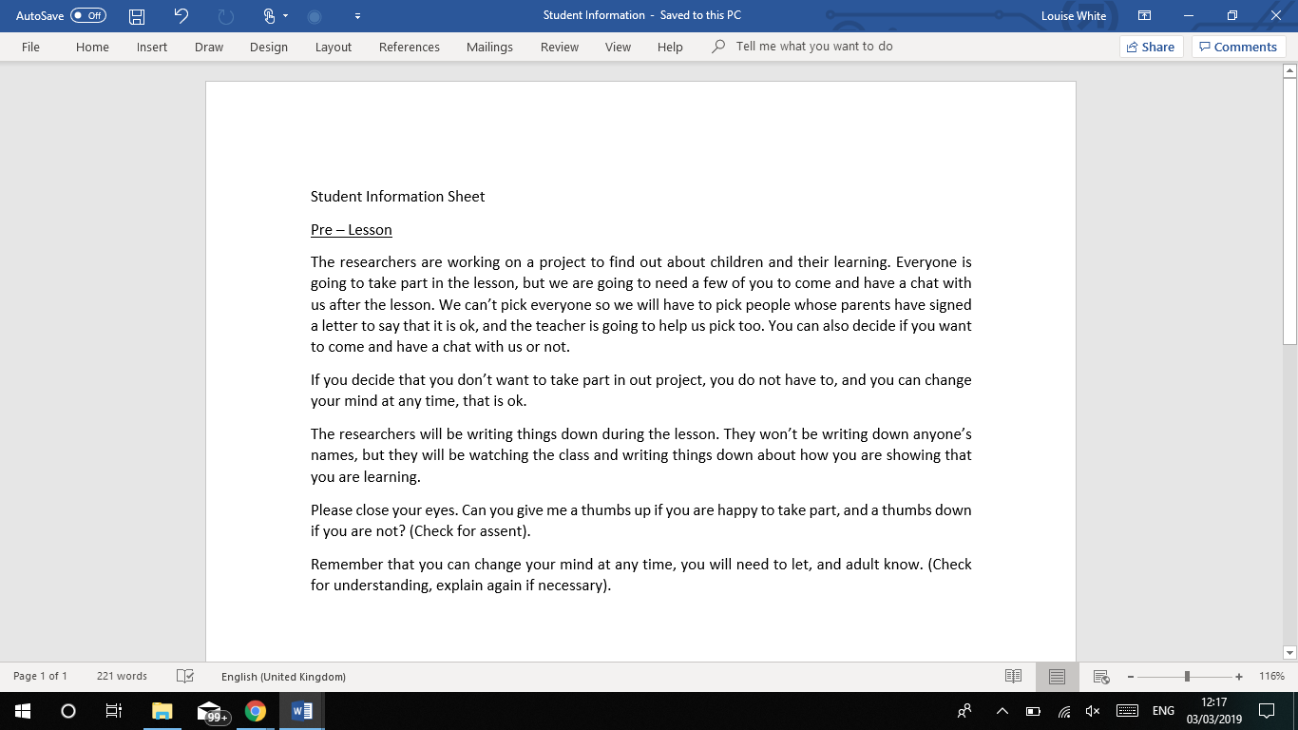

Appendix F – Outline of plan for first lesson study
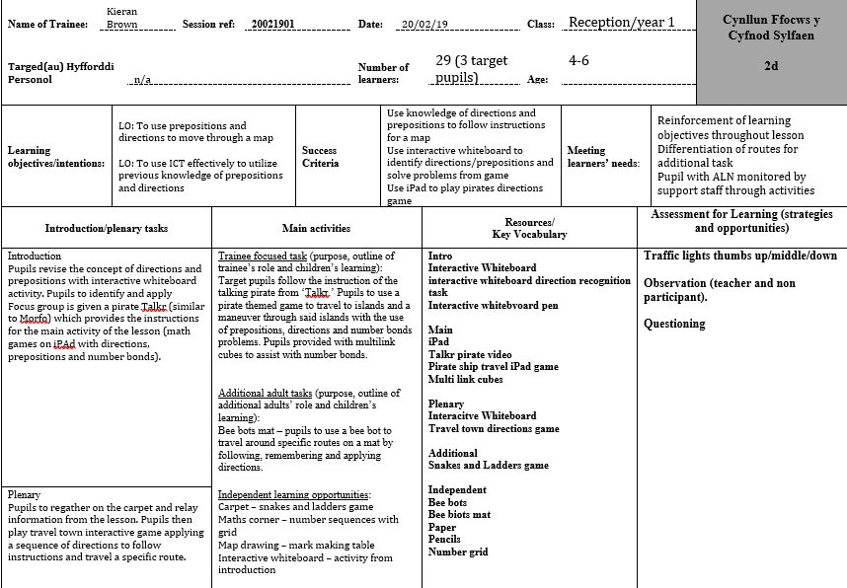
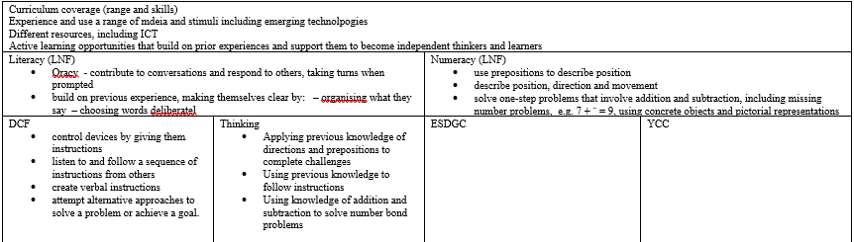

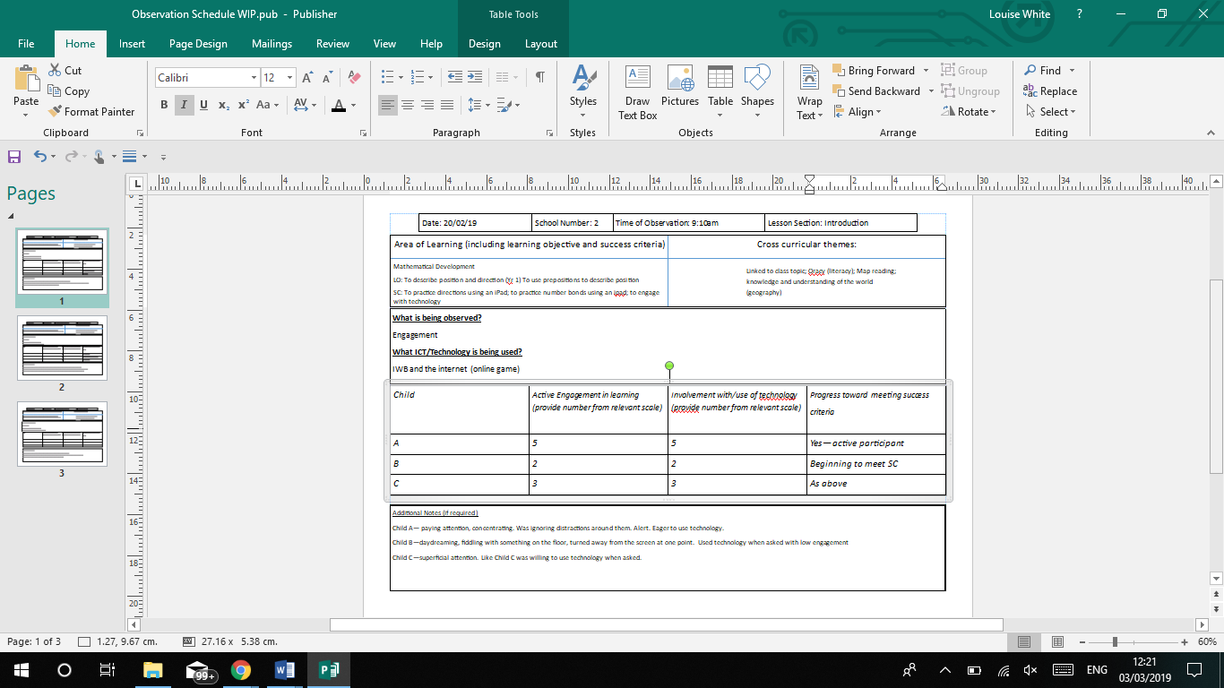
Appendix G – Observation Schedule and Notes from non participant from lesson study 1 – introduction
Appendix H – Observation Schedule and Notes from non participant from lesson study 1 - main
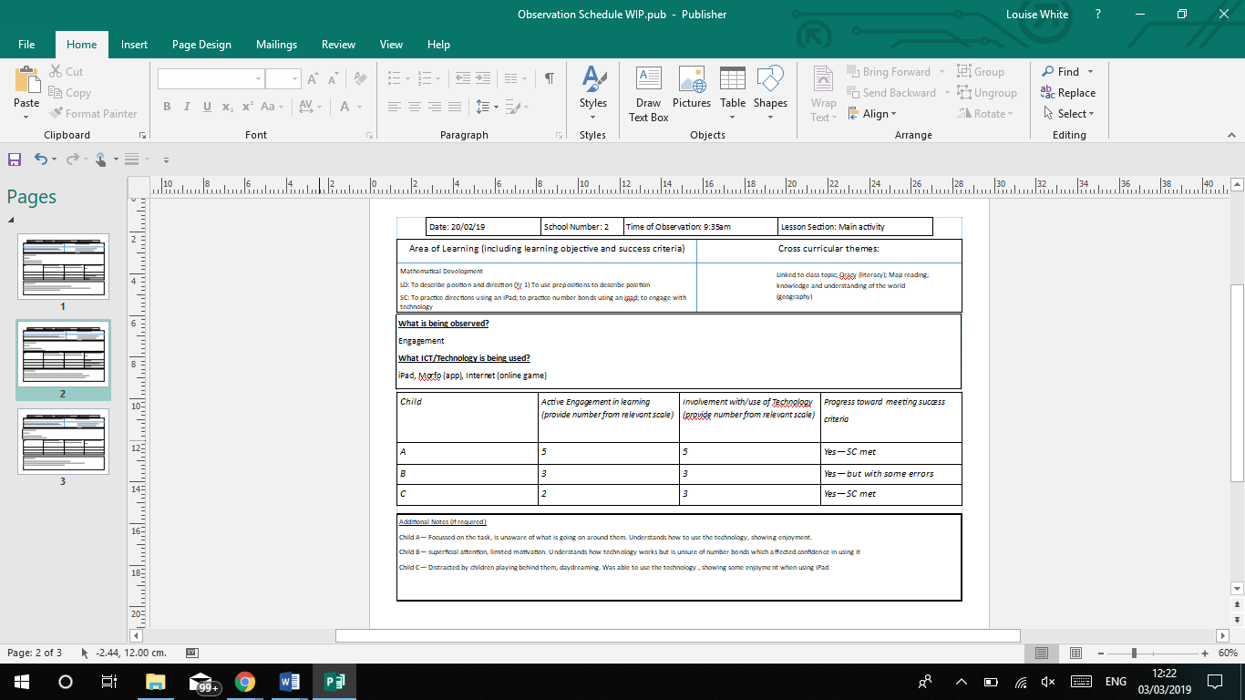

Appendix I – Observation Schedule and Notes from non participant from lesson study 1 - Plenary

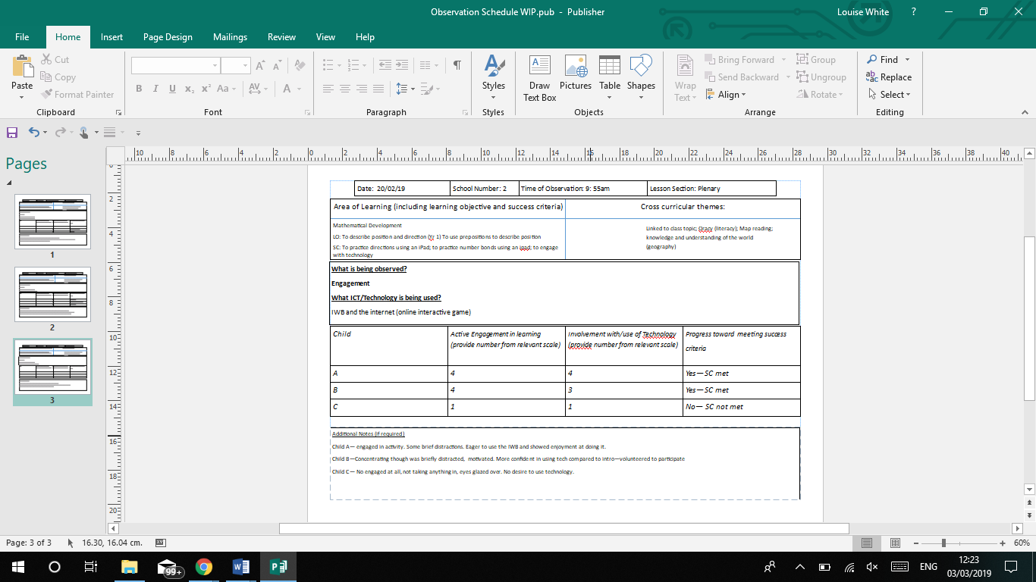

Appendix J - Transcription of participant interview following lesson study 1

Prior to recording participants were given laminated cards with smiley faces on (green, yellow, red) and were told that if at any point they wanted to leave the interview, they could tap the red face and leave. Child C asked if they could be used to ask questions, and was told yes.

What was the lesson about today?
Child A – umm…pirates
What did we do?
Child B – maths
What maths did we do?
Child B – times tables and following the arrows
Child A – directing
Directing?
Child C – directions… forwards, backwards, left, right

What part of the lesson did you like the best?
Child A – ummm…the pirate game
Child C – ummm, I liked it, I liked it when it was 5 plus 5 it was easy its just 10
What did you think was the best bit?
Child B – (pause) the arrows game

Why did you like it? Why did you like best?
Child A – Because it looked fun and it was fun, and I liked it when the pirate ship moved and got to the island and I liked the treasure when it came at the end
Child C – and I liked, I liked the sword and when we got it off the treasure chest
Child A – I liked it, I liked the creepy skeleton head
What did you like?
Child B – because you gotta follow the arrows

Was there any bit of the lesson did you not like? What part were you like hmmmm I don’t like that as much?
Child A – the pirate talking, it was a bit scary a bit spooky
Child C – umm I didn’t like the pirate talking too, it’s a bit creepy (Child C makes ‘oooooooo’ noises)
Child B – yeah creepy

Is there anything you would change about the lesson? What would you change if you could?
Child C – learning but not hard maths
Child A – maths, I would, if I was I changed the maths to police things and learn about police that’s would I would want to do (pause) and, oh I mean mountain rescue
Child C – and also I can change about maths what colours that they are called

What would you change Child B? What would you make different?
Child B - dunno

Is there anything you would keep the same about the lesson?
Child A – I would keep the pirate, I would keep the pirate aswell, for like, for like 2 more weeks
Is there anything that you would keep the same Child B?
Child B doesn’t not respond
Not sure?
Child B - No
Child C – I would keep the same, hmmm I would keep the same learning about pirates, yeah I still want to keep that the same

Do you think computers and iPads can help you learn?
Child B – uhhh
Child C – yeah coz you can play lots of awesome games and it helps and it helps you learn
Child A – (interrupting Child C) yeah but it’s bad for your head because I think so
Child C – yeah
Child B - Yes

So, how can computers help you learn? Can you describe how they help you learn?
Child C – Helps you um, you learn about stories and you can learn about Pudsey and you can learn about anything
Child A – slime, even slime. Slime. You can learn about how dinosaurs existed
Child C – and numbers
***Child B asks to use the toilet
Child A – and and you can see how tall animals are, any animals you like
Child C – an elephant is really big. There’s no way you can carry that

If I get some pictures, do you think you can put them in order? Which thing can help you learn? What do you like to use to learn?
***Note: Children did not order the pictures, they picked them up and kept them.
Child C – I’m not sure if I want to leave because I’m a yellow face. (Gasps) Alexa!
Child A – I like the iPad
Why do you like to use the iPad?

Child A – mobile phone. There’s 3 laptops. Can I take it? (Takes iPad) iPad. Um because because I can record people and there’s loads of learning apps on there
Child C – and I want to learn about music (picks up picture of an ‘Alexa.’) Yeah. You can learn how to sing.
Child A – and I like the phone.

What do those things do to help you learn?
Child C – you can learn about music and you can learn how to sing them. Like (singing) peanut butter jelly time.
What helps you learn?
Child B – phone

If teachers use computers and other things, other technology in a lesson, does that help you concentrate on your work? Why is this?
Child A – yes a little bit because…actually I want the mobile phone actually
Child B – I’ve got a Chromebook.
Child C – I don’t really understand
When teachers use computers in lessons does it help you to concentrate on your work?
Child C – yeah
Child A – not really because… I’ve got spotify on my kindle. Because when I concentrate my head goes a bit funny and and it hurts and it hurts in the middle

Who do you think should use computers more to learn, children or teachers?
All – Teachers
Child B – because if you can’t have kids and you can’t and you don’t know what to do on there
Child C – and they are really important. I’m yellow face
Child A – and if and if they are brand new you are not allowed to touch them you might have sharp nails and scram it.
You are on yellow face, do you have a question?
Child C – How does the internet work?
That’s a really good question. Can I ask some more questions and then we can explain how the internet works?

Are there any lessons that we should not use computers in?
Child A – nope
Child B – no
Child C – should have them all the time to learn
Child A – no, but they are bad for your head
Child B – no, well because you can’t use computers and iPads.
Thank you so much for answering the questions
***Note, after the recoding it was explained to Child C how the internet works

Appendix K – Outline of plan for lesson study 2
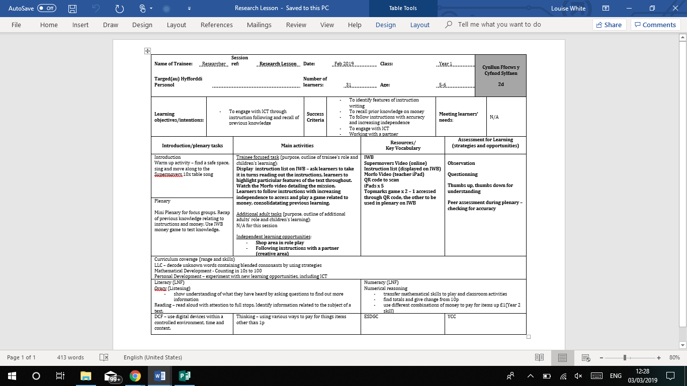

Appendix L – Observation schedule and notes from non participant from lesson study 2 - Introduction
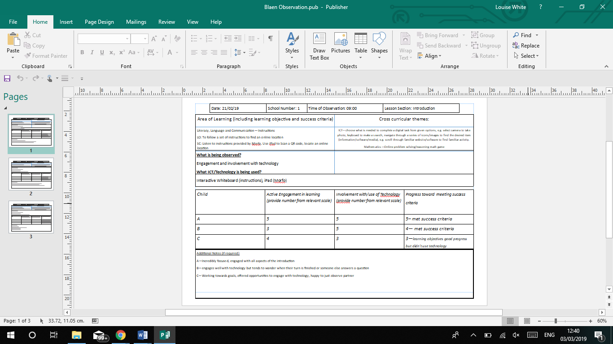

Appendix M – Observation schedule and notes from non participant from lesson study 2 - Main

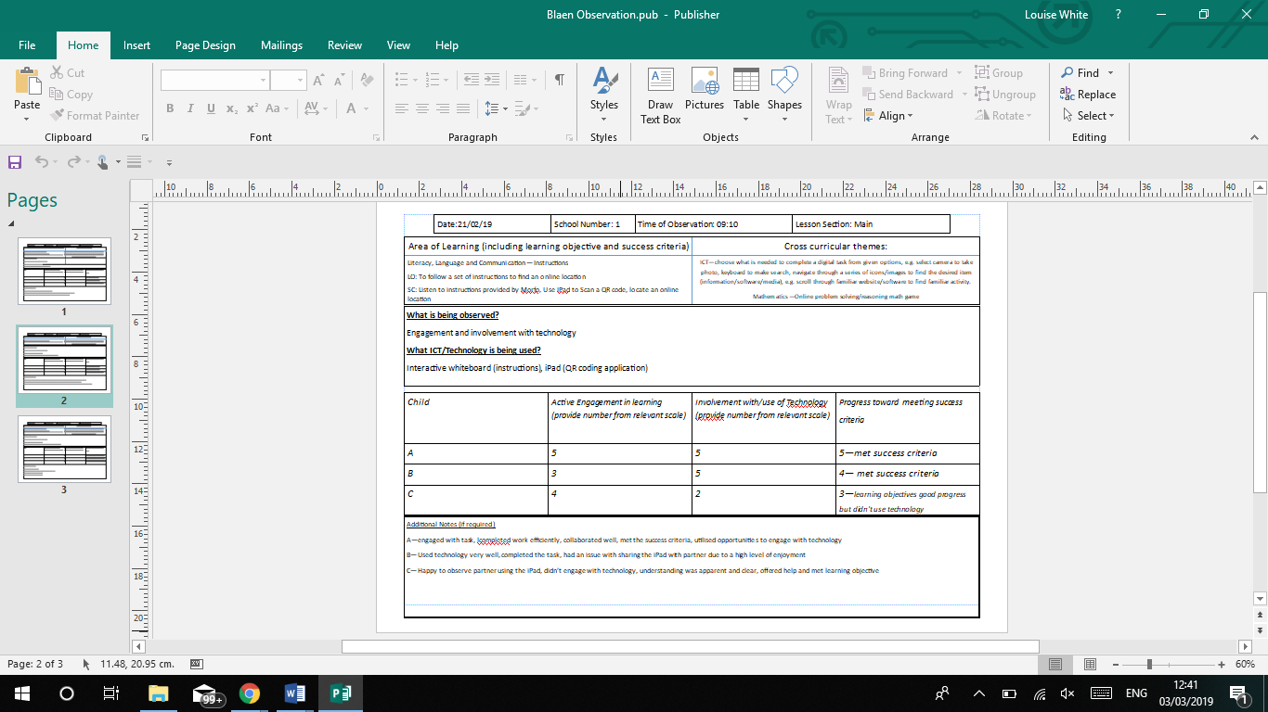

Appendix N – Observation schedule and notes from non participant from lesson study 2 - Plenary
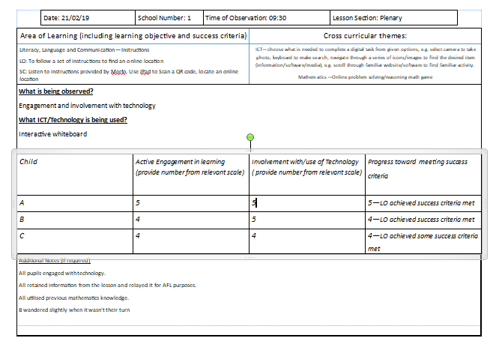

Appendix O – Transcription of participant interview following lesson study 2
Prior to recording participants were given laminated cards with smiley faces on (green, yellow, red) and were told that if at any point they wanted to leave the interview, they could tap the red face and leave.
I want you to have a little think. What was our lesson about today?
Child A - ummmmmmmm
What was the lesson about with Researcher 1 and 2?
Child A -ohhhh…a secret mission
What did we have to do for the secret mission?
Child C- watch a video of Captain America
Child B – but it was hard to understand, because he was on video
What did he ask on the video?
Child A – we had to ummm follow instructions of money
Child B and we also had to play a money game and you had to do the price of whatever it was. So say something was fifty pound you had to count with 10s, and it, you had to go 10 20 30 40 50

Thinking about the lesson, what did you like best about the lesson?
Child A - Captain America video
Child C – um, Captain America video
Child B – I liked to working with (child) to do the game
**** Child B referred to a different child in the class, referred as (child)

Why did you like the video?
Child A – because (laughing) he was like a robot, and I couldn’t hear him properly and it was funny and I was asking loads of questions
What about you?
Child C – it was because his voice was very weird
Why did you like the game?
Child B – because me and (child) got to do me, (child), me, (child), me, (child)
You had to take it in turns?
Child B – yes
What part of the lesson did you not like?
Silence
Was there anything you did not like?
Child C – no
No? Did you like it all?
Child A – well one bit, that researcher 2 wasn’t in it much and it wasn’t fair
So you think that researcher 2 should have been in the lesson more?
Child B – yes
Do you agree?
Child C – yes
Is there anything that you would change about the lesson that we did this morning?
Child B– yes
Child A – yes, so that researcher 2 could help us on the iPads
Child B – yes so that he could help us to get on the thing that we needed to get on
What do you think?
Child C – um they could in case you do something wrong researcher could help you do it right

Have a think…do computers help you to learn?
Child B- yes because it helps you count with money and some money games are really good so you know what all of the coins are, like my lucky penny
What do you think?
Child A – sometimes
Why sometimes?
Child A - because like sometimes money games can be dangerous coz if you don’t know what money it is then something might pop up as in somebody texting you saying you did it wrong you shall with me I know the answers
You need to be safe then?
Child A – Yeah
What do you think? Do computers help you learn?
Child C – some of them could be fine for kids
But not everything?
Child C – no
What about iPads in school, are they ok for us to use to learn?
Child C – yeah
Child B - sometime because if you go onto the pictures sometimes it says storage um closed because there’s too many pictures and there’s lots of selfies in there so you can’t do it coz there is so many of um silly selfies of you

So how can computers help us learn?
Child A - by um special games that nobody else can touch and they are just for you and if they are stuff for babies, not like babies but like toddlers that know how to work them the dad or mum has checked it and everything um then there’s no strangers on it um then money games and like games that they can learn with
Child C - I think they could if there was games that everyone can do and then they won’t let you um if they are mean to you?
So, the question is how do computers help us learn?
Child C – I know, to help us be like a grown up to be like a pro.
Can they teach us things do you think?
Child C - Yeah
Child B – I think sometimes that you can go on the computer and sometimes you can’t so it’s kind of safe so like say if something popped up and you don’t know what it said so you have to go get a grown up and check if there is any swear words on it

Researcher 1 has some things here, some pictures. I would like you to put them in order for me.
Which ones help us learn the most? Which ones don’t help us learn? Have a little look and put them in order.

Child B – let us learn, they help us learn songs uh well I think that helps us learn, Alexa coz did you know it can do lots of stuff so in the middle, some can go in the middle
Child C – that does not…no
***Note : Child C picked up picture of desktop
So, the desktop doesn’t help us learn?
Child A– no coz there’s loads and loads and loads and loads of things can get on that
Child B - Yes
We have desktops here, we use these don’t we?
Child A - yeah but loads of things can get on them
***Note: Child A picked up picture of phone
Child B : I think the Alexa one, actually I have an Alexa
Child C - this is my one.
What have you got there Child C?
Child C -a phone. People teach you how to be a pro at Minecraft and a pro at staying safe on your phone
What helps you learn the most?
Child C - my iPad. It makes me learn. I can learn not to be scared on ‘Goosebumps’ night of scares, not be found by the monsters, graveyard ghouls, slappy, or gnomes, and wolves and clowns
What have you picked?
Child B – Alexa. It helps you learn new things so say if you say Alexa what, why are um pine cones called pine cones, she would say, coz they um are something like coz they are bobbly or something like that

If teachers are using computers in lessons, do you think that it helps you concentrate more?
Child B – yes
Child C - no
Why do you say that?
Child B – coz you can learn new games and you know how to do those things then. So you can like know the games but not all of them coz they can have swear words on them.
You said no, they don’t help you concentrate. Can you explain that?
Child A – because you might be trying to do things and they might be trying to do things and when they are doing that thing and you are doing that thing, and your thing has noise and their thing has noise, and theirs is loud and you can’t hear yours. It’s confusing
Child C – sometimes because sometimes I don’t know how to get out. I do concentrate

Who should use computers more children on teachers?
Child B – teachers
Child A - teachers
Child C – I think I can use my iPad. Children
Child B - well I think for kids and for teachers
Why do you think that?
Child B - so they can do the register and they know who is in or not like that
Child C – because the teachers have to do dojos
Child A – uh well it’s for both of us because when the kids need to text their friends and it’s something important or when the adults needs to do the register. The childminder might need to get their friends over for some help.
What about in school? Teachers or children?
Child B– both the children might really have nothing to do and need to like play games or something and um they are getting really stressed out
Child A - when the teacher has to do the register and stuff they have to go on there

Are there any lessons that we shouldn’t use computers in?
Child B – you shouldn’t use them if someone is fixing them
Child B - and also when it’s a lesson you can, you can’t just go straight ahead to the computers because you haven’t been called and to do your super me picture and nothing else
Child C –um I can, I think it can be great for people.
Are there lessons we shouldn’t use computers in?
Child C – um searching. You shouldn’t use them for searching only teachers, you might get told off
Child A- coz if teachers need it before for you and they go to the toilet when they come back and leave a lesson for you they might be really cross and you might have to go to a different school
Child A – not in PE cos it’s going to smash
Child C – I think we can’t use it when the teacher says not to
Child B – I think not in PE coz if someone’s not got their PE uniform they can’t do it and they can only take pictures on the iPad.

Thank you all for your help

