Introduction
- Description of homelessness in young people
- What is adolescence and what does adolescence look like for these young people?
- What are adverse childhood experiences (ACE’s) and what ACE’s do these young people have in common?
- What interventions are in place to enhance these identified young people’s physical and emotional well-being?
- How can we mitigate adversity for these young people?

1. Young People who are homelessness
(A) What is homeless?
Being homeless means not having a decent, secure home that you can afford where you feel safe, can work and fulfil your potential.
It can mean that you do not have a roof over your head and have to sleep on the street.
Or it can mean that you have nowhere to go and are staying with friends or in temporary accommodation such as a bed and breakfast or hostel.
To concur with this, according to the UK Government,
‘The term ‘homelessness’ is often considered to apply only to people ‘sleeping rough’. However, most of our statistics on homelessness relate to the statutorily homeless, i.e. those households which meet specific criteria of priority need set out in legislation, and to whom a homelessness duty has been accepted by a local authority.
Such households are rarely homeless in the literal sense of being without a roof over their heads, but are more likely to be threatened with the loss of, or are unable to continue with, their current accommodation.’
(Homelessness data: notes and definitions, 2022).
(B) What are the causes of homelessness?
Family breakdown, Mental Health Issues, Debt, Pregnancy, Suffering violence or abuse, Leaving Care, Sexuality, Seeking asylum or being a refugee, Unemployment.
(C) How long have young people sofa-surfed for?
According to an article written by the BBC in December 2017, over 40% of young people between the ages of 16 and 25 have sofa surfed for one night, with around 27% sofa surfing for a week, and 3% up to six months in the UK.
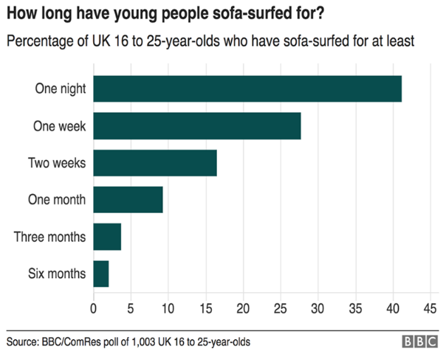
https://www.bbc.co.uk/news/uk-42427398.
(D) Video – Youth homeless through covid times
This following video was published on the BBC news is December 2020.
https://www.bbc.co.uk/news/av/uk-55399979

2. What is Adolescence?
(A) Adolescence is a time of rapid change including:
- Physical development, for example, growth spurt and sexual maturation
- Cognitive development, for example, evidence suggests brain development continues up to age 25
- Emotional development, for example, identity, self-esteem, and resilience
- Social development, for example, peer influences, sexual identity
- Behavioural development, for example, risk taking and the beginning of lifelong behaviours
- Young people experience significant physical, psychological and behavioural changes as they progress to adulthood. Appropriate and timely support for young people on their journey to adulthood is essential to ensure future health and wellbeing.
(Early adolescence: applying All Our Health, 2022).
(B) So…what does adolescence look for homeless young people and what is its impact?
- Loneliness and Isolation
Homeless young people are often separated from their community - their friends and family and support networks.
They’re left without the support young people need to guide and mentor them through life. Instead, they’re forced to become an ‘adult’, alone, overnight.
- Young people are vulnerable and at risk
Many young homeless people tell us they’d rather stay awake all night and keep moving around until morning because it’s safer to sleep in the day.
Homeless young people are more likely to take part in illegal activities. One in six homeless young people take part in criminal activity for somewhere to stay.
Abuse drugs and alcohol. Homelessness often compounds pre-existing substance misuse. It’s estimated that drugs users are seven times more likely to be homeless.
Become a victim of violence and exploitation by others.
- Disruption in Education
Homeless young people lack the stability and support they need to succeed in school. They’re much more likely to be absent for long periods and fall behind. Their situation forces them out of education, even if they’d like to continue.
This can have lifelong consequences, as they may find it harder to find a job and earn a decent living.
(Action for Children, 2022).

3. Adverse Childhood Experiences (ACE’s)
(A) What is an Adverse Childhood Experience (ACE)?
Adverse Childhood Experiences (ACEs) are “highly stressful, and potentially traumatic, events or situations that occur during childhood and/or adolescence. They can be a single event, or prolonged threats to, and breaches of, the young person’s safety, security, trust or bodily integrity.” (Young Minds, 2018).
Examples of ACE’s:
Physical abuse, Sexual Abuse, Emotional Abuse, Living with someone who abused drugs, Living with someone who abused alcohol, Exposure to domestic violence, Living with someone who has gone to prison, Living with someone with serious mental illness, Losing a parent through divorce, death or abandonment.
(B) Impact of ACE’s
Just like attachment, experiencing ACEs can have an impact on our future physical and mental health, and often ACEs can be barriers to healthy attachment relationships forming for children. Some of the effects of ACEs on our physical and mental health are:
An increase in the risk of certain health problems in adulthood, such as cancer and heart disease, as well as increasing the risk of mental health difficulties, violence and becoming a victim of violence.
An increase in the risk of mental health problems, such as anxiety, depression, and post-traumatic stress. 1 in 3 diagnosed mental health conditions in adulthood directly relate to ACEs.
The longer an individual experiences an ACE and the more ACEs someone experiences, the bigger the impact it will have on their development and their health.
(Adverse Childhood Experiences (ACEs) and Attachment - Royal Manchester Children's Hospital, 2022).
(C) What Adverse Childhood Experiences (ACE’s) do homeless young people have in common?
Emotional Neglect, Parental Separation / Divorce, Physical Abuse, Physical Neglect, Sexual Abuse, Verbal Abuse, Substance Misuse, Domestic Violence, Mental Illness.
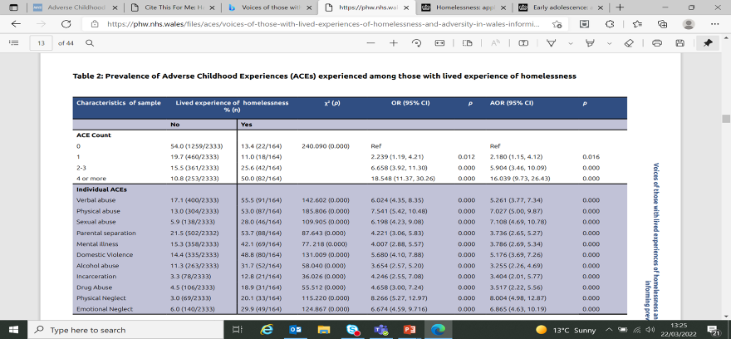
(Homelessness data: notes and definitions, Gov.uk, 2022).
As the table to the previous slide shows, compared with those with no ACE’s, individuals with four or more ACE’s were 16 times more likely to report experiencing homelessness.
As the ACE count increased, the prevalence of homelessness increased.
More than half (54.0%) of those without lived experience of homelessness reported no ACE’s at all, compared to just 13.4% of those with lived experience of homelessness.
In contrast, while 10.8% of those without lived experience of homelessness reported having four or Public Health Wales 12 more ACE’s, this increased to 50.0% of those with lived experience of homelessness.
(D) So why youth work?
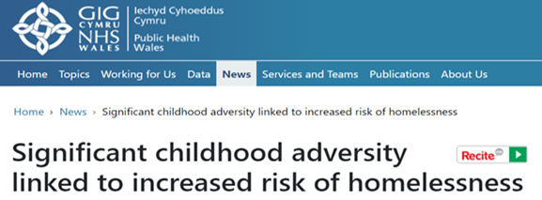
People in Wales who have suffered significant adversity in childhood are 16 times more likely than the general population to experience homelessness, according to a new study by Public Health Wales.
More than eight in 10 (87 per cent) of those with lived experience of homelessness said they had experienced at least one Adverse Childhood Experience (ACE) compared with a Welsh average of 46 per cent.
Half of those with lived experience of homelessness (50 per cent) reported they had experienced four or more ACEs. This compares to just over one in 10 (11 per cent) in the wider population.
Negative coping behaviour - such as unhealthy relationships, not being able to cope with rules and substance misuse - often starts in teenage years in response to a chaotic home life, and can lead to not coping academically and poor school attendance. These reactive behaviours continue into adulthood, resulting in homelessness. Vulnerable children and adults need early support to help them manage their trauma and build resilience.
(Public Health Wales, 2022).
(E) How does youth work help Young people who are homeless?
Long term engagement of those aged 11-25
Youth Work has the advantage of being able to be a constant in a young persons life from the age of 11 to 25 unlike social care or health where they get referred onto adult services once they turn 18.
A participative approach
A feeling of being listened to, having worth and being valued as well as gaining respect from having a voice and feeling influential. This links into the 5 pillars of Youth Work – to be participative.
‘Encouraging and supporting young people to become partners in, and share responsibility for, the opportunities, learning processes and decision-making structures which affect their own and other people's lives and environments.’
(Cwvys, 2022).
An ability to utilise community assets
Youth Workers are able to build their knowledge and professional relationships around the communities in which they are supporting young people, with this knowledge they can signpost young people to specific support such as local support groups that may benefit them.
Vicarious learning
There is nothing more powerful than a young person who has accessed support and developed independence, becoming a peer mentor - going on to support new young people who are starting out on their journey of support.
Experiential learning
Youth Work uses learning through ‘doing’ rather than formal education, as not all young people or indeed adults learn through academia.
Rights based approach
Youth Workers have the ability to put young peoples rights at the core of planning and service delivery, enhancing their capabilities as individuals so they are better able to take advantage of rights, and engage with the societies and individuals that affect their lives as well as ensuring that every child has an equal opportunity to be the best they can be.

4. What interventions are in place to enhance homeless young people’s physical and emotional well-being?
(A) Pembrokeshire Youth Services Moving Forward Project
This project supports young people between the ages of 16 and 25 in the county of Pembrokeshire with a variety of support to help them gain independent sustainable housing/tenancies such as:
- One to one support
- Workshops on healthy relationships, upcycling, healthy cooking on a budget
- Physical activities such as football, badminton, tennis
- Mindful activities such as yoga, fishing
- Offer of a free loan scheme of furniture for young people who enter into their own accommodation as well as a starter pack if a young person has been placed in temporary accommodation
- Free travel warrants for young people to get to where they need to be such as appointments.
(B) Pembrokeshire Care Society
This service works in conjunction with Pembrokeshire County Council & Ateb Social Housing to support young people to apply for private and social housing as well as providing bonds
(C) Pembrokeshire County Council & Ateb Social Housing
These provide affordable rented social housing as well as temporary accommodation for all people within the county.
(D) Pembrokeshire County Council Childcare Social Services Department
The service provide leaving care grants of up to £2000 for each looked after child when they first enter into independent living.
(E) MIND Pembrokeshire
This service offer groups sessions with likeminded people, for example ladies afternoons, craft sessions or one to one appointments providing bespoke sessions such as breathing techniques, cognitive behavioural therapy, anxiety and depression coping strategies.
(F) Citizens Advice Bureau
This service offer free of charge advice for all people who find themselves in financial difficulty.
(G) Pembrokeshire Leisure
Pembrokeshire County Council offer classes throughout Pembrokeshire at all their centres with different classes, or other physical activities. For young people who are under the support of social services or the youth service some activities can be free.
(H) Pembrokeshire Youth Outreach Team
This youth provision offer young people between the ages of 16 and 25 who are not in education, training or employment the skills and support to get into their desired career as well as offering walk and talks to support young people’s physical and mental wellbeing.
(I) Pembrokeshire Youth Services Substance Misuse Team
This service offer support, advice, guidance, reduction strategies and coping mechanisms to support young people who wish to reduce or stop their substance misuse, whether that being drugs, alcohol, or smoking.

5. How can we mitigate adversity?
EDUCATION, EDUCATION, EDUCATION!
Informally teach young people different ways they can sustain a property such as:
- The benefits of getting a good education to get a well paid and permeant job to have the ability to gain a mortgage.
- Undertake budgeting exercises to analyse their incoming and outgoings and what is affordable to them.
- Teach them how to grocery shop for ingredients for a healthy meal on a budget to make their money go further.
- Inform them of the consequences of failing to pay a mortgage / rent / bills.
SUPPORT, SUPPORT, SUPPORT!
Support young people to gain sustainable housing such as:
- Give them information on what their rights are as a tenant if they choose to rent and what the responsibilities are of them as a tenant as well those of the landlord.
- Advise them of local community groups/agencies who can help them financially, such as Pembrokeshire Care Society, Pembrokeshire County Council, Department for Work and Pensions.
- Support them to register on the local authority housing register.
- Support them with looking at affordable private rentals.
- Show and support them with their options of education or employment.
- Attend multi-agency meetings to discuss what each agency can best support an individual young person.
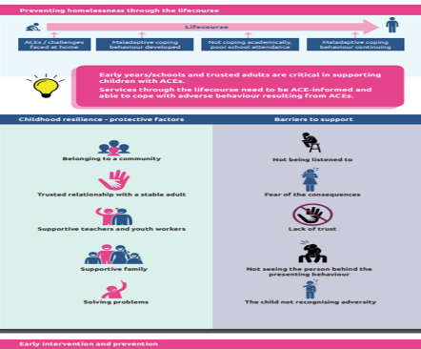
(Public Health Wales NHS Wales, 2022).

Conclusion
It is clear from evidence that some young people will find themselves homeless due to different factors such as family breakdowns, mental health problems, unemployment or low wages.
What also can be contributing factors to young people who find themselves homeless is if they have suffered one or more adverse childhood experience such as emotional or physical neglect as well as having to deal with their changes in their body through adolescence.
However there are some protective factors, such belonging to a community, a trusted relationship with a stable adult, supportive teachers, youth workers, and having a supportive family network.
To conclude, it is evident that homelessness is a concern right throughout the Country therefore professional agencies and bodies along with the Government need to continue in their efforts to eradicate this by adhering to the Strategy for Preventing and Ending Homelessness set by the Welsh Government in 2019.

References
Action for Children. (2022). What is the extent of youth homelessness in the UK? (online) Available at: https://www.actionforchildren.org.uk/blog/what-is-the-extent-of-youth-homelessness-in-the-uk/#:~:text=Homelessness%20negatively%20impact%20the%20lives%20of%20young%20people%2C,need%20to%20guide%20and%20mentor%20them%20through%20life. (Accessed 23 February 2022).

Assets.publishing.service.gov.uk. (2022). (online) Available at: https://assets.publishing.service.gov.uk/government/uploads/system/uploads/attachment_data/file/277593/What_works_to_improve_wellbeing.pdf. (Accessed 24 March 2022).

Cwvys.org.uk. (2022). Youth Work In Wales. (online) Available at: https://www.cwvys.org.uk/wp-content/uploads/2018/11/YOUTH-WORK-IN-WALES-PRINCIPLES-AND-PURPOSES.pdf. (Accessed 24 March 2022).

GOV.UK. (2022). Early adolescence: applying All Our Health. (online) Available at: <ttps://www.gov.uk/government/publications/early-adolescence-applying-all-our-health/early-adolescence-applying-all-our-health. (Accessed 22 March 2022).

GOV.UK. (2022). Homelessness data: notes and definitions. (online) Available at: https://www.gov.uk/guidance/homelessness-data-notes-and-definitions. (Accessed 23 February 2022).

Gov.wales. (2022). Social services and Well-being Wales Act 2014. (online) Available at: https://gov.wales/sites/default/files/publications/2019-05/social-services-and-well-being-wales-act-2014-the-essentials.pdf#:~:text=The%20Social%20Services%20and%20Well-being%20%28Wales%29%20Act%20changes,partner%20New%20proportionate%20assessment%20focuses%20on%20the%20individual. (Accessed 24 March 2022).

Public Health Wales NHS Wales. (2022). Voices of those with lived experiences of homelessness and adversity in Wales: Informing prevention and response 2019. (online) Available at: https://publichealthwales.nhs.wales/files/aces/voices-of-those-with-lived-experiences-of-homelessness-and-adversity-in-wales-informing-prevention-and-response-2019/. (Accessed 22 March 2022).

Royal Manchester Children's Hospital. (2022). Adverse Childhood Experiences (ACEs) and Attachment - Royal Manchester Children's Hospital. (online) Available at: https://mft.nhs.uk/rmch/services/camhs/young-people/adverse-childhood-experiences-aces-and-attachment/. (Accessed 23 February 2022).

