Database module assignment
Name: Ethan Colbeck 2007076
Date submitted : 4th May 2021

Context diagram
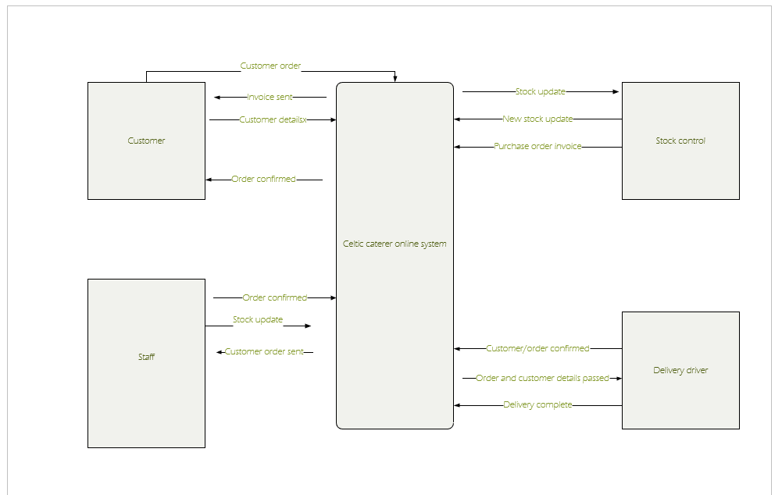
Level 0 DFD
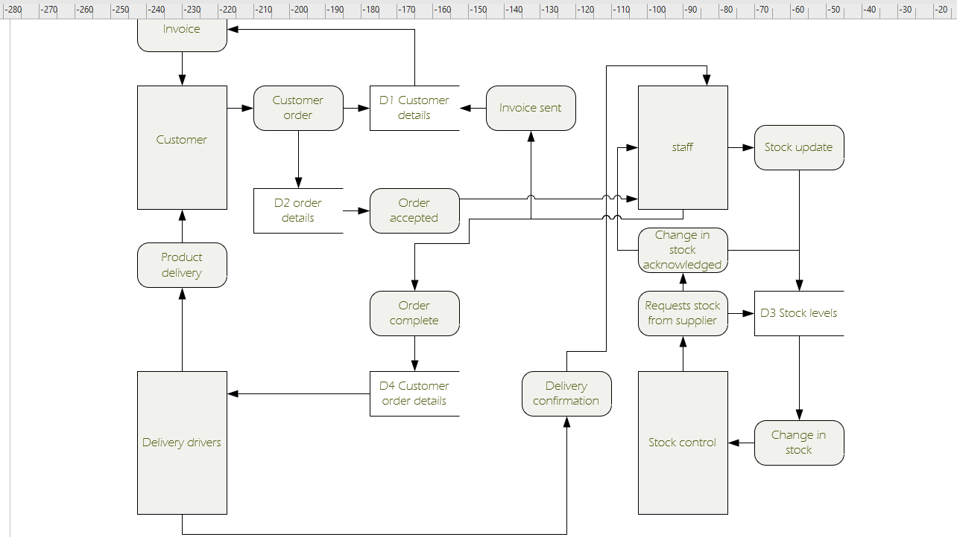

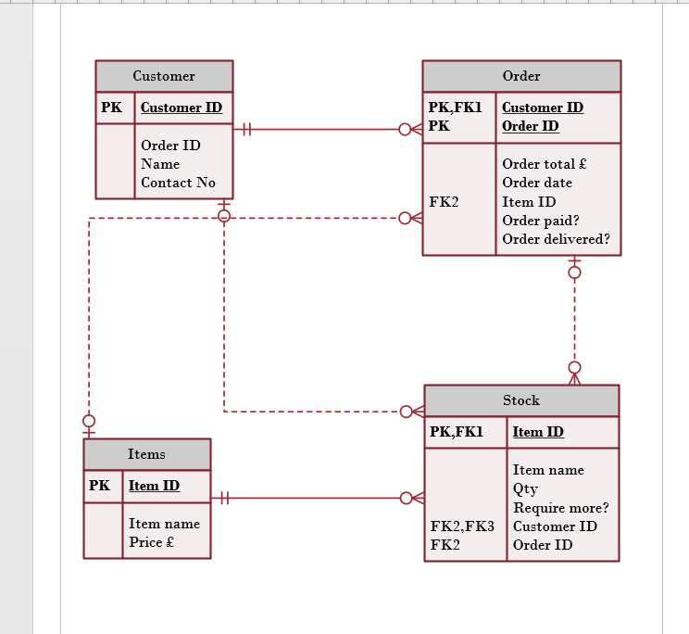
Entity relationship diagram within Visio based off my ERD in Access as shown below:
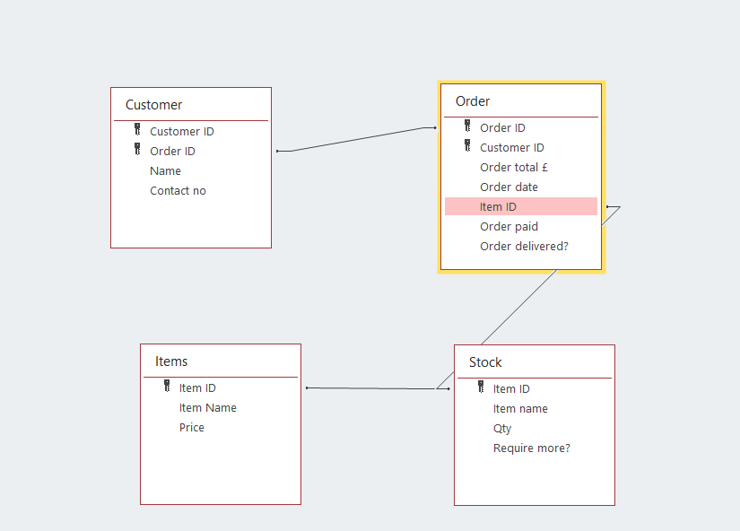

Reports
- Customer report
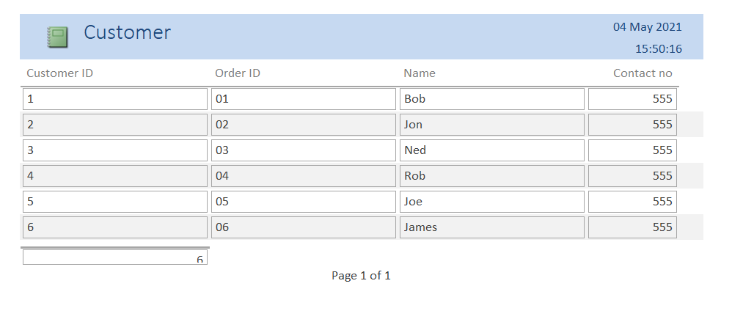

2. Items report
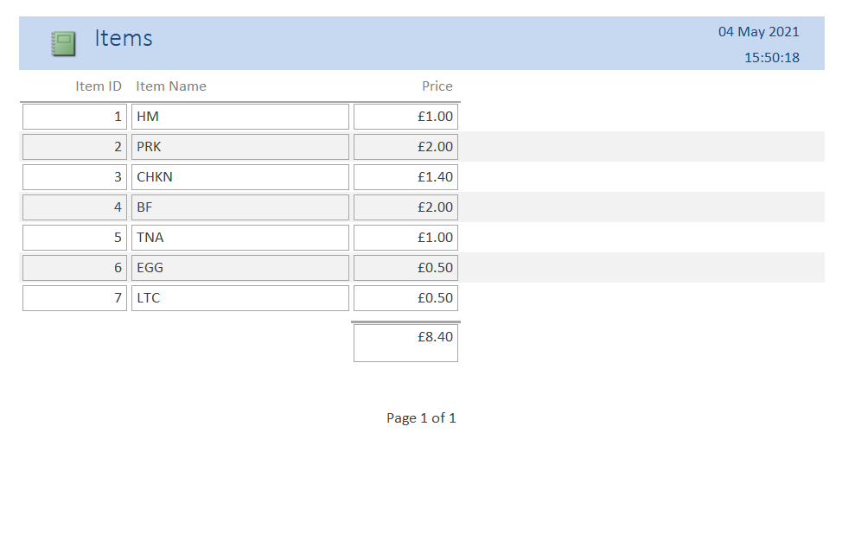
3. Orders report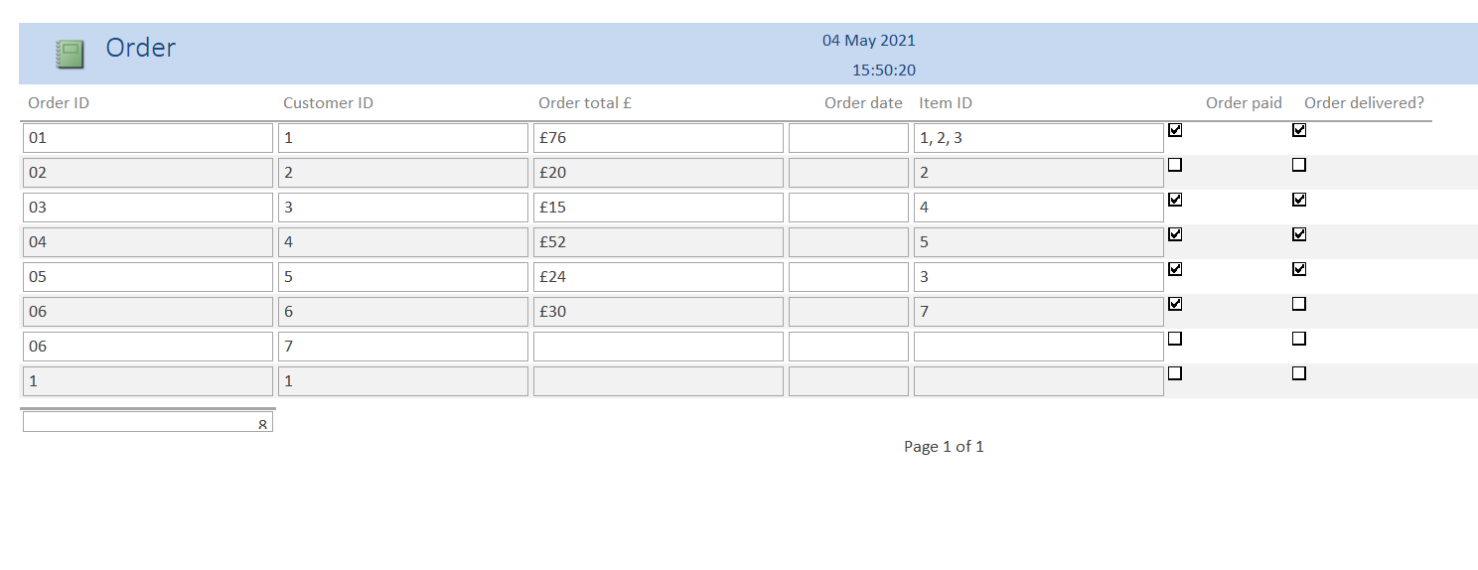

4. Stock report
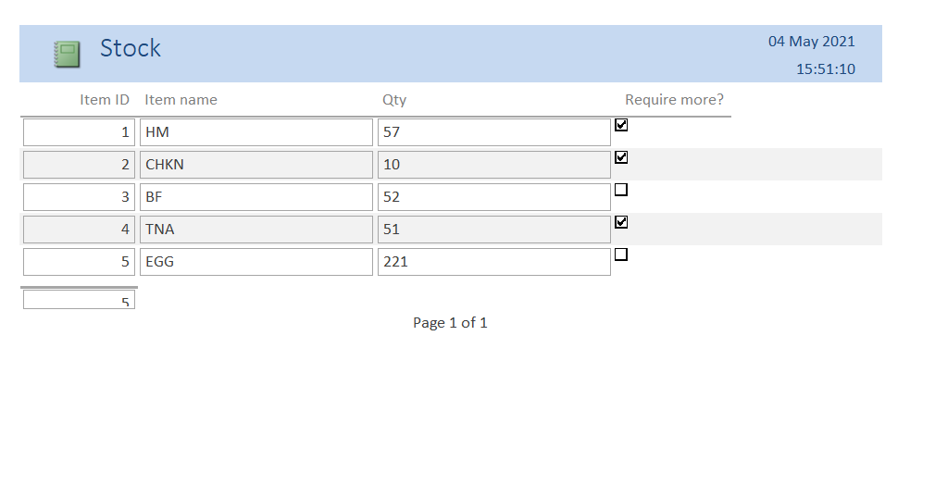
Forms
Main menu
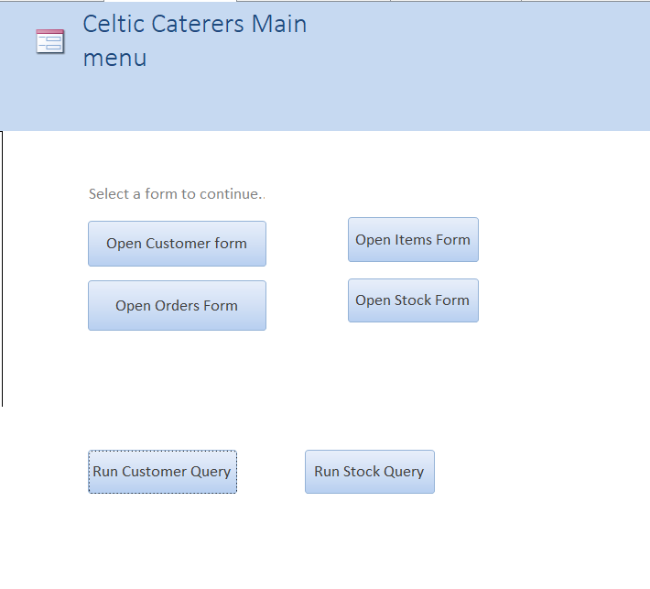
The main menu presents options to open all forms and run several queries.

Customer form, note all subforms have the same macros of cycling through each form, recording new forms, saving, deleting, opening the relevant report and printing the report.
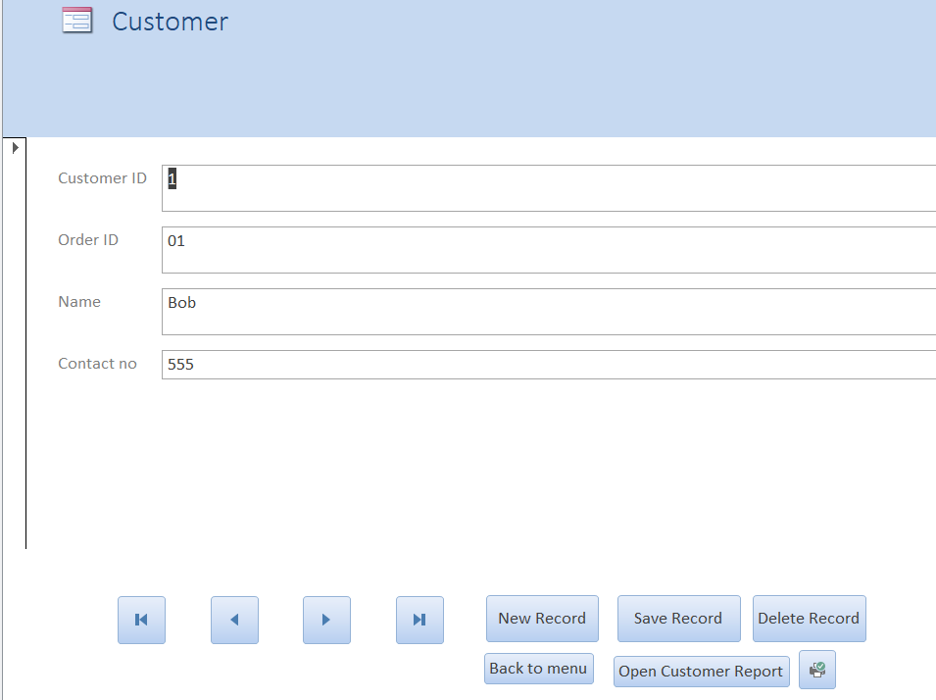

Orders form
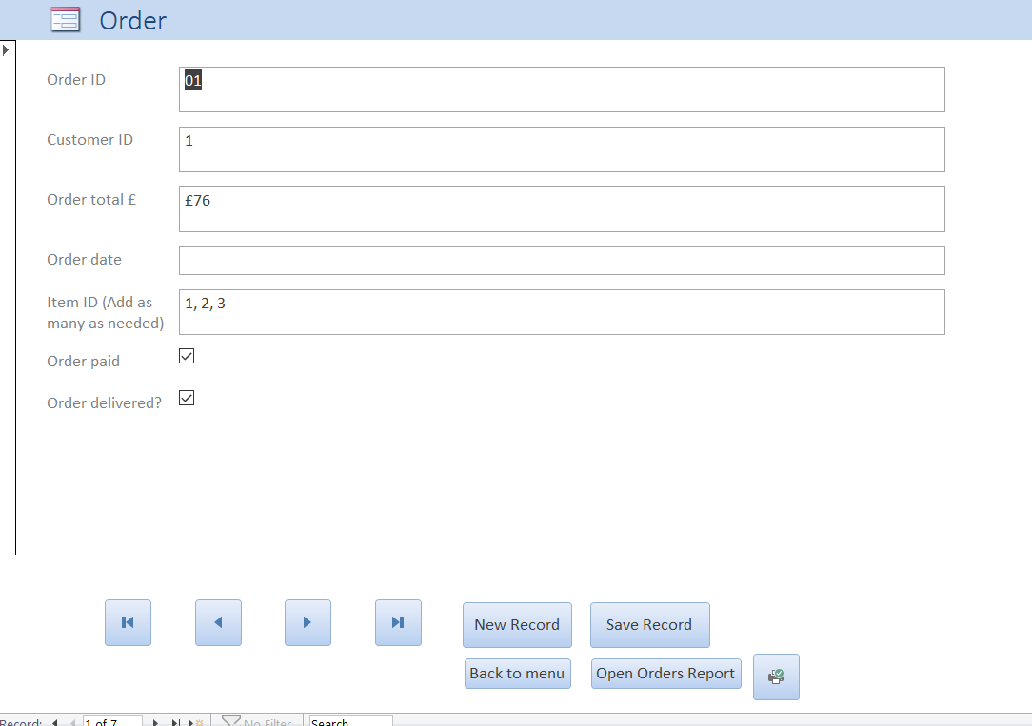
Stock form
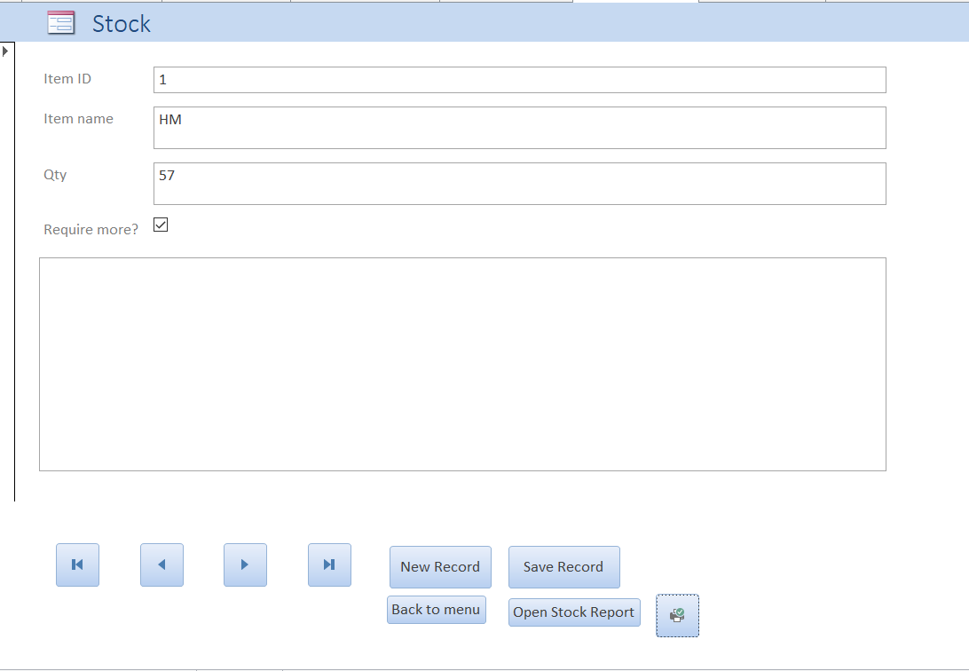
Items form
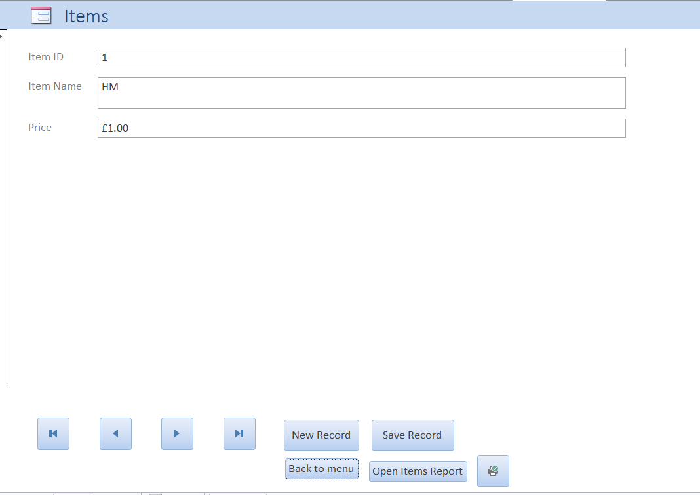
Brief user guide
The forms all interlink with macros connecting one another, and within each subform after the Main Menu is the option to open the relevant report, the printer logo is to print the specific report, and each form has the ability to add and save records.

