

University of Wales Trinity Saint David

Level 7 Assessment

Programme: MSc Advanced Manufacturing (Industry 4.0)

Module: Advanced Industry 4.0

Module Code: ACPA7000

Assignment Title: Assessment 2

Author: Mike Davies

Student Number: 213189

Submission Date: May 2023

Assignment Task
Produce a written piece of work that investigates current manufacturing systems evaluating their effectiveness at an abstract level. Identify the possible areas in which new and emerging technologies may be utilised to adapt these processes and practices. Provide a detailed analysis of the current technological factors that afford beneficial impact in addition to any humanistic or environmental implications of such adoptions. The use of a case study will provide an example of a manufacturing system for analysis purposes in addition to better illustrating some of the more unique problems that may be encountered and resolved with the employment of emergent technology.

Abstract
Introduction of Industry 4.0 Technologies in a Tier one Automotive Supply company
Industry 4.0 is a term used to describe the fourth industrial revolution, which is characterized by the use of advanced technologies such as: -
Artificial Intelligence and Machine Learning
Robotics
Industrial Internet of Things (IIoT)
Additive Manufacturing
Simulation Technologies (Digital Twins)
Big Data Analytics
Blockchain protocols
Cloud computing
IT—OT convergence
Augmented & virtual reality.

This report contains an evaluation of the introduction of industry 4.0 technologies into an automotive industry tier one manufacturing supplier, it is including a case study detailing the replacement of a manual measurements process with an automated in line measurement system at Marelli Automotive systems Llanelli plant. The report also studies the implications of the introduction of industry 4.0 technologies in general and concludes by outlining the benefits and drawbacks from a cultural and workforce viewpoint.
Marelli Llanelli plant is a long establish automotive supplier producing thermal heat exchange system products, namely Radiators, Air condition automotive condensers and charge air coolers, which are normal combined into cooling modules. Marelli Llanelli plant supply all the UK automotive OEM manufacturers and many of the big European automotive OEM manufacturers.

Description | Page No.
Title Page | 1
Assignment Task | 2
Abstract | 3
Contents Page | 4
Introduction | 5
Industry 4.0 introduction Case Study | 6
Benefits and Drawbacks of industry 4 Technologies  Conclusion | 15  23
List of Figures | 25
Reference List | 27

Introduction:
Industry 4.0 in the Automotive Industry
Industry 4.0 has led to many improvements within the automotive industry. It has enhanced production methods and reduced production lead times during the manufacturing process, allowing for greater flexibility to respond to changes in market and customer demands. These vehicles also benefit the end user by being more efficient and cost effective. (Deloitte Insights, 2020)
The key Industry 4.0 drivers in the automotive industry are the automation of technologies, such as robotics, smart sensors and artificial intelligence, which enable manufacturers to streamline production and reduce errors. (Dutt et al, 2021) Also, the introduction of Industrial Internet of Things sensing devices has allowed for increased connectivity between equipment giving access to real-time data analysis. (Deloitte Insights, 2020)
These technologies have led to improvements in all aspects of the automotive industry, including design and development, supply chain management and the manufacturing processes. Resulting in an enhanced vehicle performance, monitoring and a better driver experience. The integration of Big Data analytics and cloud computing has allowed the automotive industry to collect, store and analyse large amounts of data from various sources. (Alsen et al 2017)
This has led to new opportunities for predictive maintenance, real-time quality control monitoring and the creation of personalized products. In addition, the use of Simulation techniques (digital twins) and 3D scanning, and additive manufacturing techniques has allowed for more accurate designs, better quality and faster product development and prototyping in the automotive industry. (Lee, 2019). Figure 1 shows the various industry 4.0 technologies and the benefits derived from their use in the automotive industry.
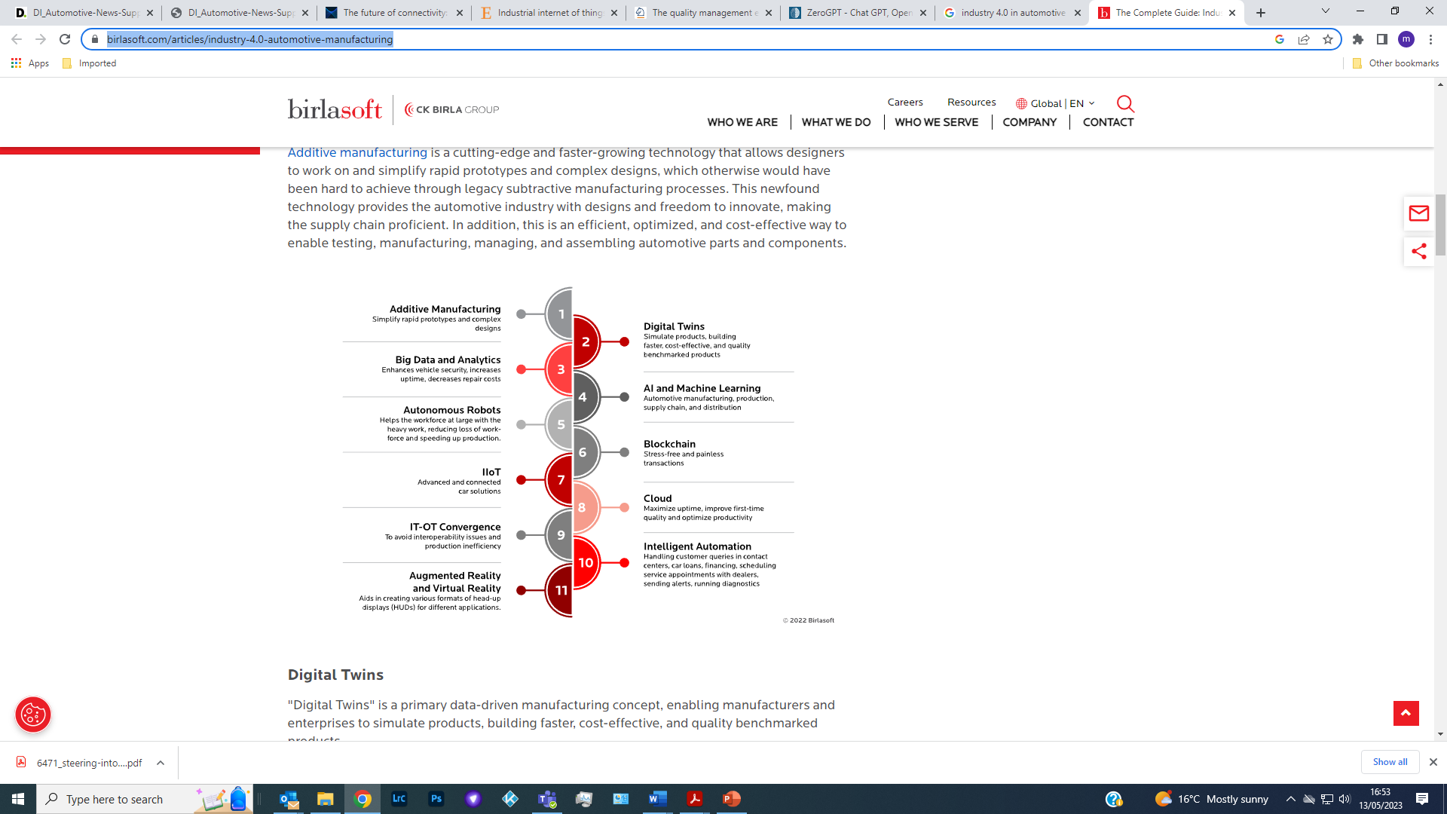
Fig 1(birlasoft, 2022)
Industry 4.0 introduction Case Study
This case study involves improvement to the manufacturing process of a car radiator by introducing an automated measurement system to replace the current manual measurement system. For great understanding and clarity to the reader a brief description of the manufacturing process in making a radiator is given below, followed by an explanation of the manual component measurement method currently in use and then an outline of the improvement automated in line measurement system. The associated cost justification presented to the management is also shown, with the calculated payback and net present value indices.
How a car radiator is made.
A car radiator is made in three stages: -
- Core manufacture, where aluminium raw materials in the form of thin coils or components are assembled into a ‘Core’ and held in clamp until brazed. There is a dedicated machine used to manufacture the radiator core using aluminium coils to produce the airway or fin and also forming aluminium coil into the tube components, which are sequenced to build the basic core. Aluminium pressed components in the form of tube plates and side casing are fitted to the basic core prior to a clamp being fitted to complete the core assembly.

- The clamped core assembly is then brazed in a furnace- taking the aluminium core assembly to just below their base metal melting point, then rapidly cooled to allow melted braze layers (thin coating on either side of the base metal) on components to solidify.

- After cooling a rubber seal and plastic tank are fitted using a clenching technique, the completed radiator is then leak tested to confirm there are no leaks.

Fig 2 shows the construction of a typical car radiator.
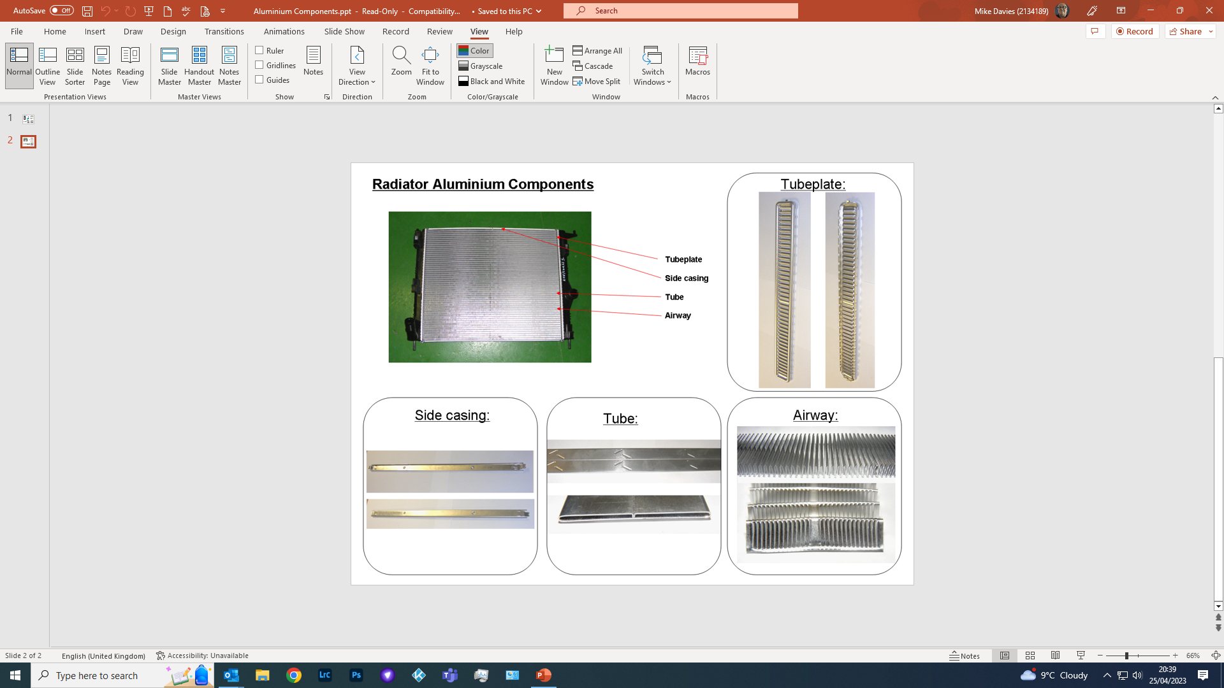
Fig. 2 (Marelli 2020).

In this activity we are looking at the manufacturing process to make the airway
The current process to manufacture the Airway is to cut louvre angle at a set angle (24 ° ± 2°) as shown on the example airway drawing shown in Fig 3

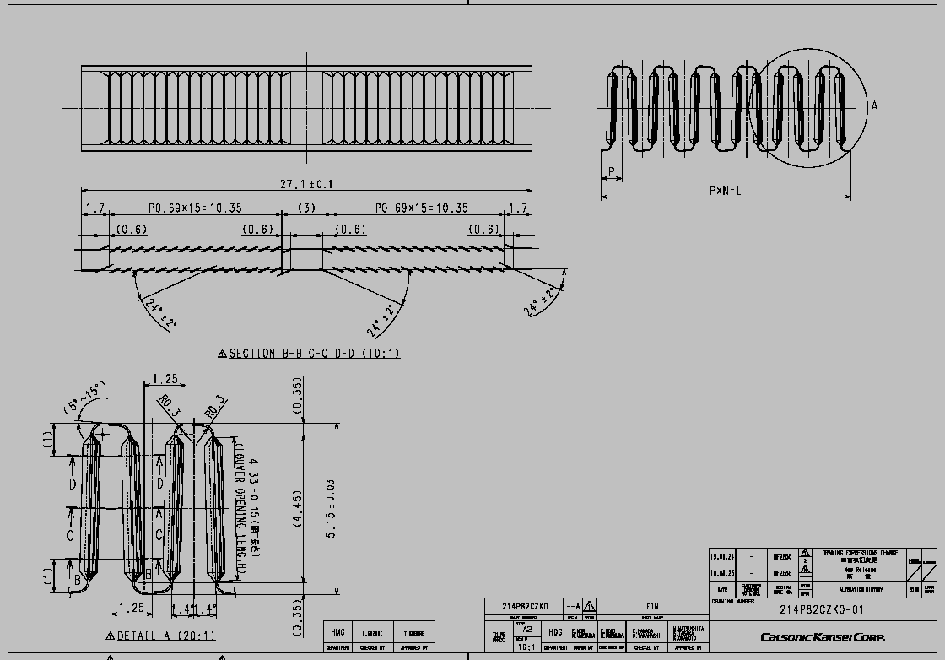
Fig 3 (Marelli 2020).
After the louvres a have been cut the airway is formed into the correct profile and height.
And then cut to the correct length.

If the airway height is too high it will cause the airways to be crushed in the core and the core would be rejected as a defect and if the airway is too low the airways will not bound to the tubes during the brazing process and the core would be rejected as a defect, so controlled the height of the core is a critical step in the manufacturing process The traditional way of measuring the airway height is for the operator to use dial test indicator to manually measure the airway height and record the reading on the control document.

The current process consists of the following process steps: -

- At start of production, samples are diverted to a dedicated area on the airway machine to enable first off measurement.
- These samples are then collected and transported to the designated quality control station.
- A Dial Test Indicator is used to measure the airway height (See figures 4 to 6 [ extract from MLUK SOS 1214 -name for internal operator instructions]).
- The observed height is written on a unique Quality Control Record Sheet, which references the correct tolerance limits.
- If the airway is within tolerance, the production run is started; otherwise, the airway height is adjusted.

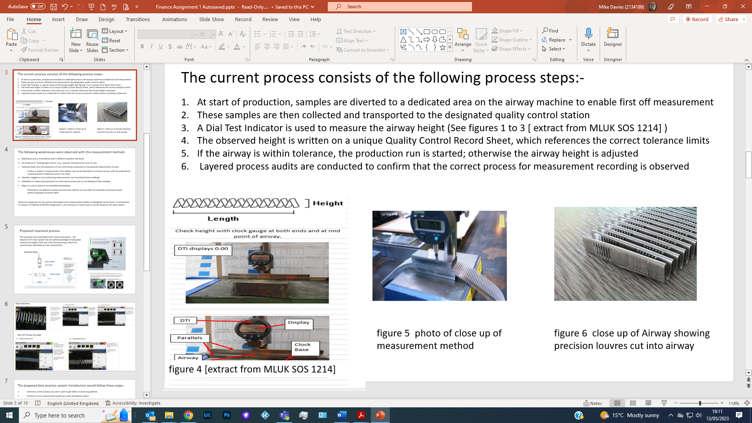

The raw material coils for the airways run for approximately 90 minutes before they run out and need to be replaced, so at the start of a shift and at every coil change the airway height measurement needs to be recorded. The airways made during the measurement process are rejected until a within specification airway height is recorded on the record sheet, which takes approximately 5 minutes.

The following weaknesses were observed with the traditional measurement method: -

- Reading accuracy inconsistency due to different operator skill levels

- No evidence of “reading data control” (e.g., operator zeroing the DTI prior to use)

- Potential delay from the production of non-conforming component to the physical measurement of parts.
If there is a delay in measurement, then defects may not be identified in a timely manner, with the potential for excessive levels of defective parts to be made.

- Operator negligence (not conducting measurements, but recording factious readings)

- Calibration of measuring equipment to confirmed accuracy prior to use leading to false readings.

- Major on cost of rejects if not identified immediately.

Potential to use defective airways and only then identify an issue after the assembly and braze process (several upstream processes later).

The manual measurement process and reject airways manufactured during the measurement process have been costed to have an annual cost of £4913.42.
Research was conducted for suitable automated measurement systems.
Two companies were consistently identified as supplying the most relevant equipment- Omron and Keyence.
Both companies supplied inline measurement equipment capable of fulfilling the brief of this task, but after several Microsoft teams meetings to discuss the system applications, it was decided that the in-line measurement system offered by Keyence was the most suitable for our application.

Proposed improved process.
The proposed new automated inline measuring system – the Keyence CVX vision system has the added advantage of being able to measure the angle of the top of the former airway, which has recently been identified as a key characteristic (Figures 7 & 8 show new system).

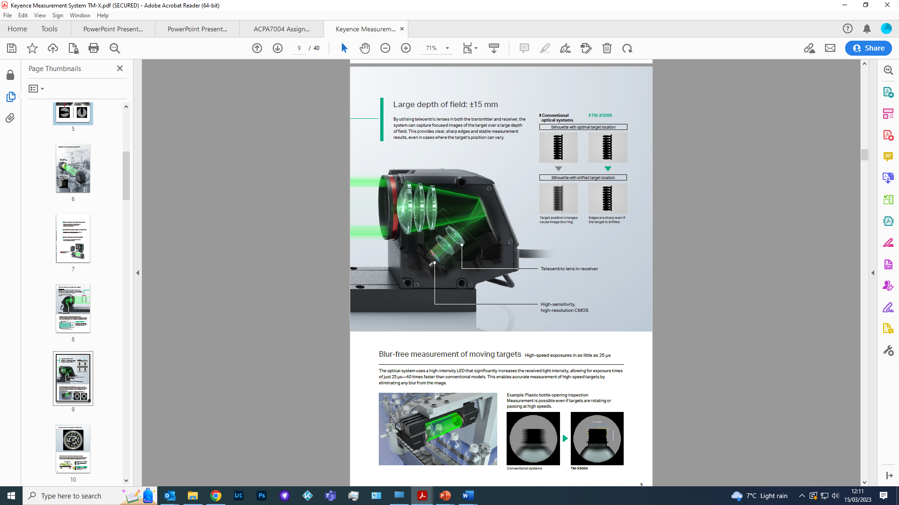
Fig 7 (Keyence 2023)
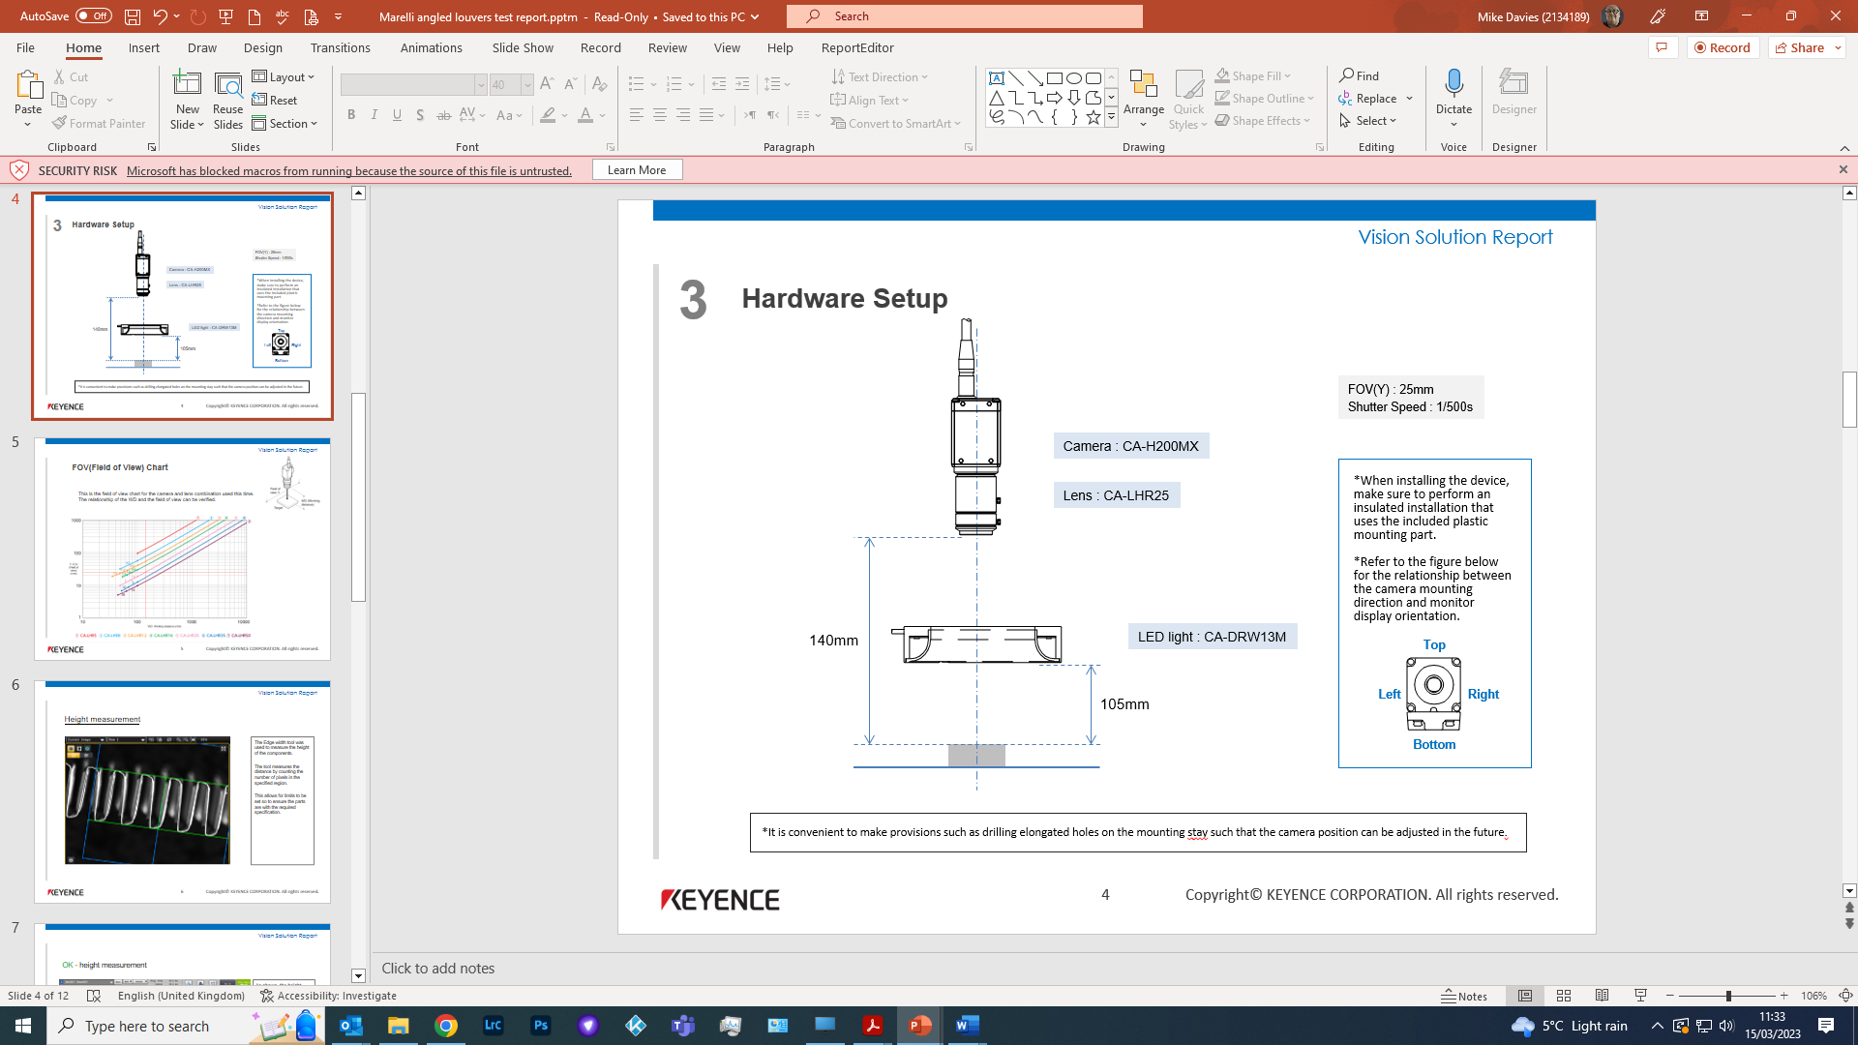
Fig 8 (Keyence 2023)

Measurement trials were undertaken with airway samples taken to the Keyence UK headquarters, so various measurement system configurations could be trialled with photographs being taken of the measurement results.

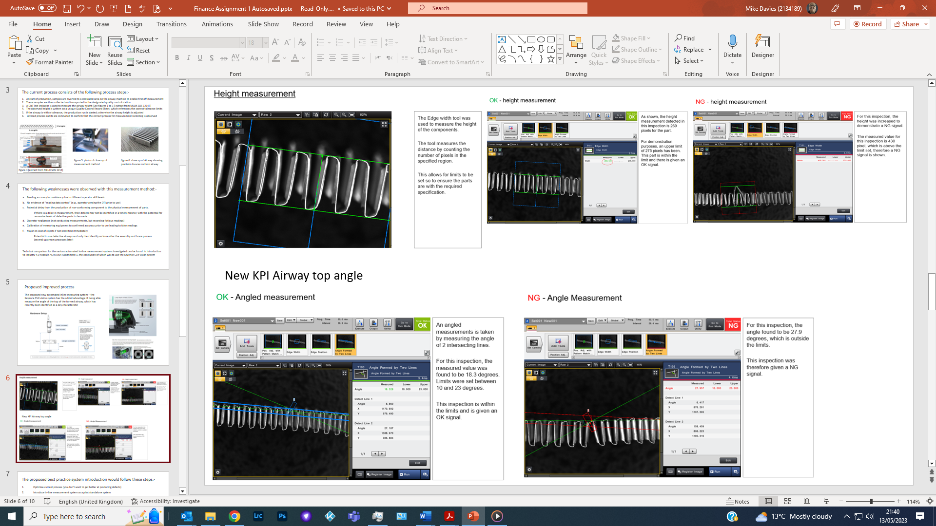

Fig 9 (Keyence 2023)

The proposed best practice system introduction would follow these steps: -

1. Optimise current process (you don’t want to get better at producing defects)
2. Introduce in-line measurement system as a pilot standalone system
3. Analyse data to set up predictive maintenance markers
4. Network to maintenance MP2 system to automate predictive maintenance flags
5. Introduce in-line measurement systems on additional core build machines
6. Network all measurement systems to conduct trend analysis on the factory as a
system.

The Finance benefits to the proposed new process
New system costs - Keyence £14,224.80 Marelli Installation & misc. costs £775.20 Total New system Cost £15,000
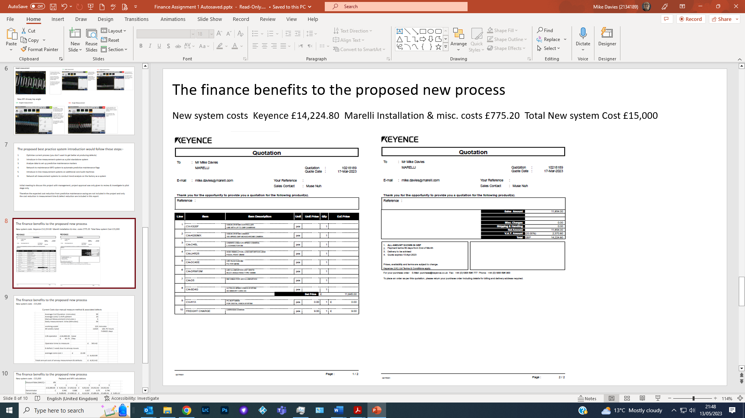
Fig 10 (Keyence, 2023)

Current Costings with the manual measure method & associated defects


The Finance benefits to the proposed new process
New system costs £15,000 Payback and NPV calculations

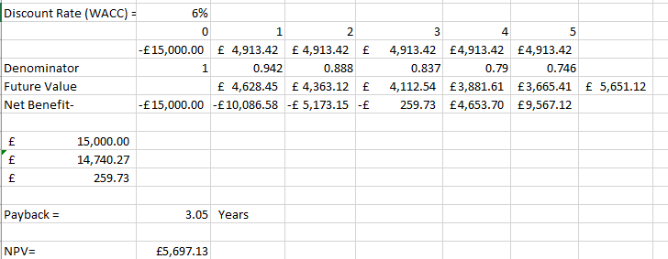
Fig 11 (Marelli, 2023)
Justification of the financial viability of this project used the accounting indices of payback, which is the Length of time it takes for the project to repay the original investment costs and net present value (NVP), which takes into account the changing value of money over time. Different funding sources were reviewed but Marelli Management have stated during project review funding would use Marelli Capex to finance this project, so other funding sources were not investigated.
Greater cost savings would be available to the company if a program was introduced that the measurement systems be fitted onto all core-build machines within Marelli Llanelli plant. This then would allow for networking of the measurement system data and big data analysis to be undertaken, which would not only introduce proactive maintenance capabilities, but linking this to machine learning or Artificial Intelligence applications to use predictive maintenance capabilities.

The difference in maintenance models and the effect on Overall Equipment Effectiveness (OEE) are shown in Fig 12
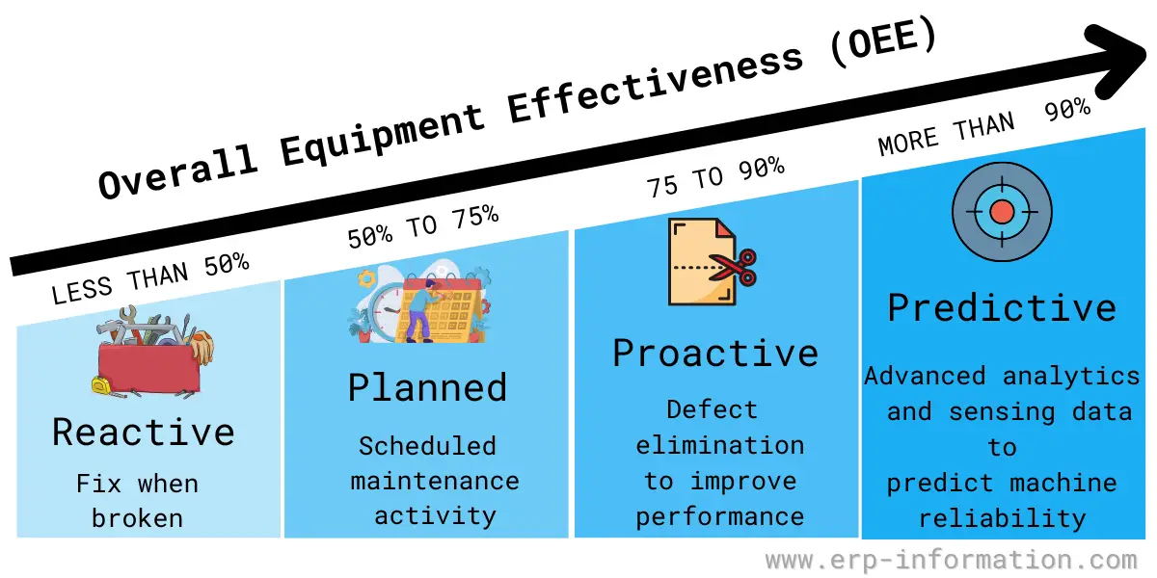
Fig 12 (erp-information.com, 2023).
Although this Case study covers the introduction of an automated measuring system, that eliminates human error risks, whilst improving the process productivity, by increased throughput and reduced defects, there are negative effects to the introduction of industry 4.0 technologies, which brings in new challenges with participant/ end user interactions and acceptance and also the requirements for new control methods, to ensure product and services quality, security and safety.
There are many published articles outlining the benefits of industry 4.0 technologies, but during this research there was limited information reviewing the drawbacks of introducing industry 4.0 technologies..
From this research the greatest risks associated with the introduction of industry 4.0 technologies can be generally grouped in to 2 groups.
- Cybersecurity of the data generated by the industry 4.0 technologies.
- Acceptance of industry 4.0 new technologies by users or participants
These risk areas as related to the automotive industry are reviewed in greater depth in the next section of this report.
- Cybersecurity
The risks associated with cybercrimes greatly increases, with cyber criminals seeking to exploit human or security vulnerabilities to steal passwords, data or money directly, or by the use of ransomware, denying access to resources, until a ransom payment has been made to remove it. There are also malicious system attacks, which are aimed at destroying or corrupting data as to render the digital systems inoperable or unreliable. (CrowdStrike, 2022)
In the automotive industry the industry 4.0 technologies have been given the broad term of the four ACES disruptions –
Autonomous driving,
Connected cars,
Electric vehicles,
Shared mobility.
These ACES disruptions all use computer software and hard, which is of risk to cyber-attacks,
2 difference sources of cyberattacks have been identified that need to be considered to ensure vehicle owner safety. (McKinsey, 2019)
- Cyber threats during the vehicle manufacturing process: -
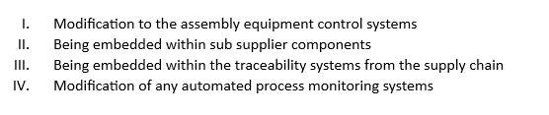
As shown if Figure 13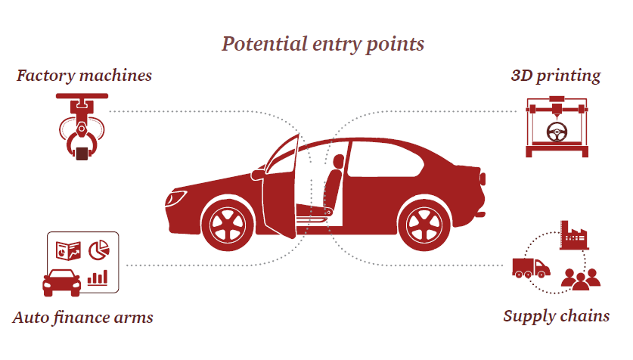
Fig. 13 (PwC, 2018)
- Cyber threats to vehicles
Every new model launched increases the cyber security threat, increased complexity and connectivity increases the software vulnerabilities and with the new standard for over the air (OTA) updates of software, cybersecurity becomes the priority for vehicle safety & security, and as vehicles on board electronic systems become smarter, with enhanced functionality the new cyber threats evolve with these advances. (ITU, 2017). Figure 14 highlights the area already targeted by cyber criminals

Fig. 14 (ITU, 2017)

Cyber threats will increase as the ACES disruptor technologies advance, and it is predicted by 2030 the cost of the electronic within a vehicle will be 50% of the total cost. As shown in figure 15.
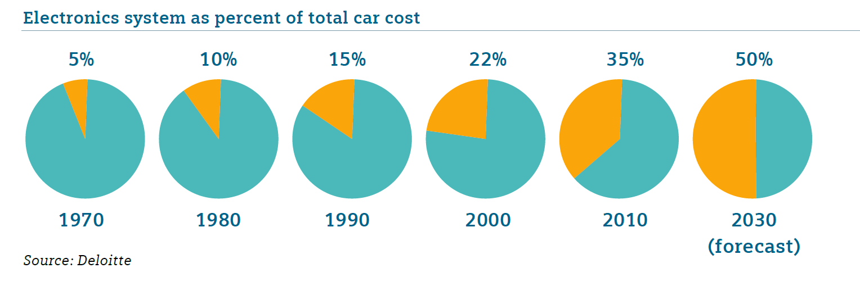
Fig. 15 (Shale-Hester 2020)

New cybersecurity standards are being released and updated for vehicle safety.

“The key principles of vehicle cyber security for connected and automated vehicles” is a guideline published by the UK government. Which identifies eight principles to improve vehicle cybersecurity for ACES technologies in vehicles”. These apply throughout the manufacturing supply chain, from designers and engineers, all the way up to senior-level executives. (Gov.UK 2017)

Whilst the United States of Americas’ National Institute of Standards and Technology (NIST) regularly release reports covering cybersecurity for various business sectors with the Core Functions of the NIST Cybersecurity Framework being categorised as: -
Identify,
Protect,
Detect,
Respond and Recover

There are many additional cybersecurity Frameworks and Models available giving latest status an advice, (following list reviewed during report investigation, but is not exhaustive)
• IIoT Consortium’s Security Maturity Model
• MITRE ATT&CK.
• ISO 27000 and IEC 62443.
• UK’s Cyber Assessment Framework (CAF)
• Cybersecurity Maturity Capability Model (C2M2)

As Tom Alrich, Automotive supply chain cybersecurity consultant explains.
“Software nowadays is pretty much made up of components. 90% of the code that's in software, the code, was not written by the company you bought it from. It was written by third parties, sometimes commercial, oftentimes open source. So, you can say that the software developer nowadays doesn't really write software, they put some glue to put the components together, and that's their product.”
(Aldrich, 2022).

Also, Felipe Fernandes, Cyber Security Manager at Jaguar Land Rover states
“If you think about a tech company like Google – Android can carry thousands of vulnerabilities. Sometimes it can have big problems if it exposes user data, but you.
are not going to kill someone because of one vulnerability.
Our environment is a little different. We are developing products that are going to be on the streets, at a speed that is not so low – so the mindset is different”.
(Fernandes, 2022).

And in executive interviews conducted by deloittes insight series blog
GM’s Jeff Massimilla stated.
“The success of the interconnected automotive ecosystem may hinge on cybersecurity.”
(Massimilla, 2019).

Whilst GM’s Kevin Tierney stated
“Cyber risk tends to lurk in the nuts and bolts of the electrical system and software. Therefore, it’s critical that we remain vigilant for cyber threats not only across the industry, but also at a very granular level among our tier 2 and tier 3 suppliers.”
(Tierney K., 2020).

In the 2021 Reith Lectures
Professor Stuart Russell - Living with Artificial Intelligence lecture outlines the issue of cyber-attacks on artificial intelligence referencing the issue of the vulnerability of programming autonomous vehicles.
(Russell 2021)

All these industry leaders have identified the risk of cyber threats and vulnerabilities within vehicle systems and there is evidence of cyberattacks via the following vehicle systems.

• Attacking device via WiFi
• Attacking device via Bluetooth
• Attacking device via media player/USB
• Attacking device via CAN/UDS
• Attacking device via Internet connection
• Attacking device via CarPlay /MirrorLink /Android Auto
• Attacking device via Internet Browser
• Attacking device via physical interfaces + bootloader
• Attacking device via update procedure (OTA)
• Attacking device via web administration system
• Finding Local Privilege Escalation misconfigurations (forcing default resets)
• Finding outdated/vulnerable components (libraries, etc.)
Have already been reported. A recent2020 study by the Ponemon Institute found that the average cost of a data breach is now $3.92 million.

2. Acceptance of industry 4.0 new technologies by users or participants
Industry 4.0 technologies bring issues during introduction, adapting industry 4.0 technologies needs to be accepted by end users for the full benefit and improvements of the new technologies to be achieved.
BDO research identifies some of the common problems to industry 4.0 technologies introduction:
- lack of skills or talent to manage complex Industry 4.0 structures.
- concerns regarding cyber security
- other priorities for capital expenditure
- lack of appropriate digital infrastructure
- lack of knowledge of digitalisation and how it can help the business.
(BDO, 2019)

The resistance to change has a long history, and there are many publish articles covering the resistance to change and the cultural aspects of change, which are relevant to this research.
it became apparent that the degree of involvement with the technology was related to the enthusiasm shown to the innovation being adopted, and also the stakeholders’ physical interactions with the new technologies, as shown the apprehension stated by some shop floor operators with the ideas of working in close proximity to cobots, especially in industries where robotic arms are already in use, having a caged off working envelop.(Davies, 2023)
but the biggest concern about the introduction of Industry 4.0 technologies, is it could lead to widespread job losses. As machines and robots become more sophisticated, they will be able to perform many jobs currently done by humans. This could lead to mass unemployment, particularly in manufacturing and other industries currently are reliant on manual labour.
Another potential negative impact of Industry 4.0 is that it could lead to increased inequality. As automation takes over more jobs, the gap between the rich and the poor is likely to widen. This is because the wealthy will be able to benefit from the new technologies, while the poor will be left behind. This is true when considering multinational companies in comparison to SMEs.
The loss of privacy should also be considered with Industry 4.0 technologies. As machines and robots become more interconnected, they will be able to collect and store vast amounts of data about our lives. This data could be used to track our movements, monitor our health, and even predict our behaviour. This could pose a serious threat to our privacy and our personal freedom. There are already major concerns about fake news & deep fake news and deep fake video circulating on the internet.
There are also reported case where these new technologies have been abused by companies’ management, with the technologies being misused to track and monitor employees.
There was also reported cases from the trade union representatives of abuse of new technologies, such as internet of things lone worker monitoring devices being used to track workers and monitor workers productivity, with the term ‘human robots’ being used to describe this situation in a recent court case. (Unite the Union, 2023)
Simon Thompson, Chief Executive of Royal Mail, was recalled by the UK Governments Business, Energy and Industrial Strategy Committee after doubts were raised over the accuracy of evidence he gave to MPs in January 2023, one of the items reported was the use of GPS devices to track and monitor postmen movements and speed of travel.
(UK Parliament, 2023).

With the issue outlined about the resistance to change the author believes that Greg Satell in his book Cascades: How to Create a Movement that Drives Transformational Change, where he references the actions of a war time underground resistance movement to the current employee resistance activities to new technology changes, the author believes this to be an extreme comparison, but it is recognised that controls need to be introduced to control and limit these technologies on a global scale, as there will always be cases of rogue states abusing set norms, (Russell, 2021).
Industry 4.0 technologies, such as artificial intelligence, robotics, and the Internet of Things (IoT), have the potential to revolutionize manufacturing and other industries. However, there are also some environmental concerns associated with these technologies.
The identified environmental disadvantages of Industry 4.0 technologies include:
- Increased energy consumption: The use of IoT devices and AI algorithms can lead to increased energy consumption. For example, a study by the World Economic Forum found that the use of IoT devices could increase global energy consumption by 20% by 2025.
- Increased waste: The production and disposal of Industry 4.0 technologies can generate a significant amount of waste. For example, the production of a single smartphone requires the use of up to 60 different minerals, including rare earth metals. Additionally, the disposal of these devices can be difficult and harmful to the environment.
(World Economic Forum, 2022)

With recent advances in artificial intelligence and the production of deep fake videos, it is becoming more difficult to distinguish between genuine or fake news or data sets.
In addition to the issues of Jobs losses & privacy already discussed there are the additional dangers of bias, as AI systems are trained on data that is collected from the real world. This data can be biased, and this bias can be reflected in the AI system's output. This could lead to discrimination against certain groups of people. As seen in recent legal cases in the United States of America about racial bias
- In 2016, Amazon's hiring algorithm was found to be biased against women. The algorithm was trained on a dataset of resumes that was heavily male-dominated, and as a result, it was more likely to recommend men for jobs. (Dastin, 2018)
- In 2019, a study found that facial recognition algorithms were more likely to misidentify black people than white people. The study found that this was due to the fact that the algorithms were trained on data sets that were heavily white dominated. (Najibi, 2020)
- In 2020, a study found that AI-powered medical algorithms were more likely to misdiagnose black patients than white patients. The study found that this was due to the fact that the algorithms were trained on data sets that were heavily white dominated. (Norori, Natalia et al. 2021)
AI could be used to develop autonomous weapons that could kill without human intervention. This could lead to a new arms race and a greater risk of war. There is also the risk of AI systems are becoming increasingly complex and difficult to understand. This could lead to a situation where we lose control of these systems, and they begin to make decisions that are harmful to us, (Russell, 2021).
An interesting consequence the author has identified is the use of digital twin technologies could have a profound effect on health & safety legislation in the UK, where the term ‘so far as is reasonably practicable’ is used to excuse companies from undertaking certain tasks or actions in their risk management evaluation. With digital twin technologies these risk assessments can be virtually conducted, therefore the use of this type of defence for not conducting through comprehensive risk assessments will not be viable in a court of law.

Conclusion
The adoption of Industry 4.0 technologies in manufacturing can bring several economic and societal benefits. As outlined in this report, these technologies can help to reduce operational costs, increase productivity, and improve product quality, which can ultimately lead to increased profitability for manufacturing companies. Additionally, the integration of these technologies can help to create new jobs in the field of technology and engineering.
However, there are also potential negative implications associated with the adoption of new technologies. The implementation of Industry 4.0 technologies requires a significant investment in technology, infrastructure, and human resources, which can be a barrier to entry for small and medium-sized enterprises (SMEs).
Here is a summary of the risks associated with the introduction of Industry 4.0 technologies:
Cybersecurity: The increasing connectivity of Industry 4.0 systems makes them more vulnerable to cyberattacks. This could lead to data breaches, system outages, and even physical damage.
Acceptance by users or participants: Some people may be reluctant to adopt new technologies, such as robots and artificial intelligence. This could slow down the adoption of Industry 4.0 technologies and limit their benefits.
Job losses: As machines and robots become more sophisticated, they are able to perform many jobs that are currently done by humans. This could lead to widespread job losses, particularly in manufacturing and other industries that are reliant on manual labour.
Increased inequality: As automation takes over more jobs, the gap between the rich and the poor is likely to widen. This is because the wealthy will be able to benefit from the new technologies, while the poor will be left behind.
Loss of privacy: As machines and robots become more interconnected, they will be able to collect and store vast amounts of data about our lives. This data could be used to track our movements, monitor our health, and even predict our behaviour. This could pose a serious threat to our privacy and our personal freedom.
Environmental impact: The increased use of energy and resources associated with Industry 4.0 could have a negative impact on the environment. For example, the use of IoT devices could lead to increased energy consumption.
These are just some of the risks associated with the introduction of Industry 4.0 technologies. It is important to be aware of these risks so that we can take steps to mitigate them. We need to invest in research and development to develop secure and reliable Industry 4.0 technologies. We also need to educate the public about the potential risks of these technologies and how to protect themselves. By taking these steps, we can help to ensure that Industry 4.0 technologies are used for good and not for harm.
Also in the UK digital twin technologies could have a profound effect on health & safety legislation in the UK, where the term ‘so far as is reasonably practicable’ is used to excuse companies from undertaking certain tasks or actions in their risk management evaluation. With digital twin technologies these risk assessments can be virtually conducted, therefore the use of this type of defence for not conducting through comprehensive risk assessments will not be viable in a court of law.

List of figures

Fig 1:
Industry 4.0 Automotive Manufacturing. (n.d.). Birlasoft website: Available from https://www.birlasoft.com/articles/industry-4.0-automotive-manufacturing. (Accessed 14 May 2023).

Fig 2:
Marelli Quality Manual – Product Catalogue. Radiator Assembly.

Fig 3:
Marelli Quality Manual – Product Catalogue. Example Airway Drawing.

Fig 4:
Marelli Standard Operation Sheet Database. [Extract from MLUK SOS 1214].

Fig 5:
Marelli Standard Operation Sheet Database. Photo of Close Up of Measurement Method.

Fig 6:
Marelli Standard Operation Sheet Database. Close Up of Airway Showing Precision Louvres Cut into Airway.

Fig 7:
Keyence. (2023.). Vision Systems Product Catalogue. Available from https://www.keyence.co.uk/landing/lpc/ppc_mb_iv3_vision-sensor.jsp?aw=googleUKinfo0200144&gad=1&gclid=CjwKCAjwjYKjBhB5EiwAiFdSfohH7aJsL4POZaQ9POs-gRDv3-mLXsvF-Pj4vTbso2Z2mdelN4XRwxoCO-AQAvD_BwE. . (Accessed 25 February 2023).
Fig 8:
Keyence. (2023). Vision Systems Product Catalogue. Schematic Diagram. Available from https://www.keyence.co.uk/landing/lpc/ppc_mb_iv3_vision-sensor.jsp?aw=googleUKinfo0200144&gad=1&gclid=CjwKCAjwjYKjBhB5EiwAiFdSfohH7aJsL4POZaQ9POs-gRDv3-mLXsvF-Pj4vTbso2Z2mdelN4XRwxoCO-AQAvD_BwE. (Accessed 25 February 2023).

Fig 9:
Marelli Quality Department vision system project proposal report. Marelli Llanelli Plant. Sample Images from Marelli Trial Report.

Fig 10:
Marelli Quality Department vision system project proposal report. Marelli Llanelli Plant. Keyence Quotation for Proposed Vision System.

Fig 11:
Marelli Quality Department vision system project proposal report. Marelli Llanelli Plant. Marelli Project Cost Justification Calculations.

Fig 12:
Types of Maintenance Effects of Equipment OEE. (n.d.). Retrieved from ERP Information website: available from https://www.erp-information.com/predictive-maintenance#Predictive_Maintenance_Definition Last updated on April 28, 2023, by Editorial Staff accessed (14 May 2023).

Fig 13:
PwC. (2018). Cyber Readiness: Are Auto Companies Prepared to Counter the Risk of an Attack? Available from www.pwc.com/automotive (Accessed 03 August 2022

Fig 14:
ITU. (2017). Security Aspects of Major Emerging Technologies Security Issues in Connected Car. Retrieved from Available from https://www.itu.int/en/ITU-D/Regional-Presence/CIS/Pages/EVENTS/2017/09_Tashkent (Accessed 27 July 2022)

Fig 15:
Shale-Hester, T. (2020, May 18). Electronics Make Up 40% of a New Car's Cost. Auto Express. Available from https://www.autoexpress.co.uk/news/352300/electronics-make-40-new-cars-cost (Accessed 25 July 2022)

References
- Aldrich, Thomas. "State of Automotive Cybersecurity 2022 - by Cybellum whitepaper." (2022). [Online] Available at: https://cybellum.com/resource/state-of-automotive-cybersecurity-2022/ (Accessed 03 September 2022).
- Alsen, Daniel, Mark Patel, and Jason Shangkuan. "The future of connectivity: Enabling the Internet of Things." McKinsey & Company (2017). Available from https://www.mckinsey.com/featured-insights/internet-of-things/our-insights/the-future-of-connectivity-enabling-the-internet-of-things (Accessed 21 April 2023)
- CrowdStrike. "The CrowdStrike 2022 Global Threat Report." (2022). Available from https://go.crowdstrike.com/global-threat-report-2022.html?utm_campaign=globalthreatreport&utm_content=crwd-laqu-en-x-tct-uki-psp-x-wht-gtre-x_x_x_x-x&utm_medium=sem&utm_source=goog&utm_term=cyber%20threats&gclid=Cj0KCQjwmZejBhC_ARIsAGhCqndqVkwRvR_nIYb4yHU2DMbu0W6E0RGu5cYBuhYuZvONtoSQ7jTIh_caAnh5EALw_wcB (Accessed 18 May 2023)
- BDO. "BDO DIGITAL TRANSFORMATION REPORT 2019." (2019). Available at https://www.bdo.co.uk/en-gb/manufacturing-digital-transformation-report (accessed 19 May 2023).
- Dastin, Jeffrey. "Amazon scraps secret AI recruiting tool that showed bias against women." Reuters (2018). Available from https://www.reuters.com/article/us-amazon-com-jobs-automation-insight/amazon-scraps-secret-ai-recruiting-tool-that-showed-bias-against-women-idUSKCN1MK08G (Accessed 17 May 2023).

- Deloitte Insight Automotive-News-Supplement (April 2020) https://www2.deloitte.com/content/dam/insights/us/articles/automotive-news_industry-4-0-in-automotive/DI_Automotive-News-Supplement.pdf April 2020 (Accessed 29 April 2023).

- Dutt, Debanjan, et al. "Steering into Industry 4.0 in the automotive sector." Deloitte Insights (2021). Available from https://www2.deloitte.com/us/en/insights/industry/automotive/industry-4-0-future-of-automotive-industry.html (Accessed 26 April 2023)
- Fernandes, Filipe. "State of Automotive Cybersecurity 2022 - by Cybellum whitepaper." (2022). [Online] Available at: https://cybellum.com/resource/state-of-automotive-cybersecurity-2022/ (Accessed 03 September 2022).
- Government of the United Kingdom. "The key principles of vehicle cyber security for connected and automated vehicles." (2017). Available from https://www.gov.uk/government/publications/principles-of-cyber-security-for-connected-and-automated-vehicles/the-key-principles-of-vehicle-cyber-security-for-connected-and-automated-vehicles (Accessed 18 May 2023)
- Lee, Sang M., DonHee Lee, and Youn Sung Kim. "The quality management ecosystem for predictive maintenance in the industry 4.0 era." International Journal of Quality Innovation 5.4 (2019): 1-11. Available at https://jqualityinnovation.springeropen.com/articles/10.1186/s40887-019-0029-5 (Accessed 10 May 2023)

- Massimilla, Jeff. "Cybersecurity in automotive industry: Jeff Massimilla interview." Deloitte Insights (2019). [Online] Available at: https://www2.deloitte.com/us/en/insights/topics/cyber-risk/cybersecurity-in-automotive-industry-jeff-massimilla-interview.html (Accessed 06 September 2022).

- Kotter, J (2011) HBR's 10 Must Reads on Change Management (including featured article "Leading Change," by John P. Kotter) Available from https://store.hbr.org/product/hbr-s-10-must-reads-on-change-management-including-featured-article-leading-change-by-john-p-kotter/12599?sku=12599E-KND-ENG. (Accessed 02 December 2022)
- Kotter, John P. "Leading change: A conversation with John P. Kotter." Strategy & Leadership 25.1 (1997): 18-23.
- McKinsey Center for Future Mobility. "The future of mobility is at our doorstep." (2020). Available fromhttps://www.mckinsey.com/~/media/McKinsey/Industries/Automotive%20and%20Assembly/Our%20Insights/The%20future%20of%20mobility%20is%20at%20our%20doorstep/The-future-of-mobility-is-at-our-doorstep.ashx accessed 15/05/2023 (Accessed 10 April 2023)
- Najibi, Alex. "Racial Discrimination in Face Recognition Technology." Harvard Science in the News (2020). available from https://sitn.hms.harvard.edu/flash/2020/racial-discrimination-in-face-recognition-technology/ (Accessed 02 May 2023)
- Norori, Natalia, et al. "Addressing bias in big data and AI for health care: A call for open science." Patterns 2.10 (2021): 100347.
- Ponemon Institute. "Why Ponemon Institute’s Cost of Data Breach Methodology Is Sound and Endures." (2020). available at https://www.ponemon.org/ (Accessed 05 May 2023)
- Russell, Stuart. "Living with artificial intelligence." Reith Lectures (2021). [on line] available at https://www.bbc.co.uk/programmes/articles/1N0w5NcK27Tt041LPVLZ51k/reith-lectures-2021-living-with-artificial-intelligence (Accessed 07 September 2022).
- Satell, Greg. Cascades: How to Create a Movement that Drives Transformational Change. McGraw Hill, 2019. Available from https://doi.org/10.48558/9KX0-4Z26. (Accessed 16 January 2023)
- Tierney, Kevin. "Building automotive cybersecurity: Kevin Tierney interview." Deloitte Insights (2020). [Online] Available at: https://www2.deloitte.com/us/en/insights/topics/cyber-risk/building-automotive-cybersecurity-interview-kevin-tierney.html (Accessed 06 September 2022).

- UK Parliament Business, Energy and Industrial Strategy Committee. "Committee recalls Royal Mail boss after claims of inaccurate testimony." (2023). Available from https://committees.parliament.uk/committee/365/business-energy-and-industrial-strategy-committee/news/175597/committee-recalls-royal-mail-boss-after-claims-of-inaccurate-testimony/#:~:text=Committee%20recalls%20Royal%20Mail%20boss%20after%20claims%20of%20inaccurate%20testimony,-24%20January%202023&text=Simon%20Thompson%2C%20Chief%20Executive%20of,gave%20to%20MPs%20last%20week. (Accessed 24 May 2023)

- World Economic Forum. "Digital solutions can reduce global emissions by up to 20%. Here’s how." (2022). Available from https://www.weforum.org/agenda/2022/05/how-digital-solutions-can-reduce-global-emissions/. (Accessed 21 May 2023)

