Name  Student ID Number | DEEPINDER SINGH  1813078
Module Title | EFFECTIVE TEAMWORK AND COMMUNICATION
Module | BMSK4002 LON
Word Count | 2000 |  |  | Date Submitted |  | 10/05/2019

INTRODUCTION
Effective teamwork and communication play an important role helping the business maintaining a positive working environment (Franz et al. 2018). However, at the same instant, if the working environment does lack an effective flow of communication and teamwork, then, management needs to face different issues such as unproductive outcomes delivered to their customers, conflict situations, employee absenteeism and many others. Hence, in the context of this assignment, it is required for focusing the significance of maintaining an effective teamwork along with communication in order to gain expected results from its workforce. However, for continuing with this report, an organization needs to focused particularly, in which some communication or teamwork issue have arisen. Hence, the concerned organization specifically for this assignment is Tesco, where, cultural issues have been identified in their workforce. Hence, the aim of this assignment is for first focusing the cultural issues identified in their workforce of Tesco plc, London, then, applications of different techniques, theories and models of communication and teamwork need to be utilized for mitigating the identified issue.
ISSUE IN THE WORKPLACE
Cooper (2016) stated that the while developing communications strategy, it is important for the organizations that they always need to lean towards the promotions and focus over positive communication. Although, there are some times found, which positive communication might be hard for coming by or might be difficult for implementing. Hence, it makes the same easy for the organizations for falling into default along with ineffective communications simply because the companies are used to. Hence, in the context of Tesco, the management recently has addressed few cultural issues, as diversity in the working culture of Tesco affects the workplace communication in a negative manner: it has been difficult for the concerned organization for managing and controlling the cultural clashes going-on in Tesco. Demir et al. (2016) stated that cultural issues occur due to various reasons, for instances, any conflict within the designation of the resources, creation of the uncertainty, friction & gossiping, lack of poor team work and collaboration and many others. Hence, in the context of Tesco, it has been identified that due to a cultural gap exists in the working culture of Tesco, management fails to engage their employees productively and effectively. Recently, the flow of communication within the workplace of Tesco is considered as poor along with ineffective, as the staff members of Tesco are less likely inclined for collaborating with each other. It has been assumed that ego of the employees working at different positions in Tesco has been take into consideration that lead to negative working culture across Tesco that results in poor teamwork, moreover, potentially, even frictions amongst the employees of Tesco (Tesco plc, 2019).
in accordance with Cardon ta al. (2015), ineffective and poor communication might result while gossiping along with rumors that then results in friction and tension within the workplace. Hence, in relation to working culture of Tesco, it has been found that management fails for addressing issues such as poor and ineffective communication, thus, developing communications strategy need to be pointless exercise as harmonious working relationship are the non-existent. In addition, the communication issues result in an unproductive working culture for the other employees who are considered as strong players for Tesco working culture as a negative one as rumors and gossiping builds animosity among the team-members along with colleagues. Therefore, Tesco has reached at that point , where, they need to face high rate of employee turnover and their productive players as leaving the organization make “Tesco” productivity and growth being declined at a face-pace as compared to its competitors. In addition, management of Tesco finds huge communication specifically over deadlines along with working processes, thus, team-leaders because of irresponsible approach of the team=members, lead to miscommunication on working processes and deadlines, are found to be confused and frustrated (Tesco et al, 2019). For instance, an employee of Tesco thinks that she is in-charge of completing a specific graph, whereas, all along, the expected task is already given to any other employees of the same group, which results in two different outputs, frustration, confusion along with lost opportunity towards further the progress associated with a specific project.
APPLICATION OF THEORIES IN RELATION TEAM WORKING AND COMMUNICATION WITHIN WORKPLACCE
Effective team work refers to the ability of incorporating strategies through which efficient execution of the tasks in relation to the achievement of organizational objectives is possible. The team working issues within any organizations are highly crucial (Cardon and Marshall, 2015).
However, issues are obvious that is found to create conflicts which are where team working is highly crucial.
in the context it is worth mentioning team working theories must be imbued within the manager of the organization in order to apply them within the workplace of Tesco. Clear concepts regarding team work is very essential that is going to help develop the team from the very initial stage in order to identify the ways through which team development may be done. One of the very effective theories includes STAR model (Charliex et al. 2016). The consideration of the factors while developing team and strategies based on which team management is going to be done. The focus of the STAR team model includes three major elements that are identified as crucial for transforming into an effective that team building. These include organization, outside influences and other teams. The factors that are taken in consideration to make the team effective include the following:
INTEGRATION: This includes the approach of the managers in order to integrate the factors that rae crucial to the development of the team. These may include skill development, effective communication system.
STRENGHTS: This includes the assessment and identification of the areas within the team where there is scope of improvisations that may lead to the strengths of the team and eventually the organization. This is where critical thinking is required to be adopted by the organization and the management as well (Chmiel et al. 2017). An open line of communication is required to be developed in order to understand the contribution of each team members that can be utilized as strengths within the organization. This is where emphasis of the team members is highly required to be done as well.
OTHRS FACTORS; This is the approach when the order factors related to leading the team are identified crucial for the management of the team making it effective and efficient.
This particular theory must be incorporated by Tesco in order to create an open line of communication issue identification behind the cultural clash can be addressed through this model through which gaps within the team and the required changes within the management approach of the company will be possible (Harris and Sherblom, 2018). Clarification of the communication barriers is going to be addressed through the incorporation of this particular model by the managers of the organization. The cultural barriers are the weaknesses that must be addressed or else internals issues are going to persist. Effective team working will lead to heightened productivity as well proficiency for Tesco as well.
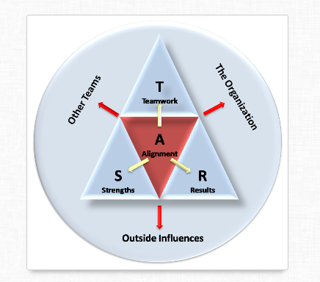
Figure1: STAR Team Model
(Sources: Holmes and Stubbe, M2015)
The communication issues are behind the lack of effective team management that are barriers to effective team management that has been evident from above discussion. The improvisations within the concept as well approach of communication within Tesco counts for the incorporation of this particular framework of cultural diversity. This is includes framework for cross-cultural engagement (Adler et al. 2016). This is a process oriented framework that focuses on the process of making communication effective within cross-cultural workplace. These include giving importance to individual cultural beliefs, then becoming familiar with the new culture or the cultures of others within any team or organization ( Salas, 2015). The process further fosters understanding and engaging the team members through effective communication practices like sharing viewpoints, stories from different cultures during free time, communication through digital platforms beyond workplace. This is referred to as value orientation that may include non-verbel communication as well through body language respect for each culture and thus establish cross-cultural communication.
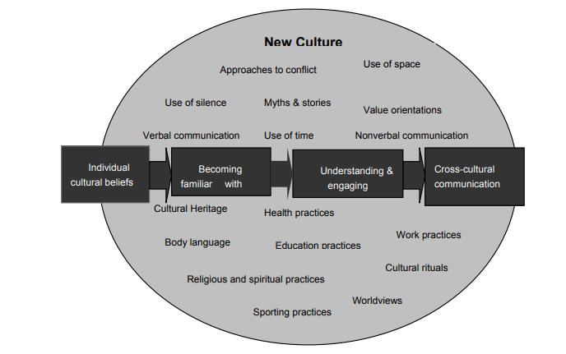
Figure 2: Framework for Cross-Cultural Engagement.
(Sources: Espinosa et al. 2015)
The issues that are apparent within the organizations Tesco includes that of the cultural clashes as well as differences within the lower and hierarchy of the as per the organizational structure. Thus, it is indicative of the fact there are cultural gaps and communication gaps as well within the human resource and the management of the organization (Chmiel et al. 2017). This is where, the exact reason behind the discontentment between the employees and the management is required to be identified. The issues that are apparent regarding team working is the very lack if the sense of team work that contributes in creation of bonding and role play as well where every member play a crucial role (Alsharo et al. 2017). The sense of shared responsibility within the team is lacking. Therefore, lack of communication within the management of the human resource is identified to be the very reason behind the team working which is evident within this particular organization. Thus, it is quite evident from the analysis, that the lack of team working skills, team management and communication skills and techniques as well are highly required by any organization in order to go for the achievement of the team working competencies that will contribute to the culture of the workplace and improve the workplace environment as well.
it is quite evident that communication and team working are integral of each other since effective communication is one of the criteria is through which team working is going to be achieved. Effective team awaking and communication in collaboration operates for the creation of a workplace environment that is more flexible and adaptable to changes, the large organizations like Tesco are highly dynamic in terms of creating strategies as environment of the workplace is changed ( Holmes and Stubbe, 2015). This is the reason that it is very important establish effective communication in the very initial with prioritization through which team working competencies may be achieved (Chmiel et al. 2017). The internal strengths of any organizations like that of Tesco are dependent on team working and effective communication as well through which the organizational objectives may be achieved. Further, it is the workplace environment that is developed through effective team working and communication skills through which addressing external issues and addressing to the changes through internal changes may be achieved by the organizations. This is highly contributing to the competitive advantage of the organization (Paul et al, 2016).
The theories that are discussed above are required to be applied within Tesco in order to address the issues that are discussed above.
TECHNIQUES AND SKILL FOR ACHIEVING TEAM WORKING AND EFFECTIVE COMMUNICATION
The application of theories is highly dependent on the inculcation as well as incorporation of the techniques through effective team working and communication may be achieved. It is worth mentioning here that this is must be implemented within the workforce that is within the employees and by the management of the company as well. A strong feedback system is the most recommended technique that is going to help in establishing a transparent communication within the organization (Salas 2015). It is very important to go for the achievement of a two way communication skill. Active involvement and participation of the employees while finalizing the human resource policy while developing organizations policies and procedures, it is very important to go for the identification of effective communication so through active participation that crates a sense of belongingness towards the organizations irrespective of the cultural differences within the workplace environment (Boies et al, 2015).
CONCLUSION
After analyzing the entire issue faced by the Tesco Company, it can be concluded that management needs to take actions towards the better flow of communication; else, the concerned company need to lose their loyal and potential employees. Furthermore, whenever. Communications in Tesco found to be ineffective, at the same instant, the management needs to improve that flaw found in the communication – flow amongst the team-members of Tesco. As the management of Tesco, fails to maintain a proper flow of communication and make the employees engaged actively that results in decreasing the morale and positive contributions of the employees in the concerned organization. In addition, friction is found in Tesco working culture that positively needs techniques and processes to be applied for improving the recent situation of cultural conflicts going-on in the working culture of Tesco.
REFERENCES

Adler, R.B., Rodman G.R. And Du Pre. A., 2016. Understanding Human Communication (Vol. 10) Oxford University Press.
Alsharo, M., Gregg, D., And Ramirez, R., 2017. Virtual Team Effectiveness: The Role Of Knowledge Sharing And Trust. Information & Management, 54(4), pp.479-490.
Boies, K., Fiste, J., And Gill, H., 2015. Communication And Trust Are Key: Unlocking The Relationship Between Leadership And The Team Performance And Creativity. The Leadership Quarterly, 26(6), pp1080-1094.
Cardon, P.W., And Marchall, B., 2015. The Hype And Reality Of Social Media Use For Work Collaboration And Team Communication. International Journal Of Business Communication, 52(3), pp.273-293.
Charlier, S.D., Stewart, G.L., Greco, L.M. And Reeves, C.J., 2016. Emergent Leadership In Virtual Teams: A Multilevel Investigation Of Individual Communication And Team Dispersion Antecedents. The Leadership Quarterly. 27(5), pp.745-764.
Chmiel, N., Fraccaroli, F., And Sverke, M., Eds., 2017. An Introduction To Work And Organizational Psychology: An International Perspective. John Wiley & Sons.
Cooper, R.G., 2016. Agile-Stage-Gate Hybrids: The Next Stage For Product Development Blending Agile And Stage-Gate Methods Can Provide Flrxibility, Speed And Improved Communication In New-Product Development. Research – Technology Management, 59(1), pp.21-29.
Demir, M., Mccneese, N.J., And Cooke, N.J., 2016, March. Team Communication Behaviors Of The Human- Automation Teaming. In 2016 IEEE International Multi-Disciplinary Conference On Cognitive Methods In Situation Awareness And Decision Support (CogSIMA) pp./28-34. IEEE.
Espinosa, J.A., Nan, N., And Carmel, E., 2015. Temporal Distance, Communication Patterns, And Task Performance In Teams. Journal Of Management Information Systems, 32(1), pp.151-191.
Franz, S., Muser, J., Thielhom, U., Wallesch, C.W., And Behrens, J., 2018. Inter-Professional Communication And Interaction In The Neurological Rehabilitation Team: A Literature Review. Disability And Rehabilitation, pp.1-9.
Harris, T.E., And Sherblom, J.C., 2018. Small Group And Team Communication. Waveland Press.
Holmes, J., And Stubbe, M., 2015. Power And Politeness In The Workplace: A Sociolinguistic Analysis Of Talk At Work. Routledge.
Paul, R., Drake. J.R., And Liang, H., 2016. Global Virtual Team Performance: The Effect Of Coordination Effectiveness, Trust And Team Cohesion. IEEE Transactions on Professional Communication, 59(3), pp.186-202.
Salas, E., 2015. Team Training Essentials; A Research – Based Guide. Routledge.
Tesco plc. (2019), Tesco PLC. Available at: https://www.tescoplc.com/ [Accessed on 15 Apr.2019].

