Research Paper about political instability and Tourism
Contemporary Themes in the Hotel and Hospitality Sector

Kissairy Valdez - 1815098
M6X01931 - Lecturer: Dale Clarke
Submission date: 22nd July 2020

Table of Content
Introduction 1
Politics and Tourism connection 2
Political transition and Tourism 3
Transition in Iranian Tourism regarding political regimes 4
Conclusion 5
References 5

Introduction

Tourism is recognized as a very important piece of many economies around the world, showing in each of them different levels of development (UNWTO, 2019). Also, according to (Hall, 1994) tourism managing and development is a process where politics are really involved and is influenced for different interests from local to national stages.
There is some significant gaps when looking for the connection between tourism and its changes and political transition. Politics have to do with tourism when speaking about marketing, policy making and development. According to (Hall, 2010) the transition lived in Politics may have significant impact on the tourism and have a huge relevance to it. This happens because political transitions help to stablish the trajectories and directions of future tourism ways. A direct example of this affirmation is that political decisions may say where an airport will be located and how the country branding and marketing should look like. As a consequence, this affects the perception of possible tourist on a specific destination for a long period, and this is not something good when the perception is not in favor of the destination.
The researcher has gathered information about the country Iran, which is a state that has been experiencing many changes in the political way as for example the substitution of monarchy to a theocracy that happened as a result of a Islamic revolution and some others international conflicts. The report examines how political and regime changes have affected the tourism industry and ideology of Iranians as well as a better understanding of political transition in hospitality.

Politics and Tourism connection

Tourism in Iran has been highly impacted by political turbulence and for (Seyfi and Hall, 2018) tourism also has been built from ideological and religious orientations or doctrines.
Apart from that, tourism may become a political issue according to (Bowen et al, 2017) because it can affect stakeholder’s interests and as a consequence the country economy. The institution in charge of managing tourism or some other political institutions and its quality impacts on tourism growth. It has been recognized that authoritarian governments encourage tourism to be antecedent of international legitimacy, a source of foreign exchange, and gives the opportunity to develop other targets without planning control or community refusal. (Richter, 1989)

Researchers as (Hall, 2010) affirm that the relationship between tourism and politics has been forged along with social contexts that are driven of the destination and origin countries with their predominant sociocultural norms and behaviors. In the same way, the society is the group that settle what is adequate, tolerable and what should not be done accordingly with the average.
On the other hand, when a transition in politics is happening the pressure from the society is applied through various democratic process, from elections and political parties to revolution and protests. Furthermore, political changes can be applied from external authorities and international institutions due to evolution on global finance system as for example World Bank, International Monetary Fund and some others. (Campbell, 2001). Therefore, the political process is influenced by the information politics receive from the socioeconomic conditions and dominate the way on how residents see the group of tourists and the tourist´s idea about the destination.
However, the previous position is not affirming that governments make use of Western Norms where political change comes through elections. In addition, many countries following liberal democracies and are considered developed countries, are marked by gradual and slow incremental shifts in tourism policy preferably from sudden and radical change. Even though, the relationship between both concepts, tourism and political transition is still poorly articulated and unclear.

Political transition and Tourism

In any touristic destination the occurrences and political circumstances are the ones that built the tourism forms and also the development.
According to (Munck, 2011) transition is a concept belonging to political systems that refers to the cycle of change among different regimes and the nature of political dynamics. As per the concept of regime, we can understand that this is only the ones in charge of state governance, but it also contains a set of rules, procedures and institutions that stablish the political practices of the system at different levels (Gossling et al., 2012). The transitions lived in politics are marked by internal events as for example elections and revolutions or in the external part it can be imposition of sanctions.
Political transition has the following characteristics:
- Is the result of the political and institutional transformation.
- Employ political actors in different ways from inside and outside of political systems.
- Normally, it takes about 20-40 years
- It is about the restructure of organizations, institutions and policy systems, the behaviour of the society and its connotations.
It can be also associated with other parts of change, including concepts such as sustainability transition. In the case of South Africa, the apartheid has been argued that still remains in a process of transition passing to a new inclusive regime with adequate institutions (Swilling & Annecke, 2012).
The events of transition may occur when the governors lose power when they are obligated from the office or is perceived a substantial change in the way of governance or policy. However, they do not show the start of a new regime but encourage to have a new process that is slightly different from the one that government started.
Since the end of World War II, transition is considered a quality of the modern world driven by drastic and essential shifts in the political area. Particularly, transition is a change from authoritarian to democratic government or in another way, the change from communism to capitalism (Pickels & Smith, 2005). An example of this phenomenon it can be the following countries: Latvia, Estonia, Lithuania (also known as Baltic states) that where more open to the democratic structure, while countries from Central Asia have been positioned to a more authoritarian model even though both parts have been also interested in encouraging tourism as a very important part of the economy in the country.

In the case of Iran they left the monarchy apart to experiment a new term of changes or transition that came together with various phases that made closer the relationships with political freedoms from the West but still having in present the theocratic influence of the clergy, the reason is that still they dominate the political institutions, from the point of view of international relations the imposition of a new regime hasn’t been reached yet.

Transition in Iranian Tourism regarding political regimes

Pahlavi Monarchy happened in 1979,since then, politics in Iran have been built in a way that people understand that religion and state are not separated concepts.

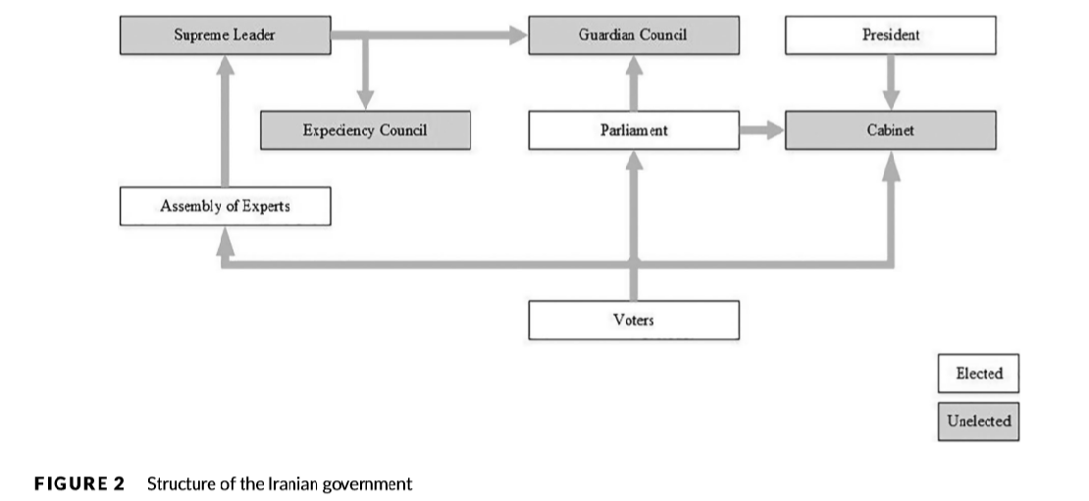

The components of theocracy are mixed with the elements of democracy as it is shown on the picture above. All candidates should be audited by the Guardian Council, and on the other hand, The Assembly of experts is the one in charge to select the Supreme Leader who is the person with enough power to endorse the president. All this positions are changed every five years and suggest that the tourism is not a priority in the overall strategic plan of Iranians politics.
Even though the positive outcome of tourism, the interest of the government in the profits coming from tourism and its development has always been limited from the beginning of the times. The reason is given to the higher level of dependence of Iran on reserve of oil and gas and not focusing in the opportunities that some other industries can offer.
Iran and its tourism is significantly dictated by local and international politics agents and transitional events. As the clerical settlement which is a very important player in the politic zone and are the ones holding formal and informal power. This fact has impacted directly on the tourism in Iran.
According to (Henderson, 2010), tourists that doesn’t follow the Islamic religion are point of interest for the conservatives and group of xenophobic or anti-Western thinking

Conclusion

In conclusion, we can say that as a touristic destination, Iran has accomplished a negative image that has been a result of the political transition and all the antecedents lived in the past years. Overall, the country should work in improving its image as soon as possible, because the current situation impedes a long term investment.
The conflicts lived between Afghanistan and Iraq that are neighbours of the country also affect in a particular way on how tourists see the destination and if its attractive or not. Also, given the political circumstances currently living with Trump in United States of America, the development of Iran tourism will continue to be problematic.
For too long, the focus has been on specific events rather than trying to understand those events within the long-term context of political transitions and the development of regimes, as well as the role of agency and structure in explaining them. Given the interplay between domestic and international political actors Iran's tourism story perhaps merits particular monitoring as it unfolds in the years ahead.

References

- Hall, C. M. (2010). Power in tourism: Tourism in power. In D. V. L. Macleod & J. G. Carrier (Eds.), Tourism, power and culture: Anthropological insights (pp. 199–213). Bristol: Channel View Publications.
- Hall, C. M. (2010). Politics and tourism–interdependency and implications in understanding change. In R. Butler & W. Suntikul (Eds.), Tourism and political change (pp. 8–18). Oxford: Goodfellow Publishers
- Hall, C. M. (1994). Tourism and politics: Policy, power and place. Chichester: John Wiley & Sons.
- Gössling, S., Hall, C. M., Ekström, F., Engeset, A. B., & Aall, C. (2012). Transition management: A tool for implementing sustainable tourism scenarios? Journal of Sustainable Tourism, 20(6), 899–916.
- Campbell, B. (2001). Governance, institutional reform & the state: international financial institutions & political transition in Africa. Review of African Political Economy, 28(88), 155–176.
- Pickles, J., & Smith, A. (Eds.). (2005). Theorizing transition: the political economy of post-communist transformations. London: Routledge.
- Seyfi, S., & Hall, C. M. (2018b). Tourism in Iran: An introduction. In S. Seyfi & C. M. Hall (Eds.), Tourism in Iran: Challenges, development and issues (pp. 3–37). Abingdon: Routledge.
- Munck, G. L. (2011). Democratic theory after transitions from authoritarian rule. Perspectives on Politics, 9(2), 333–343.
- Seyfi S, Hall CM. Political transitions and transition events in a tourism destination. Int J Tourism Res. 2020; 22:493–506. https://doi.org/10.1002/jtr.2351
- Swilling, M., & Annecke, E. (2012). Just transitions: Explorations of sustainability in an unfair world. New York: United Nations University Press.
- Richter, L. K. (1989). The politics of tourism in Asia. Honolulu: University of Hawaii Press.
- Bowen, D., Zubair, S., & Altinay, L. (2017). Politics and tourism destination development: The evolution of power. Journal of Travel Research, 56 (6), 725–743.
- World Travel and Tourism Council. (2019). Travel & tourism economic impact 2019 world. London: Author.

