University of Wales Trinity Saint David


MODULE CODE: LCBB4001
COMMUNITY ENGAGEMENT

Name: Diana Roabis
Student ID: 2028044

Executive Summary
A collaborative workforce is considered for establishing a solution against the special interest of that community in terms of their benefit under Community Engagement process. This report has considered Black, Asian and Minority Ethnic (BAME) community in UK and a program undertaken by Red Cross, a social organisation of this country. As mentioned in this report, British Red Cross has spread awareness within their organisation and overall society regarding anti-racism culture and made people understand the need to reject any kind of discrimination within workplace due to racist practices. Social media platform is the major aspect of this organisation for engaging awareness to their anti-racism program.
Table of Contents
Introduction 4
Description of Project Program 4
Analysing Best Practice engaging community engagement program 5
Community Engagement Principles 5
Establishing relationship between stakeholders and strategies for their engagement 6
Use of social media platform for project program 9
Adaption of forward-looking approach 9
Conclusion 10
Reference List 11

Introduction
A collaborative workforce is considered for establishing a solution against the special interest of that community in terms of their benefit under Community Engagement process. This report will consider Black, Asian and Minority Ethnic (BAME) community in UK and a program undertaken by Red Cross, a social organisation of this country. This program is called Anti-racism program, and this program was initiated to develop a diversified workforce within their organisation with engaging different cultures.
Several community engagement principles will be addressed in this report for addressing key issues faced by BAME group and actions taken by Red Cross to resolve those issues. Use of social media platforms and strategies suitable for engaging them for social media campaigning will be included in this report. Analysing aspects for promoting multiculturalism within the workplace and adaption of a forward-looking approach for this cause will be explained in this report based on the program undertaken by Red Cross.

Description of Project Program
Community Engagement program is a cooperative as well as collaborative approach undertaken by an organisation or a group of people to address any specific issue raised within a social community by focusing on their welfare. British Red Cross society is a neutral and impartial humanitarian network that works across the world for various social issues. They wanted to make their organisation a place, where people will feel free to seek help without any boundary of culture differences. They wanted to build equal opportunity and an environment where everyone will be treated with similar dignity.
As a result, British Red Cross spreads awareness within their organisation and overall society regarding anti-racism culture and makes people understand the need to reject any kind of discrimination within workplace due to racist practices. They initiated this program to include more employees from BAME-group within their organisation for putting diversity within a place and make effective use of different points of view of different people from BAME background (Redcross.org.uk, 2020). They have engaged different diversity and inclusion steering group for developing a continuous action plan for their anti-racism culture. Red Cross have focused on their values such as dynamic, courageous, and compassionate and inclusive work with their organisation for enforcing the Anti-racism program by involving BAME group as a target community in order to mitigate their social distinction regarding minority groups. They began to share their findings regarding diverse culture on a public platform by recruiting BAME people within their organisation.

Analysing Best Practice engaging community engagement program

Community Engagement Principles
Some key features of community management principles are careful planning and preparation of organisational purpose as well as requirements of participants regarding adaptation of diversity within their organisational structure. Red Cross will rely on their fundamental principles in order to engage in a careful planning approach within their organisational structure and they need to focus on their anti-racism program by recruiting people from the BAME group (De Weger et al. 2018). Overall aspect of this organisation was to build a place where equality will be the main concept within their workforce. As an important part of their overall anti-racism program, they have channelised their diversity network in order to develop various factors for generating opportunities for people from different cultural backgrounds. Inclusion and diversity is another important principle of community engagement process in order to incorporate diverse cultural factors within their overall organisational structure.
British Red Cross has demonstrated a survey within their organisation as a crucial part of their anti-racism program in order to identify people’s experience within this organisation after working as a potential employee coming from BAME group. Transparency and trust are another principle of community engagement process that can be maintained by British Red Cross after recruiting BAME community people within their organisation after ensuring them a transparency and trust. While working within their organisation after generating different types of experience and different point of views in terms of a specific topic that is going to be developed within Red Crosses’ organisational structure and anti-racism program (De Weger et al. 2018). The internal survey program has helped them to understand what people of their organisation were thinking regarding any event related to prejudice associated with racist activity. This overall process has been incorporated within this organisation to boost up their anti-racism program and develop a diverse culture within their workplace as a whole. As an essential part of Red Cross’s anti-racism program all the employees who have been selected from BAME community need to know about their community engagement program through the core concept of anti-racism with the help of several questions (Redcross.org.uk, 2020). The employees were asked regarding their overall experience within this organisation or outside the organisation in terms of any discriminatory as well as over-racist behaviour. As per the overall result of this survey, it was found that people of this organisation understands that it was their individual duty to handle racist activities within their organisational culture and welcome different types of people from different cultural backgrounds. The organisation is committed to meet all the requirements under UK Equality Act 2010 and incorporate all the necessary credentials for developing their organisation as an anti-racism organisation (Redcross.org.uk, 2020).
However, there are some people of this organization, who have experienced severe racism within this organisation while working due to their colour and they have also felt that racism was not tackled adequately within their organisation. This is a key issue that has been found within this organisation by their potential stakeholders who might have volunteered or worked within their organisational structure (Redcross.org.uk, 2020). The Anti-racism program within this organisation was mainly focused on creating a meaningful structure change throughout their organisation. Transparency or trust is a major principle within the community engagement process undertaken by British Red Cross in order to benefit their people associated with various organisational requirements to be felt as an essential part of their workforce without any racist activity.

Establishing relationship between stakeholders and strategies for their engagement
BAME are the minority group who still belong to the unprivileged section within this country even after a rapid growth in UK’s overall progress in terms of advancing ethnic quality. BAME people experience unemployment across UK indifferent sectors. However, based on a report, BAME women suffer from a higher unemployment rate than BAME men. BAME people experience racist comments from different sectors of their workforce and are also rejected for recruitment by various organisations across UK (Mckinsey.com, 2020).
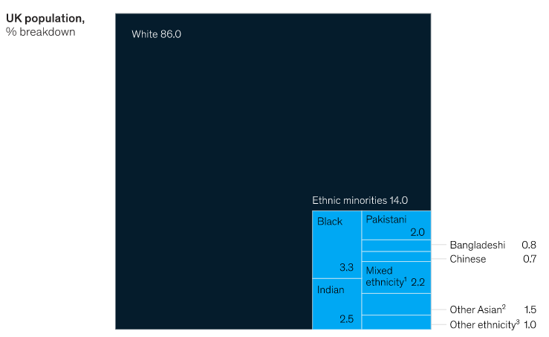
Figure 1: Ethnic minority population in UK
(Source: Mckinsey.com, 2020)
As an organisation, where people from diverse networks are welcomed as a potential part of the organizational structure, Red Cross have focused on their new heritage strategy for generating benefit to their potential stakeholders related to this anti-racism program (Cunningham and Smith, 2020). As per the history of this organisation, they have initiated this new heritage strategy to understand and confront this as a major portion of their historical background (Redcross.org.uk, 2020). They intended to know about insight lifestyle and work approach of people from different backgrounds as well as different colours to engage them within their workforce and incorporate diversity through this anti-racism program.
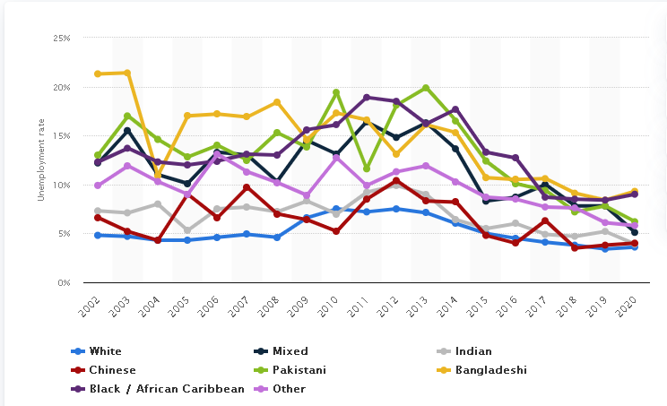
Figure 2: Rate of Unemployment in UK by Ethnicity
(Source: Statista, 2020)
Under this program, Red Cross have implemented different psychological safety tools for ensuring that there are safe spaces as well as pathways available within their key values to challenge any behaviours against BAME people, which come under racist activities. As a result, they need to ensure that a clear and concise concept regarding anti-racism language is spread across the organisation in order to develop awareness within their key stakeholders (Redcross.org.uk, 2020). The company has initiated various strategies to identify the meaning of intersectionality of experience, where social as well as political identity of a person can create serious events of discrimination within their overall organisational structure. As they have taken inclusion and diversity principle of community engagement as the most essential factor in terms of their anti-racism project, it is important for them to understand the ways through which they can improve their workforce as equal and inclusive as possible.
They have committed to aim for creating an environment for all their staff from BAME community and asses their work regardless of their sex, religion, and any other socio-economic status. In order to spread awareness among people and their core employees, social media platforms are a great aspect that can be used by this particular organisation to share their views as well as strategies to develop an anti-racism culture within their organisation and society as a whole.

Use of social media platform for project program
Nowadays social media platforms have a greater impact on their overall strategy and needs to be incorporated within a major aspect for social media platforms for taking views of people and volunteers, who are engaged with this organisation for different social work, can be a greater aspect of anti-racism concept in a society. Social insecurity that BAME people experience within their workforce can be mitigated by this approach as camping regarding this concept through their organisational strategy will encourage many people from BAME community to come, join their program, and volunteer in their organisational work without any hesitation (Jwain, 2020). Various social media platforms such as facebook, instagram and twitter can be used by this organisation to enhance their anti-racism program after developing awareness among their key people. This will help their employees from BAME community to understand and avoid the impact of social deprivation that they might feel within their workplace and regular lifestyle (Ye et al. 2020). They can engage this social media platform by targeting a specific audience for their anti-racism program and then create a user-friendly value proposition for their future employees.

Adaption of forward-looking approach
Adaptation of a forward-looking approach is the most important aspect, as it will create a behavioural channel among key stakeholders of an organisation. Forward looking approach is mainly supported by motivational theory that an organisation can generate to boost up their employee’s efficiency level regardless of their religion as well as culture. As per Herzerg’s two-factor theory, motivation is highly recommended over hygiene as it increases the employee’s satisfaction level. In this community engagement model (Alshmemri, Shahwan-Akl and Maude, 2017), British Red Cross and as a practitioner of this organisation’s anti-racism program it is important to adopt a forward-looking approach with the concept of diversity within their organisation and establish the main theory of community engagement which is equality and diversity.

Conclusion
It can be concluded that, as per this report, Red Cross works within various projects in order to take an initiative measure for the overall betterment of the society through their organisation. Main vision of this social organisation is to welcome all kinds of ethnicities within their organisation to make the multiculturalism concept more proactive. Unemployment rate has decreased in UK within ethnic group from past few years due to social media awareness and initiated taken by various social welfare organisations. As per explained in this report, social media engagement through a transparent trustworthiness commutative approach in order to grow the concept of snowballing within organisational stakeholders for transferring information as well as awareness as fast as possible to one person to another in terms of their anti-racism program.

Reference List
Journals
Alshmemri, M., Shahwan-Akl, L. and Maude, P., 2017. Herzberg’s two-factor theory. Life Science Journal, 14(5), pp.12-16.
Cunningham, H.R. and Smith, P., 2020. Community Engagement Plans: A Tool for Institutionalizing Community Engagement. Journal of Higher Education Outreach and Engagement, 24(2), pp.53-68.
De Weger, E., Van Vooren, N., Luijkx, K.G., Baan, C.A. and Drewes, H.W., 2018. Achieving successful community engagement: a rapid realist review. BMC health services research, 18(1), pp.1-18.
Jwain, A.B., 2020. Role of Social Media on Social Awareness and Engagement. International Journal on E-Learning, 19(4), pp.331-354.
Opara, V., Sealy, R. and Ryan, M.K., 2020. The workplace experiences of BAME professional women: Understanding experiences at the intersection. Gender, Work & Organization, 27(6), pp.1192-1213.
Ye, X., Zhao, B., Nguyen, T.H. and Wang, S., 2020. Social media and social awareness. In Manual of Digital Earth (pp. 425-440). Springer, Singapore.
Websites
Mckinsey.com, 2020. Problems-amid-progress-improving-lives-and-livelihoods-for-ethnic-minorities-in-the-United-kingdom. Viewed on: 26/07/2021. <https://www.mckinsey.com/industries/public-and-social-sector/our-insights/problems-amid-progress-improving-lives-and-livelihoods-for-ethnic-minorities-in-the-united-kingdom#>
Redcross.org.uk, 2020. equality-and-diversity-policy. Viewed on: 26/07/2021. <https://www.redcross.org.uk/about-us/how-we-are-run/our-policies/equality-and-diversity-policy>
Statista.com, 2020. Unemployment-rate-in-the-United-kingdom. Viewed on: 26/07/2021. <https://www.statista.com/statistics/1123370/unemployment-rate-in-the-united-kingdom-uk/>

