Art and Archaeology in Ancient Islam
Q. Choose one building and explain its significance and importance within Islamic art and archaeology? Dome of the Rock, Jerusalem
The dome of the rock located at Temple Mount, Jerusalem, has an enriched history dating back to its original construction in 691 AD. The initial construction was ordered by Umayyad Caliphate although the Dome’s true purpose is still unclear but many theories have been put forward for academic discussion. Throughout the building’s history, there is significant evidence of its destruction and rebuilding of the monument, potentially caused by earthquakes or even religious disputes between the Christian and Muslim faiths, in addition to the invasion of the temple mount instigated by the Romans. Since this, the building has had a huge impact on its audience relative to both religious and political practices between the Muslim, Jewish and Christian faiths. Its original purpose is proposed to have been a Mashhad which is described to have been a shine for pilgrims and even to this day the dome of the rock still attracts pilgrims today. Alternatively, other perspectives are that the building could have been built intended to voice a statement to the Christians and Jews by the ruler at the time. Thus, in essence creating a symbol portraying a sign of strength regardless of Islam still considered to be a young religion.
The planning of the original construction of the dome of the rock would have taken a long period of time to plan and begin the construction in what can be interpreted as a dedication to the geographical location of the site with the religious connotations attached and not to mention the intrinsic art style that would later become a distinct feature within Islamic art and architecture. By building the dome, the Muslim populous beautifully demonstrates their artistic skill by incorporating iconic Arabesque, geometry of shapes and the most admired of all, the use of calligraphy into the architecture. The purpose of combining the notion of using shapes and repeating patterns in Islamic art is to express concepts of timelessness, connectedness and symbolises an infinite extension. To this day and for the past 1300 years, the claim to the dome of the rock has been contested by each of the three religions.
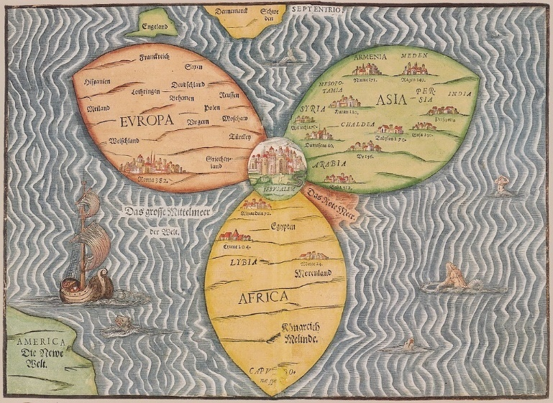
The significance of the site is paramount to the three out of the four religions currently occupying the old city in which the dome of the rock is situated. At this time, Jerusalem was and still is to this day considered to be the epicentre of the world. This is a result of religious scriptures in both the bible and the Quran mentioning this specific place in the bible it is said that this is where Adam had made his first sacrifice to god. Another belief among many Christians is that the dome of the rock situates in the same place as that of Solomon’s temple.
While also sacred to Muslims, the Quran tells of the famous prophet Mohammed journeying to heaven from the same location during ‘the night journey’. Supposedly praying with Abraham, Moses and Jesus, the prophet Mohammed while accompanied by the Angel Gabriel, Mohammed is said to have made his way to the temple mount while mounted on a mighty steed known as Borac. It is said that Mohammed ascended into the heavens to receive instructions from Allah himself. The location of the foundation stone is also said to have been the origin for the scripture concerning the angel of Israfil where he will sound the trumpet which is said to be resurrection day marking the end of the world. Using the earliest Arabic textual sources and inscriptions that can be ascertained has the potential to act as an aid in dating the origin of this belief from the beginning of the 8th century AD, the first mentioning of Mohammed’s tale. This event has been suggested to have happened around the same time or a small period of time before construction as the initial erection of the dome of the rock can be dated to 691AD. However, the downfall here is the lack of archaeological and textual evidence to formally corroborate whether the belief that these two events can be interpreted to the same period to the construction of the dome in the eight century and would be considered unwise to jump to any conclusions as it is impossible to correctly interpret the events that were underway. (Rabbat, N, 1989).
It is within the Jewish tradition that Abraham had prepared to sacrifice his son Isaac in this same place. Furthermore, the Jewish people believe a foretelling of the rebirth of Jesus Christ when the mount which was destroyed by the Roman Empire in 70AD, the last Jewish temple is rebuilt, Jesus Christ is said to rise up and return the site to the Jewish population. Once this event has occurred, it is said that the Jewish nation will only then accept Jesus as their liberator and in turn Christ will then rule the earth. In addition to this, the rock itself in which the golden dome covers is interpreted as the starting point for the beginning of the earth where the foundation stone expanded and in essence started the creation and expansion of the earth and in modern day it is still considered to be the centre of the earth. It is for this reason the Jewish populous face a certain direction when in prayer, the western wall is located within the old city and is where the activity of praying transpires.
The most interesting aspect to Islamic art is that there consist a number of intrinsic patterns and stylistic techniques which is a reoccurring theme. Islamic imagery then expands outwards to other far away cultures that becomes influenced by the Islamic style and begins to inhabit aspects of both cultural and political beings. Past studies of Islamic art in the 19th and 20th centuries, up until the 1980’s mainly looked into the study of Islamic material culture as Islamic art although, as a result of this, it was detrimental to the effect it would have in an archaeological context. This has led to an overlooked foresight in which common interpretations of the Muslim culture in that period see the Muslim society either as inert or otherwise in a spiralling decline. Consequential to this, there was inadequacies where the amount of potential archaeological knowledge of the Muslim society was already thought to have been known and as such decreases its value, and so for this reason the value was only seen within decorative, elaborate objects for retrieval to place in museums.

The of the dome of the rock was unlike any other construction building that came before it both in architecture and the outer decoration of the site. The techniques used for the design are unique and conforms to prior traditional Islamic portrayals. Some aspects of the decoration have inevitably been modified and replaced since the original construction due to political associations, however, to this day the site still bears the innovative calligraphy acting as a band which circumferences around the top of the 240m long base
The dome represents the unique Islamic art style in a sense that by using the continuation of traditional characteristics enhances the connections and emotion between people and their ancestors. Taking into consideration, the use of scripture incorporated with the architecture that circumferences the top like a band around the octagonal base. The building is thought to be one of the first monuments which we see the elegant scripture incorporated the materials used to decorate the monument were bright in colour while contrasting the blue underlay with the golden pieces of mosaic overlapping which emphasised the emotional responses and spiritual of being present at an extremely important holy site. The materials used for the golden dome was originally lead and remained unchanged from 691AD up until the early 1960’s where it was replaced with a gold coloured covering. Later in 1993 there was need to replace it once more, only this time was replaced with a solid gold covering and has remained intact since.
The tension between Islamic interpretations and the archaeological contexts within the archaeological record grows as a conflict of interest is presented that is dependent on the field of study. An archaeologist would argue the development of Islamic art would be described as an intrinsic event and still changing over the course of the time. Although, from the perspective of a different field approach, for example an art historian, the interpretation of the art style, one could suggest that the Muslim community who hold and value traditions with great respect may not interpret the art style in the same way, and therefore, would continue to see the art style with a static viewpoint where the traditions and art are infused with the architecture. The building has since been demolished and rebuilt on a number of occasions caused by due to a number of reasons, one being, conflict of interest in regards to religious aspects which resulted in warfare in Jerusalem. Another could be down to natural disaster i.e earthquakes.
The portrayal of art displayed decorated the obscure architecture within Islamic art and infusing the two together displays a unique intrinsic style which would essentially dominate Islamic art and would be iconic to Islamic culture. The same intrinsic style can be seen through the octagonal design of the dome of the rock. After a century of conflict between Muslims and Christians led to the restoration of the building which inevitably rose above the walls of the old city causing the building to become a representation of Jerusalem’s endurance with the Muslim religion.

Bibliography
Bolen, T. 2018. Temple Mount. Dome of the Rock. Retrieved from https://www.bibleplaces.com/templemount/
Israeljerusalem.com. 2018. Israeljerusalemcom. [Online]. [11 July 2018]. Available from: http://www.israeljerusalem.com/dome-of-the-rock.htm
Rabbat, N. (1989). The Meaning of the Umayyad Dome of the Rock. Muqarnas, vol.6, pp: 12-21. doi:10.2307/1602276, www.jstor.org/stable/1602276.

