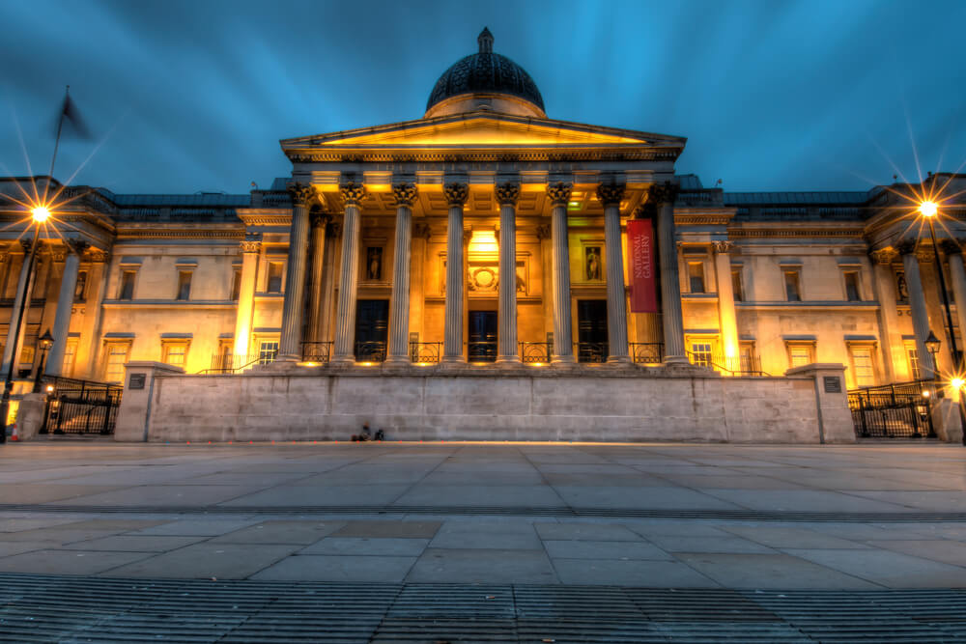
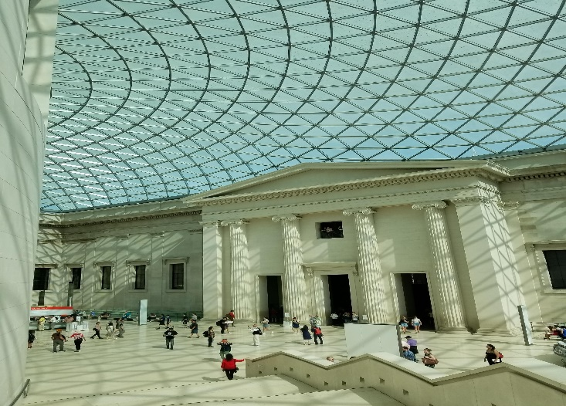
In the light of one of your visits, examine the arguments for and against removing monuments / artifacts OR buildings from their sites in the landscape to the?
(sarah cohen, 2021)
Student number: 1900688
Word count:1899
Module code: HPHE 6008

Contents
Introduction………………………………………………………………………………………………………………….1
Why moving a monument/building is a good idea?...........................................................1
Why moving a monument/building is a bad idea?.............................................................2
Conclusion………………………………………………………………………………………………………………………3
References……………………………………………………………………………………………………………………..4

Introduction
Why are artefacts and buildings moved from their original locations? Some responses to this question would be, for safety, for better appreciation, to put objects together in a collection which offers a better insight into their historically narrative. Whether this relocation is undertaken to move a monument out of the way of a road, or to place a painting into a vault out of harm’s way, people have always had ways of preserving and keeping ancient artifacts in a protected enviroment away from the chaos of modern-day life. This is an ongoing issue that is unlikely to be resolved completely. Most people have inherent curiosity, and a desire to preserve the past. However, there are many reasons why moving historical artifacts and buildings may be seen as a negative thing.one example of this could be when a painting is safeguarded by being out into a vault, because it is seen as being to valuable, for public view and the owner wants it literally locked away. then it is safe but no it cannot be seen. When artefacts and buildings are brought together and are available to public view this problem does not exist. Nevertheless, there are objects that have been taken away from their native lands, which creates further question about right and wrong. To address these questions this report will consider the British museum.
Why moving an artifact or building is a good idea?
There are many examples to suggest that collecting historical objects into the safekeeping of a controlled enviroment such as the British museum could be seen as a good thing. For example, if an historic building in a big city, is now surrounded by modern buildings, it can be seen to appear lost. once it may have stood in the square of a small village, a building may attract more visitors if it is relocated to a location that is convenient for interested visitors therefore, moving buildings to collective sites can enable living museums, were they can become part of related collections in museums. If a building is not safeguarded by being in a heritage centre, it may be subject to neglect or damage in addition, it may be tourn down an replace by modern buildings and if this is allowed to happen then that old historical building could be lost forever. Therefore, the preservation of these buildings by relocating them to heritage centres, can preserve them for the future. an example of this, would be the black country museum. In which they moved buildings from their original standing places, to build a village for educational purposes. “Explore carefully reconstructed shops, houses and industrial areas that represent the Black Country’s story” Bristol museums (2021) was a useful source.
If the monument is a piece of difficult heritage (like the Bristol Slaver) it would be better housed in a museum where its full context could be given to it in a collection of similar items. – so, people aren’t offended by them an example of a good reason to move a monument that represents difficult heritage such as the Bristol slaver if it was housed in a museum, in a collection of similar items its full context could be explained to visitors, and it could there for offer education rather than offence. In a similar way collection of artefacts viewed together in a museum enviroment are a strong tool for education for visitors and are more likely to inform when seen tis way.one of which artifacts is that of the Sutton hoo and ship burial collection. This is one of the Anglo-Saxon collections pieces, that was discovered in Sutton hoo in 1939.with over 20 burial ouns being uncovered, offering is a great and new insight into the period of British history. With the helmet being made up of iron and tinned copper alloy helmet, consisting of many pieces of iron, this of a perfect example of how some artifacts such as this are better off being kept in a controlled enviroment. Rabo(2019) was a useful source. Left in their original positions my artifacts could be lost, damaged or subject to degeneration as a result of weather exposer.to further this there is another historical artefact, in the British museum. That is made from wood, the Aztec double-headed serpent. Discovered in Mexico and believed to be from 1400-1521 AD. This piece is cut from one pieces of wood and believed to be covered with finely cut and polished turquoise, oyster and conch shell. Julie(2018)described this in her blog about the British museum. In a museum, controlled environments, and prervation are available. As a result of areological explorations some finds are exposed when they were previously protected by the soil or the tomb in which they were housed therefore, it seems appropriate to preserve and safe these objects , responsibly.
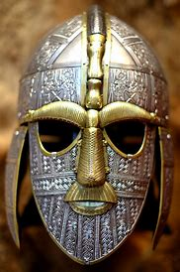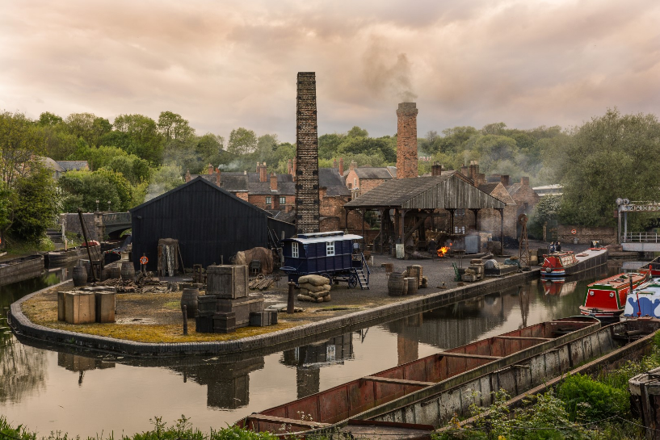
(Lark Ascending , 2015)
(Luke, 2017)

Why moving a monument/building is a bad idea?
On the other hand, there is many reasons into which that moving antient artifacts and buildings, is seen as a negative thing. The first of which is, when a building of historical importance is moved it has then been taken out of its place, moved from the very context that is why it was placed in that very spot in the first place. This could be the road, industry link that it is attached to, and with this some of why the building was put there is lost in moving it.
Furthermore, when we discuss issues on difficult heritage, we can see when moving and preserving a antient artifact or building could be seen a the wrong this to do, this can be seen when looking at the example of the British slaver in Bristol. This monument was placed there to make the building of a town by a man how has inks to slavery. Would this monument in particular be better off in the place that it stands? It could be seen as backing the causes of this monument if it was to be ovoid to a museum. The Bristol slaver is a man named Edward Colston, the status background is one that is controversial monument to a wealthy man who founded schools and charities. Based in London, he traded with Europe, and as an investor in and a committee member of the Royal African Company he made part of his fortune from the slave trade and from sugar. ref
The largest argument for why an ancient artefact or building should not be moved. Is the idea that many of the artifacts that we have in the museums in the unite kingdom, such as the British museum, are not from here. These artifacs are things that we have found and taken from forging lands many years ago. They offer an in spite into other counties culture and history. With I believe that we as a country have one of the most well-known capital cities in the world, London. London as a place is known for many different things and brings in millions of tourists each year to look at its many wonders. Some of which are the ancient artifacts that we have taken from other countries. Looking at the British museum as the perfect example, they have anything from the Rosetta stone, Elgin marbles and even a ester island head. Looking at the easter island head , why would they give it back? Thousand of people come to see it every day, they don’t have to pay entry however they pay for food, for souvenirs. They are making money from having that artifact in there collection, largely due to the fact that many people can not afford to go to easter island its self to see the original standing place of theses huge artifacs, so they come to London to see this huge popular artfact. Following on from tis point it is a Europeanly things to have the artifacts not a knowing we have them .
The issues of the artifacts that we have taken is the largest and most prominent argument for not moving acint artifacts or building. Take Nigeria as the perfect example, in 1897, British troops stole some 4,000 sculptures after invading the Kingdom of Benin (now more commly know as southwestern Nigeria). It is now over a century later, these surviving bronze sculptures are on display at museums in the England ,Germany, Austria and the United States, however not one of them is in Nigeria, their country of origin. This was also touched on in a scene of the movie the black panther. Nigeria has been asking England for the Benin bronzes for decades, with no sight of the return of these artifacts. That was until 2018, when the countries struck a deal in which the British Museum will send some bronzes to Nigeria for the Royal Museum the country plans to open in 2021. But crucially, the British Museum says it is only loaning the sculptures—it still expects Nigeria to return the goods that Britain stole. Little (2018) was a useful source of information.
To draw this to a conclusion, I believe that this will always be a point of dissuasion or conflict. There is no right or wrong, in the discussion of where or to we should move ancient artifaccts and buildings. There are argument for both, I believe that it is quite heavy depending on the artifact in question. For example I think that the British slaver monument should be oved to a place that dose nt give it credit for its tainted past, but can offer correct incite into the monument. It would further be the correct thing to move a artifact once we have removed it from its original resting place, largy due to the fact that we have exposed this said artifact to things it once , was not. I do however believe that this does not apply to when we have excavated artifacts in the past, in foreign countries. I believe that we should return the artifacts to the county’s that we have taken them from in the past. to round the report off , I think that it is down to the artifact its self and where they have came from.

References
Bristol museums, (2021) Bristol and the Transatlantic Slave Trade: Myths and Truths. available at: /www.bristolmuseums.org.uk/
(Accessed:28 September 2021).

Julie. (2018) ‘Top 10 Things to See at the British Museum’ [blog]. January 15. Available at: http://escapingthemidwest.com/british-museum/
(Accessed: 28 September 2021)

Little ,B .(2018) Will the British Museum Ever Return These Stolen Artifacts? .available at: www.history.com/news/british-museum-stolen-artifacts-nigeria
(Accessed:21 September 2021)

Rabon, J. (2019) BRITISH MUSEUM: TOP TEN ARTIFACTS TO SEE IN THE BRITISH MUSEUM WHEN YOU VISIT. available at: www.londontopia.net/culture/british-museum-top-ten-artifacts-to-see-in-the-british-museum-when-you-visit/
(accessed: 2nd October 2021)

Ascending , L .(2015) Sutton Hoo Helmet Anglo-Saxon C7th British Museum . available at: www.flickr.com/photos/vwilliams/16339730779/in/photostream/
(accessed: 21 September 2021)

Luke (2017) 10 things you might not know about the Black Country Living Museum . available at: www.birminghamupdates.com/10-things-you-might-not-know-about-the-black-country-living-museum/
(accessed:21 September 2021)

Cohen,S. (2021) Free art galleries and museums in London . available at www.timeout.com/london/museums/free-art-galleries-museums-in-london
(accessed : 2nd October 2021)

