  Component One: Student Journal (learning log) 750 words +/- 10%  Contribution to Overall Module Assessment: 25% | Student No: | 2209207
 | Module Title: | Hotel Adminstration and Front Office
 | Module Code: | BMIH 4004
 | Lecturer: | Natalie Brailsford, Dan Payne Neil Dyer, Muhammad Cassamo Scott James.
The administration of hotels requires a wide variety of various sorts of expertise and experience. During the time that I spent working at the Premier Inn Bedford, I was able to take up a lot of knowledge that proved to be helpful. During my time there, I was exposed to a wide variety of skills, which proved to be among the most useful takeaways (Blake et al, 2006). The learning cycle developed by KOLB is an effective model for carrying out research on the learning process. This learning cycle lays a strong focus on the prospect of obtaining information across a broad range of subject areas. During the course of my stay here, I have gotten experience working in a wide range of positions. The foyer of the hotel has a variety of check-in desks and places for visitors to choose from when they arrive. The fundamental objective of the check-in desk is to effectively deliver customers to the hotel and to greet them in a suitable manner once they are already there (Boella et al, 2013). A number of different reception desks and other services will be located in the lobby of the hotel.

A significant component of schooling in the modern day is the development of skills in hospitality and customer service. In order to accomplish this objective, one has to have the information necessary to apply for the suitable alternatives, which is going to be necessary in order to make the appropriate selections. Because of this one specific reason, I am quite certain that some reflection is necessary (Cappelli, 2015). The amount of reflection that he has done on the learning that he has previously done is a significant factor in determining the total capacity for learning that an individual has. One of the key reasons why the GIBBS method has been so effective is because of this. While I was staying at the Premier Inn Bedford hotel, I picked up the most valuable piece of information on the new learning process, which was about the many different views (Drinkwater et al, 2009). As a result of carrying out this operation, I have gained a broad array of new talents related to that field. The administration of a hotel from the standpoints of its many divisions is the most essential takeaway from this lesson.

Everything that involves a change in the market should be done out under guidance so that we may accomplish our goal of doing so. Adopting the mentality that everything should be centered on enhancing the experience of the customer was by far the most significant thing that I picked up from this experience (Goos and Manning, 2007). As a consequence of what the customer goes through at Premier Inn Bedford, the relationship between the two parties will grow even more solidified. In order to obtain this information, one must first have an awareness of the expectations that customers have of the hotel and the services that we give in order to meet those expectations.

When I was a guest at the Premier Inn hotel, one of the most essential things I wanted to learn was how to properly engage with guests and cater to their requirements while adhering to the policies of the establishment. The mission and vision of the hotel are what motivated me to work toward achieving this objective (Haddock-Millar et al, 2016). In this specific field, I believe that the learning process may be accelerated to some degree if one receives the right education and training. In this regard, the GIBBS reflective cycle proved to be really helpful. The requirement that full attention be given to the whole experience of the customer must be satisfied. During the time that they are staying at the hotel, there should be efficient management of the services that they are going to utilise in such a manner that they are able to ensure that they do not have any issues (Higgs et al, 2008). The total amount of time spent at the hotel will vary greatly depending on a huge number of different aspects. It is an essential factor that will play a function in deciding the total possible number of visitors who will come back to this area, and the hotel's first-rate customer service is a vital component that plays that role.

In conclusion, as a consequence of my self-reflection and subsequent learning, I am able to state that there are a great many innovative things that may be done in contemporary context to enhance the experience of hotel visitors. This is something I am able to say since I am able to declare that there are a great many novel things that may be done to improve the experience of hotel guests. My stay at the Premier Inn in Bedford was without a doubt an incredible opportunity to obtain theoretical and practical knowledge that would be useful to my growth in the years to come.

Component Two
Contribution to Overall Module Assessment: 25%
Trip Advisor Review Response 150 words +/-10%
Dear Mr. Richard, Thank you so much for your such kind words. First of all, in Premier Inn Bedford we always try to learn new things from our customers. On day to day activities we want to learn new things that will be essential for making the customer experience better. Without knowing what can be done to make it better, we can’t improve it for you.

We are glad that you have tasted our breakfast and the breakfast menu was liked by yours taste. We always think of improving ourselves. The experience in our hotel is thriving to get customer like yours. For this reason, your review is essential to look for where we can improve. The overall satisfaction should be good.
Lastly but not least, thank you Mr. Richard for choosing use over any other hotels. We hope that you will visit us soon.

Screen shot of referenced Trip Advisor review used:
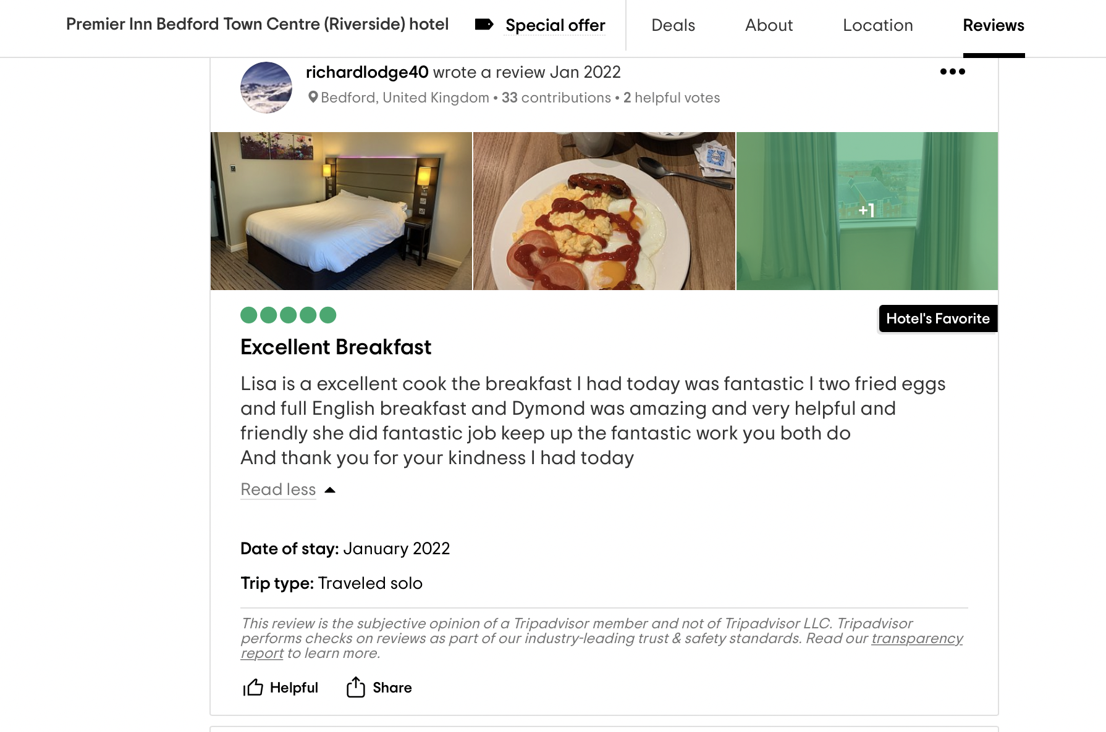
Letter of complaint response 500 words +/- 10%
Dear Sir,
To begin, please accept my sincere condolences in advance for the unsatisfactory nature of your stay at our hotel. After reviewing your previous stays, we have determined that the quality of service that you received during your most recent visit to our hotel was subpar. Nevertheless, here at the Premier Inn Bedford, we always strive to provide the highest possible level of service to our guests. There may be occasions when we are unable to give the highest potential level of service. In light of the fact that there are several new renovations now underway to enhance the quality of the service, the contextual variables should be taken into consideration here. The primary objective of this answer is to lessen the number of complaints over the usage.

You had a breakfast that wasn't up to par, and that's the first thing I want to address. Because of this, please accept our deepest condolences. The primary purpose of this context is to investigate the reason why something occurred. You had breakfast too late, sir, as per the request that was given, and you must have breakfast at seven o'clock in the morning. Even though we provide a continental breakfast in the morning, we also serve a variety of other sorts of food on our menu. Due to the fact that you specifically requested an English breakfast, we were able to provide it for you in your room had you chosen to do so. Even though we are able to provide various cuisines, you have not requested that we do so. However, we are working on developing a more effective policy for clients such as yourself, and I can assure you that this issue will never arise again.

You also said that there are children in the room next door, which is another concern. Since we did not get enough rest that night, please accept our apologies for the inconvenience. On the other hand, we do have nicer accommodations or other options available in this situation. While looking through the record, we were unable to locate any official complaints of any kind. Because there was no official complaint filed, we are unable to take any action at this time. In addition, we are certain that there are correct techniques to carry out the job in order to ensure that we will give you with a better room that will result in a better atmosphere for resting on that particular night.

Last but not least, the room does not meet your standards for cleanliness and hygiene. At the Premier Inn Bedford, we are very proud of our hotel's impeccable cleanliness. Additionally, we have a third-party auditor that checks to see whether the checklist has been completed. Because of this, we need to investigate the many actions that led to the area being dirty. On the other hand, we are looking into this situation, and since we have commitments, we will provide you with a discount of thirty percent on your subsequent stay with us. I really hope that we will be able to maintain our connection with you.

Sincerely Yours,

Premier Inn Bedford Management Team

Component Three:
Contribution to Overall Module Assessment: 50% (1000 words +/- 10%)
Writing in essay format

Element 1 – Pre-Arrival

For knowing how guest service worked one need to have proper knowledge in this regard. Only then can one begin to learn this knowledge of serving people. Because of this, the capability to form powerful teams is necessary in order to make the best possible use of the resources that are now accessible (Kaushal et al, 2021). Due to the fact that it is not easy to train individuals and thus requires a substantial amount of effort to be successful, the development of a team via the provision of the necessary training is also an essential component of this scenario in guest service specially in pre-arrival. The service starts from pre-arrival phase. When a guest took a service, one need to look for which hotel will fit the taste. For this reason, they go for quality check and assurance in those hotels which has good reputation. From start to finish, a good industry should focus on various things such as promotional event and others that will help them to increase the quality of the work which will in term help the hotel to improve the quality of services. The pre-arrival consists of the part which signifies before arriving the premise how the guest is going to be treated (Lazear et al, 2012). The overall prospect of Pre-arrival designs on the phase that is looking for making the best use of resources so that they can capture the market audience. For this reason, it is mandatory to work in a system that will be willing to push forward the service much better than their competitors.
Element 2 – Arrival

In order to provide a seamless and enjoyable stay at a hotel, a wide range of talents are required during the arrival phase. The front desk staff's communication skills are put to the test while advising guests on the hotel's amenities (McDowel et al, 2007). In order to provide excellent service to customers, handle problems when they arise, and make the place seem nice, employees need training in customer service. Check-in problems or requests out of the blue call for quick thinking and creative solutions. The capacity to problem solve and think on one's feet is essential for a smooth operation. Technical competence in hotel management software, reservation systems, and other guest management technology is necessary. To provide a comfortable and inviting environment for all guests, staff members must be culturally sensitive and empathic. During hectic arrival periods, workers must multitask, answer phones, and serve guests swiftly. Accurate visitor data, reservations, and payments must be processed with care to prevent irritating guests. The staff as a whole is responsible for providing outstanding service. The ability to promptly and professionally handle conflicts during check-in is crucial to visitor satisfaction (Ruhs, 2006). By recommending additional services or amenities, upselling may help increase clients' satisfaction. First impressions matter in the hospitality industry, so polish up your communication, problem-solving, cultural awareness, and attention to detail abilities. Employees who work to develop and hone these skills contribute to an environment that is more pleasant, productive, and welcoming.
Element 3 – Duration of stay

A wide variety of skills is required to ensure that each hotel visitor has a pleasant stay. It takes a different approach to meeting the requirements of guests after they have settled in (Van Ark et al, 2008). Effective communication enables hotel workers to continually check in with clients and manage changing difficulties or demands. To provide a positive customer experience, employees need to be flexible and fast to find solutions. Personalised stays rely on guest engagement. Care and attention are enhanced by the individual's preferences being remembered and a rapport being established. It is essential to make speedy use of the hotel's services in order to organise activities, make reservations, and suggest meals and surrounding sights. Providing high-quality housekeeping and room service is crucial to impressing guests. Crisis management is necessary for handling unexpected emergencies. Providing for guests needs calmness while putting their security and comfort first. It takes careful time management and prioritisation of tasks to make everyone who stops by feel welcome and valued. It is difficult to recommend additional services or amenities to a visitor without first understanding their preferences (Wang et al, 2014). A comfortable and personalised stay is ensured by careful attention to room presentation, amenities, and guest preferences. Input and attention from visitors are essential for constant improvement. As a result, the hotel is able to fine-tune its operations and keep its guests more satisfied. These varied skills keep guests satisfied, ensure their comfort, and help make their hotel stay one they'll never forget. Visitors' experiences are considerably enhanced when staff has these skills.
Element 4 – Departure

The departure phase of a hotel guest's stay is crucial to their last impression. This phase requires many key talents to ensure a seamless and enjoyable visitor departure. Communication skills help personnel settle final accounts, clarify costs, and say goodbye to customers. Maintaining outstanding customer service during the stay is crucial upon departure. Last-minute requests and concerns are handled quickly and properly to maintain guest service. Streamlining check-out requires efficiency and organisation. Staff should hasten processes to facilitate visitors' smooth departure. Conflict resolution skills are often required to resolve final concerns gently and successfully, ensuring visitors depart happy (Wendler et al, 2010). Subtly closing purchases, obtaining feedback, and bringing clients back requires talent. This makes visitors feel cherished and promotes return. Attention to detail is essential for correct final billing, guest requests, and a satisfactory leaving experience. Maintaining professionalism and respect is essential to thanking guests and creating a great leaving experience. To ensure a seamless exit, staff should know the hotel's loyalty programmes, check-out times, and amenities. Offer contact information for future questions, show thanks, and encourage visitors to return to build a connection. Post-departure services including baggage, transportation, and post-stay questions let clients leave comfortably. The combination of these talents encourages leaving customers to return and gives them a feeling of pleasure and value in their hotel experience. These qualities help staff make customers' departures smooth and memorable.

References

Blake, A., Sinclair, M.T. and Soria, J.A.C., 2006. Tourism productivity: evidence from the United Kingdom. Annals of Tourism Research, 33(4), pp.1099-1120.
Boella, M.J. and Goss-Turner, S., 2013. Human resource management in the hospitality industry: A guide to best practice. Routledge.
Cappelli, P.H., 2015. Skill gaps, skill shortages, and skill mismatches: Evidence and arguments for the United States. ILR review, 68(2), pp.251-290.
Drinkwater, S., Eade, J. and Garapich, M., 2009. Poles apart? EU enlargement and the labour market outcomes of immigrants in the United Kingdom. International Migration, 47(1), pp.161-190.
Goos, M. and Manning, A., 2007. Lousy and lovely jobs: The rising polarization of work in Britain. The review of economics and statistics, 89(1), pp.118-133.
Haddock-Millar, J., Sanyal, C. and Müller-Camen, M., 2016. Green human resource management: a comparative qualitative case study of a United States multinational corporation. The International Journal of Human Resource Management, 27(2), pp.192-211.
Higgs, P., Cunningham, S. and Bakhshi, H., 2008. Beyond the creative industries: Mapping the creative economy in the United Kingdom.
Kalleberg, A.L., 2011. Good jobs, bad jobs: The rise of polarized and precarious employment systems in the United States, 1970s-2000s. Russell Sage Foundation.
Kaushal, V. and Srivastava, S., 2021. Hospitality and tourism industry amid COVID-19 pandemic: Perspectives on challenges and learnings from India. International journal of hospitality management, 92, p.102707.
Lazear, E.P. and Spletzer, J.R., 2012. The United States labor market: Status quo or a new normal? (No. w18386). National Bureau of Economic Research.
McDowell, L., Batnitzky, A. and Dyer, S., 2007. Division, segmentation, and interpellation: The embodied labors of migrant workers in a greater London hotel. Economic geography, 83(1), pp.1-25.
Ruhs, M., 2006. The potential of temporary migration programmes in future international migration policy. Int'l Lab. Rev., 145, p.7.
Van Ark, B., O'Mahony, M. and Timmer, M.P., 2008. The productivity gap between Europe and the United States: trends and causes. Journal of economic perspectives, 22(1), pp.25-44.
Wang, C.J., Tsai, H.T. and Tsai, M.T., 2014. Linking transformational leadership and employee creativity in the hospitality industry: The influences of creative role identity, creative self-efficacy, and job complexity. Tourism management, 40, pp.79-89.
Wendler, C., Bridgeman, B., Cline, F., Millett, C., Rock, J., Bell, N. and McAllister, P., 2010. The path forward: The future of graduate education in the United States. Educational Testing Service.

