Industry 4.0 Advanced Manufacturing

Assignment 1 – Written Report

MSc Industry 4.0 Advanced Manufacturing

Module code: ACPA7000
Supervisor: Jaymie Phillips

Productivity measurement, evaluation, and improvement in a service environment

31st March 2022
Student: Pete Robertson
Email: 2112768@student.uwtsd.ac.uk

Productivity measurement, evaluation, and improvement in a service environment

Summary:

This paper set out to identify how a trade association could understand how to address the often-misquoted Peter Drucker phrase, “what is not measured is not managed” to understand how productivity in a service-based context can help improve performance.

Initial investigations exposed that as a knowledge intensive business service provider, this was far more complex with no industry standard, and a need to understand what data would need to be collated to understand the drivers of service efficiency.

When considering change management and team working in the hybrid context, the focus of the report moved onto practical methods to improve the productivity, and critically engaging with customers to assess the value of the service provided.

Change management, is a unique set of methodologies with no set pathway to success, resulting in the needs to understand the options and this report concludes, focus on teamwork and communication to drive productivity.

There is a role for the adoption of new software and soft skills to ensure teams are kept together and to improve output productivity, in terms of quality of service, whilst the relationship, how easy it is to engage with our process and the value perception of the output all require customer input to assess.

Technology offers improved digital solutions, so there are options to be explored, however, these are less likely to measure output productivity, more facilitate streamlined work streams and simplify communication.

Contents

3: Introduction 4
4: Investigation 4
4.1 Measuring service productivity 4
4.2 Measuring outputs against priorities for members 5
4.3 FDF team members views 6
4.4 Technology potential arising from Covid-19 6
4.6 Availability of data to FDF 7
5: Conclusions 8
6: Recommendations 8
7: References 9
8: Appendices 10

3: Introduction

The Food and Drink Federation (FDF) is the convenor, adviser and voice of the UK food & drink industry, the largest manufacturing sector in the country.
Funded by membership subscriptions and commercial revenue, FDF represent more than 1000 food and drink companies, from global brands to thriving small businesses.
The FDF is a powerful unified voice for the industry and act on our members' behalf on the business-critical issues of the day, communicating the industry's values and concerns to Government, regulators, consumers, and the media.
In addition, the FDF team can provide members with a range of expertise and guidance including food safety and science, trade and regulatory policy, nutrition and health, sustainability, process and product innovation and skills.
The organisation has 66 staff, across offices in Edinburgh and London with remote working in Wales.
Since 2014, FDF has been supporting members addressing existential threats, arising in the run up to and in and the aftermath of UK’s vote to leave the European Union, Covid-19 pandemic from in March 2020, followed by this month’s Russian invasion of Ukraine.
The sector also faces a multitude of regulatory changes from UK and devolved governments that will require an increase in capacity and breadth of expertise.
The FDF team has been put under intense pressure to prioritise where FDF focusses its efforts needs to define what it can and can’t do with the resources members make available.
With the advent of hybrid working a new the industry standard FDF also needs to assess the impacts on the productivity of individual’s and the overall FDF team.
This report investigates how FDF could assess how evaluate, measure and improve productivity within a service-based organisation.

4: Investigation

4.1 Measuring service productivity

Manufacturing productivity has understood measures such as Overall Equipment Effectiveness that use outputs in volume, inputs in labour and time however in a service context productivity is more nuanced and difficult to define.

(Biege et al, 2012) explored the challenges of measuring service productivity in innovative, knowledge intensive business services (KIBS) providers, a definition that applies to FDF, and that this requires a highly interactive and highly complex approach.

The paper continues to explain the key characteristics between products and services as being the IHIP model per

- Intangibility, of the product and outcome.
- Heterogeneity: variable and unknown results.
- Inseparability: of the provision and consumption of services.
- Perishability: of the service itself and the demand for it.

These aspects are recognisable within FDF, with Biege et al (2012), concluding that the measures of productivity in KIBS providers is complex, and not yet concretely defined.

With the above, insight there will be no clear FDF service measure that we can look to understand productivity, we need indicative measures to identify improvements.

This presents a challenge in collecting data of existing processes and procedures, which is not undertaken. Time sheets are used on an ad-hoc basis, however through manual collation that can take more time and would be better supported if easier technology logging and reporting was available.

One target area is to ensure e-mail is used in an efficient way. Analysis of individual time spent on emails, against emails read and sent, which could be collated automatically, would not be precise, however it would facilitate benchmark reports to identify those who needed help or coaching, or changes to the etiquette of mail distribution.

4.2 Measuring outputs against priorities for members

Whilst measuring inputs or process flows is clearly a challenge, the outputs of FDF’s advocacy and the impact it has on behalf of the sector on regulatory developments are also difficult to grasp specifically making any output productivity assessment relies on members own assessment of what FDF’s work achieves.

FDF maintained engagement with members through digitalising existing member engagement process of committees, surveys and working groups, whilst intensifying use of podcasts and the monthly webinar through digital and hybrid models as covid rules allowed.

The data in terms of attendees, supports the need for the service, overall, however further data analysis would help ensure only value added activities are undertaken

In their paper “accessing value in use…” (McDonald et al 2011), propose to create a specific framework to understand your customers perceived use value.

The model identifies how the provider and the customer, interlink on 4 elements of service quality, usage process, value in use and relationship quality.

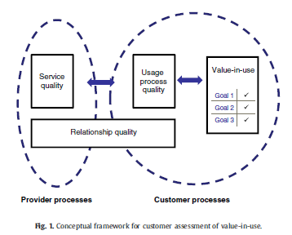

The paper goes onto to undertake a case study in a machine maintenance context, so a subset of members as a pilot would allow FDF to explore this theory in a KIBS context.

4.3 FDF team members views

FDF undertakes an annual survey colleague to assess views of colleagues, with the latest results summary and teamworking analysis in the appendices.

Working in small teams delivering the diverse and complex policy, advocacy, membership, and support functions, has increased the perceived gaps within the organisation.

During Covid, FDF has created differing communication platforms and inconsistent expectations of methods and processes of communication.

The Toyota way offers methodologies in continuous improvement (kaizen) and best practice sharing (yokoten) alongside a standardisation of communication processes as a blueprint.

Also, when considering the concerns on individual overload also expressed within the survey, consideration of how the production of output has been allocated, levelled, (haijunka) should be factored into role profiles and activity allocation.

4.4 Technology potential arising from Covid-19

From (Queen, 2021) the adoption of technology in office communication has evolved and the need to balance this with keeping teams connected and individuals engaged, will be critical to improving both individual and organisational productivity.

Platforms such as Zoom, Teams, Meet and others have evolved however this immediate proliferation of technology, has moved faster than organisational culture, or the development of process norms in FDF.

(Tome et al, 2022) suggest knowledge management as a key enabler and the model of (Edwards 2011) of transferring knowledge in a three phase process of technology, people and process. would be proposed in the post Covid-19 transition to new ways of working.

Voice software, that would, notably for people with slower typing speed including systems like Voicetyper and OtterAI would reduce time writing e-mails and papers.

Artificial intelligence meetings held in the metaverse have been experienced and can be preferred to on-screen meetings. This solution, identified in a global FDF member, is something for FDF to explore.

4.5 Organisational change management

Burnes (1996) identifies that there is not one way to approach change management and references a contingency model of change that moves toward a “bottom-up” rather than “top-down” approach to organisational change.

The combination of “bold strokes”, top-down instant changes which is appropriate given FDF is under the leadership of a relatively new CEO and long marches as a series of small-scale localised changes, that can be used to ensure the organisation has a role to play in the change.

4.6 Availability of data to FDF

One key aspect within Industry 4.0, is the power of data. In the service context, internal investigations identified that an analysis of the value of any data and how it impacted productivity is not readily available and a process analysis is necessary to identify what to measure and how is beyond the scope of this report but needed.

FDFs value to stakeholders is the ability to gain insight into the latest industry intelligence.

Data gathering currently works on subject based committees, regular surveys that require input on a pre-arranged set of questions backed up by individual relationships.

Improving the speed and depth of this data is a challenge within the sector, however making sessions more interactive with tools such as Mentimeter, would improve meeting interaction, and provide immediate insight and data.

Doherty et al, (2011) investigated the recently developed life logging approach, which uses handheld digital technology, to map the life flow of an individual, identifies limitations in a working environment.

5: Conclusions

Measuring productivity in a service environment does not have an industry standard that can be applied, requiring business specific measures to be identified.

FDF is a knowledge intensive business services entity, and with this comes even more complexity around how you can effectively measure productivity, however in working with customers can create an assessment of performance.

Change management in daily management needs to be planned alongside the roll out of technology.

Team working is also critical and the cross functional team approach to crisis management periods is a benchmark for project work streams.

The role of the leader in a hybrid working environment changes to structure non- work related engagements.

Technology is available to improve the operation of the team in digital interactions, and there is scope for FDF to explore more of them.

6: Recommendations

With the variation in demand and activities, the core productivity whilst it cannot be empirically measured, can be improved by exploring the following measures.

- Investigate software options to streamline written communication processes, gather intelligence and measure individuals time utilisation.
- Standardise the process for digital communication for cross functional and external communications. Individual teams should be empowered to define their own ways of working.
- Augment the empowering managers to contribute to change management within the overall FDF framework.
- Select two pilot categories of members and perform a perceived use value analysis to ascertain the balance between provider and customer processes.
- Benchmark the competitiveness of FDF’s impact with other competing organisations as a reflective view, with Government as the customer.
- Identify what internal data measurements would provide insight into the opportunities to improve productivity in FDF’s operating processes.
- Workload analysis of tasks needs to ensure a balance within and across teams in terms of expectation of output.
- Record and analyse attendees at FDF digital and physical events to monitor trends of demand and improve service quality.

7: References

Biege, S., Lay, G., Zanker, C. and Schmall, T. (2013). Challenges of measuring service productivity in innovative, knowledge-intensive business services. The Service Industries Journal, 33(3-4), pp.378–391.
Budhwar, P. and Cumming, D. (2020). New Directions in Management Research and Communication: Lessons from the COVID‐19 Pandemic. British Journal of Management, 31(3), pp.441–443.
Burnes, B. (1996). No such thing as … a ‘one best way’ to manage organizational change. Management Decision, 34(10), pp.11–18.
Choi, J. (1990). Positive leadership: How to build a winning team. Long Range Planning, 23(4), p.121.
Doherty, A.R., Caprani, N., Conaire, C.Ó., Kalnikaite, V., Gurrin, C., Smeaton, A.F. and O’Connor, N.E. (2011). Passively recognising human activities through lifelogging. Computers in Human Behavior, 27(5), pp.1948–1958.
Drucker Institute. (2013). Measurement Myopia * Drucker Institute. [online] Available at: https://www.drucker.institute/thedx/measurement-myopia/.
Macdonald, E.K., Wilson, H., Martinez, V. and Toossi, A. (2011). Assessing value-in-use: A conceptual framework and exploratory study. Industrial Marketing Management, 40(5), pp.671–682.
Mentimeter (2019). Interactive presentation software. [online] Mentimeter. Available at: https://www.mentimeter.com/.
Otter.ai (2021). Otter Voice Meeting Notes. [online] Otter Voice Meeting Notes. Available at: https://otter.ai/.
Queen, D. (2021). Technological impact of
COVID
‐19. International Wound Journal, 18(2), pp.129–130.
The Food & Drink Federation. (n.d.). About the Food and Drink Federation (the FDF). [online] Available at: https://www.fdf.org.uk/fdf/about-fdf/ [Accessed 1 Apr. 2022].
Tomé, E., Gromova, E. and Hatch, A. (2022). Knowledge management and
COVID
‐19: Technology, people and processes. Knowledge and Process Management.
www.voicetyper.com. (n.d.). VoiceTyper Dictation Software - Type With Your Voice. [online] Available at: https://www.voicetyper.com [Accessed 1 Apr. 2022].

8: Appendices

Figure 1 FDF: Staff Survey Executive summary October 2021

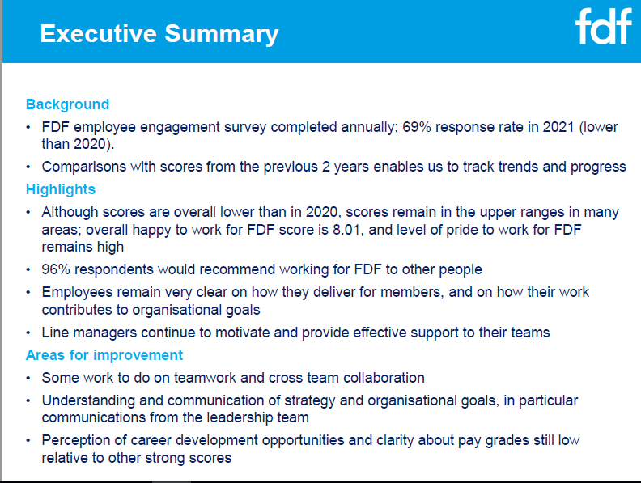

Figure 2 FDF: Staff Survey Executive summary October 2021 – Teamwork extract



