Methodology

Introduction
This chapter outlines the research design and methodology employed to explore the link between ACEs and criminality in adulthood.The chapter will detail the research approach, data collection methods, sampling strategy, and analytical framework, ensuring a systematic correlation between childhood trauma and adult criminal behaviours. By adopting a mixed-methods approach, the study integrates qualitative and quantitative data to provide a comprehensive understanding of the phenomenon(Office for Health Improvement and Disparities,2020). The chapter also addresses ethical considerations, validity, and limitations, establishing a robust foundation for investigating the long-term effects of ACEs on criminal tendencies.This study aims to achieve three key objectives: to explore the negative outcomes associated with ACEs, to review literature identifying the likelihood of adulthood criminality linked to ACEs, and to evaluate public awareness of ACEs and their connection to criminal behaviour, providing insights into prevention and intervention strategies.Research into the link between ACEs and criminality in adulthood,has made potential strides,however,has many notable gaps within what has previously been studied,such as the lack of knowledge of individuals affected by ACEs in the UK(Steptoe et al,2019).

Research Onion
The Research Onion, developed by Saunders et al (2009), provides a structured framework for designing research. It consists of six layers, each representing a step in the research process. The outermost layer begins with philosophies,guiding the research approach. Next is approaches, such as deductive or inductive reasoning. The strategies layer includes case studies, experiments, or surveys, followed by choices between mono, mixed, or multi-method designs. The time horizons layer differentiates between cross-sectional and longitudinal studies. Finally, the innermost layer focuses on data collection and analysis techniques. This systematic approach ensures clarity, consistency, and methodological rigor.

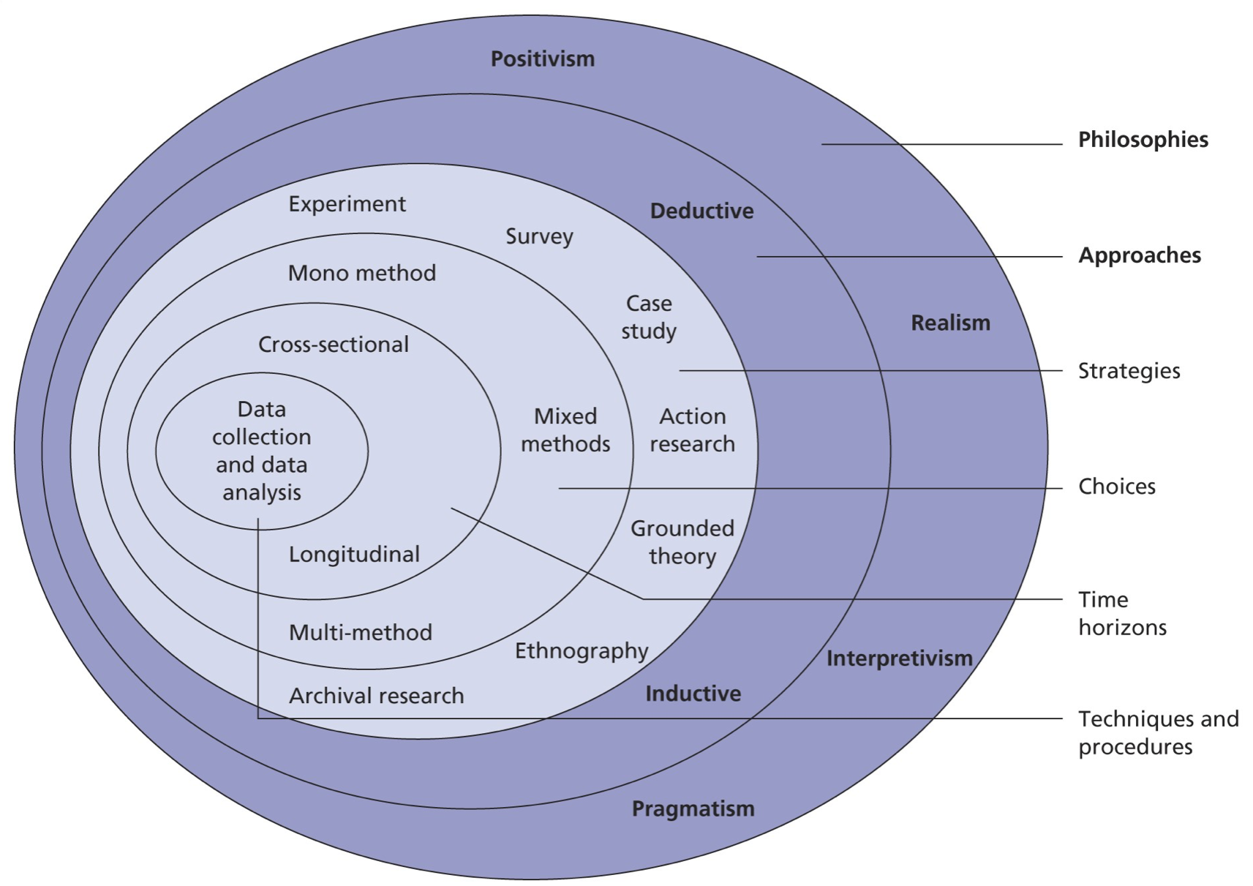

(Saunders et al,2016)

Research Philosophy
The research philosophy provides a foundation for the approach and methods employed in studying the link between adverse childhood experiences (ACEs) and criminality in adulthood. This dissertation adopts a pragmatic philosophy, integrating both positivist and interpretivist paradigms to capture the complexity of the topic. Pragmatism, as suggested by (Prime,2024), is ideal for research addressing real-world problems, as it allows for flexibility in combining qualitative and quantitative methods to provide a comprehensive understanding.The positivist model supports the use of quantitative methods to establish statistical relationships between ACEs and criminality. This objective approach ensures reliability and generalisability, aligning with Saunders et al’s (2009) emphasis on measurable outcomes. Simultaneously, the interpretivist paradigm facilitates qualitative exploration of subjective experiences, enabling a nuanced understanding of how ACEs influence individual pathways to criminal behavior.

Approaches
The research approach for studying the link between ACEs and criminality in adulthood adopts an inductive method, which emphasises generating theory from observations and data. Unlike a deductive approach, which tests pre-existing theories, the inductive method explores patterns, themes, and relationships within the data to build an understanding of how ACEs influence criminal behaviour. This approach is particularly suitable for complex, socially embedded issues like ACEs, where the pathways to criminality may vary across individuals and contexts (Gray et al,2021).The inductive technique, which focuses on qualitative data, enables the researcher to analyse lived experiences and personal narratives, offering deep insights into the ways that trauma presents itself in adulthood. Thematic analysis, for instance, may reveal recurrent themes of social marginalisation, emotional instability, or maladaptive behaviours brought on by ACEs. This supports Braun and Clarke's (2006) view of thematic analysis as an adaptable method for investigating understudied topics.In addition to providing a more thorough understanding of personal paths, the inductive approach aids in the creation of novel ideas that can guide interventions and regulations. Because of its versatility, it is especially useful for examining complex connections, such as those between ACEs and criminal activity.

Strategy
The overall plan that directs data gathering and analysis to meet research goals is known as a research strategy. According to Saunders et al (2009), case studies, experiments, surveys, ethnography, and action research are examples of common tactics. The decision is based on the approach, research philosophy, and practical limitations (Creswell, 2014). While surveys allow for generalisation, case studies provide in-depth examination . A thorough understanding is ensured by mixed-methods procedures, which combine qualitative and quantitative findings (Bryman, 2016).

Choice
The choices layer of the research onion framework (Saunders et al, 2009) is dedicated to choosing a research methodology.For this dissertation,a survey will use a single method of quantitative analysis. This decision makes it possible to gather standardised data from a sizeable sample, which makes it easier to spot trends and statistical connections between adult criminal behaviour and ACEs.
According to Creswell (2014), surveys are an effective and scalable way to gather information about respondents' self-reported ACEs and criminal histories. Furthermore, polls offer anonymity, which prompts respondents to divulge private information.
This approach is consistent with the pragmatic notion of balancing rigour and practicality while focusing the personal approach of valuing individuals opinions, the survey approach helps the study achieve its objective of finding useful information about criminality associated with ACEs.

Time Horizon
The cross-sectional time horizon used in this research focuses on data gathered between October 2024 and May 2025. Examining the association between criminality and ACEs at a specific moment in time is best done using a cross-sectional technique, which allows the researcher to examine patterns and correlations without the need for prolonged monitoring. According to Saunders et al (2019), cross-sectional studies are effective for time-constrained research, since they yield insightful results in less time. This method effectively addresses the study objectives while supporting the dissertation timeline and enabling useful data collecting and analysis.

Techniques and Procedures
This dissertation's methodology chapter describes the methods, approaches, and processes employed to carry out research, guaranteeing openness and reproducibility. The methodology adheres to a systematic framework that covers research philosophy, approach, strategy, time horizon, and data collection tools, and it is based on Saunders et al’s (2016) research onion.

The research philosophy, which governs the researcher's perspective on reality and knowledge, is the uppermost layer of the research onion. This could have to do with pragmatism, positivism, or interpretivism. The research design is also influenced by practical factors like budgetary restrictions, scheduling constraints, and ethical issues. Participant wellbeing is guaranteed by ethical approval, and viability is determined by the timeline(Bryman,2016). For example, qualitative techniques like interviews, which take more time to prepare and analyse, might be more appropriate if the study is exploratory.

Whether the data gathered is main or secondary must be specified in the technique. Whereas secondary data comes from pre-existing datasets, reports, or literature, primary data comes from brand-new techniques like surveys, studies, or interviews. The research strategy, which is another layer of the research onion, determines the decision. Typical methods include surveys, ethnographies, and case studies(Flick,2023). For instance, using semi-structured interviews to gather primary data emphasises participant experiences, which is consistent with interpretivist philosophy.

Sampling is the choice of reliable research and is consistent with the onion's research methodology. Researchers can use non-probability or probability approaches. For example, stratified random sampling may be used in quantitative research to increase generalisability, whereas purposive sampling guarantees that participants are closely related to the study issue in qualitative research(Creswell,2017). The validity of results is improved by providing a detailed description of the sample size and inclusion criteria.

The research philosophy influences the data gathering layer's analytical techniques. While quantitative research may use statistical tests like regression or correlation analysis utilising various programs,qualitative research may use thematic analysis or grounded theory. By combining the two types of analysis, mixed-methods research guarantees a thorough knowledge. Triangulation can also be used to compare the dependability of several sources(Bell et al,2022).

Lastly, resources such as databases, analytical tools, or tangible equipment must be covered by the technique. For implementation to be successful, access to scholarly publications, transcribing software, or survey platforms such as Qualtrics is essential(Yin,2018). Effective planning guarantees that the research remains rigorous while moving forward within limitations.

Limitations
The use of surveys in dissertations, particularly within a restricted time frame, presents several limitations when considered through the lens of the research onion framework (Saunders et al., 2019). These limitations span multiple layers of the framework, impacting the validity and reliability of the research.
Firstly, the time horizon of a cross-sectional study restricts the ability to capture changes over time. Surveys conducted in a short time frame provide only a snapshot of participants’ experiences and perceptions, potentially omitting seasonal, situational, or longitudinal variations (Maier et al,2023). This limitation is significant when examining complex phenomena, such as the link between ACEs and criminality, as temporal factors may influence both recollection of ACEs and current behaviours.
Second, time restrictions may make it more difficult to create reliable survey instruments at the data collection and analysis layer. Tight schedules may make it impossible to conduct imperative piloting and refinement necessary for designing and testing a valid and reliable survey (Liu,2019). Additionally, time-consuming data collection procedures like recruiting and response follow-ups increase the likelihood of low response rates and inadequate sample sizes.
The philosophical perspective also affects interpretation. A positivist survey technique may oversimplify complex human experiences like trauma, since it frequently places an emphasis on measurable facts. The study can be shallow and miss underlying mechanisms if supplementary qualitative methods aren't used.
Lastly, ethical issues like obtaining informed consent and handling delicate subjects like ACEs necessitate careful preparation, which is made more difficult by time constraints(Fisher,2020).

Conclusion
This methodology chapter has described the study's philosophical position, research approach, strategy, and data collection techniques, all of which were informed by Saunders et al.'s (2009) research onion. The selection strategies and data processing procedures improve the validity and dependability of the results, while the selected research philosophy guarantees compatibility with the study's goals (Bengtson,2016).To guarantee viability, resource management and ethical issues have also been covered. Through the methodical implementation of the research onion structure, this technique offers a strong basis for producing significant findings(Creswell,2014).

References
Bell, E., Bryman, A. and Harley, B. (2022). Business Research Methods. 5th ed. Oxford: Oxford University Press.
Bengtsson, M. (2016). How to Plan and Perform a Qualitative Study Using Content Analysis. NursingPlus Open, [online] 2(2), pp.8–14. doi:https://doi.org/10.1016/j.npls.2016.01.001.
Braun, V. and Clarke, V. (2006). Using Thematic Analysis in Psychology. Qualitative Research in Psychology, [online] 3(2), pp.77–101. doi:https://doi.org/10.1191/1478088706qp063oa.
Brody, S. (2024). The Paradox of Achieving Social Embeddedness Through Nonsocial Activities. [online] Association for Psychological Science - APS. Available at: https://www.psychologicalscience.org/publications/observer/teaching-current-directions-social-embeddedness.html [Accessed 21 Jan. 2025].
Bryman, A. (2016). Social Research Methods . [online] Available at: https://ktpu.kpi.ua/wp-content/uploads/2014/02/social-research-methods-alan-bryman.pdf [Accessed 6 Jan. 2025].
Creswell , J. (2014). Research Design: Qualitative, Quantitative, and Mixed Methods Approaches. [online] Available at: https://www.ucg.ac.me/skladiste/blog_609332/objava_105202/fajlovi/Creswell.pdf [Accessed 5 Jan. 2025].
Fisher, S. (2020). Ethical Issues in Surveys. [online] Qualtrics. Available at: https://www.qualtrics.com/blog/ethical-issues-for-online-surveys/ [Accessed 10 Jan. 2025].
Flick, U. (2023). Introduction to Qualitative Research. 7th ed. London: Sage Publications.
Gray, P., Smithson, H. and Jump, D. (2021). Serious youth violence and its relationship with adverse childhood experiences. [online] Available at: https://www.justiceinspectorates.gov.uk/hmiprobation/wp-content/uploads/sites/5/2021/11/Academic-Insights-Gray-et-al.pdf [Accessed 6 Jan. 2025].
Liu, F. (2019). Iterative Design of a Survey Question: A Case Study. [online] Nielsen Norman Group. Available at: https://www.nngroup.com/articles/survey-questions-iterative-design/ [Accessed 10 Jan. 2025].
Maier, C., Thatcher, J.B., Grover, V. and Dwivedi, Y.K. (2023). Cross-sectional research: A critical perspective, use cases, and recommendations for IS research. International Journal of Information Management, [online] 70(70), p.102625. doi:https://doi.org/10.1016/j.ijinfomgt.2023.102625.
Office for Health Improvement and Disparities (2020). Mixed Methods Study. [online] GOV.UK. Available at: https://www.gov.uk/guidance/mixed-methods-study [Accessed 20 Dec. 2024].
Prime, R. (2024). Understanding Pragmatic Research | Pragmatism Philosophy. [online] Best Dissertation Writers. Available at: https://bestdissertationwriter.com/pragmatic-research-philosophy/ [Accessed 4 Jan. 2025].
Saunders, M., Lewis, P. and Thornhill, A. (2009). Saunders, M., Lewis, P. and Thornhill, A. (2009) Research Methods for Business Students. Pearson, New York. - References - Scientific Research Publishing. [online] www.scirp.org. Available at: https://www.scirp.org/reference/referencespapers?referenceid=1903646.
Saunders, M., Lewis, p and Thornhill, A. (2016). Saunders, M., Lewis, P. and Thornhill, A. (2016) Research Methods for Business Students. 7th Edition, Pearson, Harlow. - References - Scientific Research Publishing. [online] www.scirp.org. Available at: https://www.scirp.org/reference/ReferencesPapers?ReferenceID=2397725.
Steptoe, A., Marteau, T., Fonagy, P. and Abel, K. (2019). ACEs: Evidence, Gaps, Evaluation and Future Priorities. Social Policy and Society, [online] 18(3), pp.415–424. doi:https://doi.org/10.1017/S1474746419000149.
Yin, R.K. (2018). Case Study Research and Applications: Design and Methods. 6th ed. Thousand Oaks, California: Sage Publications.

