1/8/2018
Bethan Watkins (P140639)
University of Wales Trinity Saint David
Managing change within tourism and events organisations
A case study of Airbnb: The 90-night annual limit for London hosts.

Executive Summary
This report will critically evaluate a change within a selected organisation. Two main themes will be assessed creating a conclusion and recommendations which will determine if the change within the organisation was successful.

Introduction
The Sharing Economy refers to “the use and access of shared physical or human resources or assets, rather than the fact there is no monetary exchange” (Matofska, 2016) arguably the Sharing Economy can also identify as the Gig Economy as the “labour market characterised by the prevalence of short-term contracts or freelance work, as opposed to permanent jobs” (BBC News, 2017).
This report will address the recent change of Airbnb 90 night limit ban where Airbnb must comply with Section 25 of The General Powers Act in 1973 which was introduced by the Greater London Council. This change within Airbnb ensures that all hosts comply with the Act as if not planning permission is required by any hosts who wish to exceed the 90 consecutive nights if hosts do not comply with this act this as hosts will be found with an ‘offence’ of a £20,000 fine.

Airbnb Background
Airbnb was founded in 2008 where it is based in San Francisco, California. There is a total of over 200,000,000+ users of Airbnb across the world with 65,000+ cities are using Airbnb as a form of accommodation (Airbnb, 2017). Airbnb advertises that London is boarded within sections such as Wapping, Holborn, City of Westminster, Bermondsey, LB of Tower Hamlets, Whitechapel/Brick Lane, LB of Hackney, St. Luke’s, LB of Islington, and LB of Camden. This research shall be focusing on the change as London as a whole (Airbnb, 2017).

Airbnb’s Change
From the 1st of January 2017, Airbnb complied with the current United Kingdom law and introduced a counter system that limits hosts to listing their property within the London Greater area to 90 nights per calendar year unless hosts are able to obtain planning permission from their local authority. Airbnb (2017) comments that “once the hosts receive 90 nights of bookings for the current calendar year, the system will atomically limit your listing form being booked for dates in the rest of the calendar year”. Airbnb (2017) also comments that “Airbnb is committed to growing tourism sustainably, and is the only platform that has introduced this voluntary measure to encourage responsible hosting in London”. As the majority of hosts in London have lettings out more than 90 consecutive nights a year this may be a major issue for hosts.
Dating back to the 1970’s, London short-term use of people letting their homes is strictly regulated under the legislation. The Greater London Council introduced the General Powers Act in 1973 which introduced restrictiveness of use of the “residential premises in 32 London boroughs and the city as temporary sleeping accommodation” (The National Archives, 2017).
Airbnb’s decision to take action now comes into results of a wider concern that Airbnb as a whole is impacting the long-term rental market. While local communities are also worried that the pull of Airbnb could change the nature of individual homes, buildings and the neighbourhood (Glover, 2017).

Process of the change
Understanding that Airbnb will need to change their current status quo within the organisation to comply with the Governments Act, Lewin’s force-field theory will be able to address the driving forces and the restraining forces. The underlying principle is “that driving forces must outweigh resisting forces in any situation if the change is to happen”. The figure bellows the forces for change and the forces against change, each of the factors has been scored to demonstrate whether this change would be for or against. Continuing from this, Airbnb will be able to understand the principle of the issue that lay ahead before the change has happened.
Figure 1.0. Lewin’s Force Field Analysis
Forces FOR Change | Score
Government | 5
Financial Issues | 5
Ratings from London Visitors | 3
Economic impact | 3
Housing Agents | 3
TOTAL | 19

Forces AGAINST Change | Score
Decrease with online users. | 2
Sales for London Properties will decrease | 2
Airbnb obligation towards hosts | 4
Discomfort for the hosts | 4
TOTAL | 12

Forces for Change

Government
The Government plays a major part in the reasons for the change. Created by the Government has taken steps to ensure that all people that are participating from the Sharing Economy are complying with Section 25 of the Greater Council General Powers Act 1973. Thus, planning permission is required if hosts wish to exceed the 90 consecutive nights. As stated by the Department for Communities and Local Government (2015), Londoners can participate in the Sharing Economy and benefit from the recent innovations in information technology by letting either a spare room or their whole house in the same way as other residents across the country. There has been a proposal document that has been created by the Department for Communities and Local Government, ‘Promoting the Sharing Economy in London’. This document gives outlines of why change is needed within the Sharing Economy in London. 1) There is a £20,000 fine for each ‘offence’ for failing planning permission if hosts wish to exceed the 90 consecutive nights per year arrangement. 2) According to the Department for Communities and Local Government (2015) last summer, 2014, nearly 5 million overseas visitors visited London. As some of these visitors wish to visit the city as experience London as a local this means that the visitors are staying with Londoners, or in their homes, while they are away on holiday. 3) Airbnb advertises thousands of properties in London, however, each of these rooms or houses may be in breach of Section 25 of the Act. There has been confusion and uncertainty for householders as the legislation was enforced poorly and made apparent during the London Olympics 2012. 4) The Tourism Industry within London may increase as a whole, therefore, showing a positive outcome but also families utilise The Sharing Economy may see this as extra income. 5) With visitors staying in London homes, this offers alternative accommodation other than hotels and guesthouses. 6) The Government states that they “want to give Londoners the opportunity to be part of their modern approach and able to participate fully in the sharing economy.”

Financial Issues
As mentioned previously, The Government’s proposal document if hosts or landlords do not comply with the act, and exceed the 90-night limit with no planning permission there will be classed as an ‘offence’ and a fine will be given of £20,000 per host (Airbnb, 2017).
In result of the 90-night limit per year, Airbnb are set to loose approximately £325m bookings in London, studies show from AllTheRooms that Airbnb bookings are actually threatened by the 90-night cap as some bookings will simply move to different properties on different platforms. AllTheRooms predicts that Airbnb takes thirteen per cent commission from bookings resulting to Airbnb missing commission of £100m (Independent, 2017).

Ratings from London Visitors
Trustpilot is a website where people are able to review Airbnb within the London area. (Trustpilot 1, 2017). By doing this Airbnb can read what people are saying and what thoughts they have of the company. This results overall for the company to be able to learn from guest’s experiences and what they can do to improve their services. Although this change may not be directed towards the 90-night limit, this can be seen as the more hosts that are publicising themselves within London the more reviews will be left on websites such as Trustpilot. Currently, Airbnb is rated 21% as excellent accommodation whereas on the other hand are rated extremely high with 58% of bad comments. This is an incentive for Airbnb, as they can see that comments from guests are negative and that the hosts are unable to progress as an excellent host.

Economic Impact
Dr Margarethe Theseira a London-based Economist researched that the year of 2016 Airbnb generated £502 million in economic activity. Dr Margarethe continued to state that “Airbnb guests stay longer, spend more, and explore new neighbourhoods. This undoubtedly has a positive impact on cities and residents across the UK” (Airbnb 7, 2017). According to this study, although the 90-night limit change has did not change in the year 2016, Airbnb hosts rent their homes (that they live in) on average 33 nights per year and can still earn an additional £2,822 a year. Although the 90-night limit has been introduced in 2017 this study shows a positive research as other hosts may be more accepting of the change this can be done by seeing the financial benefits (Airbnb 7, 2017).

Housing Agents
London, being one of the top places for any traveller to visit in the United Kingdom is one of the most expensive places in the world to live. Airbnb has been able to open doors for people to change the way that they live, work and travel within London. According to Business Division (2016) renters are prepared to pay up to £4m in advance to secure accommodation in the best areas of London for long-term letting period. An article that has been published by Skift.com indicate that the listings that are currently on Airbnb’s UK’s website is full of listings that belong to professional and buy-to-let investors with empty properties. Airdna (2018) provides a map of the users and a breakdown of the online users and the amount of properties that can be found within London, please view Appendix 8.1. Overall, Coldwell (2015) released and article for The Guardian commenting that Airbnb is having a negative effect on the rental market, reducing the number of long-term homes available for locals, and pushing up rents in the process.
If Airbnb will not comply with the 90-night ban within London online users within London may drop excessively thus reducing the number of online users for Airbnb.

Forces against change

Decrease with online users
As Airbnb introduced the new automated system that caps any hosts from listing their homes for more than 90-nights a year has fallen therefore, showing that either hosts are not listing their homes for more than 90-nights per year or hosts have completed planning permission for the home to be listed.
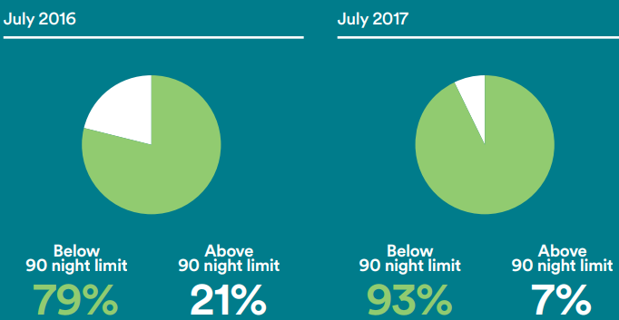

Figure 1.2. Airbnb statistics of 90-night limit
Figure 1.2 shows that only 7% are booked for 90-nights or more on a short term rental basis. This is two-thirds of a reduction due to the new automated system that has been introduced. Any hosts that have not got the relevant permission, the calenders that they have access to for the whole year has been blocked from accepting further entire-home bookings for the remainder of the year (Airbnb 8, 2017).

Sales for London lettings will decrease
As this document is addressing the reason for change within the Sharing Economy no external factors have been mentioned. Factors such as London homes are now less affordable than ever before. Smyth (2017) addresses this issue by stating that London house prices rose an average 3 percent in the year ending October to £496,000 which is less than half the 7.7 percent growth rate of the year earlier. Airbnb is more affordable for any visitors visiting London than a hotel, stated by Snelling, Colebrook, & Murphy (2016). On a per-night basis a landlord or host can offer a higher return than a long-term residential let.

Discomfort for the hosts
As this change will be effecting the hosts first-handed this can cause discomfort for all hosts using Airbnb. An article which has been released on Airbnbhosting (2018) reveals the opinions of a host and how this change will affect the individual personally. The anonymous host explains that Airbnb sent a letter to each host within London that states that the entire home listings are not shared for more than 90 nights a year. The host comments that “I think that Airbnb is trying it’s best to conform with local rules, hopefully is doing it in such a way to give hosts a chance to be seen to adhere to local rules and still host without interruption” This can be believed that the this rule may be concerning to the hosts whom wish to continue letting their homes out worry-free.
Applying for planning permission to continue letting rooms out past the 90 night rule may be because some hosts hassle, as it is believed that the “planning application process may take up to six months and is bureaucratic and costly, while the likelihood of obtaining approval is love” (Hostfully, 2017). Hostfully (2017) also comment that the attitudes for this rule changing varies from one London borough to another. Either some strongly resist in favour or other are permissive.

Obligation towards hosts
As mentioned previously, Airbnb must ensure that all London hosts are made aware of this change and ensure that everyone follow all changes that are being made. In doing so, the work load for Airbnb staff may prove strenuous.
As the Government and the media closed in to see whether Airbnb will make any changes, Airbnb did in fact create a singular webpage for hosts to visit as it explains the new rules for Airbnb which can be seen as Airbnb staff replying to hosts most common questions regarding the change, issues such as deactivating hosts automatic limit, if hosts have several listings in London and many more issues. This being said, a recommendation page has been created where a host comments that “I wish Airbnb would make it easier for their hosts to figure out how to contact them” (Brittany, 2016) providing evidence that Airbnb hosts are unable to contact them for small matters, issues such as contacting Airbnb regarding this new rule may also be an issue due to the lack of communication.
Whereas there is a page called Responsible Hosting in the United Kingdom which again explains London’s 90 night a year rule. A picture of the text has been added in Appendix 8.2.
In January 2017 the 90-night limit was introduced for 2017 calendar year. This is where the counter on any hosts Airbnb will be shown and how many listing they have left until the 90-night is up.

Change Process
Teleological is an assumption that organisations are purposeful and adaptive in which an organisation is willing to learn through this theory, whereas the Dialectical theory is a conflict between different interest groups, such as Airbnb’s hosts and the Government (Hayes, 2014). These theories offer alternative views on how Airbnb undertook the change process during the time of enforcing Section 25 of the Declaration Act.
As this is a major change Airbnb and the hosts of London went through this would show a sign of punctuated equilibrium organisation transformation. Although the company is still expanding their need to grow as a whole, by bringing the Act into force with the hosts of London this change would be perceived as a sharp burst of revolutionary change as Airbnb go through long periods of evolutionary change and short (Burns, 2014).

Airbnb Stakeholders (Power Interest Grid)
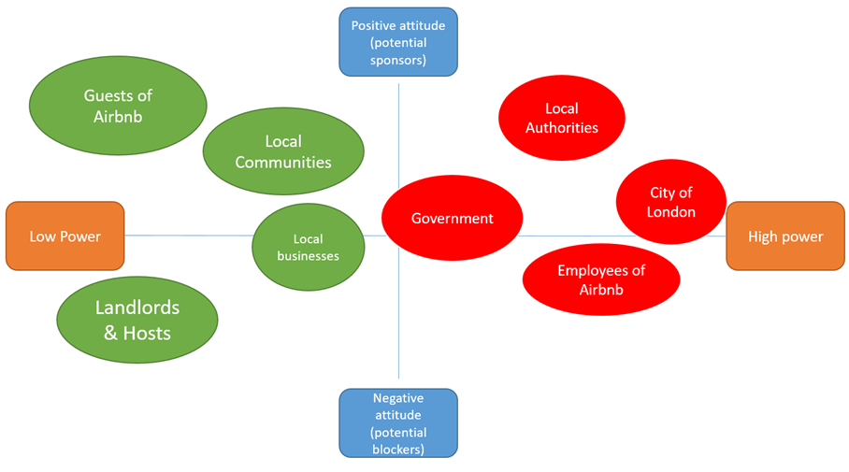
Figure 1.3 shows Airbnb’s stakeholders, also known as a power interest grid. Each stakeholder may find advantages and disadvantages of this change that Airbnb are undertaking.
Figure 1.3. Airbnb Power Interest Grid
 | Advantage | Disadvantage
Guest of Airbnb | - More hosts may advertise different properties in the surrounds of London  - Guests may feel safer knowing that the property that they are staying in are now complying with the rules | - The property that any guests had booked in advance prior to the new rule may need to book elsewhere if hosts have not applied planning permission.  - Guests may lose money if already booked.
Local Communities | - The restrictiveness of this rule will allow neighbours to complain of the guests that are staying in the property.  - Less bookings for local Airbnb hosts resulting into less vandalism for buildings. | - If less guests come to the area the economy within the area may drop therefore, less money for the local community.
Local Businesses | - The local community can visit the local businesses without a demand from guests. | - As less people may book within the communities, local shop and local restaurants may suffer a loss of income due to the less guests arriving in the area.
Landlords & Hosts | - Landlords from private properties may have an increase in guests as the 90-night limit may cause guests to stay elsewhere. | - The change will cause hosts to apply for planning permission which can cause a delay in more guests staying in their property.
Local Authorities | - Less demand for local authorities may occur.  - Demand for serious enquiries will be answered faster. | - Less demand may cause staff to have less work within the area.
City of London | - London as a whole will be less populated.  - Local transport will be less pressured. | - During the less busy periods of the year such as Christmas Airbnb guests will be able to tour London and also bringing money for the City of London.
Government | - Airbnb are complying with the rules therefore all other sharing economies will be able to follow this example.  - The Government can and will ensure the safety of all guests/tourists while staying in London. | - As the Sharing Economy is increasing the Government will need to pay closer attention to ensure that all companies are following rules.
Employees of Airbnb | - Ensuring that all hosts are complying with the new rules. | - This new change may cause employees of Airbnb more administration work for London hosts.
Figure 1.4 advantages and disadvantages of 90-night limit in London

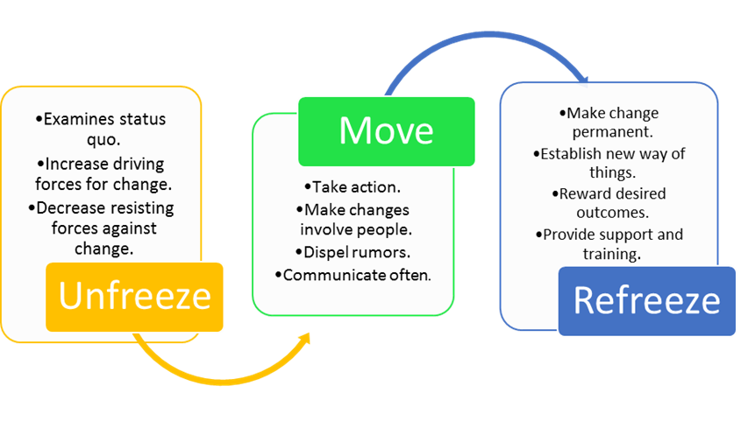
Three-step model

Figure 1.5 three-stop model of Airbnb change
Understanding that all external and internal stakeholders will be enduring change through this new rule that the Government has enforced Lewin’s three-step model can provide a contribution to the organisation change.
Unfreezing is the first stage that any organisation will need to start the change. Examining the status quo was established by Government and followed by Airbnb themselves. The Government could see that hosts of Airbnb were to complying by section 25 therefore action was needed. Lewin’s Force Field can provide evidence that the driving forces for change was significantly higher than the resisting forces showing that Airbnb are able to make this change as a permanent matter.
Eventually, after unfreezing the current status quo Airbnb will need to take action and provide the Government with evidence that the change is happening. Airbnb must understand that people are involved within this change such as internal and external stakeholders (as mentioned in figure 1.4) and the guests that use Airbnb. During this process of the change the guests may experience individual change which can be identified with Adams, Hayes and Hopson’s (1976) change curve as seen in Figure 1.6. Airbnb will need to understand that this is how individuals may or may not feel during the time of change.
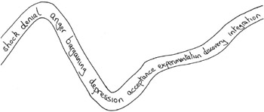

Figure 1.6 Adams, Hayes and Hopson’s (1976) change curve
Other issues may involve rumours that the media could spread regarding this change while also not communicating often. As mentioned previously, Airbnb did in fact send out a letter to all hosts according to Airbnbhosting (2017).
After the move/change has been completed Airbnb will finally complete the three-step model, this will mean to refreeze the changed status quo. Therefore introducing the current automated system that will allow London hosts to view the amount of days they have left on their calendar while also allowing the hosts to apply for planning permission if they require to succeed past the 90-night limit.

Conclusion
The change that Airbnb implemented has been overall a success. However, ensuring that all organisations that are part of the sharing economy as well as the popularity of Airbnb are keeping to the Governments rules and regulations, this may take time throughout the years but with clear communication, updating hosts, eliminating any competition that Airbnb have the status quo may remain the same.
The rule of the 90-night limit was inevitable due to hosts not complying with the act the Government created, increase of guests using Airbnb, the mass growth of people visiting London and the short-term lettings decrease of buyers Airbnb needed to seize control of the growing hosts. For future reference, it is believed that Airbnb must comply with all rules and regulations that the Government have created to ensure the safety of hosts and guests using Airbnb.

Recommendations
This section of the report will contain recommendations for Airbnb to ensure that the status quo will remain the same and if there will be a change in the possible future how Airbnb can refrain from causing unpleasant reviews.
Communication with hosts, guests and the government – Due to the lack of communication to the hosts during this change Airbnb should think it wise to communicate thoroughly if a change may occur again. This can be said for the guests as the hosts will be able to pass the correct information on to the guests as well. If Airbnb may continue to advertise their organisation in London area they must ensure that all rules are being followed within the declaration act.
Technology on Airbnb website – As Airbnb enforced this rule across the London area, the system automatically limited hosts on their calendar. Airbnb can ensure that this will remain the same for the future but also warning new hosts that join Airbnb to be mindful of the amount of times they let their properties out throughout the year by simply sending a message. Also friendliness on their app, although the automated system may work on computers guaranteeing that the system works on the app as more hosts use their mobile phone for access.
Marketing programmes for non-super-hosts – Due to the growth of super-hosts owning more properties in London regular host may find it difficult letting their properties due to the rule and over the competition. Marketing options should be made available for regular hosts or more opportunities for hosts to establish themselves on their website.

Appendix

Airdna online users map
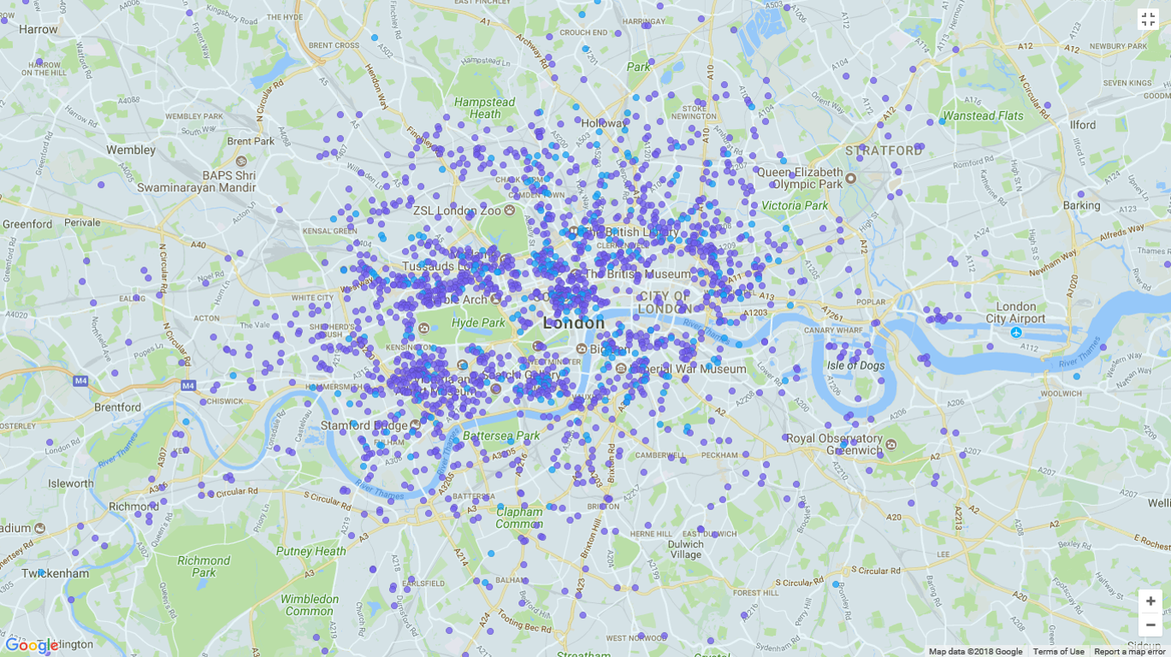
All users then are split into categories, Super Hosts, Multi-listing hosts and Single listing hosts. Airdna can then determine the percentage of users within these categories that are active using Airbnb: Super Hosts 4.235 (17%) Multi-listing hosts 5.905 (23%) single listing hosts 19,274 (77%). After this is completed the summary of the amount of properties can identify with the categories of the users: Single-listing hosts – 19,274 properties (36%) and Multi-listing hosts 33,806 (64%).

Airbnb’s hosting in London
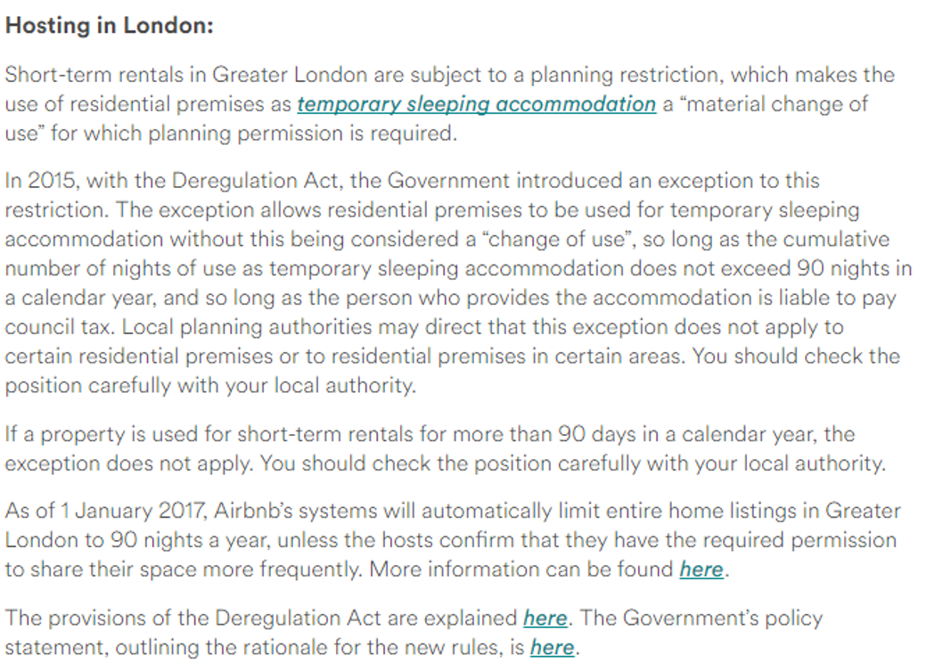
Where there is blue, italic and underlines writing the page will allow readers to visit other websites which helps the hosts understand the new rule.

References
Adams, J., Hayes, J., & Hopson, B. (1976). Transitions: Understanding and managing personal change. London: Martin Robertson.
Airbnb 1. (2017). About Us. Retrieved from Airbnb: https://www.airbnb.co.uk/about/about-us
Airbnb 2. (2017). City Of London. Retrieved from Airbnb: https://www.airbnb.co.uk/locations/london/city-of-london
Airbnb 3. (2017). How do I earn travel credit from referring a friend to Airbnb? Retrieved from Airbnb: https://www.airbnb.co.uk/help/article/84/how-do-i-earn-travel-credit-from-referring-a-friend-to-airbnb
Airbnb 4. (2017). Responsilble Hosting in the United Kingdom. Retrieved from Airbnb: https://www.airbnb.co.uk/help/article/1379/responsible-hosting-in-the-united-kingdom
Airbnb 5. (2017). Travelling Help. Retrieved from Airbnb: https://www.airbnb.co.uk/help/article/1340/i-rent-out-my-home-in-london--what-short-term-rental-laws-apply
Airbnb 6. (2017). Night Limits: Frequently Asked Questions. Retrieved from Airbnb: https://www.airbnb.co.uk/help/article/1628/night-limits--frequently-asked-questions
Airbnb 7. (2017). New Study: Airbnb Community Generates £502 Million in Economic Activity in the UK. Retrieved from Airbnb: https://www.airbnb.co.uk/press/news/new-study-airbnb-community-generates-502-million-in-economic-activity-in-the-uk
Airbnb 8. (2017). Airbnb UK Insights Report. Bringing You Home Sharing Region by Region, 48-50.
Airbnbhosting. (2018). Airbnb 90 day rule. Retrieved from Airbnb Hosting: https://airbnbhosting.co.uk/tag/airbnb-90-day-rule/
Airdna. (2018). London. Retrieved from Airdna: https://www.airdna.co/market-data/app/gb/london/london/overview
BBC News. (2017, Febuary 10). What is the 'gig' economy? Retrieved from BBC News: http://www.bbc.co.uk/news/business-38930048
Booth, R., & Newling, D. (2016). Airbnb Introduces 90-day annual limit for London hosts. Retrieved from The Guardian: https://www.theguardian.com/technology/2016/dec/01/airbnb-introduces-90-day-a-year-limit-for-london-hosts
Brittany. (2016). Airbnb. Retrieved from Recommendations for Airbnb and the community center: https://community.withairbnb.com/t5/Hosting/Recommendations-for-Airbnb-and-the-community-center/td-p/88151
Burnes, B. (2014). Managing Change. Harlow: Pearson Education Limited.
Business Division. (2016). The Impact of Airbnb in London and it's effect on letting agents. Retrieved from BusinessDivison: https://business-division.co.uk/finance/impact-airbnb-london-effect-letting-agents/https://business-division.co.uk/finance/impact-airbnb-london-effect-letting-agents/
Cameron, E., & Green, M. (2015). Making Sense of Change Management. London: Kogan Page.
Carnall, C. (2007). Managing Change in Organizations. Essex: Pearson Education Limited.
Coldwell, W. (2015). Retrieved from The Guardian: https://www.theguardian.com/travel/2015/feb/10/airbnb-to-be-legalised-in-london
Davies, M. (2017). Models of Organisational Change. UWTSD (p. 42). Swansea: UWTSD.
Department for Communities and Local Government. (2015). Promoting the sharing economy in London. Retrieved from Department for Communities and Local Government : https://www.gov.uk/government/uploads/system/uploads/attachment_data/file/402411/Promoting_the_sharing_economy_in_London.pdf
Dorsey, B. (2017). TBG. Airbnb Loyalty Program.
Evans, J., & Pickford, J. (2016). Best of Money: Airbnb backlash spells trouble for landlords. Retrieved from Financial Times: https://www.ft.com/content/f500e932-baff-11e6-8b45-b8b81dd5d080
Glover, B. (2017). Airbnb enforces 90 night annual limit for London Hosts. Kingsley Napley.
Hayes, J. (2014). The Theory and Practice of Change Management. New York: Palgrave Macmillan.
Hostfully. (2017). How London hosts can manage around Airbnb's 90-day limit. Retrieved from Hostfully: https://travel.hostfully.com/how-london-hosts-can-manage-around-airbnbs-90-day-limit-8d8ed0169c8
Independent. (2017). Airbnb to lose £325m in London bookings after holiday rental rules tighten. Retrieved from Independent: http://www.independent.co.uk/news/business/news/airbnb-to-lose-325-millions-london-bookings-rules-holiday-rental-rooms-website-online-hotels-a7506836.html
Investopedia. (2017). Sharing Economy. Retrieved from Investopedia: https://www.investopedia.com/terms/s/sharing-economy.asp
Kotter, J. P. (1995). Leading Change: Why transformation efforts fail. Harvard Business Review, 59-67.
Manktelow, J., Cook, L., Bishop, L., Moss, I., Jackson, K., Edwards, S., & Pearcey, E. (2017). Making Organizational Change Happen Effectively. Change Management .
Matofska, B. (2016, September 1). What is The Sharing Economy? Retrieved from The People Who Share: http://www.thepeoplewhoshare.com/blog/what-is-the-sharing-economy/
McGregor, D. (1960). The Human Side of Enterprise. Health Team News.
Mulholland, B. (2017, July 24). 8 Critical Change Manaement Models to Evolve and Survive. Retrieved from Process: https://www.process.st/change-management-models/
Skift, Ball, J., Arnett, G., & Franklin, W. (2014). A Deep Data Dive Into How Airbnb Is Changing London Lodging. Retrieved from Skift: https://skift.com/2014/06/21/a-deep-data-dive-into-how-airbnb-is-changing-london-lodging/
Smyth, S. (2017, November 28). London Homes Are Now Less Affordable Than Ever Before. Retrieved from Bloomberg Markets: https://www.bloomberg.com/news/articles/2017-11-28/london-homes-less-affordable-than-ever-at-14-5-times-earnings
Snelling, C., Colebrook, C., & Murphy, L. (2016). Homesharing & London's Housing Market. London: IPPR.
The Guardian. (2016, September 6). The UK firms reliant on the gig economy. Retrieved from The Guardian: https://www.theguardian.com/money/2016/sep/06/uk-firms-reliant-on-gig-economy-uber-deliveroo-
The National Archives. (2017). Deregulation Act 2015. Retrieved from The National Archives: http://www.legislation.gov.uk/ukpga/2015/20/notes/division/5/46
Trustpilot 1. (2017). Potential Customers Read Your Trustpilot reviews. Retrieved from Trustpilot: https://uk.business.trustpilot.com/?utm_medium=consumer&utm_source=for_companies&utm_campaign=consumer_cta
Van De Ven, A. H., & Poole, M. S. (1995). Explaining development and change in organizations. Academt if Management Perpectives.

