Planning and Delivering an International Meeting/Event.

A 2500 Word Report

BMIH 6007 INTERNATIONAL MEETINGS MANAGEMENT FOR THE HOTEL INDUSTRY
STUDENT: FESTUS TUMI 2121888
LECTURER: KATHRYN FLYNN

Contents

Executive Summary 2
Introduction: 2
Feasibility 3
The Event Cycle 4
Pestle Factors 4
The Event Concept 6
Aims and Objectives of the Meeting/Event 7
Event Operations 8
Venue Management 8
Marketing and Promotion 9
Event Budget 11
Industry Trends / Issues / Impacts 11
Conclusion 12
REFERENCES: 13

Executive Summary

The Greater Accra Hotel Technology Conference (GAHTC), organized by Hotel Link Ghana (HLG), aims to address the growing digitalization needs of small to medium-sized hotels in the Greater Accra region. Event studies, as defined by Getz and Page (2019), focus on the planning, management, and outcomes of planned events. The GAHTC is a strategic initiative to leverage digital solutions to enhance the competitiveness of local hotels against established international chains. The conference will be held at the Tang Palace Hotel, a venue chosen for its strategic location and robust technological infrastructure, underscoring HLG’s successful online marketing strategies.
The event will follow a project management approach, encapsulating the event cycle stages: conceptualization, planning, execution, and post-event analysis. This structured approach ensures meticulous planning and successful implementation. The conference will feature keynote speakers, panel discussions, workshops, and product demonstrations by technology partners. The aim is to provide hoteliers with practical insights into leveraging digital tools to improve their operations and occupancy rates.
Ghana's tourism industry has seen significant growth, with a 47% increase in visitors in the first quarter of 2023. However, a substantial portion of local hotels lacks a digital presence. The GAHTC addresses this gap by showcasing digital solutions that can drive bookings and enhance hotel management. With a targeted market of over a thousand hotels, the conference aims to attract 300 representatives over two days, facilitating knowledge exchange and business growth.

Introduction:

Getz and Page (2019) describe event studies as “an academic field devoted to creating knowledge and theory about planned events.” They opine further that it encompasses the “planning and management, outcomes, experience of events…..and all the dynamic processes shaping events and the reasons why people attend them.”
Events can be corporate, social, virtual, for charity, cultural (music and sporting) and community but the common thread between them is the attendance of people to a specific location for a specific purpose.
The Meetings, Incentives, Conferences and Exhibitions industry more commonly abbreviated to the MICE industry are corporate events organised by a business designed for team members, existing and potential clients, government officials or the general public.

Getz and Page (2029b) in the diagram show event studies and management can be applied to enhance tourism.
Figure 1. Event tourism
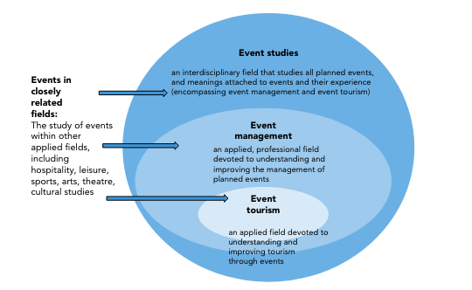

Feasibility
The planning stage contemplates the five W’s and H… the event elements that stands for “who, what, when, where, why and how.” Wolf, Wolf and Levine (2005)
Feasibility has been defined any study that can used to help determine whether there is a need to provide the need to such an event in the first place and includes the basic research that would lead to the successful outcome of the event (Bowen et al 2009)
O’Toole’s (2011) Strategic feasibility and development diagram below outlines how a city or region may be the primary stakeholder in the management of an event, determining the “host’s or client’s objectives, the process of support, the levels of support and the application process.”
Figure 2. Strategic development diagram
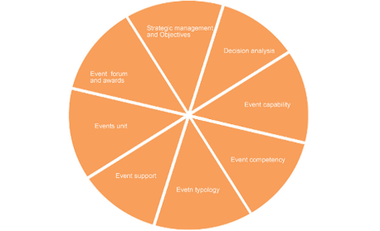

The Event Cycle

Figure 3. The event cycle

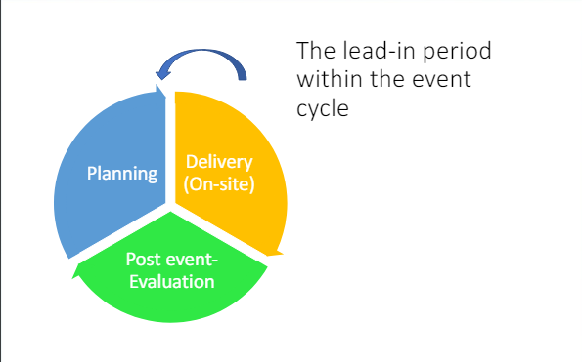
The event cycle encompasses a series of strategic stages designed to plan, execute, and analyse an event effectively. It begins with conceptualization, where the idea for the event is developed based on a specific goal or opportunity.
The planning phase follows, involving detailed logistical arrangements, budgeting, and marketing strategies. HLG meticulously chose the Tang Palace Hotel in Accra for its event, known as the GAHTC, leveraging the hotel's proximity to the international airport and its prime location in the Roman Ridge enclave. The venue was selected not only for its convenience but also to showcase the success of HLG’s online marketing technology, as evidenced by the hotel’s impressive average occupancy rate of 82% and the fact that 72% of its bookings are made online.
Execution is the stage where the event takes place. HLG’s event will feature a ticketed promotion and a mini expo, creating an engaging platform to launch their digital product. This phase requires precise coordination to ensure a seamless experience for attendees.
Finally, the post-event phase involves analysing the event's success, gathering feedback, and assessing the return on investment. This step is crucial for refining future events and enhancing HLG's strategic approach in promoting their digital solutions.
As a private for profit company, the HLG event will take the form of a ticketed promotion/digital product launch with a mini expo.

Pestle Factors
The Ghana Government has targeted tourism as a means of generating much needed foreign exchange and during the first quarter of 2023 noticed a 47% increase in visitors from 170,000 to 247,000 compared to 2022, with an anticipated income of $741m (Presidential Summit on Tourism Report 2023)
According to the Ghana Tourist Authority (GTA), the number of licensed hotels and lodges in Ghana has grown from 1,250 in 2008 to 4,190 in 2022, an increase of over 330% (Sasu, 2023)

Figure 4.
Number of licensed tourist accommodation establishments in Ghana from 2016 to 2022
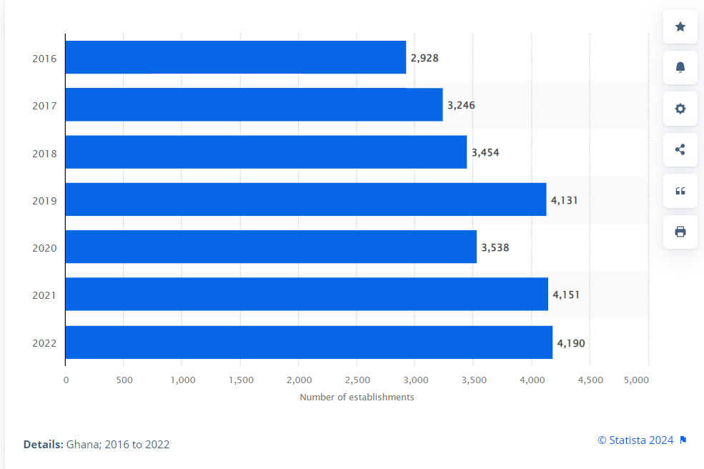

Following research conducted by GN Research in Accra in 2016, it was found that 81% of hotels in Ghana’s capital city did not have a website. (Buxton 2016) Five years later in June 2021 the CEO of the Ghana Tourism Authority reiterated the earlier research and acknowledged that 80% of hotels across the country did not have websites.
Technology and digitization in the hotel reservation process has now become the norm (Schaarschmid & Hober 2017) rather than the exception with over 66% of all hotel bookings made online (Hines and Catron, 2024)

The Event Concept
Based on the above information and seeing a business opportunity Hotel Link Ghana (HLG), a private company affiliated to Hotel Link International that offers a comprehensive digital toolbox with all the digital solutions that a small to medium hotel needs was formed.
Providing websites, Online Travel Agency connections (OTA’s), live booking engines and property management systems HLG will host the Greater Accra Hotel Technology Conference (GAHTC) and Mini Expo that will help hoteliers within the Accra metropolis take advantage of the increasing tourist numbers and compete using similar technology that the more established international hotel chains that have developed, but at a fraction of the cost.
The GAHTC will take place at the Tang Palace Hotel, in the fashionable Roman Ridge enclave of Accra, not far from the international airport. As an existing client of HLG and with an average occupancy of 82%, and with 72% of those booking made online it was chosen to show the success of a hotel using HLG online marketing technology.
The idea is to hold a conference that brings together the main technology partners that enables HLG to be a one stop solution to the small and medium sized hotels in Ghana, playing the multifaceted role of an event planner. As a slight departure from the presentation, the conference speakers will be livestreamed so as to reach hoteliers across the country, and thereby opening the potential for similar conferences across the country.
There is a lot of emphasis on digitalisation across the country and this has been spearheaded by the country’s vice President and it remains a key element of his own presidential campaign, reiterating that digital technology will take an increasing role in the tourism development of the country (Bawumia 2021)
With the steadily growing increase in tourist numbers as identified in the introduction of this report, the GAHTC’s aim is to widen the exposure of locally owned hotels using the power of the internet.
This is an opportunity that allows HLG to use this to promote and expand its current offering. Working with hotel technology partners such as OTS’s like Expedia.com; major telecom companies like MTN, other partners will include fintech companies, Smart TV resellers, accounting software and POS providers. Any local hotelier in the greater Accra area wanting to find out just how this technology can work for them ought to attend.

Aims and Objectives of the Meeting/Event

The Ghana Tourism Authority (2022) reports a total of 1202 hotel accommodation providers in the greater Accra (including Tema) area, the vast majority being of 3 star and below. Based on the earlier observation that 80% of hotels didn’t have websites that would have a potential market of over a thousand hotels to work with.
Event strategy is the ability to develop a SMART (Specific, Measurable, Achievable, Realistic and Timely) programme would determine the success of the event (Cvent Guest 2024) For instance, seeing a business opportunity, Hotel Link Ghana (HLG), a private company affiliated with Hotel Link International, decided to host an event to promote its comprehensive digital toolbox tailored for small to medium hotels.
HLG would be looking at a two day event anticipating 300 hotel representatives over the two days. The length duration of the event is in variation from the presentation made earlier in May in view of the additional information available to HLG.

Fig 5 Ghana Tourism Report (2022)
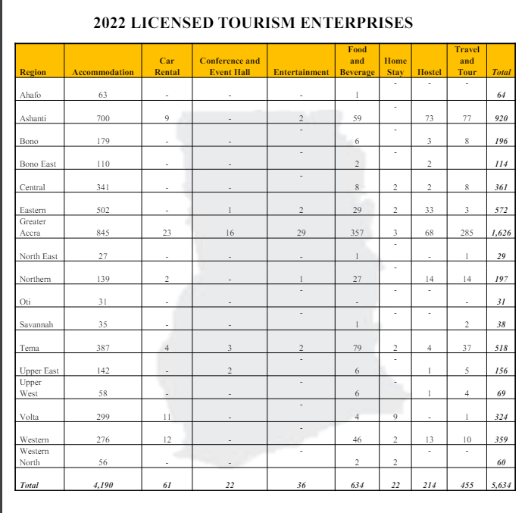

Event Operations

O’ Toole (2009) Event Management Body of Knowledge (EMBOK) Model is a “structured framework that outlines the key processes and phases involved in managing events effectively.” It serves as a comprehensive guide for event professionals to manage events systematically. The EMBOK Model categorises event management into five core domains and further breaks these down into phases and processes.”
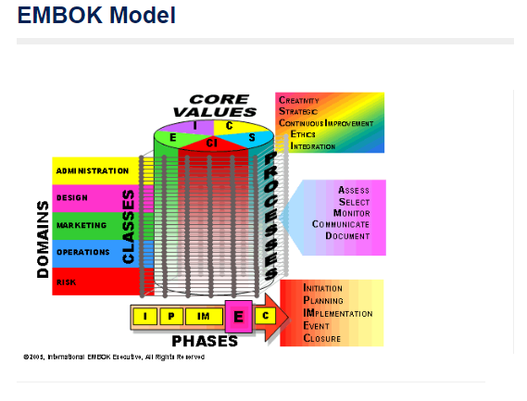

To ensure the success of the Greater Accra Hotel Technology Conference (GAHTC), several key operational aspects need to be meticulously planned and executed:
Venue Management:
The Tang Palace Hotel with its multiple conference rooms has been selected as it has the required planned seating for 900 representatives in its main auditorium. The satellite rooms 106 – 109 (fig 4) will be used for the mini expo presenters.

Fig 6. Tang Palace Hotel Layout (not to scale)
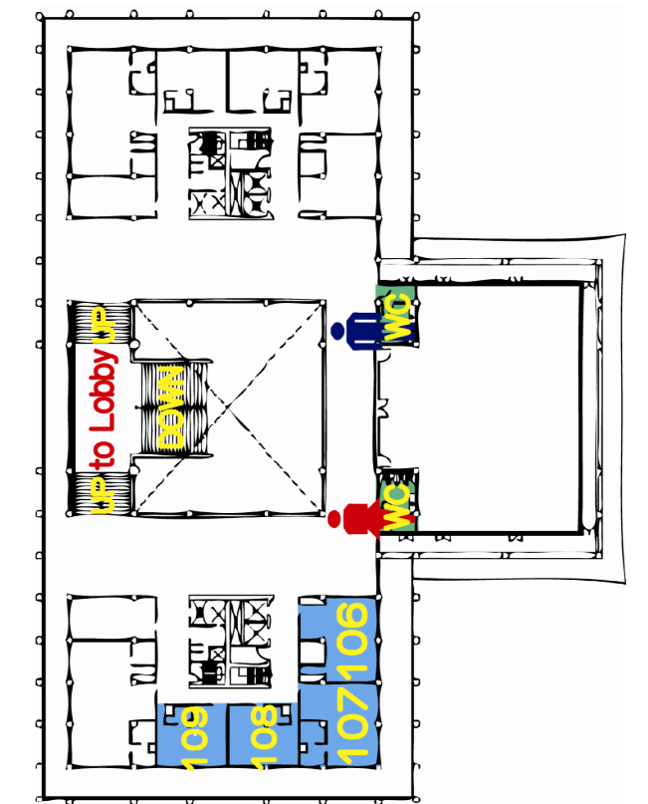

Marketing and Promotion:
Considering the conference is in essence a marketing event, McCarthy’s (1960) 4 Ps of Marketing (product, price, place and promotion); and subsequently Boom’s (1981) expansion to 7 for services marketing (process, people and physical evidence)
At the heart of this event are the commercial considerations of HLG to raise its business profile as a major hotel technology aggregator, and to tap into the growing awareness of the use of technology in all spheres of the Ghanaian hotel business as emphasised by the Vice President’s digitalisation drive.
A comprehensive marketing strategy targeting hotel owners and managers in the Greater Accra area utilising digital marketing, social media, email campaigns, and partnerships with industry associations such as the Ghana Hotel Association to deliver targeted invitations.
Registration and Ticketing: Following on from the previous presentation, HLG will be implementing an online registration and ticketing system. This includes setting up an event website, integrating secure payment gateways, and providing timely customer support. Upon arrival attendees will have a QR code that will show the order of the conference.
Program Development: HLG to lead the conference.
The conference will have keynote speakers, panel discussions, workshops, and product demonstrations with technology partners.
Resource persons and speakers from various sectors to speak at the conference. Each stakeholder has a vested interest for the event to be successful. Each stakeholder will have 30 minutes to speak about how the use of their technology will have on the success of the hotels bottom line.

Exhibitor and Sponsor Management: Engage potential exhibitors and sponsors, providing them with detailed information about booth setups, sponsorship packages, and promotional opportunities during the event. OTA’s (Booking.com, Expedia.com) Telcos (MTN, Vodafone), Smart Door Lock systems and software (Assa Bloy, Ezee), Smart TV retailers, resort photographers. Each to provide small marketing gifts like pens, tote bags, umbrellas, mugs, key holders etc. Online review companies will be on hand to share how reputable review sites all add to the total online experience.

Staffing and Volunteers: Recruit and train a team of staff and volunteers to handle various event tasks, such as registration, information desks, technical support, and crowd management.
Health and Safety: Tang Palace Hotel’s comprehensive health and safety plan, including emergency procedures, first aid stations, and compliance with local health regulations will be in place for the event.
Technology Infrastructure: The Tang Palace Hotel was chosen not only for its existing business relationship with HLG but also for its robust IT and audio visual systems that will allow for live streaming sessions, virtual participation options, and on-site technical support for presenters and exhibitors.
Post-Event Analysis: Plan for post-event activities, including collecting feedback from attendees, evaluating the event’s success against predefined objectives, and preparing a detailed report for stakeholders.

Event Budget

Developing a realistic budget for GAHTC involves estimating costs across various categories. Below is an illustrative budget breakdown:
Venue Rental: Waived in lieu of HLG services, but nominal value $2,000 - Includes conference rooms, exhibition space, and any additional facilities required.
Marketing and Promotion: $500 - Covers digital marketing, print materials, social media campaigns, and email marketing.
Registration and Ticketing: $500 - Online platform setup, payment processing fees, and customer support.
Program Development: $500 - Speaker fees (waived) as sponsors are direct beneficiaries, workshop materials, and session recordings.
Logistics Coordination: Catering will be provided by Tang Palace in lieu of HLG services
Exhibitor and Sponsor Management: No Charge - Booth setups, signage, and promotional materials provided by supporting stake holders.
Staffing and Volunteers: $500 - Recruitment, training, and stipends.
Health and Safety: $200 - First aid stations, health protocols, and insurance.
Technology Infrastructure: $500 - IT support, live streaming, and virtual participation tools.
Miscellaneous: $1,000 - Contingency for unforeseen expenses.
Total Estimated Budget: $5,700

Industry Trends / Issues / Impacts

Most of the trends and issues have been noted elsewhere in this report. Appendix 1 has a report first written in 2020 outlines the need for hotels in Ghana and the west African sub-region to move towards digitalization, and the current push by central government in Ghana as noted above now seems to be a great time to hold such a conference.

Conclusion

The GAHTC represents a critical step in the evolution of Ghana's hospitality industry towards embracing digitalization. By focusing on the needs of small to medium-sized hotels, HLG's initiative directly addresses a significant market gap, providing these establishments with the tools and knowledge to compete effectively. The choice of Tang Palace Hotel as the venue underscores the practical success of HLG’s digital marketing solutions, serving as a live case study for attendees.
The event's strategic approach, incorporating comprehensive planning and execution phases, aligns with best practices in event management. By leveraging a project management framework, the conference ensures that every aspect, from venue selection to marketing and post-event analysis, is meticulously planned and executed. This structured methodology not only enhances the event's effectiveness but also sets a benchmark for future events in the region.
The GAHTC's focus on digital solutions is timely, given the increasing reliance on technology in the tourism sector. The Ghana Government's emphasis on tourism as a revenue generator and the Vice President’s digitalization drive further support the conference’s objectives. With 66% of hotel bookings now made online, the importance of digital presence cannot be overstated. The conference provides a platform for hoteliers to learn from industry leaders, understand new technologies, and network with peers and technology providers.
In terms of practical outcomes, the GAHTC aims to elevate the digital capabilities of local hotels, thereby increasing their visibility and competitiveness. The involvement of key stakeholders, including OTA connections like Expedia and major telecom companies, ensures that the event is well-rounded and addresses various facets of hotel management. The potential for live streaming extends the conference’s reach, allowing participation from hoteliers across the country and setting the stage for similar future events.
The GAHTC is poised to be a transformative event for the Ghanaian hotel industry. By bridging the digital gap and providing actionable insights and tools, HLG is not only promoting its offerings but also contributing to the broader goal of enhancing tourism and hospitality in Ghana. This conference is a significant opportunity for local hoteliers to embrace digitalization and drive their businesses forward in an increasingly competitive market.

REFERENCES:
- Alexander, H Blog: Eventbrite All Access Event Ideas 101: Types of Events to Focus Your Attention on Right Now. Jul 2022 Available at: https://www.eventbrite.co.uk/blog/the-different-types-of-events-ds00/ Accessed: 23rd May 2024
- Ali-Knight J (2008) Book Review: Event Management Available at: Book-review---Event-Management--------------------2nd-ed--G--Bowd_2008_Touri.pdf” Accessed: 17th May 2024
- Bawumia, M (2021) Lessons on policies that strengthen household financial resilience to overcome shocks: A keynote address by Dr. Mahamudu Bawumia, Vice President of the Republic of Ghana (CSD Perspective No. 21-17). Washington University, Center for Social Development. Available at: https://openscholarship.wustl.edu/cgi/viewcontent.cgi?article=1921&context=csd_research Accessed: 19th May 2024
- Booms, B., 1981. Marketing strategies and organizational structures for service firms. Marketing of services
- Bowen, D et al 2009 National Library of Medicine “How we design feasibility studies.” Available at: https://www.ncbi.nlm.nih.gov/pmc/articles/PMC2859314/ Accessed: 18th May 2024
- Buxton, J. (2016) GN Research “81% of hotels in Accra without websites…Is Tourist Board Working?” Available at: https://www.linkedin.com/pulse/81-hotels-accra-without-websites-tourist-board-working-jacob-buxton/ Accessed: 17th May 2024
- Cvent Blog 04/04/2024 “Event Strategy Guide 2024” Available at: https://www.cvent.com/uk/blog/events/event-strategy-guide. Accessed: 19th May 2024
- Getz, D., & Page, S.J. (2019). Event Studies: Theory, Research and Policy for Planned Events (4th ed.). Routledge. https://doi.org/10.4324/9780429023002
- Ghana Tourism Authority Report Presidential Summit on Tourism (May 2023) Available at: https://ghana.travel/wp-content/uploads/2023/09/PST-REPORT-23-min.pdf Accessed: 17th May 2024
- Ghana Tourism Authority 2022 Tourism Report 4th Edition. Available at: https://ghana.travel/wp-content/uploads/2023/04/TOURISM-REPORT-2022-Final.pdf Accessed: 19th May 2024.
- Ghana Tourism Authority 2022b Tourism Report 4th Edition. Available at: https://ghana.travel/wp-content/uploads/2023/04/TOURISM-REPORT-2022-Final.pdf Accessed: 19th May 2024
- Hines, M and Catron D (2024) Phocus Wire News/ Technology Record Online Direct Bookings Are Driving Innovation in Hospitality,
Available at: https://www.phocuswire.com/h2c-study-hotel-online-bookings-digitalization#:~:text=Bookings%20through%20OTAs%20were%20down,one%2Dthird%20the%20prior%20year Accessed: 2nd May 2024
- Hotel Link: The Core Solutions for Your Property (2024) Available at: https://www.hotellinksolutions.com/hotel-marketing-solutions Accessed: 30th April 2024
- McCarthy, E.J., Shapiro, S.J. and Perreault, W.D., 1979. Basic marketing (pp. 29-33). Ontario: Irwin-Dorsey
- O'Toole, W. (2010). Events Feasibility and Development (1st ed.). Routledge. https://doi.org/10.4324/9780080940595
- O’Toole, W (2009) Available at: https://www.embok.org/index.php/embok-model-page Accessed: 23 May 2024
- Owusu Amoah, G. (2021) Daily Graphic “80% of hotels don’t have websites -CEO of Ghana Tourism Authority
https://www.graphic.com.gh/entertainment/showbiz-news/80-of-hotels-don-t-have-websites-ceo-of-ghana-tourism-authority.html Gifty Owusu-Amoah Showbiz News Jun - 27 - 2021, Accessed: 29 April 2024
- Sasu, D. 2022 Statista.com “Number of licensed tourist accommodation establishments in Ghana from 2016 to 2022” Available at: https://www.statista.com/statistics/1250228/number-of-tourist-accommodation-establishments-in-ghana/ Accessed: 17th May 2024.
- SCHAARSCHMIDT, M. and HÖBER, B., 2017. Digital booking services: comparing online with phone reservation services. The Journal of Services Marketing, 31(7), pp. 704-719. Available at: https://www.proquest.com/docview/2533456187?accountid=130472&parentSessionId=AFuVKiiOxt6XNp8qsjKNMeRmWUoTTtB6t1mTPqF1%2B9A%3D&pq-origsite=primo&sourcetype=Scholarly%20Journals
- Wolf, P., Wolf, J., & Levine, D.(2005) Event Planning Made Easy 7 Simple Steps to Making Your Business or Private Event a Huge Success—from the Industry’s Top Event Planners. Available at: https://d1wqtxts1xzle7.cloudfront.net/30566519/event_planning_made_easy-libre.pdf?1391832968=&response-content-disposition=inline%3B+filename%3DEvent_planning_made_easy.pdf&Expires=1715958346&Signature=empwBymgA1rpvBu8jrVSgy8DJyUk7i6qbbFQf~9k4VUscXhFpQmZSKNhhxbMvJXRIFW8Lmh5MAJ1kLK4uaqDq54PNmaBftTcH8lLviYHPUgCiE9TBbuqzZnegDm~7jELWL5es-Thrp6Gb6FlPQbEMC6SUpWJWUqE4VccwhXxgUM8vE~XNIosy5K1t-KUiwmEaPDWS4YD85S7U5VT2ifgaKhiPDs3UdJaT9z2wD8vICfiPs8Xp1iBSwpLAcQxFckLtG-GnS~22G~e88in87DFVX-LjwnUM9KXIFj0wbuDFnkqYjaRi0aO8iJOad1v5Ud-YBMelYq-3-QJMLvkIVyDdA__&Key-Pair-Id=APKAJLOHF5GGSLRBV4ZA Accessed: May 17th 2024

Appendix 1: HLG Tourism and Hospitality Report pdf.

