

MSc Public Health and Social Care in Practice

Social Epidemiology and Public Health Development (LCHS7000)

Component 2 Analytical Report

Student Name- Monalikumari Ishwarbhai Tandel

Student ID- 2505012

Lecturer Name- Dr. Jolly nwankwo

Word Count - 2380

Submission Date- 19 December 2025

Table of Contents
Task 1: Addressing Inequality in Ethnicity and Health Among British Older Adults 3
1.0 Introduction 3
2.0 Contextual background and underlying factors 3
2.1 Prevalence of Mental Health Issues 3
2.2 Healthcare and Social Services Accessibility 4
2.3 Mortality and British Older Adults 4
2.4 Social Isolation and Loneliness 5
2.5 Poverty and Housing Issues 6
3.0 Strategies by National Organisations to Reduce Health Inequalities 6
4.0 Organisations and their support for older adults 7
5.0 Conclusion 7
Task 2: Epidemiological Analysis of Obesity Among Younger Adults in the London Borough of Greenwich 8
1.0 Introduction 8
1.1 Overview 8
1.2 Definition and Consequences 8
1.3 Incidence and Prevalence 8
2.0 Main Body 9
2.1 Public Health Strategies 9
2.2 Risk Factors associated to the Disease 10
2.3 Health Needs Assessment for Obesity 10
2.4 Strategies by Public Healthcare Organisations 10
2.5 Impact Assessment 11
2.6 Health Intervention Programme 11
3.0 Conclusion 11
References 12

Task 1: Addressing Inequality in Ethnicity and Health Among British Older Adults

1.0 Introduction
One of the significant concerns in the healthcare system of the United Kingdom is the “inequality in ethnicity and health among the British older adults”. The targeted age group which experiences ethnicity inequality is individuals belonging from the “age group of 55 to 75 years”. Most of the British older adults from the minority ethnic groups suffer from negligence and inadequate medical attention from the healthcare professional in the United Kingdom (Keys et al., 2021). There are various factors which impact the ethnicity related health inequalities such as poverty, racial and cultural discrimination, lack of education and poor medical interventions (Watkinson et al., 2021). This task is focused to analyse the underlying factors and their factors in the ethnicity related health inequalities among the British older adults.

2.0 Contextual background and underlying factors

2.1 Prevalence of Mental Health Issues
In the “United Kingdom”, “ethnic inequalities” in mental health care is a significant concern. This kind of inequality is more observed among the British old adults. Moreover, the older adults who belong to the ethnic minority groups experience a greater number of mental health issues as compared to the majority ethnic groups. The healthcare professionals lack understanding about the ethnic inequalities and they continue to neglect the patients from the ethnic minority groups (Brayne and Moffitt, 2022). This leads to poor mental health outcomes, and results in chronic conditions of the adult such as chronic depressions and anxiety (Bansal et al., 2022). It is also evident from figure 1 that the Asian and black female adults suffer from mental health illness in the UK. This clearly indicates the relation between racism and ethnicity prevalent within the UK healthcare system. Thus, the government must take initiative to recruit more mental healthcare professionals in the government funded hospitals to reduce this kind of inequality.
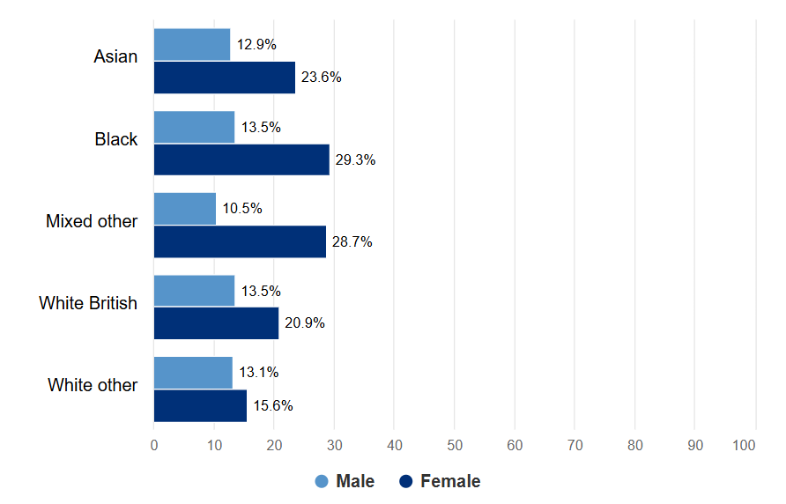
Figure 1: Rate of Mental Health Issues
(Source: GOV.UK, 2021)

2.2 Healthcare and Social Services Accessibility
As per the study of Hayanga et al., (2021), the “ethnic inequalities” are highly prevalent in the “healthcare use and quality of care” for older adults in the “United Kingdom”. It is found that about “25% of the population” in the UK suffer long term conditions. More particularly, the “older adults from ethnic minority groups who have multiple long-term conditions” such as “cardiovascular diseases, hypertension and diabetes” fail to have proper access to healthcare. Most migrants from Africa, Caribbean and Asia face racial violence while they try to access healthcare and social services (Hayanga et al., 2021). Hence the national health policies must be reformed to prioritise the medical needs of these individuals and improve the quality of care.

2.3 Mortality and British Older Adults
The mortality rates among the different “ethnic groups” in the “United Kingdom” can be identified from figure 2. It clearly indicates that the all-cause mortality rate is the highest for the White British people followed by Bangladeshi ethnic groups and mixed groups. One of the causes of the “high mortality rates” is the end of life and palliative care of the older adult belonging to the “age group of 55 to 75 years” (Pineda-Moncusí et al., 2024). Several factors such as “language barriers, cultural values and socio-economic status” impact the quality of care received by the older adult from different ethnic groups (Aker et al., 2023). Hence the family care givers and social and healthcare professionals must consider the medical needs of the patients and provide them with suitable medical interventions.
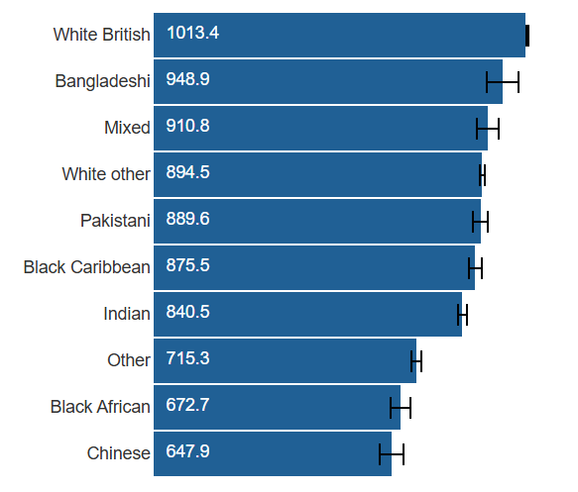
Figure 2: Mortality Rates for Older Adults from Ethnic Groups
(Source: Nafilyan, 2023)

2.4 Social Isolation and Loneliness
Davies et al., (2021) states that frailty of the old adults is highly related with their “social isolation and loneliness”. The factors of frailty such as weak vision, loss of hearing power and muscle coordination results in the reduction of life satisfaction of the old adult from different ethnic groups. The old people fail to communicate with their friends and family and thus isolate themselves from social events and feel lonely (Perry et al., 2021). It is understood from figure 3 that the White people enjoy life satisfaction more than other “ethnic groups” in the “United Kingdom”. Hence support from friends and families of the old adults is quite important to reduce their loneliness and social isolation.
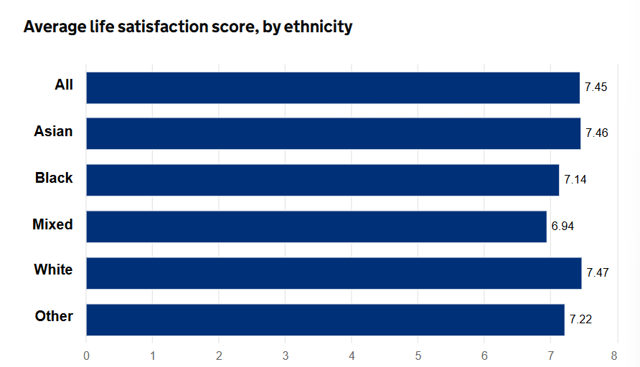
Figure 3: Average Life Satisfaction Score by Ethnicity
(Source: GOV.UK, 2024)

2.5 Poverty and Housing Issues
One of the most significant factors which impacts the “ethnicity-based health inequalities” in the United Kingdom is poverty and housing issues. The people from the minority ethnic groups suffer more from poverty than the majority ethnic groups (Kamal et al., 2021). The issues of poverty and shelter arise due to socio economic disadvantages of the working old adults from the ethnic groups (Thomson et al., 2021). The local government must take initiatives to address these issues so that the people from weaker economic sections do not suffer chronic illness and ethnicity discrimination in the medical system.

3.0 Strategies by National Organisations to Reduce Health Inequalities
The “NHS Race and Health Observatory” take several initiatives to reduce the “ethnic health inequalities” in the “United Kingdom”. The black and minority ethnic groups suffer more from this inequality than the White people. The NHS UK develops health policies such that any kind of discrimination is not practised in the healthcare organisations (Robertson et al., 2021). Moreover, the public awareness campaigns conducted by the NHS are targeted to address the issues of “housing, employment and the criminal justice system” for the black and ethnic groups. This is because these factors have a “profound negative impact on the health” of the old adults belonging to these ethnic groups (Robertson et al., 2021).

4.0 Organisations and their support for older adults
The old adults, those who encounter health disparities due to ethnicity, in the UK are assisted by the organisations like Age Uk and Federation of ethnic Minority Healthcare Organisations (FEMHO). These organisations monitor the “health status of the old adults” and report to the senior authorities of the “healthcare system of the UK”. Additionally, the campaign activities of social awareness are carried out to downplay the implications of ethnicity-based healthcare disparities in the UK healthcare system (Farooqi et al., 2022).

5.0 Conclusion
There is a major health disparity by ethnicity among British older adults which is a serious issue of concern in United Kingdom regarding health. Mental health disparities, lack of healthcare, morbidity, social isolation, poverty, and poor housing, among others, have a serious impact about older adults belonging to “minority ethnic groups in the UK”. The NHS has several national programs and assistance provided by non-governmental organizations that have been able to manage these problems. Nonetheless, additional policy changes and culturally sensitive "healthcare interventions" are necessary to provide people with equal access to care and improve the overall outcomes in “health among British older adults”.

Task 2: Epidemiological Analysis of Obesity Among Younger Adults in the London Borough of Greenwich

1.0 Introduction

1.1 Overview
Obesity is one of the most alarming health concerns which is quite prevalent among the young adults in the London Borough of Greenwich. The targeted age group for the study is from 18 to 30 years of age. The highest rates of obesity are observed in the London boroughs out of the entire United Kingdom. The reasons which contribute to such high prevalence of obesity includes the lifestyle and food habits of the young adults (D Smith et al., 2025). This study focuses on the “epidemiological analysis of obesity” among younger adults in the London Borough of Greenwich.

1.2 Definition and Consequences
Obesity is defined as a non-communicable, chronic condition which results from accumulation of excessive body fat. Obesity is indicated mostly with the help of Body Mass Index and an individual with a “BMI index of 30 kg/m² or more” is considered to be obese (Launders et al., 2022). The consequences of obesity include multiple comorbidities such as “type 2 diabetes, hypertension and cardiovascular diseases”. Moreover, the obese young adults suffer from mental illness such as depression and anxiety (Launders et al., 2022).

1.3 Incidence and Prevalence
As per World Health Organisation, “2.5 billion adults (18 years or older) are overweight and 890 million adults” are suffering from obesity worldwide. Obesity is classified as a relapsing disease which occurs due to a combination of factors such as genetics, neurobiology, and eating behaviours (World Health Organization: WHO, 2025). In the London Borough of Greenwich, more than half of the population of young adults are suffering from obesity. It is well understood from figure 4 and 5 that London has a “higher prevalence of obesity” among the young adults as compared to the rest of the United Kingdom. Moreover, the trends of obesity have also increased over the years in the UK (NHS UK, 2022).
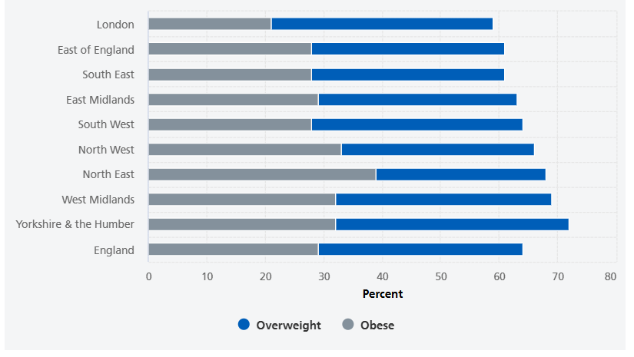
Figure 4: Overweight and Obesity among the UK young adults
(Source: NHS UK, 2022)
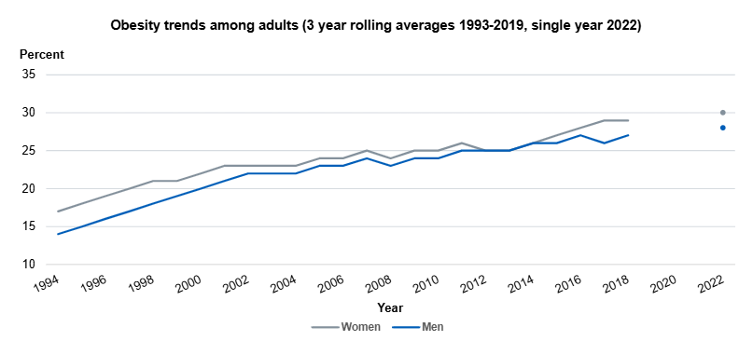
Figure 5: Obesity Trends among Young Adults in the UK
(Source: NHS UK, 2022)

2.0 Main Body

2.1 Public Health Strategies
The public health measures which are adapted to reduce the prevalence of obesity among the young adults in Greenwich includes health policy interventions, public awareness campaigns, and healthy eating programmes. The local government takes initiatives to make the young people aware of the consequences of unhealthy lifestyle and enlighten them about the risks factors related to obesity. However, the government obesity policies in England are not readily implemented that is why the obesity prevalence has not reduced over the years (Theis and White, 2021). Hence the public health measures must be strictly executed to help the situation in Greenwich.

2.2 Risk Factors associated to the Disease
Several factors such as physical inactivity, unhealthy diets, irregular eating behaviours, smoking, drinking and casual lifestyle of the young adults leads to the development of chronic conditions such as obesity. Moreover, the individuals suffering from obesity develop comorbidities such as cardiovascular disease, hypertension, kidney failure, asthma and diabetes (Rassy et al., 2023). Obesity is also related to degenerative diseases among young adults such as osteoarthritis, arrhythmias and ischemic heart disease. Moreover, obesity contributes to higher rates of mortality among the young individuals in Greenwich (Haase et al., 2021). Hence these risk factors must be considered for development of strategies to decrease the rate of obesity in the targeted age group.

2.3 Health Needs Assessment for Obesity
The prevalence of obesity among the young individuals in the “age group of 18 to 30 years” is quite high in Greenwich. Over the years the trend is on a hike and numerous factors contribute to this situation. The determinants of obesity in Greenwich include lifestyle of the individuals, socio economic status, nutritional behaviours and habits of the young adults (Council, 2022). A health needs assessment is the need of the hour to address this chronic medical condition of the young adults of Greenwich. Langan et al., (2025) states that the “United Kingdom” has the highest rates of adult obesity in the entire Europe. Obesity and overweight are significant risk factors for the young people in the London Borough of Greenwich. Hence a “health needs assessment” will be used to analyse the underlying factors for obesity and accordingly medical interventions can be developed.

2.4 Strategies by Public Healthcare Organisations
The public health approaches and strategies are quite important to address the chronic condition of obesity which is prevalent among the young adult population in Greenwich. The “World Health Organisation” states that well-being can be manifested in two ways such as subjective and objective. Thus, the objective well-being of the young people of Greenwich is entirely dependent on the public health strategies (Asmar et al., 2024). The public health measures include policy interventions, awareness programmes in educational institutions and workplaces, and strict policies for fast food manufacturers. As obesity is a “complex and wicked challenge” to be tackled, it needs proper attention from public healthcare organisations such as NHS UK (Salm et al., 2023).

2.5 Impact Assessment
Michalopoulou et al., (2024), states that the major determinants of weight in young adults is diet and physical activity. The “National Health Service of the United Kingdom” publishes guidelines for “healthy lifestyle, diet and physical activity”. Moreover, the “National Institute for Health and Care Excellence (NICE)” provides guidance on key medical interventions which can be helpful to reduce the risk and manage obesity and overweight (Michalopoulou et al., 2024). All these measures have a positive impact and help to reduce the rate of obesity among the “young adults” in Greenwich.

2.6 Health Intervention Programme
As per the general understanding in the overall examination, a health intervention programme is critical towards lowering the rate of obesity among the younger adults in the “age group of 18 to 30 years” in Greenwich. According to Bijlani et al., (2024) the local authorities in England have the essential part to play in shaping the healthy local environments and therefore contribute towards the obesity of the young adults. The health intervention programmes like Go-Golborne assists in creating awareness to the individuals of the effects of obesity and encourages them to embrace a healthy lifestyle. Furthermore, the health interventions must also enhance the “health, well-being and quality of life of young adults” in the London Borough of Greenwich (Amenyah et al., 2021).

3.0 Conclusion
In Greenwich in the London Borough, obesity in younger adults between 18-30 years of age is deemed as a rising health problem of concern. Obesity incidents are high and are affected by unhealthy lifestyle behaviour, malnutrition, lack of exercise and broader socio-economic factors. It has been noted based on epidemiological evidence that there are emerging trends of obesity and subsequent severe physical and mental health effects among the young adults. Even though there has been an intervention in terms of public health measures, national guidelines, and local programmes which have been established on intervention strategies, the effects have not been felt by a large number of people without a good performance and involvement of the community. Hence, health needs assessment, interventions, and reinforced strategies in the field of the effectiveness of the health provision are necessary to decrease the prevalence of obesity and enhance the health outcomes in the long term in Greenwich.

References
Aker, N., Frost, R., Walters, K., West, E. and Davies, N., 2023. Health inequalities for older people from minority ethnic groups receiving palliative care and end of life care: A scoping review protocol. Plos one, 18(5), p.e0285109. https://doi.org/10.1371/journal.pone.0285109
Amenyah, S.D., Murphy, J. and Fenge, L.A., 2021. Evaluation of a health-related intervention to reduce overweight, obesity and increase employment in France and the United Kingdom: a mixed-methods realist evaluation protocol. BMC Public Health, 21(1), p.582. https://doi.org/10.1186/s12889-021-10523-3
Asmar, M.L.E., Karki, M., Mall, B., Riboli-Sasco, E. and El-Osta, A., 2024. Components of joint health and wellbeing strategies: a pan-London review of all 33 local authorities. BMC Public Health, 24(1), p.3432. https://doi.org/10.1186/s12889-024-20579-6
Bansal, N., Karlsen, S., Sashidharan, S.P., Cohen, R., Chew-Graham, C.A. and Malpass, A., 2022. Understanding ethnic inequalities in mental healthcare in the UK: A meta-ethnography. PLoS Medicine, 19(12), p.e1004139. https://doi.org/10.1371/journal.pmed.1004139
Bijlani, C., Vrinten, C., Junghans, C., Chang, K., Lewis, E., Mulla, U., Seferidi, P., Laverty, A.A. and Vamos, E.P., 2024. Changes in diet and physical activity following a community-wide pilot intervention to tackle childhood obesity in a deprived inner-London ward. BMC Public Health, 24(1), p.800. https://doi.org/10.1186/s12889-024-18192-8
Brayne, C. and Moffitt, T.E., 2022. The limitations of large-scale volunteer databases to address inequalities and global challenges in health and aging. Nature Aging, 2(9), pp.775-783. https://doi.org/10.1038/s43587-022-00277-x
Council, L.C., 2022. Healthy Weight Health Needs Assessment. https://www.leicester.gov.uk/media/kktgmngs/healthy-weight-jspna-2022.pdf
D Smith, A., Kininmonth, A., Tommerup, K., Boniface, D., Gericke, C., Denning, T., Summerbell, C., Vogel, C. and Llewellyn, C., 2025. The impact of deprivation and neighbourhood food environments on home food environments, parental feeding practices, child eating behaviours, food preferences and BMI: The Family Food Experience Study-London. International Journal of Behavioral Nutrition and Physical Activity, 22(1), p.91. https://doi.org/10.1186/s12966-025-01788-7
Davies, K., Maharani, A., Chandola, T., Todd, C. and Pendleton, N., 2021. The longitudinal relationship between loneliness, social isolation, and frailty in older adults in England: a prospective analysis. The Lancet Healthy Longevity, 2(2), pp.e70-e77. https://doi.org/10.1016/S2666-7568(20)30038-6
Farooqi, A., Jutlla, K., Raghavan, R., Wilson, A., Uddin, M.S., Akroyd, C., Patel, N., Campbell-Morris, P.P. and Farooqi, A.T., 2022. Developing a toolkit for increasing the participation of black, Asian and minority ethnic communities in health and social care research. BMC medical research methodology, 22(1), p.17. https://doi.org/10.1186/s12874-021-01489-2
GOV.UK., 2021. Common mental disorders. https://www.ethnicity-facts-figures.service.gov.uk/health/mental-health/adults-experiencing-common-mental-disorders/latest/ (Accessed: December 17, 2025).
GOV.UK., 2024. Well-being. https://www.ethnicity-facts-figures.service.gov.uk/health/wellbeing/well-being/latest/ (Accessed: December 17, 2025).
Haase, C.L., Eriksen, K.T., Lopes, S., Satylganova, A., Schnecke, V. and McEwan, P., 2021. Body mass index and risk of obesity‐related conditions in a cohort of 2.9 million people: evidence from a UK primary care database. Obesity science & practice, 7(2), pp.137-147. https://doi.org/10.1002/osp4.474
Hayanga, B., Stafford, M. and Becares, L., 2021. Ethnic inequalities in healthcare use and care quality among people with multiple long-term health conditions living in the United Kingdom: a systematic review and narrative synthesis. International Journal of Environmental Research and Public Health, 18(23), p.12599. https://doi.org/10.3390/ijerph182312599
Kamal, A., Hodson, A. and Pearce, J.M., 2021. A rapid systematic review of factors influencing COVID-19 vaccination uptake in minority ethnic groups in the UK. Vaccines, 9(10), p.1121. https://doi.org/10.3390/vaccines9101121
Keys, C., Nanayakkara, G., Onyejekwe, C., Sah, R.K. and Wright, T., 2021. Health inequalities and ethnic vulnerabilities during COVID-19 in the UK: a reflection on the PHE reports. Feminist Legal Studies, 29(1), pp.107-118. https://doi.org/10.1007/s10691-020-09446-y
Langan, A.C., Cullum, R., Wilkin, S., Woodward, M., Subba, N., Skeels, A., Davies, S. and Marsh, C., 2025. Healthy Weight and Nutrition: An All-Age Approach Health Needs Assessment for Norfolk. https://www.norfolkinsight.org.uk/wp-content/uploads/2025/05/All_Age_Healthy_Weight_and_Nutrition_Health_Needs_Assessment_Apr-25.pdf
Launders, N., Hayes, J.F., Price, G. and Osborn, D.P., 2022. Clustering of physical health multimorbidity in people with severe mental illness: an accumulated prevalence analysis of United Kingdom primary care data. PLoS Medicine, 19(4), p.e1003976. https://doi.org/10.1371/journal.pmed.1003976
Michalopoulou, S., Sifaki, M., Packer, J., Lanigan, J., Stansfield, C., Viner, R.M. and Russell, S., 2024. Assessing the impact of obesity interventions in the early years: a systematic review of UK-based studies. BMJ open, 14(5), p.e076479. https://doi.org/10.1136/bmjopen-2023-076479
Nafilyan, M.B.D.A., Piotr Pawelek, Vahé., 2023. Inequalities in mortality involving common physical health conditions, England - Office for National Statistics. https://www.ons.gov.uk/peoplepopulationandcommunity/healthandsocialcare/healthinequalities/bulletins/inequalitiesinmortalityinvolvingcommonphysicalhealthconditionsengland/21march2021to31january2023 (Accessed: December 17, 2025).
NHS UK., 2022. Health Survey for England, 2022 Part 2. https://digital.nhs.uk/data-and-information/publications/statistical/health-survey-for-england/2022-part-2/adult-overweight-and-obesity (Accessed: December 17, 2025).
Perry, M., Akbari, A., Cottrell, S., Gravenor, M.B., Roberts, R., Lyons, R.A., Bedston, S., Torabi, F. and Griffiths, L., 2021. Inequalities in coverage of COVID-19 vaccination: A population register based cross-sectional study in Wales, UK. Vaccine, 39(42), pp.6256-6261. https://doi.org/10.1016/j.vaccine.2021.09.019
Pineda-Moncusí, M., Allery, F., Delmestri, A., Bolton, T., Nolan, J., Thygesen, J.H., Handy, A., Banerjee, A., Denaxas, S., Tomlinson, C. and Denniston, A.K., 2024. Ethnicity data resource in population-wide health records: completeness, coverage and granularity of diversity. Scientific data, 11(1), p.221. https://doi.org/10.1038/s41597-024-02958-1
Rassy, N., Van Straaten, A., Carette, C., Hamer, M., Rives-Lange, C. and Czernichow, S., 2023. Association of healthy lifestyle factors and obesity-related diseases in adults in the UK. JAMA network open, 6(5), pp.e2314741-e2314741. doi:10.1001/jamanetworkopen.2023.14741
Robertson, R., Williams, E., Buck, D. and Breckwoldt, J., 2021. Ethnic health inequalities and the NHS. The King’s Fund, commissioned by the NHS Race and Health Observatory. https://healthwatchgreenwich.co.uk/sites/healthwatchgreenwich.co.uk/files/Ethnic-Health-Inequalities-Kings-Fund-Report.pdf
Salm, L., Nisbett, N., Cuming, K., Hrynick, T., Lulache, A. and MacGregor, H., 2023. A whole system approach to childhood obesity: how a supportive environment was created in the city of Brighton and Hove, United Kingdom. Food Security, 15(4), pp.919-935.https://doi.org/10.1007/s12571-023-01361-9
Theis, D.R. and White, M., 2021. Is obesity policy in England fit for purpose? Analysis of government strategies and policies, 1992–2020. The Milbank Quarterly, 99(1), pp.126-170. https://doi.org/10.1111/1468-0009.12498
Thomson, L.J., Gordon-Nesbitt, R., Elsden, E. and Chatterjee, H.J., 2021. The role of cultural, community and natural assets in addressing societal and structural health inequalities in the UK: future research priorities. International Journal for Equity in Health, 20(1), p.249. https://doi.org/10.1186/s12939-021-01590-4
Watkinson, R.E., Sutton, M. and Turner, A.J., 2021. Ethnic inequalities in health-related quality of life among older adults in England: secondary analysis of a national cross-sectional survey. The Lancet Public Health, 6(3), pp.e145-e154. https://doi.org/10.1016/S2468-2667(20)30287-5
World Health Organization: WHO., 2025. Obesity and overweight. https://www.who.int/news-room/fact-sheets/detail/obesity-and-overweight (Accessed: December 17, 2025).

