Assignment title:
Role & extent of Knowledge & Information Management in Contemporary organisations.

Module: Knowledge and Information Management Skills for the Workplace.

Module code: BMSW 5106

Student name: Magdalena Konopka
Student ID: 2022639
Lecturer’s name: Toyin Adisa
Executive Summary
Knowledge and information management for HSBC are important for its success. HSBC has to change its operations due to several reasons. This paper discusses HSBC's knowledge management and its importance. Knowledge management is important for gaining competitive advantages and customers satisfaction. This study includes the SECI model for business knowledge management. Socialization, Externalization, Combination, and Internalization constitute this knowledge management strategy. This study describes the HSBC's management information system and its challenges and solutions. Overall, this paper covers HSBC's knowledge and information management. The Study highlights the importance of managing knowledge resources in order to improve organizational performance and customer satisfaction.

Table of Contents
Introduction 3
Main Body 3
Section 1: Knowledge and Information Management 3
Background of HSBC 3
Knowledge Management 4
Importance of Knowledge Management for Any Organizations including HSBC 4
Importance of Knowledge Management in Satisfying Customers and Achieve a Competitive Advantage 5
Section 2: Evaluation of Knowledge and Information Management Models/theories 6
The Role of Tacit Knowledge in Embedding Knowledge in Products and Services 6
The Role of Systematic Approach in Knowledge Sharing through Management Information Systems 6
SECI Model in HSBC 7
Section 3: Investigating of KM Techniques Used by HSBC 8
Significance of Knowledge in HSBC's Standard Operating Procedures 8
Main Outcomes that HSBC Has Been Achieving with the Use of These Procedures 9
Areas for Future Improvement by HSBC to Overcome Challenges 9
Conclusion 10
References 12

Introduction
The organization's most valuable resource is information. Undocumented, difficult to obtain information is threatened for any organization. Knowledge is also the important asset for the organizations of today’s world. Organizations require effective knowledge management to be competitive, achieve their goals, and gain a competitive advantage. This study will analyze the knowledge and information management of HSBC. HSBC is one of the largest financial companies. At present, this bank is operating in 62 countries and has 39 million customers. The advancement of technology and impact of covid-19 changed the knowledge management system in the organizations of this world. Also, customers’ expectations are also changing day by day. So, the organizations have to adopt the new things to the organizations. The HSBC also needs to change its knowledge management based on the customers’ expectations. Knowledge management is important for assisting customers of the HSBC. So, effective knowledge management is necessary for creating effective customer service. So, this study will analyze the knowledge management techniques used by HSBC and their outcomes. This study will describe the information management systems of HSBC and the problems in the information management system. Also, this study will provide the area of improvement of knowledge management and information management in HSBC through the knowledge management model. This study will use Nonaka's SECI model for managing knowledge in HSBC. The SECI model is used as a knowledge management model to explain the four knowledge components: "Socialization," "Externalization," "Combination," and "Internalization." (Mahmoud et al., 2018). The report's significant idea and conclusion have been divided into three sections to evaluate HSBC's continuous relationships and figure out how to improve its management.

Main Body

Section 1: Knowledge and Information Management

Background of HSBC
Hongkong and Shanghai Banking Corporation Limited (HSBC) was established in 1865 in Hong Kong and Shanghai. The bank was established to improve the trade between China and Europe. The headquarter of HSBC is in the London, UK. Now it is one of the largest banks in Asia. At present, the bank is operating in 62 countries. HSBC's slogan, "The World's Local Bank," comes from its worldwide network of local banks. In response to questions about bank survival strategies and "Living Wills," HSBC describes its structure as "separately incorporated and capitalized" with an executive bank in each area. Hongkong and Shanghai Banking Corporation introduced the hexagon logo in 1983. The bank provides retail banking, commercial banking, investment banking, and wealth management to the individuals and businesses. The bank has faced several financial and regulatory reform crises. The bank changed several of its functions to improve the customers’ satisfaction. In this competitive world, to being competitive HSBC invested in the technology sector. HSBC also took several strategies based on customers’ expectations. However, HSBC also gives priority to its knowledge and information management system.

Knowledge Management
"Knowledge management" refers to how an organization collects, advertises, communicates, and analyzes its data to make it available to employees. Knowledge management (KM) involves the creation of information, storage, distribution, and use (Dalkir, 2005). The first step for creating knowledge management strategy has been created through the review of goals and objectives of HSBC. (Vibhor et al, 2019). Knowledge management systems, which manage knowledge as an organization's asset, are part of organizational learning. information management connects individuals in an organization who need information to those who have it to increase the team's and business's expertise. The most difficult part of adopting a knowledge management strategy is finding software that works within the plan and encourages employees to actively engage and give relevant information. People have different views about what makes KM beneficial, and the idea discovery technique is used to describe the applied chaos that remains because of KM. Knowledge management's main goals are productivity improvement and knowledge preservation. Knowledge management guarantees the right data reaches the right people at the right time. Knowledge management helps HSBC to reduce the gaps in information by organizing data. It protects HSBC's knowledge when employees depart.

Importance of Knowledge Management for Any Organizations including HSBC
Knowledge management is important for any organization. KM helps to find the existing problems of the organizations which include assets, knowledge, and resources. KM also helps to utilize the existing resources and knowledges of the organization. (Alvesson, & Karreman, 2001). KM is essential for increasing the efficiency and productivity of any organization. Knowledge management may help HSBC to develop better relationships with customers. Save all important data in one place and simplify interactions with customers across all platforms. Expanding skills may improve communication, access to information, and knowledge sharing (Zaim et al, 2019). Knowledge management can affect the operations of HSBC. Knowledge management of HSBC may help the employees to adopt new technologies and strategies for improving their business operation. KM improves decision-making. HSBC may make better choices by saving and sharing information. Because decision-makers have more knowledge and expertise, they can make more accurate, quicker decisions. KM may help HSBC to increase customers satisfaction. Better KM may help to understand the customers’ expectations. HSBC needs KM to be competitive and inventive in the global market. Effective KM may boost productivity, decision-making, customer satisfaction, innovation, and competitiveness. Thus, KM investments may boost profits. So, knowledge management is important for the organizations including HSBC.

Importance of Knowledge Management in Satisfying Customers and Achieve a Competitive Advantage
Knowledge management may help HSBC to develop better relationships with customers. Streamline relationships with clients across all channels and save important information in one place for easy access during support. KM helps to identify the customers’ expectations; Knowledge management gathers the information from all available sources which helps to plan in a better way and improve the internal and external data access (Soltani et al, 2018). As knowledge management helps to identify the customers’ expectations and take actions based on the requirements, HSBC, and other organizations actions may satisfy the customer’s needs. The customers may be able to get benefited from HSBC as it formed the strategy based on their requirements. Thus, customers can be more attracted to HSBC and more new customers may be interested on HSBC. Which indicate the more customer satisfaction and achieve a competitive advantage than rivals. Knowledge management systems allow the stakeholders of HSBC to get important information quickly (Hellebrandt et al., 2018). As a result, the stakeholders and management of the organizations may be able to change their strategy of their organization based on the rapid information. It also helps to produce new ideas, skills in the organization. These things may help the HSBC remain ahead of the competition, achieve its objectives, and stay ahead of technology (Adesina & Ocholla, 2019). Knowledge management is thus an important tool for satisfying the customers of HSBC and another tool for achieving the advantages from the rival banks by HSBC.

Section 2: Evaluation of Knowledge and Information Management Models/theories

The Role of Tacit Knowledge in Embedding Knowledge in Products and Services
Tacit knowledge is personal, context-specific, and difficult to describe. It's learned through feeling, experience, and beliefs. Tacit knowledge is personal information, abilities, and experiences that are difficult to share through formal training or documentation. A person's personal and context-specific knowledge is called tacit knowledge (Duffy, 2000). In HSBC, tacit knowledge has been achieved through the service of the bank. HSBC values its tacit knowledge through its service. HSBC Bank employees know the bank's operations, customer preferences, and market trends well. Customers learn about this expertise through bank employees and services. The bank emphasizes recruiting and training personnel with the important abilities and expertise to offer high-quality services to customers. HSBC also supports initiatives that gather and share tacit knowledge. HSBC's customer service uses tacit knowledge. The bank's employees get extensive training to deliver great customer care. Customer service requires active listening, empathy, and problem-solving. These are the main themes for the training of HSBC. HSBC uses employees’ tacit knowledge to develop creative services to fulfill customer demands. The bank encourages employees to suggest new goods and services since they understand the market and clients. The bank regularly encourages feedback from customers to improve its services. HSBC can better serve its customers by integrating their tacit knowledge.

The Role of Systematic Approach in Knowledge Sharing through Management Information Systems
Management Information Systems are computer-based decision-support systems. Information is gathered, stored, processed, and distributed by these systems. Knowledge management depends on MIS's platform for sharing knowledge. HSBC as an international bank, now used internet for transaction and for storing data. Before internet banking, the bank operated manually. For example, a customer who wanted to create an account in another HSBC branch in another nation had to get a statement from his existing branch and bring it to the new location. Customers can create an account online or use their previous one after using internet banking. The reason of this is for storing the data of the customer by the help of online and all the branches have the access of this data. HSBC serves millions of worldwide customers through different internet-based financial services. Management at different levels utilized these information systems to make choices like loan and credit card approval. Executive support system (ESS) is used at HSBC branches. ESS analyzes data from its branches' databases using modeling and data analysis technologies. The HSBC also uses the transaction processing system (TPS). It shows branch transactions in detail. These information systems help to share knowledge among the employees of the HSBC throughout the world. These information systems are helping HSBC to create a better workplace for the employees, and it also reduced the pressure on the employees. Management information systems in HSBC reduced the burden of the customers and increased the customers’ satisfaction. More customer satisfaction may help HSBC to gain more customers and being more profitable in this competitive world.

SECI Model in HSBC
SECI's model of information dimensions is a model for organizational knowledge growth (Adesina & Ocholla, 2019). Knowledge may be categorized along four dimensions according to SECI: socialization, externalization, combination and internalization. HSBC used SECI for the development of knowledge.
- Socialization: Socialization involves exchanging tacit knowledge through interactions and experiences. Thus, direct communication, observation is the way of knowledge share. HSBC promotes collaboration and knowledge sharing through seminars, training, and meetings. HSBC promotes knowledge sharing by encouraging open communication and cooperation.
- Externalization: This involves establishing tacit information into diagrams, models, or writing. HSBC used internet-based information portals and databases to collect and store knowledge. HSBC externalizes knowledge to provide employees with important details.
- Combination: Combination creates new information through the integration of specific knowledge from different sources. Data analytics and sharing data within organization helped HSBC to combine knowledge.
- Internalization: Internalization is the learning process, and it helps to absorb new information into the existing tacit knowledge. HSBC provides several training programs to help employees learn and grow. Employees can apply internalized knowledge for the growth of the company. This will help the company to be more competitive in this world.
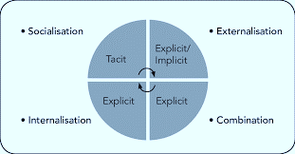
Figure 1: SECI Model (Source: Nonaka & Takeuchi, 1996)
The SECI model helps the HSBC to manage its knowledge efficiently and to be able to gain more profit.

Section 3: Investigating of KM Techniques Used by HSBC

Significance of Knowledge in HSBC's Standard Operating Procedures
HSBC's daily activities are standard procedures (Tummers et al, 2019). It means that determine the roles of the employees for daily activities. Employees of HSBC must know everything about their roles and obligations and work accordingly. Without an adequate understanding and awareness of HSBC's standard procedures, daily operations may be interrupted. Standard Operating procedures (SOPs) clarify HSBC Bank's policies, techniques, and guidelines for multiple business operations to guarantee compliance and high service standards. SOPs provide guidelines to the employees about their roles and responsibilities. Through SOPs, the employees may be able to understand the goals and objectives of their organization. By getting a clear vision of these, the employees will be able to perform better. SOPs are also important for maintaining the quality of services (James, 2014). The SOPs of HSBC includes opening the bank account for customers, providing the information to the customers, advising the customers, processing the loan, debit and credit management, risk management etc. Knowledge is important for creating the SOPs for HSBC. Because before creating the SOPs, there needs to be enough knowledge about the operations of the businesses. The HSBC gained this knowledge through various research, surveys, consultation. The gained knowledge helps to create policies, plan and SOPs. HSBC Bank's SOPs follow industry standards, legal requirements, and company regulations. To remain up-to-date SOPs are reviewed and updated regularly by HSBC. Knowledge and information are needed to analyze and update SOPs. Employees, consumers, regulators, and experts contribute this information. A good knowledge of the company’s policies, employees and customers’ expectations can help HSBC to create a strong and effective SOP. Which will help to reduce the risk of HSBC.

Main Outcomes that HSBC Has Been Achieving with the Use of These Procedures
HSBC is one of the oldest banks. So, it has a long history of knowledge management. Strong knowledge management are one of the key reasons which help to gain competitive advantages by HSBC. SOPs may help the HSBC to understand the laws of the federal, company regulations, customers and employees’ expectations and act accordingly (Hellebrandt et al, 2018). It also helped HSBC to create a more effective workplace, strong customer service and a strong banking system. The major outcomes HSBC achieving by using these procedures are following:
- By creating SOPs, the employees of HSBC are able to get clear guidelines on their roles and responsibilities. Which helps to reduce the doubling of the work. Also, the employees only work to achieve the goals of HSBC. Thus, the efficiency is increasing in the HSBC.
- During creating the SOPs, numerous research and surveys are conducted to know the customers’ expectations. As a result, the SOPs emphasize on th customers needs and employees are working to accomplish these. As a result, customer satisfaction become increasing.
- SOPs also facilitate to share knowledge among the organization. As a result, all the employees of HSBC are able to get better knowledge by sharing.
- It also connects the shareholders, employees and customers of HSBC more effectively.
- SOPs lead to organizational success by gaining more profit.

Areas for Future Improvement by HSBC to Overcome Challenges
HSBC is one of the largest banks in this world operating in 62 countries. For this huge working environment, HSBC also faced several challenges. Impact of COVID-19 is one of the major challenges for HSBC. Due to covid-19, economic recession occurred in the world. As a result, people are demotivated in the banking sector. So, HSBC have to take necessary steps for attracting the peoples of the lower- and middle-income countries to the banking sector.
HSBC have to increase the knowledge sharing culture in the workplace among the employees. This will help to create a better knowledge management system in the HSBC. This world is the world of technology. So, HSBC have to increase the use of technology to be more competitive and also have to train all the employees with the updated technology. HSBC also needs to ensure that their knowledge of management can fulfill the mission, vision and goal of the organization. For this, knowledge management must be aligned with the organizational goals. Performance metrics can increase the competition among the employees for performing better. As a result, HSBC can create performance metrics to evaluate the performance of its employees based on the provided roles and responsibilities of SOPs. The performance metrics have to be different for every country. As a result, HSBC have to understand the demand of its all customers and employees and social context I the countries in which it is operating currently. Participation of the employees in the decision-making level can increase the job satisfaction of the employees. Which can lead to the better output in the service of the employees. So, HSBC can take the necessary actions for including the employees in the decision-making process. These are the major areas which need to be improved by the HSBC. By improving these areas, HSBC can overcome the existing challenges and be able to meet the expectations of the customers. Which will also reduce the negative impacts of the COVID-19 and BREXIT.

Conclusion
Knowledge management helps businesses identify problems manage resources, increase efficiency and productivity, improve relationships with consumers, decision-making, competitiveness, and innovation. Knowledge management can assist businesses identify customer expectations, plan and optimize data access, and simplify relationships with customers across every channel. Knowledge management uses SECI to understand the four information components. Information management uses the SECI model to understand "Socialization," "Externalization," "Combination," and "Internalization" of HSBC. Knowledge management may provide HSBC with a competitive advantage. HSBC can develop customer-centric strategies by collecting and evaluating data. Knowledge management improves productivity, decision-making, customer satisfaction, innovation, and competitiveness, increasing profitability and market share of HSBC. Employees of HSBC know the bank's operations, customer needs, and trends in the market, which they share with customers. HSBC appreciates its tacit knowledge through its service and recruits and trains employees with the skills to provide high-quality services.
HSBC can improve their KM culture using several knowledge management frameworks. SECI—Socialization, Externalization, Combination, and Internalization—is a popular framework. This Nonaka and Takeuchi model focuses the creation of knowledge and exchange of information. HSBC may implement the SECI model by encouraging employees to share knowledge and experiences. Meetings, workshops, and training can accomplish this. One knowledge database where employees can access information, best practices, and lessons acquired may help HSBC share expertise. However, HSBC may start by performing a knowledge management analysis to identify knowledge management gaps and evaluate the resources required to apply the SECI model. This is possible in one year for organizations like HSBC. SECI implementation has several advantages. It may improve collaboration among employees, decision-making, and knowledge transfer by creating a knowledge-sharing culture. The SECI technique may help HSBC to improve knowledge management, business performance, and competitiveness.

References
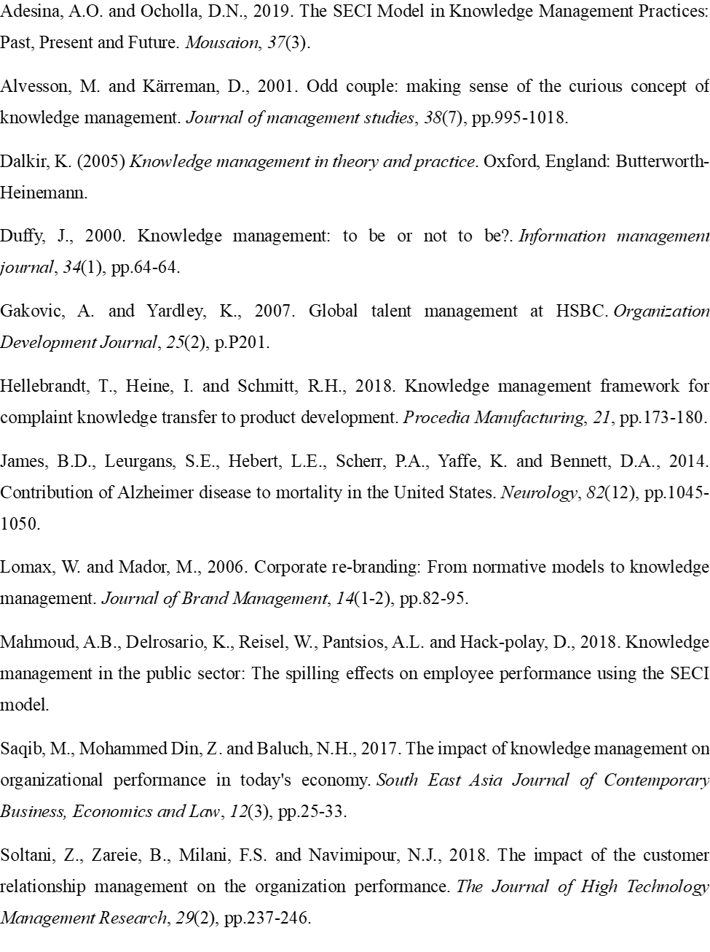
Tummers, J., Kassahun, A. and Tekinerdogan, B., 2019. Obstacles and features of Farm Management Information Systems: A systematic literature review. Computers and electronics in agriculture, 157, pp.189-204.
Vibhor, A., Mehta, B.B. and Karandikar, A.V., Commvault Systems Inc, 2019. Work flow management for an information management system. U.S. Patent 10,169,121.
Zaim, H., Muhammed, S. and Tarim, M., 2019. Relationship between knowledge management processes and performance: critical role of knowledge utilization in organizations. Knowledge Management Research & Practice, 17(1), pp.24-38.

