

Data Handling and Business Intelligence
Assignment 2-Coursework: Essay

Programme: BA Business Management
Module code: LCBB5000
Lecturer: Dr.Anupam Mazumdar
Student name: Desislava Nikolova
Student ID: 2120861

Contents
Part 01: Assessment of Average Price Increase and Decrease in Hotel Reservations 1
1.1: Introduction 1
1.2: Importance of Excel in Data Processing and Analysis 1
1.3: Excel Analysis on Given Data Set 3
Part 02: Analysis Using SPSS 5
2.1: Frequency of male and female students
2.2: Frequency of students qualified or not qualified for free lunch.
2.3: Mean and median of students qualified or not qualified for free lunch.
2.4: Mean and median difference of students for pre-test and post-test scores.
2.5: Clustering (K-Mean Clustering).
2.6: Common examples of data mining and text mining methods for each that can be used in contemporary business.
2.7: Advantages and disadvantages of using SPSS and Excel.
References 15

Part 01: Assessment of Average Price Increase and Decrease in Hotel Reservations

1.1: Introduction
The scenario was given in which a data set for hotel reservations from year 2017 to 2021 was provided. The data provided was arranges and processed in MS excel to find out the percentage increase in prices of reservation for given period of time as well as the increase was indicated using a graphical representation.

1.2: Importance of Excel in Data Processing and Analysis
Excel, short for Microsoft Excel, is a powerful program that can do a wide variety of tasks and is included in Microsoft's Office suite. It's an all-inclusive spreadsheet program with specialized functions for use in business and economic decision-making. Tasks may include but are not limited to, collecting and compiling data, doing statistical and mathematical calculations, making judgements about statistical applications, creating charts and graphs from the available data, and assisting in the creation of polished reports. Microsoft Excel, a spreadsheet program, quickly became the de facto standard in the business world. When it comes to analyzing and presenting data, business professionals have always relied on Microsoft Excel. Data analysts use software like Microsoft Excel to accomplish what they do best: make sense of disparate datasets by putting them together (Abbott, 2016).
Microsoft Excel may not be the only analytical tool available to organizations today, but it is still very important within the context of the Data Ecosystem. This is due to Microsoft Excel's major features being simple but effective for the Data Analysts, allowing for better insight extraction. Microsoft Excel allows users to customize the fields and functions that perform calculations, which is very helpful when working with complex data. Simple simultaneous user collaboration is also supported. Microsoft Excel for Data Analysts has been updated with additional features that improve the program's analytic capabilities. Excel's widespread adoption in the corporate world may be attributed to its convenient interface and large range of analytical features for working with and analyzing data. Its extensive library of Graphs, Functions, and Arrays makes it easy for Data Analysts to pick up the basics of sifting through data in search of insights (Prvan, Reid and Petocz, 2002).
Due to its widespread familiarity and user-friendliness, Excel has become a popular data analysis and processing tool. Data management, analysis, and visualization are just few of the many functions it provides. Excel's limitations become more apparent when working with more complicated or extensive data sets. Excel's user interface and spreadsheet format are appealing to folks who may not have much experience with computers or programming. Excel's in-built functions and formulae make it easy to execute basic arithmetic operations like sum, average, and count. It can handle basic data analysis needs. Excel's built-in chart types make it easy to create simple visualizations that may aid in catching patterns and trends in data at a glance. Excel may be a helpful tool for rapidly prototyping research processes for smaller datasets and fast analysis without the need for specialized software or code (Smith, 2003).
The data cleaning and organization tools in Excel include filters, sorts, and manipulation tools. It works well for cleaning up tiny datasets with little manipulation. As a result of its tabular layout, Excel is well suited for handling and displaying tabular data, making it a go-to tool for things like setting budgets, keeping track of the basics, and entering limited amounts of data. With Excel's built-in support for file sharing and collaboration, many users may work on the same file at once. However, there are several restrictions and difficulties in using Excel as an illustration. When working with massive data sets, Excel may become problematic.
Working with large datasets or conducting sophisticated computations might cause performance concerns and memory constraints. Excel's susceptibility to human mistake in data input and formula construction may introduce flaws into calculations. Finding and fixing mistakes may be laborious. Workflows cannot be programmed and reproduced in Excel. This may make it harder to reproduce studies and reduce transparency. While it's true that Excel can perform certain basic statistical operations, it may lack some of the more advanced and flexible analytical capabilities found in dedicated statistical packages. Excel isn't as powerful as specialized data analysis tools and computer languages when it comes to doing complicated statistical analyses, data transformations, and machine learning activities. In conclusion, Excel is useful for fast and easy data analysis jobs, rudimentary visualizations, and basic data administration on a small scale. Users may want to investigate specialized data analysis software or programming languages like Python, R, or tools like RStudio, Jupyter, or even more sophisticated spreadsheet applications for more complicated studies, bigger datasets, and jobs requiring automation and repeatability. The average price change was calculated in Excel, and a chart was generated to show the results. Of course, Microsoft Excel is useful for preparing, analyzing, and visualizing data on price changes in a specific dataset (Abott, 2014).

1.3: Excel Analysis on Given Data Set
I opened the dataset named as Hotel Reservations containing dates and prices. I made sure the data is organized in columns. I separated the column for price change from date set and created another column named as percentage increase/decrease in prices from the given time period of 2017 to 2021 on daily basis. Along with the column of average prices I created the column in Y where I gave the command as =(X3-X2)/1 and followed same command in whole column that gave me the values of average increase and decrease. Average increase containing the values with positive sign and average decrease was indicated by negative sign in new output column. The representation of new output column is shown as below:
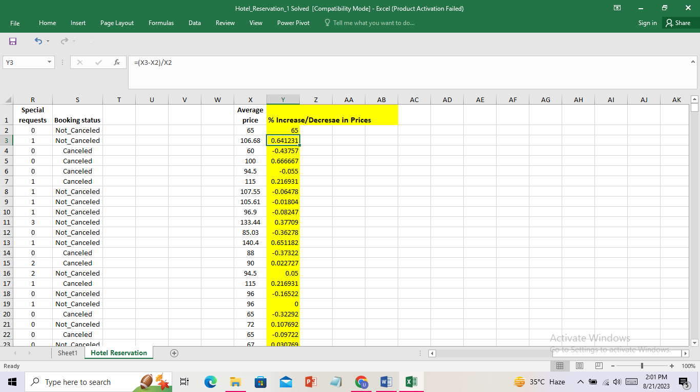
Data visualization helped my analysis immensely. Data visualization is the process of presenting data in a visual format (such a map or graph) that facilitates comprehension and the extraction of insights. Data visualization's primary objective is to facilitate the discovery of hidden relationships and anomalies in massive datasets. Information graphics is typically used synonymously with information visualization and statistical graphics.
After data has been gathered, processed, and modelled, it must be visualized so that insights may be drawn from it. This is one of the processes in the data science process. Data presentation architecture (DPA) seeks to find, locate, modify, format, and transmit data in the most effective manner possible, and data visualization is a part of that. The ability to effectively visualize data is crucial in almost every field. Teachers may use it to show off their students' exam scores, AI researchers can use it to discover new possibilities, and business leaders can use it to update their stakeholders. It's also crucial in big data initiatives. Businesses in the early stages of the big data movement required a simple method to gain an overview of the data they had gathered as it grew in size. The use of visualization software just made sense (Verma, 2012).
For similar reasons, visualization is essential for sophisticated analytics. Data visualization helps a data scientist keep tabs on findings and make sure their models are functioning as expected while they're developing complex predictive analytics or ML algorithms. This is due to the fact that pictures are worth a thousand numbers when it comes to understanding complicated algorithms. The following Excel graph shows the average percentage growth and reduction in hotel reservation costs over a specified time period:

Part 02: Analysis Using SPSS
Next part was completely based on analysis in SPSS that was conducted on Student Score dataset so first of all data from Excel was coded and entered in SPSS and analysis was conducted as shown below:

2.1: Frequency of Male and Female Students

Gender
 |  | Frequency | Percent | Valid Percent | Cumulative Percent
Valid | Male | 1304 | 61.1 | 61.1 | 61.1
Valid | Female | 829 | 38.9 | 38.9 | 100.0
Valid | Total | 2133 | 100.0 | 100.0

Analysis indicated that in class room there were 1304 male students and female students were 829. As shown in below mentioned graph:
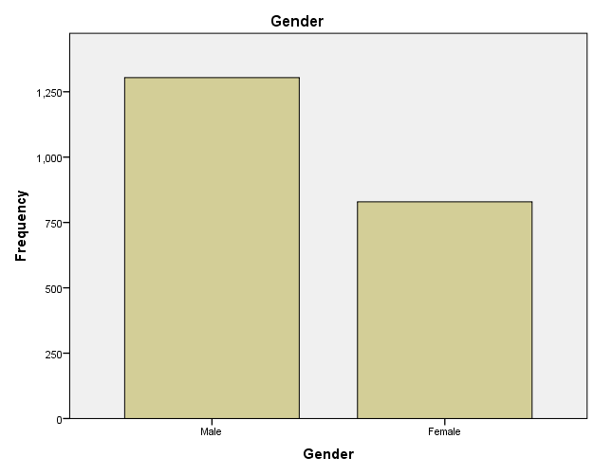

2.2: Frequency of students Qualified or not Qualified for Free Lunch

Qualified Vs Not-Qualified
 |  | Frequency | Percent | Valid Percent | Cumulative Percent
Valid | Qualified | 1295 | 60.7 | 60.7 | 60.7
Valid | Not Qualified | 838 | 39.3 | 39.3 | 100.0
Valid | Total | 2133 | 100.0 | 100.0

Analysis indicated that 1295 students qualified for the free lunch however 838 students did not qualify for free lunch as shown in graph:
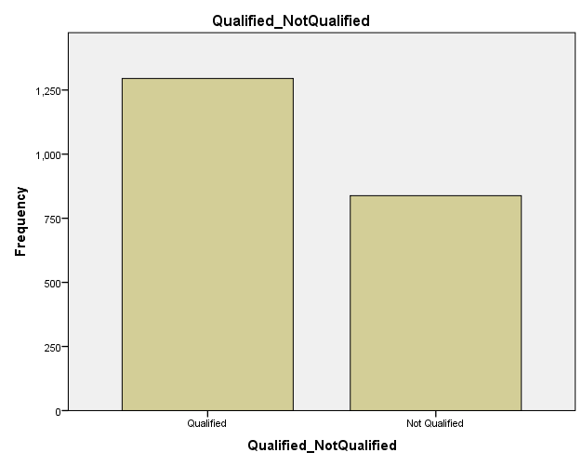

2.3: Mean and Median of students Qualified or not Qualified for Free Lunch
Mean and Median Values
Qualified Vs Not Qualified
Mean | 1.3929
Median | 1
N | 2133

Mean value of qualified vs not qualified students for free lunch was found as 1.3929 and median was found as 1 out of total values that was 2133.

2.4: Mean and Median Difference of students for Pre Test and Post Test Scores
 | Pre-test | Post-Test
Mean | 54.9559 | 67.1022
Median | 56.0000 | 68.0000
Mean Difference | -12.1463
Median Difference | -12.0000

Analysis indicated that mean difference for pre-test and post test scores was found as -12.1463 while median difference was found as -12.0000.

2.5: Clustering (K-Mean Clustering)
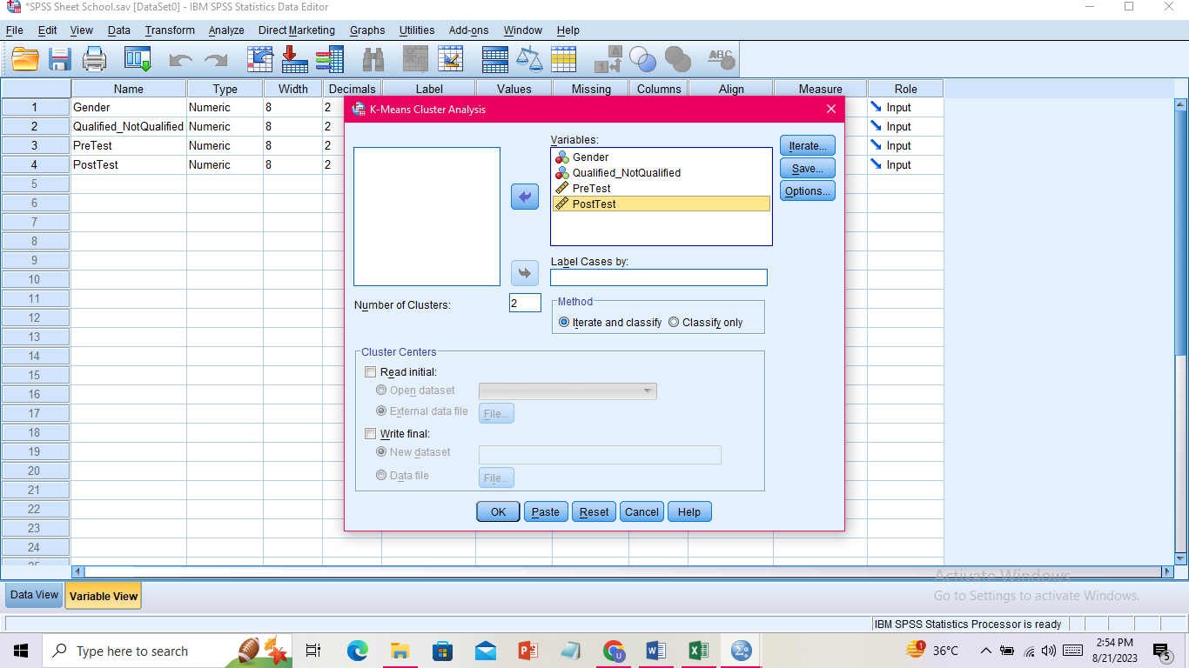
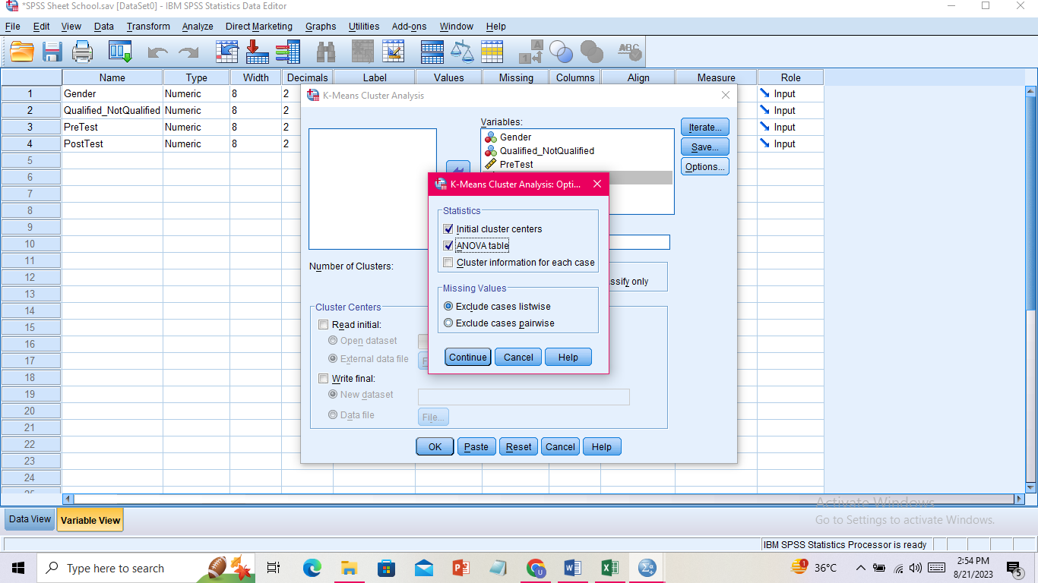
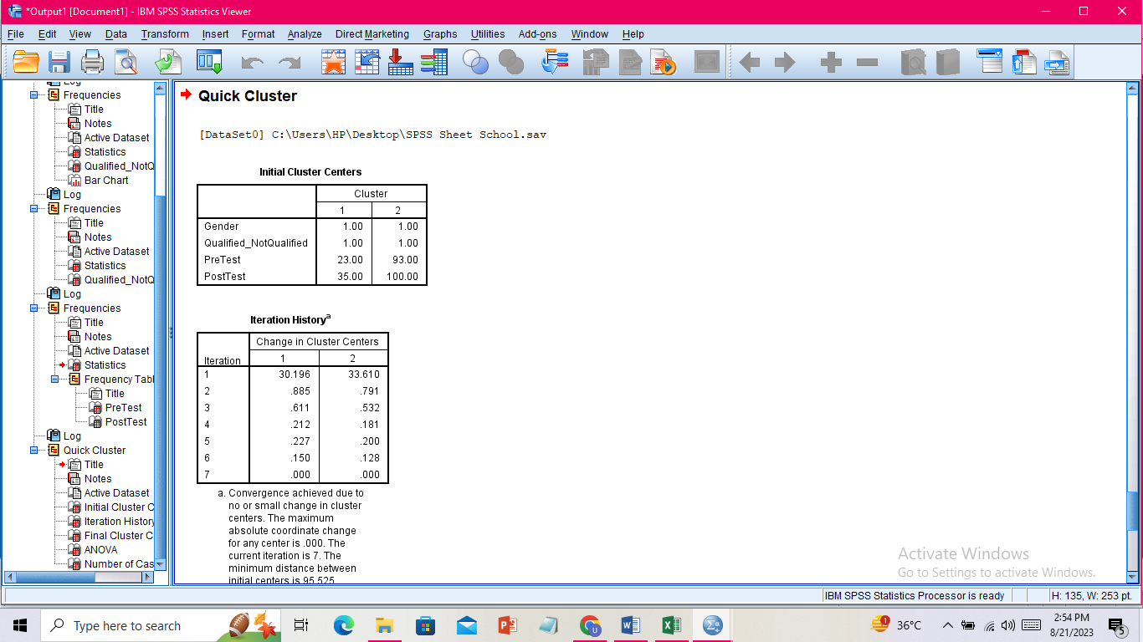
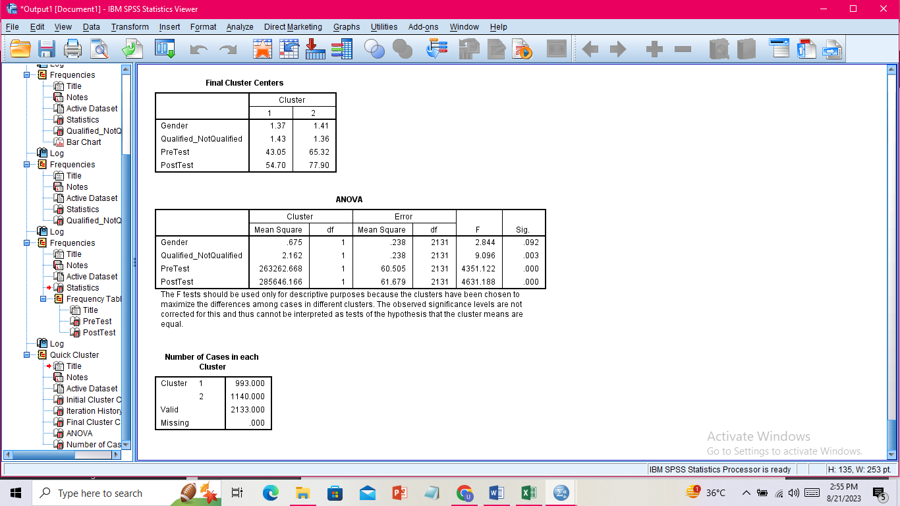
K-means clustering is an approach for grouping similar data points into sets of a certain size. The cluster center (mean) closest to each data point is used to categories it. In an effort to reduce the overall squared distances between data points and their corresponding cluster centers, the method repeatedly refines these assignments. K-means requires us to pre-define the number of clusters into which our data will be divided. This is a major choice that will have far-reaching consequences. To find the right number of clusters, we may utilize domain expertise, heuristics like the elbow approach, or validation tools. Select K data points at random from our dataset to act as the founding nodes of our clusters. Each data point is then assigned to one of the K clusters based on its distance (often measured in Euclidean units) from the cluster's center.

2.6: Common Examples of Data Mining and Text Mining Methods for each that can be used in the contemporary business.
- Data Mining
The first step in data mining is feeding raw data into statistical and algorithm-based tools designed for the purpose. These tools provide a visual representation of the findings, making the data easier to digest and use in subsequent iterations of business process improvement. Organizations utilize data mining for a variety of purposes, including developing a marketing plan, creating diagnostic tools, and cross-selling items online (Proctor, 2002). Following are the data mining method examples in businesses:
Mobile Service Providers: Data mining is used by mobile service providers in the creation of advertising campaigns and the prevention of client defection to competitors. Data mining techniques are able to forecast "churn," or consumers who want to switch suppliers, using a significant quantity of data such as billing information, email, texts, online data transfers, and customer care interactions. Based on these findings, a likelihood value is assigned. This allows mobile service providers to target consumers most likely to leave with incentives and special offers. Broadband, phone, gas, and other major service companies often employ this kind of data mining.
Retail Sector: With the use of Data Mining, grocery stores and other retailers may better cater to their consumers' preferences. Data mining techniques reveal client purchasing habits by analyzing past transactions. Supermarkets use this information to inform their decisions about product placement and promotional efforts like couponing and price-cutting. RFM clustering is the foundation of these drives. RFM is an abbreviation for "recent," "frequent," and "monetary" grouping. The advertising and marketing initiatives are tailored to the specific interests of these groups. Customers who spend a lot but just seldom will be given preferential treatment over those who spend less but make more regular purchases. Data Mining has several applications, including item cross-referencing and product suggestion.
Artificial Intelligence: Providing a machine with meaningful patterns is one way to give it artificial intelligence. Data mining results reveal these regularities. Data mining methods are also used to examine the usefulness of the results produced by artificially intelligent systems. When a consumer interacts with a computer, a recommender system may employ data mining methods to provide pertinent suggestions. Data mining is one use of AI, and one example is Amazon's personalized product suggestions based on a customer's purchase history (Pfister, Schwarz, Carson and Jancyzk, 2013).
Ecommerce: Data mining is used by many online stores to provide additional services like cross-selling and up-selling. Customers engaging with e-commerce platforms like Amazon and Flipkart see suggestions for related products and items they often purchase together. Data mining over clients' purchase histories is used to generate these suggestions.
Science and Engineering: The introduction of data mining has allowed scientists to move away from traditional statistical methods and towards "collect and store data" methods, from which they may mine for fresh insights and test out new approaches. Astronomy, geology, satellite sensors, GPS, etc. all provide massive amounts of data to the scientific community. In computer science, data mining is used to keep tabs on systems, boost performance, root out flaws, detect plagiarism, and locate problems. Opinions and feelings may be gleaned through data mining analyses of user comments on items and publications (Elliott and Woodward, 2007).
- Text Mining
In today's business world, text mining is a must-have skill. Since unstructured data is increasing at an exponential rate, businesses are turning to text mining to make sense of it all. As a result, they have been able to improve their business choices and get more in-depth business information across a variety of applications. Text classification, entity extraction (also known as named entity recognition), and sentiment analysis are all examples of text mining methods used to glean valuable information and insight from textual material. This has commercial applications since it facilitates the discovery of insights, patterns, and trends hidden inside massive amounts of unstructured data. Its quick popularity throughout the organization may be attributed to its ability to filter out irrelevant information while still returning useful results. The following text mining examples show how putting unstructured data management strategies into practice may improve both your business's efficiency and your status in the market.
Risk Management: Regardless of the field, inadequate risk analysis is a common contributor to failure. The implementation of risk management software built on text mining technologies may significantly improve the financial and insurance sectors' capacity to reduce risk. The result is that businesses may quickly and easily access information from thousands of sources (and petabytes) of text documents, improving their ability to connect information and find the correct information at the right moment.
Knowledge Management: The capacity to swiftly locate relevant information is crucial when dealing with vast amounts of text documents. Consider the healthcare sector, where companies own vast quantities of data (decades of study, clinical patient data, etc.) that may benefit their most lucrative business venture by far: the creation of brand new products. To get more insights and get goods to market quicker, businesses may benefit from text mining technologies that help them find information quickly and correctly (Cleff, 2014).
Cybercrime Prevention: Internet-based crime is on the rise due to the platform's anonymity qualities and the abundance of communication tools it provides. Today, text mining is aiding corporate organizations and law enforcement in preventing cybercrime by providing additional context for the data they receive. As a result, they can zero in on genuine dangers while reducing the amount of false positives caused by terms taken out of context.
Enhanced Customer Service: Text mining and NLP have been quite useful for customer service departments. They are widely used to enhance the customer service experience by enhancing the quality, efficiency, and velocity with which issues are resolved via the use of useful information sources including surveys, trouble tickets, and customer call notes. Chat bots rely heavily on text analysis since it allows them to collect all the data they need to offer an instant, automatic answer to the customer's query. Because of this, businesses may greatly decrease their dependency on contact center agents to resolve consumer issues.
Streamlined Claims Investigation: Wherever textual data predominates; text analytics proves to be a very useful tool. There are a variety of applications for text analysis in the insurance sector, for instance. Reviewing policies, automating claim processes, and engineering risks are three of the most prevalent applications. Insurance firms may save countless hours of research time by using text mining to find precise information. Not only does it speed up tedious tasks, but it also lessens overall portfolio risk.

2.7: Advantages and Disadvantage of using SPSS and Excel
Excel | SPSS
Advantages
- Because it stores and processes so much client information, it significantly cuts down on redundant data in the memory system.  - Excel is useful for businesses of all sizes because its user-friendly design makes it simple to enter data and do computations by both owners and staff.  - Tables, charts, and graphs are shown more professionally in excel.  - Excel will function similarly to a relational database, recognizing columns and rows. Thus, data storage and integration become less of a hassle. We may save information in a variety of Excel file types (Gaur and Gaur, 2006). | - When we need high-speed and high-performance statistical computations and data management, SPSS is our best option. SPSS is a statistical package designed for high-speed hardware and high-tech processors like supercomputers.  - Processing and storing massive amounts of user information in real time. Cluster analysis, logistic regression, and other sophisticated analytics are all a breeze with SPSS.  - All technological fields and multinational corporations may benefit from this software. SPSS pairs well with a rapidly expanding area of research and development.
Disadvantages
- Statistical calculations are a major pain in the neck with Excel. In order to carry out the statistical procedure, we need to be familiar with sophisticated analysis and advanced notions.  - Complex analytics may be difficult to master if we don't know the specifics.  - Excel often makes mistakes when entering formulae into spreadsheets, which makes accurate calculation difficult. Human mistake, malfunctioning formulae, missing files, etc. are all possible with Excel.  - Our file becomes increasingly difficult to manage and keep up with as time goes on. | - SPSS might be costly for students to acquire.  - SPSS's inadequate support for spreadsheet formatting when dealing with rows and columns is reminiscent of Microsoft Access (Abott, 2016).

References
- Abbott, M.L., 2016. Using statistics in the social and health sciences with SPSS and excel. John Wiley & Sons.
- Prvan, T., Reid, A. and Petocz, P., 2002. Statistical laboratories using Minitab, SPSS and Excel: A practical comparison. Teaching Statistics, 24(2), pp.68-75.
- Smith, B., 2003. Using and evaluating resampling simulations in SPSS and Excel. Teaching Sociology, pp.276-287.
- Abbott, M.L., 2014. Understanding educational statistics using Microsoft Excel and SPSS. John Wiley & Sons.
- Verma, J.P., 2012. Data analysis in management with SPSS software. Springer Science & Business Media.
- Proctor, J.L., 2002. SPSS vs. Excel: Computing software, criminal justice students, and statistics. Journal of Criminal Justice Education, 13(2), pp.433-442.
- Pfister, R., Schwarz, K., Carson, R. and Jancyzk, M., 2013. Easy methods for extracting individual regression slopes: Comparing SPSS, R, and Excel. Tutorials in Quantitative Methods for Psychology, 9(2), pp.72-78.
- Elliott, A.C. and Woodward, W.A., 2007. Statistical analysis quick reference guidebook: With SPSS examples. Sage.
- Cleff, T., 2014. Exploratory data analysis in business and economics. Exploratory Data Analysis in Business and Economics. https://doi. org/10.1007/978-3-319-01517-0.
- Gaur, A.S. and Gaur, S.S., 2006. Statistical methods for practice and research: A guide to data analysis using SPSS. Sage.

