Business Plan for

Tara! Pop-up Kitchen

Produced By:
Mark Jeffrey Pascual

Dated: 12 June 2025

Student Number: 2229176
Module Name: Leading Restaurant Strategy
Module Code: BMGM6001

CONTENTS

 |  |  | PAGE
1. | Executive Summary |  | ………………….1
2. | The Business Idea |  | ………………….2
3. | The Team |  | ………………….4
4. | Market Research |  | ………………….5
5. | Marketing Plan |  | ………………….7
6. | Key Resources |  | ………………….10
7. | Finances & Start-Up Support |  | ………………….14
APPENDICES:
Appendix A |  |  | SWOT Analysis
Appendix B |  |  | PEST Analysis
Appendix C Branding and Design

IMPORTANT: ALL RED TEXT IN THIS TEMPLATE SHOULD BE REMOVED/DELETED BEFORE SUBMISSION

Executive Summary
Tara! Pop-Up Kitchen is an innovative and culturally rich dining concept based in Swansea, Wales, specialising in authentic Asian Filipino cuisine fused with fresh, locally sourced Welsh produce. By celebrating the unique culinary heritage of the Philippines while supporting regional sustainability, Tara! creates memorable, seasonal pop-up dining experiences designed to engage adventurous food enthusiasts and culturally curious customers.

Operating within the casual premium dining sector, Tara! fills a market gap in Swansea by introducing Filipino cuisine still underrepresented locally to a growing audience seeking authentic, globally inspired food. The business leverages a flexible pop-up format, hosting limited-time events at rotating venues such as food festivals, cultural spaces, and farm-based dining sites, offering high-quality plated meals in welcoming environments that blend Filipino warmth with Welsh charm.

Tara!'s competitive advantage lies in its authentic menu, sustainable sourcing, and strong cultural storytelling, fostering meaningful connections between people and place. The pricing strategy balances premium quality with accessibility, ensuring value through thoughtfully crafted dishes and curated tasting menus. Marketing efforts focus on digital engagement, community partnerships, and storytelling that emphasize the brand’s core philosophy: a heartfelt invitation to gather ("Tara!" meaning "come in") and a warm farewell to remember.

Financial projections indicate the need for approximately £8,500–£9,000 in start-up capital to cover kitchen hire, equipment, licensing, and initial marketing. With sustainable margins built on ingredient cost controls and flexible supplier relationships, Tara! aims to establish a loyal customer base and achieve profitability within its first year.

Short-term goals include successfully launching the inaugural pop-up event, building strong partnerships with local venues and suppliers, and cultivating a vibrant community presence through targeted digital campaigns and cultural engagement.

2. THE BUSINESS IDEA

2.1 The Product/Service

Tara! Pop‑Up Kitchen is a unique and purpose‑driven dining concept that brings Asian Filipino cuisine to Swansea and nearby towns. Operating within the hospitality and food service industry, the business uses fresh, locally sourced Welsh produce to celebrate both cultural heritage and regional sustainability. The brand embraces the special and temporary nature of pop‑ups (Alvarado, 2023), a rare opportunity offering once‑in‑a‑lifetime experiences that leave an impression (Baras, 2015). Tara! embodies this spirit by hosting seasonal events that are limited in availability but abundant in cultural storytelling, a warm sense of community and a platform for culinary creativity. These events are designed to appeal to adventurous food enthusiasts and cultural explorers who value meaningful and socially engaging experiences.

Tara!’s value proposition lies in bridging cultural gaps through food and fostering meaningful connections between people and place. By introducing an underrepresented cuisine in the Welsh market with limited direct competition and increasing demand for globally inspired, locally sourced food.

Tara! meaning “come in” in Filipino and “goodbye” in Welsh beautifully captures the full journey of Tara! pop-up kitchen: a heartfelt invitation to gather and a warm farewell to remember.

2.2 SWOT Analysis Summary

A primary challenge facing Tara! Pop-Up Kitchen is the limited local familiarity with Filipino cuisine within the Swansea market (Cohen & Avieli, 2004). However, this also represents a strategic opportunity to introduce a distinctive culinary concept into Swansea’s expanding cultural food landscape, allowing Tara! to establish a unique market position (Welsh Food and Drink, 2021). The business’s core strengths lie in its authentic Filipino menu, rich narrative rooted in cultural heritage, and strong commitment to sustainability using locally sourced Welsh ingredients (Estrada et al., 2023). Operational constraints, such as limited access to suitable venues, present potential weaknesses. Nonetheless, these can be mitigated through strategic collaborations with local event organisers and by actively participating in seasonal food festivals to enhance visibility and market reach (Buttrey, 2024).

See Appendix A.

3. THE TEAM

3.1 Key Personnel

Name and Company Position:
Mark Jeffrey Pascual- Owner/ Head Chef
Skills and Experience:
Kitchen Management and Customer Engagement
Culinary Placements:
L’Enclume, Ynyshir rooms and restaurant, Beach House Oxwich,
Thomas by Tom Simmons
Front of House with Leadership and Development Placement:
The Grove of Narberth and The Secret Bar and Kitchen
Worked Experience in a Michelin Restaurant
Role and Responsibilities:
Menu development, sourcing ingredients, leading events, customer engagement, financial oversight, and training support staff and marketing.

3.2 Skills Gaps & Key Partners

3.2.1 Additional Staff Requirements
To ensure smooth and efficient service operations, the following roles are identified to address current skill gaps:

- Front of House (2 positions)
These roles will focus on customer service, table management, and ensuring a welcoming atmosphere. They will fill the gap in guest-facing service, freeing up the owner/chef to focus on kitchen operations.

- Sous Chef
This role is essential to support food preparation, maintain kitchen organisation, and assist in quality control. The Sous Chef will provide vital backup during events and cover operational needs when the head chef is engaged in marketing or procurement.

3.2.2 Training and Development
To ensure compliance, enhance service standards, and bridge knowledge gaps, the following training will be undertaken:

- HACCP and Food Safety Certification
Delivered free via the Food Standards Agency (FSA) and Local Authority to ensure compliance with UK hygiene regulations (FSA, n.a).

- Customer Engagement Training
- Conducted in-house through shadowing and roleplay, focusing on hospitality and storytelling aligned with brand identity.

- On-site Placement Training for FOH and Chef Roles
Utilising professional contacts to arrange informal one-day placements in established restaurants to gain service flow and efficiency insights.

- Sales & Marketing Workshops – Accessed online via Business Wales (no cost) (Business Wales, 2025), to enhance business promotion and conversion tactics.

3.2.3 Outsourced Support / Key Partners

- Accounting
Handled by the owner's spouse, knowlegeable in financial aspect, which reduces operational costs and ensures accurate financial oversight at no additional charge.

- Legal Compliance (Food Safety & Licensing)
Utilising existing professional networks within Environmental Health to receive guidance on legal requirements for temporary food operations and event-based licensing.

- Business Consultancy
Ad hoc strategic advice will be sought through local enterprise networks such as Business Wales to support early-stage growth planning and market positioning (free or subsidised).

- Point of Sale (POS) System with QR Code Integration
Modern digital POS system with QR code functionality to streamline order-taking, payment processes, and customer service. This system will provide real-time sales tracking, helping the business identify bestselling dishes, manage inventory effectively, and adapt the menu based on customer preferences. Advanced POS solutions offer vital features such as automated stock level adjustments, multi-location inventory tracking, and secure payment compliance, which are essential for small-scale hospitality operations (James, 2025).

4. MARKET RESEARCH

4.1 Market Information, Trends and External Factors

Swansea, with a population of approximately 246,700 (Swansea Council,2023), is experiencing a culinary renaissance, driven by increased cultural diversity (Heritage Fund, n.a). Nationally, the UK food sector shows an increase in demand for ethnic cuisines, especially among consumers aged 25 to 40, who prioritise authenticity, sustainability, and immersive dining experiences (Credence Research, 2024, Maxwell, 2018). This demographic trend aligns directly with Tara! Pop-Up Kitchen’s target audience.

Current market trends indicate a strong shift toward sustainable practices and experiential dining. Pop-up restaurants are growing in popularity among Millennials and Gen Z consumers, who value novelty, immersive experiences, and locally sourced ingredients (Taylor Jr. et al., 2018; Insight Trends, 2025). Ethnic pop-ups excel at providing narrative-driven, culturally rich dining experiences, which enhance customer satisfaction and loyalty (Ishak et al., 2023). Sharing authentic food stories also fosters community engagement and a sense of belonging key values for younger diners (Mulrooney, 2021).

The external environment for Tara! Pop-Up Kitchen is shaped by several critical political, economic, social, and technological factors. Politically, post-Brexit regulatory changes and increased tariffs on imported food products have incentivised UK food businesses to prioritise local sourcing to ensure supply chain stability and sustainability, a trend that aligns closely with Tara!’s commitment to using locally sourced Welsh produce (Freeman et al., 2025; Crossey, 2017) Economically, inflationary pressures and rising input costs in the hospitality sector require rigorous financial planning, with efficient budgeting and cost control becoming essential to ensure affordability for consumers while sustaining business profitability (Olsson, 2024). On the social front, there is a growing consumer appetite for authentic ethnic cuisines and immersive dining experiences, particularly among Millennials and Gen Z consumers aged 25 to 40, who value cultural storytelling and sustainability in their food choices (Taylor Jr, DiPietro & So, 2018; Ishak et al., 2023). Technological advancements, including mobile point-of-sale systems, QR-code menus, online ordering platforms, and active social media engagement, present valuable opportunities for Tara! to enhance operational efficiency and deepen customer engagement while expanding its market reach (Farooq & Bowen, 2020). These external trends inform Tara!’s strategic approach to sustainable sourcing, digital integration, and culturally resonant marketing, positioning the business competitively within the evolving hospitality.

  - Customer Profiles

Culinary Explorers (Ages 25–40)
- Urban professionals and foodies seeking authentic, immersive, and sustainable dining experiences.
- Attracted by pop-up format, cultural storytelling, and use of local Welsh produce.
- Active on social media and keen to try underrepresented global cuisines.

Cultural Enthusiasts (Ages 40–60)
- Educated, well-travelled individuals interested in cultural experiences and artisanal food.
- Enjoy food festivals, unique dining events, and trying new cuisines with depth and tradition.
- Value the seasonal, community-focused aspect of Tara!’s offerings

Filipino British & Southeast Asian Diaspora (Ages 18–50)
- Locals with Filipino heritage or Southeast Asian background seeking nostalgic, familiar food.
- Loyal to culturally reflective businesses and drawn to community-based dining.
- Appreciate the fusion of tradition and quality, locally sourced ingredients.

According to Office for National Statistic data (2022), approximately 75% of Swansea’s population falls within the working-age bracket (15–64), with a significant portion aged 25–40 an ideal target for Tara! Pop-Up Kitchen given their interest in authentic, global cuisines and experiential dining. Additionally, around 21% of the population is aged 65 and over, representing a secondary market segment that values cultural enrichment and quality dining experiences. These demographics support targeting adults aged 25–60 as the core customer base.

  - Competitor Profiles

1.Adelinas Bar and Kitchen specialises in authentic Indian cuisine, offering consistent, well-loved traditional dishes that appeal to customers seeking classic South Asian flavours. However, they lack emphasis on locally sourced Welsh produce and cultural storytelling beyond their cuisine’s heritage. Tara! Pop-up kitchen differentiates itself by combining vibrant Filipino flavours with fresh, local Welsh ingredients, creating a unique fusion experience enriched by immersive cultural storytelling that attracts diners looking for authenticity and novelty.

2. The Secret Bar & Kitchen is known for its contemporary cuisine and strong, polished branding that draws a wide audience. While their menu is creative, they do not focus on a specific cultural identity, which limits the depth of the dining experience. In contrast, Tara! Pop-Up Kitchen centres its concept on authentic Filipino heritage and narrative, pairing this cultural focus with locally sourced produce to provide a meaningful, immersive experience that resonates emotionally with customers and stands out in the market.

3. Mor Mumbles prides itself on its use of locally sourced Welsh produce and commitment to sustainability, appealing to customers who value local heritage and quality ingredients. However, its menu offers limited ethnic diversity and lacks multicultural appeal. Tara! Pop-up kitchen competes by blending Welsh ingredients with bold Filipino flavours, creating a culturally rich and innovative dining experience that attracts adventurous food lovers seeking both sustainability and novel ethnic cuisine, giving Tara! a distinct competitive advantage in the Swansea area.

5. MARKETING PLAN

5.1 Price
The pricing strategy at Tara! Pop-Up Kitchen aims to reflect the high quality, authentic Filipino Welsh fusion cuisine using premium locally sourced ingredients, while remaining accessible to food enthusiasts in Swansea. Prices are set to balance affordability with the perceived value of thoughtfully crafted dishes featuring fresh Welsh produce and specialty Filipino ingredients.

Quality Indicator:
Pricing reflects the use of premium Welsh meats (such as Salt Marsh Lamb and locally sourced pork), fresh seafood from Swansea Fish Market, and specialty Asian ingredients from trusted suppliers like Asian Grocery. The inclusion of in-house made items, such as the signature Buchi and Welsh cakes, further supports the premium positioning.

Value for Money:
Ingredient costs typically represent 25–30% of the selling price, ensuring sustainable margins while maintaining competitive pricing compared to other high-end dining options in Swansea. For example, main courses are priced between £22–£28 with ingredient costs averaging £4–£6.50 per dish, allowing the business to deliver an elevated dining experience without overpricing.

Competitive Comparison:
Prices are comparable to established Swansea restaurants offering premium seafood and locally sourced meats, yet Tara! stands out by offering a unique fusion concept combining Welsh produce with Filipino culinary traditions. The tasting menu at £53 provides a curated experience at excellent value for a 5-course meal, encouraging customer exploration and repeat visits.

Accessibility and Variety:
By including smaller snacks and vegan options at accessible price points (£11–£14), Tara! appeals to a broad customer base including those seeking lighter meals or plant-based dishes, ensuring inclusivity and expanding market reach.

Flexibility:
Seasonal substitutions and local supplier relationships enable cost control without compromising quality, allowing pricing adjustments in response to ingredient availability and market trends.

Overall, Tara! Pop-Up Kitchen’s pricing strategy aligns with its brand promise of delivering authentic, high-quality Filipino Welsh cuisine that values local sustainability and customer satisfaction.

See Appendix C.

5.2 Product
Tara! Pop-Up Kitchen offers a distinct dining experience that blends authentic Filipino culinary heritage with the rich local produce of Wales. The product aesthetics are carefully crafted to reflect this fusion, emphasizing both visual appeal and cultural storytelling.

Food Presentation
Each dish is designed to be visually striking yet approachable, combining vibrant colors and textures inspired by Filipino cuisine with rustic elegance reflecting Welsh produce. For example, bright hues from tropical fruits (mango, calamansi) and herbs contrast with the earthy tones of Welsh lamb and seasonal vegetables. Plates will feature carefully arranged garnishes such as edible flowers, toasted coconut flakes, and microgreens to elevate the sensory experience.

Portioning and Style
Dishes are portioned to balance satisfaction with the opportunity for tasting multiple flavors in one sitting, particularly through the tasting menu. Small bites like the Snack Duo or Lumpia are crafted to be crisp and inviting, ideal for sharing and social dining. Main courses are plated with modern minimalism, focusing on the quality and freshness of ingredients rather than overcrowding.

Branding and Visual Identity
The Tara! brand visual identity blends Filipino warmth and hospitality with the natural beauty of Wales. The logo uses warm, inviting colors such as deep orange and earthy green, symbolizing Filipino sunsets and Welsh landscapes. The typography is clean and contemporary with subtle traditional script influences to hint at cultural roots.

Marketing materials, menus, and packaging incorporate hand-drawn botanical illustrations of native Welsh herbs alongside Filipino motifs like the banig (woven mat) pattern. This fusion of imagery reinforces the brand’s core philosophy of bridging cultures through food.

Ambiance and Experience
The pop-up kitchen’s environment will evoke a welcoming, vibrant atmosphere using a mix of rustic wooden furniture, tropical plants, and subtle Filipino decorative accents like capiz shell lamps and woven textiles. The setup encourages community and shared enjoyment, reflecting the pop-up’s temporary yet memorable nature.

See Appendix C.

5.3 Placement
Market Positioning:
Tara! Pop-Up Kitchen is positioned in the casual premium dining sector, offering a culturally rich and locally sourced Filipino dining experience. It bridges the gap between traditional sit-down restaurants and street food by delivering high-quality meals in temporary, curated environments. The concept targets adventurous diners, foodies, and culturally curious customers who seek authentic experiences beyond the mainstream dining scene. As Filipino cuisine is still emerging in the Welsh market, Tara! stands out as a fresh, niche, and innovative offering (Mintel, 2024).

Tara! operates solely through on-site dining at rotating pop-up venues across Swansea and nearby areas. These include food festivals, farm-based dining events, and cultural venues. Customers are encouraged to dine on location and enjoy the full ambiance of the event.

At most venues, a plated sit-down service is provided to maintain the quality and presentation of the food. Where needed, takeaway is available only at the venue using eco-friendly, branded packaging.

Customer Experience:
Guests are welcomed with the Filipino expression “Tara!” meaning “Come in!”—creating an inviting, energetic atmosphere. Each pop-up is designed to reflect the fusion of Filipino and Welsh aesthetics, using natural materials, traditional décor, and local tableware. Menus are seasonal, with storytelling woven into each dish to highlight the cultural and culinary inspiration.

5.4 Promotion
Tara!’s promotional strategy leverages a combination of digital marketing, community engagement, and story-driven branding to reach target demographics effectively.

Digital Marketing
- Instagram & TikTok: Primary platforms to showcase dishes, behind-the-scenes preparation, customer reactions, and Filipino cultural snippets. Targeting food explorers aged 25–40.
- Facebook Events & Groups: Used to connect with local Filipino communities, university groups, and eventgoers.
- Google My Business & Website: SEO-optimised landing pages for pop-up schedules, menu highlights, and booking inquiries.

- Email Newsletters: Monthly updates with seasonal menus, exclusive invites, and cultural insights.

Community Engagement
- Filipino Student Groups & NHS Workers: Special offers to diaspora communities, creating loyalty and word-of-mouth marketing.
- Local Collaborations: Partnering with venues like community halls, food festivals, and cultural markets in Wales to increase footfall and visibility.
- Feedback Cards & QR Reviews: Encourage real-time feedback through short review surveys with discount incentives.
- Content Strategy: Use storytelling around food, such as the history of dishes or producer spotlights, to build emotional resonance and brand identity.
- Promote “heartfelt invitation to gather and a warm farewell to remember.” as a cultural motto representing warmth hospitality of Filipino and Welsh.

Advertising Channels
- Business Wales & Food Festivals Directory: Listing pop-up dates on regional food and drink platforms.
- PR Strategy: Pitching stories about Tara!’s underrepresented cuisine angle to local media and food bloggers (Welsh and Food Drink).

Tara!’s marketing strategy focus is rooted in authenticity, cultural pride, sustainability, and community storytelling perfectly aligned with consumer trends in ethnic dining and experiential food culture.

6. KEY RESOURCES

6.1 Premises
Tara! Pop‑Up Kitchen requires flexible culinary and trading spaces to support food production, service, administrative tasks, and occasional events.

Cloud/Shared Commercial Kitchen
- Typical cost in the UK: Between £1,500–3,000 per month, based on research into commercial kitchen rentals (NCASS, 2025; Dephna, 2024; BP2Property, 2025).
Local providers
- Cooking venues such as community kitchens (e.g., Ffarm Moelyci) often offer hourly or daily booking; custom quotes available, but typical rates in other regions suggest £200+ per day for fully equipped facilities (Ffarm Moelyci, 2025).
Operational use: Ideal for food prep and recipe development. Required licenses and insurance will depend on facility and use.

6.2 Equipment
Tara! Pop‑Up Kitchen will operate within fully equipped shared commercial kitchens, reducing the need for large capital investments in fixed kitchen infrastructure. The business will focus on owning essential tools to support branding, consistency, and professionalism in both the back and front of house.

Back-of-House (BOH) – Provided by Shared Kitchen
As standard, shared commercial kitchens from providers like Dephna (2024) and NCASS (2025) typically include:
- Commercial gas/induction hobs and ovens
- Refrigerators and freezers
- Stainless steel preparation surfaces
- Dishwashing facilities
- Ventilation and fire safety systems
- Dry/cold ingredient storage
- Handwashing and sanitation stations

Back-of-House (BOH) – Tara! Owned
Tara! will purchase portable and branded BOH tools for consistency across events:

- Chef knife set and utensil roll – £150–£300
For reliable food prep and control (Nisbets, 2024)

- Digital food thermometer and kitchen scales – £50–£80
For food safety and portioning (Nisbets, 2024)

- Branded chef jackets and aprons (2 sets) – £60–£120
To maintain hygiene and professional identity (Tibard, 2024)

Front-of-House (FOH) – Tara! Owned
To deliver a consistent guest experience across venues, Tara! will invest in:

- Ceramic dinner plates (set of 24) – £100–£150
For food presentation (Nisbets, 2024)

- Cutlery sets (forks, knives, spoons) – £50–£100
For plated service (Nisbets, 2024)

- POS system (e.g., Square Reader) – £59 + transaction fees
For efficient card payments and order management (Square, 2024)

- Printed menus and tabletop signage – £30–£50 per event
For branding and customer communication (Instantprint, 2024)

- Service trays, condiment containers, napkin holders – £30–£60
For improved table service (Amazon, 2024)

These reusable FOH assets support a professional, consistent dining atmosphere regardless of location. Tara! will minimise upfront costs by using certified, fully equipped rental kitchens. Equipment purchases will focus on portable, owned tools for food prep, branding, and FOH presentation.

This lean yet professional setup allows flexibility, brand control, and cost efficiency across multiple pop-up events.

6.3 Key Suppliers
To operate Tara! Pop-Up Kitchen effectively and maintain a high standard of authentic Filipino Welsh cuisine, it is essential to source premium, fresh, and reliable ingredients daily. The key suppliers listed below provide the necessary ingredients, materials, and products to support consistent quality and operational efficiency.

1. Castle Howell Foods
Castle Howell is the primary wholesaler for meat, dairy, and essential ingredients. They supply premium Welsh lamb, pork, including the highly prised Salt Marsh Lamb a local variety grazed on coastal salt marshes with a unique flavor profile. Dairy products such as Welsh cheddar cheese, butter, and eggs are also procured from Castle Howell.

Typical Costs:
Welsh lamb shoulder: ~£14.00/kg
Salt Marsh Lamb (premium cuts): ~£20.00/kg
Pork belly: ~£12.00/kg
Welsh cheddar cheese: ~£7.50/kg
Butter: ~£4.50/kg
Eggs: ~£0.15 each
Role: Reliable bulk supplier ensuring consistent product quality for meats, dairy, and baking essentials.

2. Gower Salt Marsh Lamb Producers
Salt Marsh Lamb is sourced directly from Gower Peninsula farms, known for their unique coastal grazing which imparts a distinct flavor and quality. This local specialty supports the restaurant’s commitment to regional produce and premium meat offerings. Orders can be made directly or through wholesalers such as Castle Howell.

Typical Costs: £18.00–£22.00/kg depending on cut and source.
Role: Specialty meat supplier enhancing menu authenticity.

3. Swansea Fish Market
Swansea Fish Market is the go-to supplier for fresh, locally caught seafood, including oysters, king prawns, John Dory, and mussels. The market provides daily deliveries which are crucial for maintaining freshness in seafood dishes.

Typical Costs:
King prawns: ~£15.00/kg
Oysters: ~£1.50 each
John Dory fillets: ~£20.00/kg
Role: Supplier of fresh seafood essential for starters and main courses.

4. Swansea Oriental Market
Swansea Oriental Market specializes in Filipino and Asian pantry staples vital to authentic flavor profiles. This includes red bean paste (for Welsh cake filling), glutinous rice flour (for Buchi dough), coconut milk, tamarind, and ube.

Typical Costs:
Red bean paste: ~£2.50 per 500g
Glutinous rice flour: ~£2.50/kg
Coconut milk: ~£1.20 per can
Role: Provider of specialty ingredients supporting Filipino culinary authenticity.

5. Gower Farmers Market
To support local agriculture and emphasize fresh, seasonal Welsh vegetables, Tara! sources produce such as baby potatoes, squash, and fresh herbs from Gower Farmers Market. These items provide the foundation for sides and garnishes in multiple dishes.

Typical Costs:
Baby potatoes: ~£2.00/kg
Seasonal squash: ~£1.50/kg
Fresh herbs: £1.00–£2.00 per bunch
Role: Supplier of seasonal and local fresh vegetables.

6. Swansea City Market
For fresh fruits integral to desserts and salads, including green mangoes and peaches, Swansea City Market is the primary supplier. Seasonal availability and quality are prioritized to complement the menu’s flavor profile.

Typical Costs:
Fresh mango: ~£2.50/kg
Peaches: ~£3.00/kg
Role: Supplier of fresh, seasonal fruits.

7. FINANCES AND START-UP SUPPORT
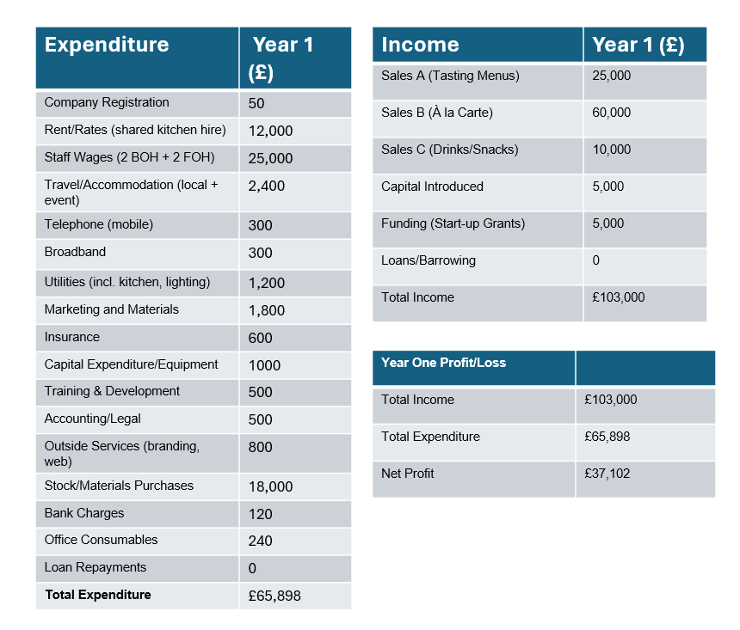
7.1 Financial Summary
To launch Tara! Pop-Up Kitchen, approximately £8,500–£9,000 in start-up capital is needed. This covers pre-trading essentials such as company registration, kitchen equipment, insurance, branding, first stock purchase, and a shared kitchen rent deposit. These funds come from £5,000 owner capital and a £3,000 start-up grant, such as those offered by Business Wales (Business Wales, 2024).

Year 1 Financial Overview
Total Income £103,000
Total Expenses £65,898
Net Profit £37,102

Revenue is based on:
Tasting menus: ~455 guests @ £55 = £25,000
À la carte: ~2,000 guests @ £30 = £60,000
Snacks: ~1,228 guests (50% of total) @ £8.14 = ~£10,000

The kitchen will operate 4 days/week (208 days/year), serving ~12 guests per service, in line with pop-up capacity and experience goals.

Key Expenditures
- Staff wages: £25,088 (2 BOH + 2 FOH), based on the £11.44/hour minimum wage for workers over 21.
- Shared kitchen hire: £12,000/year

- Ingredients: £18,000, based on high-quality Welsh suppliers (e.g. Gower Salt Marsh Lamb, Castle Howell)
- Additional expenses for marketing, utilities, insurance, and accounting have been estimated based on typical costs observed within small and medium-sized enterprises (SMEs) in the hospitality sector (FSB,2023).

APPENDICES
Appendix A – SWOT Analysis

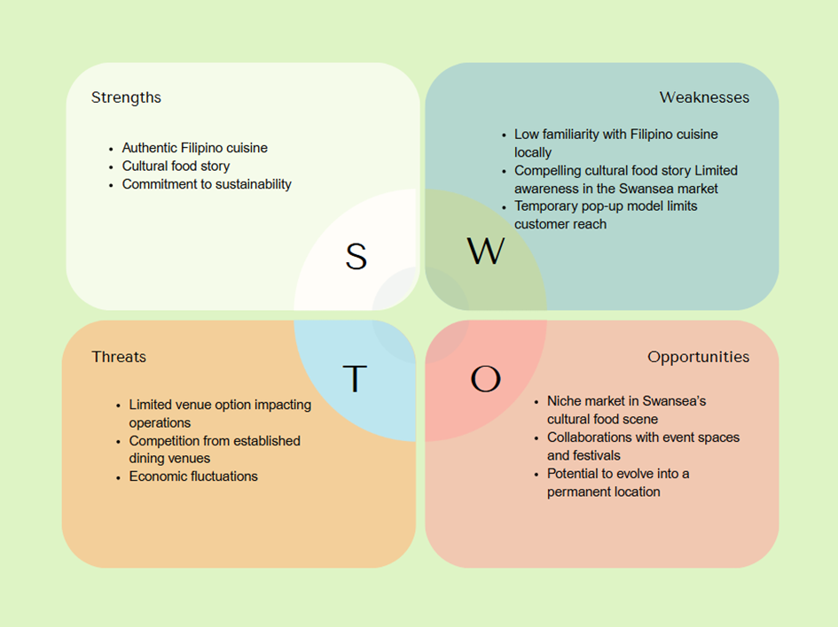
Appendix B – PEST Analysis

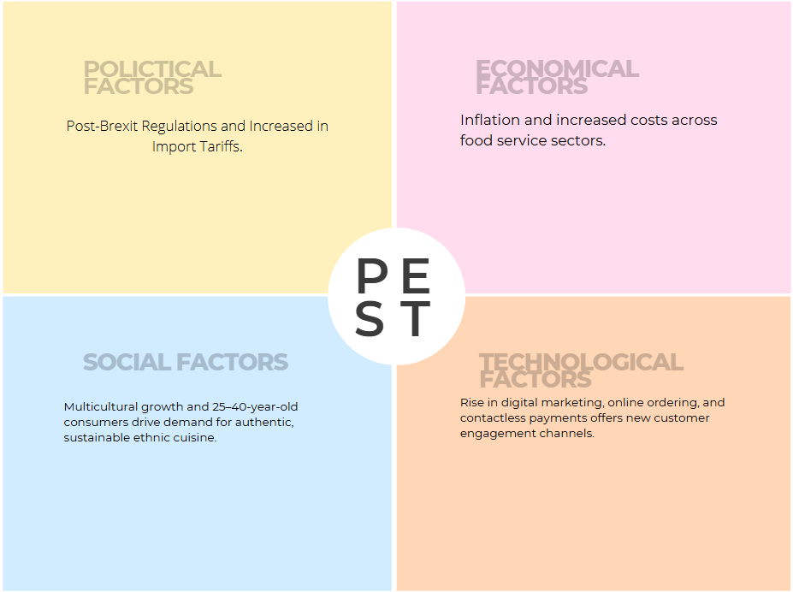

Appendix C.

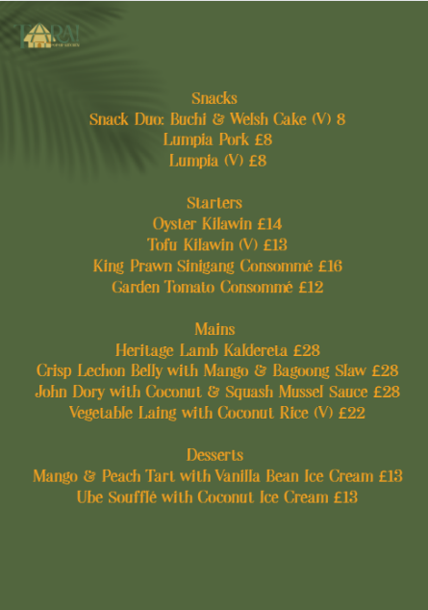
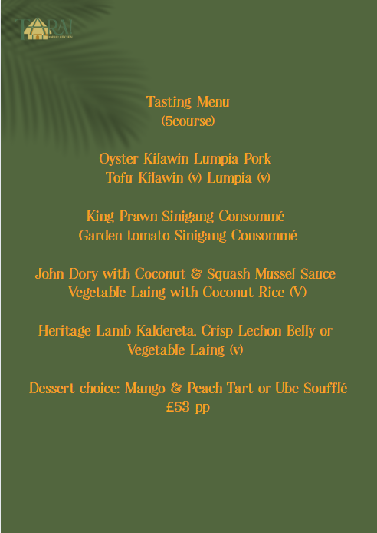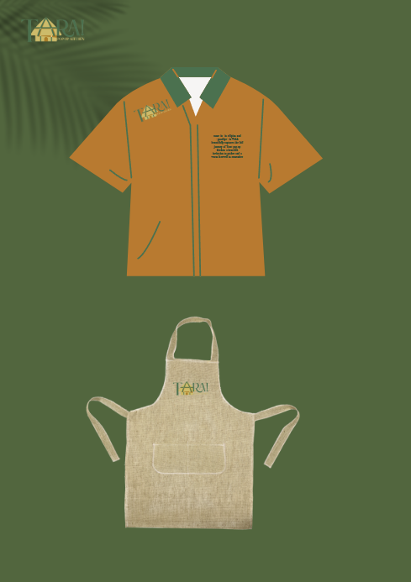
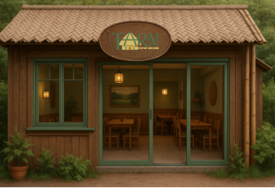

References:

Adelina’s Bar and Kitchen, (N.A). Our Story. Available at: https://adelinasbarandkitchen.co.uk/about-2/ (Accessed 10 June 2025)

Alvarado M., (2023). What is a Pop-up Restaurant and How to Successfully Start One. Available at: https://www.spoton.com/blog/what-is-a-pop-up-restaurant-how-to-start-one / (Accessed: on 2 June 2025)

Amazon UK, 2024. Catering and Table Service Tools. Available at: https://www.amazon.co.uk/ (Accessed 10 Jun. 2025).

Baras, J. (2015). PopUp republic: How to start your own successful pop-up space, shop, or restaurant. John Wiley & Sons.

BP2 Property, (2025). Commercial Property Available in South Wales. Available at: https://www.bp2property.com/properties/Albert-Hall-SA1-3EP/279129 (Accessed 11 June 2025)

Business Energy (2024). Average business energy prices in the UK. Available at: https://www.businessenergy.com/blog/no-standing-charge-tariffs-explained/ (Accessed 12 June 2025)

Business Wales, (2025). Big Ideas Wales. Available at: https://businesswales.gov.wales/bigideas/our-support/workshops (Accessed 8 June 2025)

Buttrey L., (2024). 35 Restaurant marketing Ideas to Attract More Customers. Avaialable at: https://www.eventbrite.co.uk/blog/restaurant-marketing-ideas/ (Accessed June 5 2025)

Castle Howell Foods, (2025). Wholesale price list. Available at: https://castlehowell.co.uk/pricelist (Accessed 11 June 2025).

Cohen, E., & Avieli, N. (2004). Food in tourism: Attraction and impediment. Annals of tourism Research, 31(4), 755-778. Avaialable at: https://doi.org/10.1016/j.annals.2004.02.003 (Accessed 3 June 2025)

Credence Research, (2024). UK Ethnic Food Market. https://www.credenceresearch.com/report/united-kingdom-ethnic-food-market (Accesed 10 June 2025)

Crossey S., (2017). Brexit and the Value of Local Produce. Available at: https://www.newfoodmagazine.com/article/44169/brexit-value-local-produce/ (Accessed 8 June 2025)

Dephna, (2024). How to Compare Commercial Kitchen Rental Near You. Available at: https://www.dephna.com/insights/how-to-compare-commercial-kitchen-rental-prices-near-you/ (Accessed 11 June 2025)
Estrada, M., Moliner, M. Á., Monferrer, D., & Vidal, L. (2023). Sustainability and local food at tourist destinations: a study from the transformative perspective. Journal of Sustainable Tourism, 32(5), 1008–1026. Avaialable at: https://doi.org/10.1080/09669582.2023.2195594 (Accessed 5 June 2025)

Farooq, M., & Bowen, G. (2020). Impact of social media marketing on SME restaurants in UK. GBATA 2020 GROWTH AND SUSTAINABILITY IN GLOBAL MARKETS: THEORY, EVIDENCE, AND PRACTICE, 24-29.

Federation of Small Businesses (FSB), 2023. Small Business Costs and Benchmarks for the Hospitality Sector. Available at: https://www.fsb.org.uk/resources (Accessed 12 June 2025).

Food Standard Agency, (N.A). Online Food Safety Training. Avaialable at: https://www.food.gov.uk/business-guidance/online-food-safety-training? (Accessed 8 June 2025)

Freeman, R., Garofalo, M., Longoni, E., Manova, K., Mari, R., Prayer, T., & Sampson, T. (2025). How Brexit affected the trade of UK firms (No. 701). Centre for Economic Performance, LSE.

GOV.UK (2024). National Minimum Wage and National Living Wage rates. Available at: https://www.gov.uk/national-minimum-wage-rates (Accessed on 12 June 2025)

GOV.UK (2025). Register Your Company. Available at :https://www.gov.uk/limited-company-formation/register-your-company (Accessed 12 June 2025)

Gower Farmers Market. (2025). Local seasonal produce listings. [online] Available at: https://www.gowerfarmersmarket.co.uk/ (Accessed 12 June 2025).

Gower Salt Marsh Lamb Producers. (2025). Gower Salt Marsh Lamb. Available at: https://www.gowersaltmarshlamb.co.uk/ (Accessed 11 June 2025).

Heritage Fund, (N.A). Chips, Curry and Cappucino- the Diverse Food Heritage of Swansea. Avaialable at: https://www.heritagefund.org.uk/projects/chips-curry-and-cappuccino-diverse-food-heritage-swansea
(Accessed 10 June 2025)

Industry, What Are the Solutions? International Journal of Gaming Hospitality and Tourism. 4(1). Available at: https://stockton.edu/light/documents/ijght_vol.4no.1/recent_inflation_impacts_on_the restaurant_industry-8.1.24.pdf (Accessed 8 June 2025)

Insight Trends, (2025). Restaurants: Gen Z is Shaping the Future of Dining Culture Availablet at: https://www.insighttrendsworld.com/post/restaurants-how-gen-z-is-shaping-the-future-of-dining-culture
(Accessed 8 June 2025)

Instantprint, 2024. Menu and Tabletop Printing. Available at: https://www.instantprint.co.uk/ (Accessed 10 Jun. 2025).
Ishak, F. A. C., Lokman, N. A., Ab, M. S., Karim, U. F. U. Z. A., Ismail, N. A., & Hafiz, M. (2023). Staging Memorable Dining Experience in Food Tourism: A Narrative Literature Review of Ethnic Restaurants. FAC Ishak, NAL Muhammad, SA Karim, UFU Z. Abidin, NA Ismail, & MH Hanafiah, International Journal of Academic Research in Business and Social Sciences, 13(5).

James, B., (2025). Cost-Effective POS systems for Uk and Small Businesses. Available at: https://wonderful.co.uk/blog/pos-systems-for-uk-small-business-cost? (Accessed 8 June 2025)

Maxwell, (2018). Millenials Driving Ethnice-Food Trends. Avaialabe at: https://www.foodserviceandhospitality.com/millennials-driving-ethnic-food-trends/ (Accessed 10 June 2025)

Mor, (N.A). Mor. Avaialable at: https://www.mor-mumbles.co.uk/ (Accessed 10 June 2025)

Mulrooney, H. (2021) ‘Food for thought: a pilot study exploring the use of cultural recipe and story sharing to enhance belonging at university’, Practitioner Research in Higher Education Journal, 14(1), pp. 60-71.

NCASS,(2025) Commercial Kitchen Spcaes to Rent. Available at: https://www.ncass.org.uk/commercial-kitchen-spaces-to-rent/ (Accessed 11 June 2025)

Nisbets, 2024. Catering Equipment for Professional Kitchens. Available at: https://www.nisbets.co.uk/ (Accessed 10 Jun. 2025).

Olsson, A., (2024). Recent Inflation Impacts on the Restaurant

ONS, (2022) S Swansea Population. Available at: https://www.ons.gov.uk/visualisations/customprofiles/build/#W06000011 (Accessed 10 June 2025)

Swansea City Market. (2025). Fresh fruit and vegetable supplier information. Available at: https://www.swanseacitymarket.co.uk/fresh-produce (Accessed 12 June 2025).

Swansea Council, (2023). Population. Avaialable at: https://www.swansea.gov.uk/population (Accessed 10 June 2025)

Swansea Fish Market. (2025). Fresh seafood price guide. Available at: https://www.swanseafishmarket.co.uk/prices (Accessed 11 June 2025)
.
Swansea Oriental Market. (2025). Product catalog and pricing. [online] Available at: https://swanseaorientalmarket.co.uk/products (Accessed 12 June 2025).

Taylor Jr, S., DiPietro, R. B., & So, K. K. F. (2018). Increasing experiential value and relationship quality: An investigation of pop-up dining experiences. International Journal of Hospitality Management, 74, 45-56.
The Secret Bar and Kitchen. About The Secret. Available at: https://www.thesecretswansea.co.uk/about/ ( Accessed 10 June 2025)

Tibard, 2024. Chef Clothing & Branded Uniforms.Available at: https://www.tibard.co.uk/ (Accessed 10 Jun. 2025).

UK Business Forums (2023) How much should small businesses budget for legal and accounting services?. Available at: https://www.ukbusinessforums.co.uk/articles/categories/starting-up.4/ (Accessed 12 June 2025)

UK BusinessForums (n.a). Starting Up. Avaialable at: https://www.ukbusinessforums.co.uk/articles/categories/starting-up.4/ (Accessed 12 June 2025)

Welsh Food and Drink, (2021). Cywain highlights Food Business Boom in Swansea Bay. Avaialable at: https://www.welshfoodanddrink.wales/cywain-highlights-food-business-boom-in-swansea-bay/ (Accessed June 5 2025)

