Student Name: Mariya Ilieva
Student ID: 2123768
Assignment 2

“Data Handling and Business Intelligence”
Table of Contents
Part 1: Application of data processing using of MS-Excel 3
Introduction 3
Discussions 3
Significance of MS-excel for initiating pre-processing of data 3
Application of Microsoft Excel for pre-processing the data 4
Conclusions 7
Part 2: Application of SPSS related to data analysis support 7
Introduction 7
Discussions 8
“Identification of Male and Female students” 8
“Identification of student qualifies and does not qualify for reduced/free lunch” 8
“Identification of Mean and Median regarding student qualifies and does not qualify for reduced/free lunch” 10
“Identification of mean and median differences of students' pre-test and post-test scores” 10
“Application of Clustering (K-Means Clustering) between Student No and lunch” 11
“Identification of 5 most common data mining and text mining methods” 13
“Advantages and disadvantages of using SPSS and Excel for data presentation” 14
Conclusions 14
References 16

Part 1: Application of data processing using of MS-Excel

Introduction
Identification of data handling is generally recognised as the process of managing, storing, processing and analysis of data on an effective and systematic basis. Generally, it is recognised as an essential part of organisation operations related to decision support engagement including a proper pattern approach which provides a proper innovation processing. The initiated engagement of data handling also provides proper productivity formulations and cost savings support that manages the risk management support on a proper basis (Němec et al., 2021).
The application of MS-excel is initiated for presenting a proper data analysis engagement that can be applied for the processing and formulation support regarding the data processing on a proper basis.

Discussions

Significance of MS-excel for initiating pre-processing of data
The primary identification of Microsoft Excel is initiated to provide positive and systemic support related to data engagement and analysis purposes depending on which the positivity formulations related to data maintenance can also be initiated. The presence of this type of analytical tool is initiated for stability and proper operation support which brings the ultimate support of stability formulation in a developing order (Kuneva et al., 2021). The primary maintenance of this type of engagement along with the finance also provides a positive market analysis, which is sustainable for initiating the stability appearances on a proper basis. Identification of this particular analytical tool can be initiated to pre-process data along with the following feature basis;
Analysis and store support: The primary involvement of this particular analytical tool is initiated to provide a proper volume of data gathering and analysis support with the processing of which the probable opportunity related to the problem-solving attribute can be initiated. It also provides a positive strategic identification and competency support which is initiated in order to formulate the volume of accuracy related to the statistical identification of data on a more developing basis. It is also applied for the progressive support of business visibility value that is sustainable for initiating decisions (Vlasov and Sinchukov, 2019).
Data recovery support: The application and processing support of MS Excel is initiated in order to provide a proper amount of data storing support on a timely basis which is influential to provide a proper stability approach in an effective order. The engagement of this type of approach provides positive competitive support and dynamic environment and processing under a flexible market situation which is comprehensive in order to manage the stability positions of business data analysis properly.
Report making: Along with the maintenance of data recovery and storing support it is also applied in order to proceed with some of the basic research reporting purposes with the initiative of which the positivity related to data accuracy can be identified. The presence of this particular characteristic also provides an opportunity for monetary and minimising the data breaching approach in a proper order that is influential for the progressive and some of the feasibility value of the data mining properly (Hordei et al., 2021). The engagement of this type of processing also provides the formulated rectification support as well which is applied for the maintenance of stability position of the data properly.
Research analysis: Initiating the application of this particular process also provides a proper research formulation related to the data engagement in proper order with the efficiency of which the positive development can be initiated. The presence of this approach also provides a proper volume of structural developments which is influential for productivity growth as well as a positive volume of competitive advantage support on a long-term prospect.
Security and confidentiality: The maintenance support of this particular analytical tool is also initiated to provide a positive security and confidentiality approach related to the data protection processing mainly which is sustainable for the maintenance support of business positivity and other relevant data engagement (Hohmann, 2020). With the initial support of this type of processing the progressive performance growth can also be balanced in a proper order which is comprehensive for the reason of managing a proper identification of the data formulations on a proper basis.

Application of Microsoft Excel for pre-processing the data
According to the present provided details related to the hotel reservation dataset the application of the PIVOT TABLE and IF function has been initiated that provides a positive formulation of data processing on an effective basis.
Applied the engagement of the Pivot table is initiated to provide simplified data engagement support depending on which a positive and simplified presence of data engagement can be initiated. It also provides the formulated decision-making progressive positions in a more systematic manner which is comprehensive for stability reason (Zaynalov et al., 2020). The presence of this particular table under MS Excel can be supported in order to identify the specific data from a large volume of datasheets in a simplified basis that is sustainable for initiating some of the basic decision-supportive actions mainly. It also appears the approach of flexibility as well which is comprehensive to recognise and formulations of data in a simplified basis. It is also recognised as a time-saving and user-friendly interface engagement approach that provides the positivity support related to the compatibility and analysis of data engagement properly.
Associated with the same processing, the presence of IF function related to the spread sheet engagement is initiated to provide a positive volume of logical test and performance analysis support related to true and false basis. Application of this engagement provides a proper analysis and evaluation of data processing and some of the decision-making engagement in a systematic manner (Byshevets et al., 2019). The presence of this engagement also provides the increase and competencies support related to the value of the business as well which is sustainable for initiating some of the structural management approaches on a proper basis.
According to the present provided data set the application of the Pivot table is initiated to provide general determination support regarding the decline or increase in average pricing level over the year ranging from 2017 to 2021.
Sum of Average price
Arrival_year | Total
2017 | 549304.11
2018 | 2984721.57
2019 | 18015.29
2020 | 20857.3
2021 | 19436.8
2022 | 159353.81
Grand Total | 3751688.88

Table 1: Pivot table regarding average pricing on yearly basis
(Source: By learner)
According to the present data engagement, a supportive identification regarding average pricing structure regarding the room pricing in the individual year has been provided with the identification of which a proper data formulated growth and operating development can be measured (Foulkes, 2020). In association with the present identification support it can be identified that during the period of 2021, the average pricing structure of the individual room in this Hotel mainly declined while during the period of 2018, the highest volume of average pricing approach has been initiated.

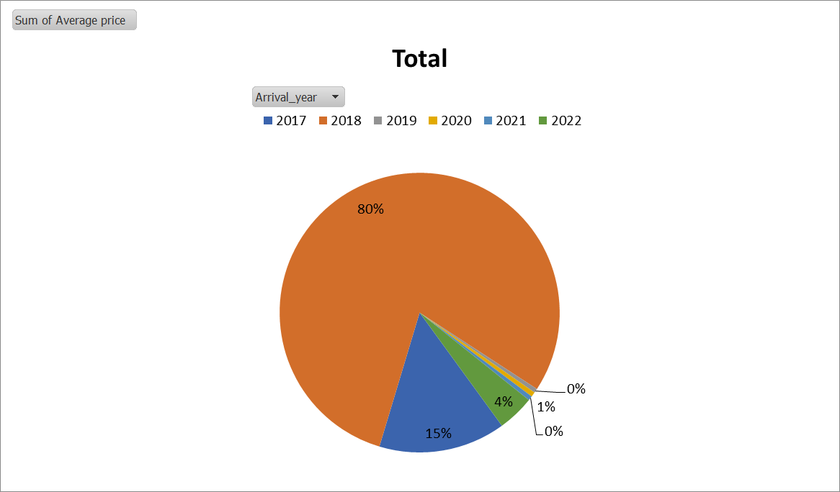
Figure 1: Pie Chart regarding average pricing on yearly basis
(Source: By learner)
Depending on the above presentation support it is basically considered that during the period of 2018 due to the reason the systematic volume of development related to the travelling engagement positive revenue progress has been initiated in the hospitality sector, while after the covid a significant level of declining approach is mainly noticed related to 2021. With the application of the above pie chart, it can be recognised that during the period of 2018 around 80% of average price development has been initiated while in the period of 2020 around 0% of the pricing approach is initiated (Fernando, 2021). With the identification of this particular analysis supports it basically considering that while in the pre-covid condition, the volume of average pricing level of individual rooms in the UK was comparatively higher in the period of covid a significant volume of declining position was initiated. However, in the present circumstances, a positive development is mainly initiated that brings the optimised position including operating the development approach on an effective basis.
Sum of Arrival_year | Adults No
Children No | 0 | 1 | 2 | 3 | 4 | Total
0 |  | 11960686 | 38709276 | 4433546 | 32288 | 55135796
1 | 2018 | 165476 | 2794930 | 48432 |  | 3010856
2 | 252250 | 92828 | 1519554 | 2018 |  | 1866650
3 | 6054 |  | 20180 |  |  | 26234
10 |  |  | 2018 |  |  | 2018
Grand Total | 260322 | 12218990 | 43045958 | 4483996 | 32288 | 60041554

Table 2: Pivot table regarding no of visitors
(Source: By learner)
Associated with the same engagement it can also recognize that in the period of 2018, the overall number of adults (related to 2 people) visited in this hotel was comparatively higher with the volume of others. Even the volume of children up to the number of 2 was 12 also representing a comparatively higher volume of visitor engagement in this hotel during the period of 2018. In the same approach, it can also be identified that in the present position, some strategic progress is required to be initiated in this business in order to formulate stable growth and some of the feasibility processing on a proper basis (Qudratova, 2022).

Conclusions
The identification and processing support of proper data engagement and handling approach is initiated for the feasibility value and some of the positive initiative's approach on an effective basis. The primary presence of MS Excel and the applications of pivot tables is systematically initiated to provide proper volume of stability and compatibility identification of the datasheet mainly with the presence of which the positivity and a competitive identification related to the data formulated approach can effectively be initiated. It also provides the formulated performance support and some of the optimised positions on a more developing basis with an initiative of which feasibility value of the current decision-making approach of this hospitality sector can effectively manage.

Part 2: Application of SPSS related to data analysis support

Introduction
A positive support of data formulation is initiated to provide decision-supportive actions which can be identified for measuring the stability and some of the performance efficiency values properly. Applied the engagement of proper data identification support can also provide the competencies and general evaluation support related to data engagement on a proper basis with the initiative of which the positivity and formulated growth can be balanced (Pallant, 2020). The presence of data maintenance and handling approach provides the formulated development related to performance efficiency mainly which is influential for development reasons.
According to the current provided performance support, general details related to data processing “Students Score” is mainly evaluated with the support of SPSS processing that brings the formulated data identification and validation approach in a proper basis.

Discussions
With the engagement of the provided data set related to the SPSS processing, some of the relevant computations and data identification has been initiated that can be applied to recognise the overall performance efficiency in the present situation.

“Identification of Male and Female students”
According to the present data supporting the identification, the overall volume of male and female students is mainly initiated with the engagement of SPSS data identification basis.
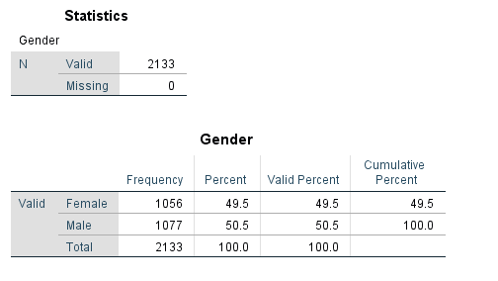
It indicates in the present position the volume of students is 2133 and out of which the total number of female students is 1056 related to 49.5% and the number of male students is 1077 indicates 50.5% respectively.

“Identification of student qualifies and does not qualify for reduced/free lunch”
In accordance with the processing support of this particular identification, the applied engagement of SPSS formulated analysis has been provided with the presence of which a positive data engagement related to the qualified and non-qualified students for lunch can be measured (Daryanto, 2020).
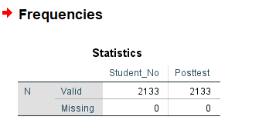
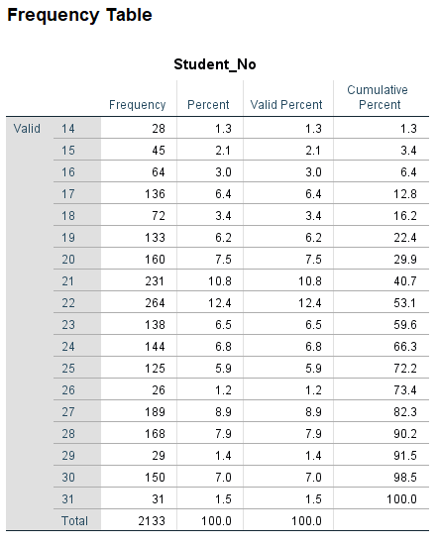
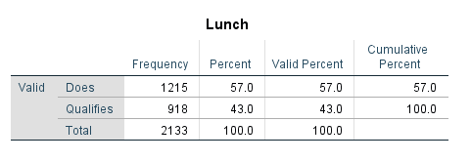
According to the present provided data engagement total volume of students in the dataset is 2133 and out of this volume “does qualified student” number is 1215 which indicates the level of 57% in the present position. And “Qualifies” student number is 918 which indicate a volume of 43% respectively.

“Identification of Mean and Median regarding student qualifies and does not qualify for reduced/free lunch”
Following the present provided data set support with the application of SPSS formulated analysis has been provided with the presence of which a positive data engagement related to the Mean and Median regarding student qualifies and does not qualify values mainly (Wagner, 2019).
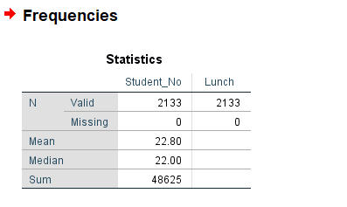
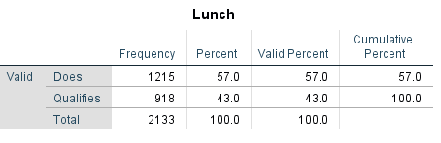
Under the present identification processing it is measured that at the present situation, the total volume of students in the dataset is 2133 and out of this volume “does qualified student” number is 1215 and the “Qualifies” student number is 918 which indicates a volume of 43%. The current computed measurement approach indicates the level of the mean is 22.80 and the median is 22.00 respectively. The presence of this engagement indicates the optimised value of the data processing approach on an effective basis (Babbie et al., 2022).

“Identification of mean and median differences of students' pre-test and post-test scores”
According to the present provided data set, support with the application of SPSS formulated analysis has been provided with the presence of a positive data engagement related to the Mean and Median regarding differences of students' pre-test and post-test scores basis.
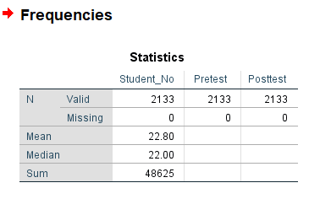
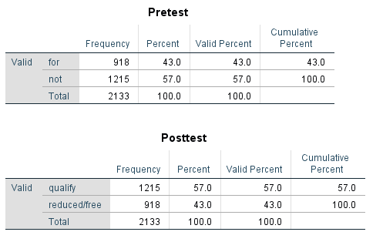
With the identification processing, it is measured that at the present situation, the total volume of students in the dataset is 2133 and out of this volume the “qualify” number is 1215 and the “reduced or free” student number is 918 which indicates a volume of 43%. The current computed measurement approach indicates the level of the mean is 22.80 and the median is 22.00 respectively. The presence of this engagement indicates the optimised value of the data processing approach on an effective basis (Cheung and Pesigan, 2022).

“Application of Clustering (K-Means Clustering) between Student No and lunch”
According to basic operating engagement, the application of “Clustering is an important technique in statistics” with the data maintenance support that is initiated for similarity processing including the operating formulation support on a proper basis. The engagement of this engagement also provides the positivity and operating development that provides the decision-supportive engagement on a proper basis. Proper maintenance support of such data approach also provides the classification processing that brings the identified progress including operating maintenance support on a proper basis (Sen and Yildirim, 2022).
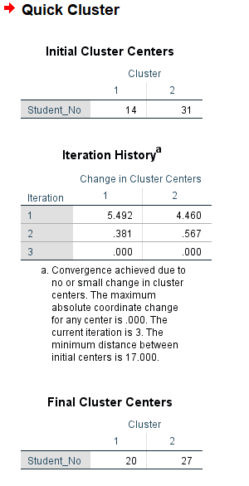
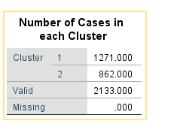
According to the general identification, the presence of cluster processing related to the data engagement of Student No and lunch is mainly evaluated which indicates the convergence achieved due to no or small changes in cluster centres support. The maximum engagement related to the coordinate processing is to initiate the centre support as 0 and the minimum distance between initial centres is 17 on a supportive basis. Including the current operating engagement, the presence of cluster 1 value is presented as 1271 and cluster 2 valued as 862 respectively.

“Identification of 5 most common data mining and text mining methods”
The application of text mining is one of the essential methods of extracting data and relevant information from unstructured text with the initiative of proper high-quality data formulations and processing support. The presence of this type of engagement is also initiated for the maintenance of particular pattern-based performances which is sustainable for the decision initiative and some of the positive learning attributes on a proper basis.
The primary application of this type of engagement is also employed in the resolutions of corporate issues which are optimised for performance efficiency. Identifying the data mining approach also applies to the same purpose which is influential for the maintenance of data competency properly. Some of the applied identification of methods related to both aspects includes;
- Classification is a supervised learning technique related to the processing of data categories on a supportive basis with the presence of which positive documentation support related to the data engagement can be identified.
- Identifying the process of clustering is also represented as a supervised learning technique related to the group of similar data with the presence of which proper attributes support including the performance efficiency is basically structured. It is also initiated for maintaining a systematic pattern-based performance which is influential for stability reasons (Opie, 2019).
- Association of rule mining is also recognised as an identified pattern which is initiated to formulate the relationship between the data set structures on a proper basis. The presence of this engagement is also formulated market-based analysis support with the presence of which a positive development and formulation growth can be balanced.
- The applied engagement of sentiment analysis is one of the primary causes related to the text mining technique which is initiated for the maintenance support of data influence and positivity engagement along with the feedback basis. The appearance of this engagement is also sustainable for managing the stability formulations in a progressive order (Watkins, 2021).
- The application of text summarising is one of the systematic processes of text mining which is influential for the development and a formulated growth support related to the data identification in a proper basis which is sustainable for the optimum positions and some of the stability approach of the data in a more developing manner.

“Advantages and disadvantages of using SPSS and Excel for data presentation”
SPSS
Advantages: Primary involvement of this particular data processing approach provides proper flexibility related to the input capability in proper order with the initiative of which data identification can be effectively balanced. It also provides positive support related to the recorded data computation and identification approach also which is influential for the development of performance competency on a more progressive basis (Williams, 2020).
Disadvantages: However this particular measurement is unable to provide some of the systematic statistical procedural engagement in a proper manner with the initiative of which the class boundary and other associated differentiation processing can be measured. It is also unable to formulate some of the storage processing including the capability formulation approach related to the data mining that is generally required for the maintenance of data validity.
MS-Excel
Advantages: Identification and processing of this particular computer measurement are used to provide some of the formula and functional engagement with the initiative of which the formulated data interpretation approach can be balanced. It also provides proper checking support including monitoring engagement with some of the positive data validity basis that is influential for the development and other associated progress reasons.
Disadvantages: The presence of this type of measurement is unable to provide a proper volume of controlling and security support that is generally required for the maintenance and processing support of data formulated identifications on a proper basis. It is also unable to provide a positive volume of standardisation and the data compatibility benefit which is also necessary for the maintenance of data formulated growth properly.

Conclusions
Applied the engagement of proper data identification support can provide the competencies and a general evaluation support related to data engagement on a proper basis with the initiative of which the positivity and formulated growth can be balanced. A positive and formulated engagement of this type of processing is also initiated for the primary data identification and validity approach which is influential to initiate the decision-making actions on a progressive basis.

References
Babbie, E., Wagner III, W.E. and Zaino, J., 2022. Adventures in social research: Data analysis using IBM SPSS statistics. Sage Publications.
Byshevets, N., Denysova, L., Shynkaruk, O., Serhiyenko, K., Usychenko, V., Stepanenko, O. and Syvash, I.R.Y.N.A., 2019. Using the methods of mathematical statistics in sports and educational research.
Cheung, S.F. and Pesigan, I.J.A., 2022. FINDOUT: Using Either SPSS Commands or Graphical User Interface to Identify Influential Cases in Structural Equation Modeling in AMOS. Multivariate Behavioral Research, pp.1-5.
Daryanto, A., 2020. Tutorial on heteroskedasticity using heteroskedasticityV3 SPSS macro. The Quantitative Methods for Psychology, 16(5), pp.8-20.
Fernando, L.S.L.K., 2021. Conceptualization of chemical kinetics using a visually enhanced teaching technique; a developed MS Excel worksheet/system. Turkish Journal of Computer and Mathematics Education (TURCOMAT), 12(11), pp.3331-3337.
Foulkes, L., 2020. Learn Microsoft Office 2019: A Comprehensive Guide to Getting Started with Word, PowerPoint, Excel, Access, and Outlook. Packt Publishing Ltd.
Hohmann, S., 2020.Calculating the distributions of number, mass and luminosity of the stars with the help of MS ExcelⓇ. European Journal of Physics, 42(1), p.015601.
Hordei, O., Patsai, B., Hurochkina, V., Ovdiienko, O. and Mishchenko, R., 2021. Optimization of the investment portfolio in the environment of table processor MS excel. Studies of Applied Economics, 39(5).
Kuneva, V., Milev, M. and Gocheva, M., 2021, March.Modeling the transportation assesment with MS excel solver. In AIP Conference Proceedings (Vol. 2333, No. 1, p. 150005).AIP Publishing LLC.
Němec, P., Stodola, P., Pecina, M., Neubauer, J. and Blaha, M., 2021.Optimization of the Weighted Multi-Facility Location Problem Using MS Excel. Algorithms, 14(7), p.191.
Opie, C., 2019. Using excel/spss in your research. Getting Started in Your Educational Research: Design, Data Production and Analysis, 309.
Pallant, J., 2020. SPSS survival manual: A step by step guide to data analysis using IBM SPSS. McGraw-hill education (UK).
Qudratova, G.S., 2022. Using Ms Excel Function to Solve Economic Problems. Indonesian Journal of Innovation Studies, 18.
Sen, S. and Yildirim, I., 2022.A Tutorial on How to Conduct Meta-Analysis with IBM SPSS Statistics. Psych, 4(4), pp.640-667.
Vlasov, D.А. and Sinchukov, A.V., 2019. MS Excel as system of support of decision-making. International Journal of Open Information Technologies, 7(3), pp.50-59..
Wagner III, W.E., 2019. Using IBM® SPSS® statistics for research methods and social science statistics.Sage Publications.
Watkins, M.W., 2021. A step-by-step guide to exploratory factor analysis with SPSS.Routledge.
Williams, H., 2020. Statistics for Politics and International Relations Using IBM SPSS Statistics. Statistics for Politics and International Relations Using IBM SPSS Statistics, pp.1-408.
Zaynalov, N.R., Narzullaev, U.K., Muhamadiev, A.N., Rahmatullaev, I.R. and Qilichev, D., 2020. Manipulating The Rotation Of Ms Excel Cells To Hide Information. International Journal of Advanced Science and Technology, 29(8s), pp.2270-2273.

