Theresa Angier
ECIE5008
Reflective Commentary

Portfolio
Student Number: 2417258

Contents

Page 3 – 5 Part 1 Reflective Commentary Essay
Page 5- 7 Part 2 Reflective Commentary Essay
Page 8 - 9 Appendix A and B
Page 10 – 11 References

Reflective Commentary
This essay comprises of two parts. Part one will explore the concept of literacy, the impact that poor literacy skills can have on an individual, and key theorists who support effective practice in improving literacy.
Part two will provide a reflection on the reading task using Gibbs’ Reflective Cycle. Graham Gibbs developed this model in 1988 to provide a structured framework for learning from experience. The cycle consists of six key stages: description, feelings, evaluation, analysis, conclusion, and action plan (University of Edinburgh, 2024).
Part 1
Literacy extends beyond the basic abilities of reading and writing to include speaking and listening skills, which are essential for effective communication and meaningful social engagement (National Literacy Trust, no date). Strong literacy skills are fundamental for us as a society to navigate through everyday life, enabling individuals to access information, participate in society, and perform routine tasks such as reading news articles or composing written communications. It is estimated that one in six adults in the United Kingdom have literacy skills equivalent to those of an 11-year-old (Didau, 2014). Research conducted in 2018 found that low literacy levels cost the United Kingdom economy approximately £81 billion annually through lost earnings and increased welfare spending (Society of Authors, 2018).
Novus (2025) argues that children who struggle with reading and writing are more likely to demonstrate reduced engagement in school. Early disengaging from education can have long term consequences, as lack of basic literacy skills often limits future opportunities. This can increase the likelihood of unemployment or lower paid work, potentially leading some individuals to seek alternative means of financial support, including involvement in crime.
There are strong links between poor literacy skills and poor mental health. Individuals with lower literacy skills are often less likely to engage socially to avoid drawing attention to their difficulties. This can lead to feelings of isolation and loneliness, which in turn may increase the risk of anxiety and depression. Both children and adults with low literacy often experience low self-esteem, as well as increased emotional and social difficulties (Communications, 2023).
Furthermore, lower income families are more likely to have lower literacy skills, The Wales Institute of Social and economic Research and data (2015) highlights that children from low-income families often begin school with weaker language skills. When parents are required to work long hours or multiple jobs to meet financial pressures, the time and attention needed to support their child’s cognitive development may be reduced.
Leatherbarrow (2025) suggests that early literacy lays the foundation for lifelong learning. The key to supporting good literacy skills is to engage children from an early age, building the foundation for reading and writing through everyday interactions. When children are exposed to language early through talking, listening and playing, it helps to expand their vocabulary, and they begin to understand sounds, and words long before schooling begins which aligns with Piaget (1936) stages of development whereby in preoperational stage (around ages 2 – 7), children begin to use language, symbols and imagination (Pound, 2005). which are essential for reading and writing.
In 2015 the Donaldson report highlighted the importance of re-structuring the curriculum in Wales, concluding “That the current national curriculum arrangements no longer meet the needs of children and young people in Wales”. (Dauncey, 2024). One of the findings of this report was that literacy, along with numeracy, should be at the heart of everyday teaching. This report led to the development of what is now known as the New Curriculum for Wales. Its focus is to embed a cross -curricular approach, promoting literacy, numeracy and digital competence across all subjects. (Welsh Government, n.d.). It emphasises that schools should design purposeful opportunities for learners to develop and apply their language and literacy skills across and within all areas of learning (Welsh Government, 2026). While this approach has the potential to positively impact literacy development, there are several limitations that must be considered. Increased class sizes, reduced funding, and cuts to support staff can hinder its effectiveness. As a result, teacher’s workload has increased, leaving them less time to provide individual support, which can negatively impact the intended outcomes of the curriculum. (Impact Wales, 2024)
Within setting A, all students are required to complete a reading assessment in year 7 to 9. This assessment enables the school to evaluate their competency levels alongside their target levels. This assessment is done yearly, allowing the school to identify any areas where additional support maybe required. As a result, appropriate provision can be put in place to support individuals in the development of their listening, reading, speaking and writing skills. (School A, 2026).
One intervention that is delivered is a literacy programme, which is delivered to small groups of students in year 7 to 9 who have been identified as needing additional support. Vygotsky’s (1935) theory of scaffolding can be seen in practice within these sessions, delivered twice weekly, students initially receive a high level of support with both there reading and spelling. However, as their confidence and capability develop, this support is gradually reduced, enabling them to work more independently. This reflects Vygotsky’s view that learners progress through guided support within their Zone of proximal development (Bates, 2023). However, while the intervention supports the learner’s development and confidence there are drawbacks, by targeting individuals many learners express an unwillingness to participate, feeling they are being singled out and highlighting to their peers the need for additional support. Additionally, if support is withdrawn too quickly, learners may struggle to progress, therefore careful planning is essential to ensure interventions are effective.
To work alongside this intervention, a whole school approach is implemented within setting A, whereby the literacy coordinator sets weekly literacy tasks delivered during registration time. These tasks typically take the form of a reading and writing activity using the “I do, we do, you do” approach. This involves the teacher reading the beginning of an article, followed by sharing reading with the students, and finally independent work where learners answer questions related to the text. This approach can be linked with Skinners (1930) operant conditioning, Skinner argued that learning is shaped through enforcement (Aubrey and Riley, 2022, p.90). In this context the students are being supported from non-readers to readers, in the first instance the teacher is expressing how to read the article with students observing how to give depth and meaning (I do) moving on to students as a group reading (we do) with the teacher providing verbal praise and feedback, finally students working independently on the written task (you do). It is important to consider that not all students engage positively with this approach. For some learners, particularly those with lower literacy levels, the thought of reading aloud can be overwhelming increasing their anxiety levels. This could result in disengagement or reduced attendance during registration time. Therefore, while this approach can be effective in supporting literacy skills, it is essential that teachers adapt their approach to ensure it is supportive to all students.
In conclusion, literacy is a fundamental skill that supports an individual both with their education and social inclusion, lower literacy levels can have significant social and economic consequences, which highlights the importance of early intervention. Theorists such as Piaget, Vygotsky, and Skinner emphasize the importance of guided support, and reinforcement in promoting literacy skills. Within setting A, both targeted interventions and whole school approaches demonstrate a commitment in supporting the improvement of all learner’s literacy skills. Strategies such as scaffolded support and the “I do, we do, you do” can be effective in developing confidence and independence. However, these approaches are not without limitations, particularly with learners engagement and anxiety levels. Therefore, it is essential that literacy support is carefully planned and adaptable to meet the needs of all learners. A balanced approach that combines early intervention, and flexible teaching strategies is key to ensuring all students are supported in developing the literacy skills required for lifelong learning and participation in society.

Part 2

For the second part of the assignment, a reading task was undertaken to demonstrate how we interact with students and support the development of literacy skills. As my role in a secondary setting means I work predominantly with students who experience difficulties engaging in mainstream education, I made the decision to focus on their emotional development, in particular how students recognise and manage their feelings and emotions, and how they respond to challenges in the moment, and reflect on their responses moving forward. For this reason, I selected a book called Big Feelings, Bigger Stories by Rana Vikas (2025) A self-published author Vikas created this book to support children through their journey of self-discovery, exploring everyday emotions its aim is to develop resilience through real life situations through a selection of short stories. For this session the story I chose to read was called “The day I stopped Pretending to be someone else” as it focused on identity, self-acceptance, and emotional awareness. The session was delivered to a group of eight students aged between 11 and 13 who have access to a provision called Tamarr within setting A. This provision supports students in years 7 to 9 to support them with emotional regulation, communication, and social interaction, alongside targeted literacy development. As outlined by setting A’s additional learning needs policy, it’s aim is to create a supportive environment in which students can develop both academically and emotionally (School A. 2022)
Prior to the session, I became very nervous. Although I am used to speaking in front of a class, the added pressure of being recorded made the experience feel significantly different. As a result, I began to question my choice of text, and whether it would be sufficiently engaging for the students. Furthermore, my decision to select a group of students with whom I do not usually have daily interactions with, increased my uncertainty, leading me to question whether I had made the appropriate choice. However, as the session progressed, I began to feel more comfortable, and my confidence gradually improved, which had a positive impact on my delivery.
Overall, I feel that the session demonstrated both strengths and areas for development. At the beginning of the session, I was extremely nervous which was apparent through my body language, particularly my difficulty to keep my feet still. This nervousness may have had a negative influence on my delivery and, consequently, reduced the level of engagement from the students. In addition, my limited prior knowledge of the book impacted my ability to maintain consistent and meaningful eye contact at the start, which meant that my delivery was less effective than it could have been. In hindsight, developing greater familiarity with the book beforehand may have allowed me to present more confidently and engage the listener more. On reflection, this highlights the importance of preparation. Having more knowledge of the text before the session may have enabled me to present confidently, therefore creating a more engaging environment for the learners.
As the session progressed, I felt more relaxed adding greater tone and expression in my reading. This appeared to have a positive effect on the atmosphere of the session. Although I attempted to encourage student’s engagement by inviting them to share, their experiences and feelings with the group, they were initially reluctant to participate. However, once the recording had finished, the students appeared more relaxed and engaged more openly. This led to me reading an additional short story, resulting in a more interactive and engaging discussion. At the end of the session, I set the students a follow up task which involved sharing information about themselves by designing a poster. This activity aimed to encourage the students to reflect on the reading and use the story to reflect on things about themselves and reinforced the meaning of the story. I explained that I would return for a second session to discuss their work. Upon my return a few days later, I was pleased to observe that all students had engaged with the activity. They produced informative and engaging pieces, which demonstrated both creativity and willingness to participate. This indicated to me that despite initial reluctance during the recorded session, the students had reflected on the activity and were able to engage more confidently in their own time. This reflects Vygotsky theory of scaffolding, whereby learners are initially supported and gradually develop the confidence and ability to complete tasks more independently (Pound, 2005, p.42). By providing a task for students to share aspects of themselves. This approach supports the development of language and confidence.
In conclusion, this task has highlighted both my strengths and areas for development. Although I initially experienced a lack of confidence due to the pressure of being recorded and working with an unfamiliar group, I feel I was able to adapt quickly as the session progressed, resulting in a more effective and engaging delivery. This experience has reinforced the importance of preparation, particularly in developing a strong understanding of the text to support a more confident delivery and meaningful interaction with students.
Furthermore, the session demonstrated that student engagement does not always occur immediately, and that providing opportunities for reflection and follow-up activities can support deeper participation. (See Appendix A and B)

Appendix A

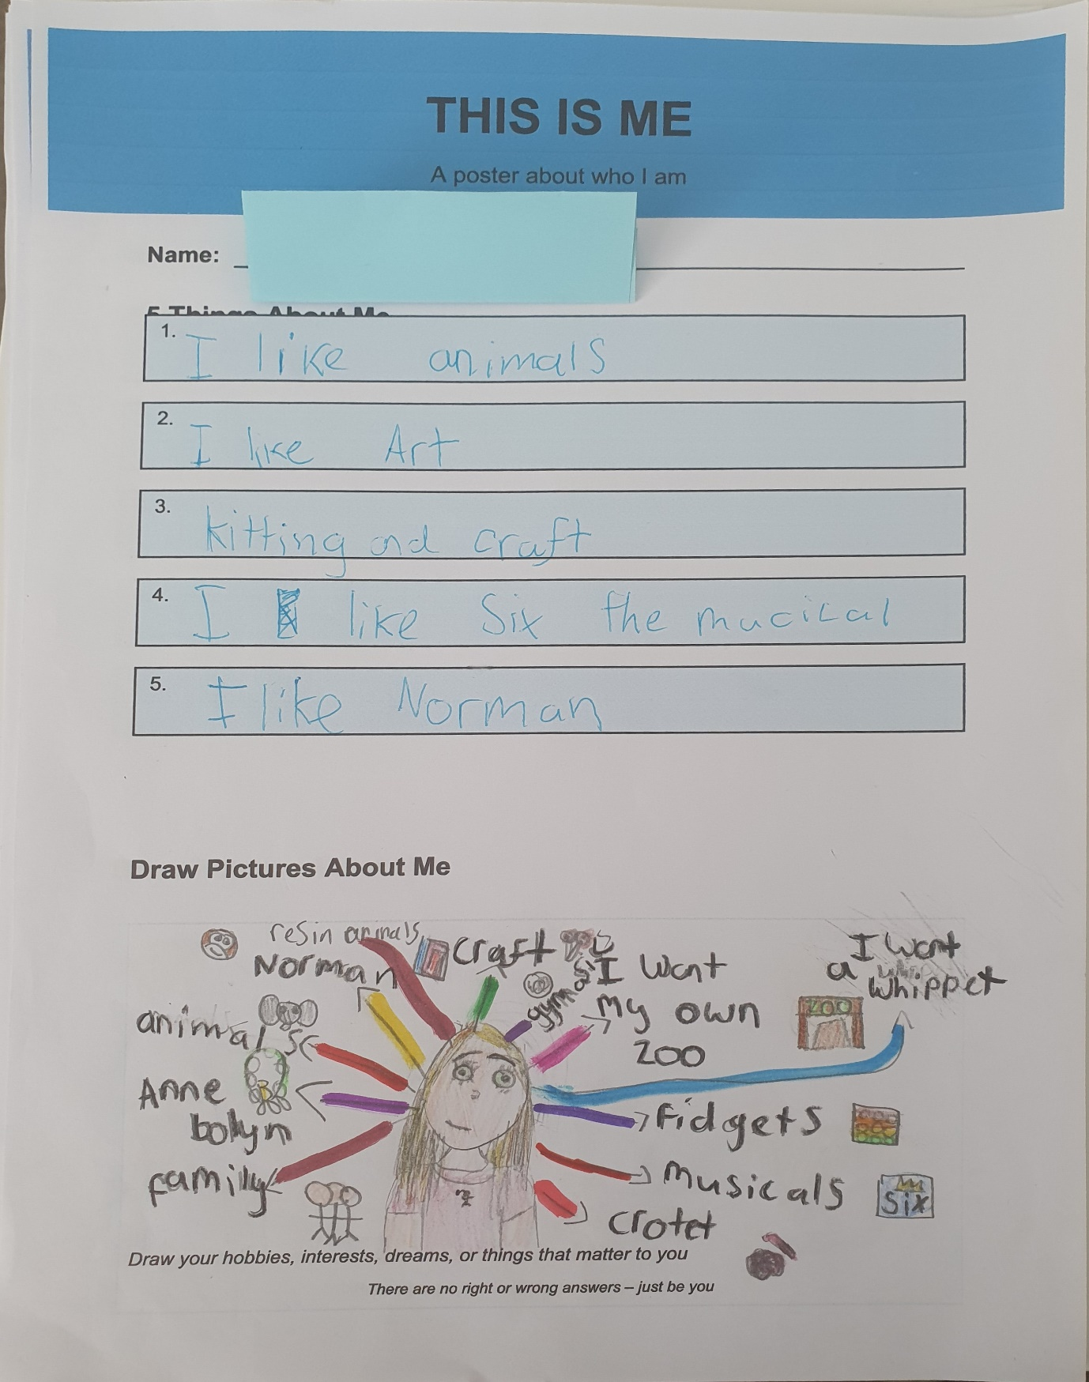

Figure 1 Image of learners follow up task (Angier)

Appendix B
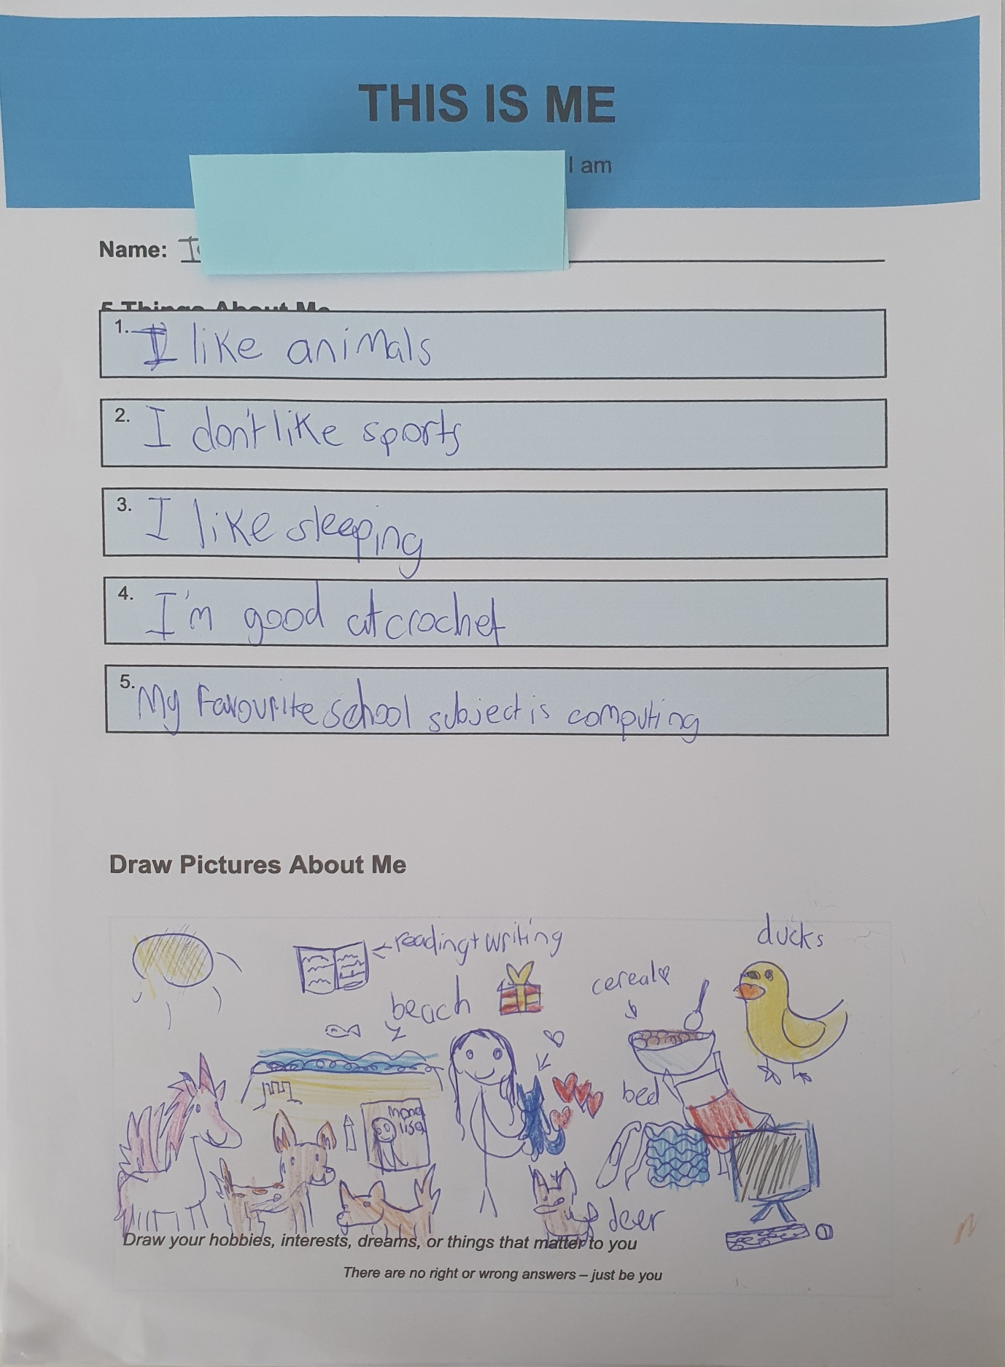
Figure 2 Image of learners follow up task (Angier)

References
Aubrey, K and Riley, A (2022) Understanding and using educational theories. 3rd edn. London: Sage.
Appendix A Angier.T. (2026) Images of learners follow up task [Photographs]
Appendix B Angier.T. (2026) Images of learners follow up task [Photographs]
Bates, B. (2023). Learning theories simplified. 3rd end. London: Sage
Communications (2023) Poor literacy linked to worse mental health worldwide study shows. University of East Anglia, 27 January. Available at: https://www.uea.ac.uk/about/news/article/poor-literacy-linked-to-worse-mental-health-worldwide-study-shows (Accessed: 17 April 2026).
Dauncey, M. (2024) Donaldson Review: His critique and vision. Senedd Research, 16 December. Available at: Donaldson Review: His Critique and Vision (Accessed: 10 April 2026).
Didau, D (2014) The Secret of Literacy. Wales: Independent Thinking Press
Impact Wales (2024) What do teachers really think about Curriculum for Wales? 19 January. Available at: https://www.impact.wales/news/what-do-teachers-really-think-about-curriculum-for-wales (Accessed: 17 April 2026).
National Literacy Trust (no date) What is literacy? Available at: https://literacytrust.org.uk/information/what-is-literacy/ (Accessed: 8 April 2026).
Novus (2025) How poor literacy rates lead to higher crime rates. Available at: How Poor Literacy Rates Lead to Higher Crime Rates (Accessed: 9 April 2026).
Pound, L (2005) ‘How Children Learn’ London: Step forward publishing Limited
Rana, V. (2025) Big Feelings, Bigger Stories: 20 short stories to help kids understand, express and grow through emotions (Age 9–12 years). Independently published.
Society of Authors (2018) SCS0240 – Evidence on the social impact of participation in culture and sport. Written evidence submitted to the Digital, Culture, Media and Sport Committee. Available at: https://committees.parliament.uk/writtenevidence/92473/html (Accessed: 9 April 2026).
University of Edinburgh (2024) Gibbs’ Reflective Cycle. Reflection Toolkit. Available at: https://reflection.ed.ac.uk/reflectors-toolkit/reflecting-on-experience/gibbs-reflective-cycle (Accessed: 30 March 2026).
Wales Institute of Social and Economic Research and Data (2015) Wales’ poorest children already falling behind with language by the time they start school. Published 22 September. Available at: https://wiserd.ac.uk/news/wales-poorest-children-already-falling-behind-with-language-by-the-time-they-start-school (Accessed: 17 April 2026).
Welsh Government (n.d.) Curriculum for Wales: summary of legislation. Hwb. Available at: https://hwb.gov.wales/curriculum-for-wales/summary-of-legislation (Accessed: 10 April 2026).
Welsh Government (2026) Principles for teaching language and literacy in Wales. First published 3 March. Available at: https://www.gov.wales/principles-teaching-language-and-literacy-wales-html (Accessed: 10 April 2026).
Ysgol Greenhill (2026) Curriculum for Wales. Available at: https://www.ysgolgreenhill.co.uk/our-curriculum/curriculum-for-wales (Accessed: 10 April 2026).
Ysgol Greenhill (2022.) Additional Learning Needs. Available at: https://www.ysgolgreenhill.co.uk/our-curriculum/additional-learning-needs (Accessed: 30 March 2026).

