Lecturer

PROFESSOR AMARE DESTA

[PhD, MEd, MSc, LCGI, BSc (Hons)]

Professor of information & knowledge ManagemenT. PROGRAMME MANAGER OF DBA.

BY

Mr. MOYOSORE TOBUN [B.Sc.(Hons), MBA.]
  - STUDENT NUMBER: 2020298

  - September 2021


  - SCHOOL OF BUSINESS
  - FACULTY OF BUSINESS AND MANAGEMENT
  - UNIVERSITY OF WALES TRINITY SAINT DAVID LONDON
  - (LCDB 7006)
  - Visions For The Future: Theoretical Perspectives On Management
  - (VFF)
  - Assessment Topic
  - Critically examining the assertion detailing the development of management theory and the contribution of contemporary management theorists and their theories to tackling contemporary management challenges.

  - DECLARATION
  - I declare that this assessment entitled “the assertion detailing the development of management theory and the contribution of contemporary management theorists and their theories to tackling contemporary management challenges.” is written by myself and is original. This assessment is submitted to the University of Wales Trinity St David London under the tutorship of Professor Amare Desta [Ph.D., MEd, MSc, LCGI, BSc (Hons)], the DBA programme manager. This assessment is not presented to any other university nor institution for research purposes, nor has it been used in any form of publication. Wherever contributions are to reference a book, paper, article, journal, or author, especially in a scholarly work, every effort to indicate this has been through Havard style referencing in the literature and acknowledged in the appendix.

Mr. Moyosore Tobun
Doctoral Candidate

  - ACKNOWLEDGMENTS
  - I want to thank the DBA programme manager Professor Amare Desta [Ph.D., MEd, MSc, LCGI, BSc (Hons)], for his support during this module (LCDB 7006), his enthusiasm, encouragement, and relentless dedication towards its successful completion.
I want to thank my family, friends, and everyone who has contributed immensely to achieving this project report.

Contents | Page
- Declaration | ii
- Acknowledgments | iii
- Table of Contents | iv
- Figures | vi
- Introduction | 1
- Early Management Theories | - 2
- Mechanistic Models to Organizations | - 2
- Organic Organizations | - 3
- Human Resource | - 4
- The Milestone Journey On Management | - 5
- Management Philosophies | - 5
- Theories of Organisations | - 6
- Contributors to Management Theory and Practices | - 7
- Taylor’s Legacy in the 21st Century | - 7
- Elton Mayo and the Human Relations School | - 7
- 1801- 1900 Foundations and Principle of Scientific Management (Theories and Paradigms) | - 9
- Contemporary issues of working in the 19th Century | - 10
- Generational Gap in management-creating the age-friendly workplace | - 10
- Contributions of 19th Century Management Theorists FW Taylor, Henri Fayol, And Max Weber-Towards Management | - 11
- Henri Fayol (1841-1925) | - 11
- What were the contributions of Henri Fayol towards management? | - 11
- Scientific Management | - 12
- Frederick Winslow Taylor (1856-1915) | - 12
- Bureaucratic Organization | - 13
- Max Weber (1864-1920) | - 13
- Post-Bureaucracy, change management, and Disorganized Capitalism. | - 14
- The Spirit of Capitalism by Max Weber | - 15
- An ideal organization from the perspective of Max Weber | - 15
- The contribution of Max Weber in management | - 16
- The Features of Weber’s Bureaucracy | - 17
- Element Of Power And Culture In An Organisation | - 17
- Max Weber’s Theory on Power | - 18
- Determinants Of Culture | - 21
- Implications to Culture | - 23
- The Theoretical Aspect of Management Culture as Part of Organizational Culture | - 23
- Managing Culture | - 24
- The club or power culture | - 25
- The Role Culture | - 26
- The Task Culture | - 26
- The Person and Existential Culture | - 27
- Socialization- Organizational Culture | - 28
- Women and Management | - 29
- Postmodernism | 30
- The 21st-century era of development in management-technology, manufacturing options, innovation, and creative thinking. | - 30
- Reference List | - 32

Figures
Figure 1.1 | CLASSICAL MANAGEMENT AND MODERN MANAGEMENT-19TH CENTURY THEORIST | 1
Figure 2.1 | - MECHANISTIC MODELS TO ORGANIZATIONS | 3
Figure 3.1 | - ORGANIC ORGANIZATIONS | 4
Figure 4.1 | - ORGANIZATIONAL PHILOSOPHIES | 5
Figure 5.1 |  | 10
Figure 6.1 | - HENRI FAYOL’S 14 PRINCIPLES TOWARDS MANAGEMENT | 11
Figure 7.1 | - A DIAGRAMMATIC REPRESENTATION TO MAX WEBER’S THREE TYPES OF AUTHORITIES | 21
Figure 8.1 | - CULTURE, STRUCTURE, AND STYLES OF MANAGEMENT | 25
Figure 9.1 | - THE ASPECT OF CULTURE- THE CULTURE GRID | 28
Figure 10.1 | - Evolution of Organization | 31

Blank Page
  - Introduction
The number and complexity of the strategic and organizational challenges confronting managers because of the changing global environment has continued to increase in the 2000s. In most companies, managers at all levels are playing catch-up as they meet these challenges by implementing new forms of organizational structure and by changing their external structures. Managers and companies that use established organizational theory and design principles to change how they operate can increase their effectiveness over time. (Jones, 2013, p.17). The early forms of management concepts have been applied throughout history in order to progress as a society. Could Stonehenge have been built without the management of all of the required tasks? What about the Mayan or Egyptian pyramids? Could the stones for these monuments have been found, cut, and moved without a plan? Management activities were needed in order to complete these massive projects. (Saylor,2013, p.1).
Hudson (2015) stated that “people have had to ‘manage’ people, operations, and organizations for many centuries; the concept of ‘management’ is less than 150 years old. It was first developed in Europe by Henri Fayol (1916) and F W Taylor (1911) in America. Both lived at a time of great optimism about the benefits of the natural sciences and sought to bring similar benefits to management science.” (p.1).
Figure 1.1 Classical Management and Modern Management-19th Century Theorist
  - 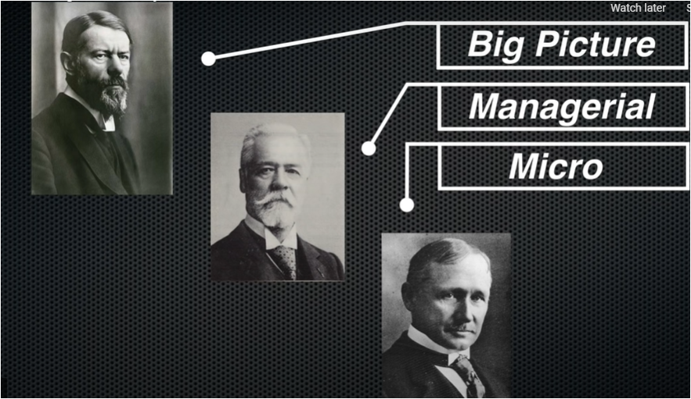
Source: (Classical Management Theory, 2017)

In their own ways, each has influenced the development of management far more than they may have envisaged in their lifetimes. Though the classical scientific models they borrowed from the natural sciences have since been shown to be less helpful than they thought at the time, faith in their ideas has lived on as management theorists have continued to refine their ideas or similar ideas derived from the frameworks. Hudson (2015, p.1).
  - Early Management Theories
The Industrial Revolution, as well as the growth of factories and mass production, created a need for strong management processes. Better and more efficient ways of manufacturing goods were needed in order to maximize productivity, bring down costs, and increase profitability. As a result, since the late 1800s, theorists have developed a wide range of methods for improving management practices. (Saylor,2013, p.1).
  - Mechanistic Models to Organizations
Mechanistic organizations have centralized decision-making and formal, standardized control systems. Essentially, they are bureaucracies. Mechanistic organizations work well in stable, austere environments. Managers integrate the activities of clearly defined departments through formal channels and informal meetings. Often, they feature many hierarchical layers and a focus on reporting relationships. (Lumen, 2021).

  - Figure 2.1 Mechanistic Models to Organizations

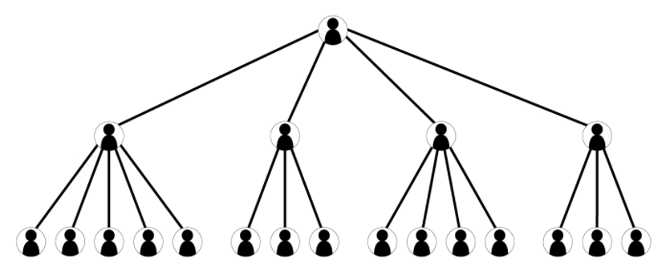
Source: (Lumen, 2021).
  - Organic Organizations
According to Lumen (2021), “organic organizations have a low degree of formality, specialization, and standardization. Their decision-making is decentralized, and their activities are well-integrated. The organic model is usually flat, and it usually uses cross-hierarchical and cross-functional teams and possesses a comprehensive information network that features lateral and upward communication and downward communication. Organic organizations look a lot like boundaryless organizations. They allow employees to cultivate more ideas and be creative because the business is not as rigidly structured. Organic structures are used in dynamic, unstable environments where the business needs to quickly adapt to change, as the structure gives the organization the flexibility to deal with fast-paced environmental change and many different elements. A good example of an organization that uses an organic structure might be a consulting firm. A consulting firm responds to customer issues as they come up, which changes with the business environment. Consulting firms want to respond to change quickly, so by choosing an organic structure; they’re able to be nimble and address their customers’ needs.”

  - Figure 3.1 Organic Organizations

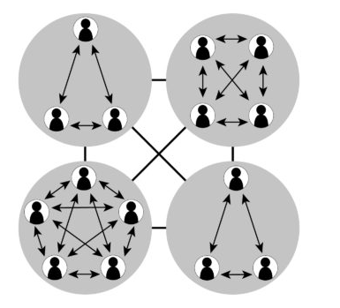
(Lumen, 2021)
  - Human Resource
According to Jones (2013), Human resources are an organization’s most important asset. Ultimately, an organization’s distinctive competencies lie in the skills and abilities of its employees. Because these skills and abilities give an organization a competitive advantage, organizations must continually monitor their structures to find the most effective way to motivate and organize human resources to acquire and use their skills. Typical kinds of change efforts directed at human resources include
- New investment in training and development activities, so employees acquire new skills and abilities;
  - Socializing employees into the organizational culture, so they learn the new routines on which organizational performance depends;
    - Changing organizational norms and values to motivate a multicultural and diverse workforce;
      - An ongoing examination of how promotion and reward systems operate in a diverse workforce;
        - And lastly, changing the composition of the top-management team to improve organizational learning and decision making (p.296)

Hudson (2015) summarised the current state of mainstream management theory into 4 categories below:
  - The Milestone Journey On Management
- The majority of managers and management theorists, including those with some knowledge of social science, are likely to be operating under the influence of classical science's ‘masculine’ mechanical ideas.
- Most managers and management theorists assume that organizations have a single purpose, should be stable and hierarchical, and have structures based on impersonal rather than personal relationships.
- Most management theorists believe there are distinct skills of management which can be taught; and
- lastly, most management theorists seek to routinise rather than to develop the human aspects of management. (p6).
Press (1990 cited in Thompson 2001, p.194) suggests that an organization's culture is based upon one or more philosophies. His ideas are developed in the figure below.
  - Management Philosophies
Figure 4.1 Organizational Philosophies 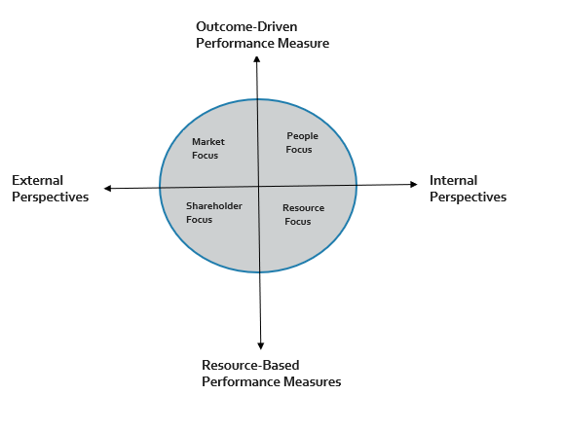
  - Source: (Thompson,2001,p.194)

The specific philosophies are related to the various stakeholders in the business and are determined by two intersecting axes. One relates to whether the business is focused more internally or externally; the other is based on performance measures. Do they concentrate more on resource management and efficiency, or outcomes and effectiveness? This creates four discrete philosophies:
- The resource focus, which concentrates on internal efficiencies and cost management.
- The shareholder focus sees the business as a portfolio of activities that should be managed to maximize the value of the business for its shareholders.
- The people focus, which emphasizes the skills and contribution of employees, and their needs and expectations.
- The market focus stresses the importance of satisfying customers by adding value and differentiating products and services. (Thompson,2001,p.195).
  - Theories of Organisations
Farnham (2010, p.40) notes how organization theory, sometimes described as organizational behavior or organization studies, is the interdisciplinary field that systematically examines and applies knowledge of how people act their roles in organizations and the factors influencing this. Organization theory draws on academic and practical disciplines such as psychology, sociology, economics, politics, philosophy, and ethics. This makes it a demanding and sometimes contradictory field of study, The concept of an organization is surprisingly complex and problematic. But organization matters in societies if only because just about everything we do occurs within them. Organizations exist for any collective, purposeful activity. They acquire resources or input to do this; they convert them into outputs, as goods and services. The difference between the value of the outputs produced and of the inputs used is the added value.
Also, from Farnham (2010), this benefits the organization's owners, managers, workforce, and customers, contributing to wealth creation and the distribution of wealth in society generally. HR practitioners need to appreciate the underlying principles of organization theory to understand the role and functions of management and the HR function and their limitations. (p.40)
  - Contributors to Management Theory and Practices
Taylor’s Legacy in the 21st Century
According to (Witzel et al. 2013, p.28), in the ranks of Taylorism reformers, the time has been kindest to the bureaucratic enhancers. Operations research, management science, and computer decision support systems all thrive-as do Taylor’s ideas. Many of his scientific management techniques have survived virtually intact and, more often, evolved. Stopwatch time study is little changed, but many computer-based standard data systems have enhanced work measurement. Gantt charts have evolved into sophisticated PERT project management and review systems, and motion studies are routinely made, although more likely using Gilbreath’s techniques than Taylor’s (Gilbreath 1911). Barth’s slide rules replaced machinist’s decisions in Taylor’s time, and computer-controlled machine centers do the same by transferring machining decisions to programmers. Lean production has become the dominant mode of modern manufacturing, and its Taylorist elements ensure an influential position for Taylor’s ideas for the foreseeable future.

  - Elton Mayo and the Human Relations School
According to Hudson (2015), the first fallacy was challenged by Elton Mayo and his colleagues at the Hawthorne plant of General Electric. Though starting from a Taylorist viewpoint, they found that intangible rewards, like esteem or group acceptance, and intangible punishments, like loss of group approval, had significant effects on worker performance. Mayo’s work inspired a behavioral scientist to invade management and develop a variety of theories of motivation, including the hierarchy of needs (Maslow, 1987), social systems theory (Emery and Trist, 1960), and hygiene theory (Herzberg, 1974).

The failure of such approaches to improve output led to different theories. McGregor (2006) suggested that the belief system of the manager would influence the manager’s approach. A manager who believes people are lazy and undisciplined will use a different approach from a manager who believes that people can be relied on to be self-motivating. Burns and Stalker (1994) found that the manager’s style was a significant factor in the success of technological companies. Similar results have been found in headteachers' and hostel wardens' studies, though Owen (1996) suggests that such conclusions may be too simplistic.
Blake and Mouton (1964) tried to integrate the Taylorist concern for output and the behavioral science pre-occupation with workplace relationships by proposing that managers’ styles combine two elements ‘concern for production’ and concern for people’ may vary both between managers and between individual situations. This theory has been developed, and Lowman (1984) has proposed a similar framework for understanding teacher behavior.
However, many writers within the human relations school of management have simply replaced Taylor’s physiological model with an alternative psychological model. They have also tended to accept Fayol’s belief that organizations have a single purpose. (pp.3-4)

According to Kiechel (2012), Frederick Taylor wrote that “The best management is a true science, resting upon clearly defined laws, rules, and principles,” clearly counted himself in their camp.
1801- 1900 Foundations and Principle of Scientific Management
(Theories and Paradigms)
Fans such as Louis Brandeis and Ida Tarbell also agreed. His stated goal was the “maximum prosperity for the employer, coupled with the maximum prosperity for each employee,” through “a far more equal division of the responsibility between the management and the workmen.” Taylor’s respect for workers’ potential contributions: The laborer should work according to a process analyzed and designed by management for optimum efficiency, “the one best way,” allowing him to do as much as humanly possible within a specific time period.
Also, Frederick Taylor wrote in his book “The Principles of Scientific Management” about “scientific management,” on the contrary, has for its very foundation the firm conviction that the true interests of the two are the same; that prosperity from the employer cannot exist through a long term of years unless it is accompanied by prosperity for the employé, and vice versa; and that it is possible to give the workman what he most wants-high wages-and the employer what he wants-a low labor cost-for his manufactures. (Taylor, 2010)

According to Lyon (2017), it included large groups working together, people working alongside machinery, increasing industry pace, and companies looking for more ways to solve their problems.
  - Contemporary issues of working in the 19th century
However, the above issues, according to Lyon (2017), also raised new questions such as:
Figure 5.1
Source: (Classical Management Theory, 2017)

“How are we going to organize all of this?

How are we going to maximise productivity?

How are we going to manage all of these people?”

  - Generational Gap in management-creating the age-friendly workplace
Indeed, the nature of work is changing dramatically. Many jobs have disappeared; others have appeared. The whole nature of work has changed: where, when, and with whom we work. Organizations have got flatter: there is, for managers, a significant span of control. More jobs are temporary; the demographic mix in teams is increasing. Whereas in the past, people tended to work demographically with others (age, sex, ethnicity, language) just like themselves, that is all changing in the new world of work, where so many groups, organizations, and teams consist of people from very different backgrounds. (Burke et al. 2015, pp.39-40)

  - Contributions of 19th Century Management Theorists FW Taylor, Henri Fayol And Max Weber-Towards Management.
  - Henri Fayol (1841-1925)
The Frenchman, Henri Fayol, was trained as a mining engineer but moved rapidly up the management hierarchy to become seen as a very successful manager. He believed that management is a science that can be taught and argued and that there are six basic business activities involved in management: technical, commercial, financial, security, accounting, and managerial. Hudson (2015).
He also contributed by saying managerial activities could be divided into five main activities such as planning, organizing, commanding, coordinating, and controlling
In the book written by Peaucelle and Guthrie (2015), Henri Fayol’s personal observations and experiments are based on his long industrial career in Mining. His career growth resulted from the pressure of ceaselessly growing managerial burdens, constantly enlightened, guided, and verified by experiments. (p183)
His experience in mining served as the foundation of his progression to being one of the most successful management theorists in the 19th Century. His contributions to management theories have helped revolutionize today’s work environment
  - What were the contributions of Henri Fayol towards management?
He divided managerial activities into five: planning, organizing, commanding, coordinating, and controlling. His 14 ‘principles of management are:
Figure 6.1 Henri Fayol’s 14 principles towards Management
Division of Labour | Subordination | Equity
Authority | Renumeration | Stability of Staff
Discipline | Centralisation | Initiative
Unity of Command | Hierarchy | Esprit de Corp
Unity of Direction | Order
Source: (Hudson, 2015)

Fayol believed that organizations could have a single purpose and operated in a relatively stable environment where a particular organisational structure could survive for many years. He believed in a centralized, hierarchical model of organisational relationships in which good managers ensured that staff were treated fairly in return for their commitment to organisational goals. Hudson (2015).
  - Scientific Management
  - Frederick Winslow Taylor (1856-1915)
He is regarded as the father of scientific management; the fundamentals and principles of scientific management have originated from him.
According to Hudson (2015 ), F W Taylor is an American scientific theorist who concentrated on the component of work rather than the structures within it is carried out. He argued that it is in the best interests of both worker and manager to break tasks down into components that enable workers to use minimum energy while producing maximum output, thereby maximizing their earnings for the least possible effort. His approach of analysing the physical movements a made and then training the worker to perform a single movement very efficiently remained a key element in many industries which relied on ‘time and motion,’ studies until the 1970s and occasionally threatens to make a comeback as it did in the 1990s in ‘activities analysis.’
Though Taylor argued passionately for improving workers’ conditions- and thereby met resistance from many managers- he failed to convince the nascent US unions that his ideas would improve many workers. Like those of Fayol, his ideas did not reach the UK until the 1930s, when some British manufacturers saw them as the only way to meet the threat of US competition. Ironically, they were introduced in the teeth of union opposition via the introduction of ‘piece work’ and eventually dismantled in the 1970s again in the teeth of union opposition. Taylor is generally-and incorrectly-regarded as supporting the worst excesses of authoritarian management due to how his ideas have been put into practice.
  - Bureaucratic Organization
Max Weber was a known German sociologist, historian, jurist, and political economist. Glynn Cochrane describes Weber as the starting point for most modern thinking about bureaucracy. His vision was that all industrialized countries would adopt bureaucracy.
  - Max Weber (1864-1920)
The scale of Weber’s ambition for bureaucracy can be seen in the fact that he thought bureaucracy might defeat capitalism: Weber tended to use ‘machine’ to refer to army efficiency.
‘The result of Weber’s military training was great admiration for the ‘machine’ as well as a martial and patriotic mentality that made him long for an opportunity someday to take to the field at the head of his company.’
Furthermore, she referred to Weber,’ from a technical and material point of view,[ bureaucracy] is unsurpassable,’ and he said his bureaucratic model worked ‘exactly as does the machine with non-mechanical modes of production.’
He also contributed that ‘precision, speed, unambiguity, knowledge of the files, continuity, discretion, unity, strict, subordination, reduction of friction and material and personnel costs are raised to the maximum in bureaucratic organizations.
Where a charismatic rule is incalculable and transitory, and patrimonial rule personal and unpredictable, the bureaucratic rule is both calculating and calculable, systematic, a coherent assemblage of parts manned by specialized personnel, ideally adapted to the domination and administration of men and the pursuit of ends through rules applied without regard to persons.
Weber’s theory of bureaucracy failed to deliver what he had promised. (pp.1-2)
“Many of Weber’s beliefs discourage creativity and collaboration in the workplace and oppose flexibility and risk.” (Peek, 2020)

  - Post-Bureaucracy, change management and ‘Disorganized Capitalism.’
According to Farnham (2010), another trend in organization theory since the 1980s is a reaction against bureaucracy. This led to the search for effective methods of managing organizational change and dealing with the speed of change in contemporary societies. Three factors drive this shift in emphasis or organization theory.
- There is the underpinning belief among some observers that the conditions for bureaucracy in the organization no longer persist.
- Others claim that stability in organizations and societies is no longer the norm and that change is endemic in the contemporary world.
- There is the observation that both the economy and society are characterized by a preoccupation with the speed of contemporary life. (Farnham,2010, p48)
Thus with globalization, the emergence of service economies in the western world and a more educated workforce. Taylorist forms of Fordism are viewed as no longer necessary. It is also suggested that people in organizations need to be flexible and innovative, especially in the light of rapid external change. As a result, there has been a development of a range of new organizational forms. Heckscher (1994) has called these ‘post-bureaucratic organizations in contrast to the bureaucratic ideal type. Other descriptions are ‘virtual,’ ‘networked,’ or ‘postmodern’ organizations. Post-bureaucracy has three main characteristics.
- Administrative rules are replaced with consensus and dialogue-based personal influence rather than status, with people being trusted to act based on shared values, not rules.
- Responsibilities are assigned based on competence for tasks rather than hierarchy and are dealt with personally rather than impersonally.
- Post-bureaucratic organizations have open boundaries, with people coming into and out of organizations flexibly, such as part-time, temporary, and consultancy roles. (Farnham,2010, p48)
  - The Spirit of Capitalism by Max Weber
Weber’s method was to focus on internal cultural factors as the key determinants of development or non-development. This helped to shape future approaches in the sociology of development. After Weber became influential, sociologists known as ‘modernization theorists’ argued that underdeveloped countries were as they were due to their internal value systems. By contrast, countries that were industrialized owed their success to a culture that promoted entrepreneurship. (Allen, 2004)
  - An ideal organization from the perspective of Max Weber
According to Peek (2020), Weber believed that bureaucracy was the most efficient way to set up and manage an organization and necessary for larger companies to achieve maximum productivity with many employees and tasks.
In an ideal bureaucracy, everyone is treated equally, and work responsibilities are divided by each teams’ areas of expertise. A well-defined hierarchical management system supports this, providing clear lines of communication and division of labor based on the layer of management one worked in.
Advancement in the organization is determined solely on qualifications and achievements rather than personal connections. Weber believed the work environment should be professional and impersonal – “work relationships” are strongly discouraged. Overall, Weber’s ideal bureaucracy favors efficiency, uniformity, and precise distribution of power.

  - The contribution of Max Weber in management
According to Davis (2020), the main contribution of Max Weber to management is his theory of authority structure and his description of organizations based on the nature of authority relations within them.
According to Weber, such an “authority” (equivalent to proper bureaucracy) involves:
- A continuous organization of official functions bound by rules.
- A specified sphere of competence involves
  - A sphere of obligations to perform functions has been off as part of a division of labor.
  - The provision of their incumbent with the necessary authority to carry out these functions.
  - …….. the necessary means of compulsion are clearly defined and their use subject to definite conditions ………..
- The organization of offices follows the principle of hierarchy …. each lower office is under the control and supervision of a higher one.
- The rules that regulate an office's conduct may be technical rules or norms …. (so) specialized training is necessary.
- ……… members………. should be separated from ownership
- …………… complete absence of appropriation of his official position by the incumbent.
- Administrative acts, decisions, and rules are formulated and recorded in writing………….

Also, from the works of Garston (2012), Weber goes on to describe the “purely bureaucratic organization” as being ”from the purely technical point of view, capable of attaining the highest degree of efficiency and is in this sense formally the most rational known means of carrying out imperative control over human beings.” (p4)

According to Weber, these are the six characteristics of bureaucracy:
  - The Features of Weber’s Bureaucracy

- Task specialization (a division of labor)
- Hierarchical management structure
- Formal selection rules
- Efficient and uniform requirements
- Impersonal environment
- Achievement-based advancement. (Davis, 2020)
  - Element Of Power And Culture In An Organisation
Power is reflected in the ownership of the business. It may be a family company with strong, concentrated power. A small group of industrial shareholders could control the business, in which case it is conceivable that short-term financial targets will dictate strategies. Structural issues include the extent to which the organization is centralized or decentralized, the role and contribution of corporate headquarters, and control and reward systems. (Thompson, 2001).
Power, according to Max Weber,
“is an aspect of social relationships and refers to the possibility of imposing one’s will upon another person’s behavior.”- Biznews, (2021).

According to Ranjan (2020), Max Weber’s definition of domination (Authority) is more specific. It refers only to those exercises of power where an actor obeys a specific command issued by another. In making the distinction between power and domination (authority), Weber put forward two types of solutions to the problem of order. Power represents action likely to succeed even against the opposition and resistance of those it is applied to. This solution is typically found in warfare and class conflict, but it is limited to instability as a long-term source of order. Legitimate domination, by contrast, involves an element of voluntary compliance from those to whom it applied and therefore embraced the issue of meaningful action. Domination can be legitimized by appealing to the principles of tradition, national legality as embodied in the enacted law, and charisma (Turner 1996).
  - Max Weber’s Theory on Power
Weber’s concept of class, status, and party and his analysis of state and bureaucracy center his concept of power. Each grouping is focused around or oriented towards power as an independent point of conflict. Each represents an aspect of and a basis for power. (Ranjan 2020)
Weber’s discussion of ‘class,’ ‘status,’ and ‘party’ are three dimensions of stratification in society, each conceptually separate from the others, and specifies that, on a practical level, each may casually influence each of the others. Weber did not ignore economic sources of power and class and considered these among the more important sources, especially capitalism. But unlike Marx, he claimed that power did not emerge only from economical sources, and he certainly does not restrict power relationships to ownership or non-ownership of the means of the production. Power can also emerge from status or party (associations concerned with acquiring power) or be pursued for its own sake. Among these different forms of power, there are cross-cutting influences and effects, so that power obtained in one of these spheres may lead to power or a change in the situation in another sphere. (Ranjan 2020). For Weber, class is an expression of economic order; to be more precise, a person's market situation determines it. Here a class denotes an aggregate of individuals who share the same market situation. So as per the identification of class situation with the market situation, there could be as many class divisions as there are minute gradations of market (economic) position. But similar to Marx, Weber also argues that the ownership versus non-ownership of property is the essential basis of class division in a competitive market. Weber distinguishes two types of classes, positively privileged class who are the property owners, and non-owners or commercial class. He also identifies the middle class, a group that can be placed between these two. For him, property or lack of property is composed of the plurality of the class statuses between which an interchange of individuals on a personal basis or in the course of generation is readily possible typically observable. (Ranjan 2020)
For Weber, power is associated with property class because they enjoy more status and privilege in society. The acquisition classes are negatively privileged, and they are workers of the various principal types. They are less influential in society. (Ranjan 2020). Social mobility is possible between different classes or strata in society.
But this movement is possible only to a limited extent, according to Weber. He says moving into a broader position range is blocked by power differentials between different classes (Crib). Weber considers both class and status group membership as the basis of social power. But the formation of a political party has more influence upon power in modern society. For Weber, a party refers to any voluntary association that aims to secure directive control of an organization to implement specific policies within the organization. Parties are the organization rather than communities or groups, and they involve striving for a goal in a planned manner. (Ranjan 2020). Weber notes that classes are in the economic order, status groups in the social order, and parties in the sphere of power. In some senses, power is not a separate order, in that classes and status groups are concerned with power. The difference between parties on the one hand, and status groups and classes on the other, is in the level of analysis; parties are an organization, whereas classes and status groups are groupings of people. If status groups of classes become well organized, they may form parties, or their parties may become the organizational wings of the class or status group. Trade unions, professional associations, ethnic organizations, and religious institutions are examples. Parties represent power at the macro level. For Weber, all three – class, status, and party are sources of power. Thus his power view is extensive, cutting across the economy, social and political parameters. (Ranjan 2020)

  - Figure 7.1
  - A Diagrammatic Representation To Max Weber’s Three Types Of Authorities

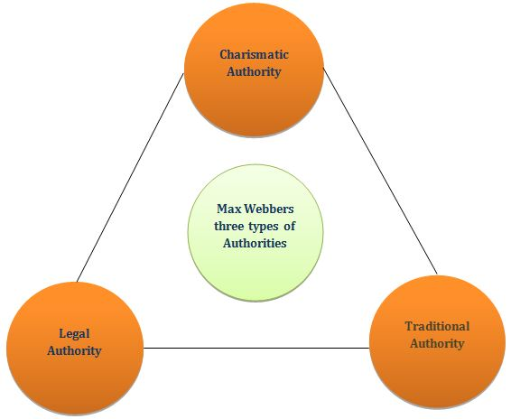

Source: (Ranjan, 2020).

  - Determinants Of Culture
According to Deal and Kennedy (1982), cited in Thompson (2001), they argued that employees must be rewarded for compliance with the essential cultural aspects if these values are to be developed and retained over time; and they concluded that people who build, develop and run successful companies invariably work hard to create strong cultures within their organizations
From the research done by Deal and Kennedy, they isolated five key elements or determinants of Culture. Which are listed below;
- The environment and critical success factors: what the organizations must do well to be an effective competitor. Innovation and fast delivery are examples quoted.
- The values that the strategic leader considers essential and wishes to see adopted and followed in the organization. These should relate to the critical success factors and employee reward systems.
- Heroes: the visionaries who create the Culture. They can come from any background and could be, for example, product or service innovators, engineers who build the appropriate quality into the product, or creative marketing people who provide the slogans which make the product or brand name a household word.
- Rites and Rituals: the behaviour patterns in which the Culture is manifest. Again, there are many ways this can happen, including employees helping each other out when there are difficulties, how salespeople deal with customers, and the care and attention that go into production.
- The cultural network: the communications system around which the Culture revolves and determines how aware employees are of the essential issues. (Thompson, 2001, p.185)
Furthermore, from the works of Thompson (2001), When the Culture is strong, people know what is expected of them, and they understand how to act and decide in particular circumstances. They appreciate the critical issues. When it is weak, time can be wasted in deciding what should be done and how. Moreover, it is argued that employees feel better about their companies if they are recognized, known about, and regarded as successful, and these aspects will be reflected in the Culture.
There can be several separate strands to the Culture in any organization, which should complement each other. For example, there can be aspects relating to the strategic leader, the environment, and the employees. There could be a strong power culture related to an influential strategic leader who is firmly in charge of the organization and whose values are widely understood and followed. This could be linked to a culture of market orientation, which ensures that customer needs are considered, and to a work culture if employees feel committed to the organization and wish to help achieve success.

  - Implications to Culture
According to (Pümpin 1987, cited in Thompson 2001 p186), Pümpin suggests that seven aspects comprise an organization's culture and that the relative significance of each of these will vary from industry to industry. These seven aspects are:
- The extent to which the organization is marketing orientated, giving customers a high priority.
- The relationships between management and staff, manifested through communication and participation systems, for example.
- The extent to which people are target orientated and committed to achieving agreed levels of performance.
- Attitudes towards innovation. The risk associated with failure must be perceived as acceptable by all levels of management if innovation and entrepreneurship are to be fostered.
- Attitudes towards costs and cost reduction.
- The commitment and loyalty to the organization are felt and shown by the staff.
- The impact of, and reaction to, technology and technological change and development. One major issue concerns whether or not the firm's opportunities offered by information technology are being harnesses.
  - The Theoretical Aspect of Management Culture as Part of Organizational Culture
Specific personal, value, business, and professional competencies are characteristic of the organization's management staff. They allow speaking about a particular culture, characteristics of the management staff, and its activities. On the one hand, according to (Aycan et al. cited in Žukauskas et al.), the model of culture fit postulates that the sociocultural environment affects the internal work culture, which in turn influences human resource management practices; on the other hand, both the sociocultural environment and certain management traditions foster the interest in which determinants of management distinguish one organization from the other,

to highlight general instrumental criteria. Although management culture is not entirely new and is used in various discourses, and some of the elements of this phenomenon are usually discussed in organizational culture, one can miss a more precise definition of the phenomenon. When speaking about the organizational culture, its formal and non-formal elements are being identified usually. The analysis of scientific literature that focuses on the topics of managerial staff and the policy they implement highlights both non-formal and formal aspects. But does this mean that the management culture can be identified only as one of the organizational culture characteristics of the managerial staff or as an independent, instrumental factor? The management culture is an integral part of the organizational culture. However, it can also be examined as a specific phenomenon from others and, when purposefully developed, can bring more efficiency to the organization. (Žukauskas et al.2018, p.17)
  - Managing Culture
According to Farnham (2010), in the 1980s, a central concern of organization studies turned to managing corporate culture. This originated in the so-called ‘excellence’ studies by Peters and Waterman (1982), Deal and Kennedy(1982), and, later, Schein (1997), which propelled ‘culture’ to the center stage of corporate analysis and review. There are various definitions of Culture, but Schein’s (1980) is prototypical. He defines it as the pattern of basic assumptions that a given group has invented, discovered, and developed. What makes a culture ‘great’ are core corporate values that management acts upon and monitors. These studies attempted to demonstrate how specific patterns of learned and shared basic assumptions framed organizational members' perceptions, thoughts, and feelings. These works tried to answer questions such as: How are things done in an organization? What is acceptable behavior within it? What organizational norms and values are transmitted to new members? What norms are members expected to use to solve organizational problems? And which ones do they use? This theoretical school assumed companies that forged a ‘strong,’ known Culture, incorporating beliefs and commitments by organizational members, would achieve good morale, high performance, and excellent results. (p47)
  - Figure 8.1 Culture, Structure and Styles of Management

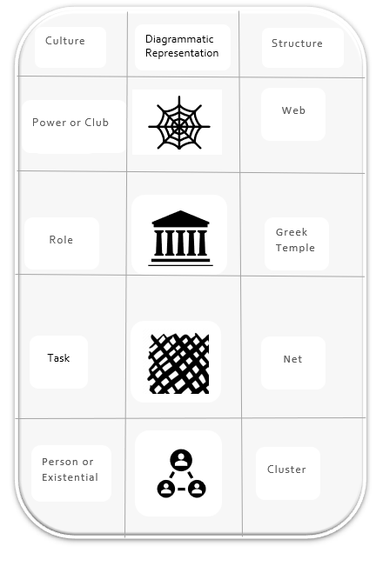

  - Source: (Thomspon,2001,p191).

Charles Handy (1976), building on earlier work by Harrison (1972), has developed an alternative classification of organizations based on cultural differences, and this is illustrated in the figure above
  - The club or power culture
In the club culture type of organization, work is divided by function or product, and a diagram of the organizational structure would be quite traditional. There would be departments for sales, production, finance, and so on, and possibly product-based divisions or strategic business units if the organization were larger. However, this structure is primarily found in smaller firms.
Handy's figure represents these functions or departments by the lines radiating out from the center, but the essential point is that concentric lines represent communications and power. The further away from the center, the weaker is the power and influence. This structure is dominated by the center and therefore is typical for small entrepreneurial organizations. Decisions can be taken quickly, but the quality of the decisions is very dependent on the abilities of managers in the inner circle. Thompson (2001, p192).
  - The Role Culture
The role culture is the more typical ‘organization’ as the Culture is built around defined jobs, rules, and procedures, not personalities. People fit into jobs and are recruited for the purpose. Hence, rationality and logic are at the heart of the Culture, designed to be stable and predictable.
The design is the Greek temple because the organization's strengths lie in the pillars joined managerially at the top. One essential role of top management is to coordinate activity, and consequently, it will be seen that both planning systems and incremental changes can be a feature of this Culture.
Although the strength of the organization is in the pillars, power lies at the top. As well as being designed for stability, the structure is designed to allow for continuity and changes of personnel, and for this reason, dramatic changes are less likely than more gradual ones. Thompson (2001, p192-193).
  - The Task Culture
Management in the task culture is concerned with the continuous and successful solution of problems, and the success of the outcomes judges performance
The challenge is more important than the routine. The Culture is shown as a net because people and other resources can temporarily be drawn from various parts of the organization for particular problem situations. Once the problem is dealt with, people

will move on to other tasks, and consequently, discontinuity is a crucial element. Expertise is the primary source of personal power, and it will determine a person’s relative power in a given situation.
The power lies in the interstices of the net because of the reliance on task forces. The Culture is ideal for consultancies, advertising agencies, and the research and development department. It can also be helpful within the role culture for tackling particularly difficult or unusual problem situations.
In dynamic environments, a significant challenge for large organizations is designing a structure and systems that allow for proper management and integration without losing the spirit and excitement typical of small, entrepreneurial businesses—Thompson (2001, p.193).
  - The Person and Existential Culture
The person's culture is entirely different from the other three, for here, the organization exists to help the individual rather than the other way round. Groups of professional people, such as doctors, architects, dentists, and solicitors, provide excellent examples. With secretarial help, printing, and telephone facilities, the organization provides a service for individual specialists and reduces costly duplication. If a circle member leaves or retires, they are replaced by another who may have to buy in.
Some professional groups exhibit interdependencies and collaboration, allocating work among the members, although management of such an organization is complex because of individual expertise and because the rewards and sanctions are different from those found in most other situations.
However, in an environment where the government is attempting to increase competition between professional organizations, and in some cases, reducing barriers to entering the profession, it is arguable that effective management, particularly at the strategic level, will become increasingly necessary. Efforts will need co-ordinating and harnessing if organizations are to become strong competitors. Thompson (2001, pp 193-194).

Figure 9.1. The aspect of Culture- the Culture Grid.
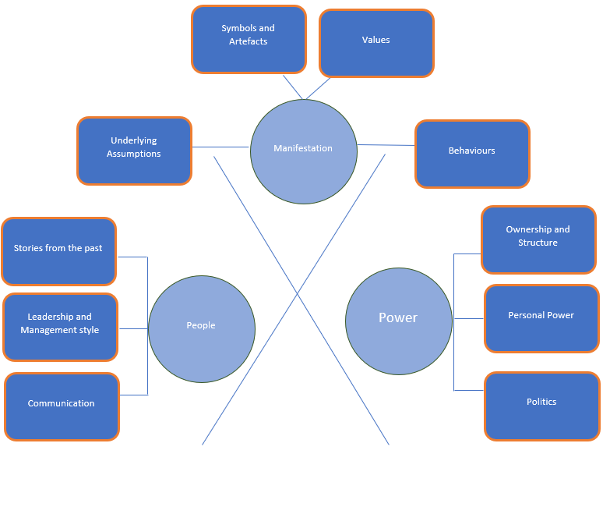

Source: Adapted from (Thompson,2001, p182)

  - Socialization- Organizational Culture
Socialization, described by Van Maanen and Schein (1979), cited in Wanberg (2012), is the process through which one “learns the ropes” of a particular organizational role. More specifically, it is “the process by which an individual acquires the social knowledge and skills necessary to assume an organizational role.” (p.27)

  - Women and Management
Apart from Stacey, for whom difference /diversity is central to his understanding of complexity and change, none of the management theorists whose ideas have been described earlier explicitly address gender issues. Both Drucker and Demming show concerns for people and implicitly or explicitly reject the mechanical models of human behavior that inform classical science, most social science, and most management theories. But neither Drucker nor Demming explicitly addresses gender issues despite their concerns for people, suggesting that there is still some way to develop theories of management that fully integrate ‘feminine’ concerns for people with ‘Masculine’ concerns of achievement. They, like the women theorist- cited by Hudson (2015), such as Jane Mouton, Joan Woodward (1980), Rosemary Stewart (1997), and Rosbeth Moss Kanter (1993) -who have made significant contributions to the development of management theory, have had a little overall impact on management theory and managers in general. Women whose managerial careers are as long as men’s make as much progress as men.
Rather the difference are between the views of women and men about what constitutes managerial effectiveness and what women and men would do in particular situations. (Burke, 2005 as cited in Hudson, 2015). This partly reflects the lack of female role models in management; women are more likely to get promotion if there are other women at their levels or above and in smaller organisations where there is not a long promotion ladder. It also reflects the different views of women and men about social networks, with men more likely to develop work-related networks and benefits from them in later promotions. Where women are given encouragement or challenging assignments early on in their careers, they are more likely to advance. (Hudson, 2015)

  - PostModernism
The key to understanding the discourse of postmodernism is the concept of difference: a form of self-reference in which terms contains their own opposites and this refuse any singular grasp of their meanings, e.g., the paradox of the ‘global village’ in which the enlargement of the world through modern communication techniques actually makes it smaller. The difference is thus a unity which is at the same time divided from itself, and since it is that which actually constitutes human discourse. (Calás et al., 1997).
  - The 21st-century era of development in management-technology, manufacturing options, innovation, and creative thinking.
In post-modernism, organizations have evolved out of traditional thinking or managing “factors of productions,” centralization of systems and process, generic command and control management style to move decentralized, facilitating and empowering, formal and informal communication and knowledge influencing environment. In a classical environment, economic consideration provided the organizations to adopt mass production strategies in order to maximize returns. This approach led to the large-scale adoption of a bureaucratic process involving specialization, standardization, formalization, centralization, and configuration (Weber, 1978 cited in Misra et al., 2013). Enterprise Resource Planning (ERP) principles augmented these practices through IT mediation and process automation like Computer-Aided Design and Manufacturing (CAD&M). This evolution in organizations is dominated by machine bureaucracy, which influenced organization structure, line of control and workflow, and concentration of authority. This evolution also led to a pattern having varying degrees of dependencies on technology. It revealed that dependence on technology was low in small batch production units, whereas large batch, mass, and continuous production organizations had the highest level of dependencies on technology. Technologies in this evolution path were seen as tools for improving efficiency, productivity, quality while ensuring mass production. (Misra et al., 2013, p.3).

Figure 10.1 Evolution of Organizations
- Classical Organization | - Post Modern Era
- Centralized | - Decentralized
Hierarchical | - Inter-functional
Command and Control | - Facilitating and Empowered
Traditional systems and process | - Technology Mediation  Knowledge Influenced systems and Processes.
Factor of production centric | - Economy of complementation and post-modernism.
Localizing Focus | - Globalization
Individual economic focus | - Networks and socially embedded
Product Orientation | - Market Orientation
Mass Production | - Mass Customization
Process Specific | - Innovation Orientation
Source : (Misra et al., 2013,p.3)

  - Reference List
  - Book References
Peaucelle, J. L. and Guthrie, C. (2015) Henri Fayol, the Manager, 6th edn. London: Pickering and Chatto (Publishers) Limited. p.183

Taylor, F. W. (2010) The Principles of Scientific Management. New York: Cosimo.
Thompson, J. L. (2001) Understanding corporate strategy. Oxford: Alden Press. p.182.
Cochrane, G. (2018) Max Weber’s Vision For Bureaucracy A Casualty of World War 1. Switzerland: Springer. pp. 1-2.

Garston, N. (2012). BUREAUCRACY: Three Paradigms. New York: Kluwer. p4.
Allen, K. (2004). Max Weber: A Critical Introduction. United Kingdom: Pluto Press.
Thompson, J. L. (2001) Understanding corporate strategy. Oxford: Alden Press. p.184.
Jones, G.R. (2013) Organizational Theory, Design, and Change. 7th edn. Essex: Pearson. p.17.
Thompson, J. L. (2001) Understanding corporate strategy. Oxford: Alden Press. p.186.
Žukauskas, P., Vveinhardt, J., and Andriukaitienė, R. (2018) Management Culture and Corporate Social Responsibility. London: IntechOpen. p.17.
Thompson, J. L. (2001) Understanding corporate strategy. Oxford: Alden Press. p.191.
Farnham, D. (2010) Human Resource Management in Context strategy, insights, and solutions. 3rd edn. London: CIPD. p.47.
Thompson, J. L. (2001) Understanding corporate strategy. Oxford: Alden Press. pp.194-195.
Jones, G.R. (2013) Organizational Theory, Design, and Change. 7th edn. Essex: Pearson. p.296.
Farnham, D. (2010) Human Resource Management in Context strategy, insights, and solutions. 3rd edn. London: CIPD. p.40.
Witzel, M. and Warner, M. (2013) The Oxford Handbook of MANAGEMENT THEORISTS. 1st edn. Oxford: University Press. p.28.
Burke, J.R., Cooper, L.C., and Antoniou, G.A.S. (2015) The Multi-generational and Aging Workforce-Challenges and Opportunities. Cheltenham: Elgar. pp.39-40.
Thompson, J. L. (2001) Understanding corporate strategy. Oxford: Alden Press. p.185.
Wanberg, C. (2012) The Oxford Handbook of ORGANIZATIONAL SOCIALIZATION. New York: Oxford University Press. p.27.
Misra, H., and Rahman, H. (2013) Managing Enterprise Information Technology Acquisitions: Assessing Organizational Preparedness. Pennsylvania: IGI Global. p.3.
Calás, M. B., and Smircich, L.( 1997) Postmodern Management Theory. Oxon: Routledge.

  - Web References
Kiechel, W. (2012) The Management Century [online] Available [Accessed 14/07/2021].

Hudson, J.R. (2015) Theories of management-Classical Management and Modern Management -Relevance Today [online] Available at Theories of management (johnrhudson.me.uk) [Accessed 16/07/2021].
Peek, S. (2020) The Management Theory of Max Weber [online] Available at The Management Theory of Max Weber - business.com [Accessed 17/07/2021].

Davis, B. (2020). What is the contribution of Max Weber in Management? [online] Available at What is the contribution of Max Weber in management? – Mvorganizing.org [Accessed 25/07/2021].

Biznews (2021) Max Weber Power and Authority. [online] Available at Max Weber Power and Authority (biznewske.com) [Accessed 25/07/2021].

Ranjan, V. (2020) Max Weber’s Theory on Power. [online] Available at Max Weber’s Theory on Power | TriumphIAS [Accessed 25/07/2021].

Lyon, A. (2017) Classical management Theory [video] Available at Classical Management Theory - Bing video [Accessed 01/08/2021].

Saylor Foundation (2013) Historical and Contemporary Theories of Management [online] Available at Are you curious about whether you are management material (saylor.org) [Accessed 03/08/2021].
Hudson, J.R. (2015) Theories of management- Elton Mayo and the Human Relations School [online] Available at Theories of management (johnrhudson.me.uk) [Accessed 10/08/2021].

Lumen (2021) Organic versus Mechanistic Models [online] Available at Organic versus Mechanistic Models | Organizational Behavior and Human Relations (lumenlearning.com) [Accessed 10/08/2021].

