BMSW4003- Digital Skills and Research Methods
Report – Research report.
Name: Viorel iorga
ID: 2131642
Topic: How Do Students Use Technology to Collaborate at UWTSD?
Tutor’s Name: Dr.Sayed Nasirpour

Abstract
This paper aims to evaluate collaboration of technology with students for effective management of learning. Covid-19 pandemic has surged using technological innovation and managed continuation of studying at that time of public restriction. Technological uses have been done with advanced tools that have inspired students to assist their future growth. It can be stated that technology has changed roles and effectiveness of teachers as well as learners. Digital learning using technological implementation has developed educational system of UK and achieved innovative understanding of students. This research has adapted primary survey method and maintained academic ethics towards participants effectively. Students have been incorporated as research preparation and their personal safety and dignity has been maintained throughout data collection and data analysis procedures.

Table of Contents
1. Introduction 3
2. Research design 3
2.1 Research question 4
2.2 Methods 4
2.2.1 Research Philosophy 4
2.2.2 Research Approach 4
2.2.3 Research Approach 4
2.2.4 Data Collection and Data Analysis 4
2.2.5 Sampling Process 5
2.2.6 Research Timeline 5
2.3 Ethical considerations 5
3. Results 6
(Questionnaire in Appendix) 6
4. Discussion 9
5. Conclusion 10
Reference List 12
Appendix: Questionnaire 14

1. Introduction
Internet, mobile technology and audio visual systems are being used for reduction of students’ limitations within their physical vicinity. As mentioned by Greszczuk et al. (2018), technological collaboration gives a broad access to students with a variety of information and resources with a simple single click. Covid-19 has restricted physical interaction among students, classmates and professors in University of Wales Trinity Saint David (UWTSD) and restricted offers of courses directly. Technological uses have developed interaction between students and professors from any geographical continent and make sure implementation of courses towards career growth of students. Technology has evaluated new learning ways using innovative tools like Google doc and excel that have helped with effective sharing of information in one click.
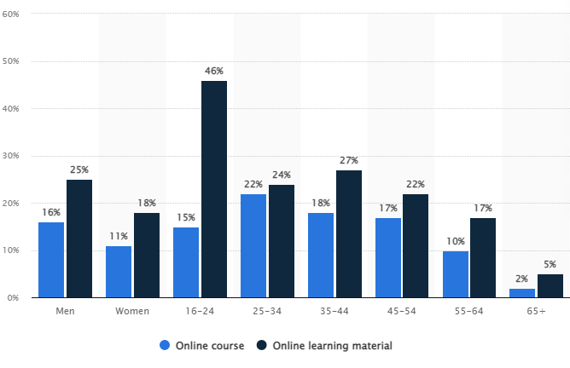
Figure 1: Online learning material and online courses using in Britain in 2020
(Source: STATISTA, 2022)
This statistic has examined that 15% learners between 16-24 ages have used online courses and 46% learners within this age group have used online learning materials. Along with this, significant 25-34 age group learners have been identified with 22% online course users and 24% learners are with use of online learning materials (STATISTA, 2022). A significant amount of technological incorporation has been observed in this statistic to continue learning and progress in era of Covid-19 pandemic.

2. Research design

2.1 Research question
- Are students confident in using technology to collaborate?
Primary question of this research is about confidence of students with use of technological platforms and technological collaboration. Such collaboration used between students and teachers and innovative delivery of courses has been implemented. It has been identified that Covid-19 pandemic has adopted digital learning and in such a way, effectiveness of technology in studying is significantly noticeable. Students have seen to be more confident with such innovation as accessing information and collaboration become easier and effective with a single click.

2.2 Methods

Figure 2: Research onion
(Source: Influenced by Saunders et al. 2015)

2.2.1 Research Philosophy
Research philosophy is assumption and belief of research that is used to develop a particular faith based on a research topic (Butler and Sinclair, 2020). This research has used positivism research philosophy that has used experimental based statistics on technological usage on learning’s. It has maintained adequate factual data based on scientific evidence and investigated digitalisation of students after Covid-19.

2.2.2 Research Approach
Research approach is a research plan that has been used throughout research based on specific ways of data interpretation and analysis (Kochkorbaevna and Hilola, 2022). This research has chosen a deductive research approach that has incorporated theoretical insights for evaluating technological use for students. This insight has developed literature and findings based on relevant observation.

2.2.3 Research Approach
Research design is a process that is used to maintain correct design of collected raw data and information (Chmielewska and Gilányi, 2019). This research has used a descriptive research approach that has developed collected raw data with descriptive insights. A wide description has helped describing all sources collaboratively and a wide description over use of technology in studying has been developed successfully.

2.2.4 Data Collection and Data Analysis
Data collection is used in research for gathering information and measuring it to achieve data for effective outcome of research. According to Nind (2020), data collection is most important part of research methods that are used for sustainable ways of data gathering, incorporation and analysis. This research has used primary data collection method to achieve direct results from human respondents and that has developed findings of this research effectively. Quantitative method has been used to achieve desired research outcomes. Survey process has been conducted on students of UWTSD that has revealed effectiveness of technology over studying. Survey process has developed a questionnaire of a total of 5 close-ended questions and gathered direct opinions of students for technological collaboration in studying.

2.2.5 Sampling Process
Sampling method is a process of research that is used for effective management of statistical analysis of research with a gathered population (Sawatsky et al. 2019). Probability sampling technique has been used in this research with a particular population and that are students of UWTSD. Total of 21 participants have been chosen for preparation of survey process. Therefore, total sample size of this research is 21 and they have been incorporated to reveal desired outcome for this research.

2.2.6 Research Timeline
Actions | 1st week | 2st week | 3st week | 4st week | 5st week | 6st week | 7st week
Introduction
Research design
Result
Discussion
Conclusion

2.3 Ethical considerations
“Data Protection Act 2018 (c.1)” has been maintained throughout research preparation journey and has maintained research ethics for participants. Result of surrey has been developed for this research purpose only and any business survey or personal practice has used this. Influenced by Gopalan et al. (2020), confidential information of participants has been protected highly and their sensitive data has not been leaked for hampering their safety in society. Maintaining Participants’ confidential information protection has been focused on throughout this research to safeguard their interests. Social safety and protection has been provided to them and their data has been developed with equal respect and dignity for all participants. This research has not gained any judgemental view towards participants and maintained academic ethics in accessing and development of their information.

3. Results

(Questionnaire in Appendix)
Question 1: How far do you agree that technological advancement helps in increasing the learning experience of students?
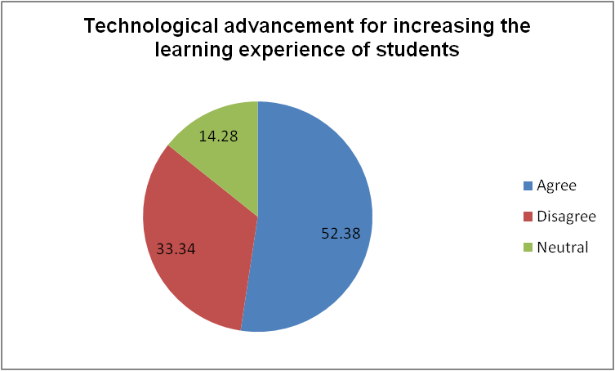
Figure 3: Technological advancement helps in increasing the learning experience of students
This question has been prepared for findings opinion of students for technological advancement for helping increment of learning experiences. 52.38% respondents have agreed that learning experience has become more effective to students with much accessible information and innovation.
Question 2: Do you agree on use of technology to collaborate student confidence?
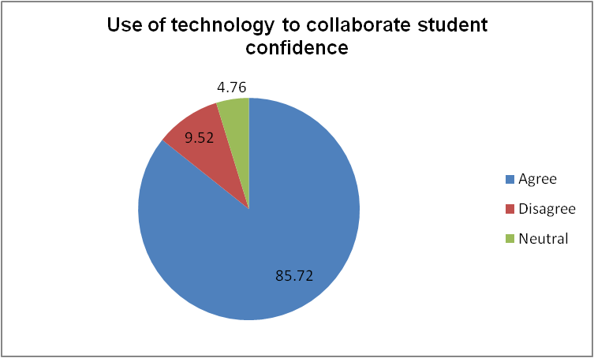
Figure 4: Use of technology to collaborate student confidence
This is second question of this survey method and that has developed whether technology can collaboration with students’ confidants or not. 85.72% participants have agreed upon this that has mentioned that technological innovation has developed flexibility of learning and so students become more confident.
Question 4: Do you learn better with technology?
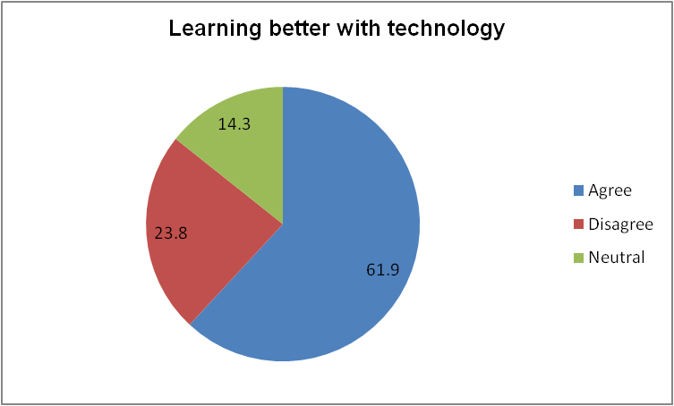
Figure 5: Learning better with technology
This question has been developed to know opinion of respondents on whether technology will develop learning better or not. 61.9% participants have agreed this and this can be analysed that more engagement of information and effective collaboration between information and learners have developed learning perspectives.
Question 4: How does digitisation help in collaboration?
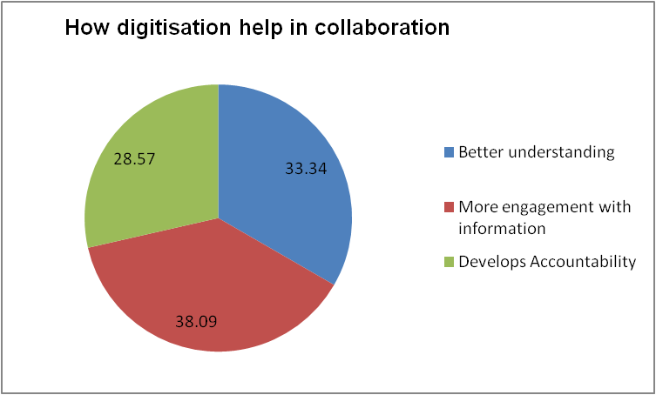
Figure 6: How digitisation helps in collaboration
Digital learning programs have been used by UWTSD and that has been developed for better enforcement of courses towards students. 33.34% have mentioned that it can be used for better understanding. Along with this, information has been used to engage students in learning and also has been identified to develop accountability of students towards allocated courses.
Question 5: Are you accustomed to digitised learning programs?
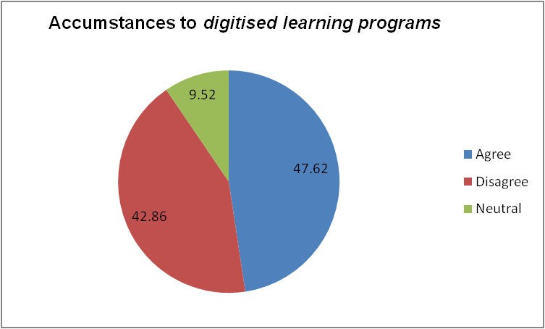
Figure 7: Adoptability to digitised learning programs
This question has asked about the adoptability of learners on used digital learning programs of UWTSD. 47.62% participants are agreed upon this that can mentioned that all students are not accustomed with use of digital learning process. Further innovation and encouragement for students are required for successful implementation of digital learning programs.

4. Discussion
Technology in education has enabled students to measure their own learning peace and that has developed experience of them over learning. It has been seen that students can spend extra time on technological platforms that used to support them with a continuation of understanding. Beside this, it can be noted that the use of technology has created motivation among students and they have been experienced with much student learning and enhanced engagement of students. According to MacLachlan et al. (2018), technological implementation for learning has unlocked keys of learning and students have experienced more in learning with more access to information in one click. Such technological experiences have also developed confidence level of students and as they can access more innovative content and more information has used flexibility in learning and students have been developed with more knowledge and confidence about subjects.
Students have become more confident as students are being situated in their own peace areas rather than classroom environment. As stated by Desmond et al. (2018), such a process has accounted for students with more innovative learning processes and they become more confident with much accessible information and learning techniques. Along with this, this research has developed findings for better learning and technological tools have developed learning experience of students and they become motivated about concept of learning. During Covid-19 pandemic, traditional learning processes became majorly inactive and innovative technologies and systems were used to collaborate with all students of UWTSD in one platform and continued courses with effective digital form of study materials and lectures. Along with this, students have experienced innovative ways of learning where imaginary concept of learning has been altered in specific innovative practical figures. Such innovation and information has majorly influenced students’ confidence towards development of learning experiences.
Digital collaboration has helped flow of learning to improve learning experience of students and in this context; students can collaborate at a global scale. As mentioned by Crick et al. (2020), cloud technology has developed collaboration of class teams and they can easily collaborate with other students and that has insisted their motivation and engagement towards courses. Digital places have been developed for students of UWTSD that achieve a greater productivity of learners on courses but survey has achieved less respondents. Such statistic can be revealed because of less innovative out-structure of University. Although, it can be noted from this survey that diversifying talent pool can be accumulated in a single platform and can effectively evaluate teaching with diverse ideas and perspectives of talent (Peimani and Kamalipour, 2021). Therefore, digitalisation has developed innovation in students and successfully engaged them in courses and learning experiences. This survey method has also helped to meet research hypotheses and influenced modern learning system for students with technological incorporation. In a pandemic condition, the education system has insisted on digitalisation that has developed motivation of students with an innovative style of learning. Collaboration has been achieved as students and teachers became collocated on digital platforms that have developed a new study experience for students.

5. Conclusion
It can be concluded that UK education system is inspired by technological collaboration. Pandemic hit has insisted UWTSD to develop digitalisation for successful delivery of courses and participation of students have been developed and based on students’ experience survey questions have been prepared. This research has chosen a primary quantitative method and analysed surveyed data obtained from 21 students of UWTSD. Total of 5 questions have been prepared in questionnaire and all of these questions have developed different opinions of students for use of technology and achievement of digitalisation. Graphical presentation of result analysis and each of questions have been analysed critically. Discussion section has been used for overall discussion of survey questions that has developed evaluation of this study based on developed literature. Digital innovation has been noticed after coming of Covid-19 pandemic that has developed incorporation of innovative taste of students with measurements of technological innovation. This research has analysed use and effectiveness of technology with sustainable incorporation of students and analysed a survey process for effective management of students along with digitalisation. Therefore, it can be mentioned that technological intervention in education system has effectively collaborate students with allocated courses and admire digital innovation for effective management of education system.

Reference List
Butler, A. and Sinclair, K.A., (2020). Place matters: A critical review of place inquiry and spatial methods in education research. Review of Research in Education, 44(1), pp.64-96.
Chmielewska, K. and Gilányi, A., (2019), October. Computer assisted activating methods in education. In 2019 10th IEEE International Conference on Cognitive Infocommunications (CogInfoCom) (pp. 241-246). IEEE.
Crick, T., Knight, C., Watermeyer, R. and Goodall, J., (2020), September. The impact of COVID-19 and “Emergency Remote Teaching” on the UK computer science education community. In United Kingdom & Ireland Computing Education Research conference. (pp. 31-37).
Desmond, D., Layton, N., Bentley, J., Boot, F.H., Borg, J., Dhungana, B.M., Gallagher, P., Gitlow, L., Gowran, R.J., Groce, N. and Mavrou, K., (2018). Assistive technology and people: a position paper from the first global research, innovation and education on assistive technology (GREAT) summit. Disability and Rehabilitation: Assistive Technology, 13(5), pp.437-444.
Gopalan, M., Rosinger, K. and Ahn, J.B., (2020). Use of quasi-experimental research designs in education research: Growth, promise, and challenges. Review of Research in Education, 44(1), pp.218-243.
Greszczuk, C., Mughal, F., Mathew, R. and Rashid, A., (2018). Peer influence as a driver of technological innovation in the UK National Health Service: a qualitative study of clinicians’ experiences and attitudes. BMJ Innovations, 4(2).
Kochkorbaevna, K.B. and Hilola, I., (2022). Developing Pedagogical Abilities in Students through Introducing Modern Forms and Methods of Education in the Mother Tongue Teaching Process. International Journal of Culture and Modernity, 13, pp.1-3.
MacLachlan, M., Banes, D., Bell, D., Borg, J., Donnelly, B., Fembek, M., Ghosh, R., Gowran, R.J., Hannay, E., Hiscock, D. and Hoogerwerf, E.J., (2018). Assistive technology policy: a position paper from the first global research, innovation, and education on assistive technology (GREAT) summit. Disability and Rehabilitation: Assistive Technology, 13(5), pp.454-466.
Nind, M., (2020). A new application for the concept of pedagogical content knowledge: teaching advanced social science research methods. Oxford Review of Education, 46(2), pp.185-201.
Peimani, N. and Kamalipour, H., (2021). Online education and the COVID-19 outbreak: A case study of online teaching during lockdown. Education Sciences, 11(2), p.72.
Saunders, M.N., Lewis, P., Thornhill, A. and Bristow, A., 2015. Understanding research philosophy and approaches to theory development.
Sawatsky, A.P., Ratelle, J.T. and Beckman, T.J., (2019). Qualitative research methods in medical education. Anesthesiology, 131(1), pp.14-22.
STATISTA (2022) Share of individuals using online learning materials and doing online courses in Great Britain in 2020, by age and gender. Available at: https://www.statista.com/statistics/882117/online-learning-in-the-uk-by-demographic/ [Accessed on: 09.06.2022]

Appendix: Questionnaire

1. How far do you agree that technological advancement helps in increasing the learning experience of students?
Options | Percentage of responses | Number of responses | Total participants
Agree
Disagree
Neutral

2. Do you agree on use of technology to collaborate student confidence?
Options | Percentage of responses | Number of responses | Total participants
Agree
Disagree
Neutral

3. Do you learn better with technology?
Options | Percentage of responses | Number of responses | Total participants
Agree
Disagree
Neutral

4. How does digitisation help in collaboration?
Options | Percentage of responses | Number of responses | Total participants
Better understanding
More engagement with information
Develops Accountability

5. Are you accustomed to digitised learning programs?
Options | Percentage of responses | Number of responses | Total participants
Agree
Disagree
Neutral

