Accounting Fundamentals-Assessment 2
LCBB4001

Student name: Georgiana Sima
Student number: 1919082
Lecturer: Dr. Widin Bongasu Sha’ven

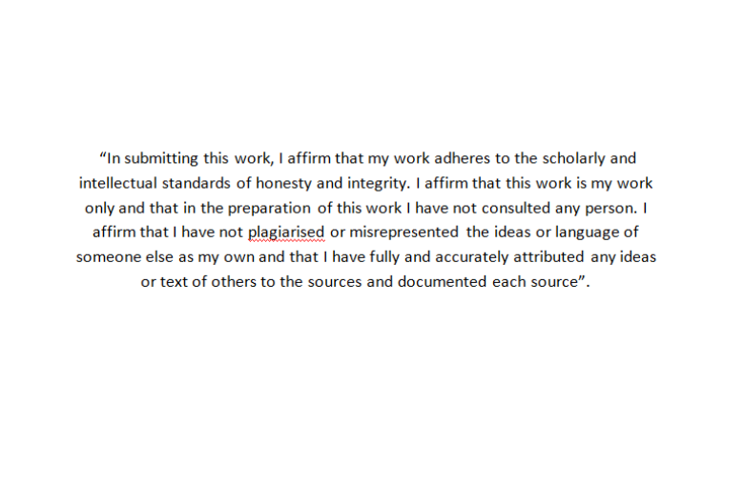

Question 1
Variable costs:
Direct Labour | £ 1.35
Direct Materials | £ 1.75
Other Direct Costs | £ 0.40

Seling price for 1 unit = £5.75
Fixed Cost of production = £180.000, and company currently sales 90.000 units

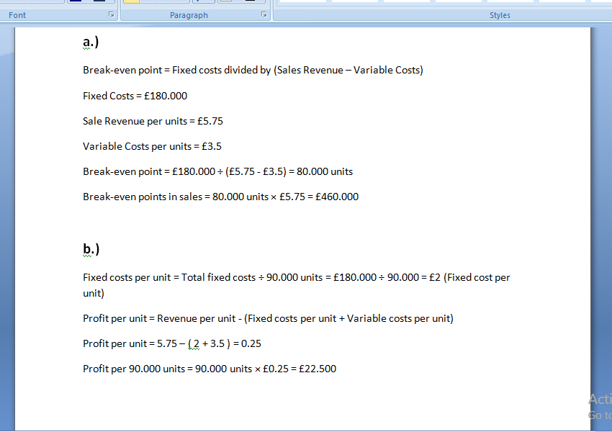

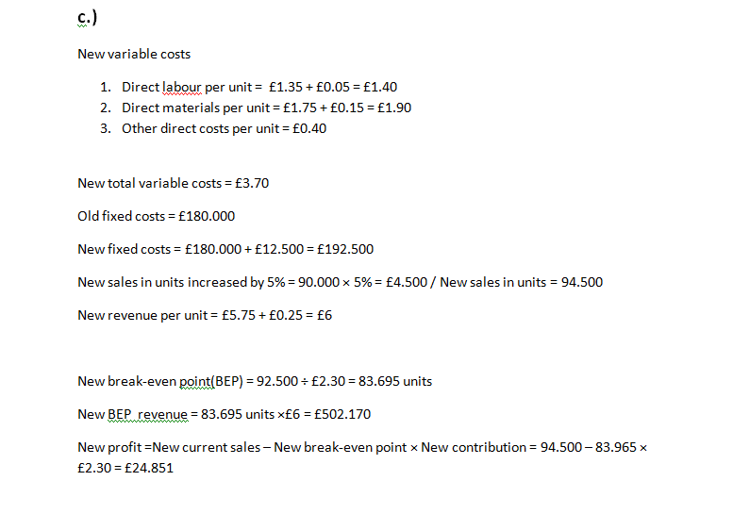d.)
According to Atrill (2016), Break-even analysis(BEA) can reveal very useful insights between cost, profit and volume but it have its limitation. They can be resumed to three general problems :
- One problem for BEA is that most businesses provide more than 1 service or product, this can cause trouble because additional sales of one product can affect another product sales of the business. Beside this there is a problem with finding the fixed costs associated with a specific service or product.
- Furthermore some type of fixed costs over the whole range of activity are not fixed. This reveal us that in the process of making the assumptions about fixed costs, great care must be taken. Because many services or products will involve various types of fixed costs that are likely to be ‘stepped‘ at different points.
- Non-linear relationship. BEA assumes that when plotted against volume of output, total revenue and variable costs are perfectly straight.

Question 2
a.)
According to Wood (2011) the financial accounting provide us information that happens in the past, backwords-looking and mainly for external users but there is a second side of accounting that looks forward and the insights of that analysis output is used within the organization by internal users / decision makers.
It consists of two conponents, one where data is processed and transformed in reports for internal users and decisions makers, and another one, where cost are recorded.
Reporting component it’s named management accounting while the costs component it’s named costs accounting.
Management accounting resemble all about collecting costs aproprietely in order for the business to take correct decisions relating to selling and manufacturing their goods and services.
So the main difference between financial accounting and management accounting that creates an advantage for the business itself is that in management accounting we are looking in the future rather than the past and the information it’s collected in managerial accounting it’s used for internal users and decisions makers rather than external users.

b.)
Management accounting can achieve the above objectives by have cost control , costing approaches and systems, budgeting and budgetary control to provide information for internal users.

References
- Atrill, P. and McLaney, E. 2016 2017. Accountig and Finance for Non-Specialists. 10th Ed. Harlow, England: Pearson, pp.271 272

- Wood, F. and Sangster, A., 2011. Frank Wood’s Business Accounting 1. 12th Ed. Financial Times Pretince Hall/Pearson pp.680 685

