Using Esgair Moel as an Example, Examine the Arguments For and Against Relocating Buildings from their Sites in the Landscape to the Safe Keeping of St Fagans National Museum of History.
Mercer, Deborah
Abstract
This report will look at the positive and negative aspects of moving the woollen mill, Esgair Moel, to St Fagans. Moving the building and machinery to a structurally and financially secure site can protect the tangible and non-tangible aspects of the Welsh woollen industry. There is also a unique opportunity to educate the public on the significance of rural industries. However, relocating the building has removed it from its factual context and history, and the authenticity of the “display” becomes questionable. In addition, the mill is now in a different economy based on footfall and public interested to obtain restoration, rejuvenation and promotion.

Keywords: Esgair Moel; St Fagans; Relocation; Preservation; Building; Woollen Industry; Wales

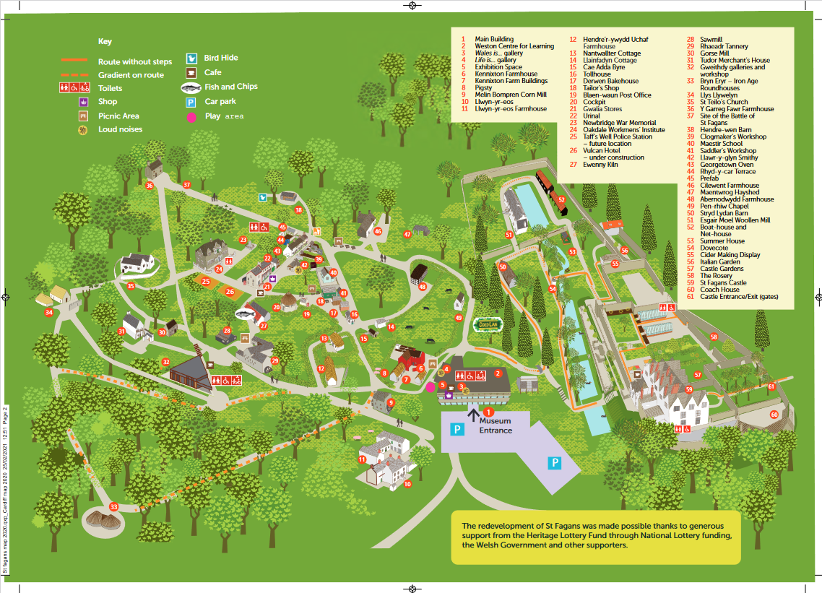
Introduction
Figure 1: Map of St Fagans (https://museum.wales/media/52014/Site-Map-of-St-Fagans-National-Museum-of-History_r.pdf Accessed on 03/10/2021). For full size map see Appendix 3
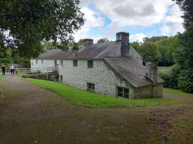
St Fagans National Museum of History is an open-air museum created in 1948, primarily by Iorworth Peate (National Museum Wales, 2018; 19). It now forms part of the National Museums and Galleries of Wales network, that includes the National Woollen Museum, the National Museum and Gallery, and the National Collections Centre (Mason, 2005: 19). St Fagans seeks to promote a specific national story of Wales (Mason, 2005; 19). The principal attraction of St Fagans is the collection of historic buildings, many of which are working examples of the crafts of the rural Welsh economy (Figure 1). The aim of St Fagans is not just as a museum of the tools of crafts but the “preservation of the actual crafts themselves and their related skills” (Williams-Davies, 1989; 216). The focus of this report is Esgair Moel Woollen Mill (Figure 2). The mill was initially built in Llanwrtyd, Breconshire, in 1760 by the Winston family, who worked the mill alongside Esgair Moel Isef farm. In 1880, the Williams family became tenants of just the mill and ran it as a business until the passing of Rees Williams in 1947 (Jenkins, 1975; 3). In 1950 the building and its machinery were moved to St Fagans as a typical example of the all-purpose woollen mills in the Teifi valley in the late 18th and early 19th century (Jenkins, 1975; 3).
This report will look at the positives and negatives of moving Esgair Moel to the confines of the museum grounds. When moving a historic building to St Fagans, the many pragmatic considerations include the practicalities of movement and the structure’s condition. Alongside these practical matters are the non-tangible aspects of heritage and memory that St Fagans seeks to protect and promote (National Museum Wales, 2018; 15). As the mill was moved in 1950, the report will focus on the non-tangible aspects.
Figure 2: Esgair Moel Woollen Mill (Mercer, 2021).

Protection of Building and Machinery
One of the main reasons for relocating a historic building to St Fagans is to protect them from demolition or save them from dereliction (National Museum Wales, 2018; 15). Alongside the desire to protect buildings, St Fagans has a limited, though substantial, space and must base decisions on what the buildings can contribute to the understanding of Welsh life (National Museum Wales, 2018; 15). Esgair Moel had only been idle for three years before its relocation, so the building and machinery were salvageable. This particular mill was selected for display at St Fagans because it is an example of the comprehensive woollen mill that appeared throughout Wales (Jenkins, 1975, 4). These mills performed all processes from washing fleece to spinning yarn to fulling fabric for the local community and frequented local markets to sell shawls and carthenni (Jenkins, 1969; 251).
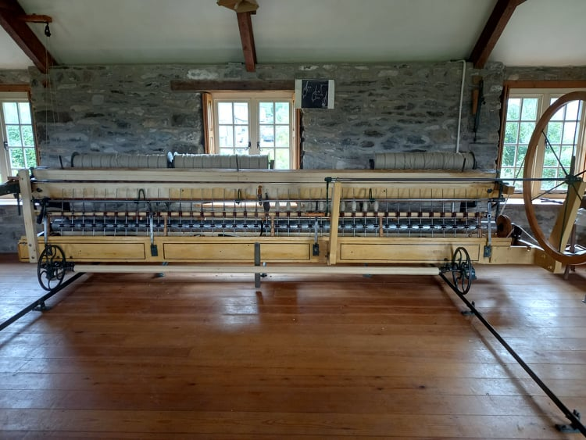
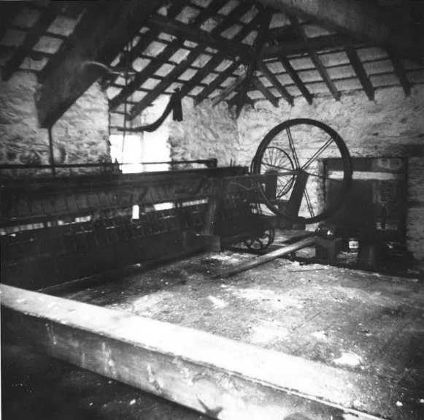
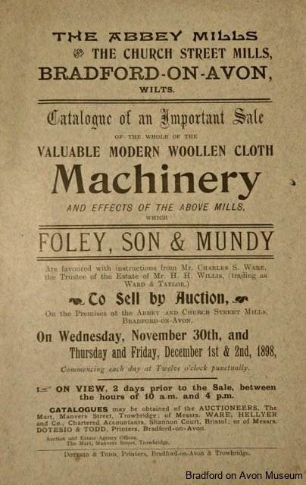
Not only was the building brought to St Fagans in 1950, but all the machinery that had been in the mill. In many cases, when mills were abandoned or left idle, the machinery was damaged by vandals (Mercer, Forthcoming) or sold off at large auctions (Figure 3). To this day, the same machinery is used to process the wool and weave blankets (Davies, 2017; 175). The protection of Esgair Moel has not only helped to educate tens of thousands of people through visitation but has also aided in the restoration of the machinery at the privately-owned Glanffrwd Mill, Cellan. In the 1960s, Margaret Bide acquired a converted twisting machine from a machinery auction in Wales (M Bide, 2018, Personal Communication, 3 November & Figure 4). Margaret visited Esgair Moel to take notes on and measurements of their working spinning jack to assist her in converting her machine back to a hand-operated spinning mule (D Jones, 2021, Personal Communication, 16 September).
Figure 4: Left- Photo of Twisting Machine in Glynarth Factory, Aberarth (Bide, M, 1960). Right- Photo of restored spinning jack in Glanffrwd Mill (Mercer, 2021).
Figure 3: Advert for an auction of woollen mill machinery. https://www.bradfordonavonmuseum.co.uk/wp-content/gallery/woollen-mills/IMG_0761.jpg

Protection of the Culture of the Welsh Woollen Industry.
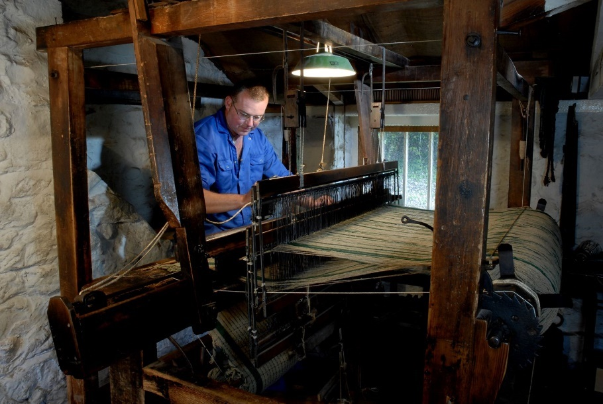
As a working exhibit, one of the essential factors of Esgair Moel being in the protection of St Fagans is the preservation of the traditions and culture of the Welsh woollen industry. The mill is run by Dewi Jones, who started working at Esgair Moel as an apprentice in 1988 (Davies; 2017; 173). As the mill does not need to rely on its output for financial security, Dewi can create authentic Welsh textiles without worrying about production times, output, and market fluctuations (Davies, 2017; 183). While Dewi does not experience the pressure of a “true” market, he epitomises the average mill worker. He has worked in Esgair Moel for over 30 years and has a passion for his work and affection for his machinery (Davies, 2017 185). The selection of Esgair Moel allows for authentic items to be made on-site, as all aspects of the industry took place in the original location (Figure 5). By the time the building was moved, there were very few working mills, and most had become specialised in one particular aspect of the process (Jenkins, 1969; 286). Esgair Moel allows people to experience the life of a craftsman in the Welsh woollen industry by presenting the tangible (machinery and products) and non-tangible (experience of a working mill and craftsman) in an accessible setting (Williams-Davies, 1989; 215). At the same time, the availability of products made at the mill in the museum gift shop helps create a palpable link between the visitors and the woollen mill; not only did they see the process, they are holding the product.
Figure 5: Dewi Jones weaving (https://museum.wales/stfagans/buildings/woollen_mill/ 03/10/2021)
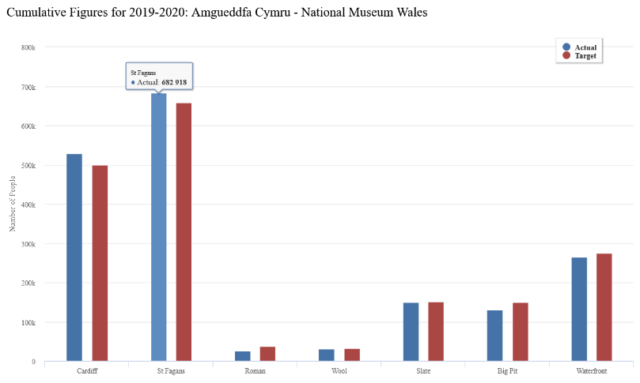
Educational Promotion
Figure 6: Statistical graph of visitors to the National Museum Wales Network (https://museum.wales/visitor-figures/cumulative-2019-20/ 03/10/2021)
Of the Museums and galleries that make up the Nation Museums and Galleries of Wales network, St Fagans consistently receives the most visitors (Figure 6). As a result, the woollen industry is accessible to many people and schools that would not otherwise interact with this vital rural industry of Wales. With the protection of St Fagans, Esgair Moel can be open to the public and be an active, working woollen mill. This creates a different engagement than if the material was presented in a display of textile machinery or description of a weaver’s life, as static displays of craft processes can lead to museum fatigue in visitors (Williams-Davies, 1989; 216). By having an active exhibit and highly skilled craftsmen, the museum can educate the public and display rural crafts in the most effective way possible; through the visibility of the crafting process and interactions with the craftsmen (Williams-Davies, 1989; 216).

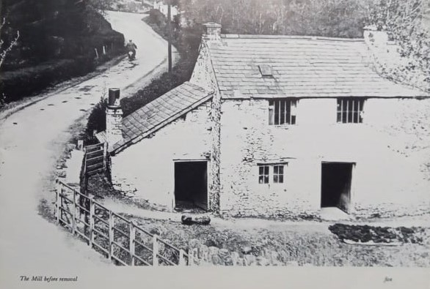
Removal from the local context.
The main issue with relocating a historic building is the loss of social and environmental context. Esgair Moel was formerly part of a smallholding in a rural community (Jenkins, 1975; 3 & Figure 7). It now sits isolated, surrounded by a large wall and fed by an artificial pool instead of a river and mill pond (National Museum Wales, no date). How reflective can the building be when removed from the context of its original community and environment? No matter how much attention is paid to recreating the original setting, it is impossible to truly recreate the historical, social, and environmental context (Peltola, 2008; 20).
Figure 7: Esgair Moel before relocation to St Fagans (Jenkins, 1975; 5)
As much as historic buildings affect the communities and environments they are located in, those factors also affect the building (Peltola, 2008; 15). Because of this, not only is the context of the building irrevocably altered by relocation but the historical landscape of where it came from is changed as well (Peltola, 2008; 18). For example, in communities where mills are still active, such as Glanfrwd Mill, Cellan local people have fond memories of the mill being active in the Welsh woollen industry even though it was derelict for three decades (D Davies, 2021, Personal communication 20 September). Even when buildings have been converted or left derelict, house names and architectural remains are evidence of their contribution to the local community and its history (Figure 8).
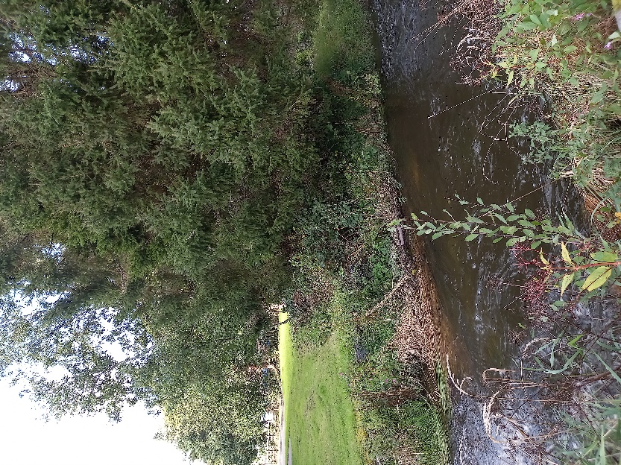
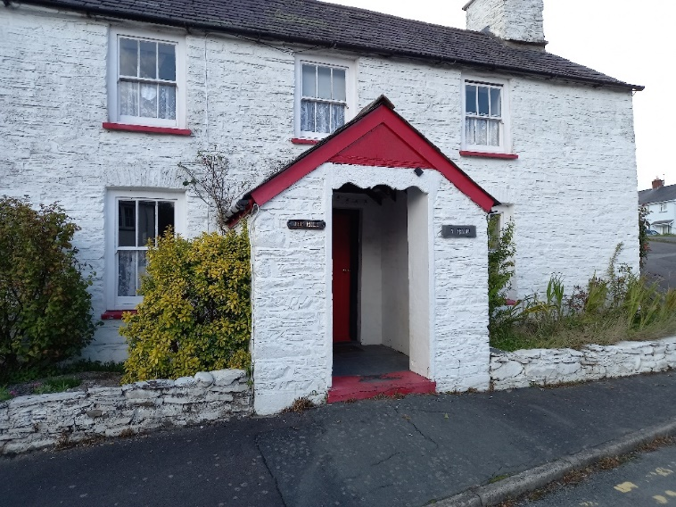
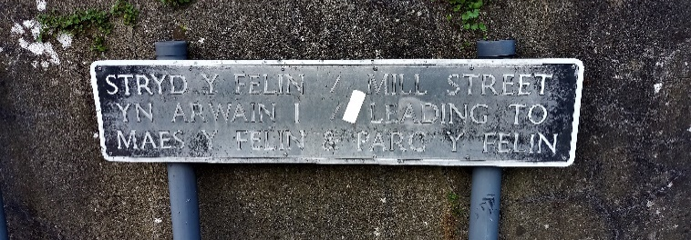
Figure 8: Top Left- Mill Street, Lampeter road sign (Mercer, 2021). Bottom Left- "The Mill" House, Lampeter (Mercer, 2021). Right- Overgrown leat, Lampeter (Mercer 2021).
Authenticity
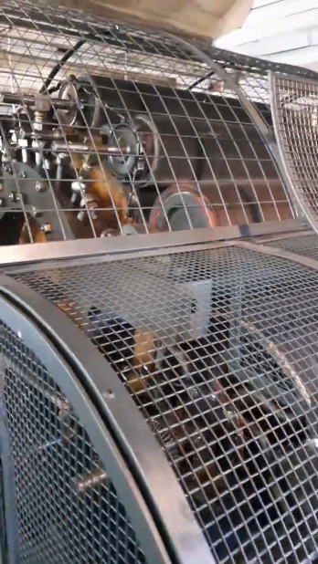
The relocation of the mill has had a significant effect on the authenticity of Esgair Moel. While a waterwheel initially powered the mill, it was disconnected from the machinery some years ago for health and safety reasons (D Jones, 2021, Personal Communication, 16 September). These concerns also led to surrounding the carding machinery with a cage (Figure 9). This is, of course, a necessary safety precaution, but it does detract from the authenticity of the site. The risk involved in working the woollen mill was very high and a significant part of the lifestyle of those in the industry. Even people who had lived in the industry their entire lives were susceptible to injury and death (D Jones, 2021, Personal Communication, 16 September).
Figure 9: Screengrab of video of carding machinery at Esgair Moel (Mercer, 2021; https://www.youtube.com/watch?v=OOJBrnhrg84).
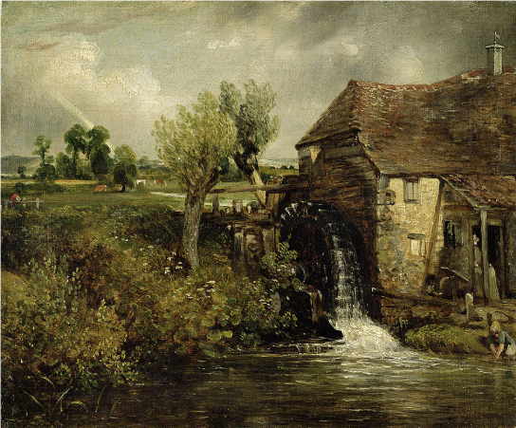
A critical issue that needs considering is why are we trying to preserve this piece of Welsh history in this way? The new context of the “protected” museum environment has removed Esgair Moel from the realities of the Welsh woollen industry and given it a romanticised image of a water-powered mill like those seen in the paintings of John Constable (Figure 10). As much as historians, archaeologists and curators desire to create as comprehensive a collection as possible, the woollen industry displayed in St Fagans did not exist.
Figure 10: Constable Painting (https://fineartamerica.com/featured/parhams-mill-gillingham-dorset-1824-john-constable.html 02/10/2021)
Pressure of Public Approval
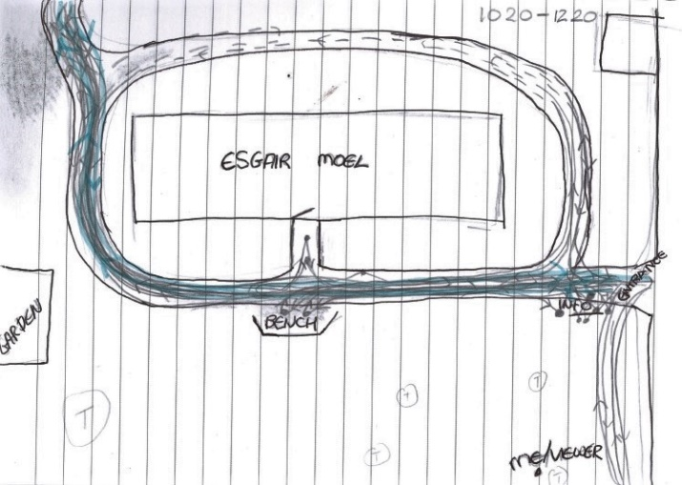
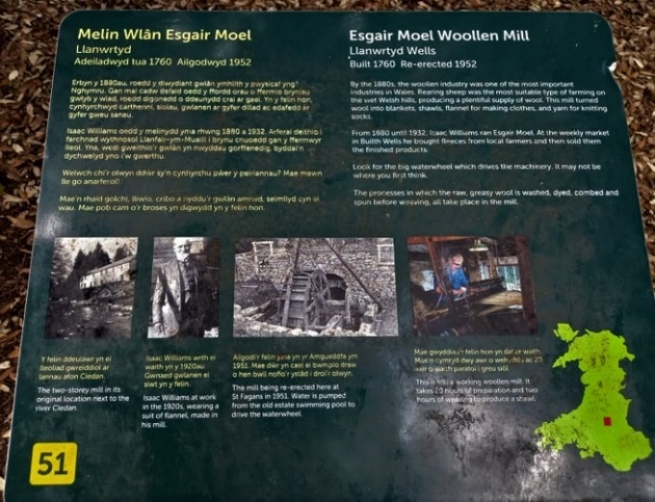
Esgair Moel is situated on the periphery of St Fagans due to the location of the pool to supply water. Footfall observations were made on the morning of Saturday 25 September 10:20-12:20 to analyse the significance of the mill’s location (Figure 11 and Appendix 1 & 2). The mill is not manned at the weekend but was not on the list of closed buildings. During the two-hour observation period, 600 people entered the St Fagans site, and 33 visited the mill grounds. Of those 33, 6 stopped to read the information board (Figure 12), four walked off the main path around the mill, 2 checked the door, and two sat on the bench outside the mill (Appendix 2). Less than half the people who visited the mill grounds interacted with the mill itself. Most people took a direct route, implying their visit was merely in passing to or from the Castle and gardens. Another building checked off the list. Due to low footfall, the mill is a low priority for development, maintenance and showcasing. The waterwheel has been disconnected for several years. The initial intention was for the wheel to be restored and displayed; however, this has not happened yet as other projects on site have taken priority (D Jones, 2021, Personal Communication, 16 September).
Figure 11: Footfall Map (Mercer, 2021) For full map see Appendix 1
While this data helps to show how the location of Esgair Moel and interest in the industry can affect public engagement, it is significant that the mill was closed. Dewi Jones performing his daily tasks at the mill are part of the nature of the exhibit, as is the dangerous machinery that prevents it from being accessible to the public when unmanned (Davies, 2017; 182). Dewi does not currently have an apprentice to learn how to run the mill traditionally, so when he is no longer able to work the machinery, Esgair Moel will lose the linchpin between the heritage and the public.
Figure 12: Information Sign for Esgair Moel (Mercer, 2021)

Conclusion
When considering the relocation of any historical artefact, each one must be treated individually (Peltola, 2008; 3). In the case of Esgair Moel, relocating to St Fagans has provided the building and machinery with unparalleled protection from the ravages of dereliction and urbanisation. The financial security provided by being out of the economic system enables Dewi Jones to work with traditional machinery in a traditional way (Davies, 2017; 183). Esgair Moel does more for the protection and promotion of the Welsh woollen industry than any converted rural mill possibly could due to its location in one of the most visited museums in Wales. However, there are significant negatives to the relocation of Esgair Moel. The lack of local context and complex authenticity issues can confuse the public understanding of woollen production, romanticising the industry. Even with the working element increasing engagement, a lack of interest from the public could affect how the mill is conserved and presented by the museum (D Jones, 2021, Personal Communication, 16 September). Overall, the benefits provided by relocating the mill to St Fagans far outweigh the negatives. By being in the museum, there is a part of the Welsh woollen industry for people to see and study. If the building had remained in Llanwrtyd, Breconshire, it would have decayed or been converted. The issues of authenticity raised in this report mainly affect those looking for a “pure” example of a heritage that no longer exists in its “true” form. Safety considerations are the driving force behind many alterations, which are legitimate concerns in the 21st century and have been made sympathetically (D Jones, 2021, Personal Communication, 16 September). Despite the pressure for public engagement, St Fagans would never let any of their buildings deteriorate beyond repair. The mill may not be “high” on the list, but it is ON the list (D Jones, 2021, Personal Communication, 16 September).
Esgair Moel has entertained the public and educated experts for decades and will continue to do so for many more. It is an indispensable resource for the study of the rural woollen industry in 19th century Wales. The protection of St Fagans ensures this heritage, even if all other woollen mills (traditional and modern) were left idle.

Appendix
Appendix 1
Footfall map of Esgair Moel. Observations were performed on Saturday 25 September 10:20-12:20. The observer (labelled me/viewer) was positioned out of sight of both entrances. The blue line represents dogs; the dashed lines represent the estimated path when the subjects were out of sight. The large dots represent people standing in one place for several seconds.
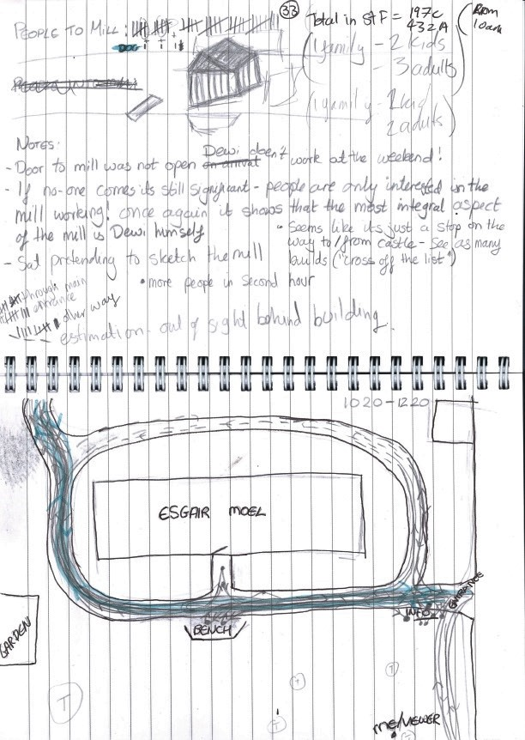
Appendix 2
Table of data obtained from the observations of footfall at Esgair Moel.
Total Number of people in St Fagans | Adult | 432
 | Children | 179
 | Total | 611
Number who Visited Mill | Adult | 27
 | Children | 6
 | (Dogs) | (3)
 | Total | 33 (36)
Entrance to Mill Used | Main | 23
 | Secondary | 10
 | Total | 33
Number Interacted with Mill | Information Board | 6
 | Walked to back of Mill | 4
 | Check Door | 2
 | Sit on Bench | 2**
 | Total | (14) 11*
* Two people who walked behind the mill also interacted with the information board, and 1 checked the door.
** Two people sat on the bench together for 20 minutes.

Appendix 3
Large map of the St Fagans site. Accessed on https://museum.wales/media/52014/Site-Map-of-St-Fagans-National-Museum-of-History_r.pdf 03/10/2021
Reference List
Davies, B. 2017. Woollen Mills of Wales. Gomer Press, Llandysul.
Jenkins, J. G. 1975. Esgair Moel Woollen Mill. National Museum of Wales Welsh Folk Museum, Cardiff.
Jenkins, J. G. 1969. The Welsh Woollen Industry. National Museum of Wales Welsh Folk Museum, Cardiff.
Mason, R. 2005. Nation Building at the Museum of Welsh Life. In Museum and Society; Vol 3, No 1. University of Leicester. Pp 18-34.
Mercer, D. Forthcoming. How the Decline of the Welsh Woollen Industry Affected Rural Mills: A Case Study of Cellan Factory. In Melin 36. The Welsh Mill Society, Cardigan.
National Museum Wales. No Date. Esgair Moel Woollen Mill. Accessed on https://museum.wales/stfagans/buildings/woollen_mill/ 03/10/2021.
National Museum Wales. 2018. Guide Book. National Museum Wales, Cardiff.
Peltola, X. 2008. Moving Historic Buildings. All Theses; 352. Accessed on https://tigerprints.clemson.edu/all_theses/352 30/09/2021.
Williams-Davies, J. 1989. The preservation and Interpretation of Traditional Rural Crafts at the Welsh Folk Museum. In Journal of Design History; Vol 2, No 2/3 Oxford University Press (on behalf of Design History Society), Oxford. Pp 215-218.

