Introduction to 3D Modelling
ACCA 4042
3D Modelling Showcase Video Presentation
Beauregard Brown
2502007
BA (Hons) Computer Games Design

Table of Contents:

Task 1: Screenshots from Presentation

Task 2: Link to view/download video from cloud storage

Task 3: Link to view video on selected platform (YouTube)

Task 4: Bibliography with IEEE referencing

Task 1 – Screenshots from Presentation

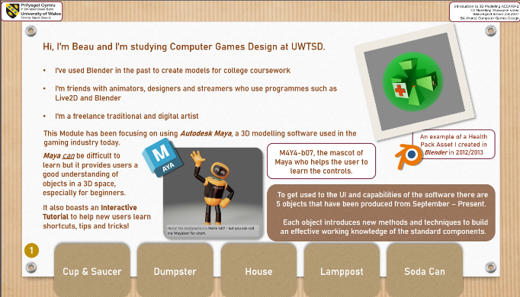
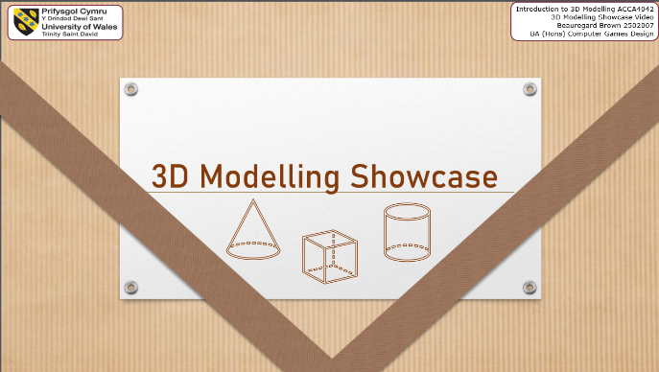
Screenshots from Presentation in case of inability to view on selected platform

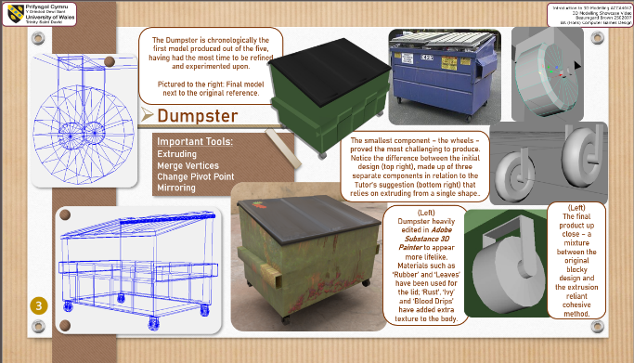
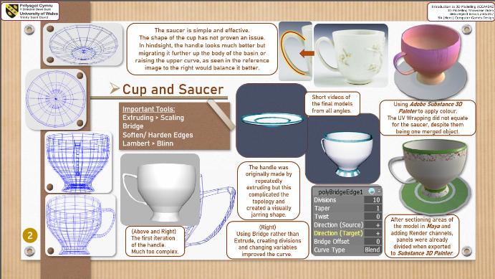

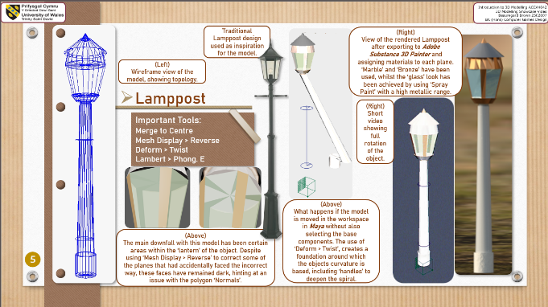
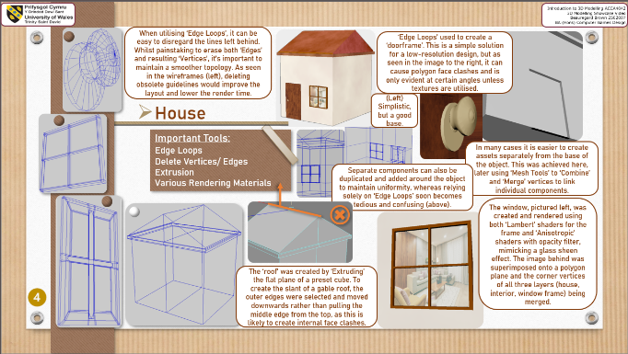

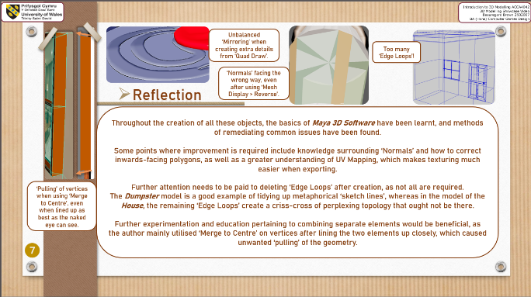
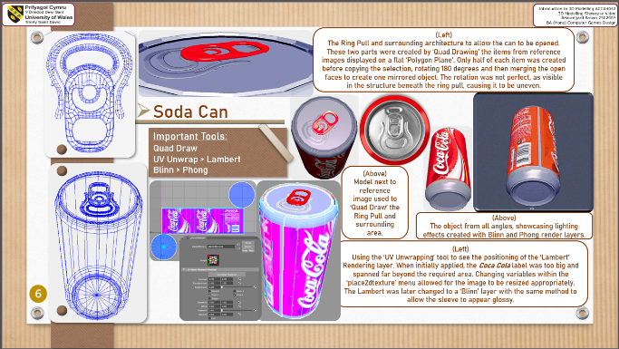

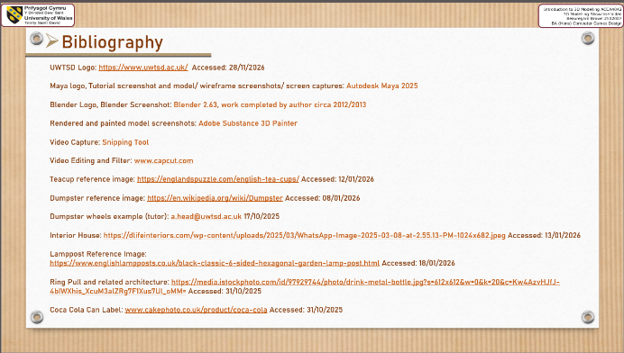

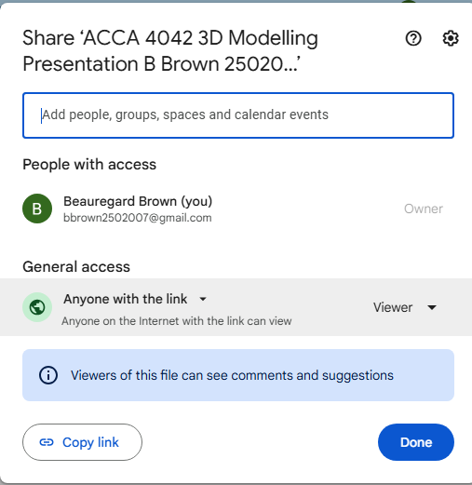
Task 2 – Link to view/ download presentation from Cloud Storage
https://drive.google.com/file/d/194GZ4t74GEJSD-l5ZjVfIuo15oPk7YC3/view?usp=drive_link

Task 3 – Link to view presentation on chosen platform (YouTube)
https://youtu.be/IrcwiSmtRpQ
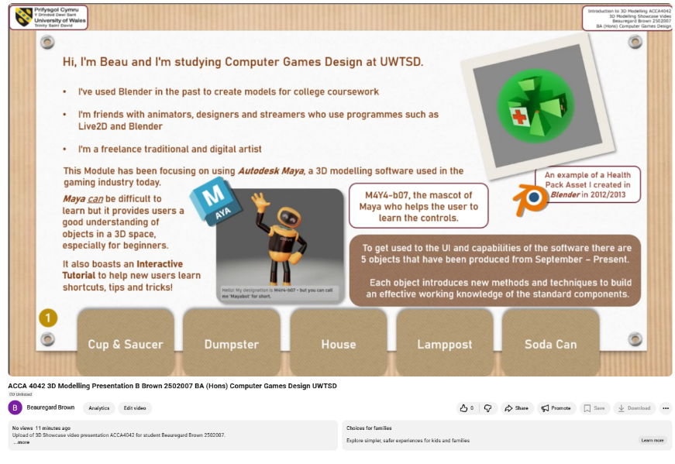

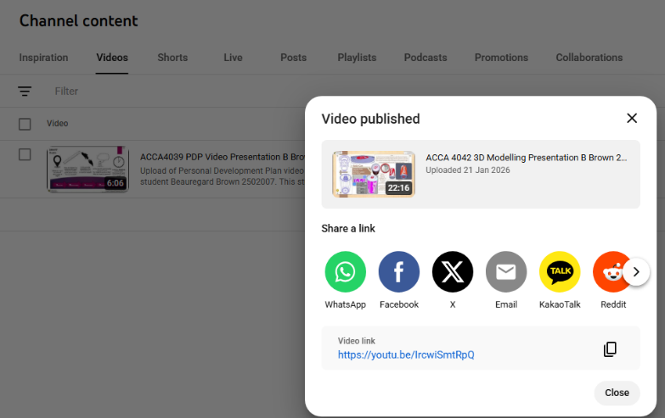

Bibliography:
UWTSD Logo: https://www.uwtsd.ac.uk/ Accessed: 28/11/2026
Maya logo, Tutorial screenshot and model/ wireframe screenshots/ screen captures: Autodesk Maya 2025
Blender Logo, Blender Screenshot: Blender 2.63, work completed by author circa 2012/2013
Rendered and painted model screenshots: Adobe Substance 3D Painter
Video Capture: Snipping Tool
Video Editing and Filter: www.capcut.com
Teacup reference image: https://englandspuzzle.com/english-tea-cups/ Accessed: 12/01/2026
Dumpster reference image: https://en.wikipedia.org/wiki/Dumpster Accessed: 08/01/2026
Dumpster wheels example (tutor): a.head@uwtsd.ac.uk 17/10/2025
Interior House: https://dlifeinteriors.com/wp-content/uploads/2025/03/WhatsApp-Image-2025-03-08-at-2.55.13-PM-1024x682.jpeg Accessed: 13/01/2026
Lamppost Reference Image:
https://www.englishlampposts.co.uk/black-classic-6-sided-hexagonal-garden-lamp-post.html Accessed: 18/01/2026
Ring Pull and related architecture: https://media.istockphoto.com/id/97929744/photo/drink-metal-bottle.jpg?s=612x612&w=0&k=20&c=Kw4AzvHJfJ-4bIWXhis_XcuM3alZRg7F1Xus7Ul_oMM= Accessed: 31/10/2025
Coca Cola Can Label: www.cakephoto.co.uk/product/coca-cola Accessed: 31/10/2025

