One Sample t-test, Explore, Independent t-test &
Paired Samples t-test

One Sample t-test

This test compares the mean value of a sample of data to a known value in the population.

Question 1

The 40-hour work week is an established standard for full time employees. Work less, and you feel guilty for not putting in a full week. Work more, and you feel that you are performing beyond expectations. Use the data below collected from a random sample of 45 graduate employees in a certain week to test, at the 5% significance level, the hypothesis that the average university graduate who is employed full time, works a 40 hour week.

Number of Hours worked for University Graduates
35 | 31 | 45 | 41 | 35 | 46 | 20 | 35 | 60
32 | 38 | 26 | 48 | 47 | 40 | 36 | 32 | 40
44 | 39 | 28 | 55 | 46 | 36 | 27 | 48 | 35
29 | 38 | 42 | 41 | 37 | 37 | 48 | 33 | 55
41 | 25 | 51 | 38 | 37 | 52 | 44 | 43 | 40

Select a new datasheet using File, New, Data.
Click on Variable View in the bottom left-hand corner of the screen and format
a variable for Hours. Enter Hours worked per week for University Graduates under Label, in order to add detail to the information generated in the output.
Click on Data View and enter the data as shown below for the 45 cases.

 | Hours
1 | 35
2 | 32
3 | 44
4 | 29
5 | 41
6 | 31
7 | 38
8 | 39
9 | 38
10 | 25
etc.

Save.
To examine the distribution of the data, select Graphs, Legacy Dialogs, Histogram, and transfer the variable Hours worked per week for University Graduates (Hours) into the Variable dialogue box. Select the check box Display Normal Curve. Click on Titles and enter Hours worked per week for University Graduates, Continue, OK.
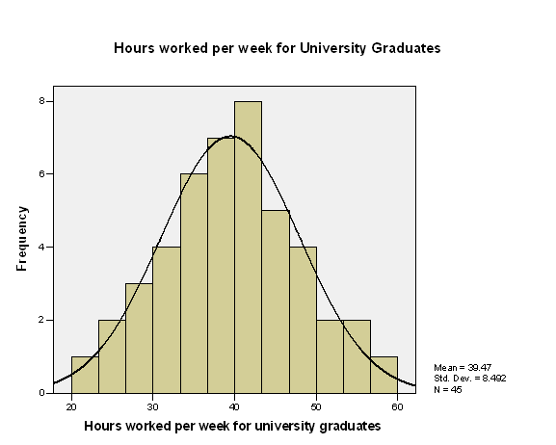

The data displays an approximate Normal Distribution, which is a condition for the reliable application of the one sample t-test.

One Sample t-test

Test, at the 5% significance level, the hypothesis that the average university graduate who is employed full time, works a 40 hour week.

Null Hypothesis H₀: The mean number of hours worked by graduates is 40hrs
Alternative Hypothesis H₁: The mean number of hours worked by graduates is not 40hrs

Select Analyze, Compare Means, One-Sample T test.
Move the variable Hours worked per week for University Graduates (Hours) into the Test Variable dialogue box. In Test Value type 40, OK.
The output is shown below.

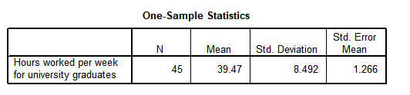
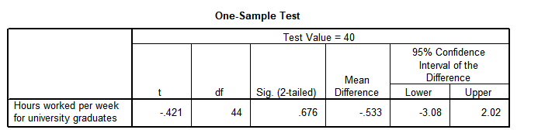

There are two tables of output. The One Sample Statistics provides the standard descriptive statistics.

One Sample Test
t = −0.421 and the Sig. = 0.676.
Since Sig. > 0.05, then Accept H₀ at the 5% level of significance.
The sample evidence indicates that the average university graduate who is employed full time, works a 40 hour week.

The mean difference in this sample between the number of hours worked and the test mean (of 40 hrs) is −0.533hrs, but there is a 95% chance that this mean difference for the population of all graduates could lie between −3.08hrs and 2.02hrs.

Note: No difference between the test value and the sample mean would be represented by a mean difference of 0. Since a mean difference of 0 is plausible as it falls within the confidence limits −3.08hrs to 2.02hrs then this information also concludes that there is not enough evidence to suggest a significant difference.

Question 2

Return to the data editor
Select the data set Data - Q2.sav which contains a variety of demographic and additional items for a sample of US citizens.

Test, at the 5% significance level, whether the mean income of a sample of people in a particular area is any different from the national average of $50,300.

Null Hypothesis H₀: The population income is $50,300
Alternative Hypothesis H₁: The population income is not $50,300

Select Analyze, Compare Means, One-Sample T test.
Move the variable income into the Test Variable dialogue box.
In Test Value type 50.3, OK.
The output is shown below.

Test

One-Sample Statistics
 | N | Mean | Std. Deviation | Std. Error Mean
household income in ,000 | 30 | 72.9000 | 29.68031 | 5.41886

One-Sample Test
 | Test Value = 50.3
 | t | df | Significance |  | Mean Difference | 95% Confidence Interval of the Difference
 | t | df | One-Sided p | Two-Sided p | Mean Difference | Lower | Upper
household income in ,000 | 4.171 | 29 | <.001 | <.001 | 22.60000 | 11.5172 | 33.6828

t = 4.171 and the Sig. < 0.001.
Since Sig. < 0.05, then Reject H₀ at the 5% level of significance.
The sample evidence indicates that the mean income of the people in this area is not $50.3.

Explore, Independent t-test & Paired Samples t-test

Independent Samples t-test

This test is used to determine whether there is any difference between two independent groups of data.i.e. investigating whether the data comes from the same or different distributions.

Question 3

Select the data set Data-Q3.sav which contains the results of a survey for university students.

From the data set, the variables considered are:
gender has labels 0 = Male, 1 = Female

q14_aw_02 (The workload is too heavy)

Exploring the Data
Investigation of the data is first necessary in order to establish whether the data follows a Normal distribution.

Select Analyze, Descriptive Statistics, Explore.

Transfer q14_aw_02 (The workload is too heavy) into the Dependent List, and Male or Female (sex) into the Factor list.

Click on Plots, deselect Stem-and-leaf and select Histogram under Descriptive, Continue, OK.

The output is shown below.

Case Processing Summary
 | Gender | Cases
 | Gender | Valid |  | Missing |  | Total
 | Gender | N | Percent | N | Percent | N | Percent
The workload is too heavy | Male | 44 | 100.0% | 0 | 0.0% | 44 | 100.0%
The workload is too heavy | Female | 69 | 100.0% | 0 | 0.0% | 69 | 100.0%

Descriptives
 | Gender |  |  | Statistic | Std. Error
The workload is too heavy | Male | Mean |  | 4.39 | .226
The workload is too heavy | Male | 95% Confidence Interval for Mean | Lower Bound | 3.93
The workload is too heavy | Male | 95% Confidence Interval for Mean | Upper Bound | 4.84
The workload is too heavy | Male | 5% Trimmed Mean |  | 4.40
The workload is too heavy | Male | Median |  | 4.50
The workload is too heavy | Male | Variance |  | 2.243
The workload is too heavy | Male | Std. Deviation |  | 1.498
The workload is too heavy | Male | Minimum |  | 1
The workload is too heavy | Male | Maximum |  | 7
The workload is too heavy | Male | Range |  | 6
The workload is too heavy | Male | Interquartile Range |  | 3
The workload is too heavy | Male | Skewness |  | -.184 | .357
The workload is too heavy | Male | Kurtosis |  | -.633 | .702
The workload is too heavy | Female | Mean |  | 4.04 | .163
The workload is too heavy | Female | 95% Confidence Interval for Mean | Lower Bound | 3.72
The workload is too heavy | Female | 95% Confidence Interval for Mean | Upper Bound | 4.37
The workload is too heavy | Female | 5% Trimmed Mean |  | 4.03
The workload is too heavy | Female | Median |  | 4.00
The workload is too heavy | Female | Variance |  | 1.836
The workload is too heavy | Female | Std. Deviation |  | 1.355
The workload is too heavy | Female | Minimum |  | 1
The workload is too heavy | Female | Maximum |  | 7
The workload is too heavy | Female | Range |  | 6
The workload is too heavy | Female | Interquartile Range |  | 2
The workload is too heavy | Female | Skewness |  | .175 | .289
The workload is too heavy | Female | Kurtosis |  | -.686 | .570

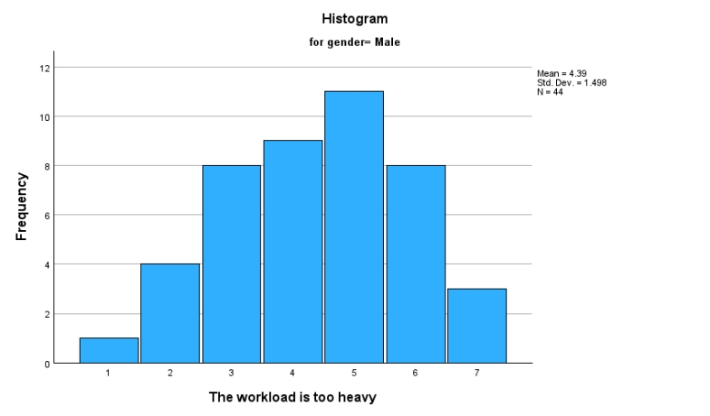

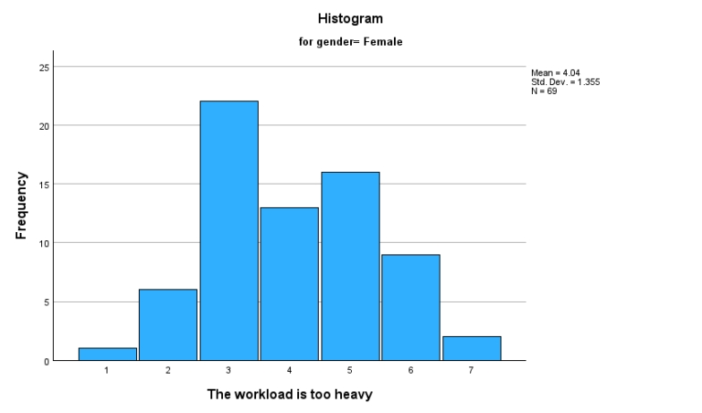

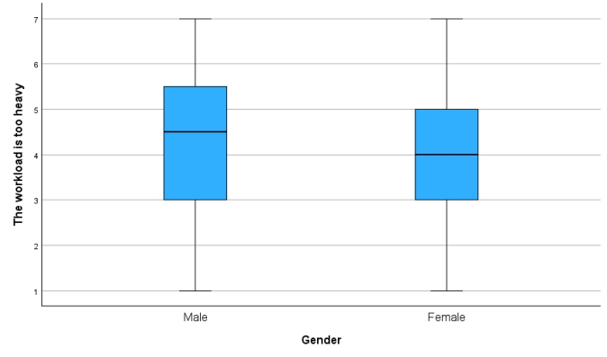

The descriptive statistics show that there is a difference in the male and female total scores about how heavy the workload is. The other statistics suggest that both distributions are reasonably normal, since there is no significant skewness or kurtosis.

The shape of the histograms are approximately normal and the boxplots indicate that the two groups have similar variances.

An overall conclusion from all the evidence implies an approximate normal distribution.

Error bars display the dispersion of the data and show the upper and lower range within which it is 95% likely that the true population mean lies.

Select Graphs, Legacy dialogs, Error Bar and with Simple error bar selected, click on Define. Transfer q14_aw_02 (The workload is too heavy) into the Variable dialogue box and gender into the Category Axis dialogue box.
Click on Titles and type Workload Heavy Score in Line 1 of Title, Continue, OK.
The output is shown below.

Graph
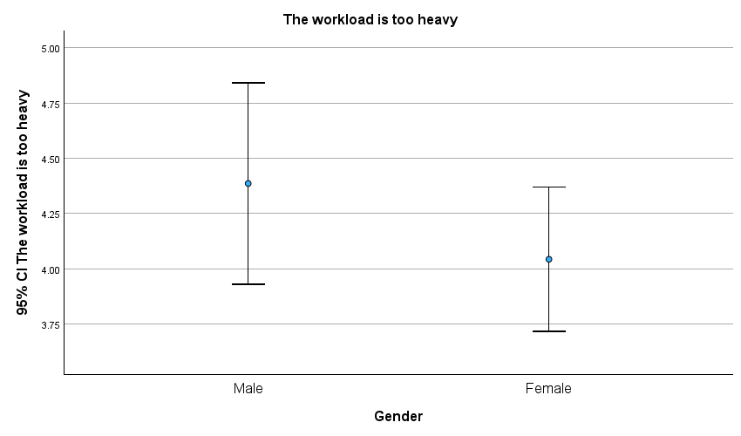

The error bars indicate that the distributions are not very different. This can be confirmed using the t-test.

Independent T-Test

Null Hypothesis H₀: There is no difference in the workload heavy
score between the male and female participants.
Alternative Hypothesis H₁: There is a difference in the workload heavy
score between the male and female participants.

Select Analyze, Compare Means, Independent-Samples T Test.
Transfer q14_aw_02 (The workload is too heavy) into the Test Variable dialogue box and gender into the grouping Variable dialogue box.
Click on Define Groups. In Group 1: type 0 and in Group 2: type 1, Continue, OK.
The output is shown below.

T-Test

Group Statistics
 | Gender | N | Mean | Std. Deviation | Std. Error Mean
The workload is too heavy | Male | 44 | 4.39 | 1.498 | .226
The workload is too heavy | Female | 69 | 4.04 | 1.355 | .163

Independent Samples Test
 |  | Levene's Test for Equality of Variances |  | t-test for Equality of Means
 |  | F | Sig. | t | df | Significance |  | Mean Difference | Std. Error Difference | 95% Confidence Interval of the Difference
 |  |  |  |  |  | One-Sided p | Two-Sided p | Mean Difference | Std. Error Difference | Lower | Upper
The workload is too heavy | Equal variances assumed | .711 | .401 | 1.259 | 111 | .105 | .211 | .343 | .272 | -.197 | .883
The workload is too heavy | Equal variances not assumed |  |  | 1.231 | 84.978 | .111 | .222 | .343 | .279 | -.211 | .897

For Levene’s Test for the Equality of Variances, F = 0.711, Sig. = 0.401 > 0.05
Since the variances are not significantly different, at the 5% level, then the top row of the t-test should be used.
For the t-test , with equal variances assumed, t = 1.259 with 111 degrees of freedom, Sig. = 0. 211> 0.05. Accept H₀ at the 5% significance level.
The sample evidence indicates that there is no significant difference in the total workload heavy score between the males and the females.

___________________________________________________________________

Question 4

Select the data set salary-with-data - Q4.sav which contains records of a sample of employees of a large organisation.

Test, at the 5% significance level, whether there is any increase in the proposed productivity-based salary as compared with the present salary of the employees.

Exploring the Data
Investigation of the data is first necessary in order to establish whether the distribution of the differences between the two sets of data are normal.

The differences between the paired data must first be evaluated.
It is necessary to create a variable called diff by subtracting the present salary (salnow) from the initial salary (salbeg).

Select Transform, Compute and type in diff in Target Variable.
Transfer productivity-based salary (prodsal) into the Numeric expression dialogue box, click on the minus sign on the keypad, transfer present salary (salary) into the Numeric expression, OK, then OK.

Select Analyze, Descriptive Statistics, Explore.
Transfer diff into the Dependent List.
Click on Plots, deselect Stem-and-leaf and select Histogram under Descriptive.
The output is shown below.

Explore

Case Processing Summary
 | Cases
 | Valid |  | Missing |  | Total
 | N | Percent | N | Percent | N | Percent
diff | 30 | 100.0% | 0 | 0.0% | 30 | 100.0%

Descriptives
 |  |  | Statistic | Std. Error
diff | Mean |  | .2833 | .08292
diff | 95% Confidence Interval for Mean | Lower Bound | .1137
diff | 95% Confidence Interval for Mean | Upper Bound | .4529
diff | 5% Trimmed Mean |  | .2981
diff | Median |  | .3000
diff | Variance |  | .206
diff | Std. Deviation |  | .45416
diff | Minimum |  | -.80
diff | Maximum |  | 1.10
diff | Range |  | 1.90
diff | Interquartile Range |  | .62
diff | Skewness |  | -.357 | .427
diff | Kurtosis |  | .029 | .833

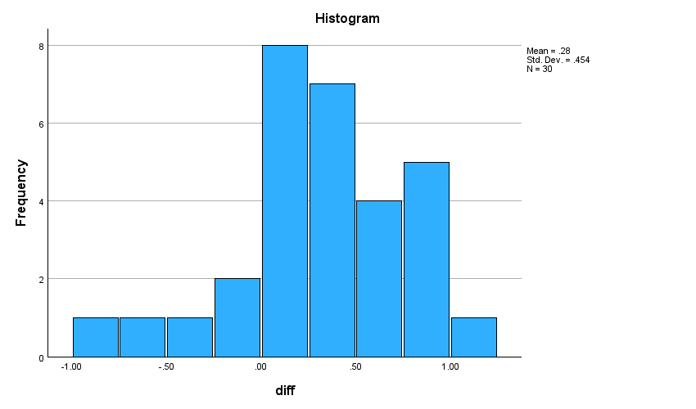

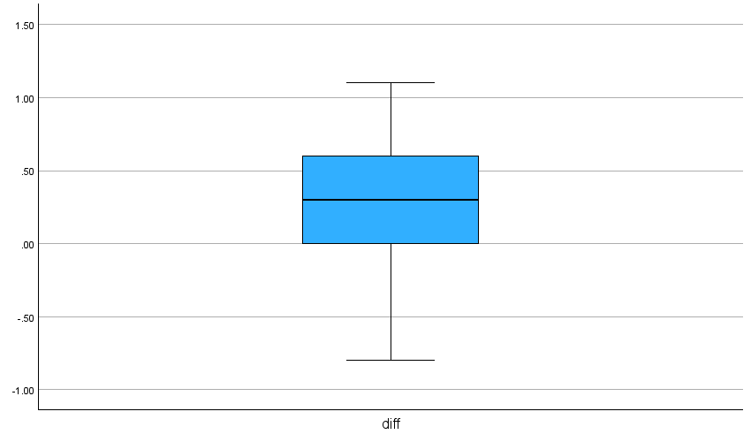

The descriptive statistics suggest that the difference between the two variables is not exactly a normally distributed variable since there is skewness. But, we can still proceed with the Paired T test.

Paired T-Test

Null Hypothesis H₀: There is no difference between the productivity-based salary and the present salary.

Alternative Hypothesis H₁: The present salary is greater than the productivity- based salary.

Return to the data editor.
Select Analyze, Compare Means, Paired-Samples T-Test.
Click on both present salary and productivity- based salary then select them for Paired Variables, OK.

The output is shown below.
T-Test

Paired Samples Statistics
 |  | Mean | N | Std. Deviation | Std. Error Mean
Pair 1 | Present Salary (£000) | 22.173 | 30 | 4.4357 | .8099
Pair 1 | Productivity based salary (£000) | 22.457 | 30 | 4.4264 | .8081

Paired Samples Correlations
 |  | N | Correlation | Significance
 |  | N | Correlation | One-Sided p | Two-Sided p
Pair 1 | Present Salary (£000) & Productivity based salary (£000) | 30 | .995 | <.001 | <.001

Paired Samples Test
 |  | Paired Differences |  |  |  |  | t | df | Significance
 |  | Mean | Std. Deviation | Std. Error Mean | 95% Confidence Interval of the Difference |  | t | df | One-Sided p | Two-Sided p
 |  |  |  |  | Lower | Upper
Pair 1 | Present Salary (£000) - Productivity based salary (£000) | -.2833 | .4542 | .0829 | -.4529 | -.1137 | -3.417 | 29 | <.001 | .002

t = -3.417 and the Sig. = 0.001<0.05 for a one-tailed test. Reject H₀ at the 5% significance level.
There is evidence to suggest that the present salary is greater than the productivity- based salary.

