What is the biggest threat to humankind?

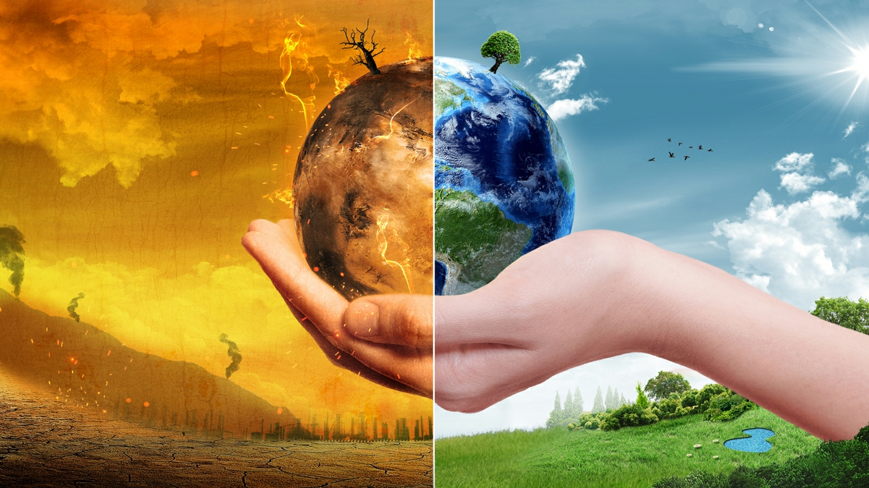
Climate Change

Climate change is posing a severe threat to humankind with its rising temperatures, adverse effects of extreme weather patterns, increased dangers of wildfires, loss of biodiversity, stresses to food producing systems.
As WWF (No Date) mentions as global temperatures rise, glaciers will melt, leading in an increase in sea levels that will flow onto land, causing severe flooding with economic ramifications and money spent on repairs. Eventually some areas could be submerged under water permanently.
As Dashoff, J (2021) mentions wildfires are a threat to people's lives, their homes, and businesses, as well as the ecosystem and climate. Forest fires release carbon dioxide into the atmosphere as they burn, contributing to pollution and raising already high CO2 levels. Wildfires can harm soil, resulting in a loss of vegetation.
As Adebayo, M (2022) mentions Crops, livestock, forests, and fisheries are among the food-producing systems facing new challenges. Climate change has a negative impact on soil production. Areas are growing drier and more prone to drought, while other areas are experiencing an increase in heavy rainfall. Temperature rises will change the length of growing seasons which will then affect yield in some areas.
For centuries humankind has been slowly killing the planet, by depleting its natural resources and polluting the air with greenhouse gases. As Nunez, C (2019) mentions Greenhouse gases have a wide range of environmental and health consequences. They contribute to respiratory problems caused by smog and air pollution, as well as contributing to climate change by trapping heat. The way we live is altering and it is frightening to think what is ahead of us, that’s why humankind needs to continue to act to accommodate a sustainable future for generations to come as we are to blame for the ramifications ahead.
As Sir David Attenborough quoted in the Observer "The truth is: the natural world is changing. And we are totally dependent on that world. It provides our food, water and air. It is the most precious thing we have, and we need to defend it." (McKie 2012)

Skills to be Successful as a Financial Advisor

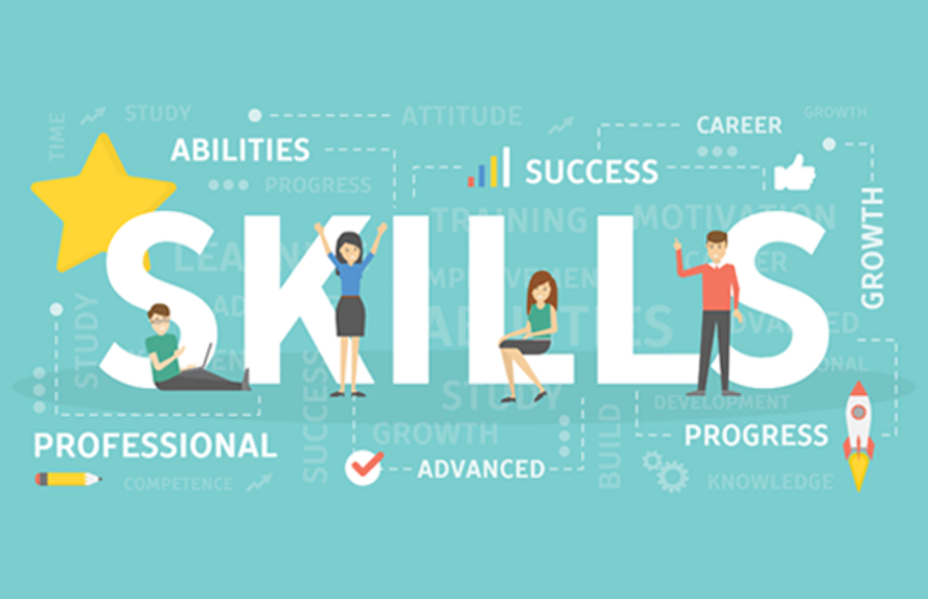
Negotiation

Negotiation is an important skill I will need to be as a financial advisor as according to Barot, H (No Date) It can assist in achieving long-term job success, increased productivity, and reduce workplace tensions. Knowing the appropriate way to negotiate can achieve a beneficial outcome. Negotiation skills aid in the development of trust, effective communication, and the resolution of conflicts.

Conflict Management
Conflict occurs naturally in workplaces as is to be anticipated, however it is essential to understand how to manage conflict. According to Indeed Editorial Team (2021) the goal of conflict management is to make conflict a productive component of the workplace, where you can contribute to an environment where conflict is accepted, controlled, and used positively. By managing conflict can reduce anxiety, turn disagreements into opportunities and create a healthy work atmosphere where people do not have to be afraid of or avoid conflict and can speak up.

Critical Thinking
I do believe that critical thinking is an important skill to as a financial advisor as according to Indeed Editorial Team (2021) critical thinking helps people solve challenges and develop methods that can help them perform better at work. Engaging in critical thinking contributes towards independence, confidence, and reflection. By practicing this skill can rationally link concepts, analyse, and assess arguments, uncover contradictions and faults in your own and others' work, solve complex problems, and engage in reflection.
These skills will benefit me now and in the future by boosting my confidence, making me a more productive person mentally and physically. It will also show me where I need to improve my skill set, which will be hugely beneficial. By continuing to practice these skills will help me succeed as a financial advisor and can contribute to a positive work environment.

The Merits of Design Thinking in Business Management

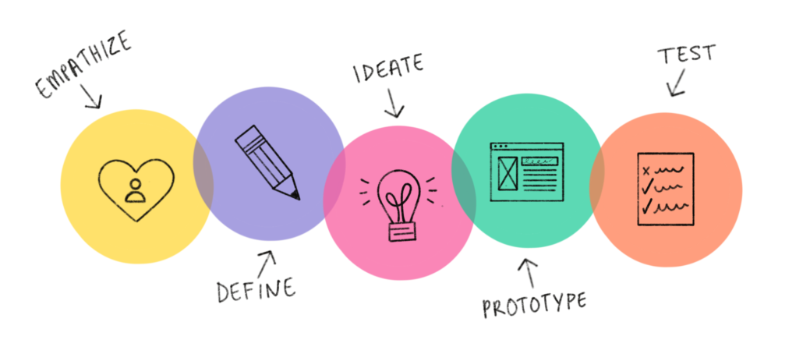
As Dam, R & Siang, T, mention design thinking is a method for extracting, teaching, learning, and using human-centred ways to address issues in a creative and inventive manner (n.d.)
Design thinking can help me with critical, creative, and imaginative thinking which can contribute towards creative, complex, and ambiguous situations. Design thinking is a smart form of thinking that is human centred. It can help me be empathetic, solve difficulties, and continue to question in my Business Management course.
Design thinking can help me whilst I do assignments as it can help solve as Stevens, E, mentions wicked problems which are a type of issue that is extremely difficult to solve. Climate change, poverty, and world hunger are examples of wicked problems. Wicked problems are those that do not have a permanent solution (2021). If I had to produce a proposal on how to make an area prosperous by regenerating a town, the design thinking processes can assist me by using the 5 stages of design thinking which are according to UWTSD
Empathise – Understanding the needs, expectations, and behaviours of the target audience.
Define – Defining the problem statement that needs to be solved, over the business goals and ensuring it remains human centred.
Ideate – Collaborating on and developing numerous ideas and solutions to the difficulties outlined in your problem statement
Prototype – will be a small scale mock up or digital presentation. The stage is to turn the idea into something practical to be tested on users. Feedback can be gathered, and changes can be made before the initial testing phase. (n.d.)
Test – Putting the prototype in front of real users and monitoring how they interact with it. At this point, feedback can be collected, and if there are any issues, improvements can be made.
Design thinking is a positive process that will help me succeed in my business management course.

Blog 1 References

Adebayo, M (2022) Climate change threatening food production supply in Nigeria – Expert. Daily Post. Retrieved From: Climate change threatening food production, supply in Nigeria - Expert - Daily Post Nigeria

Dashoff, J (2021) Wildfire and Climate change: A burning Issue. National Science Foundation. Retrieved From: Wildfire and climate change: A burning issue | Beta site for NSF - National Science Foundation

King, M, B (2019) Research examines ramifications of climate change on different populations. UNM Newsroom. [Image] Retrieved From: Research examines ramifications of climate change on different populations: UNM Newsroom

McKie, R. (2012) David Attenborough: force of nature. The Observer. Retrieved From: David Attenborough: force of nature | David Attenborough | The Guardian

Nunez, C (2019) Carbon dioxide levels are at a record high. Here`s what you need to know. National Geographic. Retrieved From: Carbon dioxide in the atmosphere is at a record high. Here's what you need to know. (nationalgeographic.com)

WWF (No Date) Why are Glaciers and sea ice melting? WWF. Retrieved From: Why are glaciers and sea ice melting? | Pages | WWF (worldwildlife.org)

Blog 2 References

Aventis Learning Group (2020) They’re Not Soft Skills; They Are Essential Skills For You To Shine At Work. [Photograph]. Retrieved From: They’re Not Soft Skills; They Are Essential Skills For You To Shine At Work - Aventis Learning Group

Barat, H (No Date) 10 Reasons why Negotiation Skills are important. Frantically Speaking. Retrieved From: 10 Reasons Why Negotiation Skills Are Important (franticallyspeaking.com)

Indeed Editorial Team (2021) What`s the Importance of Critical Thinking in the Workplace? Indeed. Retrieved From: What's the Importance of Critical Thinking in the Workplace? | Indeed.com

Indeed Editorial Team (2021) Conflict Management Skills: Definition and Examples. Indeed. Retrieved From: Conflict Management Skills: Definition and Examples | Indeed.com

Blog 3 References

Dam, R & Siang, T (n.d.) What is Design Thinking and Why Is It So Popular? Interaction Design Foundation. Retrieved From: What is Design Thinking and Why Is It So Popular? | Interaction Design Foundation (IxDF) (interaction-design.org)

Ireland South East (2019) Funding approved for the Centre for Design in Kilkenny [Photograph] Retrieved From: Funding approved for the Centre for Design in Kilkenny - Ireland South East

Stevens, E (2021) The Key Principles and steps of the Design Thinking Process. Career Foundry. Retrieved From: A Complete Guide to the Design Thinking Process in 5 Steps (careerfoundry.com)

UWTSD (n.d.) Introducing Design Thinking. Unit 3, Section 1, Slide 10. Contemporary Challenges: Making a Difference. [Video] Retrieved From: Course Player - UWTSD Equal Site (equal-online.com)

