

Design and implementation of object detection web application based on Flask

by
Hankun Chai

Supervisor: Dr Tim Bashford

MSc Software Engineering

Abstract
The aims of this dissertation design, develop an object detection software based on web application to detect specific classes and location information of the pictures or video stream that the users uploaded. This software allows users to upload the file to get result or open the existed camera on device to detect the photo, it can also realize real-time video object detection. The dissertation investigates current object detection algorithms and technologies to choose a better detecting model to implement the project. And, the dissertation also chose a programming language and a web development framework to implement the web functions.
In this dissertation, an experiment is undertaken to reveal the detection performance of YOLO v3 model and SSD model on a platform with Intel core i5-8400 and Nvidia GTX 1060 6GB. By comparing the results, YOLO v3 based on Keras was chosen as the detection model in this project. To lower the difficulty of using Keras model, web development framework based on Python is selected. Because the number of objects in this project is relatively small, a lightly and easy-learned framework Flask was selected. To implement the objects of the project, several HTML5 pages and JavaScript scripts are designed. Detection method of YOLO v3 and Flask application details are in Chapter 4 Design and implementation.
The application is tested against all three functions. Almost every function tested well. Finally, recommendations are made for further refinement and efficiency.

Contents
Abstract 2
List of Figures 6
List of Tables 8
1. Introduction 9
1.1 Backgrounds 9
1.2 Aims 9
1.3 Objectives 9
1.4 Structure of the report 10
1.5 Research Methodology 10
1.5.1 Method in Design 10
1.5.2 Evaluation Criteria 10
1.5.3 Method in Experiment 11
Method in Implement 11
1.5.4Programming language and Deep learning library 11
1.5.5 Hardware 11
1.5.6 Web and Server development 11
2. Literature Review of Convolutional Neural Network 12
2.1 The Definition of Convolutional Neural Networks 12
2.1.1 Convolutional Layer 12
2.1.2 Pooling Layer 13
2.1.3 Activation Layer 14
2.1.4 Fully Connected Layer and Softmax 15
Conclusion 15
3. Literature Review of Object Detection Based on CNNs 16
3.1 Two-stage algorithms 16
3.1.1 RCNN 16
3.1.2 Fast-RCNN[30] 17
3.1.3 Faster-RCNN 17
3.2 One-stage algorithms 18
3.2.1 YOLO 18
3.2.2 YOLO v3 19
3.2.3 SSD 20
Conclusion 21
4. Design and implementation 23
4.1 Experiment of testing detection algorithms 23
4.1.1 Metrics of evaluating detection model 23
4.1.2 mAP of YOLO v3 and SSD 24
5.1.3 Conclusion of detect model 25
Software Design 26
4.2 Choosing Web development framework 26
Option 1: Django 26
Option 2: Tornado 26
Option 3: Flask 27
Option 4: Twisted 27
Chosen option 27
Implementation 28
4.3 Web page design 28
4.3.1 Home page 28
4.3.2 File upload page 29
4.3.3Take photo page 31
4.3.4 Realtime detection page 33
4.4 Implementation of Flask application 34
4.4.1 URL setting 34
4.4.2 Detection method 35
4.4.3 Storage solutions 36
4.4.4 Implementation of functions 36
Conclusion 37
4. Results and evaluation 38
4.1 Page 38
4.2 Performance of upload function. 39
4.3 Performance of photo function. 40
4.4 Performance of real-time detection 41
Conclusion 42
5. Conclusion and recommendation 42
5.1 Summary 42
5.2 Conclusion 42
5.3 Recommendation for future work 43
5.3.1 The file storage method 43
5,3,2 User accessing 43
5.3.3 UI design 43
5.3.4 User number restrict 43
5.3.5 Video stream uploading 43
6. Reflection 44
References 45

List of Figures
Figure 1 Structure of LeNet 10
Figure 2 Convolution Operation 11
Figure 3 Max pooling operation 12
Figure 4 Sigmoid 12
Figure 5 tanh(x) 12
Figure 6 ReLU 12
Figure 7 RCNN operations 14
Figure 8 Fast-RCNN 15
Figure 9 Faster-RCNN 15
Figure 10 Region Proposal Network 16
Figure 11 YOLO system 16
Figure 12 Structure of YOLO v3 17
Figure 13 SSD structure 18
Figure 14 some process in SSD detection 19
Figure 15 IoU 21
Figure 16 mAP for SSD 22
Figure 17 detection result of SSD 22
Figure 18 Sample Result 23
Figure 19 mAP for YOLO 23
Figure 20 Detection Result on YOLO 23
Figure 21 result of detect an image on SSD 23
Figure 22 result of detect image on YOLO 23
Figure 23 structure of project 34
Figure 24 Accessing URL on Chrome of Win 10 36
Figure 25 Access page on iPad 36
Figure 26 Accessing home page by Chrome on Android 36
Figure 27 Home page on Android Figure 28 Home page on Win10 37
Figure 29 Upload page Figure 30 File chosen 37
Figure 31 Test image file 37
Figure 32 alert of upload Figure33 alert after process 38
Figure 34 detect result of example image 38
Figure 35 Upload and photo function on Android 38
Figure 36 Photo results 39
Figure 37 Camera test result 39
Figure 38 server console results 40

List of Tables

Table 1 Flask features 28
Table 2 Function of web pages. 28
Table 3 Functions in Upload page 31
Table 4 Solutions to take photo page 33
Table 5 Requirements and solution of Camera page 34
Table 6 URLs 35

1. Introduction

1.1 Backgrounds
Vision is one of the important senses of human beings, and more than 80% of the information is provided by visual feedback.[1] Therefore, machine vision has also become a hot research field at present, which is worthy of our study. In recent years, machine vision has been increasingly used in human transportation, logistics, security and other aspects, and it plays an important role in replacing the feature recognition of artificial repetitive machinery. [2]Many scholars at home and abroad use convolutional neural network for image recognition. For example, r-CNN [3], SPP-NET, VGG[4] and other recognition networks can complete the target recognition task.
However, they are all based on the regional nomination method to perform image cutting and feature extraction, which is obviously very inefficient. This is because for a picture, if, based on regional nomination method to detect objects in the process of locating we need to cut as much as possible of the image, from the Angle of space we will have hundreds or thousands of times the size of the cut image, but also need to use convolution neural network to learning of these images, no doubt will have larger waste in time and space. The large amount of computation is not suitable for miniaturization. However, The YOLO algorithm proposed by Redmond[5] can not only ensure the identification accuracy, but also improve the computing efficiency and speed up the detection.
Also, the convolutional neural networks always require a powerful platform, for example, a computer with high performance CPU and graphics card. But it is not realistic to carry the devices in some circumstances. So, a remote detection should be developed.
Web applications can process the data from the client side in the server side, and receive the results. It will cost less to detect an object with mobile device.

1.2 Aims
- To choose a proper detection method that can detect the objects in an image and return the classes and location information with acceptable accuracy and speed.
- To develop a web application that allow users:
- Upload image files to server, and receive the detection results on the browser.
- Call the camera on the device (if available) to take photo and upload to server and then receive the detection results
- Call the camera on the device (if available) and return the real-time detection results.

1.3 Objectives
The objectives of this project are:
- Determine which kinds of detection algorithm will be chosen, traditional method or method based on Convolutional Neural Networks.
- Analyse the detection algorithms and choose a most satisfied model as the detection module of the project.
- Determine development language, web application framework based on the detection algorithm.
- For each function module, design reasonable HTML page and JavaScript script.
- According to the functions, design the detection methods of detecting image and detecting video.
- Implement the web application.

1.4 Structure of the report
There are mainly three parts of this report. The first one the base theory that support the development and implementation of detection and web application. Literature review revolves the theory of object detection based on the convolutional neural network and the introduction of some web development framework based on Python. The second part illustrates an experiment of testing the performance of YOLO and SSD algorithm[6] and the design and implementation of the web application. The last part shows the performance of the software.
- Chapter 1 is the introduction of this project. it illustrates the backgrounds, aims and objectives, and the research methodology.
- Chapter 2 and Chapter 3 are the literature review. They illustrate the theory of CNNs and some detection algorithms.
- Chapter 4 shows the details to design and implement the software.
- Chapter 5 shows the test result and performance of the software.
- Chapter 6 is the conclusion and recommendation.
- Chapter 7 gives the reflection in the process of implementation.

1.5 Research Methodology
The report needs to consider the proper algorithms and the programming methods with an aim of developing a software that can implement all the functions needed. This chapter involves the methods of choosing detection algorithm, programming language, and how to test performance of the algorithm and software.

1.5.1 Method in Design
Detection algorithm is the most essential part in this project. A good detection algorithm could greatly improve the performance of the software.
In order to choose a proper algorithm to implement the function that could meet the accuracy the software requires, in this project, my prior method is grasp the information of machine learning fields. From the most authoritative conferences and scientific journals, it implies that the detection algorithms based on convolutional neural network show more advantages in many aspects comparing with the traditional image processing methods. This project takes the method of convolutional neural networks as the core algorithm.
Considering of the costs and the adaptability on different device, web pages rather than an app is a better choice as the client side.

1.5.2 Evaluation Criteria
As the decision of using convolutional neural networks [7](CNNs) as the detection algorithm, the criteria of judging the performance could be the its own criteria and other evaluation criteria.
In CNNs, there is a few pieces of criteria, for examples, the accuracy and mAP (mean Average Precision),[8] confidence and recalls. In detection software, response time, processing time, etc. By combining of those standards, proper criteria can be decided.

1.5.3 Method in Experiment
In order to decide which kind of detect algorithm based on CNNs should be implemented in this project, an experiment should be designed to test the performance in this environment.

Method in Implement
In order to develop a software to achieve the task that could detect the objects in images that user uploads or in real time videos, some decisions should be made.

1.5.4Programming language and Deep learning library
Basically, almost all deep learning projects are programmed in two kinds of language: C⁺⁺ and Python[9,10]. So, in order to develop a deep learning model to implement a task, Python was chosen because I use it much more, and am familiar with it. In Python, to develop a neural network model, there are several tools such as TensorFlow[11], Keras[12], Caffe, Torch etc. In this project, model and weights is not necessary to be trained by ourself, so a light and easy-using tool should be considered. And Keras is a minimalist, highly modular neural network library that is simple to use, runs seamlessly on the CPU and GPU, and encodes in a minimalist, clear style. So Keras is the final decision.
As one of the most powerful Python IDE, JetBrains PyCharm is regarded as the best Python IDE when it comes to artificial intelligence and machine learning[13]. Most importantly, PyCharm incorporates multiple libraries (such as Matplotlib and NumPy) to help developers explore more options available.
In conclusion, Python is the programming language and Keras is chosen as the deep learning library to construct the detection model. All of them are implement on the PyCharm IDE.

1.5.5 Hardware
In deep learning, data processing requires massive operational capabilities. From an operational point of view, neural networks are mainly composed of many floating-point matrices. Modern neural networks, however, may have thousands to millions of floating-point matrices (so-called deep learning), and therefore require a lot of memory bandwidth to access these massive floating-point matrices. A GPU has a much higher memory bandwidth than a CPU. Intel's Core I9-7980XE, for example, has about 57GB/s of memory bandwidth, while NVIDIA's Tesla P100 has 900GB/s[14].
So, a compute with GPU is needed.

1.5.6 Web and Server development
Considering of that detection model is programmed in Python, it is decided that Python is also used to develop the server program and client pages. In Python there are several libraries that support sever development like Django, Tornado, Flask and Twisted. Among these 4 libraries, considering that only a few services we need to supply, a light library that support HTML protocol is enough [15]. Flask is lightweight and modular[16]. So, it is easy to convert to a Web application or framework when few extensions and not many permissions are needed.
In conclusion, Flask in Python will be used in developing the server and we application.

Literature Review of Convolutional Neural Network

To develop a system that can detective objects in an image, there are a few methods to achieve this aim. Among those methods, the most efficient and popular ways are based on a deep neural network named convolutional neural networks(CNNs)[5]. It is important to understand how the CNNs work on the image processing and a number of key structures of it.

The Definition of Convolutional Neural Networks
The early model of the convolutional neural network, called the neurocognitive machine, is a deep feedforward network inspired by the receptive field in biology. The convolutional neural network can realize end-to-end learning and make training easier. Through forward back propagation, gradient descent, chain derivation, feedback error signals, and finally adjusting the weight of each layer, stronger generalization ability is realized.
LeNet, regarding as the prototype of CNN, was designed and proposed by Yann LeCun in 1998[]. It is used to recognize handwritten digits and is widely used in the recognition system of bank Numbers. Its network structure is shown in Fig 1.
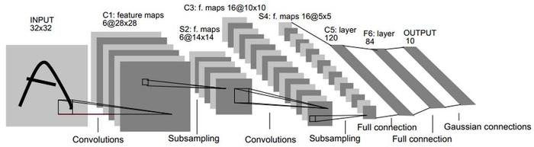
Figure 1 Structure of LeNet
In Fig 1, Layer Ci is the convolutional layer, layer Si represents the pooling layer, also known as the lower sampling layer, layer Fi represents the fully connected layer, and i represents the label of each layer.

Convolutional Layer
The Convolution Layer is a structural Layer for Convolution operation, also known as feature extraction Layer, and also one of the core layers of convolutional neural network. Fig.2 shows the schematic diagram of convolution operation, and Equation.1 is the mathematical expression of convolution operation[17].
$X_{j}^{l}=f(\sum_{i∈M_{j}}{X_{j}^{l-1}*K_{ij}^{l}+b_{j}^{l}})$ (1)
In this equation: $M_{j}$, represents the set of selected input images; "$*$" stands for convolution operation; $l$ represents the current number of layers; $b$ is the above offset; $K$ represents the convolution kernel weight matrix; $X_{j}^{l-1}$ represents the output feature graph matrix of the previous layer or the input image pixel value matrix of the input layer; $X_{j}^{l}$ represents the output after convolution; $f(.)$ stands for nonlinear activation function.
Convolution operation: Through the convolution kernel, the pixel value of the image sliding horizontally or vertically along the coordinates of the input image with a fixed step length corresponds to the convolution kernel for convolution operation, that is, the new two-dimensional feature graph can be obtained, and the number of convolution kernel determines the number of channels of the two-dimensional feature graph. After convolution operation, activation function will be introduced to nonlinear process, so as to improve the expression ability of the whole network. This operation is similar to the filtering operation in image processing and has the ability to extract features[18].
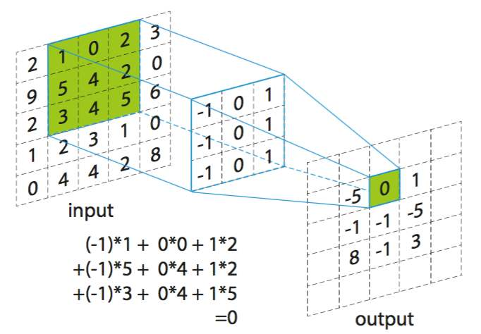
Figure 2 Convolution Operation
In deep convolutional network, the size of convolution kernel matrix has a great influence on the network parameters and computation. The convolution kernel is too small, which cannot effectively extract image features due to the network's high speed but small visual range. If the convolution kernel is too large, it will ignore the detailed information because the visual range is too large and contains too much global information []. At present, the convolution kernel size of the mainstream network is generally 3X3,5X5 and other odd Numbers, so that it has a centre, which can capture the upper, lower, left and right centres.

Pooling Layer
Pooling layer, also known as sampling layer, mainly performs aggregation statistics of feature information of adjacent areas based on relative image invariability, replaces all features with summary statistical features, and realizes dimensionless compression of convolution layer convolution result and retains effective information.[] The pooling layer is expressed by mathematical formula as follows:
$X_{j}^{l}=f(down(X_{j}^{l-1}))$ (2)
Where, $X_{j}^{l-1}$represents the upper layer output, and $down\left(.\right)$function represents the lower sampling function. $f(.)$ stands for activation function(referred in 1.4). There are two common pooling methods: Max Polling [19]and Mean Polling. [20]The difference between them lies in the different calculation methods. Maximum pooling means that the maximum value of pixels in a region is selected to represent the characteristics of the region, and average pooling means that an average value of pixels in the region is obtained as the eigenvalue of the region. In practical operation, maximum pooling is commonly used, and its operation process is shown in Figure 3 below.
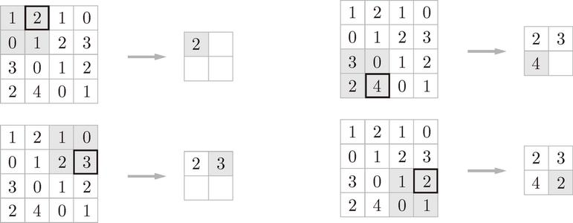
Figure 3 Max pooling operation
In the structure of convolutional neural network, pooling layer and convolutional layer often appear in pairs. Through pooling operation, feature dimension is reduced, computational complexity is reduced, and overfitting is effectively avoided. Meanwhile, pooling enhances the invariability of translation deformation and enhances the robustness of network to image changes.

Activation Layer
The main function of activation layer is to provide nonlinear modelling capability of the neural network.[21] If there is no activation function, then the network can only express linear mapping. At this point, even if there are many hidden layers, the whole network is equivalent to the single-layer neural network. Therefore, it can also be considered that only after adding activation function, deep neural network has hierarchical nonlinear mapping learning ability. With activation function and enough hidden layer, our neural network is not the linear combinations of inputs, and it can approximate any function. [22]
And some common activation functions are shown below.
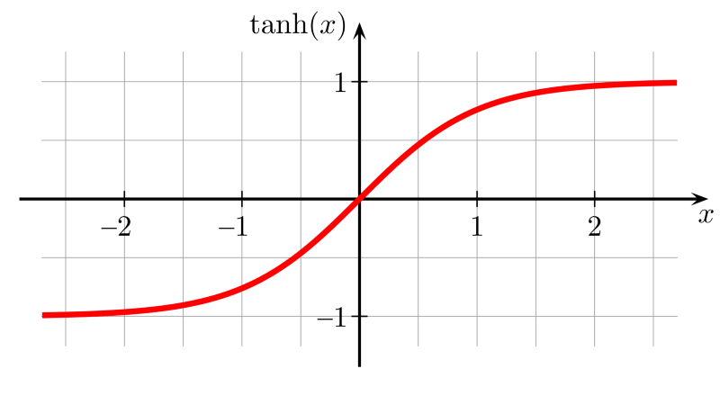
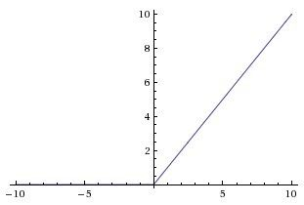
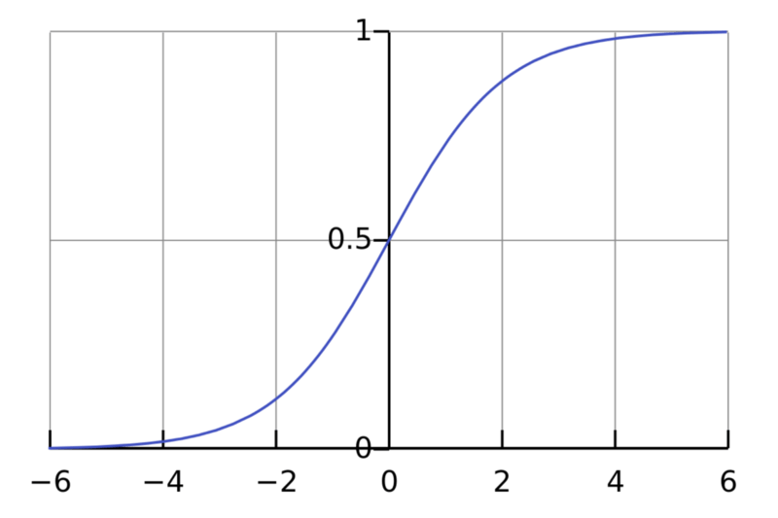
Figure 4 Sigmoid

Figure 5 tanh(x)
Figure 6 ReLU

Fully Connected Layer and Softmax
The fully connected layer generally appears at the end of the network [23], realizing all connections between the neurons in this layer and each neuron in the upper layer. The convolutional layer and pooling layer map the original data to the hidden layer feature space, while the fully connected layer map the highly purified distributed feature to the sample marker space, transform the convolutional output two-dimensional feature map into a one-dimensional vector, and pass it into the final classifier[24].
When solving multi-classification problem, the vector feature output from the full connection layer is finally realized by Softmax classifier. SoftMax regression[25] model is extended from the Logistic regression model. For the given test input, SoftMax regression model operates with E as the base exponent by adding the weight product and bias parameters, and finally normalizes the probability distribution, making it within the range of (0, 1), and making the sum of all probabilities equal to 1. For an input data X, the probability distribution formula of its y= I category is as follows:
$$p\left(y=i | x;θ\right)=\frac{e^{θ_{i}^{T}x}}{\sum_{j=1}^{k}{e^{θ_{i}^{T}x}}}$$
Then for a K-dimensional input vector, estimate each classification result of X, and predict the probability value of k classification as follows:$$h_{θ}\left(x^{\left(i\right)}\right)=\left[\begin{matrix}p(y^{(i)}=1|x^{(i)};θ) \\ \begin{matrix}p(y^{(i)}=2|x^{(i)};θ) \\ ⋯\end{matrix} \\ p(y^{(i)}=k|x^{(i)};θ)\end{matrix}\right]=\frac{1}{\sum_{j=1}^{k}{e^{θ_{j}^{T}x}}}\left[\begin{matrix}e^{θ_{1}^{T}x^{(i)}} \\ e^{θ_{2}^{T}x^{(i)}} \\ \begin{matrix}⋯ \\ e^{θ_{k}^{T}x^{(i)}}\end{matrix}\end{matrix}\right]$$
Where, $h_{θ}\left(x^{\left(i\right)}\right)$represents the hypothesis function and $θ_{i}$ represents the model parameters to be fitted, which are determined by the maximum likelihood estimation. The category with the highest final probability value is the result of the neural network prediction classification.

Conclusion
This chapter has described the basic theory and initial structure of convolutional neural networks. By the convolutional layers and the pooling layers, the network can extract the feature of the image, the activation layers and weight optimization based on back propagation give the network the ability to approximate the function that can give out the probability of the category it belongs to by the Softmax.
As discussed, the CNNs could obtain the feature of image, and the basic function of CNN is to classify the image into different categories by analysing the features. In order to classify the category of the object that need to detect, the CNN is an important tool.
And the next Chapter will introduce some object detection algorithm based on convolutional networks.

Literature Review of Object Detection Based on CNNs

Currently, there are two object detection algorithms: one-stage and two-stage. Two-stage means that the detection algorithm needs to be completed in two steps. Firstly, candidate regions need to be acquired and then classified, such as R-CNN series. In contrast, one-stage detection does not need to find candidate areas separately, input images, and then output target categories and positions, typically with SSD/YOLO.

Two-stage algorithms

3.1.1 RCNN
As discussed, the object detection has two missions. The first one is the localization and another one is classification.
For localization, the algorithm should process the image and output the location of an object. For instance, it need output a bounding box the contain an object. For classification, the aim is to recognize which category the object belongs to. After these two processes, the objects of the image can be located and classified.
Following this idea, Ross Girshick[26] proposed Region-CNN in 2014.
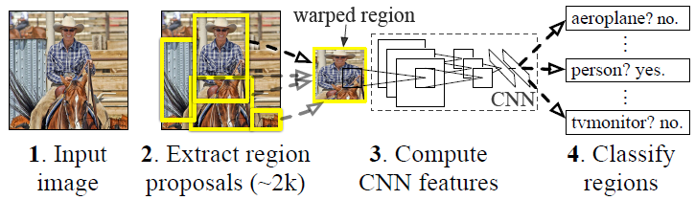
Figure 7 RCNN operations
The RCNN algorithm is divided into four steps
- One image generates 1000 ~ 2000 candidate regions
- For each candidate region, deep network is used to extract features
- The features are sent into SVM[27] classifier of each category to judge whether it belongs to the category
- Fine correction of candidate frame position using regression
For generating the candidate regions[28], the selective search[29] method is used to generate about 2000-3000 candidate regions from an image. The basic ideas are as follows:
- An over segmentation method is used to segment the image into small regions
- Look at the existing small areas and merge the two areas that are most likely to merge. Repeat until the entire image is merged into a region
- Output all the existing regions, called candidate regions
- The candidate region generation and subsequent steps are relatively independent, and any algorithm can be used in practice.
RCNN needs a lot of candidate regions to improve accuracy, but there are many areas that overlap with each other. If we have 2000 candidate regions and each of them needs to be fed to CNN independently, we may need to extract features repeatedly for different ROI (Region of Interest)[28]. Therefore, the training and prediction speed of RCNN is very slow.

3.1.2 Fast-RCNN[30]
In order to improve the process speed of RCNN, Fast-RCNN was proposed in 2016[16]. Fast-RCNN uses CNN network to extract the features of the whole image first, instead of extracting each image block several times. Then, we can directly apply the method of creating candidate regions to the extracted feature map. For example, Fast-RCNN selects the convolution layer conv5 in VGG16 to generate the mapping feature block of ROI region on the corresponding feature map, which is used in the object detection task. We use ROI pooling to convert feature blocks into fixed sizes and send them to the full connectivity layer for classification and location. Because fast RCNN does not extract features repeatedly, it can significantly reduce the processing time.
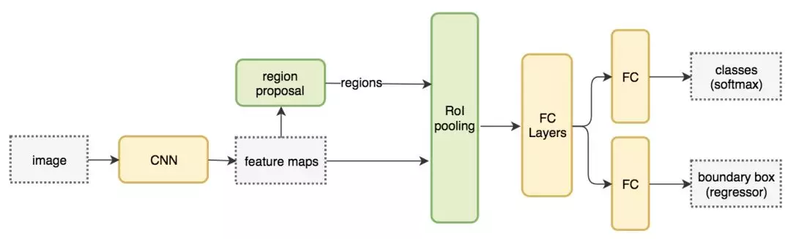
Figure 8 Fast-RCNN

3.1.3 Faster-RCNN
Fast-RCNN relies on external candidate region methods, such as selective search. But these algorithms run on the CPU and are slow. In the test, Fast-RCNN takes 2.3 seconds to predict, of which 2 seconds is used to generate 2000 ROI. Therefore, the calculation of region generation becomes the bottleneck of the whole detection network[31].
Instead of using fixed algorithms to get candidate regions, let the network learn what its candidate area should be. Therefore, Fast-RCNN adopts the same design as Fast-RCNN, but it replaces the candidate region method with region generated network (RPN)[28]. The new candidate area network (RPN) is more efficient in ROI generation and runs at 10 milliseconds per image.
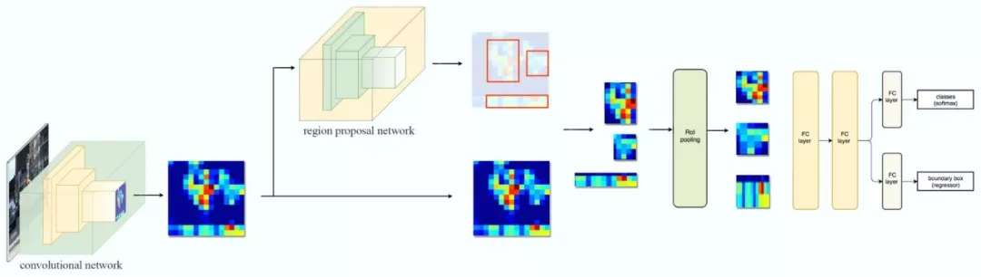
Figure 9 Faster-RCNN
Region Proposal Network (RPN) takes the output characteristic map of the preceding convolution network as input, such as the conv5 characteristic map of VGG16.It slides a 3 by 3 convolution kernel on the feature map to use the convolution network to construct candidate regions that are independent of category. Using a VGG network to extract features, each 3x3 region gets a 512-dimensional feature vector[32], which is then sent to two separate, fully connected layers to predict the bounding box and two target scores (either the target or not).We can actually use regressors to calculate individual target scores, but for brevity, Faster R-CNN uses classifiers of only two categories: those with and without targets.
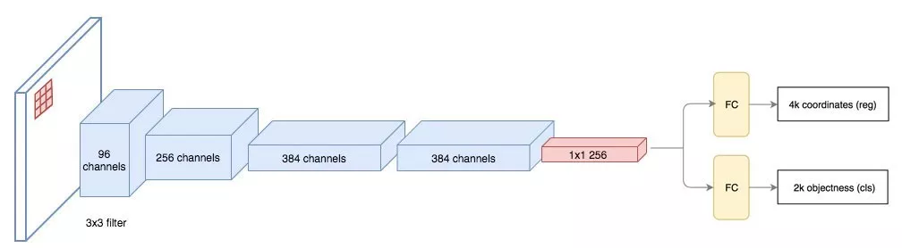
Figure 10 Region Proposal Network

3.2 One-stage algorithms

3.2.1 YOLO
Overall, YOLO uses a separate CNN model to achieve end-to-end object detection. The whole system is shown in Figure 8 YOLO system: First, the input image is resized to 448x448, then it is sent to CNN network, and finally the network prediction results are processed to obtain the detected target. Compared with R-CNN, it is a unified framework with faster speed, and the training process of YOLO is also an end-to-end process[33].
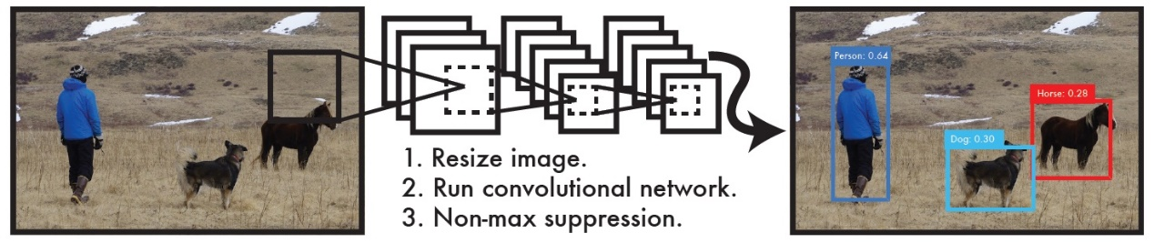
Figure 11 YOLO system
Specifically, YOLO's CNN network splits the input image into a $S×S$ grid, []and then each cell is responsible for detecting the target whose centre falls within the grid. As shown in Figure 6, you can see that the centre of the target falls within a cell in the lower left corner, which is then responsible for predicting the dog. Each cell can predict the $B$ bounding boxes and the confidence score of the bounding boxes. There are two aspects of confidence, one is the probability that the bounding box contains the target, and the other is the accuracy of the bounding box. The former is denoted as $P_{r}(Object)$, when the bounding box is the background (i.e., it does not contain the target), then $P_{r}\left(Object\right)=0$. When the bounding box contains the target, $P_{r}\left(Object\right)=1$. The accuracy of the boundary box can be characterized by the IOU (intersection over union) of the prediction box and ground truth, denoted as ${IoU}_{pred}^{truth}$. Therefore, confidence can be defined as $P_{r}\left(Object\right)*{IoU}_{pred}^{truth}$.
YOLO's confidence level is usually considered as the probability of whether a bounding box contains a target, but it's the product of two factors, and the accuracy of the prediction box is reflected in it. The size and position of the bounding box can be represented by four values: [$x,y,w,h$], where $(x,y)$is the central coordinate of the bounding box, and $w$ and $h$ are the width and height of the bounding box. It is also important to note that the predicted value $(x,y)$ for the centre coordinates is the offset value relative to the coordinate point in the upper-left corner of each cell, and the unit is relative to the size of the cell, The $w$ and $h$ prediction values of the bounding box are the ratio of width to height relative to the entire image, so theoretically the size of the four elements should be within the $[0,1]$ range. Thus, the predicted value of each bounding box contains five elements: $(x,y,w,h,c)$, where the first four represent the size and position of the bounding box, and the last value is confidence.

3.2.2 YOLO v3
YOLO V3 [34] is further improved on the basis of YOLO V2[33], and can achieve the effect of faster running speed and higher detection accuracy. Its structure is shown in Figure 12.
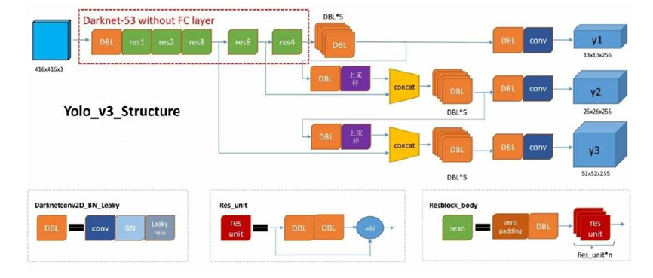
Figure 12 Structure of YOLO v3
YOLO V3 USES a combination of multiple scale feature maps to make predictions. The fusion method like FPN (Feature Pyramid Networks) is used to predict the location and category of multiple scale Feature maps, thus improving the accuracy of object detection.
In YOLO V3, the dimension clusters were also used as the base box to predict the boundary boxes. K - means way [35]to the target box dimension of the data set clustering, get nine different size reference frame, according to the reference frame size sorting, divide it into multiple dimensions on the characteristics of the diagram, including dimension greater characteristic figure using smaller reference frame, the scheme makes the final number of a priori box than YOLO v2, feature extraction effect is better.
YOLO V3 USES new networks for feature extraction. From the perspective of network structure, compared with Darknet-19 network in YOLO V2, residual unit was added. Using continuous 3X3 and 1X1 convolutive layer, YOLO V3 expanded it to 53 layers and named the network as Darknet-53. 53 convolution layer and the network structure contains five max pooling layer, at the same time, after each convolution layer increases the batch normalization operation and remove the dropout operation, to avoid over fitting phenomenon. The network Darknet-53 is more powerful than Darknet - 19,and more efficient thanResNet-101[36] or ResNet-152 [37]. In category prediction by using ImageNet dataset, YOLO v3 does not use SoftMax classification to output each box, instead, several separate logistic classifiers were used. And binary cross-entropy loss was used in the training process to predict the classification.

3.2.3 SSD
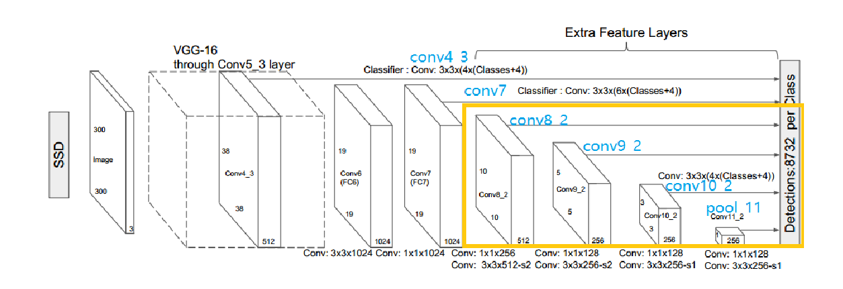
SSD (Single Shot MultiBox Detector) [6] object detection model: This model is a method to integrate image detection and recognition into a network model of deep learning for processing. When the network model is used, the size and aspect ratio of the prior boxes in each detection feature graph are defined in advance, and the number of prior boxes is set for each feature graph of the network. In the subsequent detection process, the network model will produce a confidence score for whether the object category in the prior box on each feature graph exists or whether it matches a detection object. Meanwhile, in the subsequent training process, the prior box with targets will be adjusted to better match the detected objects more accurately. In general, the network model will combine the feature maps in each detection feature map (feature map with different resolution) for more accurate object detection and recognition processing. The difference between SSD object detection model and the network model of RPN is that SSD does not need to use the pixel or feature resample method in the process of recommendation generation and detection, and all operations are merged into a network model. These advantages ensure that the training process of SSD network model is simple and can be used seamlessly with other systems. SSD model has passed the test of various object detection and recognition data sets. From these tests, it is concluded that SSD model has more advantages than RPN network detection model, and its performance is outstanding not only in the detection speed but also in the detection accuracy. The SSD network structure diagram is shown in Figure 13
Figure 13 SSD structure
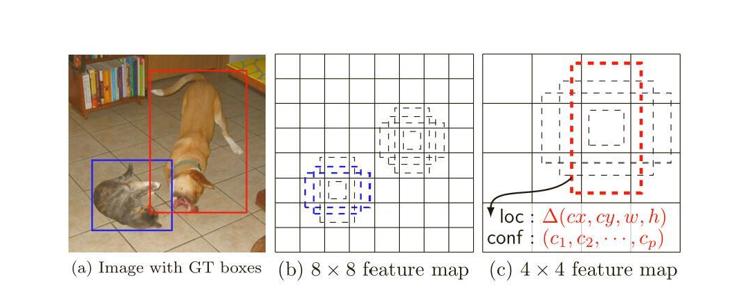
As can be seen from Figure 13, the basic network model of SSD network model is VGG-16-Atrous structure. The yellow box in Figure 13 is an additional feature extraction layer added to enable the SSD network model to have stronger feature detection capability. The main difference between SSD network model and YOLO network model is that SSD model is not only used for object detection and identification on the final feature map, but also five other special layers are selected as the network model prediction scheme. Image in Figure 13 illustrates the SSD network model in the prediction process in detail, as you can see from the table, the SSD model in the process of object detection, first from the characteristics of the basic network layer (conv4_3, conv_7) for feature extraction and detection, and then further use the extra feature extraction layer (conv8_2 conv9_2, conv_10_2, pool_11) to extract the characteristics of target identification. In order to allow more image targets to be detected, the SSD network model adopts the small convolution kernel operation method of the VGG model, that is, in the feature extraction layer of the SSD network model, a large number of small convolution kernels are used for object detection.
Figure 14 some process in SSD detection
Figure 2.12 is a partial process description of the SSD network model when detecting the target in Figure 14(a). It describes that the input of the network is an image with a real box. During the network training, a feature graph like (b) in Figure 14 will be output. In the characteristic map network model will be in accordance with the relevant rules generate multiple prior box, and these prior box receptive field is relatively small, so will be able to accurately detect small targets for, namely the kitten will be detected in the graph, and on the goal of network need to pass information back, until the subsequent output characteristic figure can detect big goals, namely the puppy in the graph will appear in the field, at this point, the network can be detected accurately the position..
Advantages of SSD network Framework:
- The accuracy of SSD object detection network can be higher than that of the Faster RCNN model, and its detection speed is Faster than that of the YOLO model.
- The core of SSD model is to use convolution kernel for convolution operation on feature map to predict the category scores and offsets of a series of prior boxes.
- SSD model detects and identifies targets on feature layers of different sizes, aiming to improve the detection and recognition accuracy of the whole network. And it can also get the detection result of different aspect ratio.
- Improvement of the model Even for low-resolution image input, THE SSD model can have a good detection accuracy.
- The model was tested on PASCAL VOC[38], MS COCO and ILSVRC data sets for detection and identification performance, and the model was fundamentally strictly evaluated. The result was that the network model had high detection speed, high detection accuracy and high overall performance evaluation results.

Conclusion
This chapter illustrate how the convolutional neural network process the image and detect the objects of images. Some metrics of detection are also described.
As discussed, there are 2 different way for CNNs to detect the image:
- Find the location box and then classify the object in the box;
- Find the most likely box that contains the target object then adjust the box.
The one-step network has better performance in detecting accuracy but would take more time than one-step algorithm. This chapter particularly mentioned the YOLO v3 model and SSD model because they performance well in both accuracy and process speed. They are regarded as the final two options as detecting model in this project.

Design and implementation
This chapter outlines the experiment of the performance test of detection models and the design of the object detection web application. The details are given in terms of how to test the performance and the basis of choosing models. According to the decisions made, the design of web application is made.

4.1 Experiment of testing detection algorithms

4.1.1 Metrics of evaluating detection model
The task of the object detection problem is: given an image, then
- find their position,
- classify the target.
Therefore, object detection needs to involve the location information of the target in the image and the classification of the target. In object detection, mAP (mean Average Precision) is the top metric of the performance evaluation of object detection model
For any algorithm, the measurement is always compared with the Ground Truth of the data. Ground Truth is the true value of the data. The Ground Truth includes the category of the target in the image and the boundary box of each target in the image.
In the object detection algorithm, we often need to evaluate the similarity between two rectangular boxes. Intuitively, the similarity can be calculated by comparing the distance between the two boxes, overlapping area, etc., and the IoU can precisely achieve such a measure. IoU means Intersection over Union. The IOU represents the overlap rate of the generated candidate bound and the ground truth bound, that is, the ratio of their intersection and union. The higher the correlation, the higher the value. Ideally, it should overlap completely, so the ratio is 1.
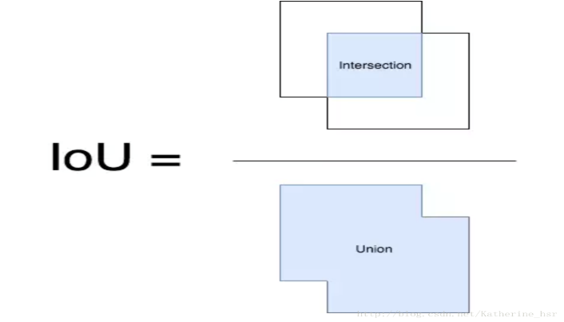
Figure 15 IoU
In object detection, to judge whether the detection is correct by IoU, threshold need to be set. The most used threshold is 0.5, that is: if IoU > 0.5, it is considered as True Detection (Correct); otherwise, it is considered as False Detection (Wrong). By comparing the calculated IoU value with the set IoU threshold value (such as 0.5), the correct detection times $A$ of each class in each image is calculated. For each image to be detected, Ground Truth has been marked, so we can get the number $B$ of the actual target of a given category.
So, the detecting precision for class$c$ on a particular image is:
${Precision}_{C}= \frac{A}{B}= \frac{{N(TruePositive)}_{c}}{{N(TotalTimes)}_{c}}$ .
${N(TruePositive)}_{c}$ means the times that the result is correct on this image, and ${N(TotalTimes)}_{c }$means total detecting times. Then the average precision (AP) for class C is:
${AveragePrecision}_{C}= \frac{{\sum{Precision}}_{C}}{{N(TotalImages)}_{C}}$.
So, the mAP can be obtained by averaging the average precision of all classes:
$meanAveragePrecision= \frac{\sum{AveragePrecision}}{N(Classes)}$.
That is, mAP is equal to the sum of the average precision of all categories divided by the total number of categories.

4.1.2 mAP of YOLO v3 and SSD
To choose a better model to implement the function of detecting, a YOLO v3 model and SSD model based on Keras are tested to calculate the mAP. The weights of the models are from YOLO website (YOLO.h5) []and Mega(weights_SSD300.h5df)[].
The tool to test the mAP is from Cartucho[] on GitHub. In order to calculate the mAP of the two algorithms, 100 random images of 19 classes in VOC-2007 dataset are selected to test.
The procedures of calculating the mAP are blew:
- Copy the images to target folder;
- Copy the Ground Trues file (.XML file or .txt file) for each image to target folder;
- Detect the sample images and save the prediction results (in .txt format) to target folder;
- Run the mAP calculation tools;
- Obtain the result data.
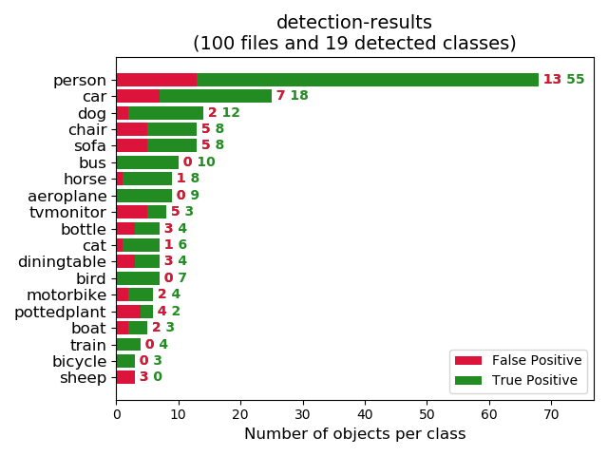
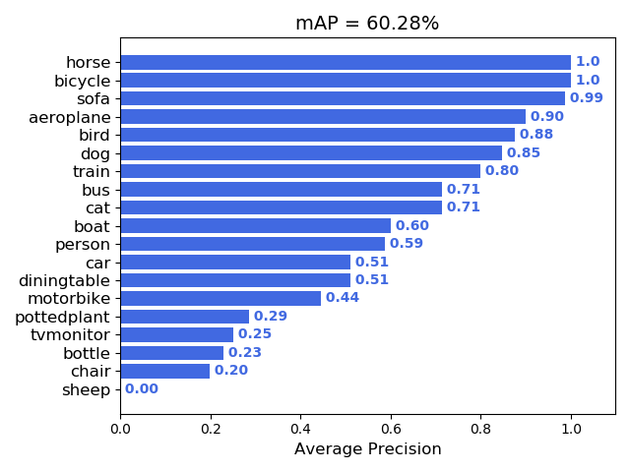
For the SSD with weights weights_SSD300.h5, mAP for the 100 images is shown in Figure 3
Figure 16 mAP for SSD
Figure 17 detection result of SSD
From the Figure 2 Figure 3, we can see the mAP for SSD is 60.28% in 19 classes.
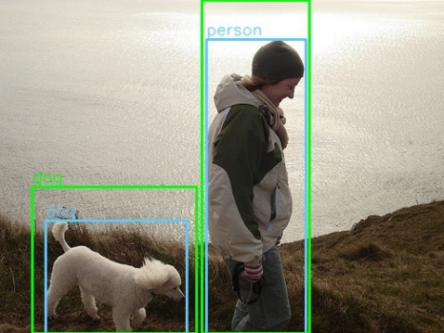
A sample result picture is Figure 4. In this picture, the blue box is the ground true and the green box is the prediction. When the IoU is bigger than the threshold, the prediction is considered as a true positive result.
Figure 18 Sample Result

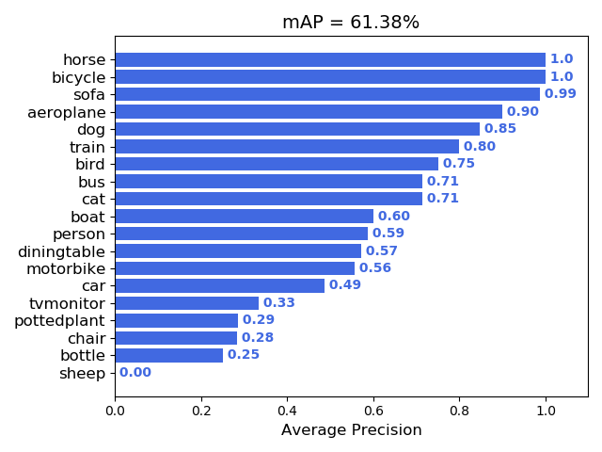
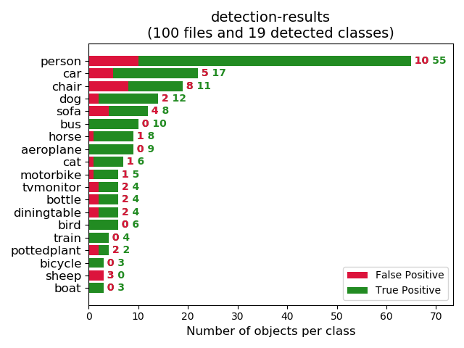
And for YOLO v3, mAP for the 100 images is shown in Figure 6
Figure 19 mAP for YOLO
Figure 20 Detection Result on YOLO
As it shown among Figure 5, Figure 6, Figure 3 and Figure 4, the mAP of SSD is 60.28%, and the mAP of YOLO is 61.38%.
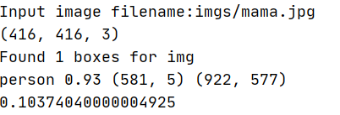
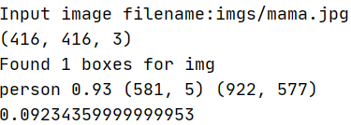
On a computer with Windows 10 and graphic card GTX 1060, by using TensorFlow-gpu 1.14.0, Keras 2.1.5, the average time of detecting an image on YOLO v3 is 0.0923s. The average time on SSD is 0.1037s.
Figure 21 result of detect an image on SSD
Figure 22 result of detect image on YOLO

5.1.3 Conclusion of detect model
In section mAP of YOLO v3 and SSD, experiments show that the mAP of SSD is 60.28%, and the mAP of YOLO is 61.38%. The average detecting time is 0.0923 per image and 0.1037 per image.
By Comparing the mAP and average detecting time, YOLO v3 should be selected as the detection model in this project.

Software Design
After the detection model decided, the next mission is to design the web application. Considering of the YOLO v3 model is based on Keras and TensorFlow, which are implemented in Python in this project, a web application framework which can implemented in Python is a better choice.

4.2 Choosing Web development framework
On Python, the most used web-application frameworks are: Django, Tornado, Flask and Twisted.

Option 1: Django
Django is an open source Web application framework written in Python that supports a number of database engines, makes Web development fast and extensible, and is constantly updated to match the latest Python versions. For novice programmers, start with this framework. The main things Django is known for are:
- The success of Django is largely due to its near-perfect official documentation
- a full set of solutions, Django provides a full set of solutions, the basic to what is what, and all Django built, the development site should be handy tool Django basically give you do a good job, so development efficiency is needless to say, out of the problem is also easy to find, not in your code is in the source code of Django.
- strong URL routing configuration, Django allows you to design very elegant URLS, in Django you can basically say goodbye to ugly GET parameters.
- Self-management backstage, Admin Interface is a function in Django that is quite attractive, allowing you to have a complete backstage management interface almost without writing a line of code.
- The system is tightly coupled. If you find some of the built-in features of Django not very good, it will be difficult to replace them with third-party libraries you like, such as ORM and Template, which will be discussed below. It's almost impossible to use SQLAlchemy or Mako in Django, and even a few patches can be very, very awkward.
- 6, Template function is weak, cannot insert Python code, to write more complex logic need to use Python to implement Tag or Filter.
Django is a big picture, focused on efficient development, and is best known for its fully automated management background: it can automatically generate database structures and a fully functional management background just by using ORM and doing simple object definitions.

Option 2: Tornado
Tornado Web Server, also known as Tornado Web Server, is a Web Server and Web application framework written in Python language. It was used by FriendFeed company in its own website FriendFeed. After being acquired by Facebook, the framework was opened to the public in September 2009 in the form of open source software.
Tornado as a Web framework is a lightweight Web framework with asynchronous non-blocking IO handling.
As a Web server, Tornado has a relatively excellent load resistance capability. The official deployed Tornado in the way of Nginx reverse proxy to compare with other Python Web application frameworks, and the maximum page views exceeded the second place by nearly 40%.
Tornado has excellent performance. It attempts to solve the C10k problem, which deals with 10,000 or more concurrences.
Tornado framework and server together constitute a full stack alternative to WSGI. Tornado network framework or Tornado HTTP server alone in the WSGI container has certain limitations. In order to maximize the performance of Tornado, it is recommended to use both tornado network framework and HTTP server.

Option 3: Flask
Flask is a lightweight Web application framework written in Python. BSD licensing is based on the WerkzeugWSGI toolkit and the Jinja2 template engine.
Flask is also called a "MicroFramework" because it USES a simple core and USES an extension to add additional functionality. Flask has no database and forms validation tools used by default. Flask, however, retains the elasticity of Flask. Flask-extension can be used to add these features: ORM, forms validation tools, file uploadings, various open authentication techniques.
Flask is very light and requires very little cost to develop a simple web site. Very suitable for beginners to learn. Flask Framework. After you learn how to use Flask frameworks, you can consider learning how to use plugins. For example, use WTForm + flask-WTForm to verify your form data, and SQLAlchemy + Flask-SQLAlchemy to control your database.
Flask is lightweight but scalable (more than 37,000 stars on GitHub know this is not a bad idea) and allows us to customizable and customizable features when developing.

Option 4: Twisted
The biggest advantage of the Twisted framework is that while it is itself just a spars-bound engine, it supports many other extensions that can be used to extend its capabilities, such as programming from low-level networks (TCP/UDP) and advanced applications (HTTP, IMAP, SHH, and so on). So Twisted is naturally good for writing professional services, but not for regular Web applications. Developers must write a lot of things themselves to implement the features that come with Django. Twisted is currently active in development and maintenance, working to migrate code to Python 3, and its core functionality has recently been rewritten, but many third-party modules suffer from compatibility issues.

Chosen option
Because only a few functions need to be implemented in this project and CNN image detection model requires massive computing power, a light web framework is needed for this project.
In these 4 frameworks, the main features of Flask are small and light, the native components are almost zero, the components provided by the three parties please refer to Django is very comprehensive, belongs to the compact framework. Comparing with other 3 framework, the merits and disadvantages of Flask are in Table 1:

Advantages: | Disadvantages:
Simple. Flask routing and routing functions are set by modifier, so the developer does not need to match with other files. | For large web site development, rules for routing mappings need to be designed, otherwise code clutter will result
Flexible configuration, there are many ways to configure. different environment configuration is also very convenient;
Flask is easy to start with.
Low coupling. Flask can be compatible with multiple databases and templates
Table 1 Flask features
One of our goal is to implement a real time real-time video detection, and the mainstream video transmission protocols are not available on Flask. Also, there would be much time spent on the processing the decoding and encoding processes when using video transmission as the method.
For these reasons, Flask is selected as the web framework.
Considering of the high demand of instantaneity in the processes of reading files, detecting images, saving images, and posting images, using database to organize the image files could not be a good idea.

Implementation
From the initial stage to the to the final solution, there are several different aspects of the project needed to be designed. These aspects include web page design and implementation of necessary functions, implementation of detecting function, Flask application.

4.3 Web page design
To meet the different requirements of the project, several pages are needed. The structures and functions are shown in Table 2
PAGE NAME | MAIN FUNCTIONS
Home page | Initial page;  Navigating to other pages.
File upload and detect | Allow users to upload image;  Show the detection results
Photo detection | Allow users to take photo (if the device has a camera, and it is callable), and upload it.  Receive and Show detection result.
Real-time detection | Allow users to using camera (f the device has a camera, and it is callable);  Show the video processed.
Table 2 Function of web pages.
As it is decided that the project is developed by Flask, all the web pages should be developed on HTML5 and JavaScript.

4.3.1 Home page
Home page only have a few functions, and the first one is that it is the initial page. Every accessing require will return to this page if the URL is not defined. For instance, if there are 2 URL that users are allowed to access, http://localhost:8080/home and http://localhost:8080/helloworld, any other accessing request to URL like http://localhost:8080/ or http://localhost:8080/hellow will be redirected to the home page. This function will be implemented in Flask application.
Another function in this page is that users can access other function page from this home page. In order to achieve this function, a few button components are added to this page. The main HTML code and JavaScript code examples are:
<button onclick = " Camera() "> Camera </button >

function Camera(){
window.open( "/camera",'_self')
}

The parameter '_self' means open this URL in the current page.

4.3.2 File upload page
In this page, users can choose an image file (like .jpg, .png, etc.), then upload it to the server.
In order to implement this function, a form component is added to choose file.
<div >
<input type = "file" name= "FileUpload" id= "FileUpload" >
<button class = "layui-btn layui-btn-mini" id = "btn_uploadimg" > Upload files </button >
</div >
To read the file object from the upload form, a FormData Object is instantized, and by using the getElementById() function, the file object can be read and copied to the FormData object.
const fileObj = document.getElementById("FileUpload").files[0]; // javastript Obtain the file object
if ( typeof ( fileObj ) == "undefined" || fileObj.size <= 0 ) {
alert( " Please Select An Image ");
return ;
}
var formFile = new FormData();
formFile.append("action", "UploadVMKImagePath");
formFile.append("file", fileObj); //Append the file object

To upload the file, there are several methods to send the HTTP POST request to the target URL, in this project all the HTTP requests are sent by AJAX of jQuery. The reason is that it is the most familiar method for me.
The upload example code is:
$.ajax({
url: "/upload/"+name+count, //target URL, and file name
data: formFile,
type: "Post",
dataType: "json",
cache: false,//No need to store it in cache
processData: false,// File must uploaded to the server in its original data type.
contentType: false,
success: function (result) {
filename = result.filename;
console.log( result )
count=count+1;
alert( "Upload success!" );
console.log( count )
},
})
})

Another function is to send an instruction to the server that make the server call the process method to process the image. The processing method will be explained in Implementation of Flask app section.
A button and JavaScript function are designed to implement this function, and it also using AJAX to send the HTTP request.
The final function in this page is to show the detection result. A button and an img HTML5 component whose attribute herf is set to the target URL is created to show the result.
The example code is:
The HTML code is:
<button onclick="show()"> show </button>
<span >
<img id="show_pic" style='width: auto; height: auto; max-width: 900px; max-height: 600px' src="">
</span>
The JavaScript code is:
function show() {
d = new Date()
$("#show_pic").attr("src","/show/"+filename+"?"+d.getTime())
}
In the function show(), because almost all browser cannot access a same URL many times, a Data object is instantized to add some parameters to URL to avoid the rule, and then picture can be refreshed.

All the solutions to the requirements of upload page is shown in Table 3

Requirements | Solutions
Select local image files | Use form component;  Create FormFile object to store the file.
Upload file | Use Ajax to send FormData to target URL
Send processing instruction | Create button component and use Ajax GET method to send instruction.
Show the detection result | Create an img component to show image;  Using the button and a function to change the attribute herf of img to get the processed image.
Table 3 Functions in Upload page

4.3.3Take photo page
The main function of this page is that call the camera of users device(if available ), and other functions are identical to the upload page.
Considering of the situation when mobile device (like cell phone) using form to select an image file, the mobile system (like Android and iOS) will give two option: open the camera or select from the local storage. So, there will be unnecessary to write an individual page for mobile device users. And the solution is to redirect the page to Upload page when mobile device users accessing.
In order to achieve it, the type of accessing device must be identified. The function: navigator.platform will return the browser information. So, in Home page, when press the button Take_photo, the page will be redirected to upload page. The code is:
function Take_photo(){
const system = {};
const p = navigator.platform;
system.win = p.indexOf("Win") === 0;
system.mac = p.indexOf("Mac") === 0;
system.x11 = (p === "X11") || (p.indexOf("Linux") === 0);
if(system.win||system.mac||system.xll){//if the device is PC
window.location.href="/photo";
}else{ //if the device is mobile device
window.location.href="/upload";
}
}
The main function in this page is that browser calls the local camera (if it is available ) and take photo, then upload it to server and show the result. The main difference between this page and upload page is calling the camera and take photo, so, other work is duplicated.
To call the camera, the first step is to ask for the permission to camera.
if (navigator.mediaDevices.getUserMedia === undefined) {
navigator.mediaDevices.getUserMedia = function (constraints) {
// Obtain existed getUserMedia(if exists)
var getUserMedia = navigator.webkitGetUserMedia || navigator.mozGetUserMedia;
if (!getUserMedia) {
return Promise.reject(new Error('getUserMedia is not implemented in this browser'));
}
return new Promise(function (resolve, reject) {
getUserMedia.call(navigator, constraints, resolve, reject);
});
}
}
var constraints = { audio: false, video: {width: 720,height:720} }
navigator.mediaDevices.getUserMedia(constraints)
.then(function (stream) {
var video = document.querySelector('video');
if ("srcObject" in video) {
video.srcObject = stream;
} else {
video.src = window.URL.createObjectURL(stream);
}
video.onloadedmetadata = function (e) {
video.play();
};
})
.catch (function (err) {
console.log(err.name + ": " + err.message);
});

In the code, object video captures the video camera stream, and the stream can be shown in the component video. Component Canvas can capture current frame of the video component. So, it can be the tool to take photo.
pzBtn.addEventListener("click", function () {
// click to take photo
context.drawImage(video, 0, 0, 300, 300);
// get the image in fomat of base64
var image = canvas.toDataURL('image/png');
// base64to image file
const file = new FormData();
file.append("file",base64toFile(image,count+'.jpg'))
As it shows, using canvas to capture current frame (base64), and transform it into image file. Finally, upload and process the file and display the result as in Upload page.
The main function of this page is Table 4

Requirements | Solutions
Call the local camera | Use navigator.mediaDevices.getUserMedia to ask for permission and open the local camera.
Obtain the video stream | Use video component to obtain the stream from getUserMedia;
Take photo and save it as a file | Use canvas to capture a frame of the video stream;  Transform it from base64 to file
Upload, process, display | The same way with page upload
Table 4 Solutions to take photo page

4.3.4 Realtime detection page
In this page, the main function is to transfer the video stream to server and then display the results as video on page.
In this project, there are two options to implement this function.
- Solution 1: upload the stream to server directly, and receive the processed stream then play it.
- Solution 2: capture multiple frames from camera every second, upload the frames to server in order and then request the processed images in order. Finally display them as it is a video stream.
For solution 1, it requires the streaming media protocols (like RTSP) and encoded stream. And it is too complicated for a small application, furthermore, the original Flask does not support the streaming media protocols.
So, solution 2 is selected. To implement it, several functions need to be design.
To obtain the permission to call the camera and video stream from the camera, some methods in Take photo page section can be used. What to do next is to take photo regularly. In JavaScript, there is a method called setInterval(callback,ticks). This method can call the callback function every specific ticks, for examples, setInterval(upload,100) means execute function upload every 100ms. So, we can upload files to server regularly by this method. Also, the displaying function can be implemented in the same way.
At first, the upload function is similar with those in other pages. The only difference is that every image file is renamed by order. Secondly, the display function is slightly different:
const d = new Date();
function show(){
$.ajax({
url:"/is_frames",
method:"GET",
success:function (res){
$("#video_span").attr("src","/show_frame/result"+frame_count+".jpg"+"?"+d.getTime())
frame_count=frame_count+1
console.log(frame_count)
}
})
}
There is a global variable frame_count. It adds itself one when the target image exists and has been displayed. It ensures the order of displaying.
And then there are the frame capture function and the simulated stream display function:
$("#Capture").click(function (){
var lit1=setInterval(up,300);
$("#stop").click(function () {
clearInterval(lit1)
})
})
$("#show_video").click(function (){
var lit2= setInterval(show,500)
$("#stop").click(function () {
clearInterval(lit2)
})
})
As it shows that when the button #Capture or #show_video is clicked, the srtInterval() function starts and run callback function up every 300ms or show every 500ms.
The reason why the iteration time is set as 300ms and 500ms is to ensure the image is detected when the GET request arrives.
Also, there is a button #stop which can clear stop the literation.
In all functional pages, there is a method named clear_cache(), this method is designed to clear the all the image uploaded and processed in server. And the clear_cache() method in Camera page can also set the variable frame_count to 0.

The main functions of camera page are in Table 5
Requirements | Solutions
Capture video stream | Use setInterval() function to take photo, upload files, display results
Post frames
Get results and display
Other duplicated requirements | See previous sections
Table 5 Requirements and solution of Camera page

4.4 Implementation of Flask application
After developing all the web pages, the Flask server needs to be design and implemented.

4.4.1 URL setting
To implement all the function, many URLs should be designed. In Flask, the routing method is in the format like :
@app.route('/')
def hello_world():
return render_template('home.html')

For every page, it needs a URL to allow user access, and for each function, there also should be unique URLs.
For every function, the URLs are in Table 6:
Page | Function | URL
Home | Page url | '/home'
Upload | Page url | '/upload'
Upload | Process | '/process'
Upload | Upload url | '/upload/<string:filename>'
Upload | Display | '/show/<string:filename>'
Upload | Clear_cache | '/clear'
Take_photo | Page url | '/photo'
Take_photo | Process | "/process_photo"
Take_photo | Upload url | '/save_photo/<string:filename>'
Take_photo | Display | '/show_photo/<string:filename>'
Take_photo | Clear_cache | '/clear_photo'
Camera | Page url | '/camera'
Camera | Process | "/process_frames"
Camera | Upload url | '/save_video/<string:frame_num>'
Camera | Display | "/show_frame/<string:filename>"
Camera | Clear_cache | '/clearframes'
Camera | Is show result available | "/is_frame"
Table 6 URLs

4.4.2 Detection method
As decided, YOLO v3 is selected as the solution to detection. The model obtained from GitHub doesn’t have methods that meet the project requirements. So, the detection method should be implemented.
Method 1: Rewrite the detection method
Input an image file, call the detect method to detect, then save it.
def detect_img(filen_ame):
while True:
img_path = "./upload/" + filen_ame
try:
image = Image.open(img_path)
except:
print('Open Error! Try again!')
continue
else:
r_image = YOLO().detect_image_and_save(image)
Image._show(r_image)
r_image.save("./static/pic/" + filen_ame)
from keras.backend import clear_session
# destroy the current TF Graph, then create a new TF Graph to avoid conflicts
clear_session()
break

Method 2: detect all the images in a target folder:
def detect_folder(yolo, result_path):
import cv2
path = "./static/saved_frames/"
count = 0
while 1:
if os.listdir(path):
for files in os.listdir(path):
try:
image = Image.open(path + files)
image = yolo.detect_image(image)
image = image.convert("RGB")
image.save(result_path + "result" + str(count) + ".jpg")
count = count + 1
os.remove(path + files)
if global_variebles.frame_reset:
count = 0
global_variebles.frame_reset = False
except OSError:
pass
except:
pass

By calling this method, all the images in target folder will be detected and the results will be saved in the target folder with a particular name.

4.4.3 Storage solutions
Considering of the high demand of instantaneity of processing and the unfamiliarity with the database, local memory of the device is used to save the data.
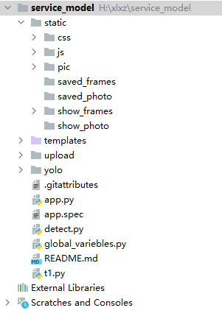
The structures of folder is shown in Figure 20
Figure 23 structure of project
In Figure 9, folder upload stores the uploaded pictures from upload page, static/pic folder stores the processed picture. The folder static/saved_photo and static/show_photo store the uploaded photo and processed photo. The folder static/saved_frames and static/show_frames store the uploaded video frames and processed video frames.

4.4.4 Implementation of functions
The main methods in this application are:
- Accept the POST request from Web page, and save file in target folder;
- Accept the Process request, and detect the image and save the result in target folder.
- Accept the GET request from the web page, and response;
And here are some example methods:
@app.route('/upload/<string:filename>', methods=['POST'])
def uploadpic(filename):
if request.method == 'POST':
f = request.files['file']
f.save(os.path.join(app.config['UPLOAD_FOLDER'], secure_filename(filename + ".jpg")))
return jsonify(message="success",
filename=filename + ".jpg")

Other details are in submitted code.
Because some browsers reject to allow the page to call the local media device if the URL is not safe, an open SSL certificate is added to the Flask application.
if __name__ == '__main__':
app.run(host='0.0.0.0', port=8080, ssl_context="adhoc")

This code means using local certificate because we cannot provide a certificate that admitted by browser.

Conclusion
To reach the goal of this project, there are several solutions need to be chosen:
- Choose a detection model which has a better performance;
- Choose a proper web development framework which can meet the requirements
For detection model, an experiment that shows the mAP and average detecting time was set in Section Experiment of testing detection algorithms. The result shows YOLO v3 has better performance on this platform (Nvidia GTX 1060 6GB, Intel Core i5-8400).
By comparing with other 3 Python web development framework, Flask was chosen because its lightness and easy-developed feature.
For each function, individual web pages were designed, including Home, Upload, Take_photo, and Camera. The details of implementation are in submitted code. Some details of implementation of Flask application is also in this chapter.
Over all, this chapter illustrates the design and implementation of this software with some details.

Results and evaluation
This chapter will show some test of the software.

Page
This section will show some pictures of each page.
To this application, domain names are not necessary. And it uses the port 8080 at localhost as the access point.
Because the authorized SSL was used and there is no valid certificate, the browser on Windows 10, Android, and iOS would give a warn that this URL is not safe.
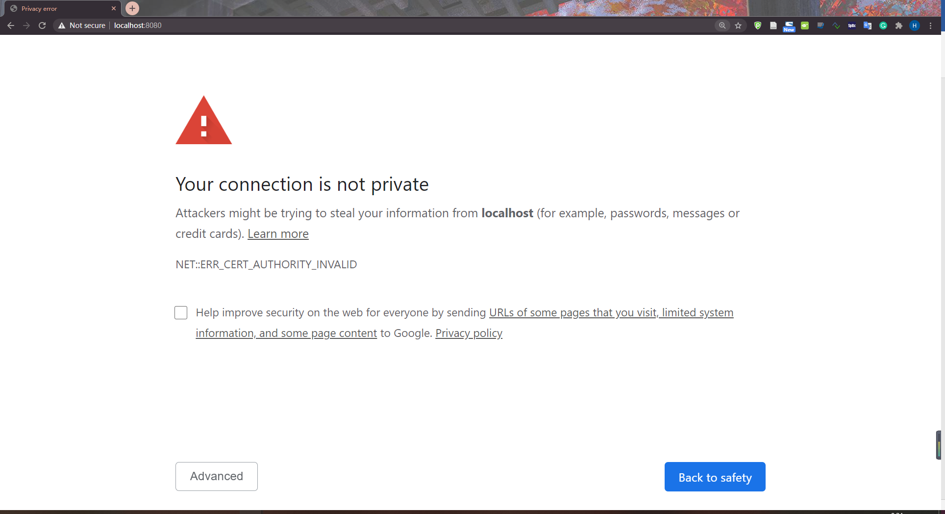
Figure 24 Accessing URL on Chrome of Win 10
For other device which is not the server platform, it can access the page by using https://192.168.1.2:8080 if it in the same LAN;

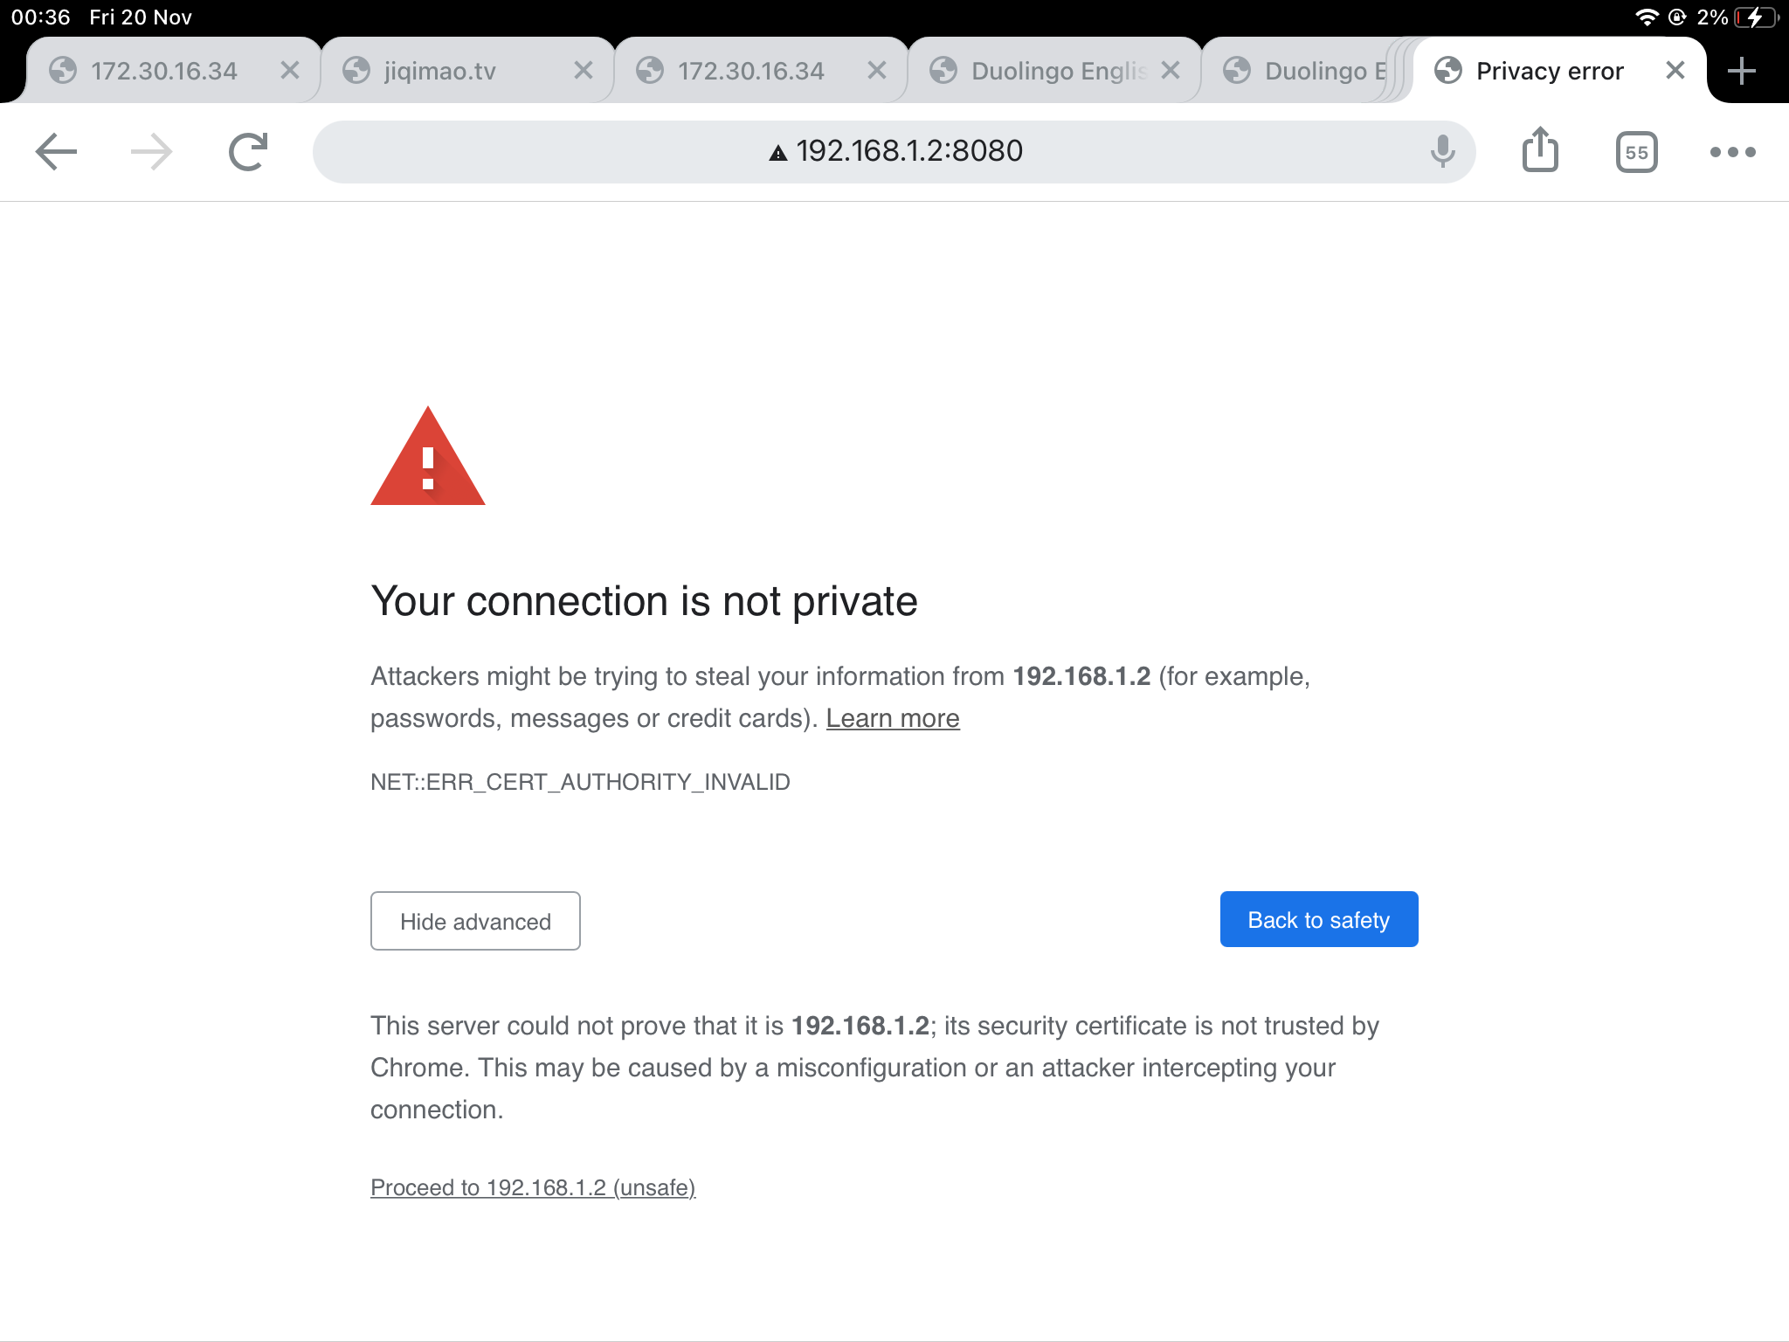
Figure 25 Access page on iPad

Figure 26 Accessing home page by Chrome on Android

For mobile devices, an Android phone(Redmi K20 Pro with Android 10) is regarded as the example to test the performance.
The home page is blowing and test fine.
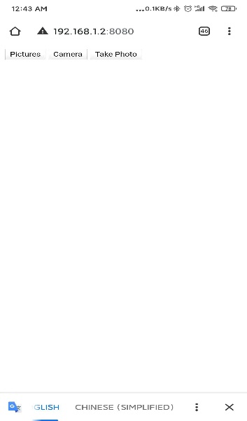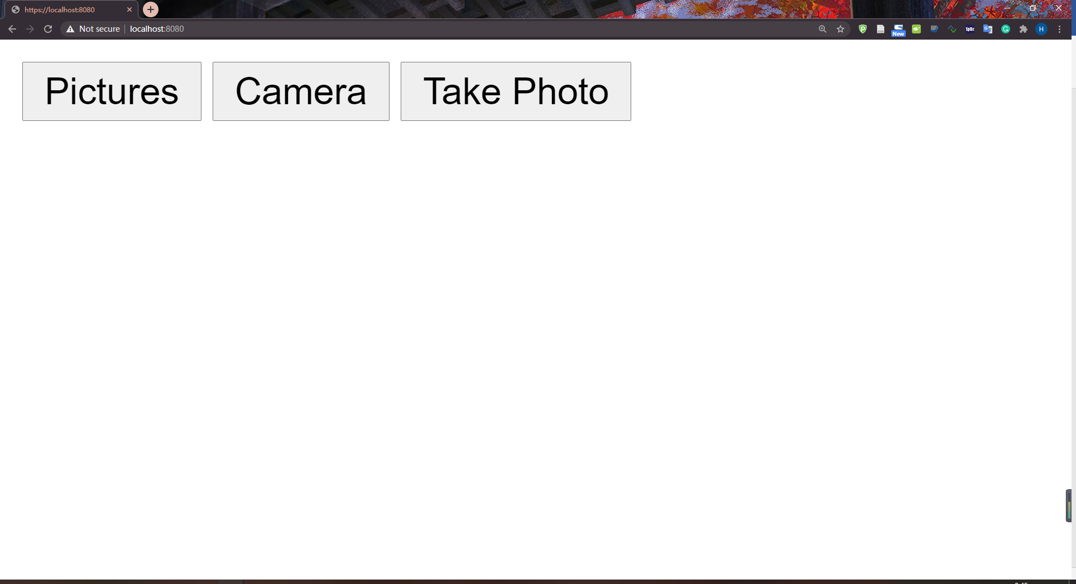
Figure 27 Home page on Android Figure 28 Home page on Win10
The other pages will be tested with the function.

Performance of upload function.
In the page upload, the main function is to upload file and show the result.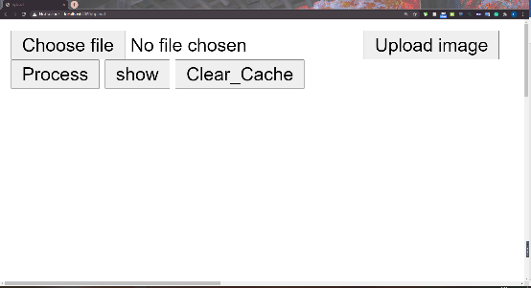 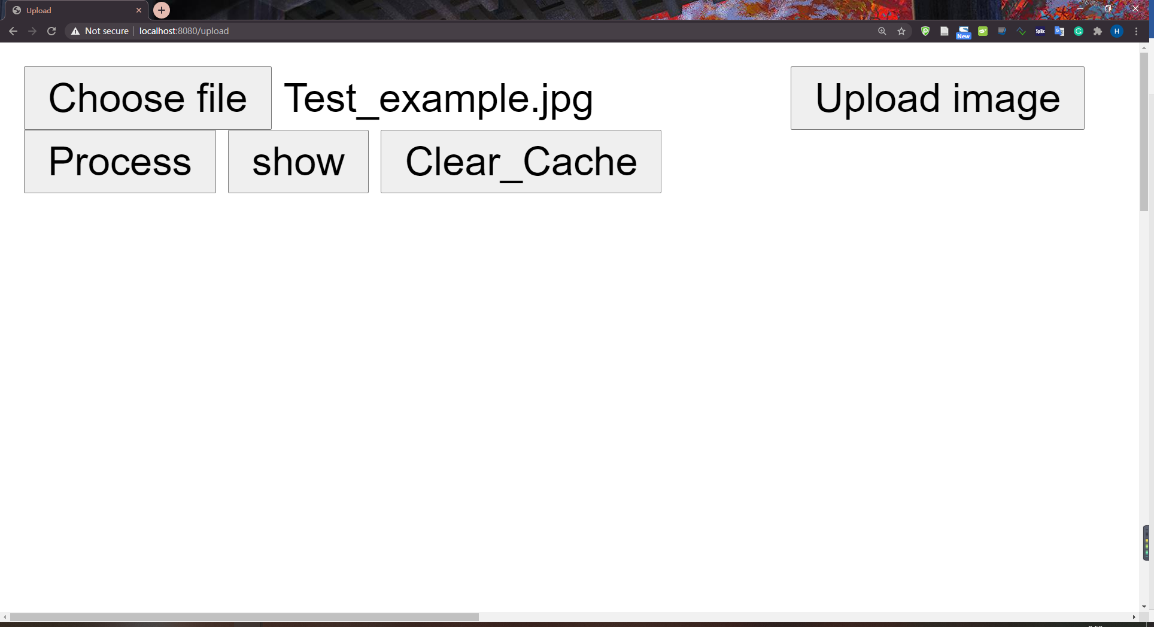
Figure 29 Upload page Figure 30 File chosen

The testing file is Figure 31,and this image only contains two object(person).
Figure 31 Test image file
After clicking the button Upload image and Process, the page would alert like Figure 32 and Figure 33. And after clicking the button show, the result would show in page like Figure 34 and Figure 34 show the function detect two person with possibility of 100% and 97%.

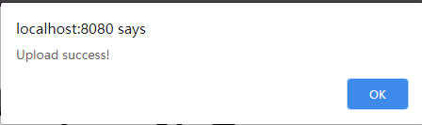
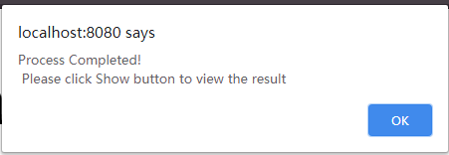

Figure 32 alert of upload Figure33 alert after process
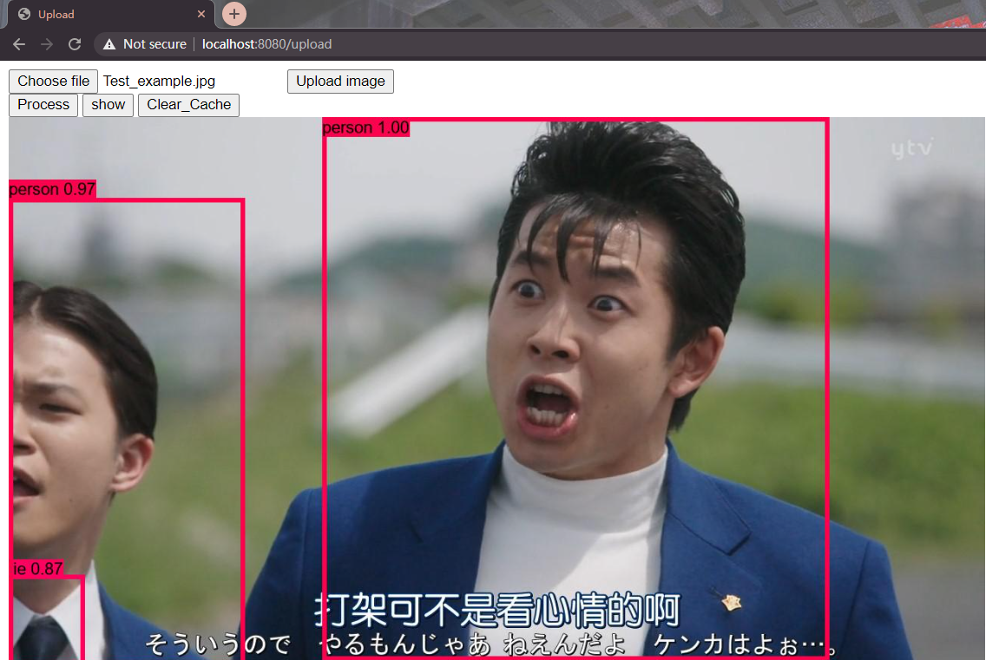
Figure 34 detect result of example image

Performance of photo function.
For this function, the test runs on both Android device and PC. As discussed in 4.3.3Take photo page, when using this function, the android device can automatically call camera by using upload function. And it shows in Figure 35
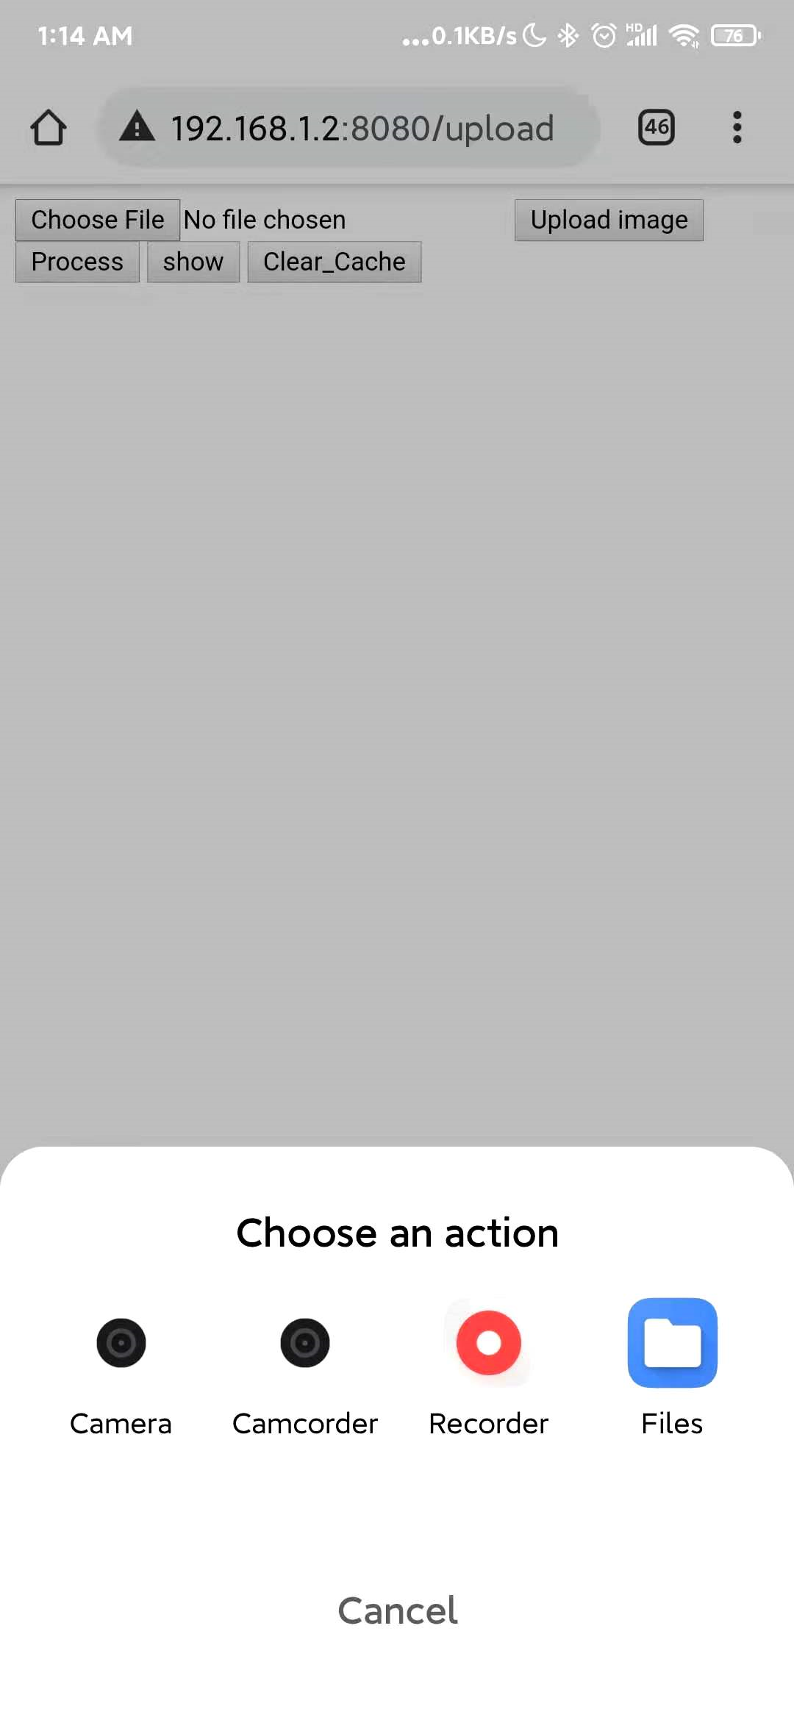
Figure 35 Upload and photo function on Android
And the performances of taking photo on chrome are in Figure 36. Form this page we can see the model detected a cup with possibility of 98%, a keyboard with possibility of 95%, and a person (my hand) with possibility of 30%.

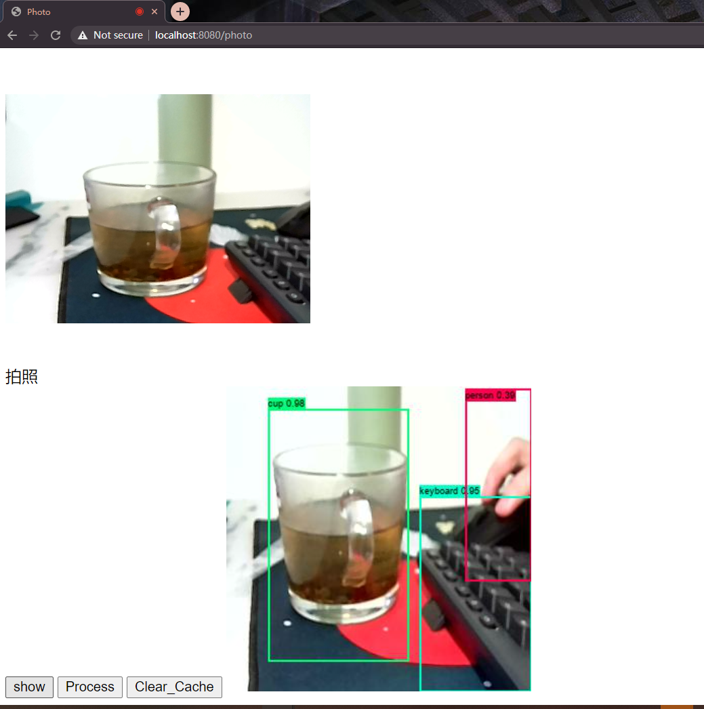
Figure 36 Photo results

Performance of real-time detection
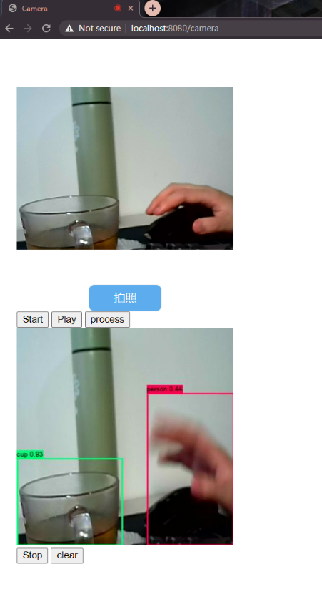
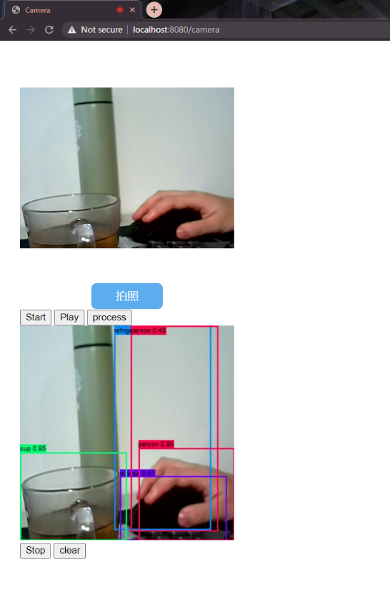
The final function is real-time detection. The test results on PC chrome are in Figure 37Figure 37, and Figure 38.
Figure 37 Camera test result
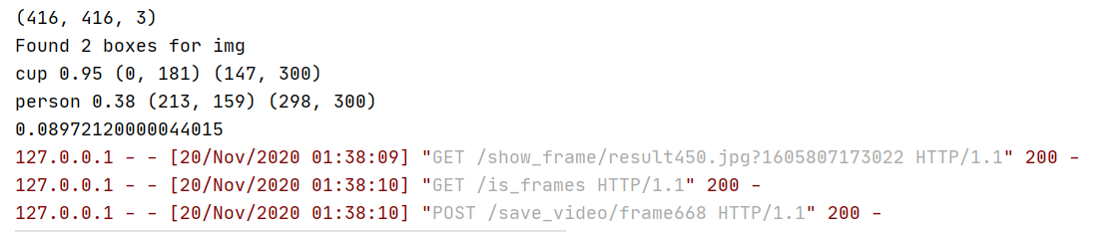
Figure 38 server console results
These two figures show that the real-time function running well.

Conclusion
This chapter shows the test of each function. Overall, the application running well in most aspects. Because of some flaws of HTTP request, there are some frames were lost or some requests not arrive in order, and it cause some frames lost.

Conclusion and recommendation

5.1 Summary
In the introduction part of the report, the application prospect and some problems of target detection are proposed, and the purpose and objectives of this report are proposed for this subject. Under this premise, the target detection technology of machine vision and its web development methods were investigated in literature. Then, the characteristics of CNN, RCNN, YOLO, SSD, application architecture and principle as well as development steps were studied as preparation for the study.
By designing and implementing an experiment that compared the performances of the YOLO v3 model and SSD300 model, a better model and web developing framework are chosen for this project.
Flask framework and Keras YOLO V3 detection model were used to analyse the characteristics of the system, the design principles to be followed when designing the system, the software and Web page were designed, and the implementation of the system was completed according to the functions.

5.2 Conclusion
In the literature review, the target detection technology based on CNN (Convolutional neural network) provides theoretical basis and feasible basis for designing a target detection Web application based on Keras YOLO V3 Model. In the system implementation of this report, Flask is adopted as the system development method, before and after interaction is conducted through Ajax, and the detection method is written using Python.
In the Design section, a mAP computing experiment was used to compare the performance of YOLO V3 and SSD300 on the same platform. The conclusion of using YOLO V3 as the detection model is drawn. Since the convolutional neural network is mostly implemented in Python, in order to remove the risks brought by code migration, web development framework based on Python is adopted for development. But the Flask framework is a lightweight framework to develop web applications, considering that project only implements a few functions.
In the Implementation part, combining the features of the functions and design principles, the webpage page and script are designed and implemented. Create a Web page for each different function.
- In the Home Page, realize the function of navigation to other pages;
- Realize the function of detecting and displaying the results of uploaded files on the Upload page;
- In take_photo page, the function to upload and display the detection results is implemented.
- In Camera Page, the function of calling the Camera for real-time target detection is realized
Finally, test all the features on PC and Android phones.
During the testing process, deficiencies were found.

5.3 Recommendation for future work
This detection software has shortcomings in the following aspects that need to be improved

5.3.1 The file storage method
In this project, OS package in Python was used to organized the files rather than database. It could be better if using database.

5,3,2 User accessing
Because the SSL certificate was the local certificate from a Python package OpenSSL, the iOS user cannot call their camera by browser. This software could use a valid SSL certificate to avoid the problem.

5.3.3 UI design
UI is one of the most attractive part for a web page. In this project, none of the pages looks good. So, designing a good-looking UI can be better.

5.3.4 User number restrict
Because the software uses specific folder to store the files, only one user can use the take_photo function and the real-time function at the same time, or there would be mistakes. So, the user service and storing method should be redesigned.

5.3.5 Video stream uploading
In this project, the stream uploaded by posting the frames captured on Canvas component. Because of the flaws of HTTP protocols, it could lost many frames and is inefficient. So, the stream upload method could be redesigned.

Reflection
Convolutional neural network has been my passion since the beginning of my graduate career. I have done similar research in Wuhan University of Technology, and it has always been very interesting for me to classify and identify images. This whole project has been a great challenge and great fun for me. At the beginning of the whole project, the whole world experienced a huge disaster with COVID-19, which caused many unexpected things to happen. I returned to China for another semester, which shortened my time again. But I did it in the end.
As soon as I started working on this project, I had the idea of using YOLO or SSD for detection. I am familiar with these methods, but I am not at all familiar with developing Web applications in Python. Due to the suspension of classes caused by the epidemic, the knowledge I learned in school about Web and Server development was not very complete. This led to my difficulties at the beginning.
The positive aspect of developing this project is that I have expanded my existing knowledge and skills and used a new programming language and Web framework to develop an application that I am not very familiar with, which enables me to have a deeper understanding of Python and Server Development. Other aspects of the project allowed me to consolidate my knowledge of target detection algorithms.
If I were to complete this project again, I think I would use the video streaming protocol to transmit images to the back end in real time. And I use a database to manage my data. I'm also going to make my UI more beautiful.
All in all, I have gained a lot from this project.

References
[1] Dongsheng, L. V. . (2018). Application analysis of computer vision technology in industry. Modern Information Technology.
[2] Sonka, M. , Václav Hlavác, & Boyle, R. . (2014). Image processing, analysis, and machine vision. Journal of Electronic Imaging, xix.
[3] Sonka, M. , Václav Hlavác, & Boyle, R. . (2014). Image processing, analysis, and machine vision. Journal of Electronic Imaging, xix.
[4] Girshick, R. , Donahue, J. , Darrell, T. , & Malik, J. . (2014). Rich Feature Hierarchies for Accurate Object Detection and Semantic Segmentation. CVPR. IEEE.
[5] Redmon, J. , Divvala, S. , Girshick, R. , & Farhadi, A. . (2016). You Only Look Once: Unified, Real-Time Object Detection. Computer Vision & Pattern Recognition. IEEE.
[6] Liu, W. , Anguelov, D. , Erhan, D. , Szegedy, C. , & Berg, A. C. . (2016). SSD: Single Shot MultiBox Detector. European Conference on Computer Vision. Springer International Publishing.
[7] Ji, S. , Xu, W. , Yang, M. , & Yu, K. . (2013). 3d convolutional neural networks for human action recognition. IEEE Transactions on Pattern Analysis & Machine Intelligence, 35(1), 221-231.
[8] Harman, D. . (1995). Overview of the eighth text retrieval conference (trec-8). Information Processing & Management, 31( 3), 271-289.
[9] Masters, T. . (0). Practical neural network recipes in C++. Practical neural network recipes in C++ /. Academic Press.
[10] Manaswi, & Kumar, N. . (2018). Deep learning with applications using python || cnn in Keras. , 10.1007/978-1-4842-3516-4(Chapter 8), 105-114.
[11] Matthews, A. G. D. G. , Mark, V. D. W. , Nickson, T. , Fujii, K. , Boukouvalas, A. , & León-Villagrá, Pablo, et al. (2016). Gpflow: a gaussian process library using tensorflow. Journal of Machine Learning Research.
[12] Hung, J. , Goodman, A. , Ravel, D. , Lopes, S. C. P. , & Carpenter, A. E. . (2020). Keras r-cnn: library for cell detection in biological images using deep neural networks. BMC Bioinformatics, 21(1).
[13] Unknown(0). Vergleich eclipse - pycharms | python-ide: jetbrains veröffentlicht pyc. | heise developer news-foren. Hse Ztschriften Verlag.
[14] He, K. , Gkioxari, G. , Piotr Dollár, & Girshick, R. . (2017). Mask R-CNN. 2017 IEEE International Conference on Computer Vision (ICCV). IEEE.
[15] Mufid, M. R. , Basofi, A. , Rasyid, M. U. H. A. , Rochimansyah, I. F. , & Rokhim, A. . (2019). Design an MVC Model using Python for Flask Framework Development. 2019 International Electronics Symposium (IES). IEEE.
[16] Alemu, M. B. . (2014). Rest api : implementation with flask-python. Lapin Ammattikorkeakoulu.
[17] Bayar, B. , & Stamm, M. C. . (2016). A Deep Learning Approach to Universal Image Manipulation Detection Using a New Convolutional Layer. Acm Workshop on Information Hiding & Multimedia Security. ACM.
[18] Klein, B. , Wolf, L. , & Afek, Y. . (2015). A Dynamic Convolutional Layer for short rangeweather prediction. Computer Vision & Pattern Recognition. IEEE.
[19] Krizhevsky, A. , Sutskever, I. , & Hinton, G. . (2012). ImageNet Classification with Deep Convolutional Neural Networks. NIPS (Vol.25). Curran Associates Inc.
[20] He, K. , Zhang, X. , Ren, S. , & Sun, J. . (2014). Spatial pyramid pooling in deep convolutional networks for visual recognition. IEEE Transactions on Pattern Analysis & Machine Intelligence, 37(9), 1904-16.
[21] Lin, H. T. , & Lin, C. J. . (2003). A study on sigmoid kernels for svm and the training of non-psd kernels by smo-type methods. Submitted to Neural Computation.
[22] Frei, M. , & Kruis, F. E. . (2021). Fiber-cnn: expanding mask r-cnn to improve image-based fiber analysis. Powder Technology, 377, 974-991.
[23] Evan Shelhamer, Jonathan Long, & Trevor Darrell. (2017). Fully Convolutional Networks for Semantic Segmentation. IEEE Computer Society.
[24] Lin, M. , Chen, Q. , & Yan, S. . (2013). Network in network. Computer ence.
[25] Yizhao, W. , Manli, H. , Shuner, C. , Hongbin, H. , & Weiping, L. . (2019). Optical fiber terminal number recognition system based on improved faster r-cnn algorithm. Optical Communication Technology.
[26] Cheng, B. , Wei, Y. , Shi, H. , Feris, R. , Xiong, J. , & Huang, T. . (2018). Revisiting rcnn: on awakening the classification power of faster rcnn.
[27] Saunders, C. , Stitson, M. O. , Weston, J. , Holloway, R. , Bottou, L. , & Scholkopf, B. , et al. (2002). Support vector machine. Computer Science, 1(4), 1-28.
[28] Ren, S. , He, K. , Girshick, R. , & Sun, J. . (2017). Faster r-cnn: towards real-time object detection with region proposal networks. IEEE Transactions on Pattern Analysis & Machine Intelligence, 39(6), 1137-1149.
[29] Ma, J. , Shao, W. , Ye, H. , Wang, L. , & Wang, H. . (2017). Arbitrary-oriented scene text detection via rotation proposals. ieee transactions on multimedia, PP(99), 1-1.
[30] Girshick, R. . (2015). Fast r-cnn. Computer ence.
[31] Jiang, H. , & Learned-Miller, E. . (2017). Face Detection with the Faster R-CNN. IEEE International Conference on Automatic Face & Gesture Recognition (pp.650-657). IEEE.
[32] Sun, X. , Wu, P. , & Hoi, S. C. H. . (2018). Face detection using deep learning: an improved faster rcnn approach. Neurocomputing, 299(JUL.19), 42-50.
[33]Redmon, J. , & Farhadi, A. . (2017). YOLO9000: Better, Faster, Stronger. IEEE Conference on Computer Vision & Pattern Recognition (pp.6517-6525). IEEE.
[34] Redmon, J. , & Farhadi, A. . (2018). Yolov3: an incremental improvement. arXiv e-prints.
[35] Wong, J. A. H. A. . (1979). Algorithm as 136: a k-means clustering algorithm. Journal of the Royal Statistical Society, 28(1), 100-108.
[36] Dai, J. , Li, Y. , He, K. , & Sun, J. . (2016). R-FCN: Object Detection via Region-based Fully Convolutional Networks. Advances in Neural Information Processing Systems. Curran Associates Inc.
[37] Shih, Y. F. , Yeh, Y. M. , Lin, Y. Y. , Weng, M. F. , Lu, Y. C. , & Chuang, Y. Y. . (2017). Deep Co-occurrence Feature Learning for Visual Object Recognition. IEEE Conference on Computer Vision & Pattern Recognition. IEEE.
[38] Everingham, M. , Gool, L. V. , Williams, C. K. I. , Winn, J. , & Zisserman, A. . (2010). The pascal visual object classes (voc) challenge. International Journal of Computer Vision, 88(2), 303-338.

