Technical Report

Will Bath
2501932

Engineering Skills
ACHA4022A

Word count – 1,886

Contents:

Pg 3. – Introduction

Pg 3/4. – Health and Safety

Pg 4/5. – Security Risk Matrix

Pg 5. – Engineers’ Role in Society

Pg 6. – Problem Solving

Pg 7. – Team Structure

Pg 8. – Conclusion

Pg.8/9. – Reference List

Introduction:

This technical report will demonstrate and explain the professional and practical skills required to safely and effectively carry out engineering-related tasks. This report will cover the importance of health and safety in engineering environments, as well as an evaluation of modern security within the automotive sector. As well as this, it shall consider and analyse the professionalism and responsibilities that fall on engineers and the problems they face regarding sustainability and ethical conduct. Finally, the report will compare and contrast the problem-solving methods used during the design process and the impact that the team’s structure and collaboration methods have on the design process as a whole.

Health and Safety:

A pillar drill is a simple and safe piece of equipment however, if health and safety precautions and regulations aren’t followed, many risks are posed. Firstly, the Personal Protective Equipment (PPE) at Work Regulations 2022 must be followed. This regulation means that an employer must carry out a PPE suitability assessment and provide the necessary PPE free of charge to its employees. It is the employee’s responsibility to maintain and replace the PPE, as well as ensure it is used in accordance with the training and instructions provided and worn at all times necessary. (GOV UK, 2022). Employees and employers must also follow the Provision and Use of Work Equipment Regulations 1998 (PUWER), which means that all equipment must be inspected and maintained to an efficient working and operating standard. This must be logged and kept up to date in accordance with the manufacturer’s specifications. This regulation also covers employees and ensures that anyone using or supervising the machinery is adequately trained and cleared on any required health and safety checks. Effective measures to prevent access and harm from dangerous parts of machinery, such as the spindle on a pillar drill, must be in place and functioning correctly. For example, the guard on a pillar drill is commonly connected to the emergency stop so that the machine can be stopped in an emergency to prevent harm to the operator or surrounding employees. (GOV, 1998).

Hazard | Who is at risk? | Likelihood  (1-5) | Severity  (1-5) | Risk Factor | Description of risk posed | Prevention Method
Contact with drill bit | Operator | 4 | 4 | 16 | An operator may come into contact with the spinning drill bit and cause potential cuts. As well as this any loose clothing or jewellery may be caught and drag the operator into the machine risking much more severe injuries. | Ensuring guards are in place around moving components, and when removed the machine shuts off immediately. As well as multiple emergency shut offs should be nearby and all operators must not be wearing lose clothing or jewellery.
Overheating of Drill Bit | Operator | 3 | 3 | 9 | Drill bits may overheat causing potential burn and fire risks | Use cutting fluid/coolant and don’t touch the part or drill bit straight after operation.
Debris | Operator/  Bystanders | 5 | 3 | 15 | Swarf may be ejected from the drilling area and contact the operator or bystanders | Ensure operator and bystanders are wearing eye protection and appropriate guards are in place.

Security Risk Matrix:

The automotive industry is becoming much more reliant on automation and digital software, due to this the industry is much more vulnerable to cyber-attacks. As well as this the increased amount of digital technology packed into modern day production vehicles leave them at a higher risk of security threats. Vehicles may be vulnerable to remote telematic/infotainment attacks where cloud API’s can be used to issue control messages or even take control, of vehicles remotely. A modern-day example of this was the Jeep Cherokee remote hack which showed how attackers could control and manipulate all control aspects of the vehicle due to an exposed cellular interface. (BBC, 2015) Another common security risk is Keyless Entry attacks and theft where attackers use RF amplifiers to extend the signal of key fobs which allows the vehicle to be unlocked and started. This is the most common and prominent attack in the modern day due to thieves being able to quickly and easily steal high value vehicle to export them for quick cash. (Leasing.com, 2020) The increase in autonomous vehicles has seen an increase in the usage of LiDAR and camera technology, this opens the risk to sensor spoofing. While this isn’t an issue in the real world currently in the future it may be a severe security risk where attackers can alter autonomous car data potentially taking over control. (Cornell University, 2025) Cyberattacks may also target the supply chain element of the automotive sector in the form of suppliers, manufacturers and dealers. This poses then risk of sensitive data being exposed and vehicle production being halted completely. The biggest example of this is the JLR cyber attack where the entire computer system had to be shut down halting sales and production resulting in a £485m loss. (BBC News, 2025)

Threat | Likelihood | Impact | Response
Remote Telematics | 4 | 4 | Increased security within the backend of API’s and multifactor authentication.
Keyless Entry emulation | 5 | 5 | Different technology within key fobs, more secure casings and storage options that reduce the risks of signal emulation.
Sensor Spoofing | 1 | 5 | Higher levels of security within sensor data.
Supply Chain Attacks | 3 | 4 | Backup software and systems, as well as multifactor authentication and stronger firewalls.

Engineers Role in Society:

Chartered engineers must follow strict ethical standards and guidelines; these are set by the Engineering council and the Institution of Mechanical Engineers (IMechE). The Engineering Council sets the standards In the UK for Engineering competence as well as Ethical principles. These are enforced so that engineers show “respect for life, law the environment and public good” as well as “contributing to building a sustainable society”. (Engineering Council, 2025). The IMechE code of conduct also expresses the importance of ethical duties including “maintaining a sustainable environment”. (IMechE, 2025) However, the IMechE is more focused on running programmes within specific sectors such as motorsport to help reduce environmental impact such as introducing the usage of low-carbon fuels.

For motorsport engineers both codes of conduct emphasise the importance of environmental responsibility meaning that they must follow strict safety and legal requirements. These come into effect during the design and manufacturing process, as well as fuels and logistical operation. Life cycle assessment of parts and materials is becoming a big focus of attention also. The environmental impact of carbon fibre is a big topic due to the high energy required to produce it, toxic chemicals released and the end-of-life options due to it not being biodegradable nor easily recyclable. However, the focus on down-cycling carbon fibre more effectively is currently being worked on to reduce its negative impact on the environment. (Composites Construction UK, 2023).

Both codes of conduct emphasise the importance of honesty and transparency meaning that teams in motorsport must record and report emissions during their entire programme to ensure that evidence-based justifications for sustainability related decisions can be made and announced.

Problem Solving:

When a new product is in the development stage issues and problems are going to arise frequently such as, failures, defects and failures to meet specs/requirements. The engineering team must efficiently and successfully overcome these issues with problem solving techniques. Root cause analysis can be used to locate the originator of the problem using diagrams, questioning and data analysis. The benefits to RCA are that the cause of the issue will be located meaning that the originally detected issue will not occur again, this saves time and resources for the development team in the long run. (ASQ, 2025). Once the problem has been identified development teams will use a diagram to identify possible causes to resolve the problem, these come in the dorm of an Ishikawa diagram. Also known as a fishbone diagram, these help to show all probable solutions and their outcomes and paths that can be taken to resolve the issue. An example is shown below:
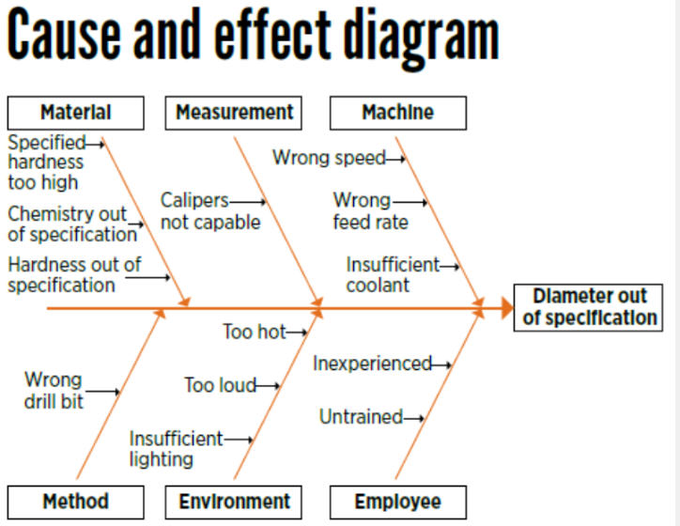 (ASQ, 2025)

For more complex and in-depth problems a Logic tree may be used to break down a large problem into smaller sub problems to devise multiple solutions. While like a fishbone diagram, logic trees allow for multiple roadmaps to be laid out to show multiple ways of solving complex problems by breaking them down. (McIvor, 2021)

The Ford Motor Company developed the 8D approach to combine problem solving techniques widely used in engineering. During this the development team forms cross functional groups so that the problem can be identified, these groups use RCA to do so. Next, fishbone diagrams are produced to identify the most effective problem-solving method. After implementing these techniques an evaluation is carried out to ensure that the problem will not reoccur. This method ensures traceable and sustainable solving of problems. (Quality One, 2025)

Team Structure:

While working on the MCR car during Pembrey testing I worked as part of a large team of people to ensure the car was spanner checked, and the setup was changed to collect data. This was carried out in a time-controlled environment and under high pressure conditions to ensure the car was safe and ready to run in the correct time window. The team was structured in a way where more experienced members of the team assisted others with tasks, and everyone was split into small groups/pairs to delegate tasks effectively. As well as this, everyone helped with different tasks to ensure everything was carried out within the time window allocated. Personally, I spanner checked the rear left and then helped with wiring the sensors on the rear deck. This helped to ensure all the necessary jobs were carried out in time. However, due to the sheer size of the team and new members the garage became very crowded and hectic especially when under a time crunch. If more control had been taken by a senior member the garage could have been less hectic and more organised due to people being assigned to certain areas to prevent confusion and congestion due to the amount of people in a small space. For example, F1 teams operate using a hierarchical and specialised team structure to organise the large amount of team members. The team principle overseas everyone and under them is a sporting director, chief strategist and race strategist which oversee certain elements of the team. This is effective due to each element of the team having a specific leader to operate under allowing for more effective operation due to the team having a specific individual to report to. The engineering team is separate and contains a similar structure which helps to separate each area of the team’s operation. The same story goes for the pit crew, where a chief mechanic oversees operation and oversees each member underneath them. (Mansell, 2025).
Below is an image showing how a hierarchy operates:

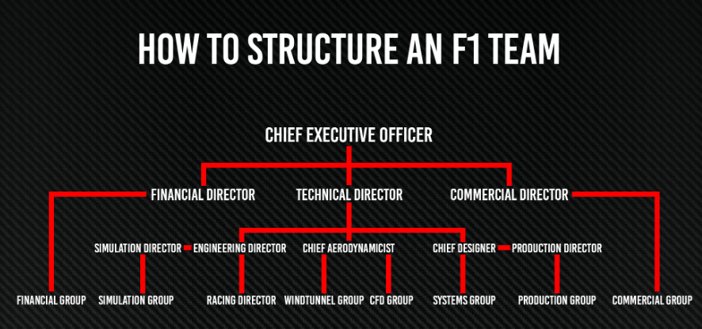
(Anderson, 2023)

Overall a more organised hierarchical team structure would have resulted in a more organised and efficient team working structure at the Pembrey test day.

Conclusion:

This report has covered the key practices required within engineering operations and the specific standards that must be met and followed by engineers. It has also highlighted the importance of health and safety as well as the regulations that must be followed by all employees and employers and engineers’ roles within society form an ethical and environmental sense. As well as this, the importance of security and what measures should be taken were analysed as well as the structure of a team and how potential problems can be analysed and solved effectively.

References:
Anderson, G. (2023). How Andretti must structure its F1 team. Retrieved from The Race: https://www.the-race.com/formula-1/gary-anderson-the-structure-andrettis-f1-team-will-need/
ASQ. (2025). Fishbone Diagrams. Retrieved from ASQ: https://asq.org/quality-resources/fishbone?srsltid=AfmBOopQ-fuhg8C4PwFtyFi3xnyN3mpq2GI2EezMncsy6JzgJInle2Dv
ASQ. (2025). What is Root Cause Analysis . Retrieved from ASQ: https://asq.org/quality-resources/root-cause-analysis?srsltid=AfmBOooJVhDbvv9ziKhAnPUUUJcspSI2Fkh9Cu-s9OtfkAXjNkMOKrXt
BBC. (2015). Hacked Jeep USB update criticised. Retrieved from BBC News: https://www.bbc.co.uk/news/technology-34156598
BBC News. (2025). Jaguar Land Rover posts heavy loss after cyber-attack. Retrieved from BBC News: https://www.bbc.co.uk/news/articles/ckg1w255gy1o
Composites Construction UK. (2023). What is carbon fibre’s environmental impact? Retrieved from CCUK: https://www.fibrwrap-ccuk.com/blog/from-strength-to-sustainability-unravelling-carbon-fibres-environmental-impact
Cornell University. (2025). Seeing is Deceiving: Mirror-Based LiDAR Spoofing for Autonomous Vehicle Deception. Retrieved from arxiv.org: https://arxiv.org/abs/2509.17253
Engineering Council. (2025). Setting Standards. Retrieved from engc: https://www.engc.org.uk/our-role-as-regulator/setting-standards
GOV. (1998). PUWER. Retrieved from HSE : https://www.hse.gov.uk/work-equipment-machinery/puwer-overview.htm
GOV UK. (2022, 4). PPE at work. Retrieved from Health and Safety Executive: https://www.hse.gov.uk/ppe/ppe-regulations-2022.htm
IMechE. (2025). CODE OF CONDUCT explained. Retrieved from imeche.org: https://www.imeche.org/about-us/imeche-governance/governance-and-finance-reviews/code-of-conduct-explained
Leasing.com. (2020). Keyless car theft. Retrieved from leasing.com: https://leasing.com/guides/relay-car-theft-what-is-it-and-how-can-you-avoid-it
Mansell, S. (2025). The Anatomy of an F1 Team: The Unseen Heroes Behind the Racing Glory. Retrieved from Fluid Jobs: https://fluidjobs.com/blog/the-anatomy-of-an-f1-team-the-unseen-heroes-behind-the-racing-glory
McIvor, M. (2021). The Logic Tree: The Ultimate Critical Thinking Framework. Retrieved from Global Insights: https://globisinsights.com/career-skills/critical-thinking/logic-tree/
Quality One. (2025). Eight Disciplines of Problem Solving (8D). Retrieved from Quality One International: https://quality-one.com/8d/

