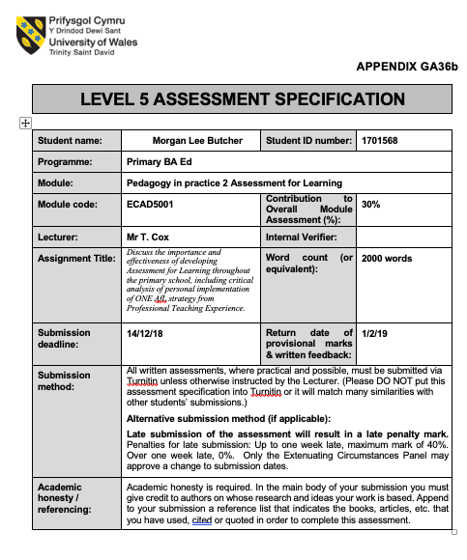
Sadler (1998) describes Assessment for Learning (AfL), also referred to as formative assessment, as assessment specifically intended to provide teachers or students with feedback to improve the student’s learning. The Assessment Reform Group (1999, p.2) state that AfL is one of the most ‘powerful educational tools for promoting effective learning’, however they emphasise it must be used correctly in order to benefit the learners. Jones (2005) explains that there are four elements of effective AfL; Sharing aims and criteria with the learner, providing and using feedback, quality of questions, and peer and self-assessment. The following information highlights the importance of using AfL in the classroom. Black and William suggest that AfL is effective when the students are actively involved in their own learning (Bates, 2016). This is reflected in Wales’ National Curriculum where it describes how learners should develop their ability to ask and answer their own questions and determine success criteria for their own work (DCELLS, 2008a). Donaldson (2015, p.69) is of the same opinion, as he determined that teaching is most effective when learners ‘take increasing responsibility for their own learning’. Donaldson (2015) and Black and Williams emphasise the importance of learners understanding the learning intensions and taking responsibility to achieve them (Bates, 2016). Hattie (2009) shows within his research that feedback from the students entailing what they can and cannot do is more effective than the teacher providing the students with feedback. This suggests that using AfL for pupils to determine where they are within their learning allows them to take responsibility of their own learning and informs the teacher of what they must do to progress their students. Jones (2005) highlighted the fact that the effectiveness of this element of AfL depends on the quality of the feedback given to the teacher of the learner. This shows that the teacher’s knowledge and understanding of the AfL strategy is imperative to the effectiveness of the strategy and its benefit on the pupils’ learning, to which Stiggins (2002) would agree as he questions whether teachers are prepared to implement effective AfL strategies within the classroom, due to their lack of experience and inadequate training. Fries-Gaither (2008) shows in her research that questioning pupils allows the teacher to evaluate their prior knowledge of topics and their learning within a lesson. However, as previously stated this is dependent on the teacher’s knowledge of effectively using questioning as an AfL strategy (Jones, 2005). Furthermore, Harrison (2013) states that implementing AfL requires teachers to reconsider their practice, to which many teachers are unwilling. Harrison (2013) and Stiggins (2002) both highlight the importance of the role of the practitioner for AfL strategies to be effective. Vygotsky was of the belief that people learn from ‘Most Knowledgeable Others’ and their interaction with them results in a greater understanding of information than what could have been comprehended alone (Bates, 2016, p.54). This is strongly linked to peer assessment and it shows that pupils peer assessing each other’s work provides them with the opportunity to learn and benefit from their work and provide them with feedback. In contrast, Abraham Maslow theorised that student comfort is a lower-order need that must be obtained in order to progress to higher-order needs, for example self-confidence (Bates, 2016). This implies pupils must feel comfortable when sharing work with peers or they will not benefit from the experience. Additionally, DeWitt (2014) states that in order for learners to be fully engaged they must be in a comfortable learning environment.
The AfL strategy that will be discussed within this assignment is an adaptation of the ‘Exit Notes’ strategy. The AfL strategy is comprised of two elements; Self-assessment and feedback from the pupils. During the plenary of a lesson the pupils were handed individual post-it notes, and it was explained to them that they must write their name, how they felt about the work they had produced, what went well during the lesson, what they need to do to improve their work, and, if they wanted to, write a comment to the teacher. The pupils were reminded of the success criteria of the lesson and were prompted to use it when reflecting on their work. The structure of the post-it notes used by pupils is shown in appendix 1. Once the pupils had completed their post-it note, they stuck it on the page they completed their work on, gave their book to the teacher, and then they were allowed to exit the class. The teacher will then use the ‘Exit Notes’ when planning future lessons to guide them on what information the pupils require to progress their learning, and also identify pupils whom require extra support within future lessons.
The strategy aims to develop the pupils’ ability to self-assess their work and understand which elements of the work is good and what they must do to improve. The Welsh Government highlighted the importance of pupils self-assessing their work and stated that it ‘fosters reflective learning’ (DCELLS, 2008b, p.11). Donaldson (2015, p.42) supports this as he suggests how Wales’ new curriculum should develop learners’ ‘personal effectiveness’ by providing them with opportunities to reflect on their own work and the work of others. Therefore, this shows how the AfL strategy is aligned with Donaldson’s (2015) suggestions for Wales’ new curriculum. Black and William (1998) also agree that self-assessment is an effective form of AfL, however they state that for it to be effective the learners must be taught how to self-assess their own work and teachers must provide them with the skills to understand the purpose of the learning and what they must do to achieve it. McDonald and Boud (2003, quoted in Nicol and Macfarlane-Dick, 2006) shows in their research that training students how to self-assess shows improvement in their examinations. When implementing the AfL strategy during Professional Teaching Experience the effectiveness of the strategy increasingly improved the more times the pupils used the strategy. Appendix 2 shows two examples of a pupils’ exit notes, the first ‘Exit Note’ they completed and their most recent. The improvement the pupil has shown with regards to their self-assessment exemplifies the statement by Black and William (1998) about the importance of learners understanding how to self-assess their work. Black and William (1998) continue to inform that learners are often either too critical of their own work or too kind. Jones (2005) agrees with Black and William, and states that the promotion of learner self-esteem is highly important for effective self-assessment. This shows that pupils must have an understanding of the expectations of the work, for example the success criteria, in order to effectively assess the work themselves and justify their assessment. Within the ‘Exit Note’ strategy, when pupils are reflecting on their work and their learning the teacher discusses and reflects on the success criteria and prompts the pupils to use it when writing on their post-it note. Sadler (1989) describes how incoherent expectations of work can result in ineffective AfL, suggesting that the success criteria of the lesson must be clear for all learners in order for them to effectively self-assess their work. Asking the pupils to state what they must do next to progress their learning justifies how they felt during the task and what went well as they have identified what they need to improve, showing an understanding of the success criteria, to which Black and William (1998) stated was required for effective self-assessment.

The strategy also provides the teacher with feedback on where the pupils currently are in their learning, where they need to go and what they must do to get there (DCELLS, 2008b). The Welsh Government describes how effective feedback results in the teacher redirecting their actions so that the student’s future learning is aligned with their learning expectations (DCELLS, 2008c). This shows that, by using the ‘Exit Notes’ as feedback from the pupils it allows the teacher to see what they must focus on to ensure that their learner is progressing. However, Nuthall (2007, quoted in Hattie, 2009) has shown within his research that 80% of feedback provided by students to the teacher is incorrect, and he implies that a number of students giving feedback are unequipped with the skills to accurately articulate their progression during a lesson. Jack Mezirow would agree, as he believed that critical reflection was a feature of adult education, which suggests that pupils of the primary school age would not be able to effectively reflect on their work (Bates, 2016). Nuthall (2007, quoted in Hattie, 2009) and Jack Mezirow (Bates, 2016) both imply that the feedback given from the pupils may not be an accurate representation of how the pupils are actually progressing, and therefore the teacher would not be able to effectively plan for the students’ future learning. During Professional Teaching Experience, the ‘Exit Note’ strategy was utilised during the first column subtraction lesson to a year 5 class. On the whole the class excelled with subtraction, which was reflected in their ‘Exit Notes’ by pupils suggesting that they should use bigger numbers to extend their understanding, as shown in appendix 3. However, Pupil A’s feedback informed the teacher that they found great difficulty in the lesson, as shown in appendix 4. This resulted in Pupil A’s work being examined where it was discovered that they had understood how to use the column subtraction method but their knowledge of subtracting 1-digit numbers from 1-digit numbers was insufficient. Therefore, the pupil’s feedback was used, and they were provided with a hundred square to support their subtraction and showed improvement during the lesson. This exemplifies, as stated by DCELLS (2008c), that pupils’ feedback can be used as an effective form of AfL to inform the teacher of how they must adapt their teaching to benefit the learner.

If the ‘Exit Note’ strategy were to be used as a whole school approach to AfL then the strategy must be adapted to accommodate each specific age group. Within the Foundation Phase the strategy would prove difficult to use as an effective form of AfL as the pupils are not able to physically write their reflections and ways forward. The strategy could be adapted for the Foundation Phase where the pupils use an application on an iPad to verbally record their reflection and way forward, allowing the teacher to listen to the learner’s reflection and adapt their future teaching. This is reflected within the Foundation Phase curriculum as it states that learners should be given the opportunity to ‘use a range of media’ and ‘communicate in a range of contexts’ (DCELLS, 2015, p.13). The questions used to prompt the reflection should include simpler vocabulary, such as ‘good’ and ‘better’, to ensure that the learners understand. The application could also include the teacher asking the questions to support lower attainable learners. With regards to a whole school approach, one would suggest that practitioners are trained to effectively use the AfL strategy, due to the statements previously made by Harrison (2013) and Stiggins (2002). The ‘Exit Note’ AfL strategy promotes the learners to self-assess their work and suggests ways they could improve it. This is increasingly relevant for the future of education in Wales, as Donaldson (2015) proposes that Wales’ curriculum should develop pupils’ ability to reflect on their work to become effective learners. However, if the AfL strategy were to be used during every lesson then the learners would omit developing other essential skills, for example peer-assessment and receiving feedback from the teacher. One of the goals of the curriculum is to create learning activities that challenge all learners, therefore using the same AfL strategy during every lesson would not continuously challenge learners and subsequently not achieve a goal of the curriculum (DCELLS, 2008a). Therefore, it is recommended that teachers use the strategy, among others that develop different skills, when appropriate. The strategy also allows the teacher to receive feedback from all pupils to which they would not achieve without speaking to each pupil individually, and the teacher can use the feedback to influence future lessons. On the contrary, Nuthall (2007, quoted in Hattie, 2009) would disagree as his research shows that 80% of learners do not have the ability to provide accurate feedback to the teacher. Therefore, it is recommended that the pupils must be taught how to self-assess their work, using the success criteria, and provide feedback to the teacher, based on Black and William’s (1998) statement that learners must be taught these skills. The strategy ensures that all pupils partake, as they must provide the teacher with the post-it note within their book before exiting the class. This means that once they have completed their exit-note they can go for their break. However, Alexander Neill theorised that rewards and punishments should be avoided and should not be relied upon to motivate students (Bates, 2016). This could also result in the feedback from the pupils being at a poor standard as they want to exit the classroom as soon as possible. Therefore, it is recommended that the ‘Exit Note’ allows pupils to line-up by the door and wait for the bell, as oppose to pupils wanting to finish the work to leave the classroom.

References
Bates, B. (2016) Learning theories simplified. London: SAGE Publications Ltd.
Black, P. and William, D. (1998) Inside the black box: Raising standards through classroom assessment. London: GL Assessment.
DCELLS. (2015) Curriculum for Wales: Foundation Phase Framework. Cardiff: Welsh Government.
DCELLS. (2008a) Skills framework for 3 to 19-year-olds in Wales. Cardiff: Welsh Assembly Government.
DCELLS. (2008b) Why develop thinking and assessment for learning in the classroom? Cardiff: Welsh Assembly Government.
DCELLS. (2008c) Assessment for learning and the National Literacy and Numeracy Framework. Cardiff: Welsh Assembly Government.
DeWitt, P. (2014) ‘Comfortable Learning Environment: Soften the Blow of Accountability?’ Education Week [blog]. 30th October. Available at: https://blogs.edweek.org/edweek/finding_common_ground/2014/10/comfortable_learning_environment_soften_the_blow_of_accountability.html (Accessed: 3rd December).
Donaldson, G. (2015) Successful Futures. Crown copyright. Available at: http://gov.wales/docs/dcells/publications/150317-successful-futures-en.pdf (Accessed: 6th December 2018).
Fries-Gaither, J. (2008) Questioning Techniques: Research-Based Strategies for Teachers. Available at: https://beyondpenguins.ehe.osu.edu/issue/energy-and-the-polar-environment/questioning-techniques-research-based-strategies-for-teachers (Accessed: 3rd December)
Harrison, C. (2013) ‘Assessment for learning: are you using it effectively in your classroom?’ The Guardian, 29th August. Available at: https://www.theguardian.com/teacher-network/teacher-blog/2013/aug/29/assessment-for-learing-effective-classroom (Accessed: 3rd December 2018).
Hattie, J. (2009) Visible Learning: A synthesis of over 800 meta-analyses relating to achievement. Oxon: Routledge.
Jones, C. (2005) Assessment for learning. London: Learning and Skills Development Agency
Nicol, D. and Macfarlane-Dick, D. (2006) ‘Formative assessment and self-regulated learning: a model and seven principles of good feedback practice’, Studies in Higher Education, 31(2), pp. 199-218. Available at: https://www.researchgate.net/profile/David_Nicol/publication/228621906_Formative_Assessment_and_Self-Regulated_Learning_A_Model_and_Seven_Principles_of_Good_Feedback_Practice/links/561bcc9808aea80367242f55.pdf (Accessed: 6th December 2018).
Sadler, D. R. (1989) ‘Formative assessment and the design of instructional systems’, Instructional Science, 18, pp. 119-144. Available at: http://pdf.truni.sk/e-ucebnice/iktv/data/media/iktvv/Symposium_LTML_Royce%20Sadler_BFormative_Assessment_and_the_design_of_instructional_systems.pdf (Accessed: 6th December).
Sadler, R. (1998) ‘Formative assessment: Revisiting the territory’, Assessment in Education, 5(1), pp.77-85.
Stiggins, R. J. (2002) ‘Assessment Crisis: The Absence of Assessment for Learning’, Phi Delta Kappan, 83(10), 758-765. DOI: 10.1177/003172170208301010
The Assessment Reform Group. (1999) Assessment for Learning: Beyond the Black Box. s.l: University of Cambridge.
The Assessment Reform Group. (2002) Assessment for Learning: 10 principles. Available at: http://www.hkeaa.edu.hk/DocLibrary/SBA/HKDSE/Eng_DVD/doc/Afl_principles.pdf (Accessed: 2nd December 2018).

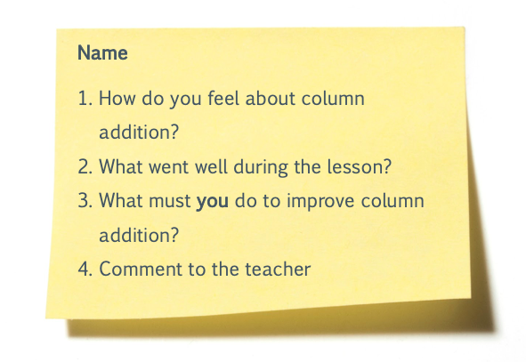
Appendix 1

Appendix 2
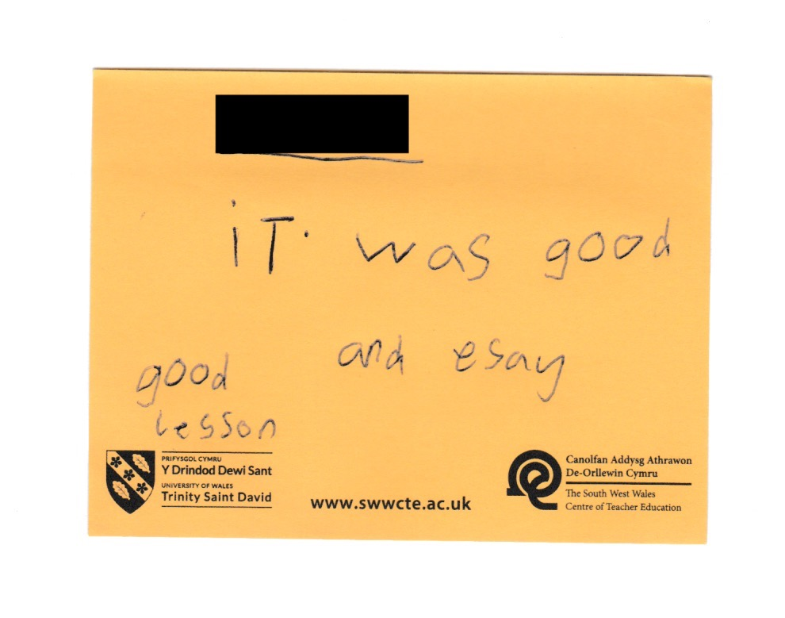

First time the pupil used the ‘Exit Note’ Assessment for Learning strategy

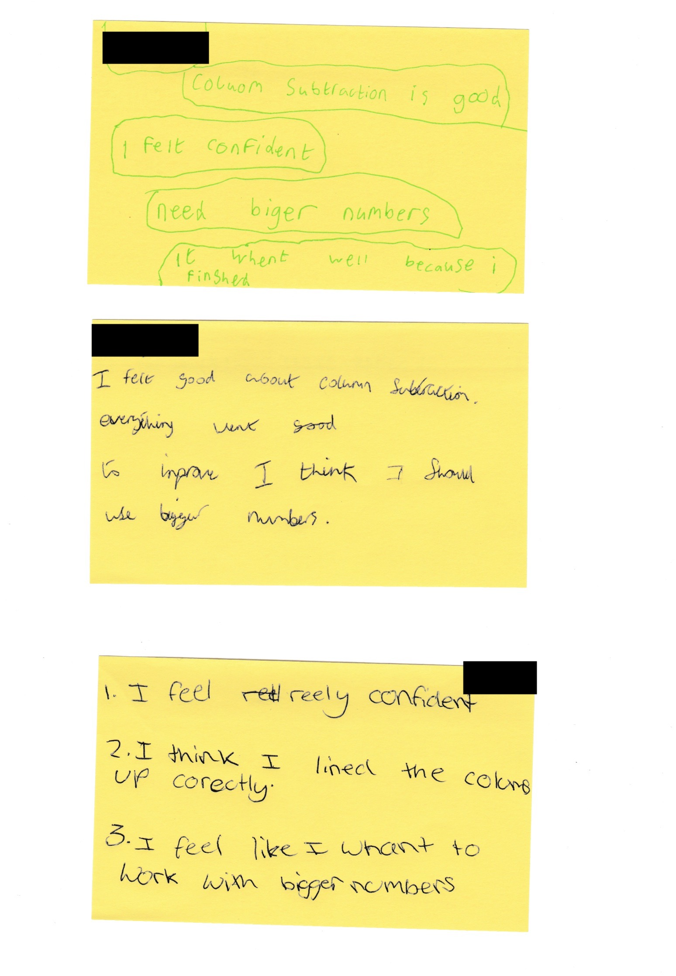

The most recent time the pupil used the ‘Exit Note’ Assessment for Learning strategy

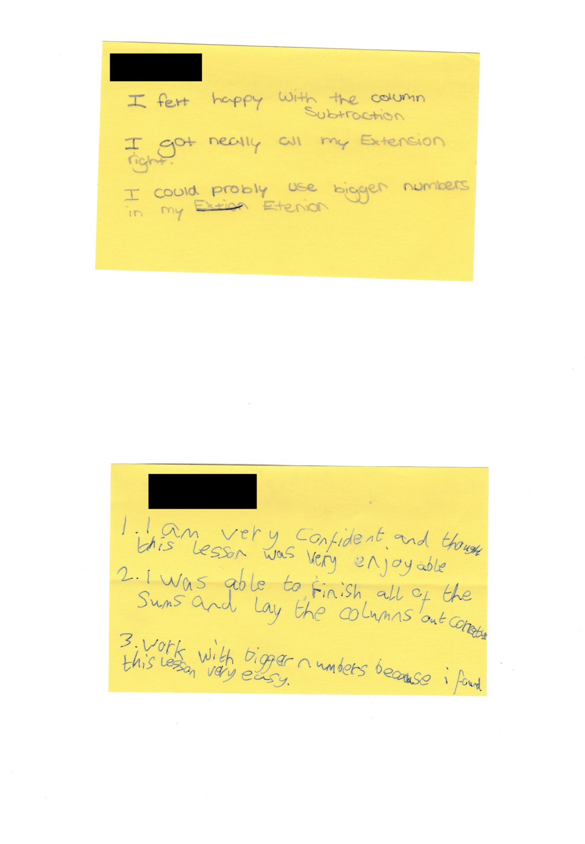
Appendix 3

Appendix 4


