Module Name: Managing Enterprise
Module Code: BMSW4011
Assessment: Business plan and reflection
Student Name: Ruzena Mizigarova
Student Number: 2321859
Lecturer: Mel Squire
Deadline: 6th March 23:59PM

Table of Contents
TASK 1 2
PART 1 – BUSINESS PLAN 2
1. Product / Service Proposition 2
2. The Idea Behind the Story 3
3. Business Ownership Structure 3
4. Mission, Aim, SMART Objectives & USP 4
5. Physical Location and Rationale 4
6. Human Resources 5
7. Marketing Activities 6
8. Market Research 6
9. Financial Resources 7
10. Competitor Analysis 9
11. SWOT Analysis and Viability Conclusion 9
TASK 1 11
PART 2 – REFLECTION 11
1. Entrepreneurial Skills Developed 11
2. Skills That Had the Biggest Impact 11
References 12

AI Acknowledgement
I confirm that I have not presented any AI- generated materials as my own work. I confirm that i have copies of my drafts, notes, and other resources I used, which I may be asked to provide in evidence.

TASK 1

PART 1 – BUSINESS PLAN

1. Product / Service Proposition
EcoGlow is an environmentally friendly luxury home fragrance and candle shop in Cardiff, in the city Centre. The company markets hand-poured soy and coconut wax candles, reed diffusers made of essential oils, wax melts, and a refillable candle system to minimize waste. The packaging of products can be done using recyclable and plastic-free substances, and this strengthens the environmental position of the brand (Rossi and Bianchini, 2022). EcoGlow will focus on the eco-friendly consumer aged between 20 and 45 years who appreciate ethical consumption and does not compromise on aesthetics. It is placed in the affordable luxury segment where sustainability and sophisticated design blend, and the customers have the privilege to enjoy a superior sensory experience (Minh and Hue, 2025).

Figure 1: EcoGlow – Sustainable Luxury Boutique

2. The Idea Behind the Story
EcoGlow was created due to increasing concern regarding the environmental effects of the candles made of paraffin and the overpackaging of the candles in the home fragrance market. As a sustainability-seeking consumer, I was able to see the gap in the retail market in Cardiff regarding a fully refillable and environmentally friendly luxury candle store. EcoGlow is not only an opportunity to become a business but also a lifestyle choice in terms of being ethical. This business endeavor is commercially viable and personally significant as it supports my environmental responsibility, creativity, and community involvement values (Camilleri et al., 2023).

3. Business Ownership Structure
EcoGlow will be a sole trader in business. This organization has been chosen based on its simplicity, low start-up, and total manager control. The benefits are that there are easy registration, fewer legal formalities, and retention of profits directly. Although such disadvantages are that there will be unlimited personal liability, and this is that it may not be easy to raise substantial capital. Despite these risks, sole trader status is suitable in the start-up stage as it offers flexibility in operation, easy decision-making, and administrative needs that can be handled as the business takes an interest in the market (Kluzek et al., 2023).

4. Mission, Aim, SMART Objectives & USP
Mission Statement
To enlighten households with sustainable, ethically designed luxury home fragrances that stimulate conscious life (Son, 2024).
Business Aim
To make EcoGlow the most sustainable luxury candle boutique in Cardiff in three years.
SMART Objectives
- Make a revenue of £60,000 in the initial 12 months.
- Increase the number of followers (both social media and combined) to 3,000 in a year.
- Achieve a 40% refill customer rate by Month 12.
- Achieve two local corporate gifting alliances in a year.

USP
The first refillable sustainable luxury candle boutique in Cardiff, a blend of environmentally creative ideas and design.

5. Physical Location and Rationale
EcoGlow store will be situated in Cardiff city Centre, which would preferably be in Morgan Arcade because it has a good independent retail culture and pedestrian traffic. The location has attracted professionals, students, and tourists who visit landmarks that are close to the area like Cardiff Castle. This population segment fits well in the target market of EcoGlow, which is environmentally conscious for consumers who want to purchase high-quality lifestyle products. The location of the boutique in a vintage arcade supports the luxury image of the brand, as well as the distinction between it and other stores selling the same products to an average consumer (Debenedetti, 2021).
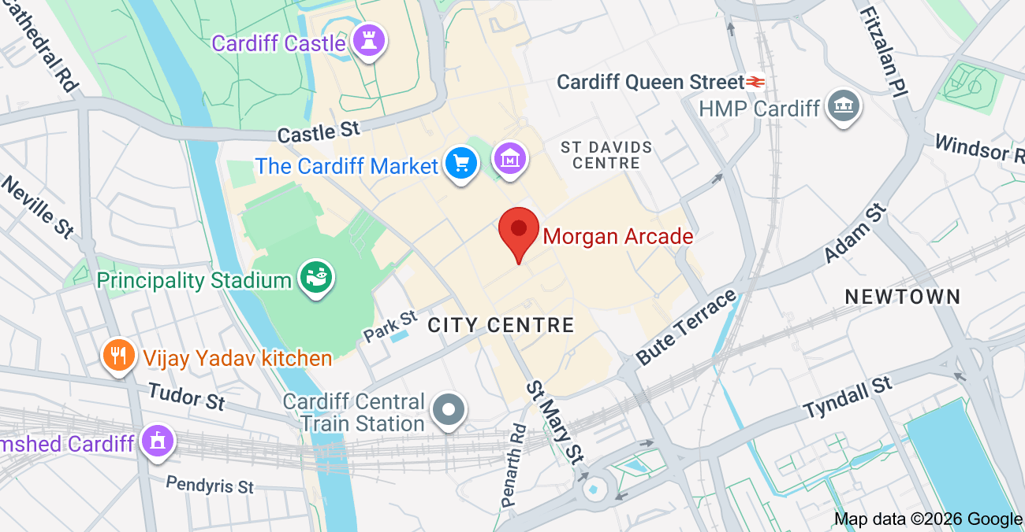
Figure 2: Google map of Morgan Arcade

6. Human Resources
In the first year, EcoGlow will hire two personnel: the Owner/Manager (full-time) and a part-time Sales Assistant. The Owner will control production, financial management, coordination of suppliers, marketing strategy, and workshop facilitation (Jaboob et al., 2024). The Sales Assistant will also oversee customer service, the refill station, and in-store sales assistance.
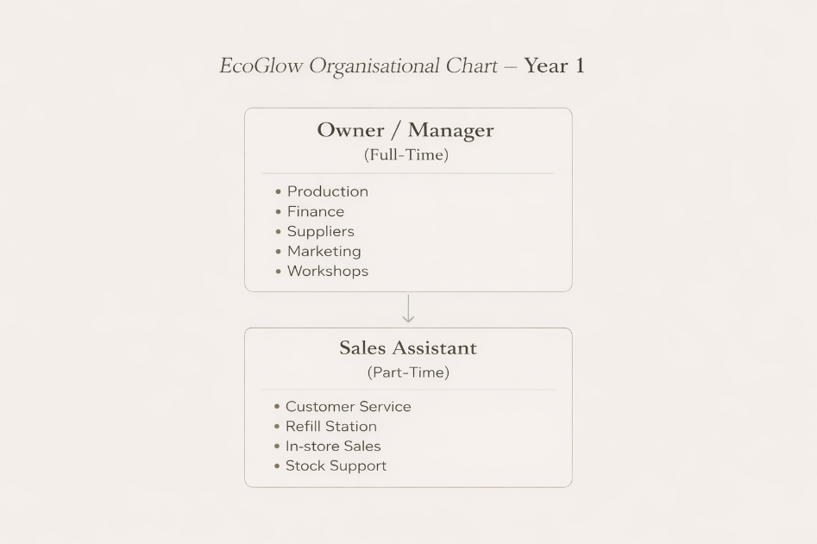
Figure 3: Organizational Structure
This lean system reduces labor expenses, and there is also efficiency in the operations at the early stages of growth (Ghelani, 2021).

7. Marketing Activities
The strategies that EcoGlow will embrace in the marketing mix will be digital, experiential, and local PR campaigns. Instagram and TikTok will feature behind-the-scenes production, sustainability education, and product launches in the form of short-form videos. A promotion that will be used will be a Refill and save promotion, where returning customers will have a 15 percent discount on their purchases. Local lifestyle bloggers and Wales Online will be covered in PR campaigns. The workshops on monthly candles will create engagement and brand loyalty within the community.
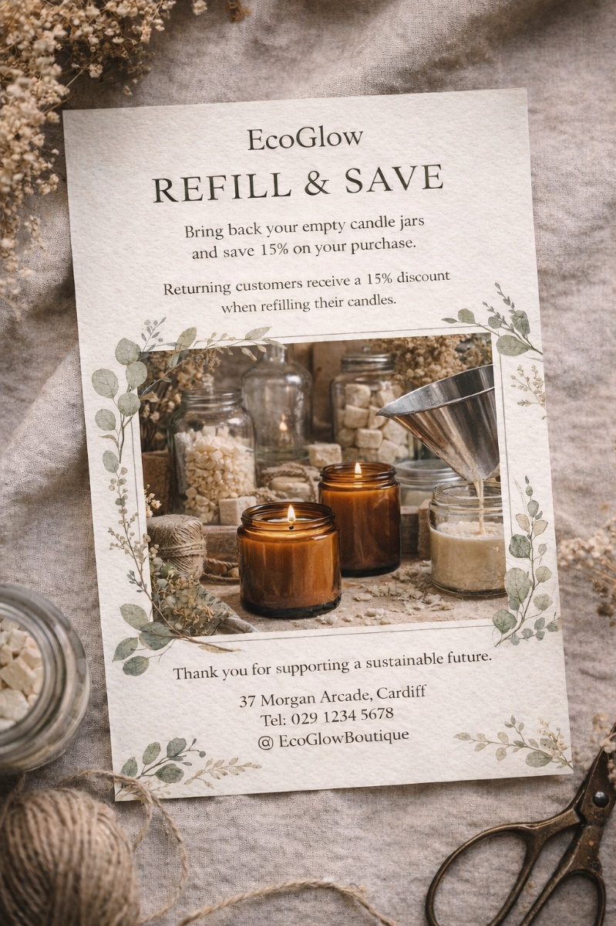
Figure 4: Refill & Save at EcoGlow

8. Market Research
The online survey involving 50 people in the city of Cardiff was the primary research. It was shown that 68% of people like environmentally friendly candles, 72% are ready to pay more for sustainable packaging, and 60% buy candles at least once a month. Instagram polls were also used to verify the interest in refillable options. Secondary research resulted in the consistent growth of the UK sustainable retail market growing and people becoming more interested in ethical luxury products (Kunz et al., 2020). These results directly impacted the refill model, premium pricing strategy, and selection of the location in a city Centre EcoGlow, as it indicates obvious demand in the market and help to prove the business viability.
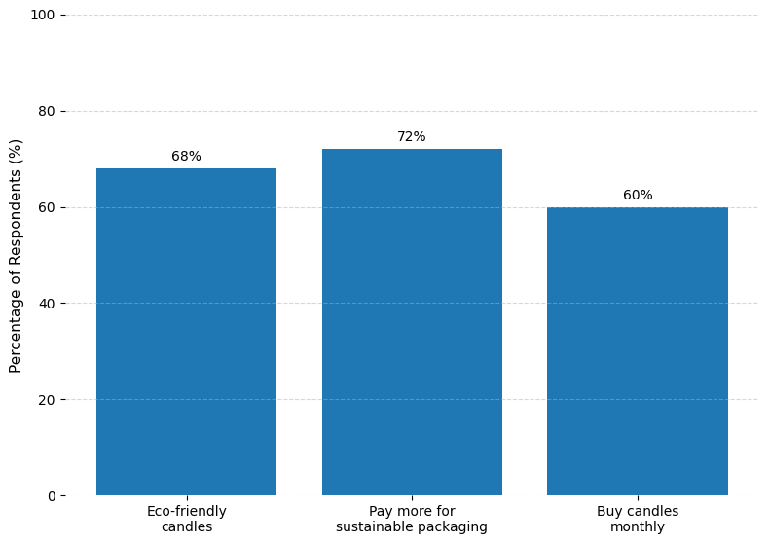
Figure 5: Cardiff Sustainable Candle Market Survey

9. Financial Resources
Table 1: EcoGlow Financial Overview — Start-Up Costs, Funding Structure, Operating Expenses, and Break-Even Analysis
Category | Item / Detail | Amount (£) | Notes
Start-Up Costs | Rent Deposit (3 months) | 6,000 | Based on £2,000 per month city-Centre unit
 | Shop Fit-Out & Interior | 7,000 | Shelving, counters, decor, lighting, signage
 | Equipment | 3,500 | Wax melters, molds, safety equipment
 | Initial Inventory | 4,500 | Wax, oils, jars, packaging, diffusers
 | Branding & Marketing | 2,000 | Website, logo, printed materials, launch
 | Licenses & Insurance | 1,500 | Public liability, product insurance
 | POS System & Technology | 1,000 | Till system, card reader, laptop
 | Working Capital Reserve | 4,500 | 3-month cash flow buffer
 | Total Start-Up Costs | 30,000 | Fully funded at launch
Sources of Finance | Personal Savings | 15,000 | Owner investment
 | UK Start-Up Loan | 15,000 | Government-backed loan
 | Total Funding Available | 30,000 | Matches total start-up costs
Monthly Operating Costs | Rent | 2,000 | Fixed cost
 | Utilities | 250 | Electricity & water
 | Part-Time Staff Wages | 900 | Sales assistant
 | Stock Replenishment | 1,200 | Variable cost
 | Marketing Budget | 300 | Social & promotions
 | Insurance | 125 | Monthly allocation
 | Miscellaneous | 225 | Contingency
 | Total Monthly Costs | 5,000 | Fixed & variable combined
Sales Forecast (Month 1) | Revenue | 4,000 | Initial trading month
 | Expenses | 5,000 | Operating costs
 | Net Cash Flow | -1,000 | Early deficit
Sales Forecast (Month 8) | Revenue | 7,500 | Growth stage
 | Expenses | 5,000 | Operating costs
 | Net Cash Flow | +2,500 | Profit begins scaling
Sales Forecast (Month 12 – Peak) | Revenue | 12,000 | Christmas peak
 | Expenses | 5,500 | Slight seasonal increase
 | Net Cash Flow | +6,500 | Strong seasonal profit
Break-Even Analysis | Monthly Fixed Costs | 5,000 | Based on operating costs
 | Gross Margin | 60% | Average margin on products
 | Break-Even Revenue Required | 8,333 | £5,000 ÷ 0.60
 | Units Required Per Month | 298 candles | £8,333 ÷ £28
 | Projected Break-Even Month | Month 8 | Based on Forecast

Financial Feasibility Evaluation
- A slow increase in revenues is realistic in terms of building brand awareness.
- The improvement in profitability is made very high by seasonal peaks (Christmas).
- The margin of 60% is healthy to sustain operations.
- The start-up loan is sustainable as there is a good cash flow after Month 8.
- Working capital reserve ensures early negative months of cash flows.

10. Competitor Analysis
The main competitors are: The White Company, Jo Malone, Cardiff gift boutiques on their own, and online Etsy sellers. There are premium brands that have high brand recognition but are much more expensive and do not have refill programmers like Jo Malone. Independent sellers are sellers with a handcrafted appeal, but little retailer presence (Kumar et al., 2021). EcoGlow will be distinguished by its luxury positioning, which is refillable, and good environmental policies. Competitive analysis proves that there is an opportunity in Cardiff in the mid-high range sustainable boutique that will provide an affordable yet high-quality experience.

11. SWOT Analysis and Viability Conclusion
Table 2: EcoGlow – Detailed SWOT Analysis
SWOT Category | Factor | Detailed Explanation | Impact on Business | Strategic Response
Strengths | Clear Sustainable USP | EcoGlow is positioned as Cardiff’s refillable, sustainable luxury candle boutique, differentiating it from competitors. | Strong brand differentiation and customer appeal. | Place more emphasis on sustainability messages in every marketing campaign.
Strengths | Refillable Innovation | The refill system reduces waste and encourages repeat purchases. | Increases customer retention and promotes loyalty. | Install loyalty programmers based on refill frequency.
Strengths | Luxury Boutique Positioning | Located in Morgan Arcade, enhancing premium perception. | Justifies a mid-to-high pricing strategy. | Ensuring high-end store designs and branding.
Strengths | Strong Founder Commitment | Owner-led management ensures passion and quality control. | Greater quality control and brand recognition. | Continue direct customer engagement and storytelling marketing.
Weaknesses | Limited Initial Capital | The £30,000 start-up budget restricts rapid expansion. | Slower early growth potential. | Strive to keep a lean cost base and strategic reinvestment of profits.
Weaknesses | Low Brand Recognition | New entrant in a competitive retail market. | First challenge in getting a steady flow. | Invest in local PR and influencer collaborations.
Weaknesses | Small Staffing Structure | Only two employees in Year 1. | Strain operations at peak times. | Take part-time flexibility and schedule optimization.
Weaknesses | Dependence on Local Market | Primarily reliant on Cardiff footfall. | The revenue will be subjected to fluctuations in the local economy. | Develop e-commerce and online sales channels.
Opportunities | Growth in Ethical Consumerism | Rising demand for sustainable products. | Expanding target market size. | Position EcoGlow as sustainability leader in Cardiff.
Opportunities | Corporate Gifting Expansion | Businesses seeking sustainable gifting solutions. | Additional B2B revenue stream. | Formulate corporate packages and local alliances.
Opportunities | E-commerce Development | Online platforms enable nationwide sales. | Increases scalability beyond Cardiff. | Launch website in Year 2 with delivery options.
Opportunities | Subscription Services | Monthly candle subscription model. | Predictable recurring revenue. | Launch collections and subscription offers that are limited.
Threats | Economic Downturn | Reduced discretionary spending on luxury goods. | Lower sales volume. | Provide discounted deals and value deals.
Threats | Established Luxury Competitors | Strong competition from recognized brands. | Customer loyalty barriers. | Emphasize refill USP and local independent appeal.
Threats | Rising Rental Costs | Morgan Arcade retail costs may increase. | Higher fixed expenses reduce profit margins. | Negotiate the lease conditions and track the alternatives for relocation.
Threats | Supply Chain Price Fluctuations | Wax and essential oil price volatility. | Increased production costs. | Enter into long term supplier contracts and diversify suppliers.

Conclusion on Viability
EcoGlow has strong market alignment, differentiation, and scalability despite the presence of financial and competitive risks. The sustainability focus and refill model will offer the competitive edge that will contribute to the overall business viability and long-term development opportunities.

TASK 1

PART 2 – REFLECTION

1. Entrepreneurial Skills Developed
I have also acquired and enhanced a very broad base of entrepreneurial skills that go beyond theoretical knowledge through the course of the Managing Enterprise module. Financial planning and cost awareness have been one of the largest spheres that have grown. The lectures in finance on fixed, variable, and capital costs, cash flow forecasting, and break-even analysis made me think critically regarding the realistic financial requirements of the launching of EcoGlow. I shifted my perspective on what profit is (sales and costs) to the realization of liabilities management, revenue anticipation, and continuous positive cash flow.
I also improved my market research and marketing skills. The knowledge of market segmentation and targeting, positioning and differentiation strategies helped me to clearly clarify the sustainable luxury positioning of EcoGlow. I did not assume that there was demand but used systematic research methods to find a given target market and match my product offering on similar lines.
The third way to improve strategic thinking was to undertake a SWOT analysis and an appraisal of my business idea. This made me analyze the weaknesses and threats in a true manner as opposed to concentrating only on the strengths. Besides, my knowledge about the planning of recruitment, legal obligations, and leadership issues that were taught by human resources gave me insight into the multifaceted nature of responsible people management.
Organizational skills and time management were also examined as several parts of the business plan were prepared within time limits. On the whole, the module has enhanced my analytical thinking mentality and my practical entrepreneurial consciousness.

2. Skills That Had the Biggest Impact
Financial literacy was the skill that affected me the most. Before this module, I did not value the significance of identifying and forecasting the costs in detail and cash flows. I was essentially changed in how I viewed the viability of a business with the concept of fixed costs and their fixity in regard to the sales volume. Now I understand that only passion will not keep a business alive, and hard financial planning will.
My attitude was also greatly affected by data-driven decision-making. My ability to support the pricing approach, market positioning, and differentiation by doing research instead of relying on opinions made me more confident in strategic planning. I have now realized the significance of evidence-based thinking in the success of an entrepreneur.
Lastly, self-awareness building by means of critical appraisal and SWOT analysis enabled me to recognize aspects of further development, most specifically the risk management policy and scalability in the long term. This insight has made me stronger and more ready to face the business challenges of the world.
Generally, this module has changed my knowledge of entrepreneurship from a creative thought to a process that is structured, strategically oriented, and financially based. I am now more confident, analytical, and professionally equipped to venture into entrepreneurship in the future.

References
- Camilleri, M.A., Troise, C., Strazzullo, S. and Bresciani, S., 2023. ‘Creating shared value through open innovation approaches’: Opportunities and challenges for corporate sustainability. Business Strategy and the Environment, 32(7), pp. 4485-4502. https://doi.org/10.1002/bse.3377
- Debenedetti, A., 2021. ‘Luxury stores as home-like places’: How domestic meanings are staged and mobilized in luxury retail. Journal of Business Research, 129, pp. 304-313.
- Ghelani, H., 2021. ‘Advanced in lean manufacturing’: improving quality and efficiency in modern production systems. Valley International Journal Digital Library, pp. 611-625.
- Jaboob, A.S., Awain, A.M.B., Ali, K.A.M. and Mohammed, A.M., 2024. ‘Introduction to operation and supply chain management for entrepreneurship’. In Applying Business Intelligence and Innovation to Entrepreneurship (pp. 52-80). IGI Global Scientific Publishing.
- Kluzek, M., Bielicki, M., Schmidt-Jessa, K., Gabrusewicz, T. and Perez, K., 2023. ‘Legal Form Choice’: Uncovering Influential Factors for Entrepreneurs in a Young Market Economy. Available at SSRN 4593382. https://dx.doi.org/10.2139/ssrn.4593382
- Kumar, A., Sikdar, P. and Saha, R., 2021. ‘Seller experience assessment in online marketplace’: a scale development study. Benchmarking: An International Journal, 28(7), pp.2315-2342.
- Kunz, J., May, S. and Schmidt, H.J., 2020. ‘Sustainable Luxury’: Status and perspectives for future research. Business Research, 13(2), pp.541-601. https://doi.org/10.1007/s40685-020-00111-3
- Minh, H.V. and Hue, N.T.T., 2025, October. ‘Branding Strategies in the Luxury Goods Market’: Managing Brand Identity, Customer Perception, and Competitive Positioning in a Saturated Market. In Proceedings of the International Conference on Contemporary Studies in Social Sciences (ICSSSS 2025) (p. 97). Springer Nature.
- Rossi, J. and Bianchini, A., 2022. “Plastic waste free”–A new circular model for the management of plastic packaging in food value chains. Transportation Research Procedia, 67, pp.153-162. https://doi.org/10.1016/j.trpro.2022.12.046
- Son, E., 2024. ‘A review of air pollution and ethical consumption behavior due to fragrances. Environmental Research and Technology, 7(4), pp. 626-636. https://doi.org/10.35208/ert.1453891

