SOLIDS WORKSHEET

Solids 1. IPF
1. Which type of intermolecular/interparticle force exists in all solid substances?
(A) dispersion forces (B) dipole-dipole forces
(C) ionic bonds (D) covalent bonds
2. Which of the following is not matched with the appropriate dominant form of interparticle force present in the solid?
(A) Mg- London Dispersion (B) methane, CH₄ - London Dispersion
(C) SiO₂ - covalent bonds (D) CH₃F – dipole dipole
(E) KNO₃ - ionic bonds

3. Which of the following is not matched with the appropriate dominant form of interparticle force present in the solid?
(A) Ar - London Dispersion (B) C (diamond) - London Dispersion
(C) NaCl - ionic bonds (D) CH₂O – dipole dipole
(E) Na – metallic bonds

Solids 2. Properties/H-Bonds

4. As heat is added to the system, what occurs from point (a) to point (b)?
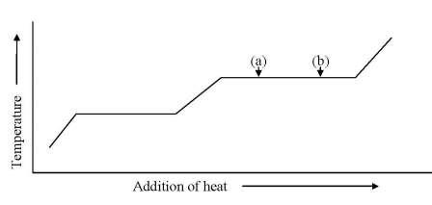
(A) a solid is melting (B) a liquid is boiling
(C) a liquid is increasing in temperature (D) a gas is decreasing in temperature

5. Rank the various "heats" of water in order of decreasing size (out of heat of fusion Δ_{fus}H, heat of sublimation Δ_{sub}H, heat of vaporization Δ_{vap}H.
6. For solid substances of the same approximate formula mass, the lowest molar heat of fusion is to be expected for
(A) Ionic substance (B) Polar covalent substance
(C) Non-polar covalent substance (D) Metallic substances
(E) Network covalent structures
7. The later members of group VIA form hexafluorides: SF₆, SeF₆, and TeF₆. At a given temperature, one of these is a solid, one a liquid and one a gas. Specify which is which.
8. Which of ethane and ethanol experience London Dispersion forces in the solid and liquid states?
9. Which of the following correctly lists the compounds in order of increasing strength of intermolecular forces?
(A) H₂S, H₂O, NO (B) CH₃CH₃, CO₂, CH₄
(C) CH₄, H₂S, NH₃ (D) NH₃, HF, H₂S

10. Which of the following has the lowest boiling point?
(A) HF (B) HCl (C) HBr (D) HI

11. Which of the following substances should have the highest heat of vaporization?
(A) SiH₄ (B) NH₃ (C) HCl (D) PH₃ (E) H₂S

12. Which of the following should have the highest boiling point?
(A) SiO₂ (B) Ar (C) CO₂ (D) Hg (E) H₂O

13. Which of the following substances would be expected to have the highest melting point?
(A) CH₃CH₂CH₂OH (B) CH₃OCH₃ (C) CH₃CH₂CH₂CH₂CH₃
(D) HOCH₂CH₂OH (E) CH₃CH₂OH

Solids 3. Phase Diagrams
14. For a pure substance, three phases are present simultaneously at …………..
15. The critical temperature of oxygen is –118°C. What pressure is required to form liquid oxygen at room temperature, about 25°C?
16. Which of the following statements is true?
(A) Both the triple point and the critical point of a substance are dependent on the substance only, but not on temperature or pressure.
(B) Both the triple point and the critical point of a substance increase with a decrease in temperature.
(C) The triple point of a substance increases when the pressure increases.
(D) The critical point of a substance decrease when the temperature increases.

17. Which of the following is false concerning sublimation?
(A) The reverse process of sublimation is deposition
(B) At pressures below the triple point, substances can sublime.
(C) Dry ice (frozen CO₂) can be liquified at pressures above the triple point pressure
(D) Ice cannot sublime
18. Consider the phase diagram shown. Which of the following statements is incorrect?
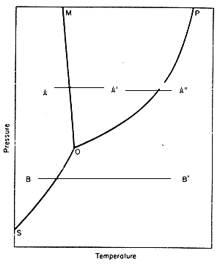
(A) The path A to A" through A' represents melting and then vaporization.
(B) O represents the triple point of the substance.
(C) P represents the critical point of the substance.
(D) The path B to B' represents sublimation.
(E) The substance for which this is the phase diagram cannot be water.
19. According to the phase diagram of methanol shown, which statement is correct? 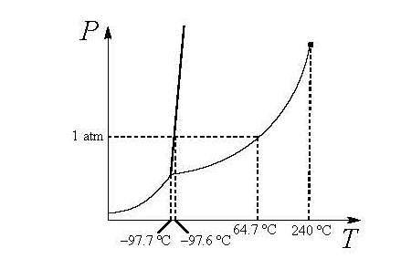
(A) Solid, liquid, and gaseous methanol can only coexist at pressures above 1 atm.
(B) Solid methanol sublimes at atmospheric pressure.
(C) At 200 ºC and 1 atm pressure, methanol is a supercritical fluid
(D) Water and methanol have the same relationship between freezing point and pressure as they both have hydrogen bonding
(E) At 1.25 atm pressure, the boiling point of methanol is greater than 64.7 ºC
Solids 4. Bonding etc
20. Which one of the following properties is least characteristic of substances composed of small, covalently-bonded molecules?

(A) low melting point (B) low boiling point
(C) weak bonds (D) poor electrical conductor when solid
(E) poor electrical conductor when molten

21. Which of the following properties is least characteristic of metals?

(A) high melting point (B) high boiling point
(C) brittleness (D) good electrical conductor when solid
(E) good electrical conductor when molten

22. Which of the following properties is least characteristic of ionic compounds?

(A) high melting point (B) high boiling point
(C) brittleness (D) poor electrical conductor when solid
(E) poor electrical conductor when molten



