LO1: Be able REVIEW AND EVALUATE AN ORGANISATION’S APPROACH TO TALENT PLANNING.

  - Assess how and to what extent the organisation undertakes workforce and talent planning.

Workforce planning is defined by the CIPD (2021) as the course of stabilising the skills or labour supply against what is required. The CIPD (2021) maintains it is ‘about getting the right number of people with the right skills employed in the right place at the right time, at the right cost and on the right contract to deliver an organisation’s short and long-term objectives.’

The workforce plan at the Neath Port Talbot Council (NPTC) shares some similarities with this, as it establishes that the aim of the plan is ‘to ensure that the Council has the right number of people with the right skills and attitudes in place at the right time to deliver its services and functions’, as we can see on EV1.

The NPTC workforce plan has been implemented since 2018, and was designed on the foundation of the following steps:

- Setting out the key challenges for our employees over the following five years, articulated in the Corporate Plan objectives and priorities, the Medium-Term Financial Plan, the Asset Management Plan and the Corporate Risk Register.

- Understanding the current workforce within the Council and the issues which may affect the capacity and supply of suitably skilled employees over the next five years.

- Seeking to anticipate the demand for employees and specifically the sort of skills and competencies required to take the Council forward.

- Developing an action plan to seek to ‘bridge the gap’ between our current and identified future workforce needs.

- Establish mechanisms for monitoring and reviewing the plan and sustaining the workforce planning processes.

This, once again, shows a resemblance with the different stages to the workforce planning process found by the CIPD (2021), as we can see in the figure below.

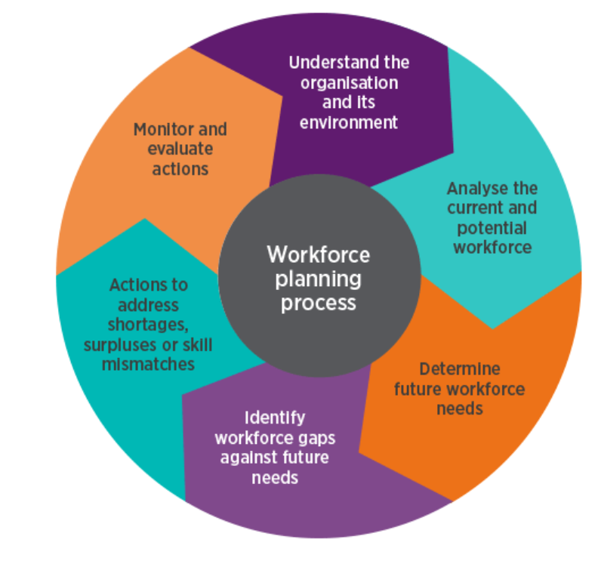CIPD, 2021

The NPTC workforce plan analysed the workforce in 2017 and identified significant underlying trends, as shown on EV2. It is interesting to see that the highest percentage of employees falls under the directorate of Education, Leisure and Lifelong Learning as Teaching Staff (23%), and on the previous two years the workforce was reduced by 6.18%, the result of the challenging financial pressures, along with the economic, social, legislative and demographic. Moreover, in terms of absence, the main reason was stress and mental health.

The plan intended to shape the workforce on the following 5 years, to attract, retain and motivate the employees with the best skills to deliver services and achieve the strategic goals, once more basing it on the CIPD (2021) statement which establishes that by implementing workforce planning, the organisations may:

- Reduce labour costs.
- Improve employee retention
- Improve quality and productivity
- Enhance employees’ work-life balance
- Target inefficiencies
- Respond to customer needs
- Identify strategies for developing employees

The NPTC workforce plan states that it must be aligned with the Council’s Vision, Values, Well-being Objectives, Financial Planning, Asset Management Planning and Governance Arrangements, in order to understand what the future workforce will look like, how they will work and what their objectives will be, as we can see on EV3. Once more, it agrees with the CIPD (2021), which maintains that workforce planning ought to be linked to the organisation’s objectives and be part of the strategic business planning process.

It is important to highlight the Medium-Term Financial Plan (EV4), where it is stated that the Council’s budget was reduced by £78 million since 2010, resulting in reducing the workforce by a quarter. Thanks to the Council's social partnership between the elected members, officers and trade unions, all the change programmes required to reduce staff were delivered protecting the workforce from compulsory redundancy to the maximum extent possible.

The Council also counts on the Head of Service Workforce Planning Group, which includes trade union members and meets regularly to manage the reduction in staff whilst safeguarding employment and decreasing compulsory redundancies. One of the measures reinforced by the group was the restrictions on external recruitment, which gives priority in a recruitment and selection process to those in risk of redundancy or medical redeployment. I have enclosed the Council’s Recruitment and Selection policy (EV5).

As Covid hit in 2020, the Workforce Planning Strategy’s focus was to redeploy employees to front line services. An example was the implementation of the Safe and Well Scheme, which delivered essential goods to those vulnerable people within the Neath Port Talbot County Borough. I have attached a spreadsheet with some examples of redeployment (EV6).

  - Analyse internal and external information relating to the organisation’s future people and skills needs and the availability of talent.

I have analysed internal information regarding the staff who left the Council since October 2021 until March 2022. One of the sectors with a high number of leavers is Social Services, with a total of 64 within that period (EV7). As of 16th of May 2022, there are 13 jobs posted in the Council’s jobs portal, some of which contain more than one vacancy (EV8).

The Department of Health and Social Care (Gov.uk, 2021) has published the results of the Adult Social Care workforce survey, which collected responses from almost 9,000 adult social care settings in England. Unfortunately, I have been unable to find similar results for Wales, but the responses gathered from this survey show a significant similarity with the situation in the Council. The main issue shown in this survey is the challenge in recruiting staff and accessing agency workers, with percentages of 81.9 and 77.9, respectively. The following areas which the respondents found also challenging were recruiting and maintaining morale (EV9). As regards to the reasons why staff leave, the survey found that it is due to a better pay outside the care sector (EV10).

When comparing these results to the data from the Council, a quarter of the leavers did not provide a reason, whereas from the 75% of the remaining departers, retirement and promotion elsewhere are the next most common causes (EV7).

The Social Care sector shows both skills shortage for the near future, both in NPTC and England, but also it has acquired a negative image as a profession, especially since Covid hit us, due to the long working hours caused by self-isolating staff, and the low remuneration (BBC News, 2021).

  - Assess the extent to which current organisational planning activities are addressing potential needs.

The NPTC has received an increase on funding, resulting in the creation of the Recruitment Taskforce Team at the end of 2021, which I joined in January 2022. Its aim is ‘to fill vacant posts across the Neath Port Talbot County Borough with suitably qualified and experienced people and to do so at pace, working with key partners’ (EV11).

As of 15th of November 2021, there were 100 vacancies only in Social Services, reduced to 61 by the 7th of December 2021 (EV11). The Recruitment Taskforce Team has had a substantial impact on the reduction of the vacancies, by supporting the managers rewriting Job Descriptions and Person Specifications, and attending job fairs.

The pay scale of social care staff, from the newly qualified social worker to the principal social worker, was analysed through eleven councils, including Neath Port Talbot. The pay scales included the basic pay and the market supplement, along with other incentives that the council is providing. I have been unable to obtain a copy of the report due to confidentiality, but the recruitment specialist has confirmed that discussions are still ongoing to match our pay scale in the Council to the market rate.

The Training department has also developed some Taster Sessions, which are being promoted in the job fairs through leaflets and via social media, as we can see on EV12, although they have not been remarkably successful so far, as per the feedback received.

The Council is also providing information on its website about different training programmes related to Social Care (EV13), published every year in April. There is also a rolling advert for Social Workers on the jobs portal (EV14), as an ongoing process to create a talent pool.

LO2: BE ABLE TO RECOMMEND WAYS TO IMPROVE AN ORGANISATION’S APPROACH TO TALENT PLANNING.

- Make reasoned recommendations for how the organisation can maintain an appropriate number of people with the skills required by the organisation.

Reilly (2015) establishes that the execution of a workforce plan is usually its execution, as it is usually the management team who argue that its design is complicated and HR requests information that is hard to produce.

Reilly (2015) recommends drawing up a straightforward plan, focusing only on key information to identify business issues to find out what caused them. It is also imperative that the plan is aligned with other HR processes, such as succession planning, which refers to the activities that will allow the organisation to develop their employees in order to move into roles when they become vacant or new positions created due to expansion (Wilkinson and Taylor, 2016).

NPTC has a Succession Planning Toolkit (EV15) with specific details on how to carry it out. There is also a page with The Training and Development department is also planning on delivering training sessions for managers to be confident with the tool (EV16). This toolkit is also in the process of being used to recruit new employees in the SWTRA (South Wales Trunk Road Agent), as per email on EV17.

Since the NPTC workforce planning was implemented in 2018, two years before the pandemic hit all over the world, there have been changes in provisions and processes impacting on the workforce and this has created a need for all the organisations to undertake workforce planning (CIPD, 2021), not only due to Covid, but also as a consequence of Brexit, which has produced changes in the labour market.

As I have mentioned before, the Social Services directorate in NPTC has experienced a high turnover in the last six months. A great deal of work has been already carried out by the Recruitment Taskforce Team since January 2022, but the figures still show 13 vacancies to recruit for (EV8).

Recommendations

- To provide the Home Care Workers with a mean of transportation, such as rental cars, since the budget for the Council has been increased, to enable them to reach to these rural areas where there is limited transportation. One of the requirements to work as a Home Care Worker is to be able to drive and to own a car to the different locations where they are needed, most of them situated in rural areas within the Neath Port Talbot County Borough. The leaflet created by our marketing team (EV18) highlights the benefits of working as a Home Care Worker, which, after attending different jobs fairs during the months of March, April and May 2022, the feedback received from potential candidates was that some of them did not own a car or could not even drive.

- To partially fund the costs of obtaining a driving license, as a method of training the staff, taking advantage of the budget increase within the council.

- To liaise with the comprehensive schools to offer our Taster Sessions in Social Care, which have only been promoted through the job’s fairs, and extend it to the Swansea area too. As an example, Swansea University is promoting some of its Engineering Studies in different schools across the United Kingdom, as per conversations with some employees involved in this. They show presentations about their area of work and day to day tasks, but also, they involved the students in practical activities which seem to be very engaging and give them an idea of what the work would be like.

- Rebranding our job adverts, job descriptions and person specifications. Recently, the NPTC jobs portal has been redesigned to make it more attractive to the candidates. However, when looking at the job adverts, job descriptions and person specifications, I have found that there is no consistency, each directorate seems to have their own template to fill in, and the format seems old and untidy. By looking at the documentation from other institutions, some changes might be implemented, such as ensuring the wording is not discriminative and by adding some of the values from our corporate plan.

LO3: BE ABLE TO CONTRIBUTE TO PEOPLE RESOURCING STRATEGIES.

  - Identify and explain the rationale for a specific resourcing activity within the organisation.

In 2021, there was a substantial amount of job vacancies across the NPTC which had been advertised over three times and had not been filled. These vacancies belonged mainly to the social care sector and the schools cleaning and catering.

As the funding for the NPTC had been increased, there was a possibility to create a team to help filling these posts, the Recruitment Taskforce Team. It is formed by the HR managers from the different directorates which are struggling to cover the vacancies, along with the HR Principal, Head of HR, IT, Learning and Development and two Recruitment Specialists and two Recruitment Support Officers.

  - Agree roles and responsibilities with other contributors to the activity.

I joined the NPTC as a Recruitment Support Officer in January 2022 to support the activities outlined in the Recruitment Taskforce Plan (EV11). One of my main responsibilities is to manage the recruitment process, from placing the advertisements on different multimedia channels to the appointment procedures, pre-employment checks and issuing new starter contractual documentation, ensuring confidentiality and equality, as stated on my job description (EV19). I also work closely supporting other HR colleagues and managers advising on recruitment policy and best practice.

As the Recruitment Taskforce, I have represented the NPTC in different job fairs that have taken place in Neath, Port Talbot and Swansea, where we have liaised also with other employers and promoted the jobs we had available at that precise time.

I have also been involved in a rebranding exercise for the Council, by developing a new template for Job Description and Person Specification (EV20) and incorporating our values to it. Different templates were being used across the directorates, and the appearance of some of them was rather untidy. I also designed a leaflet on the reasons to work for NPTC (EV21), to distinguish the Council from other organisations, which agrees with the ideas developed by the McKinsey organisation, such as work-life balance, or long-term career opportunities (Taylor, 2019).

To support the managers with the recruitment activity I have also created presentations on how to write engaging job adverts (EV22) and a guide for interviewing (EV23), some of which have already been published on the intranet (EV24). I have also attached the email from my manager requesting me to produce these documents (EV25).

  - Identify organisational procedures and legislative requirements which underpin the activity.

The NPTC, in its Safe Recruitment Policy, states that ‘the recruitment and selection activities will be carried out in a fair, consistent effective and professional manner. The organisation is committed to applying its equal opportunities in employment policy at all stages of recruitment and selection. Shortlisting, interviewing and selection will always be carried out without regard to gender, sexual orientation, marital status, colour, race, nationality, ethnic or national origins, religion or belief, age or trade union membership, unless lawfully allowed for certain specific posts’, as seen on EV26. This statement adheres to the Equality Act 2010 (Legislation.gov.uk, 2022a). It is also declared that the Council must provide any documentation, including recruitment, bilingually, if the post is deemed Welsh Essential or Welsh Desirable (EV27), in accordance with the Welsh Act 2016 (Legislation.gov.uk, 2022b).

All the positions to be filled are advertised through the NPTC website (www.npt.gov.uk/jobs), and other social media platforms such as LinkedIn and Facebook. We have also created an advertorial for the Evening Post, on EV28, most suitable for possible candidates who do not possess computer skills.

  - Plan and prepare for agreed role, ensuring the availability of any materials or resources required.

EV29 shows some actions required to do to improve the recruitment pack in the Home Care sector, like reviewing the job description (JD) and person specification (PS) of the roles to be advertised, to be carried out by the Recruitment Specialist.

Also, my manager requested that I support this activity by developing a new format for the JD and PS, with the access to the latest Corporate Plan to be able to include the Council’s values (EV25).

During the job fairs that we have attended, we have gathered some feedback on material which we could request to be created in order to improve our image as an employer of choice (Taylor, 2019), which was passed onto our manager for approval.

The materials needed to carry out this activity are a laptop and internet connection to access websites and the Council’s intranet, both available.

  - Undertake agreed role in a timely and accurate manner, in line with organisational procedures and legislative requirements.

The Recruitment Specialist have been working with all the managers who have ‘hard to fill’ vacancies and has made some improvements in terms of wording on the JDs and PSs.

To develop the new format for JD and PS, I accessed several organisations websites, such as Cardiff Council and Swansea University. The first detail I noticed was that every JD and PS kept to the same standards in terms of image, even if they belonged to separate departments, something that was not followed in the NPTC. They also included their corporate logo and, some of them, even their values.

I then designed a new template which included both the job description and person specification (EV20), following the NPTC guidelines to publish corporate documentation, established in our intranet. The template was originally created in English and then translated to Welsh for our jobs with ‘Welsh Desirable’ or ‘Welsh Essential’, following the Welsh Language Act 2016 (legislation.gov.uk, 2022b). Both have already been circulated and published in our recent job adverts.

As a team, we are in the process of designing and creating some material to expose in future job fairs, like banners and table clothes, showing the different departments where candidates might like to work, along with our values and including a QR code to be able to access the website.

  - Reflect on the effectiveness of the resourcing activity in meeting required objectives and report back to stakeholders.

I have received very positive feedback from different members of the HR team, including my manager (EV30) which shows I have completed the task given. From this week, we will be monitoring the success of the new template through the number of ‘hits’ we get through our website.

The CIPD (2022) shows the resourcing activity within the specialist knowledge and explains that the professionals involved in resourcing activities ought to be focused on understanding the candidate experience, designing effective assessment and selection methods and how to make effective recruitment decisions.

Looking at the standards set, I find myself in the foundation level, as I have recently joined the Recruitment Taskforce Team, although I have expressed my desire to keep learning and the involvement in other activities which go beyond my job description, to be able to achieve the associate level in 12 months’ time.

