Programme: MSc Public Health and Social Care in Practice

Module: Quality Assurance and Service Improvements

Module code: LCHS7006

Title: Component 2: Service Improvement Report

Name: smruti jayeshkumar patel

Student No: 2430369

Topic: Chhattisgarh Sterilisation Deaths (2014)

Table of Contents
Introduction 2
Main Body 3
1. Donabedian Model: Evaluating Structure, Process, and Outcomes 3
2. Fishbone Diagram: Identifying Multi-Level Root Causes 4
3. SWOT Analysis: Understanding the Strategic Context 6
4. Integrating Frameworks for Evidence-Based Improvement 8
Recommendations 8
Benchmarking 12
Conclusion 12
References 14

Introduction
Background and Significance of the Quality Issue
The quality, safety, and ethicality of healthcare are core pillars of the public health systems around the world. Nevertheless, the breakdown of clinical governance, lack of safety control, and pressurised service offering may cause disastrous consequences. The 2014 Bilaspur sterilisation disaster in Chhattisgarh, India, is one of the most pressing instances of how vulnerabilities in the system, processes, and leadership can come together and produce extreme dangers to patients. In this case, 15 women died, and over 90 were hospitalised with the effects of tubectomy procedures carried out under unfavourable conditions, including overworking, insufficient sanitation, and potential drug contamination (Indianexpress.com, 2025). These incidents not only talk of procedural failure, but they also indicate a systematic organisational and policy level failure of the organisation in the delivery of reproductive health services.
In terms of quality improvement, the case can be viewed as one of the key issues in terms of public health since it shows the breach of accepted surgical safety standards, ethical norms, and patient rights. The scale of the damage, along with the avoid ability of the event, makes the case an excellent learning experience to health systems all over the world. It is in line with global priorities such as the WHO patient safety framework and NHS dimensions of quality, such as safety, effectiveness, governance, equity and patient-centred care. This failure can be understood after a systematic assessment to determine the underlying reasons, provide corrective guidance, and devise future systems that strengthen the strategies.
Case Study Evaluation
The central problem described in the case study is the unsafe and unethical carrying out of the mass sterilisation procedures in a state-based family planning programme. The surgeon had operated on about 83 patients in a space of a few hours, which is way above the national boundaries of 30-35 surgeries each day per surgeon, and it shows that the surgeon did not adhere to the surgical rules and worked too much (Bbc.com, 2025). The major stakeholders who were involved are the women who were involved in the procedures, the families, the front-line medical workers, the medical authorities who were overseeing the procedures, and the overall health system whose credibility and ethical principles were compromised.
Quantitative data are the number of deaths (15), the number of hospitalisations (90+), and the total volume of surgery done within one session (Indianexpress.com, 2025). Qualitative evidence entails investigator reports about unsanitary environments, reuse of instruments, poor staffing, and coercive or ill-informed consent. All the data demonstrate the absence of just immediate clinical risk but major systemic risks, such as impaired infection control, insecure acquisition of drugs, the lack of personnel, and the lack of proper governance.
Purpose and Structure of the Report
In this report, the root causes of this incident are analysed by evidence-based quality improvement models, such as the Donabedian Model, Fishbone Diagram, SWOT analysis, and PDSA cycle, to develop practical measures of sustainable improvement. These models are critically applied in the following sections to identify failures and make recommendations on improved, safer, ethical, and systemically sound service delivery.

Main Body

1. Donabedian Model: Evaluating Structure, Process, and Outcomes
The Donabedian Model offers a theoretical framework for measuring healthcare quality in terms of linking structure, procedure, and results (McCullough et al. 2023). It is relevant to the case of Bilaspur because it helps to reveal the impact that systemic and environmental shortcomings had in the direct impact on unsafe clinical practices.
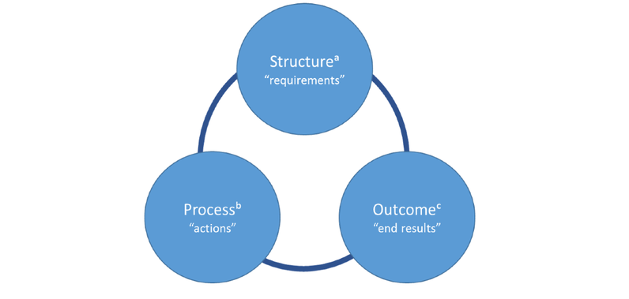
Figure 1: Donabedian Model
(Idea Taken from McCullough et al. 2023)
Structure is the conditions of an organisation and the physical conditions that facilitate the delivery of care. The case evidence points to overwhelming structural shortcomings: the operations were performed in a deserted facility with no sterile equipment, inadequate ventilation and the necessary surgical instruments. Lack of adequate workforce, low levels of supervision, and the target-oriented sterilisation campaigns exacerbated the structural environment (Newindianexpress.com, 2025). The aforementioned conditions do not comply with the internationally recognised requirements of surgical preparedness that prioritise sterilisation, workforce competence, and necessary infrastructure as the precondition of the safe delivery of procedures (Who.int, 2025).
Process entails the real techniques and measures adopted in the provision of care. The failures in the processes were massive and multi-layered in Bilaspur. The action of 83 tubectomies in a short time shows the violation of the safe surgical procedures, which worsen the ability to control the infection, observe the postoperative period, and provide informed consent, which are the key elements of a safe surgical practice. According to research, preventable surgical harm is closely connected to process failures (Thehindu.com, 2025). The administration of contaminated antibiotics is also evidence of poor compliance with the pharmaceutical handling standards and failures in procurement control.
The outcomes were disastrous: 15 deaths, more than 90 hospitalisations, extensive complications, and the loss of confidence of people (Bbc.com, 2025). These results indicate systemic failures and not just clinical failures due to a focus on numerical sterilisation targets at the expense of patient safety. In the model of Donabedian, poor outcomes are an indication of weaknesses of structural capacity as well as process reliability. Consequently, the implementation of the model to the case shows that there is a close causal relationship between unsafe environments, high-risk workflow practices and preventable mortality.

2. Fishbone Diagram: Identifying Multi-Level Root Causes
The Fishbone (Ishikawa) Diagram allows the systematic and thorough examination of the underlying reasons of the failures manifested in the situation and provides more depth than the broad categories (Majka, 2023). In conducting this analysis, 6 areas are analysed, including People, Processes, Policies, Equipment, Environment, and Management.
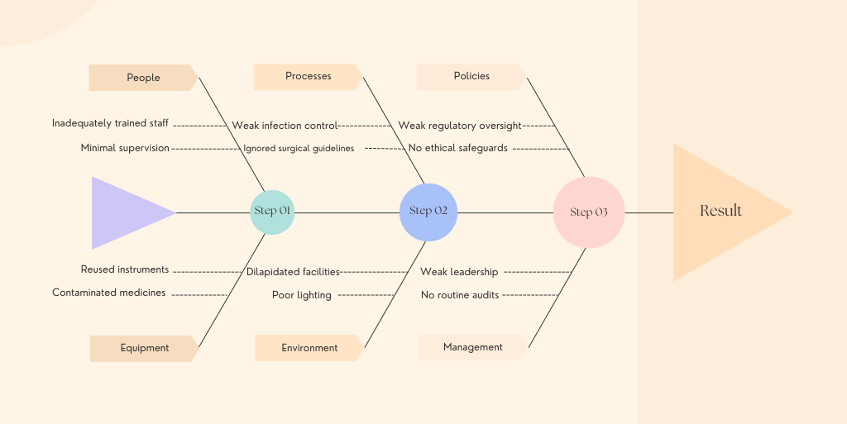
Figure 2: Fishbone Diagram
(Self-developed in Canva)
Human resource weaknesses are brought out by people factors. The employees received insufficient training, the level of supervision was low, and the overall surgeon violated the safe procedure limits. It is pointed out in the literature, though, that these kinds of behaviours are usually influenced by the systemic pressures and not individual negligence (Fiks, 2024). Here, the targets had of aggressive population-controlling developed a culture that pushed a clinician to focus on volume, as opposed to the necessity to keep people safe, which solidified how the actions of individual clinicians mirrored the forces of the broader organisation.
The processes were also being compromised. Among the main failures were the absence of infection-related measures, the non-observance of surgical protocols, the non-fulfilment of the sterilisation process, and the absence of observation of surgical patients. These procedures are particularly fundamental factors contributing to the WHO Surgical Safety Checklist, and the failure to be attentive to them raises the chances of sepsis, haemorrhage, and other adverse effects (Kimeli and Kipchirchir, 2025). This incredibly high turnaround rate accounts for a systematic lack of consideration in regard to the recommended surgical pacing.
The unsafe environment was also a result of policies. Weak regulatory control, coupled with inadequate enforcement of safety measures facilitated by the national sterilisation target system, presented structural weaknesses. Literature acknowledges that the use of target-driven programmes tends to yield negative incentives which compromise patient-centred care and ethical decision-making (Cokelet, 2023).
Proper equipment shortages were huge. This reuse of surgical equipment, insufficient autoclaving facilities and postoperative drugs that were contaminated were indicative of severe shortcomings in procurement and award of quality assurance. The lack of strong regulation of supply chains has been commonly associated with morbidity that can be avoided in resource-deprived contexts (Basu et al. 2022).
Some of the environmental factors comprised an ageing facility, too many surgical areas, ineffective lighting, and the absence of proper sterilisation areas. Such conditions seriously undermine sterility and increase the risks of postoperative infections.
Lastly, Management failures were central to it. There was supervision of poor leadership, a lack of sufficient risk evaluation, a lack of auditing systems, and the implementation of a safety culture, which did not stop systemic issues from sneaking into the picture (Hald et al. 2025).
In general, the Fishbone analysis shows that the tragedy was caused by connected failures within numerous fields, which is consistent with the Swiss Cheese model created by Reason and explains why wholesome and system-wide change should have been introduced.

3. SWOT Analysis: Understanding the Strategic Context
A SWOT analysis is useful to establish the case in a larger organisational and policy context through considering internal Strengths and Weaknesses, and external Opportunities and Threats. The method is popular among the NHS projects of quality improvement to motivate strategic decision-making.
Strengths: In spite of terrible failures, the overall Indian public health has its strengths, which include an established national reproductive health programme, skilful surgeons and policy frameworks which, when in place properly, would facilitate safe sterilisation (Selvaraj et al. 2022). The incident also led to serious national questioning, which generated pressure to reform.
Weaknesses: It was mainly the weaknesses which caused injuries. They involve bad governance arrangements, shabby facility arrangements, training, and supervision, a culture of satisfying numerical goals, untrustworthy procurement of pharmaceuticals, patient education, and audit systems (Tabish, 2024). These vulnerabilities are in line with the body of literature regarding systemic vulnerabilities within resource-constrained environments.
Opportunities: The possibilities to improve are good with a potential to align with the world standards of safety, greater human dedication to the rights of reproductive health, and financial resources allocated to maternal health programs, as well as the prospects of incorporating the WHO guidelines of surgical safety (Who.int, 2025). The opportunities to improve the quality assurance can also be provided through international partnerships and digital monitoring systems.
Threats: The risk factors are external threats of the existence of socio-economic disparities, political pressure to restrain population growth, rural healthcare resources, and possible mistrust of the population concerning the tragedy. The other threats are instability in the supply chain and resisting organisational change, a typical obstacle that is noted in health reform literature.
Strengths | Weaknesses
- Existing national reproductive health programme  - Skilled surgeons and established policy frameworks for safe sterilisation  - National scrutiny after the incident, creating momentum for reform (Selvaraj et al. 2022) | - Poor governance and inadequate facility conditions  - Lack of staff training, supervision, and accountability  - Target-driven culture compromising safety  - Unreliable pharmaceutical procurement and weak supply chains (Tabish, 2024)  - Limited patient education  - Absence of audit or quality monitoring mechanisms
Opportunities | Threats
- Alignment with WHO/global safety guidelines (Who.int, 2025)  - Stronger government commitment to reproductive rights and maternal health  - Potential for digital monitoring and quality assurance systems  - Opportunities for international partnerships  - Implementation of surgical safety checklists and protocols | - Persistent socio-economic inequalities and rural resource limitations  - Political pressure to meet population-control targets  - Public distrust following the tragedy  - Instability in drug supply chains  - Resistance to organisational or cultural change
The SWOT analysis shows that even though internal weaknesses contributed to the tragedy, there are several external opportunities that can sustain positive change, provided they are utilised to advantage.

4. Integrating Frameworks for Evidence-Based Improvement
A composite application of the Donabedian, Fishbone and SWOT approaches provides a multilayered explanation of the Bilaspur case by analysing structural failures of the case, causal factors and strategic constraints. Donabedian emphasises macro-level quality deficiencies in the system; Fishbone emphasises micro-level root causes in the system. SWOT contextualises the capacity of organisations to improve.
More importantly, the combination of these models is consistent with the applicable best practice principles in quality improvement, according to which the combination of multiple analytical tools in quality improvement is advisable. The generated insights lead to the idea of the need to strengthen the governance, implement the standards of surgical safety, and better the infrastructure and ethical, patient-centred care (Gorry et al. 2023). Notably, they also emphasise the essential role of the leadership and cultural change that would be discussed more in the recommendations and implementation strategy.

Recommendations
The Bilaspur sterilisation tragedy is a serious disaster of healthcare systems, where structural, procedural, and managerial flaws were all factors that directly undermined patient safety and ethical principles. To remedy these failures, the remedies necessary include those that are aimed at the underlying causes using the evidence-based quality improvement models. Based on the Donabedian Model, Fishbone Diagram and SWOT analysis, it is suggested to use four recommendations, with PDSA, PDCA, Lean, Six Sigma and Kotter Change Model to offer an action plan to improve the carers and consequently the hospital via the following four recommendations to facilitate lasting changes in governance, clinical practice, human resource competency and organisational culture.
1. Strengthen Governance and Management Oversight (PDCA)
The causes of the incident included management lapses, which included poor supervision, weak auditing mechanisms and poor implementation of policies. PDCA (Plan-Do-Check-Act) provides a methodical way of resolving these systemic problems by allowing recurring enhancements and inculcating responsibility (Samuel and Farrer, 2025).
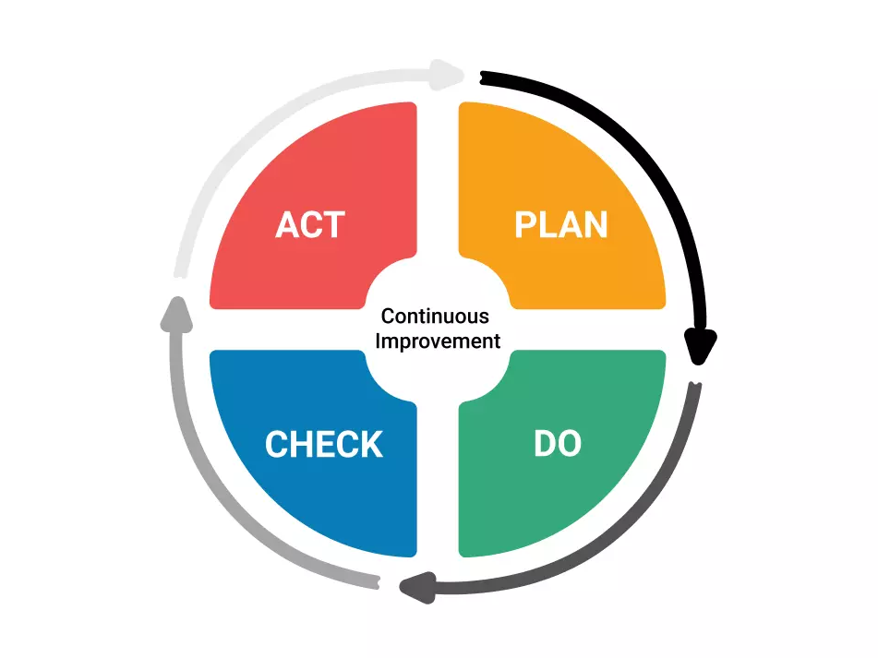
Figure 3: PDCA
(Idea Taken from Samuel and Farrer, 2025)
- Plan: Create detailed supervision procedures and auditing systems which are consistent with the national and WHO surgical safety standards and provide well-defined roles, responsibilities, and reporting lines.
- Do: Rent special monitoring teams within surgical camps to implement safety protocols and to control the implementation of standards of patient care (Monczka et al. 2024).
- Check: audit on a regular basis to quantify conformity to infection control, surgery thresholds, and patient safety standards.
- Act: Policy and supervision structures. Refinements of the audit findings are made based on the gaps and strengthening of corrective actions to ensure the sustenance of continuous improvement.
Through the use of PDCA, the governance structures may continue to develop over time to establish a culture of accountability that would see the continuation of safety, compliance, and ethical standards.
2. Standardise Clinical Processes Using Lean and PDSA
Adverse outcomes were largely contributed to by process inefficiencies such as fast patient throughput, poor infection control and lack of sterilisation. Workflow optimisation based on lean principles to remove inefficiencies and standardise work processes, and PDSA (Plan-Do-Study-Act) cycles to lead to the iterative testing and refinement of interventions, can be used (Barr and Brannan, 2024).
In specific camps, a pilot programme may be used to implement updated surgical procedures, placing special emphasis on compliance with the sterilisation protocols, postoperative care, and safe surgical boundaries (Almansour et al. 2024). It is possible to see the measurable results, including infection rates and postoperative complications, creating incremental changes before global implementation. The combination of Lean and PDSA would be used to make sure that the clinical processes are efficient, safe, and sustainable, with the intention of increasing patient safety and decreasing variability and errors in practices.
3. Enhance Training and Human Resource Competency Through Six Sigma
Anthropogenic elements, such as insufficient training and stresses due to target-oriented policies, increased the risk of injury. Six Sigma approaches have been able to bring variation in clinical performance down in a systematic manner and ensure that human error is minimised (Trakulsunti et al. 2021). The aseptic techniques, surgical safety procedures and practices of giving ethical consent to managers should be part of structured training programmes. Good, safe surgical pacing, emergency response and inter-professional teamwork can be reinforced by the use of simulation-based exercises.
The measures of performance make it possible to do regular evaluations and interventions. The implementation of Six Sigma is a strategy that not only allows for to standardise of competence among the staff but also guarantees the quantitative reduction of errors, which can serve as a solid base to improve patient outcomes and patient safety culture sustainability.
4. Foster Ethical, Patient-Centred Culture Using Kotter’s Change Model
Patients Inc. is faced with ethical lapses and policy pressures that indicate the necessity of a cultural change towards patient-centred care. The 8-Step Change Model of Kotter offers the steps to be taken to instil this culture with the initiation of the urgency of patient safety and a group of guiding coalitions of senior clinicians and administrators (Busari, 2025). The constitutionality maintained in communication of the significance of informed consent, patient autonomy and adherence to ethical standards can change the organisational norms.
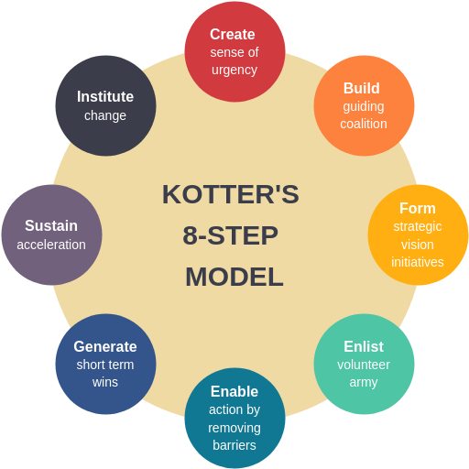
Figure 4: Kotter’s Change Model
(Idea Taken from Busari, 2025)
By incorporating PDSA cycles into the operational process, it would be guaranteed that the cultural and procedural enhancements are constantly tracked, assessed, and enhanced (Awu, 2025). Through integrating change management concepts and the use of continuous improvement models, organisations have the potential to develop an ethical culture, increase levels of trust in the organisation among the public and reduce the risk of coercion or short-cut measures in care delivery.
These recommendations would need to be executed by paying the trained personnel, infrastructural and training funds and sufficient time to entrench the cultural and procedural changes. Short-term measures to assess success should be through compliance audits, adherence to surgical safety measures and a decrease in complications, whereas the long-term measures to assess success rely on long-term patient safety, increased ethical compliance and strength of organisational culture.

Benchmarking
By comparing the Bilaspur practices of sterilisation with the national and international standards, including WHO guidance on surgical safety and the Indian Ministry of Health standards, one would find that there is a lot of disparities in terms of patient safety and quality assurance. Best practice based on sterilisation procedures, such as maintenance of sterilisation limits, prevention of infection and informed consent, is exhibited by high-performing NHS Trusts and global reproductive health programmes (Chopra et al. 2024). By matching the suggested improvements to such benchmarks, measurable objectives and regular observation would be guaranteed. Though differences in the context of the Indian and the NHS setting play a role in the transformation of professional knowledge, benchmarking offers several useful insights on process standardisation, supervision, and ethical compliance to facilitate sustainable quality improvement.

Conclusion
An examination of the Bilaspur sterilisation tragedy highlights the high value of the systemic governance model, strong clinical processes and ethical leadership in addressing patient safety. Inspiring lessons learned were the fact that failures were not confined to a single action but instead a combination of interacting weaknesses among people, processes, policies, equipment, environment and management. The implementation of such theoretical frameworks as the Donabedian Model, Fishbone Diagram, and SWOT analysis made it possible to have a systemised view of these root causes, and the quality improvement models -PDCA, PDSA, Lean, Six Sigma, and Kotter Change Model offered an evidence-based approach to root cause removal.
Results show that theory and practical interventions can be combined to inform sustainable change. It is foreseen that by strengthening the governance, standardisation of clinical practice, increased training and encouraging patient-centred ethical culture, all outcomes would be enhanced by decreasing complications, implementing safety practices and improving individual accountability of staff. System-wide performance enhancements are also aided by such interventions as entrenching the ongoing performance monitoring, repetitive learning, and safety culture.
The talk improvements can be extended over analogous healthcare environments by embracing common structures, using audits and benchmarks, as well as entrenching cycles of assessment and enhancement. The attributes of proactive supervision and ethical decision-making, as well as building organisational cultures that ensure the focus on patient well-being rather than on numbers, are highlighted in leadership lessons. The overall areas requiring future research involve an evaluation of the long-term effectiveness of these interventions, patient satisfaction of patients, and observing the adherence to ethical standards in sterilisation programmes. Through this case, medical administrations can learn to thrive with sound and effective strategies that can prevent such tragedies from recurring in order to provide safer, ethical, and quality reproductive healthcare provision.

References
Almansour, M.S., Althobiti, N.M.A., Alharthi, F.F.A., Alharthi, M.A.G., Alharthi, A.S.D., Al Mansour, M.H.A., Al Mansour, H.H.S., Al Hokash, M.K.H., Aldawais, Y.H., Alduways, S.F.A. and Alduways, A.M.A., 2024. Preparing the Operating Room for Various Surgical Procedures. Journal of International Crisis and Risk Communication Research, 7(S9), p.3258.
Awu, D., 2025. Quality Improvement Project Enhancing Communication Perceptions among Nursing Staff in the Operating Room.
Barr, E. and Brannan, G.D., 2024. Quality improvement methods (lean, PDSA, Six Sigma). In StatPearls [Internet]. StatPearls Publishing.
Basu, S., Copana, R., Morales Jr, R., Anugulruengkitt, S., Puthanakit, T., Maramba-Lazarte, C., Williams, P., Musembi, J., Boga, M., Issack, M. and Hokororo, A., 2022. Keeping it real: antibiotic use problems and stewardship solutions in low-and middle-income countries. The Pediatric infectious disease journal, 41(3S), pp.S18-S25.
Bbc.com (2025) “India sterilisations: Doctor arrested over operation deaths” Available at: https://www.bbc.com/news/world-asia-india-30032878 [Accessed on: 25.11.2025]
Busari, M., 2025. Clinical Nurse Specialists as Change Agents in Oncology: Leadership Strategies for Promoting Evidence-Based Practice.
Chopra, M., Hou, X., Nimako, K.T. and Roder-DeWan, S., 2024. Hospitals in Health Systems: Opportunities for Efficient, High-Quality, and Integrated Care.
Cokelet, B., 2023. Competitive virtue ethics and narrow morality. Philosophical Studies, 180(12), pp.3567-3591.
Fiks, E., 2024. State intimacies: sterilization, care and reproductive chronicity in rural North India.
Gorry, J., Gibson, L., Bukenya, D.J., Odeyemi, P. and Brown, M.O., 2023. Patient safety, global governance, and the right to health in integrated primary health care. In Research Handbook on Patient Safety and the Law (pp. 193-205). Edward Elgar Publishing.
Hald, E.J., Gillespie, A. and Reader, T.W., 2025. Problems in dealing with problems: How breakdowns in corrective culture lead to institutional failure. British Journal of Management, 36(1), pp.73-90.
Indianexpress.com (2025) “Chhattisgarh sterilisation tragedy: Two and a half years, deaths of 13 mothers later” Available at: https://indianexpress.com/article/india/chhattisgarh-sterilisation-tragedy-two-and-a-half-years-deaths-of-13-mothers-later-4605460/ [Accessed on: 25.11.2025]
Kimeli, C. and Kipchirchir, Y., 2025. THE ROLE OF NURSE IN PROMOTING PATIENT SAFETY IN THE OPERATING ROOM DURING SURGERY.
Majka, M., 2023. Fishbone diagram.
McCullough, K., Andrew, L., Genoni, A., Dunham, M., Whitehead, L. and Porock, D., 2023. An examination of primary health care nursing service evaluation using the Donabedian model: A systematic review. Research in nursing & health, 46(1), pp.159-176.
Monczka, J., Ayers, P., Berger, M.M. and Wischmeyer, P.E., 2024. Safety and quality of parenteral nutrition: Areas for improvement and future perspectives. American Journal of Health-System Pharmacy, 81(Supplement_3), pp.S121-S136.
Newindianexpress.com (2025), “Surgeon Behind Botched Surgeries Held, Blames Administration” Available at: https://www.newindianexpress.com/nation/2014/Nov/13/surgeon-behind-botched-surgeries-held-blames-administration-682116.html [Accessed on: 25.11.2025]
Samuel, S. and Farrer, H., 2025. Integrating the PDCA Cycle for Continuous Improvement and Academic Quality Enhancement in Higher Education. Journal of Comparative and International Higher Education, 17(2), pp.115-124.
Selvaraj, S., Karan, A.K., Srivastava, S., Bhan, N. and Mukhopadhyay, I., 2022. India health system review.
Tabish, S.A., 2024. Procurement Management in Health Care Systems. In Health Care Management: Principles and Practice (pp. 309-335). Singapore: Springer Nature Singapore.
Thehindu.com (2025), “Sterilisation deaths: SC notice to Chhattisgarhovernment of Chhattisgarh over reports of deaths after sterilization” Available at: https://www.thehindu.com/news/national/Sterilisation-deaths-SC-notice-to-Chhattisgarh/article60490340.ece [Accessed on: 13.10.2025]
Trakulsunti, Y., Antony, J., Dempsey, M. and Brennan, A., 2021. Reducing medication errors using lean six sigma methodology in a Thai hospital: an action research study. International Journal of Quality & Reliability Management, 38(1), pp.339-362.
Who.int (2025), “Why safe surgery is important” Available at: https://www.who.int/teams/integrated-health-services/patient-safety/research/safe-surgery [Accessed on: 08.10.2025]

