

University of Wales Trinity Saint David, Birmingham
Assignment Title: Aspire Retailers Cloud Management with Azure
Module: Cloud Computing Administration
Module code: ACCB6025
Student Name: Cristian-Constantin Paraschiv
Student ID: 2026077

Contents
Abstract 4
Introduction 4
A) How Aspire Retailers are supported by the Cloud solution in instantly meeting their demands for computing services. The characteristics of load balancing. 5
B) Cloud service providers and an examination of their services. 7
1. Amazon Web Services (AWS) 7
1.1 Compute 7
1.2 Storage 7
1.3 Database 8
1.4 Networking 8
1.5 Machine Learning 8
2. Google Cloud Platform (GCP) 9
2.1 Compute 9
2.2 Storage 9
2.3 Database 9
2.4 Networking 9
2.5 Machine Learning 9
3. Microsoft azure 10
3.1 Compute 10
3.2 Storage 10
3.3 Database 11
3.4 Networking 11
3.5 Machine Learning 11
C) Aspire Retailers may control their cloud expenditures depending on the compute configurations shown below. 12
1. Azure Pricing Calculator: 12
2. Azure Total Cost Ownership – “TCO”: 13
D). Azure Active Directory (AD) is employed. Building users becomes placed into practise. 19
E). Cloud governance in Azure. 24
F). Disaster recovery Microsoft Azure toward Aspire Retailers 31
Conclusion 32
References 34

Aspire Retailers Cloud Management with Azure

Abstract
Due to its on-premises datacentres approach, home improvement retailer Aspire Retailers is presently experiencing difficulties. The bottleneck for timely application delivery has evolved into managing hardware and software acquisition, installation, deployment, setup, and network monitoring. A critical need is the necessity for computing resources like servers, storage, and databases to be promptly accessible for development and deployment. The management of Aspire Retailers has chosen to move its infrastructure to the cloud after realising its advantages. By supplying scalable, on-demand resources, this move is anticipated to streamline their IT processes and shorten the time it takes for their apps to reach the market. Additionally, cloud computing's worldwide accessibility makes it easier for businesses to expand into new areas since services may be set up nearer to consumers. Reliability is raised by cloud-based systems' strong disaster recovery capabilities and high availability. The addition of cloud-based load balancing will improve their operations even further. Load balancing guarantees equitable network load distribution, improves redundancy and fault tolerance, offers scalability, and increases overall efficiency. These characteristics make it possible for Aspire Retailers to offer their clients a dependable, highly available online service while also improving the user experience, a crucial component in retail.

Introduction
Traditional on-premises data centres may provide big problems for enterprises, especially in the retail industry, as the digital transition quickens. Applications are frequently delivered to customers later than expected because of the laborious and time-consuming process of coordinating hardware and software acquisition, installation, deployment, setup, and network monitoring [2]. Home renovation retailer Aspire Retailers is now overcoming these difficulties. They are considering a move to cloud computing to enhance their service delivery and take advantage of prospects in new markets. The choice was motivated by the possible benefits that cloud computing may offer, such as the instantaneous accessibility to computer resources, scalability, global reach, and high availability [1]. Scalable, on-demand resources for servers, storage, and databases are offered through cloud computing. This decreases the time to market for their apps [2] by getting rid of the difficult and cumbersome process of managing hardware and software. Additionally, the organisation may deploy services closer to clients in various areas thanks to the cloud data centres' worldwide presence, which enhances service delivery and user experience [1]. Aspire Retailers and other retail businesses must have high availability and reliable disaster recovery capabilities, which are ensured by implementing cloud solutions. Data may be replicated over several sites and backed up in real-time, which lowers downtime and improves service dependability [2]. Another important element in this transformation is the function of load balancing that cloud computing provides. It enables redundancy, fault tolerance, scalability, and overall efficiency by uniformly distributing network load across numerous servers, improved end-user experience and perhaps increasing sales [3]. Additionally, as an IT administrator, leading Aspire Retailers in implementing the cloud, providing a thorough comparison of three clouds, as well as utilising TCO and Plan to manage Azure expenses, Azure Directory, Governance Strategies, Policy, and Disaster Recovery.

How Aspire Retailers are supported by the Cloud solution in instantly meeting their demands for computing services. The characteristics of load balancing.
The provision of computer services through the internet (the cloud) as opposed to a nearby on-premises data centre is known as cloud computing. Servers, storage, databases, networks, software, analytics, and artificial intelligence are some of these services. Businesses only pay for the cloud resources they really utilise because the service is on-demand [4].
The benefits of cloud computing for Aspire retailers are many:
- Cost Efficiency: By moving to the cloud and skipping the costs of purchasing, operating, and maintaining on-premises equipment and software, Aspire Retailers save money. Paying for what Aspire Retailers really use, which saves a lot of money [5].
- Scalability and Flexibility: When necessary, cloud services may simply be scaled up or down. Aspire stores may easily upgrade if they require additional memory or processing capability. Furthermore, to speeding up time, slowing time may save resources. By avoiding paying for unused resources, this scalability improves your capacity to react swiftly to company growth and change [6].
- Accessibility and Collaboration: Employees of Aspire Retailers may access the information they want a site experiencing an online interaction and anywhere thanks to the hosting of data and services in the cloud. This dramatically enhances productivity and teamwork [7].
- Disaster Recovery and Business Continuity: To guarantee that your data is always safe and available, cloud computing companies offer reliable data backup, disaster recovery, and business continuity solutions. To keep customers satisfied and continue operating in the case of a calamity, this is crucial for Aspire Retailers [8].
- Innovation and Agility: Aspire merchants benefit from cloud computing by becoming more inventive and flexible. Launch new services, try out novel concepts, and react to market developments more swiftly [9].
- Focus on Core Business: Aspire merchants will be able to concentrate more on their primary business of selling home improvement items by outsourcing IT infrastructure maintenance responsibilities to a cloud provider. This entails that you may concentrate more resources on enhancing your goods and services, enhancing the client experience, and expanding your company [10].
Furthermore, switching to the cloud would greatly increase Aspire Retailers' operational effectiveness, scalability, capacity for innovation, and business focus, spurring the expansion of the company.
For merchants like Aspire merchants that must effectively handle enormous levels of online traffic and offer dependable, high-performance service to their consumers, load balancing is a key component in the cloud computing area. Aspire shops may take use of the following major load balancing capabilities:
- Distribution of Network Load: Distributing network traffic equally among several servers is one of the fundamental goals of load balancing. As a result, Aspire Retailers' website and application function better overall and overloading of a single server is avoided [11].
- Redundancy and Fault Tolerance: When a server goes down, a load balancer instantly switches network traffic to an operational server, enhancing the dependability and accessibility of Aspire Retailers' services. Customers will always be able to visit her website thanks to this functionality, even if the server is down [12].
- Scalability: By spreading the load among multiple servers, load balancing enables the capacity to manage increased traffic in an effective manner. To manage the increasing traffic as Aspire Retailers expands, extra servers may be deployed to the load balancer [11].
- Efficiency: Resource utilisation is optimised via load balancing, which reduces costs. Because all servers share the burden, rather than some being overwhelmed and others being idle, it is used more effectively [13].
- Improved User Experience: By ensuring that users are always forwarded to the server with the greatest resources available, load balancing enhances the user experience. A good user experience may enhance consumer happiness and boost revenue for Aspire shops [14].
- Health Checks: Each server's condition is frequently checked by the load balancer. Her Aspire Retailers application's overall performance is not impacted by server failures since the load balancer stops transferring traffic to unresponsive servers [15].
- SSL Termination: As a result of a load balancer's ability to handle SSL encryption and decryption, your server will be under less stress and be able to process more requests [16].
- Session Persistence: This function, sometimes referred to as "sticky sessions," enables a load balancer to route every request made by a single client to a single server at once. This is crucial for retail applications where consumers manage transactions while pushing shopping trolleys [17].
To effectively manage online traffic, deliver a smooth user experience, and guarantee high uptime of their services, Aspire Retailers must have load balancing capabilities (Illustration 1). In the following phase, three clouds additionally compared.
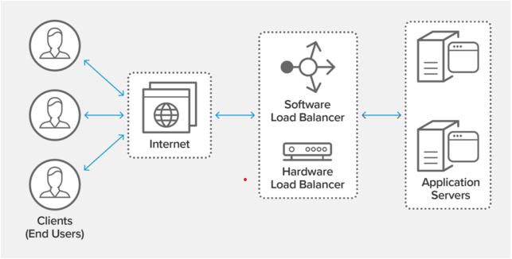
Illustration 1: Functionality of load balancing (https://www.nginx.com/resources/glossary/load-balancing/).

B) Cloud service providers and an examination of their services.
Despite its start, cloud computing has gone far in its development. Thus, no longer an issue of being employ Cloud Computing. Although several cloud suppliers flooding the market, AWS, Azure, and Google Cloud Platform sit firmly as the most prominent major cloud suppliers. Furthermore, the three clouds and their services:

1. Amazon Web Services (AWS)

1.1 Compute
- In the AWS cloud, EC2 provides adjustable and scalable computing capability. This service enables rapid scaling of capacity, both up and down, as computing needs vary. Security and networking may be established, and storage can be controlled, using EC2. EC2 offers a variety of instance kinds that are optimised for specific scenarios according to memory, CPU, instance storage, and networking capabilities.
- A server-less computing service called Lambda executes code in response to certain events, including data changes in an S3 bucket or a DynamoDB tables, or HTTP requests through Amazon API Gateway. Lambda maintains computing resources automatically, making it simple to create apps that respond fast to new information.

1.2 Storage
- An object storage service called S3 allows users to save and use any quantity of information via online world. It offers flexibility, safety, and efficiency which comprise among the best in the business. Aside from backup and restoration, S3 may also be used for archiving, content distribution, analytical information pools with hybridised server preservation.
- For usage with EC2 instances, EBS offers containers for permanent block storing. To provide high availability and durability, each EBS volume replicates itself dynamically. inside its Availability Zone.

1.3 Database
- The managed relational database service RDS offers a variety of database instance types that are enhanced for I/O, memory, or performance. Amazon Aurora, PostgreSQL, MySQL, MariaDB, Oracle Database, and SQL Server are only six of the well-liked database engines that are supported.
- Key-value and document data types are supported by DynamoDB, a managed NoSQL database service. It provides a flexible pricing structure that bases fees on consumption while delivering good performance at any size.

1.4 Networking
- Amazon Virtual Private Cloud (VPC): AWS resources may be launched into a specified virtual network thanks to VPC. Because it gives users the ability to choose which resources are accessible to the public and which are private, it dramatically improves data security.

1.5 Machine Learning
- Machine-learning algorithms may be quickly built, trained, and deployed by programmers as well as information researchers, with SageMaker, a product that is entirely regulated. SageMaker offers all the machine-learning components in one set of tools, allowing models to be developed more quickly, with less work, and for less money.
- AWS offers a full variety of services and products for creating new applications, converting current ones to the cloud, and designing, developing, and implementing several data processing and analytics techniques. It offers scalable, adaptable, and affordable solutions to satisfy a range of demands and is built to accommodate almost any cloud workload [18]. In addition, below is an illustration of Amazon Web Services (Illustration 2).
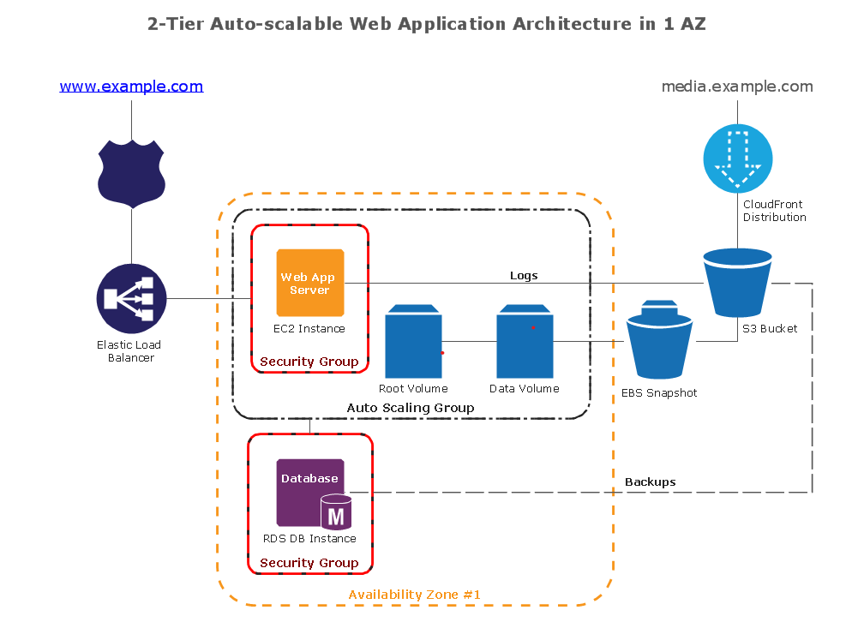
Illustration 2: Diagram of an auto-scalable, two-tier web application from Amazon Web Services (https://www.bing.com/search?q=google+cloud+services+documentation&qs=n&form=QBRE&sp=-1&ghc=1&lq=0&pq=google+cloud+services+documentation&sc=10-35&sk=&cvid=C452BA239882424C9.

2. Google Cloud Platform (GCP)

2.1 Compute
- Google Compute Engine (GCE): Scalable and adaptable virtual machines are offered by GCE and are powered by Google's infrastructure. These virtual machines (VMs) may be customised with different CPU and RAM combinations, as well as the choice of SSD or HDD storage. GCE is a reliable option for computing workloads due to its integration with Google's networking, data storage, and data analytics services [19].
- Google Cloud Functions: GCP's event-driven serverless computing platform named Cloud Functions. It enables the creation of simple, one-purpose functions that may be connected to events released by cloud infrastructure and services. Small, single-purpose functions may be created using Cloud functions as a simple, event-based, asynchronously computation solutions that does not require the administration of a server or execution infrastructure [19].

2.2 Storage
- Google Cloud Storage (GCS): GCS is a service that stores and provides access to objects of data. It provides four distinct storage classes that are suited to various use cases: Standard for high-performance, multi-regional for storing data utilised globally, Regional for storing data in a particular region, and Nearline/Coldline for preserving data [19].
- Persistent Disk: For virtual computers, Persistent Disc provides SSD and HDD block storage. It may be automatically copied within the same region or even across several regions, and it is robust and very effective [19].

2.3 Database
- Google Cloud SQL: The creation, management, and administration of databases on Google Cloud are made simpler by Cloud SQL, a fully managed relational database service. SQL Server, PostgreSQL, and MySQL instances are all supported [19].
- Google Cloud Firestore: Firestore is a NoSQL textual repository designed for rapid applications growth and development, outstanding performance, and automatic scalability. As it provides extensive client libraries, real-time updates, and offline support, it is especially well suited for serverless web, mobile, and gaming applications [19].

2.4 Networking
- Google Cloud VPC (Virtual Private Cloud): For the resources and services of Google Cloud, VPC offers networking capability. The ability to establish and administer a private network in the cloud using Google's infrastructure is made possible by VPC's global, scalable, and flexible nature [19].

2.5 Machine Learning
- Google Cloud AI and Machine Learning Platform: Developers of all levels may train unique machine learning models using the platform's array of machine learning solutions. It provides pre-trained models for Vision AI, Speech-to-Text, Text-to-Speech, Natural Language, Translation, and other tasks by utilising Google's machine learning capabilities [19].
Several cloud computing services are offered by Google Cloud Platform, whose core framework remains identical as Google utilises recognised providing consumption goods, such as Google Search and YouTube. It is commended for its affordable costs, powerful analytics and machine learning capabilities, and exceptional offerings like BigQuery and Kubernetes Engine [19]. Furthermore, an illustration with GCP services (Illustration 3).
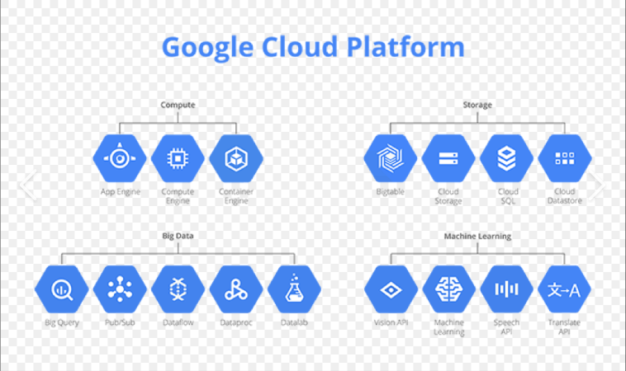
Illustration 3:Several Google Cloud Platform products (https://www.dynatrace.com/news/blog/a-brief-intro-to-full-stack-performance-monitoring-on-google-cloud-platform/).

3. Microsoft azure

3.1 Compute
- Azure Virtual Machines (VMs): Scalable and on-demand computing resources are offered via Azure VMs. They provide a wide range of machine sizes to satisfy various computing demands and are made to cater to a wide range of use cases, including testing environments, application development, and production-grade applications [20].
- Azure Functions: A serverless compute solution called Azure Functions enables the on-demand execution of code without the need to explicitly setup or maintain infrastructure. The Internet of Things (IoT), system integration, data processing, and the creation of straightforward APIs and microservices are all excellent uses for this service [20].

3.2 Storage
- Azure Blob Storage: A scalable object storage option for unstructured data is Azure Blob Storage. It is made to handle any sort of data, making it excellent for storing backup data, disaster recovery data, massive volumes of unstructured data, and sending pictures or documents straight to a browser. It may also be used to store files for distributed access [20].
- Azure Disk Storage: Block-level storage volumes are available for Azure VMs using Azure Disc Storage. The discs come with high-performance SSD and HDD alternatives and may be managed or unmanaged by Azure [20].

3.3 Database
- Azure SQL Database: A relational database service with automated scalability and a pay-as-you-go price structure is Azure SQL Database. It is built on Microsoft SQL Server's latest reliable edition and offers superior security and in-memory speed, making it a good option for many applications, Furthermore, diagram with services shown in Illustration 4 [20].
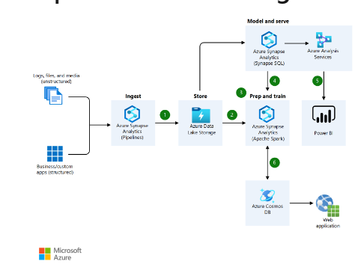
Illustration 4: Diagram of a possible architecture (https://learn.microsoft.com/en-us/azure/architecture/icons/).
- Azure Cosmos DB: A worldwide dispersed, multi-model database services. offers transparent multi-region replication, elastic throughput, and storage scalability, and 99th percentile low latency performance [20].

3.4 Networking
- Azure Virtual Network (VNet): To operating virtual machines and applications, Azure Virtual Network offers a completely secure environment. Any more Azure assets, such as Virtual Machines (VM), might be safely they might connect to regional interactions, the Internet, and one another thanks to VNet. [20].

3.5 Machine Learning
- Azure Machine Learning: A cloud-based predictive analytics service called Azure Machine Learning makes it easier to build and use predictive models as analytics solutions. It provides tools for preparing data, training machine learning models, deploying models, and managing models at scale [20].
One of the top cloud service providers is Microsoft Azure, which is well-known for its enterprise-level functionality, extensive security measures, and strong support for businesses with a Microsoft focus. It is becoming growing popular as a platform for applications using artificial intelligence and machine learning [20]. The price calculator for Aspire Retailers is highlighted in the subsequent step.

C) Aspire Retailers may control their cloud expenditures depending on the compute configurations shown below.

Pricing and cost analysis in Azure are essential components of efficiently managing cloud spending for Aspire merchants. Aspire Retailers can estimate, monitor, and optimise prices depending on unique requirements thanks to Azure's wide range of pricing models and capabilities. Pricing and cost analysis are examined in Azure Pricing Calculator and Azure Total Cost Ownership for Aspire Retailers:

1. Azure Pricing Calculator:
This online tool from Microsoft Azure enables users to evaluate the pricing of various Azure services based on the needs of Aspire Retailers [21]. By choosing services, virtual machine instances, storage configurations, network resources, and other elements required for an application or workload, it allows for configuration customization:
- Azure Pricing Calculator: A comprehensive variety of Azure capabilities, including computation, storage, databases, networking, AI, and more, available to Aspire merchants. The amount, area, time frame, and service level that are needed may all be configured [21].
- Calculate expenses: Based on scenario-selected services and setups, the calculator estimates the monthly prices. The price breakdown for each service and resource is visible to Aspire merchants. Aspire merchants may compare prices across various Azure areas thanks to this as well [21].
- Save and share estimates: Aspire Retailers stores pricing estimates for subsequent review and comparison or for cooperation with others [21].
- Export estimates: Using the price calculator, Aspire Retailers may export the estimates as a CSV file for later examination or distribution with other parties [21].
Additionally, a presentation of two Azure Pricing Calculator examples for Aspire Retailers, followed by a comparison and analysis of pay-as-you-go and reserved instances (monthly) in Illustrations 5 and 6.
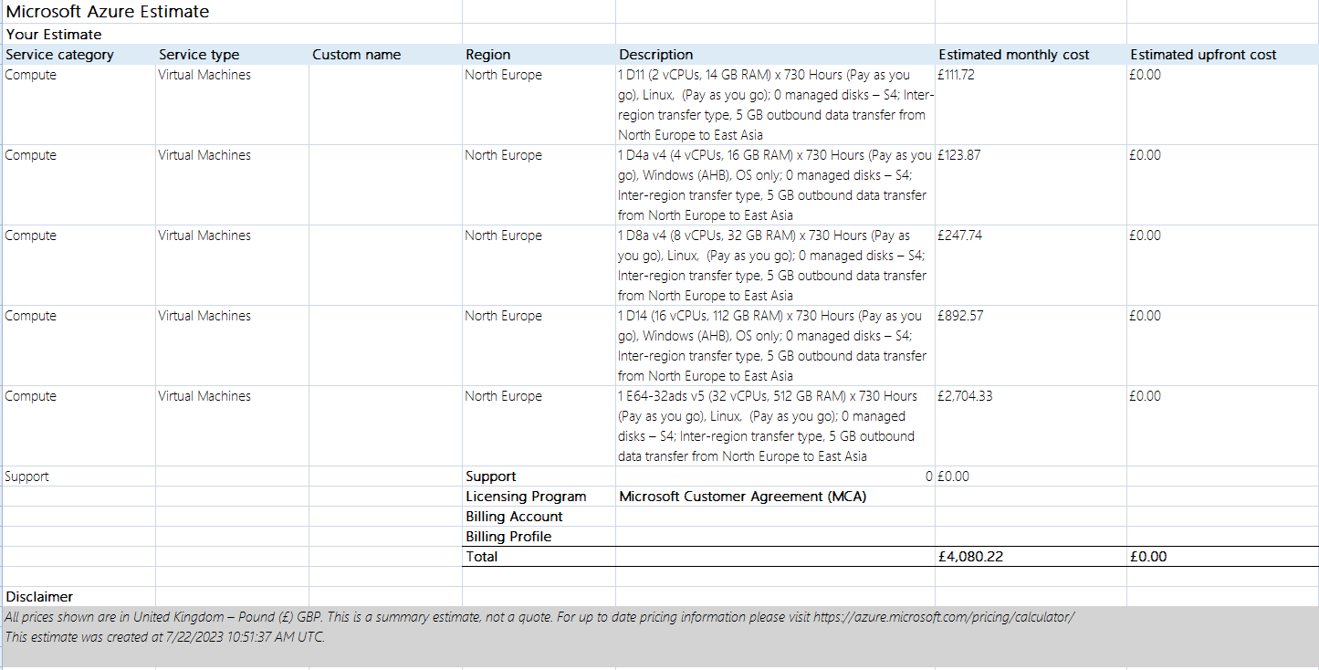
Illustration 5: Pay-as-you-go Aspire Retailers
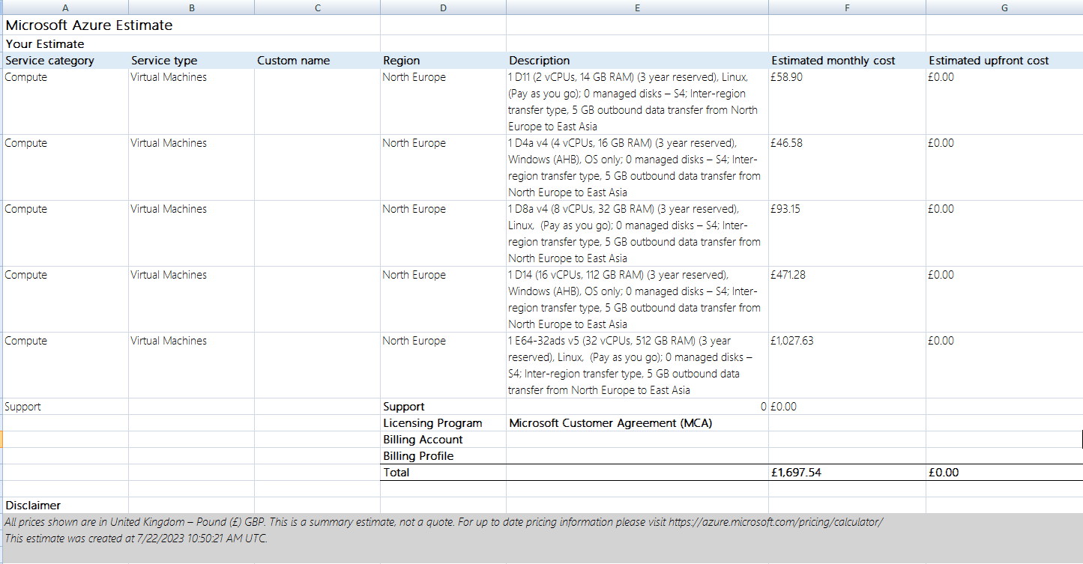
Illustration 6: Reserved instance Aspire Retailers.
The charges are determined by the resources Aspire Retailers use rather than a fixed rate like a pay-as-you-go client. The Reservation instance, on the other hand, allows Aspire Retailers to receive considerable savings over the PAY-AS-YOU-GO pricing by agreeing to utilise specified services for a predetermined time (one to three years). In addition to the reservation instance, Aspire Retailers can also benefit from a licence for hybrid advantages, which lower the prices.

2. Azure Total Cost Ownership – “TCO”:
                - TCO studies help businesses determine the total cost of shifting workloads to the cloud and keeping them there for a long time, generally many years. It takes into consideration expenses including those related to buying gear, paying for software licences, keeping networks up to date, employing personnel, and covering other pertinent charges. TCO analysis enables firms to assess a wide range of choices and make knowledgeable decisions about technology expenditures by contrasting various solutions, such as on-premises infrastructure and cloud services. TCO assessments help businesses find potential cost-savings possibilities and assess the financial effect of the technology they choose over the long run [21]. In addition, an examination of Aspire merchants was given:

- The Total Cost of Ownership (TCO) for Aspire Retailers' current on-premises infrastructure is £71,499.03, whereas the TCO with Azure's cloud infrastructure is £51,957.34. This comparison highlights the financial benefits of migrating to Azure's cloud architecture. The on-site infrastructure's compute expenses come to £44,967.97. However, in Azure, these costs are reduced to £30,027.74. Due to Azure's ability to provide compute resources on demand, which allows for more efficient resource utilisation, this drop has occurred (Illustration 8 to 10).
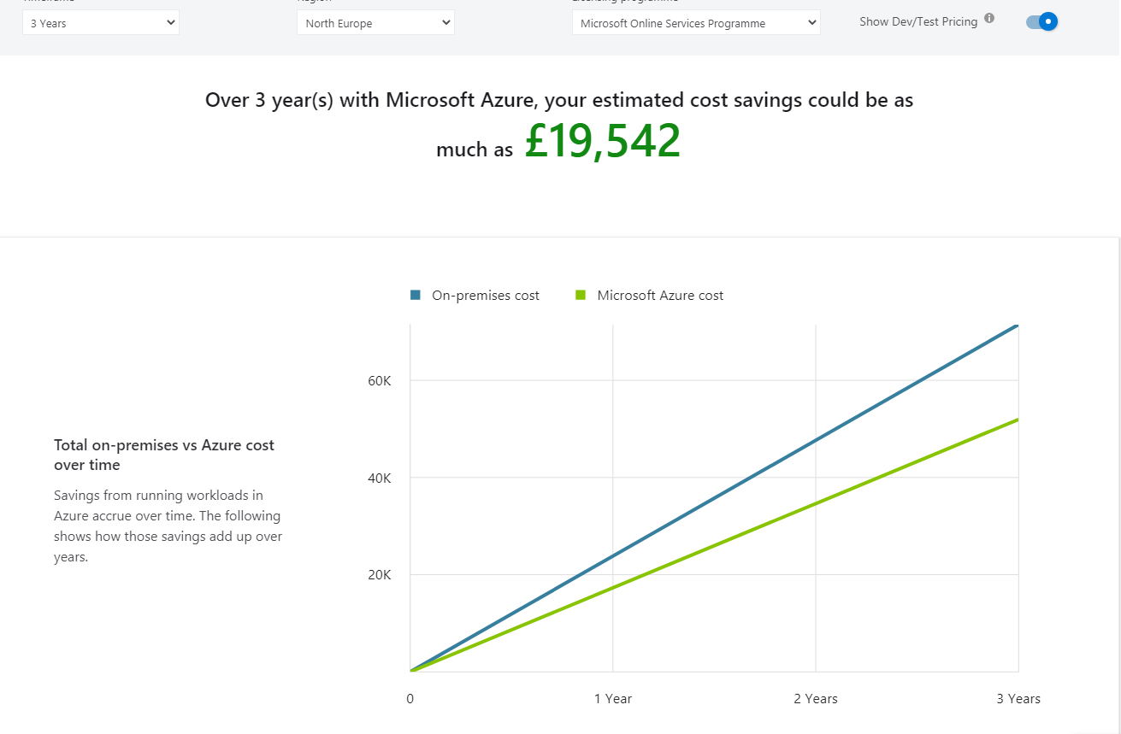
Illustration 7: Graph Total on-premises vs Cost over time.
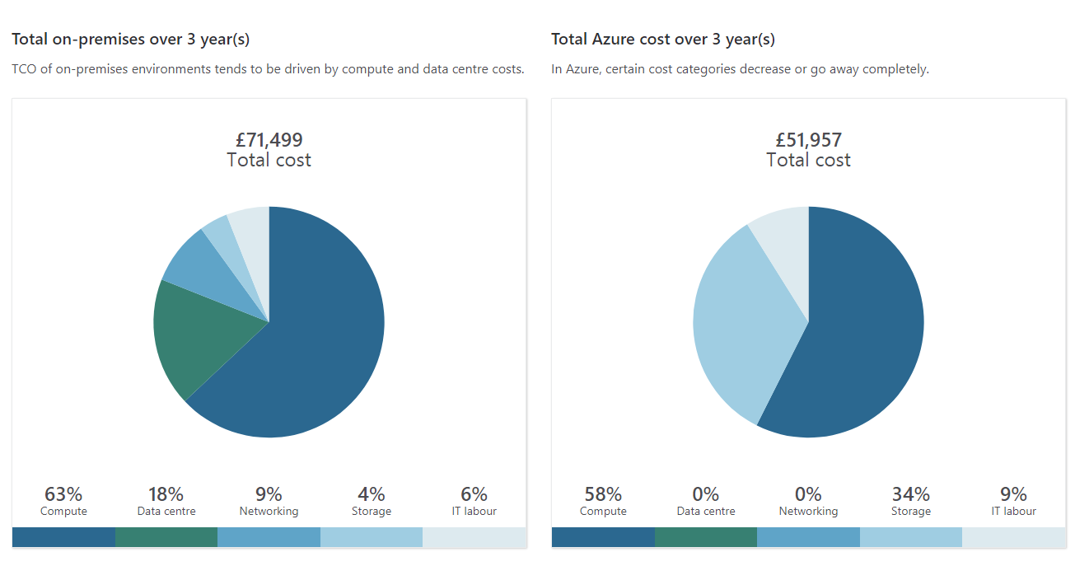
Illustration 8: Pie chart.
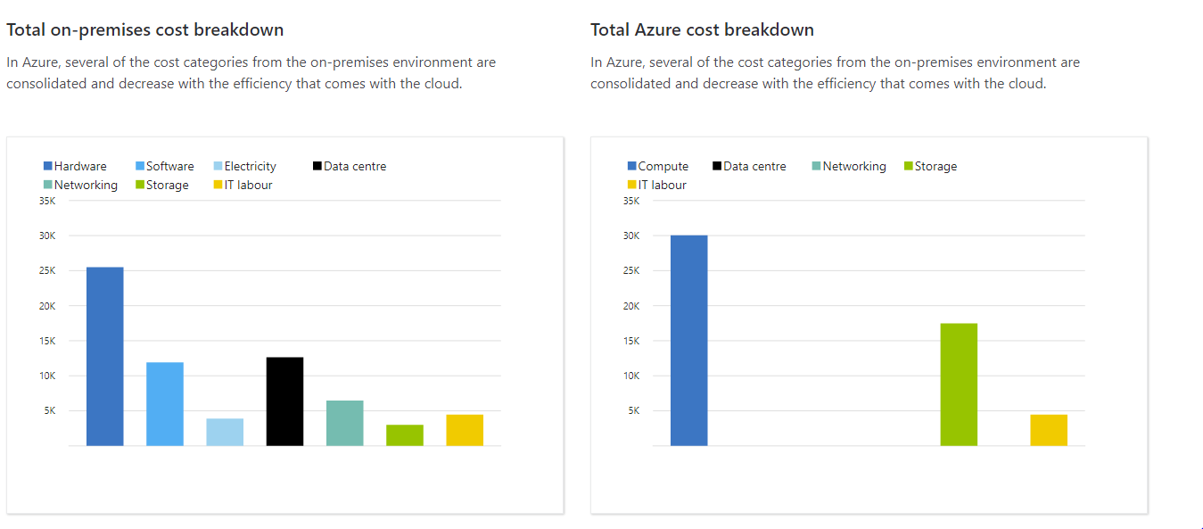
Illustration 9: Another overview with graphs.
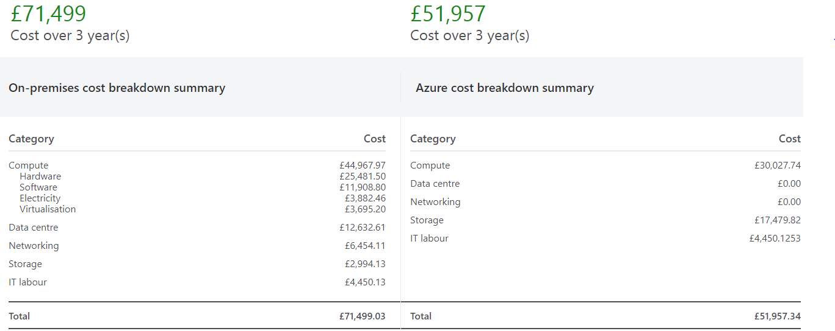
Illustration 10: Cost breakdown summary.
- With Azure, the significant hardware expenses of £25,481.50 and software costs of £11,908.80 associated with on-premises infrastructure are fully eliminated. This is the case since Azure's cloud service comes with all necessary hardware and software (Illustration 11 and 12).
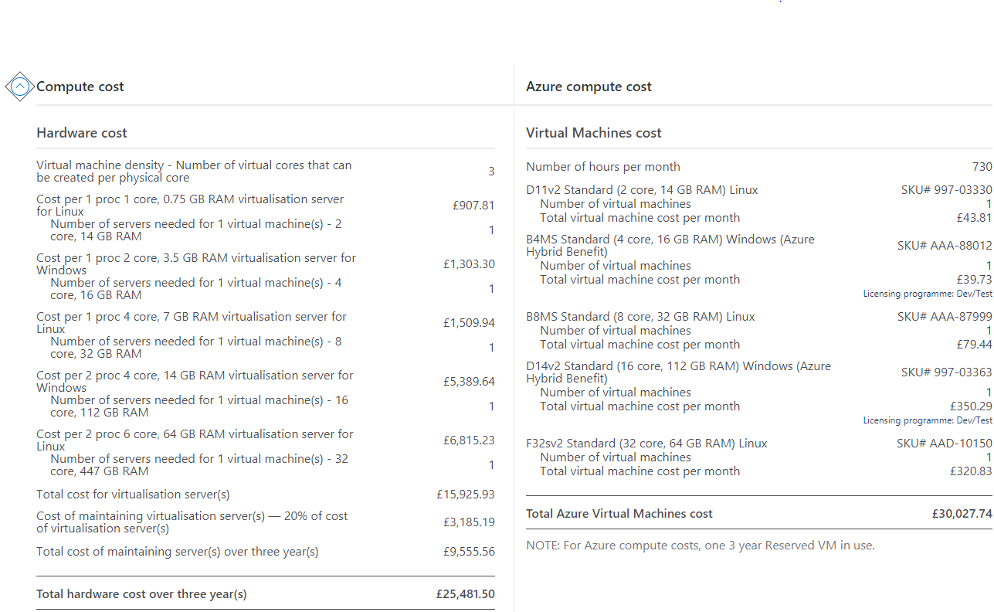
Illustration 11: Compute cost.
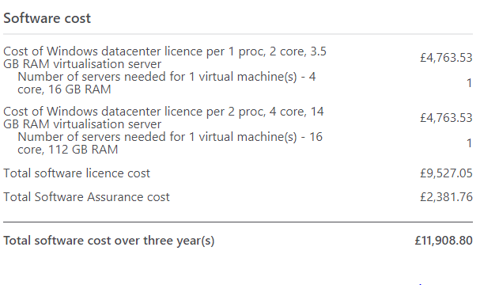
Illustration 12: Software cost.
- Networking expenses, which total £6,454.11, virtualization costs, which total £3,695.20, and data centre fees, which total $12,632.61, are not included in the rates for Azure, much like energy costs, which are incurred under the on-premises infrastructure and total £3,882.46. Azure cloud service users do not need to pay these costs individually because they are covered by their price plan (Illustration 13, 14 and 15).
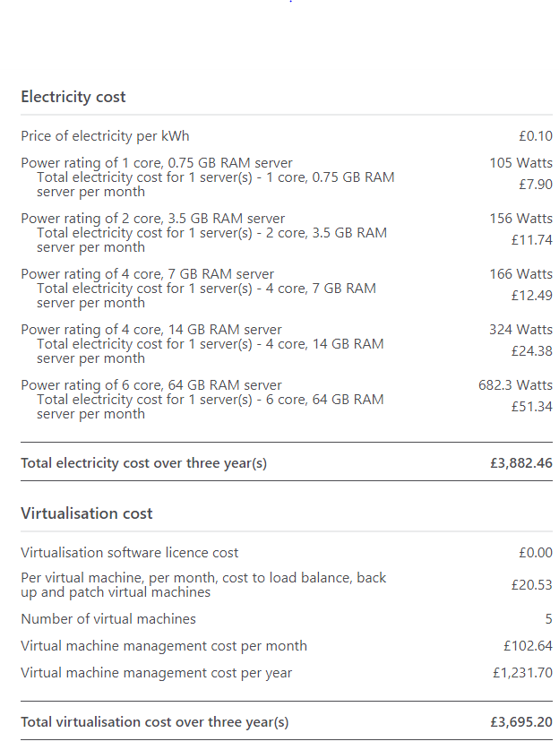
Illustration 13: Electricity and Virtualisation cost.
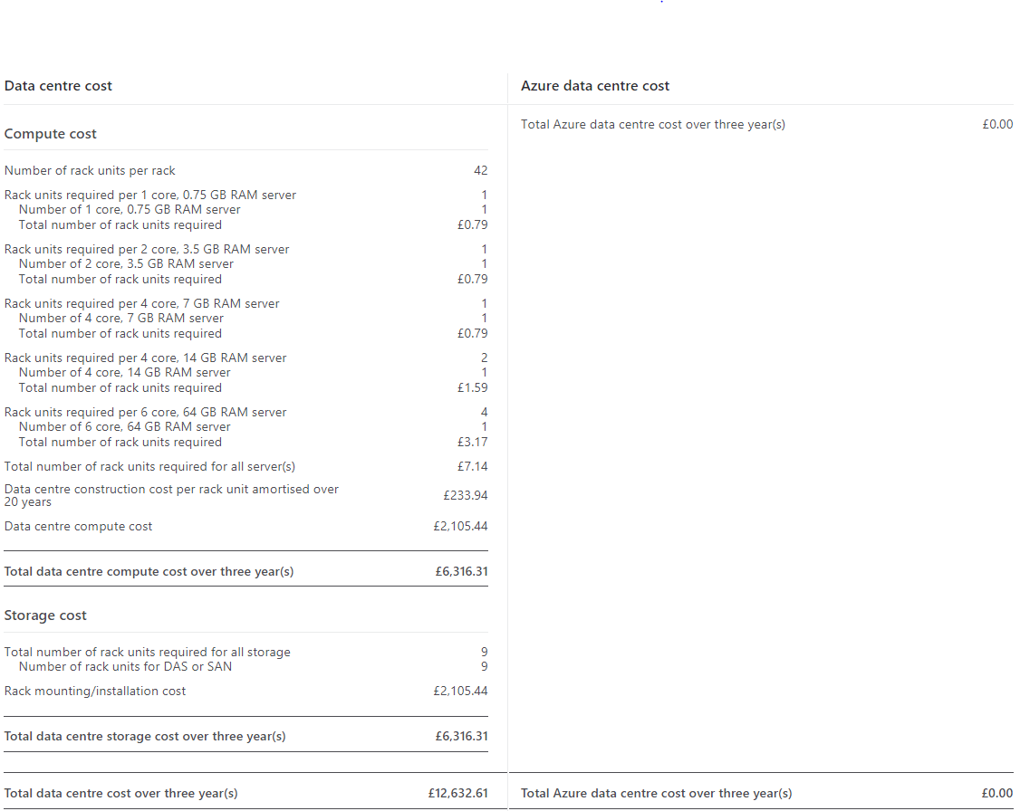
Illustration 14: Data centre and storage cost.
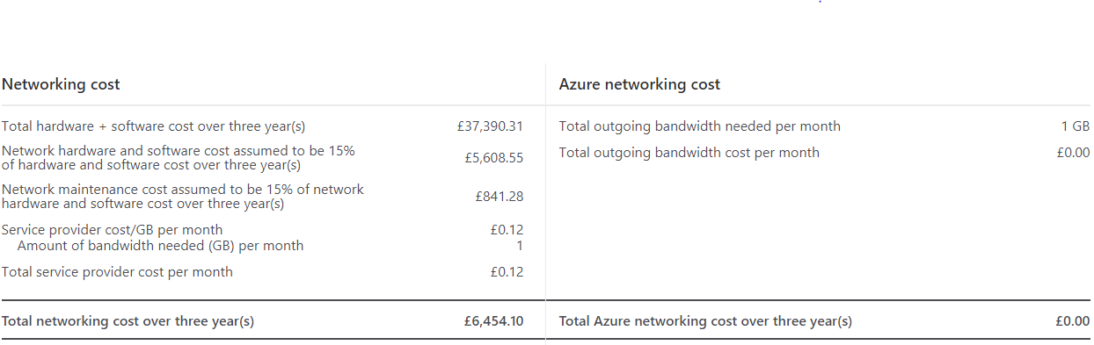
Illustration 15: Network cost.
- Storage costs drop from £2,994.13 for the on-premises model to £1,479.82 for Azure. Azure's storage services provide scalability and flexibility, and they are usually less costly than managing storage internally (Illustration 16).
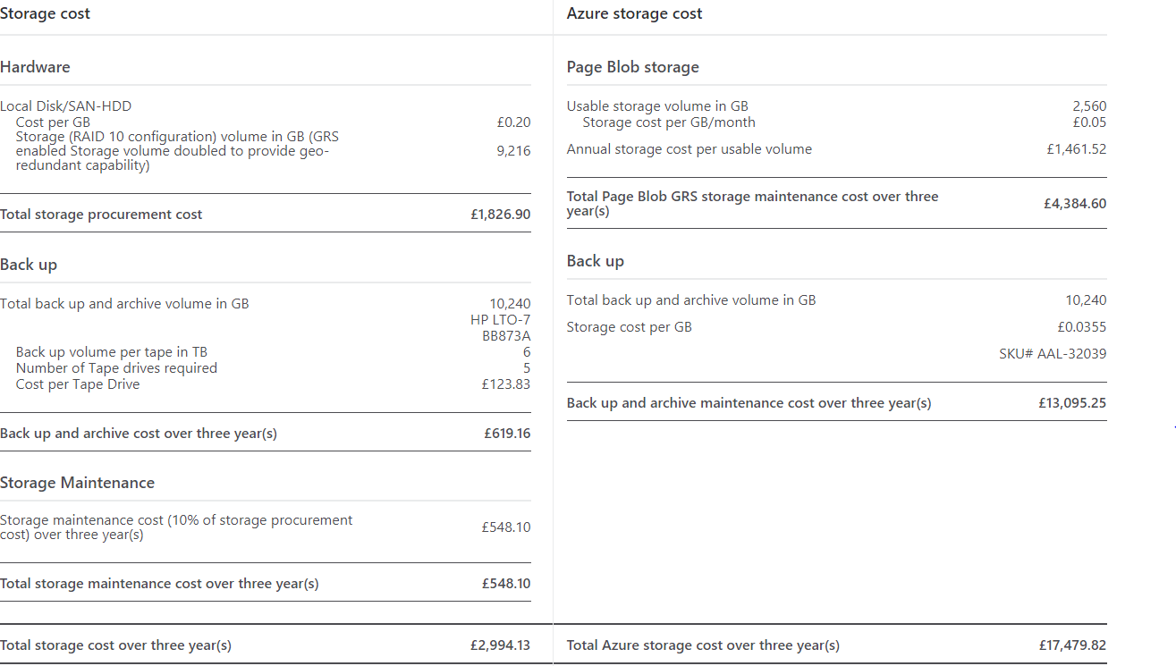
Illustration 16: Storage Cost
- Not to mention, IT labour costs remain same at £4,450.13. Even while this cost doesn't change, it's important to remember that switching to Azure may free up IT specialists from routine maintenance tasks, enabling them to focus on more strategic initiatives.
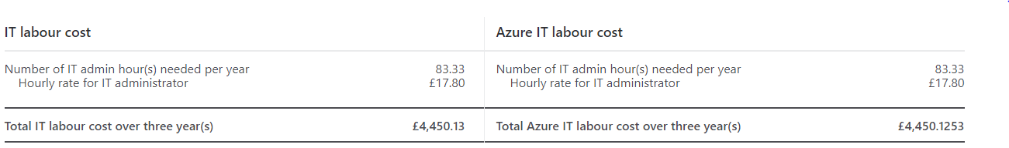
Illustration 17: IT labour.
Azure's cloud infrastructure might result in significant financial savings for Aspire Retailers. By eliminating different costs associated with maintaining an on-premises data centre and by maximising processing and storage capabilities, Aspire Retailers may be able to save a significant amount of money. This discussion demonstrates how inexpensive Azure's cloud infrastructure is as well as the benefits Aspire Retailers might experience if they move. Additionally, Azure AD and the ways in which it facilitates maintaining and presenting Identities.

D). Azure Active Directory (AD) is employed. Building users becomes placed into practise.
Adopting Azure Active Directory (Azure AD) will help Aspire Retailers support their growing company and properly manage identities [22]. Using Azure AD has the following benefits:
1. Centralized Identity Management: IT managers may more easily create, edit, and disable user accounts because to Azure AD's ability to provide Aspire Retailers with a centralised repository for maintaining user IDs. This promotes uniformity and lowers the possibility of user management mistakes [31].
2. Single Sign-On – “SSO” for increased Productivity: Users may sign in once and effortlessly access several apps and resources with Azure AD's SSO features. Users no longer must remember several passwords, which improves productivity overall [30].
3. Enhanced Security with Multi-Factor Authentication – “MFA”: MFA may be enforced for users by Aspire Retailers, offering an extra degree of protection to guard against unauthorised access. Sensitive data is protected, and the risk of password-related assaults is reduced [29].
4. Conditional Access Policies for Granular Control: Aspire Retailers may specify access controls that depend on circumstances thanks to the conditional access functionality of Azure AD. They can impose access restrictions based on user responsibilities, device compliance, and geographic location, ensuring that resources are accessed appropriately and securely [28].
5. Identity Protection for Threat Detection: Aspire Retailers can identify and address any identity-related risks and attacks with the aid of Azure AD Identity Protection. To identify suspect sign-in actions and offer useful insights, it makes use of cutting-edge machine learning algorithms and Microsoft's worldwide threat intelligence [27].
6. Self-Service Capabilities: Users may maintain their own identities by changing passwords and requesting access to apps thanks to the self-service capabilities of Azure AD. Users are given the ability to autonomously perform normal identity-related procedures, which lessens the stress on the IT department [26].
7. BYOD Support: Security restrictions for Bring Your Own Device (BYOD) scenarios may be enforced using Conditional Access rules from Azure AD. Aspire Retailers may set criteria to guarantee that only authorised and compatible devices can access company resources, ensuring security while facilitating a flexible working environment for users worldwide (Illustration 18) [25].
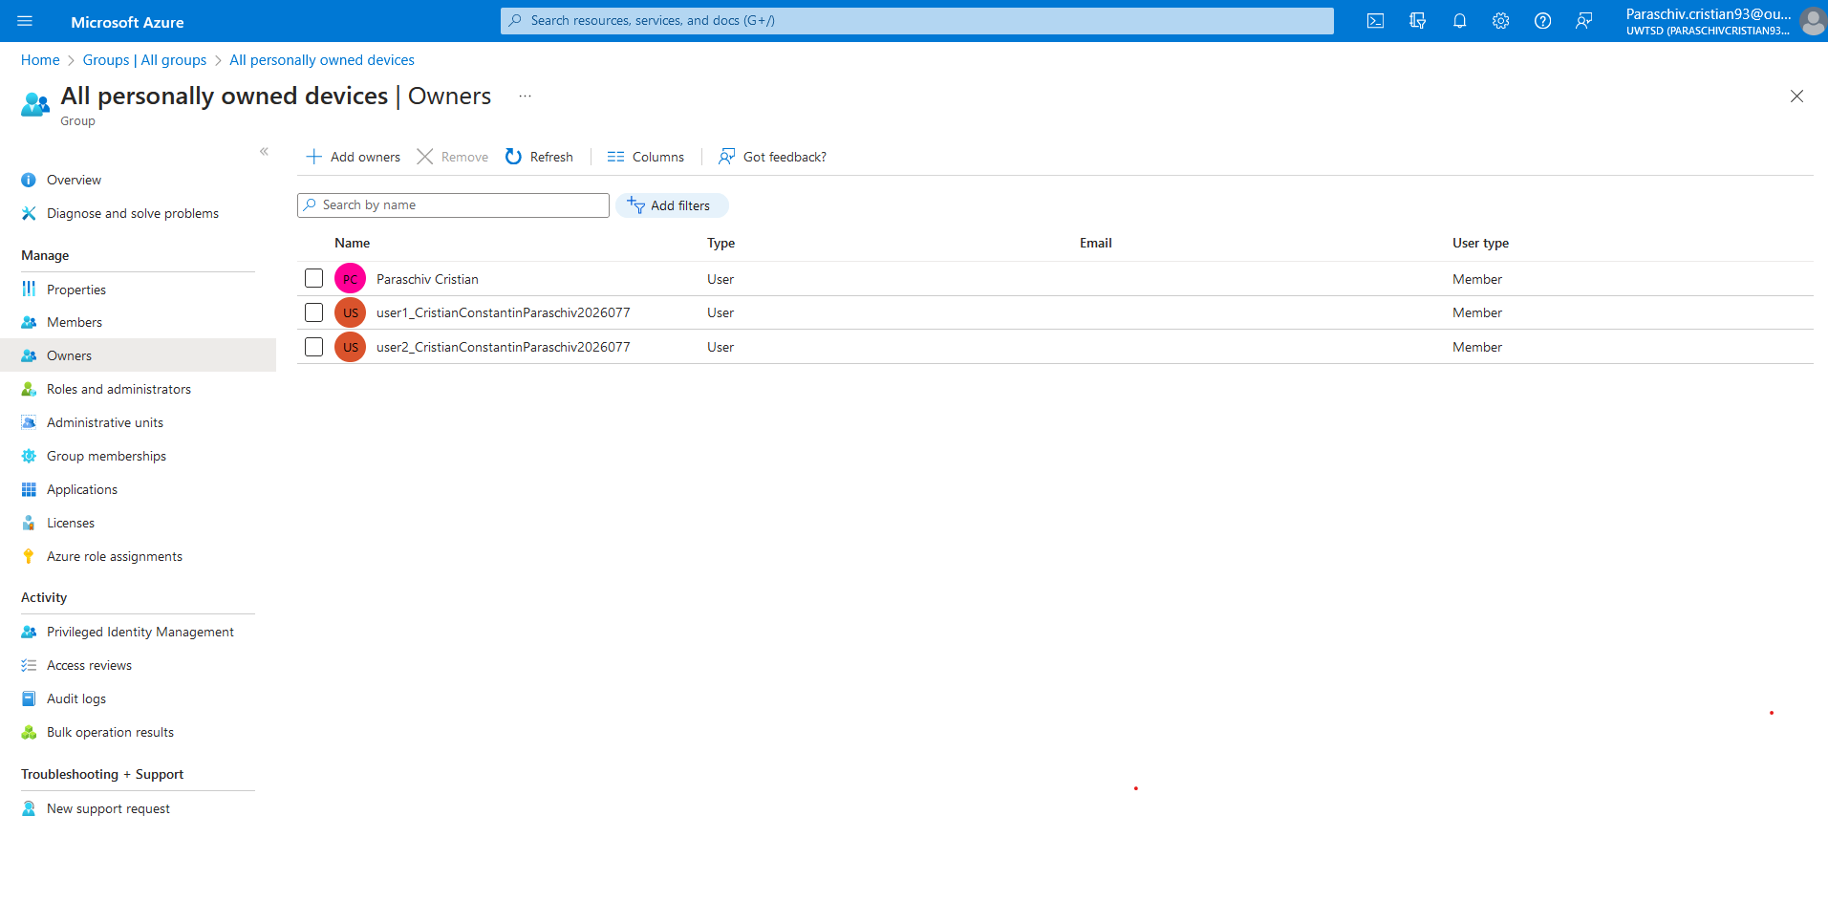
Illustration 18: BYOD
8. Integration with Microsoft Ecosystem: The implementation and maintenance of Microsoft cloud services like Office 365, Dynamics 365, and SharePoint are made easier by Azure AD's seamless integration with a variety of Microsoft services and apps. The entire user experience is improved as a result [24].
9. Global Reach and Scalability: Azure AD is built to expand effectively, supporting the expansion of Aspire Retailers' company without sacrificing performance. Additionally, it provides a worldwide presence via data centres, guaranteeing low-latency access to Azure AD services for customers in various areas [23].
The following examples show how to implement creating two users in Azure Active Directory, presentation for Aspire Retailers:
- The establishment of a username in AD is highlighted and demonstrated in the following example (Illustration 19 to 23).
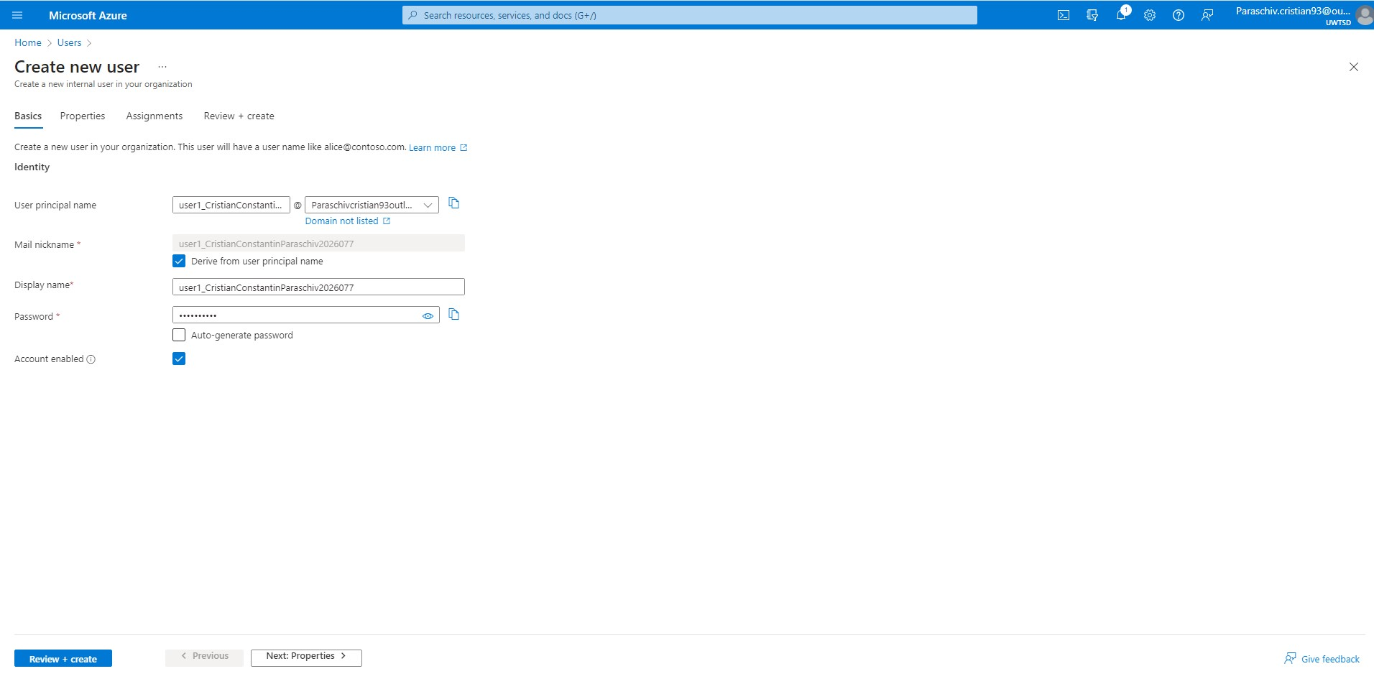
Illustration 19: New user1_CristianConstantinParaschiv2026077.
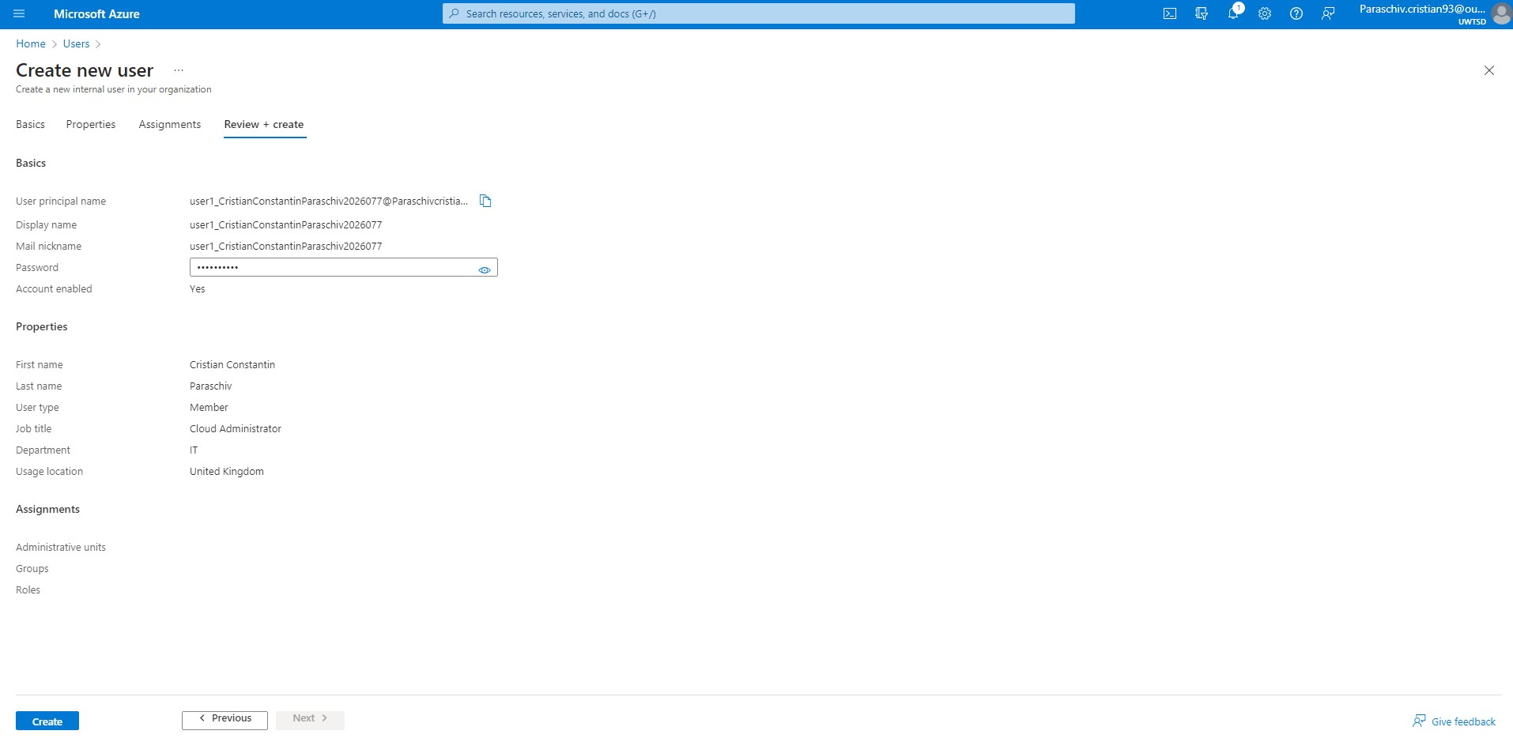
Illustration 20: Review and create user1_CristianConstantinParaschiv2026077.
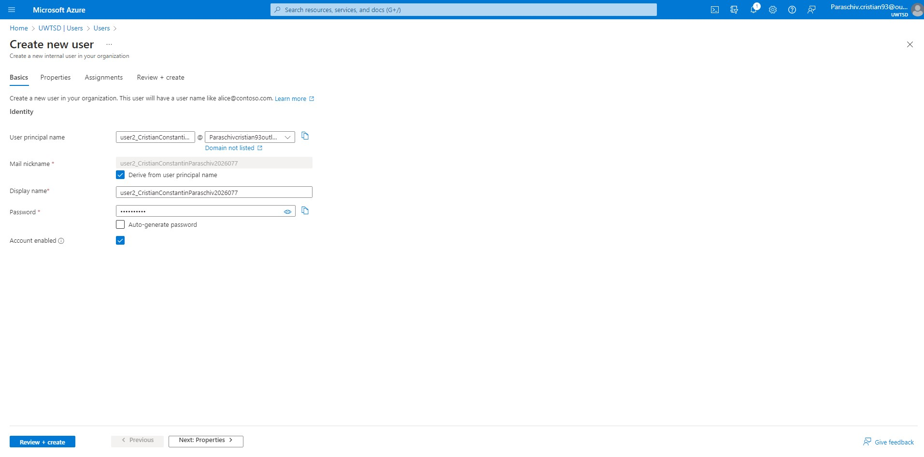
Illustration 21: New user2_CristianConstantinParaschiv2026077.
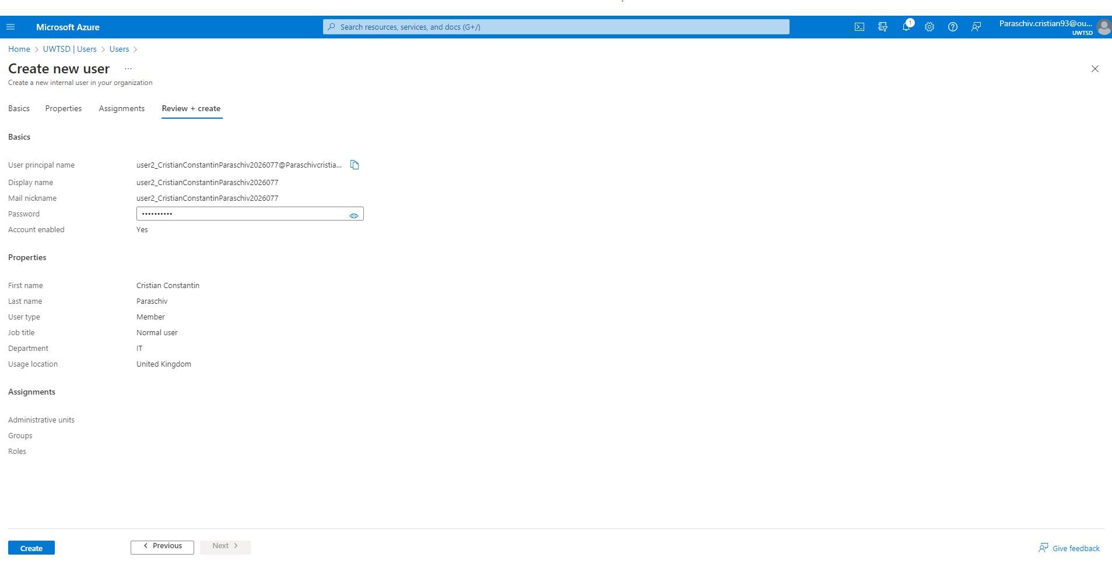
Illustration 22:Review and create user2_CristianConstantinParaschiv2026077.
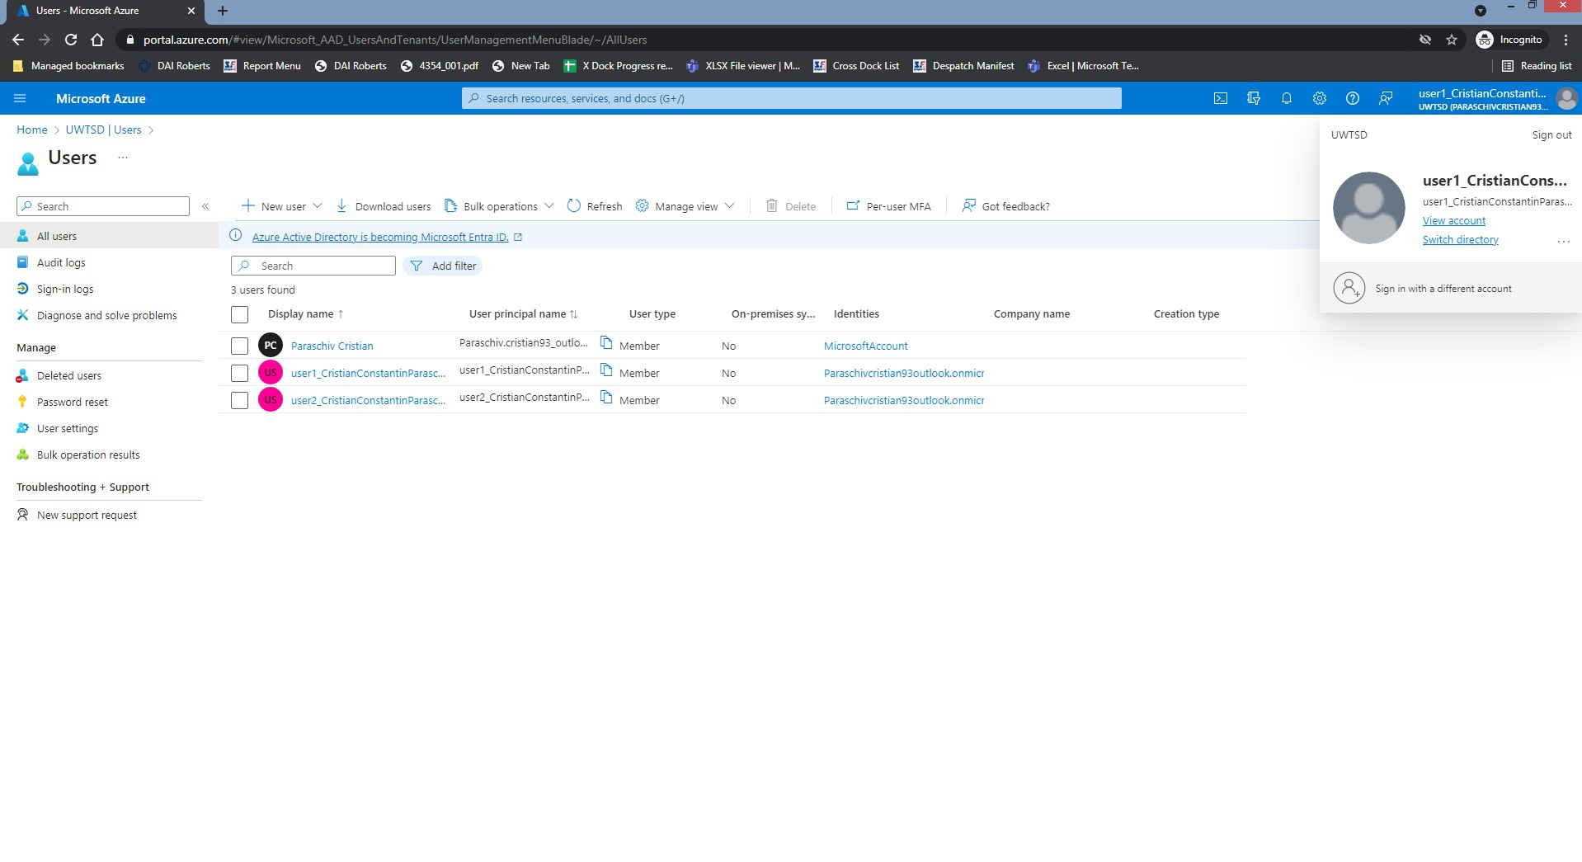
Illustration 23: A picture with created users.

When a new user account is established, the user may use the allocated username and password to log into any services that support Azure Active Directory. The given role and the user's participation in groups will determine the user's access to resources and applications. In addition, a governance plan for Aspire Retailers was given in the next phase, along with role assignment, resource group creation, tag creation, and user testing.

E). Cloud governance in Azure.
An organization's implementation of a set of guidelines, rules, and best practises to guarantee the secure and effective use of cloud resources is referred to as a cloud governance strategy. It aids in setting rules for managing and monitoring cloud systems, reducing risks, and upholding regulatory compliance. Resources are used efficiently, expenses are kept under control, and access to critical data is securely monitored thanks to cloud governance [32].
Aspire Retailer may benefit from several capabilities and services that Microsoft Azure provides to help secure access to cloud resources, including:
- Azure Active Directory (Azure AD): Azure AD is Microsoft's online solution for managing identities and access rights. To handle user IDs and access to multiple Azure services centrally, Aspire Retailer may make use of Azure AD. To improve security and simplify user authentication procedures, it offers capabilities including single sign-on (SSO), conditional access controls, and identity protection [33].
- Azure's resource groups offer a logical framework for managing and organising linked resources. They provide a means to group resources with comparable management, deployment, or lifecycle requirements. Resource groups may be used by Aspire Retailers to efficiently organise their Azure resources and provide consistent management and governance procedures. Azure storage accounts offer a scalable and secure way to store and retrieve different kinds of data. Azure Storage accounts may help Aspire Retailers store and manage their data more efficiently (Illustration 24,25 and 26) [34].
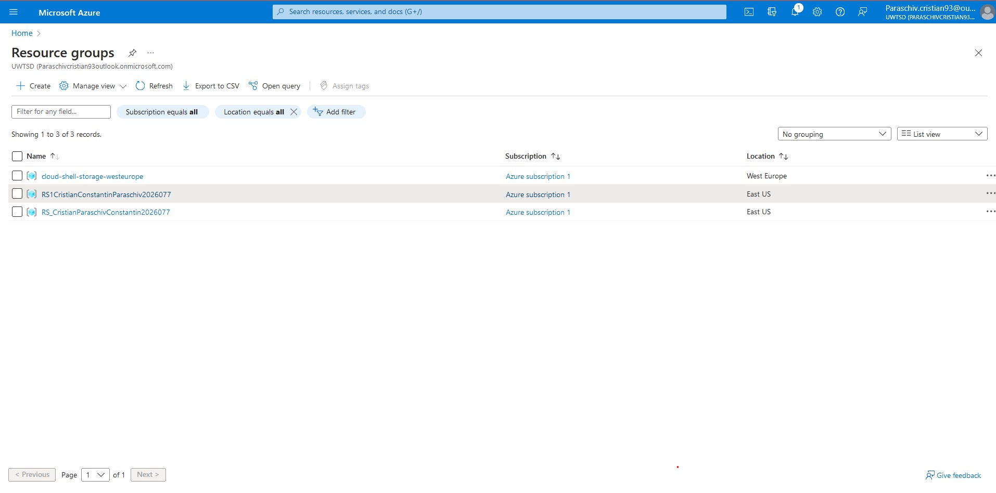
Illustration 24: Resource group presentation.
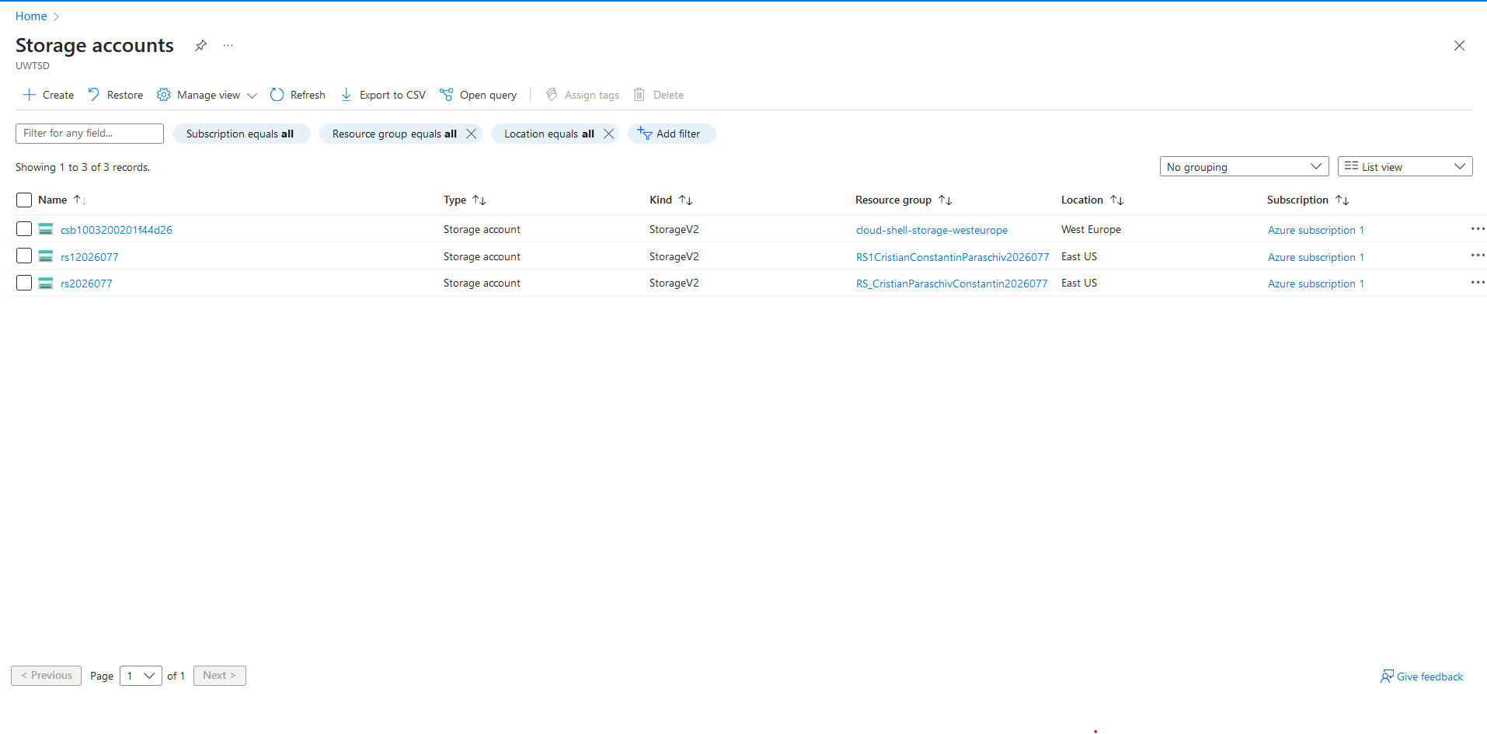
Illustration 25: Storage for each resource group.

- Identity and Access Management (IAM): According to Azure's strong IAM features, Aspire Retailer can manage who has access to its cloud services. Only approved users or programmes will be able to access certain resources thanks to their ability to create complex access controls, roles, and permissions (Illustration 26,27,28 and 29). As an additional security measure, Aspire Retailer may also use multi-factor authentication (MFA) [34].

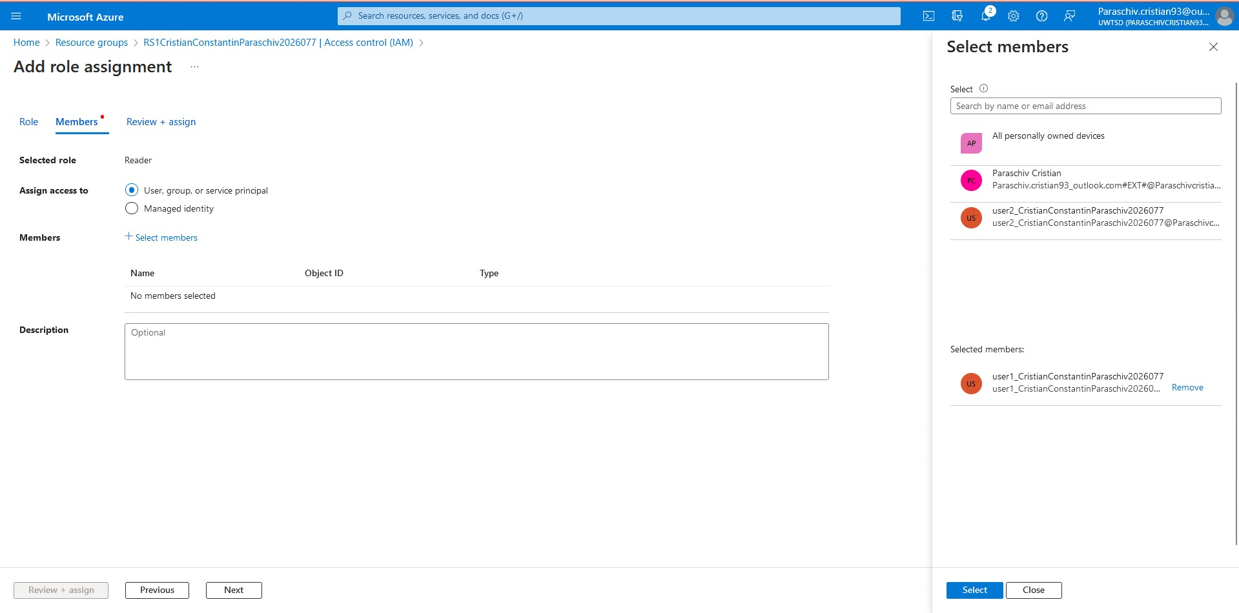
Illustration 26: Role Assignment user1_CristianConstantinParaschiv2026077
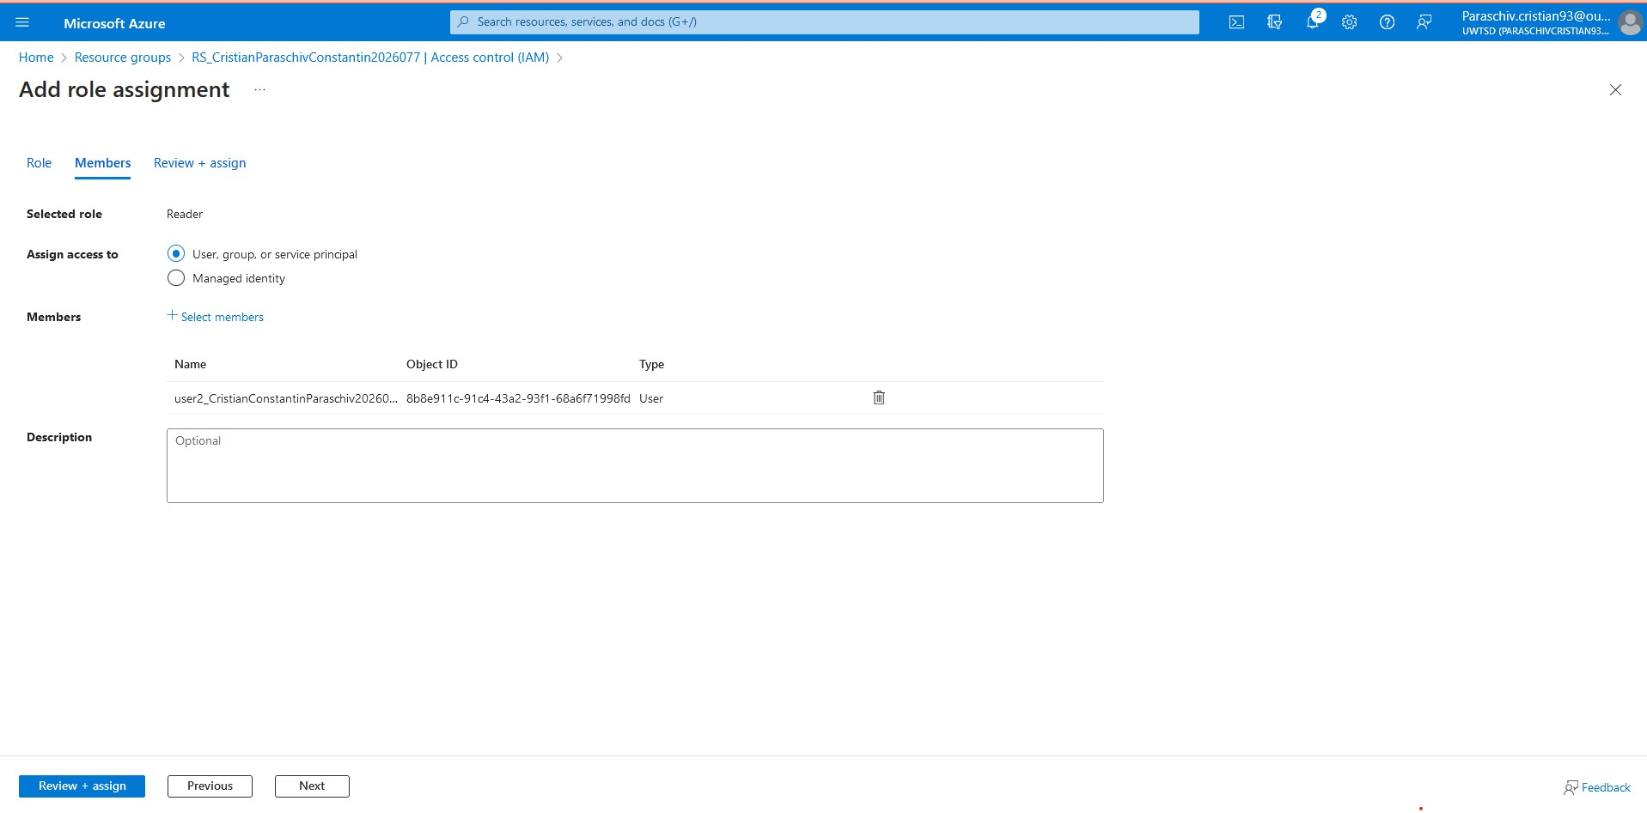
Illustration 27: Role Assignment user2_CristianConstantinParaschiv2026077
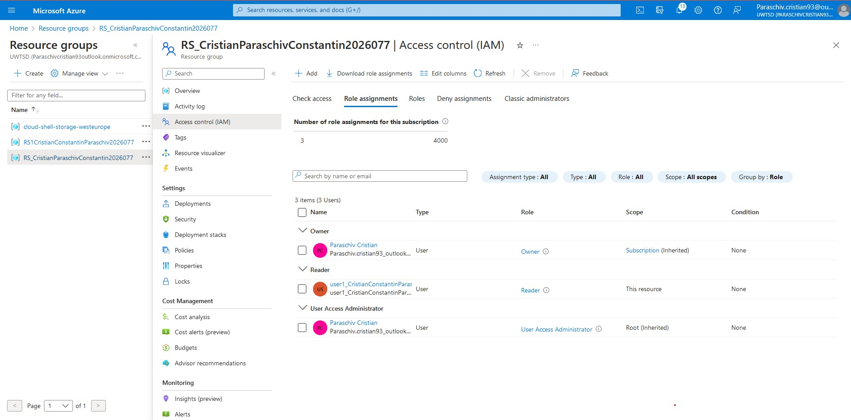
Illustration 28: Access control (IAM) - As a "Reader"
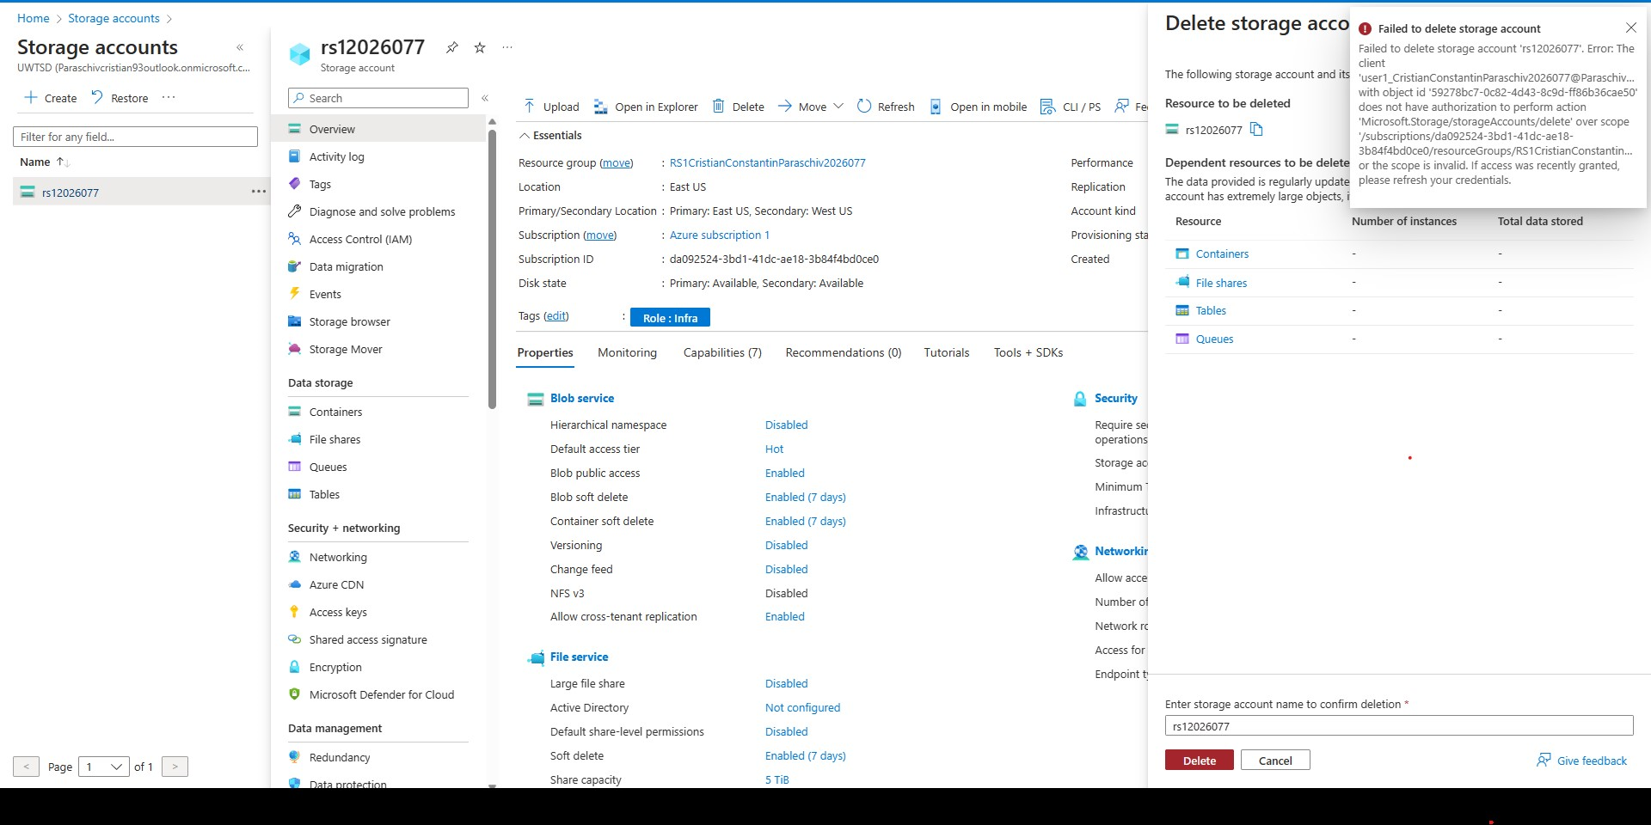
Illustration 29: User testing - Storage error delete message.

- Azure Policy: Aspire Retailer may specify and enforce rules and norms for its cloud resources using Azure Policy. By establishing policies for security, compliance, and resource utilisation, they can make sure that their infrastructure and apps follow predetermined guidelines. Azure Policy can assist in imposing other security measures such as resource tagging, password complexity restrictions, and encryption specifications [35].
- Azure Security Centre: To see the security status of their Azure resources, Aspire Retailer can use Azure Security Centre. It offers suggestions, threat intelligence, and ongoing monitoring to find and address potential security flaws or vulnerabilities. Aspire Retailer may use the policies and notifications provided by Security Centre to proactively manage security concerns [36].

Policy recommendation for Aspire Retailer: "Require tagging on resources with the specified tag and its value."
- Policy description: All cloud resources deployed within the Azure environment of Aspire Retailer must be marked with a certain tag and its accompanying value. Tags offer useful metadata that may be utilised for organisation, cost distribution, and resource management. This policy promotes effective resource monitoring and management by ensuring uniform resource tagging practises throughout the organisation.
- Policy enforcement: Azure Policy, a pre-installed function in Azure, may be used by Aspire Retailer to enforce this policy. They can create a special policy that examines all deployed resources to see if the necessary tag and its value are there. Resources will be scanned by Azure rules, and those that don't adhere to the rules will be flagged. Resources that are not compliant can be fixed or prevented from being deployed until the necessary tagging is used [37] (Illustration 30, 31, 32, 33, 34 and 35).
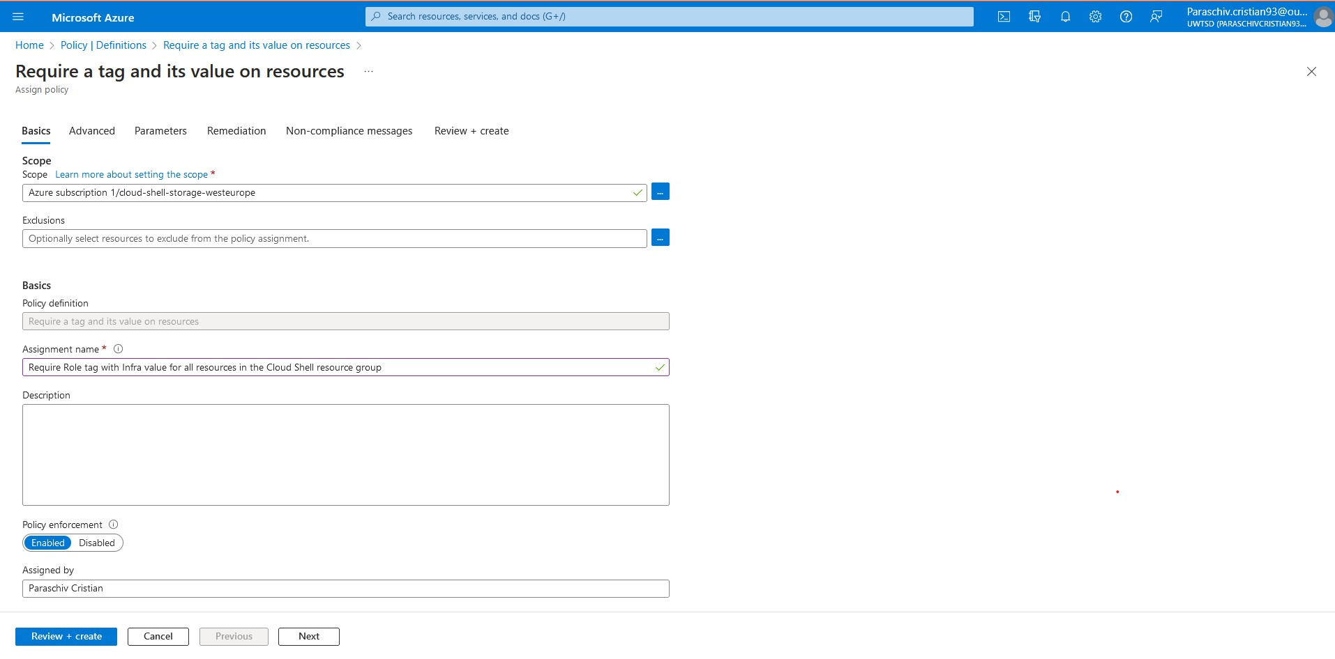
Illustration 30: Enforce the Tag to all the resources: cloud-shell-storage-westeurope.
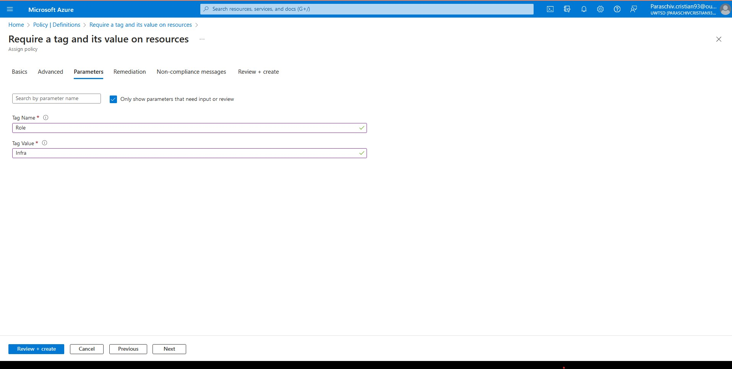
Illustration 31: Roles and Values within Policy.
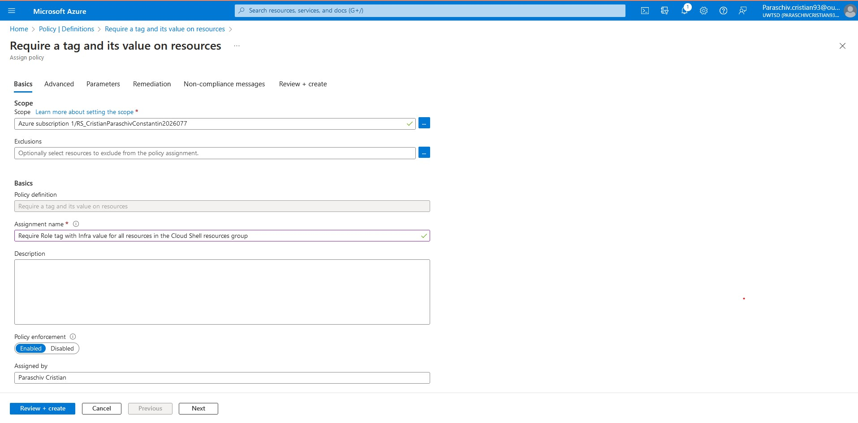
Illustration 32: Enforce the Tag to all the resources: RS_CristianParaschivCristian2026077
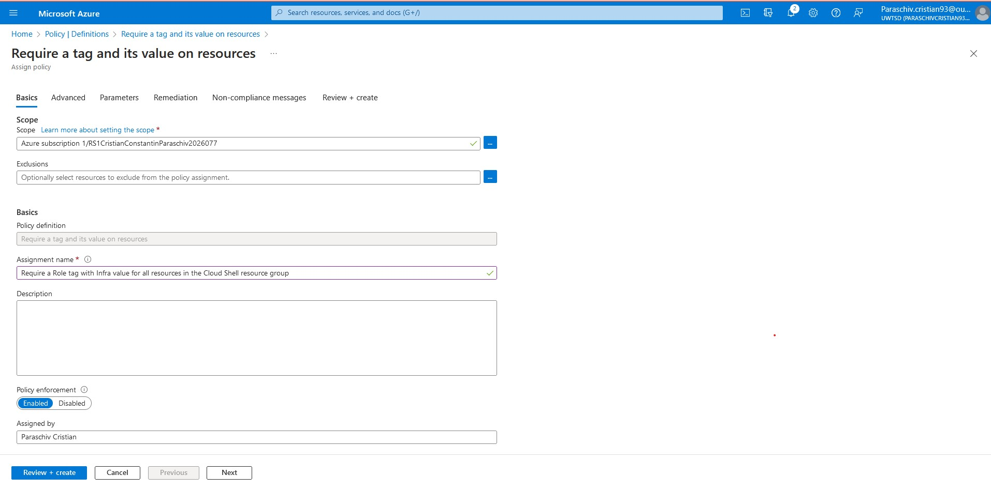
Illustration 33: Enforce the Tag to all the resources: RS1CristianConstantinParaschiv2026077.
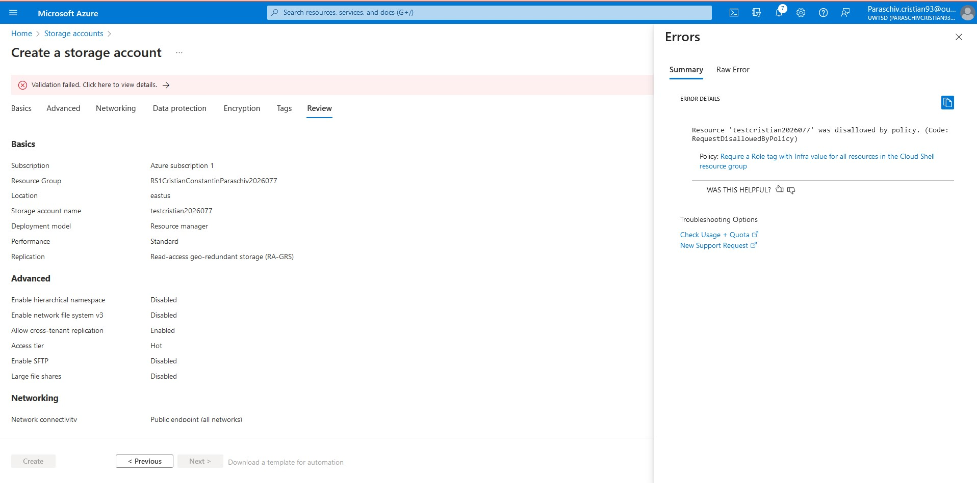
Illustration 34: Creating storage testing without tags.
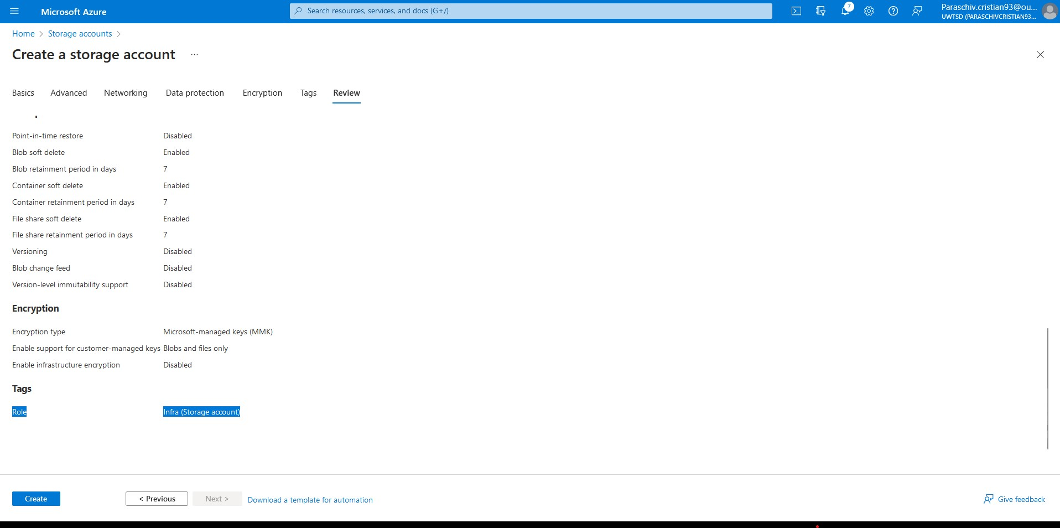
Illustration 35: Creating storage account with tags.
By establishing this policy into place, Aspire Retailer can make sure that their cloud resources are properly organised and managed, facilitating easier and more effective resource tracking, cost allocation, and control. A disaster recovery plan was also given for Aspire Retailers in the next phase.

F). Disaster recovery Microsoft Azure toward Aspire Retailers

To maintain business continuity in the case of a disaster or disruptive event, disaster recovery (DR) in the cloud refers to the process of duplicating and restoring crucial data, apps, and infrastructure. In comparison to conventional on-premises systems, cloud-based DR has more flexibility, scalability, and affordability.
Microsoft Azure, a well-known cloud platform, offers strong Disaster Recovery assistance, making it the perfect option for businesses like Aspire Retailer. The following are some significant ways Azure facilitates disaster recovery [38]:
1. Azure Site Recovery – “ASR”: With the help of Azure's Site Recovery feature, physical servers and virtual machines may be replicated and recovered to an on-premises data centre or another Azure region. Because ASR supports a wide range of operating systems and offers ongoing data protection, the risk of data loss during a disaster is reduced.
2. Regional Redundancy: The locations of Azure's data centres are dispersed throughout many geographies. Because each zone is made to function on its own, there is less chance that localised events would cause broad outages. To increase resilience, Aspire Retailer can adopt DR solutions that entail copying data and resources to a backup area.
3. Azure Backup: For data stored in Azure, Azure Backup offers a dependable and secure offsite backup option. This solution may be utilised by Aspire Retailer to safeguard crucial information, workloads, and programmes from unintentional deletion, corruption, or other data loss incidents. For increased security, Azure Backup enables long-term retention and encryption.
4. Azure Traffic Manager: A DNS-based global load balancer called Azure Traffic Manager may split up incoming user traffic among several Azure regions. By making use of this service, Aspire Retailer may direct traffic to a working area after a crisis, guaranteeing that their customers can continue to get service.
5. ExpressRoute: Azure ExpressRoute offers a private and dedicated network connection between an organization's on-premises infrastructure and Azure. This high-performance network connection enables simultaneous data replication between on-premises and Azure, enhancing data consistency in disaster recovery scenarios.
6. Disaster Recovery Drills: Businesses may use Azure to test the effectiveness of their disaster recovery plans without harming their production environments. Aspire Retailer may review their DR plan on a recurring basis to identify and correct any potential issues or inefficiencies.
7. Pay-as-you-go Model: Organisations like Aspire Retailer may use Azure's pay-as-you-go pricing model to only pay for the resources they use during replication and recovery procedures. This economical strategy guarantees that DR capabilities are available to companies of all sizes.
Organisations like Aspire Retailer may benefit from the extensive Disaster Recovery solutions provided by Microsoft Azure. Aspire Retailer may establish a strong and dependable disaster recovery strategy, minimising downtime, and data loss in the event of unanticipated catastrophes or interruptions, by utilising Azure's DR capabilities.

Conclusion
For Aspire Retailers, switching to Microsoft Azure has proven to be a game-changer. They have reaped several advantages from switching from an on-premises data centre to the cloud, which has had a favourable influence on their company operations.
First off, by switching to Azure, Aspire Retailers are no longer responsible for managing and maintaining physical infrastructure and software. They now have access to a variety of cloud services, including servers, storage, and databases, all of which can be instantaneously provided and speed up and improve the efficiency of developing and deploying applications.
By switching to Azure, considerable cost reductions have been realised. They had to pay for running and maintaining a physical building, buying, and powering servers, and controlling cooling systems in the data centre. They have more flexibility and expense control thanks to Azure's pay-as-you-go approach, since they only pay for the resources, they really utilise. Additionally, they have further decreased their long-term expenditures by using Azure Reserved Instances for certain compute configurations, making the move to the cloud a prudent financial move.
For Aspire Retailers, using Azure Active Directory has simplified user administration by making it simpler to manage user accounts and group accounts. Users from all around the world may safely access the essential programmes and data from their own devices thanks to support for "Bring Your Own Device" (BYOD), increasing flexibility and productivity.
Aspire Retailers has effectively grown their business into new areas by utilising Azure's global presence and scalability. To serve their expanding consumer base, they have been able to outsource their marketing activities and rely on Azure's dependable and high-performance infrastructure.
Aspire Retailers' choice to switch to Microsoft Azure has proven to be a wise and profitable one. They have increased their business agility, decreased the complexity of IT management, and realised considerable cost savings by implementing the cloud. They have improved user productivity and accessibility globally with the help of Azure services like Azure Active Directory and BYOD capabilities, which has fueled development and success in their sector. Overall, the transition to the cloud has prepared Aspire Retailers for a bright future.

References
[1] A. Li, X. Yang, S. Kandula, and M. Zhang, ‘CloudCmp: comparing public cloud providers’, in Proceedings of the 10th ACM SIGCOMM conference on Internet measurement, Melbourne Australia: ACM, Nov. 2010, pp. 1–14. doi: 10.1145/1879141.1879143. Available at: https://dl.acm.org/doi/abs/10.1145/1879141.1879143
[2] P. Mell and T. Grance, ‘The NIST Definition of Cloud Computing’. Available at: https://nvlpubs.nist.gov/nistpubs/legacy/sp/nistspecialpublication800-145.pdf
[3] M. Mishra, A. Das, P. Kulkarni, and A. Sahoo, ‘Dynamic resource management using virtual machine migrations’, IEEE Commun. Mag., vol. 50, no. 9, pp. 34–40, Sep. 2012, doi: 10.1109/MCOM.2012.6295709. Available at: https://www.researchgate.net/publication/260670190_Dynamic_Resource_Management_Using_Virtual_Machine_Migrations
[4] H. Saini, A. Upadhyaya, and M. K. Khandelwal, ‘Benefits of Cloud Computing for Business Enterprises: A Review’, SSRN Journal, 2019, doi: 10.2139/ssrn.3463631. Available at: https://papers.ssrn.com/sol3/papers.cfm?abstract_id=3463631
[5] D. G. Chandra and M. D. Borah, ‘Cost benefit analysis of cloud computing in education’, in 2012 International Conference on Computing, Communication and Applications, Dindigul, Tamilnadu, India: IEEE, Feb. 2012, pp. 1–6. doi: 10.1109/ICCCA.2012.6179142. Available at: https://ieeexplore.ieee.org/abstract/document/6179142
[6] S. K. Majumdar, ‘Scalability versus flexibility: firm size and R&D in Indian industry’, J Technol Transf, vol. 36, no. 1, pp. 101–116, Feb. 2011, doi: 10.1007/s10961-009-9147-x. Available at: https://link.springer.com/article/10.1007/s10961-009-9147-x
[7] G. Westerman, D. Bonnet, and A. McAfee, Leading digital: turning technology into business transformation. Boston, Massachusettes: Harvard Business Review Press, 2014. Available at: https://books.google.co.uk/books?hl=en&lr=&id=Fh9eBAAAQBAJ&oi=fnd&pg=PR4&dq=The+Benefits+of+Cloud+Computing+for+Aspire+Retailers+Employees+books&ots=o9TqD21psd&sig=FA8DPRPwsZej6-74TkXiLZje014&redir_esc=y#v=onepage&q&f=false
[8] N. M. Gunturu, ‘A Framework for Successful Corporate Cloud Transformation’, IJCTT, vol. 70, no. 3, pp. 9–15, Mar. 2022, doi: 10.14445/22312803/IJCTT-V70I3P102. Available at: https://arxiv.org/abs/2304.05333
[9] B. Nicoletti, Cloud computing in financial services. Houndmills, Basingstoke, Hampshire: Palgrave Macmillan, 2013. Available at: https://books.google.co.uk/books?hl=en&lr=&id=FV2YAAAAQBAJ&oi=fnd&pg=PP1&dq=The+Benefits+of+Cloud+Computing+for+Aspiring+Merchants:+How+to+Become+More+Creative+and+Adaptable.&ots=uYm05gWlD8&sig=YYSX1P7STLAZyR3xca_6Lt3qxvU&redir_esc=y#v=onepage&q&f=false
[10] A. Cordella and L. Willcocks, ‘Government policy, public value and IT outsourcing: The strategic case of ASPIRE’, The Journal of Strategic Information Systems, vol. 21, no. 4, pp. 295–307, Dec. 2012, doi: 10.1016/j.jsis.2012.10.007. Available at: https://www.sciencedirect.com/science/article/pii/S0963868712000558
[11] A. Akbar Neghabi, N. Jafari Navimipour, M. Hosseinzadeh, and A. Rezaee, ‘Nature-inspired meta-heuristic algorithms for solving the load balancing problem in the software-defined network’, Int J Commun Syst, vol. 32, no. 4, p. e3875, Mar. 2019, doi: 10.1002/dac.3875.Available at: https://onlinelibrary.wiley.com/doi/full/10.1002/dac.3875
[12] R. Cattell, ‘Scalable SQL and NoSQL data stores’, SIGMOD Rec., vol. 39, no. 4, pp. 12–27, May 2011, doi: 10.1145/1978915.1978919. Available at: https://dl.acm.org/doi/abs/10.1145/1978915.1978919
[13] Z. Liu, M. Lin, A. Wierman, S. H. Low, and L. L. H. Andrew, ‘Greening geographical load balancing’, in Proceedings of the ACM SIGMETRICS joint international conference on Measurement and modeling of computer systems, San Jose California USA: ACM, Jun. 2011, pp. 233–244. doi: 10.1145/1993744.1993767. Available at: https://dl.acm.org/doi/abs/10.1145/2007116.2007139
[14] R. Kaur and P. Luthra, ‘Load Balancing in Cloud Computing’. Available at: https://citeseerx.ist.psu.edu/document?repid=rep1&type=pdf&doi=bf4d4a91828e524c366fe2c53f1d345fd0eec821
[15] G. G. Vadakkepatt et al., ‘Sustainable Retailing’, Journal of Retailing, vol. 97, no. 1, pp. 62–80, Mar. 2021, doi: 10.1016/j.jretai.2020.10.008. Available at: https://www.sciencedirect.com/science/article/pii/S0022435920300713
[16] P. Membrey, D. Hows, and E. Plugge, Practical Load Balancing: Ride the Performance Tiger. in Springer eBook Collection. Berkeley, CA: Apress, 2012. Available at: https://link.springer.com/chapter/10.1007/978-1-4302-3681-8_11
[17] D. Carrera, V. Beltran, J. Torres, and E. Ayguade, ‘A Hybrid Web Server Architecture for e-Commerce Applications’, in 11th International Conference on Parallel and Distributed Systems (ICPADS’05), Fukuoka, Japan: IEEE, 2005, pp. 182–188. doi: 10.1109/ICPADS.2005.30. Available at: https://ieeexplore.ieee.org/abstract/document/1531125
[18] AWS Documentation, “User guides, code samples, SDKs and toolkits, tutorials, API and CLI references, and more”. [Online]. Available at: Welcome to AWS Documentation (amazon.com)
[19] Google Cloud documentation, “Guides, code samples, architectural diagrams, best practices, tutorials, API references, and more”. [Online]. Available at: Google Cloud documentation | Documentation
[20] Microsoft Azure Handbook. [Online]. Available at: Windows Azure Handbook for UK CSVs (microsoft.com)
[21] Plan and manage your Azure costs. [Online]. Available at: https://learn.microsoft.com/en-us/training/modules/plan-manage-azure-costs/
[22] Microsoft Entra ID documentation. “Microsoft Azure Active Directory (Azure AD) is being renamed to Microsoft Entra ID. Use Microsoft Entra ID to manage user identities and control access to your apps, data, and resources”. [Online] Available at: https://learn.microsoft.com/en-us/azure/active-directory/
[23] M. A. Hossain, R. Agnihotri, M. R. I. Rushan, M. S. Rahman, and S. F. Sumi, ‘Marketing analytics capability, artificial intelligence adoption, and firms’ competitive advantage: Evidence from the manufacturing industry’, Industrial Marketing Management, vol. 106, pp. 240–255, Oct. 2022, doi: 10.1016/j.indmarman.2022.08.017. Available at: https://www.sciencedirect.com/science/article/abs/pii/S0019850122002012
[24] M. Wali, Learn Microsoft Azure: Build, Manage, and Scale Cloud Applications Using the Azure Ecosystem. Birmingham: Packt Publishing Ltd, 2018. Available at: https://books.google.co.uk/books?hl=en&lr=&id=052BDwAAQBAJ&oi=fnd&pg=PP1&dq=The+Benefits+of+Integrating+Microsoft+Ecosystems+with+Azure+Active+Directory&ots=V2xAEzvXx4&sig=QNLNIoolGbq_hLtD_TSWeBv2sqE&redir_esc=y#v=onepage&q=The%20Benefits%20of%20Integrating%20Microsoft%20Ecosystems%20with%20Azure%20Active%20Directory&f=false
[25] D. Jaramillo, N. Katz, B. Bodin, W. Tworek, R. Smart, and T. Cook, ‘Cooperative solutions for Bring Your Own Device (BYOD)’, IBM J. Res. & Dev., vol. 57, no. 6, p. 5:1-5:11, Nov. 2013, doi: 10.1147/JRD.2013.2279600. Available at: https://ieeexplore.ieee.org/abstract/document/6665081
[26] M. Kuperberg, ‘Blockchain-Based Identity Management: A Survey From the Enterprise and Ecosystem Perspective’, IEEE Trans. Eng. Manage., vol. 67, no. 4, pp. 1008–1027, Nov. 2020, doi: 10.1109/TEM.2019.2926471. Available at: https://ieeexplore.ieee.org/abstract/document/8792372
[27] A. Singh, A. Payal, and S. Bharti, ‘A walkthrough of the emerging IoT paradigm: Visualizing inside functionalities, key features, and open issues’, Journal of Network and Computer Applications, vol. 143, pp. 111–151, Oct. 2019, doi: 10.1016/j.jnca.2019.06.013. Available at: https://www.sciencedirect.com/science/article/abs/pii/S1084804519302188
[28] Y. Yu et al., ‘Dynamic control flow in large-scale machine learning’, in Proceedings of the Thirteenth EuroSys Conference, Porto Portugal: ACM, Apr. 2018, pp. 1–15. doi: 10.1145/3190508.3190551. Available at: https://dl.acm.org/doi/abs/10.1145/3190508.3190551
[29] S. Ayinala and R. Murimi, ‘On a Territorial Notion of a Smart Home’, in Proceedings of the 1st Workshop on Cybersecurity and Social Sciences, Nagasaki Japan: ACM, May 2022, pp. 33–37. doi: 10.1145/3494108.3522766. Available at: https://dl.acm.org/doi/abs/10.1145/3494108.3522766
[30] G. A. Gellert, J. F. Crouch, L. A. Gibson, G. S. Conklin, S. L. Webster, and J. A. Gillean, ‘Clinical impact and value of workstation single sign-on’, International Journal of Medical Informatics, vol. 101, pp. 131–136, May 2017, doi: 10.1016/j.ijmedinf.2017.02.008. Available at: https://www.sciencedirect.com/science/article/pii/S1386505617300394
[31] K. Mahroof, ‘A human-centric perspective exploring the readiness towards smart warehousing: The case of a large retail distribution warehouse’, International Journal of Information Management, vol. 45, pp. 176–190, Apr. 2019, doi: 10.1016/j.ijinfomgt.2018.11.008. Available at: https://www.sciencedirect.com/science/article/abs/pii/S0268401218306972
[32] K. Gai and S. Li, ‘Towards Cloud Computing: A Literature Review on Cloud Computing and Its Development Trends’, in 2012 Fourth International Conference on Multimedia Information Networking and Security, Nanjing, China: IEEE, Nov. 2012, pp. 142–146. doi: 10.1109/MINES.2012.240. Available at: https://ieeexplore.ieee.org/abstract/document/6405648
[33] R. Cattell, ‘Scalable SQL and NoSQL data stores’, SIGMOD Rec., vol. 39, no. 4, pp. 12–27, May 2011, doi: 10.1145/1978915.1978919. Available at: https://dl.acm.org/doi/abs/10.1145/1978915.1978919
[34] N. Sultan, ‘Making use of cloud computing for healthcare provision: Opportunities and challenges’, International Journal of Information Management, vol. 34, no. 2, pp. 177–184, Apr. 2014, doi: 10.1016/j.ijinfomgt.2013.12.011. Available at: https://www.sciencedirect.com/science/article/abs/pii/S0268401213001680
[35] J. Moura and D. Hutchison, ‘Review and analysis of networking challenges in cloud computing’, Journal of Network and Computer Applications, vol. 60, pp. 113–129, Jan. 2016, doi: 10.1016/j.jnca.2015.11.015. Available at: https://www.sciencedirect.com/science/article/abs/pii/S108480451500288X
[36] N. A. Sultan, ‘Reaching for the “cloud”: How SMEs can manage’, International Journal of Information Management, vol. 31, no. 3, pp. 272–278, Jun. 2011, doi: 10.1016/j.ijinfomgt.2010.08.001. Available at: https://www.sciencedirect.com/science/article/abs/pii/S0268401210001143
[37] P. Gonczol, P. Katsikouli, L. Herskind, and N. Dragoni, ‘Blockchain Implementations and Use Cases for Supply Chains-A Survey’, IEEE Access, vol. 8, pp. 11856–11871, 2020, doi: 10.1109/ACCESS.2020.2964880. Available at: https://ieeexplore.ieee.org/abstract/document/8952728
[38] Backup and disaster recovery for Azure applications. [Online]. Available at: https://learn.microsoft.com/en-us/azure/well-architected/resiliency/backup-and-recovery

