Critically reflect upon what constitutes family in a contemporary world. Reflect upon whether ‘families’ are still important in today’s society.

This assessment focuses on what a traditional family is – it discusses the typical 1950’s family (Murdock, 1949) and how society have evolved from that aspect of a ‘traditional family’. However, it also discusses how a family could be a form of a social construct as well (Lock and Strong, 2010). It discusses the terms on what a non-traditional family is within the 21st century and how lone parent family are at risk of exclusion from society. It also focuses on how parents but mostly children become resilient to tricky situations within society – it also talks about primary socialisation.
It shows how family units have changed over the years and how more ‘couples’ are progressing with their career before settling down and having children. It states what ‘women’s roles’ were before the welfare state was put into place and what women were perceived to do. final, it focuses on whether or not family is still important in today’s society.
People have many ways of defining a family and what being part of a family means to them. Families differ in terms of economic, cultural, social, and many other facets (McDowell and Pringle, 1994, p. 74).

When we consider a traditional family, Murdock (1949) refers to family has a ‘social group characterised by common residence, economic co-operation and reproduction’ – Murdock 1949) suggest that a family unit is based on ‘two adults of both sexes, cohobating in the same household, with one or more children, taking responsibility for the children’s welfare’. However, McDowell and Pringle (1994) disagree with this definition as it is ‘functionalist and does not recognise diversity of ways in which caring relationships can be organised – they refer to it has a kinship’.
The definition of kinship refers to ‘the ties which exist between individuals who are seen as related both through birth and through mating; primarily concerned with the ways in which mating is socially organised and regulated, the ways in which percentage is assigned, attributed and recognised; birth is traced, rights are transferred and groups are formed’ (Edholm cited in McDowell and Pringle, 1994, p. 70). Anthropological definition of kinship recognises that the notion of family is socially constructed (McDowell and Pringle, 1994).
According to Lock and Strong (2010, p. 19) ‘social constructionism, is the social construct of reality – it is a theory which is based on knowledge in sociology and communications and it examines the development of jointly constructed understandings of the world that form the basis for shared assumptions about reality. Ferrante (2011) idea of a family structure is based on ‘a social institution that binds people together through various means, blood, marriage, norms and laws – there is no concrete group which can be universally identified as the family’. He believes that there are several institutions to blame for creating the ‘cereal packet family’ but not all sociologists agree with what appears to be a typical ‘British’ family.
Whereas, Gittens (1993) refers to family has a ‘group of persons directly linked by kin connections, adult members of which assume responsibility of caring for children’ – this definition includes grandparents and it encourages close, positive family bonds. Even though there are positive aspects of this definition, there is also some negative aspects, such as, if there is no extra family e.g. grandparents’ around due to families not living close together now, there could be financial strain on the ‘caregiver’ having to stay home to look after the children and then there could be lack of employment progression for the main ‘caregiver’ (Holden, 2001).
Gittens (1993) suggests that the ‘perfect ideology of the family would have us constructed to believe that there is only one family type, one correct way in which individuals should live and interact with each other’; the traditional 1950’s family.
However, other sociologists would criticise this functionalist theory by Murdock – Marxist and feminist theories would argue against his ‘rose-tinted harmonious consensus view’ of the ideal family (Haralambos and Holborn, 2013). Marxist theory argues that it ‘meets the needs of capitalism, not those of the family members or society as a whole’ (Webb, Westergaard, Trobe and Steel, 2008) – according to Marx (1996) the ‘functions of the family are performed purely for the benefit of the capitalist system’, he suggests that the main factor of shaping all the ‘social institutions, including the family, is know has the mode of production’ – this is known has the upper class owning and controlling the factories etc. in society.
Webb et al (2008) states that in modern society, ‘it is the capitalist class that owns and controls these means of production – as the mode of production evolves, so does the family’. Before ‘classes’ were introduced within society, all members of society in this ‘day and age’ owned the means of production – this was known as a ‘primitive society’ (Webb et al., 2008) – ‘at this stage of social development, there was no family structures’.
According to Marx and Engels, cited in Webb et al. (2008) their theory developed over time, due to ‘society’s wealth increasing, the forces of production developed further’. Their research stated that once the wealth increased, private property was finally able to develop, and a new class of men were able to ‘emerge and control the means of production’ (Webb et al., 2008) – this change eventually seen the ‘patriarchal monogamous nuclear family’ form.
During this period, ‘monogamy became essential due to the inheritance of private property’, men were more likely to marry a person of the opposite sex and have children; only so they knew they were the ‘paternity of that child and/or children – they were able to know that their ‘legitimate heirs inherited from them’ (Webb et al., 2008). Engels’ view of the ‘monogamous nuclear family’ steered to a society that had control of women – men had every aspect of control over them, especially of a women’s libido; women were turned into ‘a mere instrument for the production of children’ (Webb et al., 2008).
However, Marx (1996) argued this, he believed to have seen society with no ‘labels’; his theory was based on an ‘overthrow of capitalism and private ownership of the means of production’, this is when he stated women would achieve ‘liberation from patriarchal control’ – ‘a classless society will be established in which the means of production are owned collectively, not privately’. Marx (1996) then suggested that there would be no need for the ‘patriarchal nuclear family’, this means that due to no private ownership forming, there would be no need for children due to no ‘transmitting of private property’.
Most theorists base a traditional family on a father, mother and two children living under one household, this is the standard ‘television family’ (Giddens, 2006); however, living within the 21st century the ‘traditional family’ is somewhat very different from the standard ‘1950’s family structure’ (Murdock, 1949).
Giddens (2006) research states that today, children are raised much differently, this includes being raised by lone parents, grandparents, extended, blended or by homosexual families; even still, children do not define a family – the perception that parents and children make a family is a very vague definition; many individual’s within the 21st century choose not to have children or many cannot have children due to personal circumstances. There seem to be many definitions of a family, but a more universal definition would state that individual’s class their group of friends to be family, and many other adults would consider pets as defining members of their family unit also (Giddens, 2006).
There are many definitions of family, including the Oxford University Dictionary (2018) states that a family is a unit, living under one roof, with parents and children. However, a family is how the individual themselves define the unit – living within the 21st century, you can have several families within a lifetime, or even at once (Giddens, 2006) – every individual is different, whether they define their family unit has ‘traditional or unique’, every family unit is different, and it is whatever works for that individual. Each individual in a family has a role, rights and responsibilities, but family members also influence each other son that they are not totally ‘separate’ individuals (Giddens, 2006) – there are different norms and values in every family.
“Whether made of blood relatives, friends, or pets, or a combination of these, your family can offer you the support you need to thrive” (Blessing, 2015).

Haralambos and Holborn (2013) states that a lone parent family consists of a family unit with one parent raising child and/or children on their own; often, the lone parent being a woman compared to statistics proving that 96% of lone parents are women and the other 4% consists of males (Office of National Statistics, 2016). Within the UK, lone parent families are the biggest change society has seen, 1 in 4 children are born into a lone parent household (Haralambos and Holborn, 2016; Office of National Statistics, 2016).
Due to there only being one parent at home, it does limit work and income in some cases – many may not have support from other family members, due to their work commitments, living in a different community or personal circumstances, like family members not getting along (Giddens, 2006). Lone parent families are more at risk of exclusion, poverty and other fundamental reasons (World Childhood Foundation, 2018); the parent can be at risk of not having the moral and emotional support of a parent who is married; especially if they are unable to work, that parent can also be the subject of poverty and exclusion (Pierson, 2009).
Whereas, the child could be subject to neglect by the parent, due to them unable to buy them new clothes, nutritional food etc. and the child being bullied at school due to them not having the ‘new high end gadgets’ (World Childhood Foundation, 2018); many theorists also believe that the child could be abused due to the parent taking their frustration and anger out on the child also. This can affect the child’s mental health and can be a stress factors that pose an increase risk for the child (Howard, 2017). This could also result to the child being taken away from their parent and that parent resulting in drug intake according to the Office of National Statistics (2016); with this fact rising by 4.6% in 2016.
According to the United Nations Convention of the Right of the Child (UNRCR) (2018), ‘every child has a right to be cared for by their parents’ – if they are at risk within their household and ‘separation is necessary due to the best interests of the child’, every child has the right to grow up within a safe and healthy environment (World Childhood Foundation, 2018).
However, taking into consideration the UNRCR (2018) policy that ‘every child has the right to be cared for by their own parents’, there are systems put into place to help this be achievable, such as social workers and other support groups (Gov, 2018).
According to Hill, Stafford, Seaman, Ross and Daniel (2007) states that resilience is important for a number of reasons – ‘it enables us to develop mechanisms for protection against different experiences which could be overwhelming for one another’. Resilience is the ‘ability to adjust and recover to change happening within the life spam and any misfortune that could occur also’; this can help children to be more resilient, resources suggests that they can face challenges much more easily (Hill et al, 2007).
Resilience is formed for children and adults, it is the process of ‘facing adversity, trauma, tragedy, threats or sources of stress’ – this could mean stress within the workplace, financial stress and health problems for adults and for children it could stress factors of being bullied in school, abuse and neglect in a household and health problems also (Hill et al, 2007).
There are many parental strategies that can help a child to become resilient according to Hill et al (2007) these are: ‘warmth responsiveness and stimulation; providing adequate and consistent role models; harmony between parents; spending time with children; promoting constructive use of leisure; consistent guidance; and, structure and rules during adolescence’ – to follow these guides will help the child to do well in life; but, has stated by World Childhood Foundation (2018) this will not always be the case. Children can always be exposed to risk factors throughout their childhood and sometimes before their ‘primary socialisation’ stages have come to an end (Angelus, 2012).
Primary socialisation is a period from a child’s childhood – this usually happens before a child is seven – this is where a child learns and builds themselves through experiences and interactions (Angelus, 2012). This process starts from one and initially starts with the family; this is where children learn how to ‘bond, create relationships and understand important concepts like love and trust’ (Angelus, 2012). This is also where a child learns what is right and wrong in ‘society, social norms and cultural practices’ that will eventually become apart of that child’s everyday life (Angelus, 2012).
Living within the 21st century, family has changed overtime, especially with new generations being born and growing up in a different era of time from the previous generations. However, the Office of National Statistics (2018) states that in 2017 there were 19.0 million families living within the UK, this has risen by 15% since 1996 – whereas, there are 12.9 million married families, but statistics prove that cohabiting couple families are vastly approaching married in 2017.
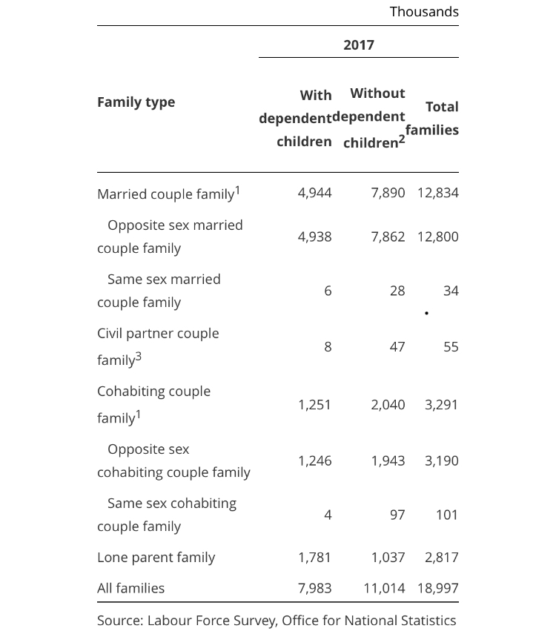
(Image 1; Office of National Statistics, 2018).
This table above shows family types within a 2017 UK. Even though there are many versatile family units, they all have one thing in common, apart from lone parent families, there is a much higher number of families living without independent children (Office of National Statistics, 2018). Has this able shows, there is a significant change in families, they are not just the ‘ideal nuclear family’ anymore, with the every changing society, families are now forming for different aspects, such has same-sex marriages, cohabiting couples and lone parent families (Office on National Statistics, 2018).
While undertaking more research, Parke (2013) stated that more women within the 21st century are now perusing their career instead of settling down and starting a family – Office of National Statistics (2017) provide information stated that the birth rates are declining over the years, more women are more likely to start parenthood at the age of 30, whereas, middle-class women are at the age of 40 (Parke, 2013).
The last 100 years have seen huge changes in legislation, technology, attitudes and expectations that have led to a massive feminisation of the work force since the second world war (Parke, 2013). Although, has the years went on women were started to been as equal, there were still some differences (Holden, 2001); during the 20th century women were mostly seen has the ‘main caregiver’, thus, leaving the man to be the main ‘breadwinner’ – women were still seen to provide care for sick relatives and children due to being married, whereas, women who were not married during this period their jobs would be based as a paid carer within the emerging welfare state.
During, the ‘interwar years’ women who were not married and living outside the norm of society e.g. not married or have children, were seen as ‘surplus women’ (Holden, 2001). Prior to the welfare state there was nothing else a woman ‘could do’, except the ‘natural caring role of women’ (Parke, 2013).
However, women’s work was not seen as work within war time and not recognised within social policy – this ‘duty was done out of love and compassion to service the needs of the family’ (Holden, 2001) – this blur the lines between ‘caring for’ and ‘caring about’.
During, the 21st century women now have a ‘widespread of contraception leading to deferred decision about starting families’ (Parke, 2013), this has changed from 100 years ago due to there being no contraception and more children being born in working-class families whereas, of those living within middle-class families (Holden, 2001).
Before the welfare state came into force in the 20th century, ‘family and kinship traditionally provided services such as the care for the young and elderly’, during, the 21st century, due to ‘industrialised countries’, it is now easier for countries to provide medical attention through hospitals and carers, leaving the term ‘family less important in this aspect’ (Halla, Lackness and Scharler, 2013).
Whereas, the Voices for the Working Families (2018) states that family is very important within the 21st century – their term for family is to be able to ‘feel secure, to have someone who you can count on and who you can share your problems with’, but also, someone you should respect too.
Their research suggests that family ‘provides love, support and that it is a framework of values to each and every single one of their members’ – a family is something you can share each other’s ‘life goals’, sorrows and joys; ‘provide a setting for personal growth’; family is the most important ‘influence on a child’s life’; provides for their needs; security, identity and values; support; being able to spend time with family shows an individual and child the value of love; a child can learn a foundation of ‘self and gains’, which they can incorporate for the rest of their lives (Voices for the Working Families, 2018). They also believe that family traditions have a huge influence on families and their experience together – for instance, family holidays, parties and church – these experiences can give families the ‘stronger sense of belonging’ (Voices for the Working Families, 2018).
Also, the Labour Manifesto (2015) also cover every single aspect of family during their manifesto – family is one of their main goals; they believe children and parents are a family unit including grandparents; they want to increase paternity leave for fathers, so they have more bonding time with their child; they want to help working families and they realise that pay is a major issue; and, they want to support the health and well-being of all.
“As a country we value compassion, tolerance, and a sense of decency. But pressures on family life, growing inequality, anxieties about crime and anti-social behaviour and a widespread loss of trust in our governing institutions, are creating insecurity in many communities” (Labour Manifesto, 2015).

To conclude, has society is changing and progressing further into the 21st century, are families just has important or are careers more important now? McDowell and Pringle (1994) have stated that families are just socially constructed, so have we followed suit for decades and believed they are key role in life, when maybe, they are not – or, have we been socially constructed to believe that the ‘perfect ideology family’ is in fact the 2:4, 1950’s family (Murdock, 1949).
As society changed over the decades, so did the perception of family, whereas, in 50 years’ time, the perception of family will probably be different again. From research gained from the Labour Manifesto (2015) and Voice of the Working Families (2018) family is a very important part of every day life and without it we would not be who we are has people. Whereas, research from Halla et al., (2013) state that from the changing welfare state, family is not as important has it once was before World War Two. People are less reliant on family members for help, especially for health-related caring, due to the National Health Service.
What will happen to the term ‘family’ within the next 50 years? it has already changed so much within the last 50 years, no doubt the term of family will change again for the social norm.

