UNIVERSITY OF WALES TRINITY SAINT DAVID
Name: Md samsul islam Student Id: 2006222
Module: Business intelligence and utilization
Course: BA Business and Management
Assessment 2: writing report
Lecturer: Joy Botu
Submission deadline: 13th May 2022
Word count: 2600

Part 1
CrimeRate | percentage | Youth | Region | Education | ExpenditureYear0 | LabourForce | Males | MoreMales | StateSize | YouthUnemployment | MatureUnemployment | HighYouthUnemploy | Wage | BelowWage
45.5 | Low | 135 | 0 | 12.4 | 69 | 540 | 965 | 0 | 6 | 80 | 22 | 1 | 564 | 139
52.3 | High | 140 | 0 | 10.9 | 55 | 535 | 1045 | 1 | 6 | 135 | 40 | 1 | 453 | 200
56.6 | High | 157 | 1 | 11.2 | 47 | 512 | 962 | 0 | 22 | 97 | 34 | 0 | 288 | 276
60.3 | High | 139 | 1 | 11.9 | 46 | 480 | 968 | 0 | 19 | 135 | 53 | 0 | 457 | 249
64.2 | High | 126 | 0 | 12.2 | 106 | 599 | 989 | 0 | 40 | 78 | 25 | 1 | 593 | 171
67.6 | High | 128 | 0 | 13.5 | 67 | 624 | 972 | 0 | 28 | 77 | 25 | 1 | 507 | 206
70.5 | High | 130 | 0 | 14.1 | 63 | 641 | 984 | 0 | 14 | 70 | 21 | 1 | 486 | 196
73.2 | High | 143 | 0 | 12.9 | 66 | 537 | 977 | 0 | 10 | 114 | 35 | 1 | 487 | 166
75 | High | 141 | 0 | 12.9 | 56 | 523 | 968 | 0 | 4 | 107 | 37 | 0 | 489 | 170
78.1 | High | 133 | 0 | 11.4 | 51 | 599 | 1024 | 1 | 7 | 99 | 27 | 1 | 425 | 225
79.8 | High | 142 | 1 | 12.9 | 45 | 533 | 969 | 0 | 18 | 94 | 33 | 0 | 318 | 250
82.3 | High | 123 | 0 | 12.5 | 97 | 526 | 948 | 0 | 113 | 124 | 50 | 0 | 572 | 158
83.1 | High | 135 | 0 | 13.6 | 62 | 595 | 986 | 0 | 22 | 77 | 27 | 0 | 529 | 190
84.9 | High | 121 | 0 | 13.2 | 118 | 547 | 964 | 0 | 25 | 84 | 29 | 0 | 689 | 126
85.6 | High | 166 | 1 | 11.4 | 58 | 521 | 973 | 0 | 46 | 72 | 26 | 0 | 396 | 237
88 | High | 140 | 0 | 12.9 | 71 | 632 | 1029 | 1 | 7 | 100 | 24 | 1 | 526 | 174
92.3 | High | 126 | 0 | 12.7 | 74 | 602 | 984 | 0 | 34 | 102 | 33 | 1 | 557 | 195
94.3 | High | 130 | 0 | 13.3 | 128 | 536 | 934 | 0 | 51 | 78 | 34 | 0 | 627 | 135
95.3 | High | 125 | 0 | 12 | 90 | 586 | 964 | 0 | 97 | 105 | 43 | 0 | 617 | 163
96.8 | High | 151 | 1 | 10 | 58 | 510 | 950 | 0 | 33 | 108 | 41 | 0 | 394 | 261
97.4 | High | 152 | 1 | 10.8 | 57 | 530 | 986 | 0 | 30 | 92 | 43 | 0 | 405 | 264
98.7 | High | 162 | 1 | 12.1 | 75 | 522 | 996 | 0 | 40 | 73 | 27 | 0 | 496 | 224
99.9 | High | 149 | 1 | 10.7 | 61 | 515 | 953 | 0 | 36 | 86 | 35 | 0 | 395 | 251
103 | High | 177 | 1 | 11 | 58 | 638 | 974 | 0 | 24 | 76 | 28 | 0 | 382 | 254
104.3 | very high | 134 | 0 | 12.5 | 75 | 595 | 972 | 0 | 47 | 83 | 31 | 0 | 580 | 172
105.9 | very high | 130 | 0 | 13.4 | 90 | 623 | 1049 | 1 | 3 | 113 | 40 | 0 | 588 | 160
106.6 | very high | 157 | 1 | 11.1 | 65 | 553 | 955 | 0 | 39 | 81 | 28 | 0 | 421 | 239
107.2 | very high | 148 | 0 | 13.7 | 72 | 601 | 998 | 0 | 9 | 84 | 20 | 1 | 590 | 144
108.3 | very high | 126 | 0 | 13.8 | 97 | 542 | 990 | 0 | 18 | 102 | 35 | 0 | 589 | 166
109.4 | very high | 135 | 1 | 11.4 | 123 | 537 | 978 | 0 | 31 | 89 | 34 | 0 | 631 | 165
112.1 | very high | 142 | 1 | 10.9 | 81 | 497 | 956 | 0 | 33 | 116 | 47 | 0 | 427 | 247
114.3 | very high | 127 | 1 | 12.8 | 82 | 519 | 982 | 0 | 4 | 97 | 38 | 0 | 620 | 168
115.1 | very high | 131 | 0 | 13.7 | 78 | 574 | 1038 | 1 | 7 | 142 | 42 | 1 | 540 | 176
117.2 | very high | 136 | 0 | 12.9 | 95 | 574 | 1012 | 1 | 29 | 111 | 37 | 1 | 622 | 162
119.7 | very high | 119 | 0 | 11.9 | 166 | 521 | 938 | 0 | 168 | 92 | 36 | 0 | 637 | 154
121.6 | very high | 147 | 1 | 13.9 | 63 | 560 | 972 | 0 | 23 | 76 | 24 | 1 | 462 | 233
123.4 | very high | 145 | 1 | 11.7 | 82 | 560 | 981 | 0 | 96 | 88 | 31 | 0 | 488 | 228
127.2 | very high | 132 | 0 | 10.4 | 87 | 564 | 953 | 0 | 43 | 83 | 32 | 0 | 513 | 227
132.4 | very high | 152 | 0 | 12 | 82 | 571 | 1018 | 1 | 10 | 103 | 28 | 1 | 537 | 215
135.5 | very high | 125 | 0 | 12.5 | 113 | 567 | 985 | 0 | 78 | 130 | 58 | 0 | 626 | 166
137.8 | very high | 141 | 0 | 14.2 | 109 | 591 | 985 | 0 | 18 | 91 | 20 | 1 | 578 | 174
140.8 | very high | 150 | 0 | 12 | 109 | 531 | 964 | 0 | 9 | 87 | 38 | 0 | 559 | 153
145.4 | very high | 131 | 1 | 12.2 | 115 | 542 | 969 | 0 | 50 | 79 | 35 | 0 | 472 | 206
149.3 | very high | 143 | 0 | 12.3 | 103 | 583 | 1012 | 1 | 13 | 96 | 36 | 0 | 557 | 194
154.3 | very high | 124 | 0 | 12.3 | 121 | 580 | 966 | 0 | 101 | 77 | 35 | 0 | 657 | 170
157.7 | very high | 136 | 0 | 15.1 | 149 | 577 | 994 | 0 | 157 | 102 | 39 | 0 | 673 | 167
161.8 | very high | 131 | 0 | 13.2 | 160 | 631 | 1071 | 1 | 3 | 102 | 41 | 0 | 674 | 152

Region | 1 | Region |  | 0
Sum of Crime Rate |  | Sum of Crime Rate
1610.9 |  | 3221.1
Region | (All)
Sum of Crime Rate
4832/100000 = 0.04832

The crime rate data shows the numbers of crime rising and lower depending on the rate of crime in particular time. First, the sum of the crime rate when the value of the region 1 is 1610.9. click insert and go for pivot table and create new worksheet data. Then drag down the crime rate to values and region to filters fields than it comes with top of the excel sheet sum of crime data with the region 1 and 0. When the region data is 0 the sum of crime rate is 3221.1. to find out the number of offences per million 100000/4832 for all region which results 0.04832. secondly, the IF formula, the numbers of the excel sheet which is on the left like if the top of the sheet first come up with A, B, C if say A1 or A2, so the formula is =IF(A2>50,"High","Low") it results the crime rate is low because the crime rate is below 50 which is 45.5, the region is 0, the involvement with crime by the number of youth 135, education 12.4, mature unemployment rate was 22 but the youth unemployment rate increased to 80 when the wages was high 564 and below wages 139. If A3 column crime rate is more than 50 which counted as high because increase of offences by males which is 1045, youth unemployment 135, mature unemployment increased to 40, the below wages increased to 200. For A4 column the crime rate is also high which has increased number to 56.6, the youth rate has increased to 157 for region 1, the male offences have decreased to 962 as well decreases of mature unemployment and youth unemployment when the below wages have increased to 276. We can see from the excel worksheet data from A5 crime rate data which is 60.3 and to A24 crime rate which has increased the numbers of crime rate to 99.9 when there are a lot of ups and down of different patterns, but it is still high because the crime rate is more than 50. The highest rate of crime in education is 14.1, Males crime rate 1029, the youth unemployment rate is 135 but we can see from A21 crime rate which is very flexible rate despite the crime rate is high in other circumstances. A31 crime rate decreased respectively when the wages were increased to 631 which was the highest wages rate in this crime rate worksheet. The youth employment increased when the minimum wages was more than 250. In A25 crime rate counted as high crime rate which is 104 because of the rate of the education 11, the males’ crime is 974, below wages was 254 despite high youth unemployment was 0 when the youth unemployment was 76 as declined of mature unemployment to 28. However, there are a lot of fluctuation in crime rate from the numbers of column A1 to A25 calls High where one is below 50 which is 45.5 where is a lot of disaster in different sectors due to lack of control of crime in the worksheet. The column number A26 has crime rate which is very high as the formula used =IF(A26>100,’’very High’’, ‘’High’’). However, from column number A26 to A30 crime rate was rising consecutively where education crime rate has highest increase to 13.8, the highest male crime rate is 1049, the highest labour force was 623, the highest unemployment rate, which was 113, and the highest wages was 589. In addition, the increases of crime rates region 0 due to below wages which was 560, mature unemployment was 40 and some ups and down in education and labour force causes more crime or increase of crime. If we see the state size from A26 to A30, the size is 47, 3, 39, 9, 18, 31 are mostly sizes of small and the sectors of crime more than high which defines the very high crime rate in this region or state. Moreover, another reason for crime in this region is for high youth unemployment that is only data of 0 and 1. The crime rate in column A42 region 0 which is highest number of crimes in education sector 14.2 comparing to whole crime rate of the table but it has some decreases of crime in other columns such as male crime rate has 985 where column A40 has 1018 of crime rate by male. The wages are very important for increasing the employment rate all are above 200 and highest wages 620 for data number A33. Overall, the crime rate of this worksheet downside is very high due to unemployment, below wages, increases of male crime rate, labour force, expenditure and education. The whole table or worksheet highest number of crime rate A48 which is above 150 where 1071 of males’ crime rate, youth unemployment rate above 102, below wages is 152 which is the lowest wages rate of this worksheet, and the education crime rate is 13.4 which is high. So, it is very interesting to say that the crime has increased, and only A1 data has decreased on this worksheet and excel.

Part 2
The students like vanilla flavour statistics?
 |  | Frequency | Percent
Missing | System | 201 | 100.0

The pie chart shows for students who are male and female in the frequencies.

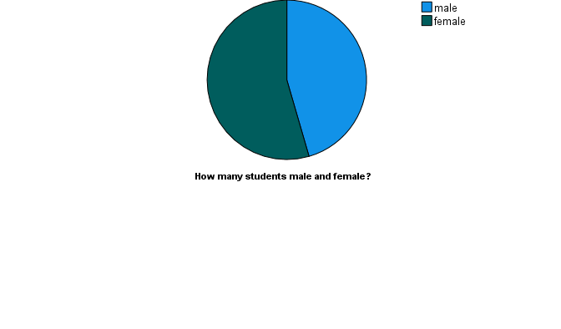

The students are male and female?
N | Valid | 200
N | Missing | 1

The students’ male and female?
 |  | Frequency | Percent | Valid Percent | Cumulative Percent
Valid | male | 91 | 45.3 | 45.5 | 45.5
Valid | female | 109 | 54.2 | 54.5 | 100.0
Valid | Total | 200 | 99.5 | 100.0
Missing | System | 1 | .5
Total |  | 201 | 100.0

There is total 200 students where 91 students are male, and 109 students are female. The 100 percent of students like vanilla flavour of ice cream. However, the pie chart shows in percentage where 45.5 valid percent of students are male, and 54.5 percent valid students are female in 201 students. In addition, if any students are missed than the percentage of total students’ 99.5 percent which is 200 and males are 45.3, females are 54.2 percent students.

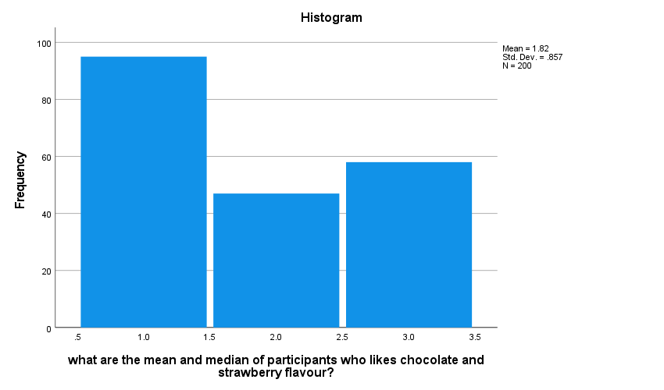

the mean and median of participants who likes chocolate and strawberry flavour
N | Valid | 200
N | Missing | 1
Mean |  | 1.82
Median |  | 2.00
Minimum |  | 1
Maximum |  | 3
Percentiles | 25 | 1.00
Percentiles | 50 | 2.00
Percentiles | 75 | 3.00

the mean and median of participants who likes chocolate and strawberry flavour?
 |  | Frequency | Percent | Valid Percent | Cumulative Percent
Valid | vanilla | 95 | 47.3 | 47.5 | 47.5
Valid | strawberry | 47 | 23.4 | 23.5 | 71.0
Valid | chocolate | 58 | 28.9 | 29.0 | 100.0
Valid | Total | 200 | 99.5 | 100.0
Missing | System | 1 | .5
Total |  | 201 | 100.0

The mean and median of participants who likes chocolate and strawberry flavour, the Histogram shows the mean is 1.82 and the median is 2.00 which has been calculated by SPSS software data analysis. Although, the mean is adding all the numbers together and divided by its values which results the mean, and the median is the middle of the data which is very hard to find in large data set. So, SPSS data analysis software is the easiest process for the business to do the analysis in time. However, the frequency for Vanilla flavour is 95, strawberry flavour 47 and chocolate flavour 58 in total 201. The SPSS data analysis shows the whole items or frequencies in the data set.

Part 2

Descriptive Statistics
 | N | Minimum | Maximum | Mean | Std. Deviation
female | 200 | 0 | 1 | .54 | .499
video | 200 | 26 | 74 | 51.85 | 9.901
puzzle | 200 | 26 | 71 | 52.40 | 10.736
Valid N (listwise) | 200

Final Cluster Centres
 | Cluster
 | 1 | 2 | 3
Zscore(female) | .24371 | .91142 | -1.09170
Zscore(video) | -1.01169 | .31230 | .55145
Zscore(puzzle) | -1.02042 | .61025 | .26927

Number of Cases in each Cluster
Cluster | 1 | 60.000
Cluster | 2 | 69.000
Cluster | 3 | 71.000
Valid |  | 200.000
Missing |  | .000

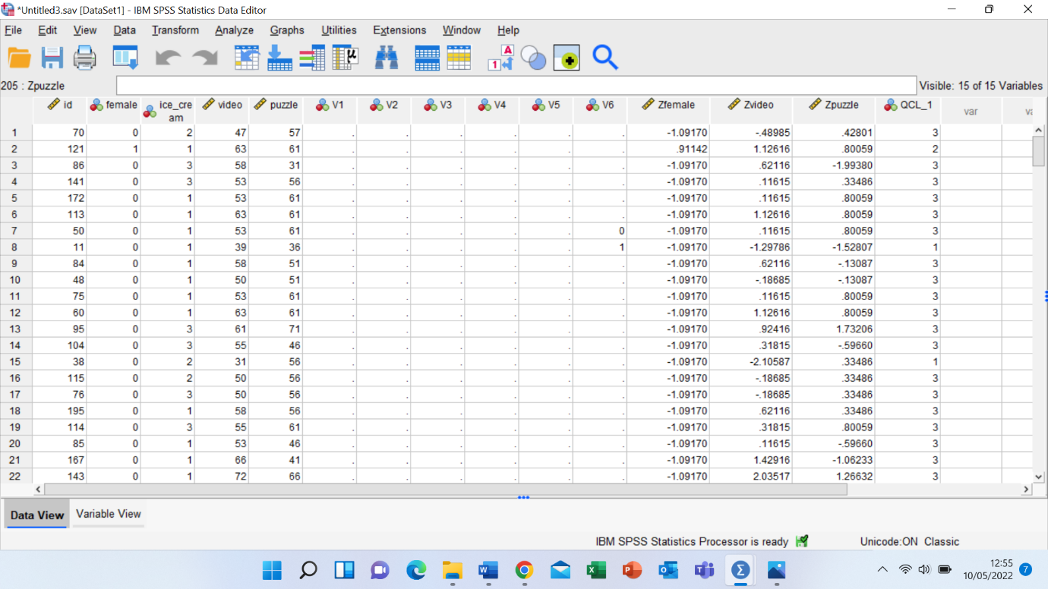
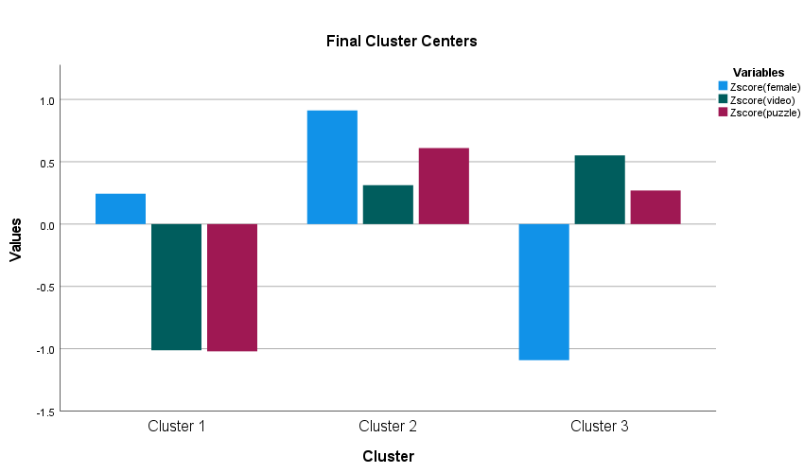
a)
First, when the values of the cluster for female is slightly positive but video games and puzzle games has declined to -1.0 for first cluster. We can see from the screenshots, the first cluster membership for id 70 which K-means clustering membership is 3 which has greatly negative values of female, but video game and puzzle has positive sign by increase. In the 2nd cluster from the bar chart, female, video game and puzzle every sector has good improvement than the cluster 1 and 3. The membership of cluster 2 with id 121 which has great values of data scored increasing so it is great to say that cluster 2 is better than the other clusters.

b) there are a lot of difference between data mining and text mining. However, data mining is finding out the data which is hidden in a table, or which is come up with small calculations. For example, cluster 1 shows the number of cases 60.000, secondly cluster 2 shows the number of cases 69.000, thirdly cluster 3 shows the number of cases 71.000 those are total results or individual results of each data which is a data mining. And text mining is a summary of a large data set which can be seen by the frequencies or descriptive statistics in mean, median, minimum and maximum. It shows the total results of the cases where female mean is .54 but deviation is .499 in total number of females. So, it is a listwise result of data set in a sample of summary.

C) here is the examples of advantages and disadvantages of using SPSS software.
Advantages | Disadvantages | Excel
It is a statistical package for the business to analyse the large amount of data. | SPSS can not be used for very big data for example analysing the clinical data set. | Excel software has research process of evaluating data by analysing, ethical, methodological and conceptualization.
It is very important for software to perform in complex manipulation and analyse with simple instructions. | SPSS is fully licenced which is good but very expensive to buy. | The clinical database can be performed or identified in the excel.
SPSS has large amount of process for a business such as planning, data collecting, data access or management, preparation and data analysis | Sometime SPSS is very hard to understand for data analysis. | The Excel software can be used for analytical or statistical component research process.
SPSS is very useful for many departments such as Health sector, government, Education sector, marketing, data mining and text mining. | SPSS only used for academic and business purposes. | The spreadsheet helps the clinical process to apply these to database (Sewell, 2006).
Statistics are frequencies, descriptive and ratio statistics which specific positions of the variables to analyse the data faster and easier. | SPSS is not as common software as Excel which could be used for any personal computers. | One of the most common software found for personal computers without any cost and best perform software for databases.
It results of mean, median, minimum, maximum or in percentages. | SPSS data analysis is very hard to find on online to resolving any issues or problems in any circumstances. | The online resources are also available for data analysis.
SPSS also helps us a large selection of charts, graphs for subsequent analysis also it often used for quantitative and qualitative data.

