

LOCATION: Swansea | LLEOLIAD: abertawe
LEVEL 4 | LEFEL 4
EXAMINATION PERIOD | CYFNOD ARHOLIADAU
January 2024 | IONAWR 2024
MODULE CODE: ACDA4004
Micros Peripherals & Interfaces
TIME: 2 HOURS
answer all questions

Equipment or materials required. Please select from the following:
Adnoddau neu ddefnyddiau sydd eu hangen.

Cyfrifiannell/Calculator

Llyfr Agored/Open Book

Arall/Other Nodwch/Please Note ……………………….

ANSWER ALL QUESTIONS (marks add up to 50 in total)

- The following comprise a number of mnemonics from the PIC16F84 microprocessor instruction set. Give the meaning of what each mnemonic stands for and explain what the instruction actually does.

  - RETURN
[2 Marks]
  - SLEEP
[2 Marks]
  - ADDLW
[2 Marks]
  - BCF f, b
[2 Marks]
  - DECF
[2 Marks]

- Provide circuit diagram sketches as well as written explanations, detailing two different hardware based methods of how you might solve or reduce the incidence of switch bounce for the input of a typical PIC microcontroller IO pin

[10 Marks]

- Draw the logic symbol for an AND gate and provide the truth table for it.
[3 Marks]

- a) Produce a truth table for the following logic circuit, solving the states for the final ‘output’ block, but also showing all the intermediate nodes that were used in this final calculation. (7 marks)

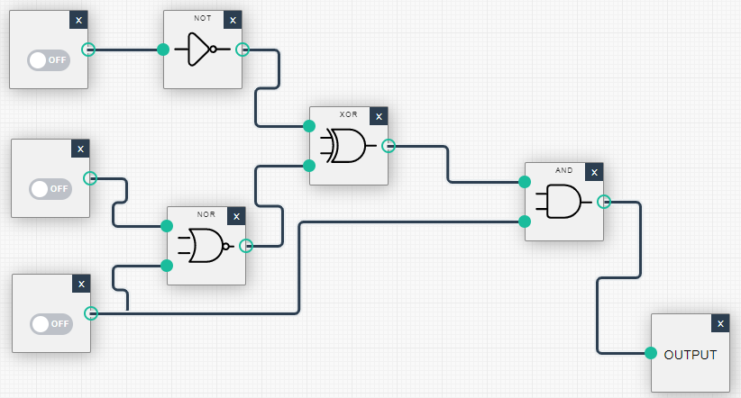

b) By visually inspecting the final truth table, suggest a far simpler logic diagram that would produce the same result. (3 marks)

- Provide diagrams to show typical Harvard and Von Neumann processor architectures. Also state one advantage that each of the two types provides over the other.
[10 Marks]

- BY using text and diagrams, explain the principle of how you can implement a simple DAC by using a single microcontroller output pin that produces a PWM digital signal.

[7 Marks]

Diwedd/End

