



Level 4 Assessment Specification
Student name: | VASILE ALEXANDRU ROGOZ | Student ID number: | 2224930
Programme: | International Hotel Management
Module: | Hospitality and Guest Services
Module code: | BMIH4003 | Contribution to Overall Module Assessment (%): | 50 %
Lecturers: | Charlotte Joyner  Luciana Suardi | Internal Verifier: | Ffion Cumberpatch
Assignment Title: | Presentation  The role and importance of quality service, hospitality, and guest services within the  hotel industry | Word count (or  equivalent): | 10 minutes
Hand Out Date: | W/C 11th Sept 2023 | Submission | 23:59 pm Monday
 |  | deadline: | 20th Nov 2023

Table of Contents
Introduction 4
Main Consumers of Marriot Hotel and Resorts 5
Scope of the Guest Services in Marriot Hotel and Resorts 6
Roles of the Guest Service at Marriot Hotel and Resorts 7
Functions of the Guest Services of Marriot Hotel and Resorts 8
Significance of Hospitality Services 9
Initiatives to Fulfil the Guest Expectations 10
Conclusion 11
Reference 12

Slide No: 01
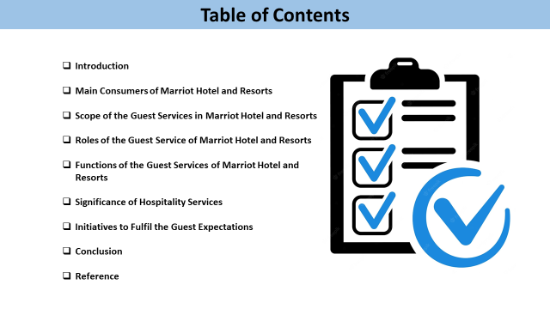
Note:
Table of Contents
Slide No: 02
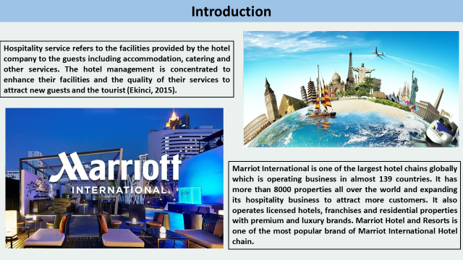
Note:

Introduction
Hospitality service refers to the facilities provided by the hotel company to the guests including accommodation, catering and other services. The hotel management is concentrated to enhance their facilities and the quality of their services to attract new guests and the tourist (Ekinci, 2015). Marriot International is one of the largest hotel chains globally which is operating business in almost 139 countries. It has more than 8000 properties all over the world and expanding its hospitality business to attract more customers. It also operates licensed hotels, franchises and residential properties with premium and luxury brands. Marriot Hotel and Resorts is one of the most popular brands of the Marriot International Hotel chain.

Slide No: 03
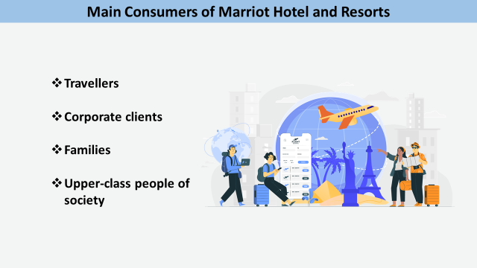
Note:

Main Consumers of Marriot Hotel and Resorts
Marriot International is one of the most luxurious and premium hotels in the world. It has so many sub-brands that represent its hotels. The main customers of Marriot Hotel and Resorts are travellers and corporate clients. Travellers are visiting different countries to visit historical or prominent things of the particular country where they needed lodging and catering facilities (Godovykh, 2022). And business clients also arrange their meetings or event at Marriot Hotel and Resorts. Families are spending their quality time in the resorts and hotels for entertainment and refreshment. Upper-class people of society are also customers of Marriot International who are spending their leisure in a hotel with good restaurant services.

Slide No: 04
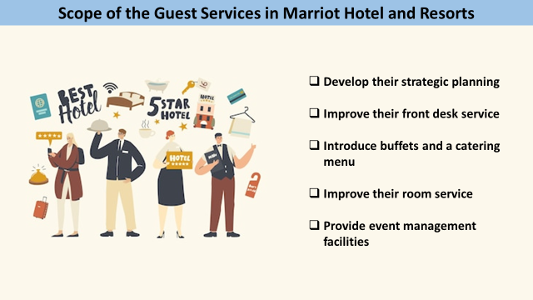
Note:

Scope of the Guest Services in Marriot Hotel and Resorts
Hotel management should concern about the improvement of their guest services and bringing innovation in their services for better customer experiences. The hotel management should concentrate to increase their facilities as well as develop their strategic planning for attracting targeted customers (Rihova, 2014). The hotel management can improve their front desk service by providing adequate information to the customer about guest services. It should introduce buffets and a catering menu to attract new customers. It should improve their room service and expedite the beauty of the interior. It can also provide event management facilities for arranging a business meeting or wedding party.

Slide No: 05
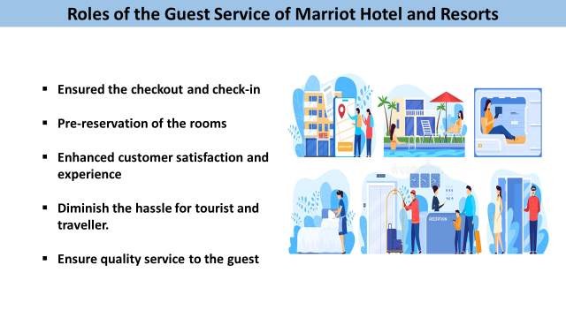Note:

Roles of the Guest Service at Marriot Hotel and Resorts
Appropriate guest service indicates the proper management of the guest by providing maximum facilities. The guest service has ensured the checkout and check-in of the guest in the hotel. The guest service facilitates the guest with pre-reservation of the rooms and other services. the front desk officer of the hotel provides adequate information and facilities to the guest (Foster, 2016). the proper guest service of the hotel enhanced customer satisfaction and experience. Guest service also includes the transportation service of the guest that diminish the hassle for tourist and traveller. The experienced and skilled employees ensure quality service to the guest for the best customer experience.

Slide No: 06
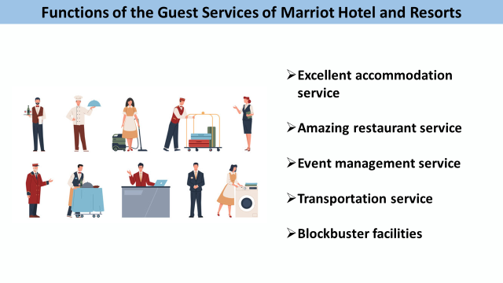
Note:

Functions of the Guest Services of Marriot Hotel and Resorts
The hotel management has to manage different services and facilities to attract new customers as well as provide quality service to the existing customers. Marriot Hotel and Resorts has excellent accommodation service with a beautiful design and interior room. The hotel also has amazing restaurant service that provides quality food to the guest. it also includes an event management service where people can arrange weddings and celebrate birthdays as well as arrange business meetings (Godovykh, 2022). The hotel also includes a transportation service for the guest that will help him from going one place to another. It also has a small park for the children as well as blockbuster facilities.

Slide No: 07
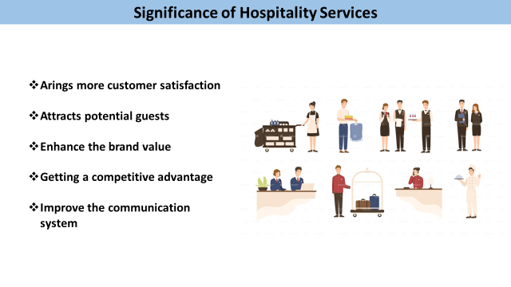
Note:

Significance of Hospitality Services
The hospitality industry is greatly dependent on the guest and their positive experience. If the guest is satisfied with the hospitality services he will come further and also suggest their surroundings. The hotel management should focus on developing a strategy that brings more customer satisfaction. It also attracts potential guests towards the hotel of its brand value. Adequate quality service of the hotel helps to enhance the brand value of the hotel. It is also responsible for getting a competitive advantage. Hospitality services also improve the communication system between employees and guests (Ekinci, 2015). The skilled and experienced hotel staff are giving quality service to their guest for a better experience. Quality hotel service helps to create a strong position in the market as well as ensure adequate marketing strategy.

Slide No: 08

Note:

Initiatives to Fulfil the Guest Expectations
The main duty of the hotel management is concentrated to improve their hotel services and fulfilling the needs of their loyal customers. At first, the company has to develop a strategic plan to know the demand or expectations of the guest. Provide supreme support that helps to feel the guest's special and significant. Recruit an experienced and smart front desk officer who will manage new guests cordially which makes him think special from others. The hotel also ensures sustainable eco-friendly development that will help the hotel to attract new customers (Quesado, 2022). The hotel company also evaluate the guest feedback to develop their services for better customer expectations. Ensure the professional behaviour of the employees to bring customer satisfaction towards the hotel.

Slide No: 09
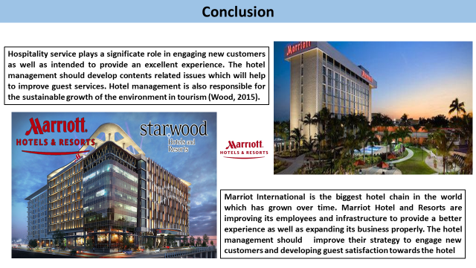

Note:

Conclusion
Hospitality service plays a significate role in engaging new customers as well as intended to provide an excellent experience. The hotel management should develop contents related issues which will help to improve guest services. Hotel management is also responsible for the sustainable growth of the environment in tourism (Wood, 2015). Marriot International is the biggest hotel chain in the world which has grown over time. Marriot Hotel and Resorts are improving its employees and infrastructure to provide a better experience as well as expanding its business properly. The hotel management should improve their strategy to engage new customers and develop guest satisfaction towards the hotel.

Slide No: 10
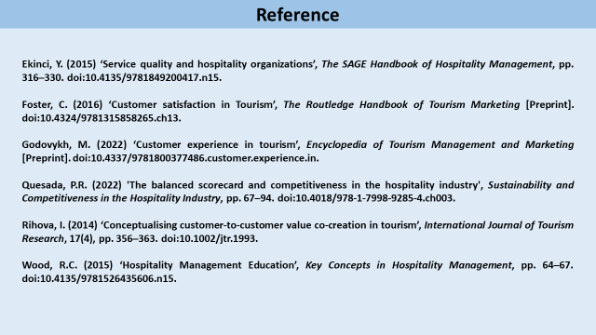
Note:

Reference

