Imaginary Realms: Creating Story Universes
The watchmen of the Tea Horse Trail
Ranshu Guo
2121933
2024.12.14

Contents
1. Introduction to the story 1
1.1 Summary of the story 1
1.2 Types and overall tone of the story world 1
1.3 Central theme of the story 2
2. Main roles 3
2.1 Mary 3
2.2 A group of businessmen traveling together 4
2.3 Tibetan merchants 4
2.4 Tibetan elderly 5
3. Narrative design elements 6
3.1 Ancient Tea Horse Road 6
3.2 Mary's Tea garden 6
4. Political pattern and social background of the story 6
4.1 Political pattern of the story 6
4.2 Social Background 8
5. Narrative structure 9
5.1 Current scene shots: 9
5.2 Interlude: The conflict between the caravan and the Tibetan caravan 9
5.3 Interjection: Distress and unity in the snowstorm 10
5.4 Final shot: Mary's realization and return 11
5.5 Summary 11
6. Summarizes 11

1. Introduction to the story

1.1 Summary of the story
The narrative follows the rise and experiences of Mary, a young Naxi woman whose family has cultivated Pu ' er drink for years and life in Yueying Village in Lijiang. Mary was eager to leave her home and discover the ancient tea-horse road connecting Yunnan and Tibet despite her mother's tea-growing prowess. The old Tea Horse Road facilitates the trade and motion of various ethnicities and cultures. Mary set out on this prehistoric trade way with the help of her mothers. During the journey, she met with Tibetan wagons, learned to address issues amid conflicts and misunderstandings, and realized the importance of polite ties and cooperation between ethnic groups. The caravan experienced tough issues, such as snowfalls, and Mary worked with various caravan members to learn about the Tea Horse Trail's history, traditions and wisdom. After finishing her deal, Mary arrived in Lhasa, Tibet, and learned from an ancient Tibetan that the Tea Horse Trail was a way for material exchange, the distribution of devotion, and the realization of the meaning of life. With this understanding and wisdom, Mary went back to her hometown, determined to carry on the tradition of keeping the family drink garden and educating everyone on the importance of the Tea Horse Trail.
Through Mary's growth and self-discovery, the story explores cultural exchange, ethnic cooperation, harmonious coexistence between man and nature, and the inheritance of faith and wisdom.

1.2 Types and overall tone of the story world
The world of this story belongs to the historical fantasy world, which combines the realistic historical background with some spiritual elements rich in symbolic significance. The story takes place on the Ancient Tea Horse Road, a historic trade route, which not only connects different nations and cultures, but also carries profound historical and humanistic inheritance. The function and historical background of the ancient Tea Horse Road itself as a commercial road provide a realistic basis for the story, while the different national cultures, beliefs, traditional customs, and the growth and adventure of the characters add a level full of fantasy and mystery. Mary's journey begins in a traditional Naxi village and gradually deeps into a dialogue with nature, faith and culture, revealing a story world rich in spiritual exploration and growth.
The tone of the story is warm and profound, revelatory and philosophical. It not only describes the growth of characters with delicate strokes, but also full of profound interaction and understanding between human and nature, human and culture. The story explores themes of growth, exploration, courage and wisdom through Mary's journey from youthful aspirations and challenging adventures to her ultimate self-discovery. Despite the difficulties of the journey, the story presents a positive force through people-to-people cooperation, cultural exchange, and the support of faith.
At the same time, there are some moments of tension and conflict in the story, such as the misunderstanding and conflict between the caravan and the Tibetan caravan, and the predicament in the snowstorm, but these are eventually resolved, reflecting the tenacity and wisdom of human nature. Therefore, the tone is not a single pessimism or joy, but a combination of challenges and hope, full of human brilliance story atmosphere.

1.3 Central theme of the story
The core theme of the play can be based on the heroine's self-discovery and growth.
The old Tea Horse Road in the account is a path of material exchange and a gate of common understanding and communication between various cultures. The narrative emphasizes compassion, communication, and respect for other cultures through Mary's interactions with Tibetan caravan members and her discourse with character. This cultural exchange allows people to find understanding amid conflict and reconciliation amid mistake. This shows the strong communication and understanding between society and lifestyle. The narrative explores the outside world, practices reverence for character, mountains, and the atmosphere, and explores the outside world. In the midst of blizzards and snow-capped mountains, Mary and the caravan people face significant challenges in the natural world and demonstrate a strong sense of harmony with characteristics. The old Tea Horse Road's journey is a spiritual inheritance, inside exploration, and material exchange. The account emphasizes the distribution of devotion, wisdom, and the meaning of life through the terms of the Tibetan old and Mary's spiritual enlightenment. People of all nationalities, ideas, and nations have a spiritual connection thanks to the old Tea Horse Road. When Mary faced a variety of problems and difficulties as a child, she displayed tenacity and bravery. This nature is both a check of the brain and a challenge to the outside earth. The caravan people are constantly battling natural causes, including frost and hurricanes, on this historic street. They do so despite their commonalities, which is one of the story's guiding principles, through cooperation and unique bravery.
Mary's story shows her transition from a young person to a mature caravan member, and her deep awareness of her responsibility and mission.

2. Main roles

2.1 Mary
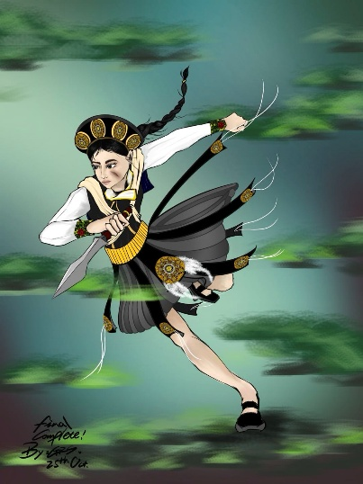
Mary is a young girl from Yueying Village in Lijiang. She was about seventeen or eighteen years old and had long black hair, often tied in a simple ponytail, which swung gently as she walked. Her eyes were deep black, clear and vivid, as if she were always exploring the world. The face is a little handsome, but in the wind and rain and snow, her skin is a little bronzed, showing that she is not afraid of hard work and tough toughness.
She is slender but strong, and her hands are a little rough, showing her hard work in the tea garden. In terms of dress, she wears simple and practical Naxi traditional dress, dark cotton long dress and waist jacket, but the skirt at the bottom is a medium length skirt more suitable for activities. With the progress of the journey, the clothes are slightly worn, but she still maintains a simple and strong temperament.
Figure1:Mary modeling pictures
Mary's heart was filled with a longing for the unknown world. Although she cherished the responsibilities entrusted to her by her family, she always felt that she was lacking something. The stories of the ancient Tea Horse Road and the legends of her ancestors aroused her curiosity from a young age, and she often fantasized about the legendary world outside in the stories of her elders. She has a strong sense of mission in her heart, in her heart, she is not just to help the family, but to give new life and meaning to this ancient trade route.
During the journey, Mary's heart kept changing. From the initial green and curious, she gradually understood the profound significance of the ancient Tea Horse Road, and experienced the trust between people, the collision between cultures, as well as the courage and wisdom at the moment of life and death. Her journey is both an internal enlightenment and an investigation of the outside earth. She developed skills for handling conflict and interpersonal relationships, and she took on the role of a dependable "watchman" despite the constant pressure. Mary may be a younger woman with endless thoughts about the outside at the beginning of the story. She has grown from a curious young girl who only wanted to explore the outside world to a woman who can take responsibility, understand others, and pass on the spirit of the Tea Horse Road. On this ancient road, she not only interacted with different caravans and resolved conflicts, but also shared stories and passed on wisdom with Tibetan merchants, and finally realized her inner transformation.
Mary's growth is multi-level, she learned to face challenges, deal with the complex relationship between people, and gradually understand that the Tea Horse Road is not only a channel of material exchange, but also a bridge connecting the soul and culture.

2.2 A group of businessmen traveling together
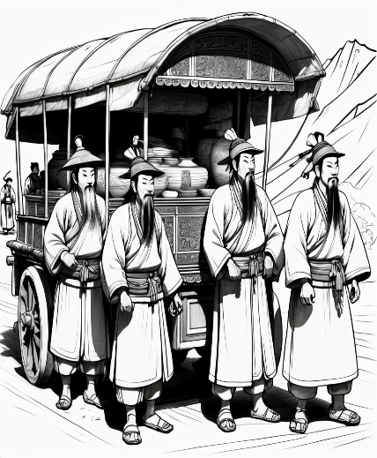
This Naxi caravan is a caravan with a long tradition and experience. The caravan consists of a group of merchants wearing traditional Naxi costumes with strong national characteristics, mainly robes of cotton cloth and simple belts. The costumes are simple but durable, suitable for long journeys. The members of the caravan are mostly old and experienced traders, their faces bearing the signs of age, but their eyes are firm and gentle, revealing their familiarity with the ancient Tea Horse Road and their acceptance of the difficult life along it. People in a team usually work well together and efficiently, showing their collective spirit and trust in each other.
Figure 2:A conceptual map of a team of Naxi businessmen
Throughout the journey, Mary developed a deep emotional connection with the caravan members. She not only learned how to trade with other caravans, but also gradually understood the culture and history behind the ancient Tea Horse Road through her interactions with fellow merchants. Through this experience, Mary not only found her calling, but also understood the true meaning of "watchman" - to guard this time-honored and wise trade route and pass on its spirit.
In short, this Naxi caravan is not only a companion to Mary's adventure, but also an integral part of her growing up, and their wisdom, courage and unity together shape Mary's journey and allow her to find herself on the ancient Tea Horse Road.

2.3 Tibetan merchants
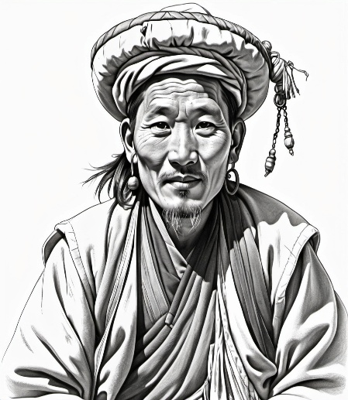
The appearance of Tibetan businessmen often gives the impression of perseverance and calm. Their dark skin, often with a healthy tan, is shaped by long journeys, showing their resilience in the mountains and cold climates.
There were often complicated relationships among caravans on the ancient Tea Horse Road. Tibetan merchants and other ethnic caravans (such as Naxi caravans) will meet frequently, exchange materials, but also need to maintain a harmonious relationship. In the story, there are misunderstandings and conflicts between Tibetan and Naxi businessmen, but the two sides eventually resolve the dispute through calm consultation and mutual understanding. In dealing with these conflicts, Tibetan businessmen usually show great negotiating skills and patience, knowing how to stand up for their own interests in the transaction, and being able to properly handle the differences between the two sides to avoid worsening the situation.
Figure3:Tibetan businessman character concept map
The relationship between Mary and the Tibetan merchant eventually becomes a symbol of the story, representing the complex and profound connection between people on the ancient Tea Horse Road. When she completed her journey and returned to the Moon Shadow Village, Mary not only brought back supplies, but also brought back her deep understanding of the spirit of the ancient Tea Horse Road. The image of Tibetan businessmen in the heroine's mind is no longer a simple trading partner, but a guide in her cultural journey, a friend and a partner in common struggle.

2.4 Tibetan elderly
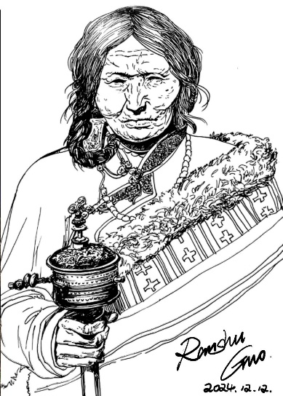
Elderly Tibetan women often wear traditional Tibetan clothing, usually colorful Tibetan robes, with delicate ethnic embroidery, the colors of the clothes are often red, green, blue, etc., meaning auspicious and good luck. Their hair is often braided or wrapped in a headscarf, which is simple but dignified.
In the story, the presence of an elderly Tibetan woman can symbolize Mary's cultural awakening and spiritual growth during her journey. With a kind of maternal care and profound wisdom, the old man guided Mary to a deeper self-understanding and cultural identity. She not only conveyed to Mary the cultural significance behind the ancient Tea Horse Road, but also let Mary understand the true spirit of this ancient road - it is not only a channel for business exchange, but also a way to reach the heart and seek the meaning of life.
Figure4:Tibetan Elderly woman
In general, Tibetan elderly women are a symbol of deep wisdom in Tibetan culture, and their attitude toward life, mantras and respect for tradition have deeply influenced Mary, helping her to complete a profound transformation from the outside world to the inner world.

3. Narrative design elements


3.1 Ancient Tea Horse Road
The ancient Tea Horse Road is not only the channel of material trade, but also the spiritual journey and growth of the heroine Mary. The ancient Tea Horse Road in the story is a difficult and historic business road, which runs through the culture and life of different nationalities.
The mountain path of the Tea Horse Road is often winding, and the edge of the narrow mountain path is often precipitous. The trail is sometimes smooth and sometimes steep, but in any case, the caravan must be careful, because every step of the way can face natural threats such as rock slides and flash floods.
Figure 5:Tea horse Road scene
In the higher mountains, where snow tops are covered, the air is thin and cold, and the wind whistles. And the continuous mountains in the distance are overlapping, like a huge barrier, guarding the land of the ancient Tea Horse Road.

3.2 Mary's Tea garden
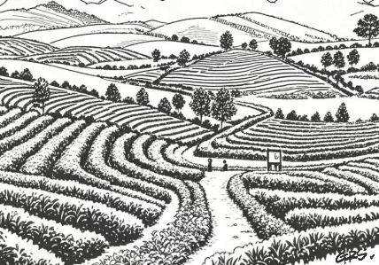
Mary's tea garden is located in a quiet valley deep in the mountains of Lijiang, surrounded by verdant mountains and lush green trees. In spring and summer, the green tea buds twinkle with dew, and the tea fragrance permeates, as if entering a green world. In the early morning, the sun shines through the mist in the tea garden, and the dew glows on the tea leaves as the tea farmers, dressed in traditional Naxi costumes, skillfully pick the leaves. Mary walks through the tea garden with her eyes focused and gentle, and her fragrant tea is widely loved by the villagers.
Figure 6:Mary's tea garden scene

4. Political pattern and social background of the story

4.1 Political pattern of the story
The relationship between multiple ethnic groups on the Tea Horse Road is one of the central political contexts of the story. In particular, the interaction between Naxi and Tibetan caravans reflects the complex relationship between different ethnic groups. In this relationship, the cooperation and exchange between the caravans went beyond mere material transactions, and also involved understanding and mutual assistance at the cultural, religious and even political levels. Despite the differences among ethnic groups, through long-term economic exchanges and cultural collisions, they have learned to respect, understand and cooperate with each other, reflecting a balanced and relatively harmonious political ecology.
Naxi and Tibetan caravans often met on the ancient tea Horse Road and depended on each other for the exchange of materials (Naxi provided Pu 'er tea, Tibetans provided horses and salt). This complementary economic relationship has led to the establishment of a friendly and cooperative relationship between the two nations in business, but in specific transactions, there will be friction due to cultural differences and conflicts of interest. For example, the economic conflict between the Tibetan traders who feel that their horses are underpriced and the Naxi traders who feel that the Tibetan traders are overpriced is resolved in the story, but reflects the complex game of political and economic interests between the ethnic groups. This is the interaction between the two sides.
In the story, the caravan members resolve conflicts through calm mediation and exchange of goods, showing the tolerance and reconciliation between ethnic groups in actual economic exchanges. Such cooperation is not only about survival, but also represents the political consensus reached among different ethnic groups and cultures to build friendly relations through trade and exchanges, resolve conflicts, and promote regional peace and prosperity. This is tolerance and accommodation between nations.
Of course, on the one hand, as an important economic and trade channel, the ancient Tea Horse Road also affected the political pattern of the border areas to a certain extent, and became a key link for economic and political interaction of all parties. The control and governance of the region by different regimes may be somewhat loose or decentralized. As a trade channel across the borders of multiple regimes, the ancient Tea Horse Road played a role in easing conflicts, promoting exchanges and stabilizing borders in the political pattern at that time. Caravans and travelers along the route were often not strictly regulated by specific national or local authorities, but relied on the rules of cooperation and trade between their respective peoples.
Second, the harshness of the natural environment (such as the snowstorm on Meili Snow Mountain) becomes one of the great challenges faced by the caravans in the story, and these natural environments also reflect the political landscape on the Tea Horse Road. The natural conditions and geographical location of the frontier region determined the difficulty of political control, and the caravan members relied on the power of nature, culture and faith to protect themselves and survive beyond mere political power.
On the other hand, various ethnic groups maintain their cultural independence and spiritual inheritance through the ancient Tea Horse Road, demonstrating how to maintain self-identity in the context of multi-ethnic integration. In the story, in a multi-ethnic region, the Naxi, Tibetan and other ethnic groups maintain a relatively independent culture and way of life. This cultural independence is reflected in the story through Mary's family tradition of cultivating Pu-erh tea, as well as through the beliefs and customs of Tibetan traders. The elders passed on the culture, beliefs and wisdom of their respective peoples through oral history, songs and legends.
The account shows a social environment based on ethnic cooperation, cultural inclusion and economic exchange, emphasizing the importance of tranquil and peaceful coexistence.

4.2 Social Background
In Lijiang, Yunnan Province, China, Yueying Village, a Naxi settlement, is the setting of the account. One of China's racial minorities is the Naxi persons. They have a distinctive speech, reading, and tradition that exist in the rocky area that borders Yunnan and Sichuan. As a descendant of the Naxi racial group, Mary inherited the mother's drink garden and Pu'er tea production capabilities. The" Pu' well drink" mentioned in the story is one of the important supplies for the Naxi people to trade with the outside world, and the old tea Horse Road is an important financial and cultural link between them and the cultural groups in Tibet and different areas. On the old Tea Horse Road, particularly Tibetan wagons, are that caravan of different ethnic groups at the same time. Tibetan and Naxi cultures have very different cultures, and the historical Tea Horse Road has evolved into a meeting point for both. The conflict and intervention mentioned in the story both present the potential for reconciliation through communication and understanding as well as the inconsistencies and tensions between various countries as a result of divergent cultural and economic interests. In the cultural history of the account, the world in which Mary lives is generally a traditional village society based on agriculture. Drink serves as a vital link between settlements and the outside world and serves as a foundation of the business. The island's social structure is built on the family, and the seniors ' wisdom and traditions are important in daily life. Her family and the storied trade way of Tea Horse Road influenced Mary's development. This perspective suggests that the ancient Tea Horse Road is not only a commercial road, but also carries some kind of spiritual exploration. Through the discussion of this belief, the story further strengthens the ancient Tea Horse Road as a symbol of cultural inheritance and spiritual communication.
Political culture, social nature, and faith weave together to form Mary's story of growth and self-discovery, making the historic Tea Horse Trail a profound symbol of culture, spirituality, and human interaction.

5. Narrative structure
To tell the story of The Watchmen on the Tea Horse Trail, I chose to use the technique of episodic narration. A flashback is usually an episode or memory from a story that is interspersed into the narrative at a current point in time, enriching the emotions and themes of the main line by retracing past events.

5.1 Current scene shots:
Scene: Tea garden in Moon Shadow Village
At the beginning of the story, Mary returned to the tea garden in her hometown, and the camera first started from her back, shooting her from a distance through the green tea trees. This shot can use a medium shot to show the tea gardens around her and the peaceful village environment. The mountains and rivers in the background and the houses in the distance convey a sense of belonging and peace.
Shot 1:
Mary stopped and took a deep breath, a mixture of emotion in her eyes. The camera focuses on a close-up of her face as she stares into the distance, as if thinking of something. At this point, the camera can slowly zoom out to reveal her surroundings, symbolizing the experiences she has brought back from the outside world and the profound inner changes.
At this point, flashbacks begin to enter and the camera cuts to the caravan's past journey.

5.2 Interlude: The conflict between the caravan and the Tibetan caravan
Scene: A confrontation between a caravan and a Tibetan caravan
The camera cuts to the caravan exchanging goods with another Tibetan caravan. In the background are vast grasslands where caravans stop to trade. Looking down from a high place, the camera showed caravans and Tibetan caravans arranged in an orderly manner. The businessmen from both sides stood in front of their respective teams, and the atmosphere seemed a little tense for a while.
Lens 2 (Mary's perspective):
The camera focuses on Mary, filming her concern and unease about the transaction. She stood apart from the crowd, frowning slightly, confusion and doubt on her face. The camera gradually zoomin to capture the confusion in her eyes and the lack of solution to the price dispute of foreign businessmen. At this time, her understanding of the ancient Tea Horse Road remained on the surface, and she did not understand the culture and deep reasons behind the conflicts and disputes.
Shot 3 (Tibetan businessman):
The camera turns to the Tibetan traders, one of whom is agitated over a price dispute. The camera shots his expression from the side, his face tense, his eyes full of doubt and dissatisfaction. The camera uses close-ups to capture his clenched fist, showing the escalation of the conflict.
Lens 4 (Caravan mediation):
The camera quickly cuts to the senior merchant in the caravan, who calmly steps forward to try to mediate the conflict. The camera takes a close shot and focuses on his expression, showing his calm eyes and slightly furrowed brow, showing his wisdom and maturity in dealing with disputes. The camera then quickly cuts to his dealings with Tibetan traders, who have sought to settle the dispute by offering to exchange additional goods such as dry food and herbs. Through the quick switch of the camera, the atmosphere between the two sides gradually changed from tension to relaxation.
As the camera moves from the tense confrontation to Mary, her eyes begin to change and become noticeably more thoughtful. At this time, the memory of the interlude ended, the camera once again cut back to the current situation, Mary's heart gradually changed.

5.3 Interjection: Distress and unity in the snowstorm
Scene: Snowstorm in Meili Snow Mountain
The camera continues to cut to the caravan being caught in a snowstorm at Meili Snow Mountain. The initial shot shows the grandeur and harshness of the snowy mountains, and the shot uses a wide Angle to show the scene of snowflakes, the storm is blowing violently, and the horses of the caravan are struggling to move forward in the wind.
Shot 5:
The camera is shot through medium shots, showing the caravan members struggling to march through a snowstorm. Everyone's faces are tired and determined, and the camera slowly pans in, focusing on the faces of the merchants and Mary in the caravan, their eyes are firm, their bodies are slightly stiff, and they seem to be enduring great difficulties.
Scene 6 (Mary's inner change):
The camera cuts to a close-up of Mary, as the snowstorm hits, her eyes are no longer simple fear, but gradually appear a sense of responsibility. The camera can use her slightly clenched lip and clasped hands to show that she has changed from a dependent girl to an adult who faces difficulties bravely.
Shot 7 (Caravan collaboration):
Next, the camera cuts to the close cooperation between the caravan members and the Tibetan traders. The cameras caught them helping each other as they repaired equipment and fed horses. The characters in the camera began to exchange eyes frequently, conveying a silent tacit understanding and unity. At this time, the camera can use the switch between close-range and mid-range, and delicately depict the exhaustion and perseverance of everyone, as well as the trust and mutual assistance between them.

5.4 Final shot: Mary's realization and return
Scene: Lhasa, Tibet
As the caravan passes through the snowy mountains, the camera cuts again to the peaceful scene of Lhasa. The camera shot a panoramic view of Lhasa from above, with the sun shining on ancient buildings and quiet streets. Mary stood in this hallowed place with peace and understanding in her eyes. The camera moves from her eyes to capture the smile on her face.
Scene 8 (Inner Awakening):
The camera again focuses on Mary's face, showing that she has gradually grown from a young girl to a woman with deep self-awareness. She recalled the words of the Tibetan elders she met in Lhasa: "The ancient Tea Horse Road is not only a passage for goods, but also a way to convey faith and wisdom." Mary's inner peace and confidence are reflected on camera.
Scene 9(Homecoming):
In the end, the camera returned to the Moon Shadow village, and Mary's return did not have violent emotional fluctuations, but was a calm and peaceful. She stood in front of the tea garden, gazing at the mountains and rivers in the distance. By pulling away, the camera gradually presents the scene of her integration with nature, symbolizing that she has completed an inner journey, from a young person who yearns for the outside world to a watchman who truly understands the spirit of the ancient Tea Horse Road.

5.5 Summary
Through the insertion of memories and past events into the narrative of the current time, the inner changes and growth of the characters are better demonstrated. Each interlude not only advances the plot, but also shows the changes in the character's inner world through the switch of the camera, from her doubts and conflicts to the final realization and maturity. This lens arrangement not only enriches the layered sense of the story, but also deepens the theme of the spirit of the ancient Tea Horse Road, making the story more touching and profound.

6. Summarizes
"The Watchman of the Tea Horse Trail" tells the story of Mary, a young girl who experiences growth and adventure on the Tea Horse Trail.
In the later animation production, the journey in the story is full of challenges, and the rhythm of the animation should be adjusted according to the changes in the plot. The action scenes can be more intense and fast as Mary goes through dilemmas and challenges; In the part of cultural exchange and inner growth, slow and emotional shots can be used to highlight the psychological changes and ideological collisions of characters.
Music is crucial in this kind of story. We can use background music that combines ethnic styles and traditional Naxi and Tibetan Musical Instruments to create an atmosphere of cultural integration. At the same time, the use of sound effects should enhance the sense of immersion, such as the wind of a snowstorm, the sound of horses running, etc., should be carefully designed to enhance the interaction between the picture and emotion.
As the core of the story, the ancient tea Horse Road has a strong symbolic significance. In the animation, visual symbols (such as tea leaves, horses, pendants, etc.) can be repeated to echo Mary's growth and awakening. As a guardian of the ancestors, the pendant can be used as a symbol of Mary's strength at a critical moment, giving her the courage to move forward in difficult situations.
Through careful picture design, character creation and plot arrangement, the animation can better present the profound theme of The Watchmen of the Ancient Tea Horse Road, allowing the audience to feel the warmth of humanity, cultural wisdom and spiritual awakening behind this ancient trade road.

