
LCLM4006: Enterprise and Entrepreneurship
Task 1: Individual Written Business Plan
Student Name: Sandra Urselina Robalo Silva
Student ID:2423591
Weekend Group:7
Module: Enterprise & Entrepreneurship
Teacher: Andry Rakotovololona

Table of Contents
Overview of the Business Idea 3
Environmental Analysis (PESTEL) 5
Marketing Strategies 7
Funding Requirements and Startup Expenses 8
References 9

Overview of the Business Idea
Business Concept: Refill Local is a new social business model that is meant to bring about sustainability in the UK secondary schools. The business offers free refills of toiletries such as soaps, shampoo, and hand sanitiser in easily located refill points. Student-led sustainability clubs run these stations, which promote participation of students as well as environmental awareness (Corcoran, 2023). Refill Local will decrease the amount of plastic waste, encourage responsible consumption, and contribute to the overall environmental goals of the UK by making schools incorporate environmentally friendly practices into their daily routine.
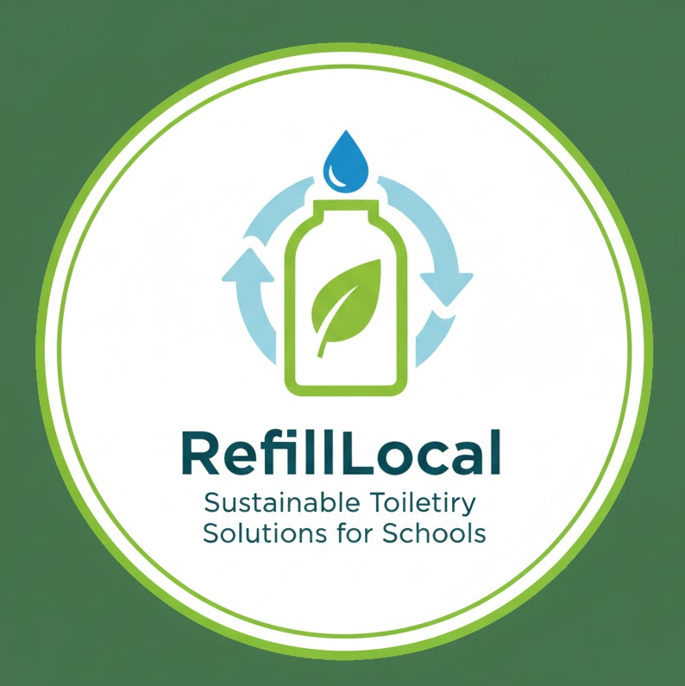
Figure 1: Logo for the Business
Source: (Author)
Unique Selling Proposition (USP): Refill Local stands out by combining its environmentally friendly innovation and involvement of the students. The service is zero-waste, unlike the traditional models based on products, but it aims at minimising the use of single-use plastic bottles (Robertson, 2021). The alternative approach by engaging students in the running and administration of refill stations reduces costs and provides education to the young people, as well as making them capable of spearheading sustainability measures in their neighbourhoods.
Management Structure:
- CEO/Founder: Oversees overall strategy, vision, and investor relations.
- Operations Manager: The position will be in charge of installation, maintenance, and logistics of the refill stations.
- Marketing & Communications Officer: Markets the program to schools and students, and communities, where outreach campaigns are managed (Wals and Corcoran, 2023.
- Finance & Admin Officer: Budgeting, allocation of funds and financial reporting.
Legal Structure:
Refill Local will have the structure of a Limited Liability Company (LLC). It is a protective mechanism against the individual property of the founders, raises the level of credibility with the schools and investors, and well as the possibility of further expansion and external investment (Davis and Elliott, 2023). The LLC structure offers a more formal structure, and both operational and financial duties are well-established and controlled.

Environmental Analysis (PESTEL)
Political: UK government policies have laid more emphasis on sustainability and environmental responsibility, especially in the education sector. The strategies are aimed at promoting environmentally friendly activities in schools, e.g. the Plastic Waste Reduction Strategy or the national recycling programs. Refill Local has a chance to be employed in schools because they are frequently encouraged to use zero-waste solutions (Teasdale et al. 2023). Refill Local is complying with these policies by providing refill stations for toiletries, so the business may be granted government grants, assistance by local authorities, or environmental funds. Also, environmental awareness policies for schools give schools the freedom to incorporate sustainability programs into their school curriculum.
Economic: Economic factors are of primary concern in schools, which are often constrained by tight budgets. Conventional buying of toiletry disposables is a recurrent expenditure that may wring tight budgets. Refill Local alleviates this problem by offering a way to solve the problem, which is cost-effective and will produce zero waste, allowing schools to no longer must buy single-use items again. The model that is operationally oriented is created in such a way that it has the least possible maintenance needs, which reduces the long-term expenses and offers an evident financial merit to the involved institutions. Moreover, the venture can gain sponsorship from companies and agencies that are environmentally conscious and provide some additional sources of funds, contributing to the project's sustainability in terms of the economy.
Social: Social factors are important determinants of the adoption of Refill Local. The environmental consciousness of the students, parents, and the overall community is growing fast, with the young people insisting that schools and other organisations need to practice sustainability. The active engagement of students in the control of refill stations will help Refill Local develop leadership skills, collaborative work, and environmental responsibility, building a feeling of ownership and engagement (Tan Luc et al. 2022). Parents will also tend to embrace the initiative because it can be used to improve the learning experiences, besides making a positive contribution towards the environment.
Technological: Refill Local will use the latest technology of refill stations, like automated dispensing machines and electronic tracking, to monitor the use of products, inventory, and student turnout. These technology solutions will help to maintain operational efficiency, minimise wastage and deliver actionable insights to engage in continuous improvement. The use of technology also helps the enterprise to become professional and innovative, which may make schools, parents, and potential investors trust it more. Moreover, technology can be used to implement scalable solutions, which means that Refill Local can be expanded to several schools without the need to significantly complicate its operations.
Environmental: Refill Local has a primary mission to decrease the amount of plastic waste and achieve environmental sustainability. The business has a direct impact on the local and national environmental objectives by substituting single-use toiletry bottles with refillable solutions. The ecological advantages of the business are supported by the process of sustainable sourcing of products and responsible consumption practices (Cardella et al. 2021). Further, environmental impact indicators, including plastic-reduction rates, may be reported to schools and communities, which will increase the credibility and strengthen the culture of sustainability.
Legal: It is necessary to comply with UK legal requirements to operate in schools. Refill Local must comply with the health and safety rules of toiletries, hygiene, product safety, and coverage of liability. Legal factors also involve getting school approvals, keeping insurance cover, as well as adhering to laws on data protection in recording student participation.

Marketing Strategies
Target Market: Refill Local will target primary markets consisting of the UK secondary schools, students, educators, and administrative personnel. Values among the second audience groups are the parents who appreciate sustainable processes and eco-friendly organisations, interested in collaboration to develop environmental education (Baquero and Monsalve, 2024). The business is tapping into a captive group because schools are geared towards the student, where the culture of sustainability is adopted and transferred into the greater community.
Marketing Channels: Refill Local will adopt integrated direct and online marketing channels to access its market. Direct school relationships will include talks to school administrators, the sustainability coordinator, as well as parent-teacher associations to illustrate the value of refill stations. Digital communication will take advantage of social networks, such as Instagram and TikTok Tok to target students, and LinkedIn to reach the school administration and the possible sponsors. Another direction that the business will take is to seek partnerships with environmentally friendly brands and local councils, who can offer resources, sponsorship, and a broader community presence.
Promotions: Refill Local will use such promotions as certificates of sustainability of participating schools, student competitions, and local press and newsletters to promote it. Non-monetary rewarding of the schools and the students can only enhance more involvement, as it will create good publicity that will make other schools join (Lall and Park, 2022).
Customer Engagement: Refill Local’s strategy will focus on an active approach to interaction with students and school employees. To watch the user experience, find the improvement, and adjust the service to the specific needs of the schools, feedback cycles will be created. Refill stations will be managed by sustainability clubs led by students, which will instil a sense of responsibility.
Refill Local can guarantee that its sustainability message gets through with this combination of focused marketing, strategic alliances, and active engagement, as well as maximising the number of people adopting the company and increasing the magnitude of its social and environmental impact.

Funding Requirements and Startup Expenses
Funding Needed: Refill Local would need a start-up capital of approximately $18,000 to start up successfully. This capital will be used to start with the arrangement of refill stations, buying of toiletries, marketing, and staffing the first month of operations. Proper allocation of such funds is needed to make sure that the service is operational, sustainable, and appealing to schools and investors (Lall and Park, 2022).
Funding Sources: Refill Local will identify several sources of funds to take in the capital. The grants offered by governmental agencies and environmental bodies that promote lowering the levels of plastic waste and introducing environmentally friendly practices in schools are supported by sustainability grants. Social enterprise-conscious investors can provide capital on a future basis or equity (Teasdale et al. 2023). Also, students, parents and local communities can engage in a crowdfunding campaign that would yield financial support as well as awareness. Refill Local lessens the risk of financial damages by diversifying the sources of funding, which enhances the chances of successful implementation.
First Month Expenses:
The initial operational costs for Refill Local include several key components:
- Purchase and installation of refill stations – about £8,000 to purchase top-quality and durable dispensing units in several schools.
- Initial stock of toiletries – approximately £3,500 worth of soap, shampoo, and hand sanitiser, so that the refill stations are well stocked (Robertson, 2021).
- Marketing materials – £2,000 will be used in this strategy in terms of flyers, social media advertising, and presentations to schools and the general community.
- Staff salaries or stipends – £3500 in the first month as salaries of Operations Manager, Marketing Officer, and Finance/Admin Officer.
- Logistics and transport costs – £1,500 to distribute, install and maintain refill stations.
Refill Local manages these start-up costs well to secure a profitable and seamless start-up and show investors that it has the financial planning and operational capacity to operate. Proper utilisation of money will also build on the credibility and sustainability of the business, which will make the business more successful in the short term.

References
Baquero, J.E.G. and Monsalve, D.B. (2024.) From fossil fuel energy to hydrogen energy: Transformation of fossil fuel energy economies into hydrogen economies through social entrepreneurship. International Journal of Hydrogen Energy, 54, pp.574–585.
Cardella, G.M., Hernández-Sánchez, B.R., Monteiro, A.A. and Sánchez-García, J.C. (2021). Social entrepreneurship research: Intellectual structures and future perspectives. Sustainability, 13(14), p.7532.
Corcoran, P.B., Weakland, J.P. and Wals, A.E. eds. (2023). Envisioning futures for environmental and sustainability education. BRILL.
Davis, J. and Elliott, S. eds. (2023). Young children and the environment: Early education for sustainability. Cambridge University Press.
Lall, S.A. and Park, J. (2022). How social ventures grow: Understanding the role of philanthropic grants in scaling social entrepreneurship. Business & Society, 61(1), pp.3–44.
Robertson, M. (2021). Sustainability principles and practice. Routledge.
Tan Luc, P., Xuan Lan, P., Nhat Hanh Le, A., and Thanh Trang, B. (2022). A co-citation and co-word analysis of social entrepreneurship research. Journal of Social Entrepreneurship, 13(3), pp.324–339.
Teasdale, S., Bellazzecca, E., de Bruin, A. and Roy, M.J. (2023). The (R) evolution of the social entrepreneurship concept: A critical historical review. Nonprofit and Voluntary Sector Quarterly, 52(1_suppl), pp.212S–240S.
Wals, A.E. and Corcoran, P.B. eds. (2023). Learning for sustainability in times of accelerating change. Brill.

