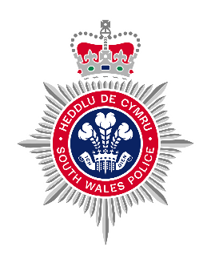
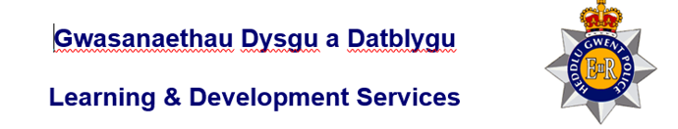

Domestic Violence Role play
Scenario 5 – location to be specified by SWP/Gwent Trainer (dwelling)

Scenario Requirements
- Two role actors, appropriately dressed – (as instructed by course trainers)
- Two officers appropriately dressed – (as instructed by course trainers)
- Control room operator.
- Assessor to be in full possession of relevant definition regarding the offence being assessed as well as the relevant assessment criteria sheet that must be completed by the assessor during the observations.
- Dwelling

Safety Reminder
- Safe working environment, risk assessment to be completed of the venue.
- Assessor to have given full briefing to Role actor/s and Officers/s being assessed prior to the role play.
- If officer is to detain / arrest role actor then this will be done by the officer taking hold of the role actors arm and informing them that they are being detained / arrested.
- For GWP, no handcuffs are to be used if the officer wishes to use handcuffs then they should inform the subject that they are handcuffed. Subject should place hands to the rear when informed.
- For SWP, handcuffs can be used in accordance with the Officer’s PST training.
- NO actual UDT strikes, takedowns or ground restraints are to be used.
- If there are any safety issues identified then the identifying officer should immediately call “CHECKMATE” to the role play and report their findings to the assessor.
If there are no safety issues the role play will run its course and the assessor will call “END EX” once they are happy the role play has concluded.

Trainer briefing to student(s)
You are on independent uniformed foot patrol (location as directed by the course trainer) when you are updated via your own control room as to 999 call from a concerned neighbour. The caller has stated that they are concerned about the welfare of their elderly neighbour. Their neighbour has an 18-year-old grandchild who is in the house, and the caller can hear them screaming and shouting and things banging against the walls. Their neighbour is very frail and vulnerable. The caller wishes to remain anonymous. You are tasked with attending the call. It is the time of day and day of the week that the practical is taking place.

The following details can be passed on to the student if they ask for further information-
- There is no further information to hand regarding the incident, the caller has hung up.
- Police systems have one previous log linked to the address which to a parking dispute four years ago.
- No back up available currently due to other commitments.
- If you require any radio checks and have a radio available, use your radio to gather any further information required, the course trainer will designate someone to act as the controller.
- Deal with the incident as you see fit.
- Consider the following-

- Officer safety
- Communication skills
- Relevant offences
- Legislation
- NDM

Trainer briefing to Role Actors
The elderly neighbour lives alone, they have no other family apart from their 18-year-old grandchild.
Today they have come around again demanding money from them. They do this most weeks. The elderly person is struggling to pay their bills. They have tried to tell them that they can’t afford it but their grandchild then gets angry. Today they have asked for £50. They have squeezed the fingers together on their grandparent’s left hand when they have said ‘no, I haven’t got it’. They have felt something “pop.” They have pain, redness and swelling to their little finger on their left hand.

Overall outcome of the scenario
- Suspect to be arrested for Actual Bodily Harm (ABH) under Section 47 Offences against the Person Act 1861.
- Correct use of arrest and search powers (s32) if completed are to be shown by the student.
- Officer to demonstrate safe working practices
- NDM should be followed.
- Police Personal procedures- radio procedures and recording of incident in PNB should be carried out in line with force policy.
- Officer to complete relevant documentation if applicable (DASH, Use of force, Social Services Referral)
- Officer to consider victim safeguarding (to be discussed during feedback)

Role Actor 1 script - suspect
When officers knock the door, you will answer and say:-
“YEAH WHAT?”
After the initial introduction and reason for talking to you, your reply will be:-
“THERES NOTHING WRONG WITH MY NAN/GRAMPY, I LOOK AFTER THEM”
You will reluctantly let officers into the property.
You will stand next to your Nan/Grampy and place your hand on their shoulder. When asked to go to another room you will.
If arrested and cautioned, you will reply “I’VE DONE NOTHING WRONG, I LOOK AFTER THEM THAT’S ALL”
Role actor to provide own details
PNC Result if checked.
No wanted or missing markers, warning marker for drugs, 1x possession of cannabis, 1x possession of cannabis with intent to supply.

Role Actor 2 script – victim
When officers enter the property you will be sat in a chair. You will be holding your left hand, you will be shaking and crying. If your grandchild places their hand on your shoulder, you will flinch.
When separated from your grandchild you will say to officers:-
“THEY’RE A GOOD BOY/GIRL REALLY, THEY’VE HAD A TOUGH LIFE, THEY DIDN’T MEAN TO HURT ME”
When asked what has happened you will say:-
“IT’S MY FAULT, I COULDN’T GIVE HIM THEM MONEY, THEY HURT MY HAND, THEY NEED HELP”
When your grandchild is arrested you will say:-
“IT’S FOR THE BEST”
You will get confused and upset if asked for your details. Role actor to provide own details but with age appropriate DOB.
NO TRACE PNC

Please follow the above script to ensure fairness to all candidates.
Actual Bodily Harm (ABH) Section 47 Offences Against the Person Act 1861
A person is guilty of an offence who assaults any person, thereby occasioning him actual bodily harm.

