Owain Maybanks
1706433
Materials and Manufacturing
ADDA4001 Assignment 2- Component Analysis
Skateboard Deck
Word count: 1521
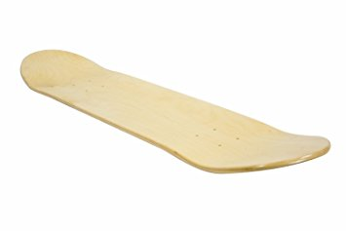

Contents page
Page 1- Contents page
Page 2- Skateboard deck overview, Manufacturing Process
Page 3- Components of a Skateboard deck
Page 4- Life span, Design considerations, Finishes
Page 5- New material, Material properties, how will the aluminium be incorporated into the product?
Page 6- Manufacturing process and assembly, Life span, Conclusion, Reference list
Skateboards are usually made of wood and glue, in layers pressed and stuck together. One of the most common woods used in the construction of the board is maple but others that are most frequently used are birch plywood and bamboo, bamboo is used in skateboards because of its spring back qualities and hardness but bamboo is used in longer skateboards (long boards). One of the most common material choices for the deck of the skateboard is plywood. People who have only just started skateboarding usually start off using plywood but often move on to a more advanced material like aluminium, fibreglass or another form of artificial material. They use such materials because they need to be strong, thick and to an extent flexible. Plywood the material mainly used is shown below.
Manufacturing process.
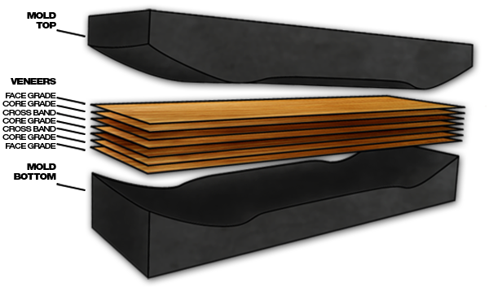
For the deck of the skateboard the process usually involves pressing multiple layers of the wooden material together with glue. There are a few main types of glues that are frequently used in the production of skateboard decks, these include: PVA which gives a board some water resistance and it has a flexible line when dry, Epoxy which gives the deck a harder stiffer feel because the epoxy laminates the wood, SK8 which is a one-part unique polymer glue which gives a deck strength a firmness as well as water resistance and is typically used in cold pressing manufacturing. The thickness of the deck will vary depending on the strength and material used but usually the deck is made up of the between six to nine layers of pressed plywood, that together with the glue normally makes the skateboard deck around 10mm thick, changing the thickness of the sheets or the number of pieces in the board will affect its weight, flexibility, and riding properties. But these thicknesses may vary depending on the size and shape of the skateboard depending on its intended use and make. After the pressing the excess material is trimmed off and removed before smoothing the edges down to a curved, rounded edge before adding varnishes and waterproofing. If the deck is to be painted then that would be the next step in the process but if not, the next step would be screwing the trucks to the decks before attaching the wheels and bearings to the trucks. Finally grip tape is added to the top surface of the deck.
Image 1

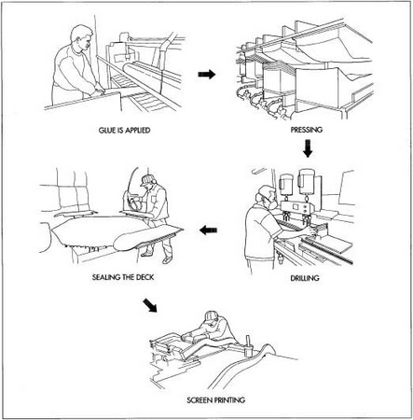

Image 2- http://www.madehow.com/Volume-6/Skateboard.html
Components of the skateboard.
Other than the deck the skateboard has a few other components: the grip tape, the wheels, the bearings and the fittings that hold the wheels to the deck (the trucks).
- The bearings allow the wheels to roll smoothly, they come in steel and ceramic steel as standard, but ceramics have less friction and last longer, however they cost more.
- The trucks are large metal pieces under the board that house the axel and attach the wheels to the board, normally these are made of solid pieces of aluminium which are either cast or forged and are the strongest part of the board. The size of the trucks will vary depending on the type of skateboard you have.
- Skateboard wheels are typically made of polyurethane, wheels of a skateboard also vary depending on the type of skateboard, the owner’s own preference and the environment the board is being used in. The size and thickness of the wheels will also have an impact of the speed at which the board can travel at. As will the hardness of the wheel, harder wheels are faster, and softer wheels are slower but offer more grip.
- The grip tape is a coarse, rough sandpaper-like material that is applied to the top of the skateboard deck with an adhesive to provide traction. The grip tape allows the rider's feet to grip the surface of the skateboard deck and helps the skater stay on the board while doing tricks. Until they fall off of course.
Lifespan.
The average lifespan of a normal skateboard deck is hard to tell because each skateboarder uses the board differently and for different times. But after doing some research I discovered that a lot of people who push the skateboard to its limits usually find that the deck will start to break within two to three months of constant use. However, without pushing the deck to its limits and with care and a reasonably large amount of time spent on the board the deck can last a year, with some people saying that they have had the same deck for a few years before it finally broke. These where normal wooden decked skateboards.
Design Considerations.
Design considerations for a wooden deck would be the length and width of the deck, modern decks vary in size, but most are 18 to 27 cm wide. Wider decks can be used for greater stability when skateboarding. Standard skateboard decks are usually between 71 and 84 cm long. As well as the weight of the user and the stress it might go though while being used. These factors must be taken into consideration when selecting the new material to make the skateboard deck because the size of the deck effects the amount of materials used which will affect the cost of making the deck out of that material.
Finishes.
The skateboard deck would be finished with varnishes and waterproof coatings to protect the wood. The grip tap on the deck could be considered a finish to the deck even though it’s a component in the design of the deck. The underside of the deck, if the owner makes it so, can have designs or paint on the underside of the deck.

Chosen material: Aluminium
I have chosen aluminium as the material to add to or become the skateboard deck.
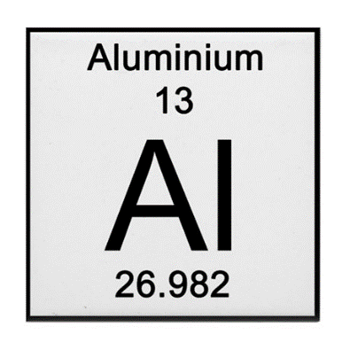
Material properties.
Pure aluminium is soft, ductile, malleable, corrosion resistant and has a high electrical conductivity. Its widely used for foil and conductive cables but by combining it with other elements such as copper, zinc, magnesium, silicon, manganese and lithium. Small additions of chromium, titanium, zirconium, lead, bismuth and nickel are also made, and iron is invariably present in small quantities. These alloys make the overall aluminium stronger, giving it higher strength for more applications and making it one of the lightest engineering metals, having a strength to weight ratio far greater than steel. When exposed to air, a layer of aluminium oxide forms on the surface, this layer has excellent resistance to corrosion. It is resistant to most acids but less resistant to alkalis.
How will the aluminium be incorporated into the product?
The skateboard deck could either be made completely out of a sheet of aluminium or there would be a single layer of aluminium incorporated into the deck. The singular layer of aluminium would be a better idea because it would still retail the same aesthetic as a normal skateboard just with a bit of aluminium either hidden in the layers or at the base of the deck. This is better than a solid aluminium sheet skateboard deck because if the deck gets bent then it would become difficult to ride and hard to bend back to its original shape and even if it was bend back into shape the deck wouldn’t necessarily be the same or ride the same.
Therefore, the sheet of aluminium would replace one or two of the plywood layers in the deck of the board meaning it will be around the same thickness as a layer of the plywood used (1-2mm thick possibly thicker for more strength), the ideal place for this to be located would be at the bottom of the deck because it would protect the base of the wood because of the materials strength and finishes can be applied to aluminium so it can still be painted. Also because of the corrosion resistant properties of the aluminium the base of the deck will last a lot longer and not corrode in water or acidic conditions. The chucks could also be welded to the aluminium giving the bond between the metal trucks and metal base a stronger bond.
Manufacturing process and assembly.
The process could stay the same, but the pressure and glues used in the pressing stage would have to change, higher pressure and the adhesives might change to JB-Weld Steel Epoxy, Araldite or 3M 5200 (3M Marine Adhesive Sealant 5200 Fast Cure) which it a type of adhesive sealant. The aluminium sheet would be bent into shape and glued to the shaped plywood pieces.
Life span
The decks life span would be increased by adding a layer of aluminium to the back of the deck because of its strength and it would protect the layers of plywood its fixed to. It also means the deck would be harder to snap or be worn down by any tricks the user does.
Conclusion
To conclude by adding a layer of sheet aluminium into the deck would increase the strength and durability of the deck as well as some aesthetic bonuses, its high strength to weight ratio also makes it light weight with little impact on the overall performance of the skateboard.

Reference list:
Information about Aluminium- https://www.azom.com/article.aspx?ArticleID=2863 Information on Skateboards- http://www.madehow.com/Volume-6/Skateboard.html
How to make a skateboard- https://www.wikihow.com/Make-a-Skateboard - information on the skateboard components
Information on woods and man-made boards- https://ministryofwood.com/the-nitty-gritty-materials/

