Name:Ossian De’Ath

Student Number: 2520279

WORKSHEET 1a – TESTING (Using Variables)

- Original code:
[Copy and paste your original code from Moodle into this box. Do not change it.]
#### Catch Up 30/03/2026 - Assignment 1.

# Show how varaiables can capture infomation by taking the following 4 bits of infomation.
# Student Surname
# Car registration
# Current Age
# Hours per week of lectures.

# Making it look okay.
print("Student Infomation")
print("==================")
print()

# Varaiables below - implement error handling.

studentSurname = input("What is your Surname?\n")

while len(studentSurname) >= 20 or len(studentSurname) <= 0:
print("Surname must be less than or equal to 20 characters.")
studentSurname = input("What is your surname?\n")

carReg = input("What is your Car registration?\n")

while len(carReg) >= 8 or len(carReg) <= 0:
print("Car Reg plates must be no longer than 7 characters with no space between the characters.")
carReg = input("What is your Car registration?\n")

# Error flagging for age and number of hours per week.
# May try do something which stops user from inputting their age above a certain age
# e.g. can't be younger than 17, but can't be older than 110 for example.

flag = 0

while flag == 0:
try:
CurrentAge = int(input("What is your current age?\n"))
except ValueError:
print("Not a valid Age")
else:
flag = 1

# May try do something which stops user from inputting more than 100 odd hours a week.
flag = 0

while flag == 0:
try:
LectureHours = float(input("How many hours of lectures do you do a week?\n"))
except ValueError:
print("Not a valid Age")
else:
flag = 1

# print varaiables.

print("\nYour student details are as follows:\n", "Last Name: ", studentSurname, "\n", "Car Registration Plate: ", carReg, "\n", "Current Age: ", CurrentAge, "\n", "Weekly Lecture Hours: ", LectureHours)

- Code Testing

For each test below, run your code and enter the values provided. Provide a screenshot of the programme running. Did the programme behave correctly or did it do something unexpected? Fill in a box for each test below. You should present 14 separate boxes, 1 for each test. (Note: the first box is provided as a template)

Surname:
- Enter JONES
- Leave blank
- Enter 123

Car registration:
- Enter CN66RBU
- Leave blank
- Enter BG56345DFE (ie too long for a UK car registration number)

Current age
- Enter 34
- Enter 150
- Enter -4
- Enter a letter

Hours per week of lectures
- Enter 12
- Enter 15.5
- Enter -4
- Enter 150 (ie longer than the maximum possible hours that the University is open in a week)

Test: i
Surname: JONES

Screenshot(s) of output:
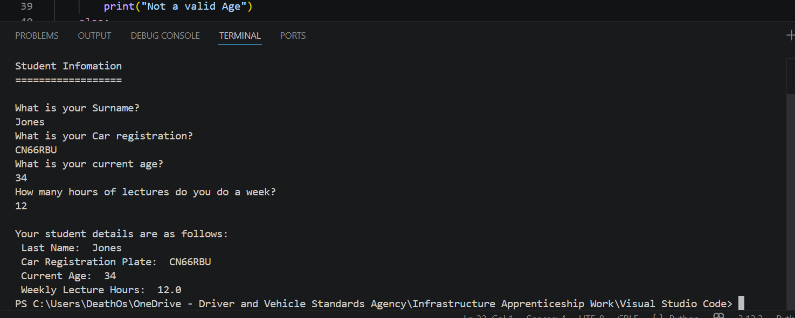
Result: Did the programme behave as expected ie syntactically and logically correct?
YES
If NO, what went wrong?
No issue, system performed as expected.
If YES, comment on what happened
I could enter the surname “Jones”, the system captured it as a variable, and then outputted the results correctly as you can see it states “Last Name: Jones”

Test: i
Car Registration : CN66RBU

Screenshot(s) of output:
Result: Did the programme behave as expected ie syntactically and logically correct?
YES
If NO, what went wrong?
No issue, system performed as expected.
If YES, comment on what happened
I could enter the Car Registration “CN66RBU” and the variable was stored and then printed further down under “Car Registration Plate: CN66RBU”

Test: i
Current Age: 34

Screenshot(s) of output:
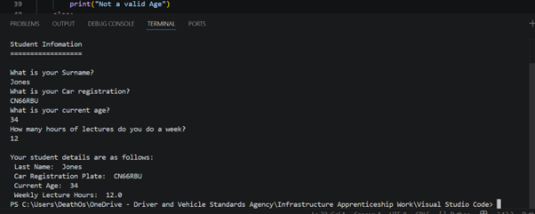
Result: Did the programme behave as expected ie syntactically and logically correct?
YES
If NO, what went wrong?
No issue, system performed as expected.
If YES, comment on what happened
I could enter the current Age as 34 and the system would store the variable and print the variable as: “Current Age: 34”.

Test: i
Hours Per Week: 12

Screenshot(s) of output:
Result: Did the programme behave as expected ie syntactically and logically correct?
YES
If NO, what went wrong?
No issue, system performed as expected.
If YES, comment on what happened
I entered the weekly hours as 12, and the program captured and stored the variable, and then printed the variable as: “Weekly Hours completed: 12.0”

Test: ii
Surname: Leave blank
Screenshot(s) of output:
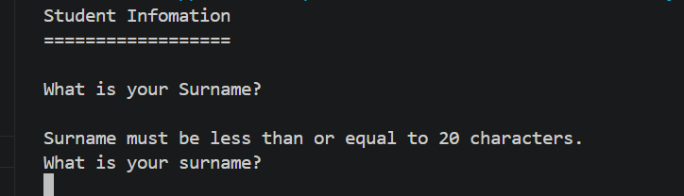
Result: Did the programme behave as expected ie syntactically and logically correct?
YES
If NO, what went wrong?
Nothing went wrong.
If YES, comment on what happened
When left blank, no characters are detected, so the length of the text is below a certain value ( => 0) so there must be at least 1 character entered for the Student Surname. You get the above error to try again. Then if I enter a name e.g Jones. It allows me to continue on.
To carry on I have just entered my cars registration plate…

Test: ii
Car Registration: Leave blank

Screenshot(s) of output:
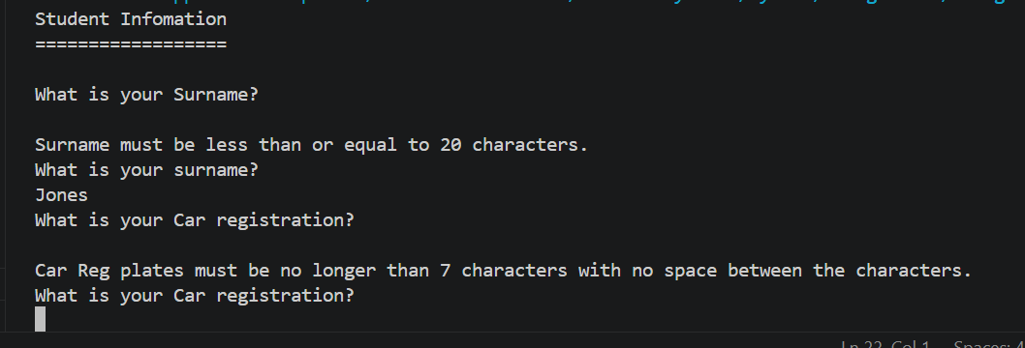
Result: Did the programme behave as expected ie syntactically and logically correct?
YES
If NO, what went wrong?
Nothing went wrong.
If YES, comment on what happened
When left blank the car registration would say you need to fill in the car registration and it must not be longer than 7 characters with no spaces between the characters. This works as it should. However, it may be best to take into consideration that not everyone drives/owns a car, so it may be best if we ask if they own a car first, then proceed with the reg plate.

Test: ii
Current Age: 150
Screenshot(s) of output:
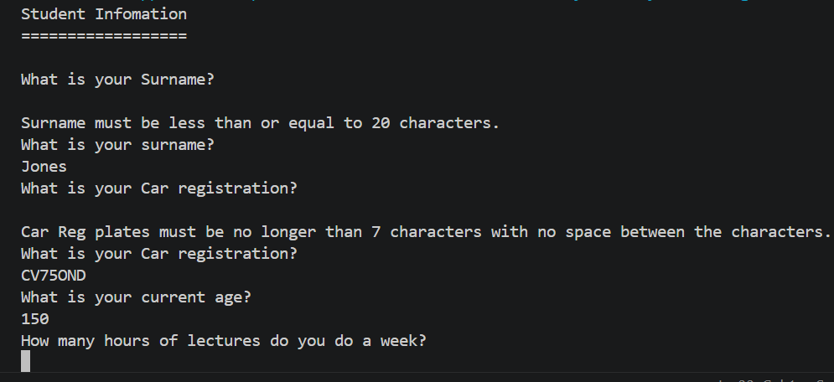
Result: Did the programme behave as expected ie syntactically and logically correct?
Maybe….
If NO, what went wrong?
The actual ability to capture the variable works fine, however there may be some logic needed, as no one has ever lives to 150 years old so this may need to be fine-tuned.
If YES, comment on what happened
So, the program works, as it captures your age as an input, and then stores it as a variable as you can print the variable, however like mentioned above, we may need an age limit on this!

Test: ii
Hours Per Week: 15.5
Screenshot(s) of output:
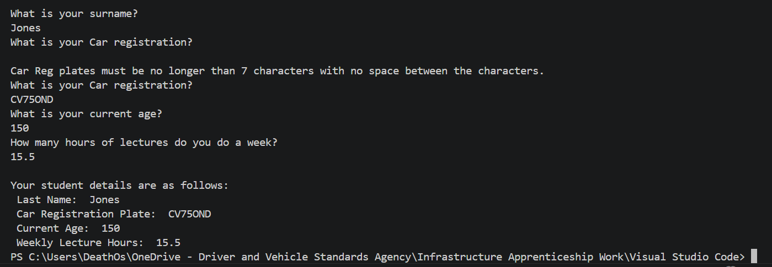
Result: Did the programme behave as expected ie syntactically and logically correct?
YES
If NO, what went wrong?
Nothing went wrong.
If YES, comment on what happened
When I enter a float, the system was set up to have floats as you could have 20.5 hours of lectures a week, e.g. 20 hours and 30 minutes of lectures each week for example. This functioned as corrected, as the variable was stored and was able to be printed at the end as the correct value!

Continue the rest of the tests below. (Copy and paste a box for each one)

Test: iii
Enter 123
Screenshot(s) of output:
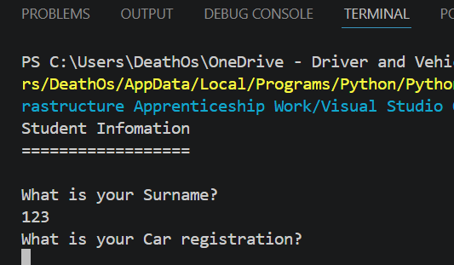
Result: Did the programme behave as expected ie syntactically and logically correct?
YES and NO
If NO, what went wrong?
So, ideally I’d want to stop users from having numbers in their name, however I believe it to be very hard to stop numbers from being a string.
If YES, comment on what happened
The variable works, and stores the surname as 123, which shows the actual code itself works, but there’s not enough validation for numbers in the surname section as a number can be a string.

Test: iii
Enter BG56345DFE
Screenshot(s) of output:
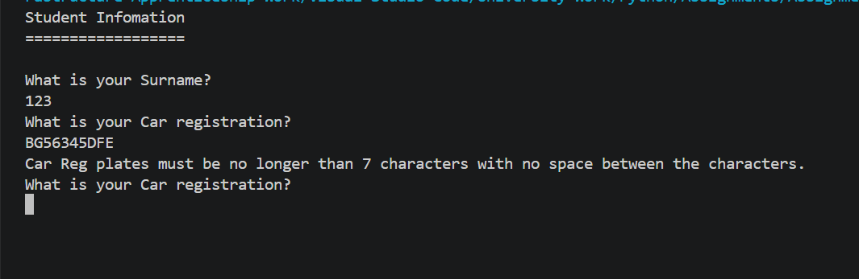
Result: Did the programme behave as expected ie syntactically and logically correct?
YES
If NO, what went wrong?
Nothing went wrong.
If YES, comment on what happened
As you can see, when you enter a registration plate which is too large (or left blank) the error will be present. It will state you must have a car reg which is no longer than 7 characters with no spaces between the characters. This is because a registration plate in the UK will typically be XX00 XXX so 7 characters, but you can get plates which are smaller than this etc, so it is best to have the value at minimum 1 character all the way to 7.

Test: iii
Enter -4
Screenshot(s) of output:
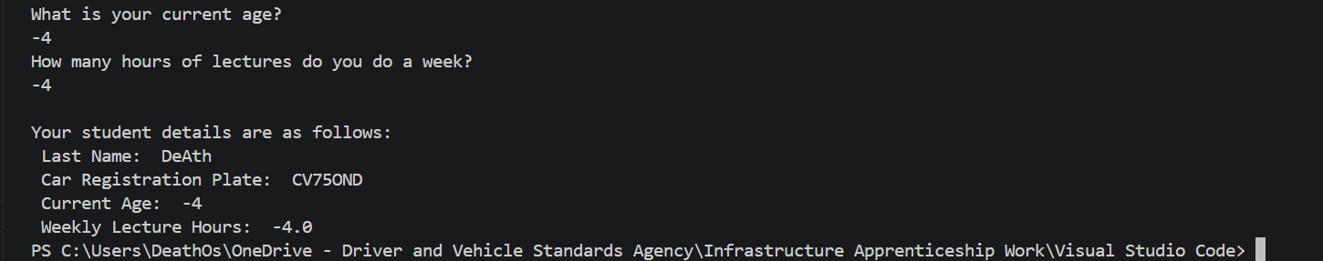
Result: Did the programme behave as expected ie syntactically and logically correct?
YES and NO
If NO, what went wrong?
You can’t be -4 years old. So I need to add some validation to ensure the user enters a number about 0 and below 100 for example.
If YES, comment on what happened
It captured the value and stored it as a variable and printed it, just validation needed to ensure data is accurate.

Test: iii
Enter -4
Screenshot(s) of output:
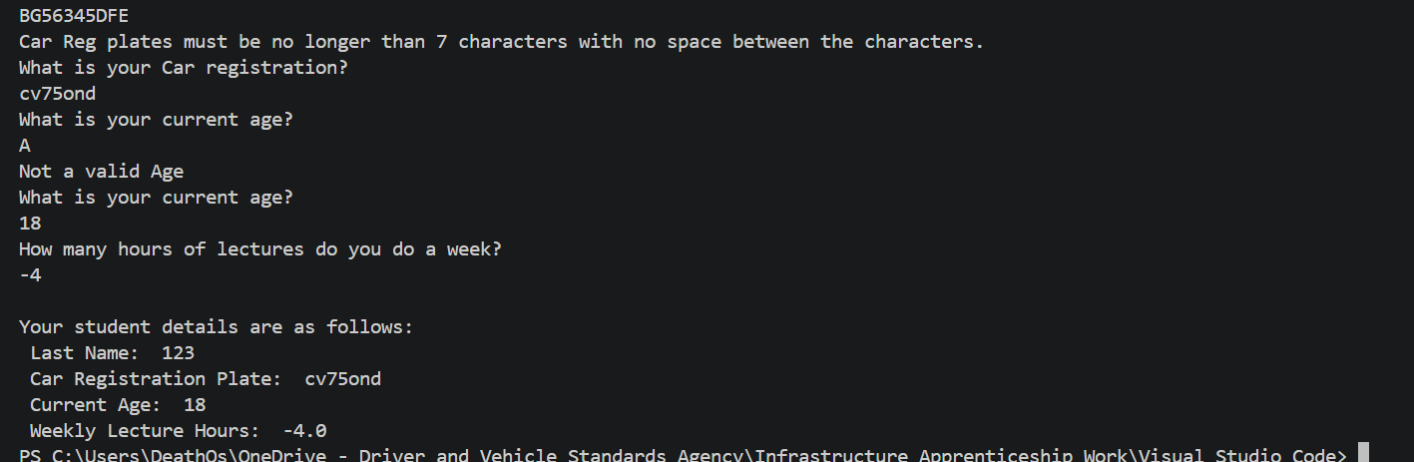
Result: Did the programme behave as expected ie syntactically and logically correct?
YES and No
If NO, what went wrong?
Ideally, a student wouldn’t do minus hours in a course, I need to make some validation here which makes sure the number which could be entered is not below 0, and not above 168 as this would be the maximum amount of hours a person could do a week. Realistically though a person would probably only be able to do around 112 hours a week if they had 8 hours of sleep every night, so I may decide the maximum value here.

If YES, comment on what happened
The value was correctly recorded and printed, so this section works fine, however validation is needed, like I mentioned above.

Test: iv
Enter a letter (will enter A)
Screenshot(s) of output:
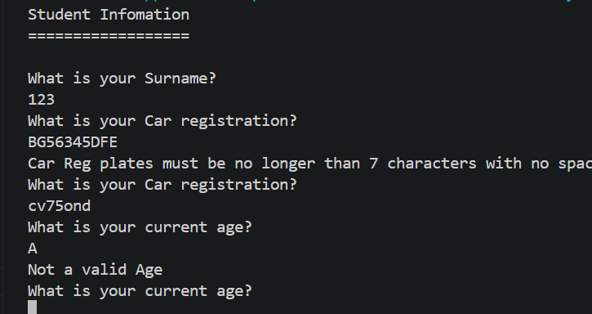
Result: Did the programme behave as expected ie syntactically and logically correct?
YES
If NO, what went wrong?
Nothing went wrong.
If YES, comment on what happened
Your age must be a number, not a letter. When a letter is entered it captures a value error, which is caught in a while statement while looking for the Value error., which only lets you out when you enter a valid integer.

Test: iv
Enter 150 (longer than uni is open each week)
Screenshot(s) of output:
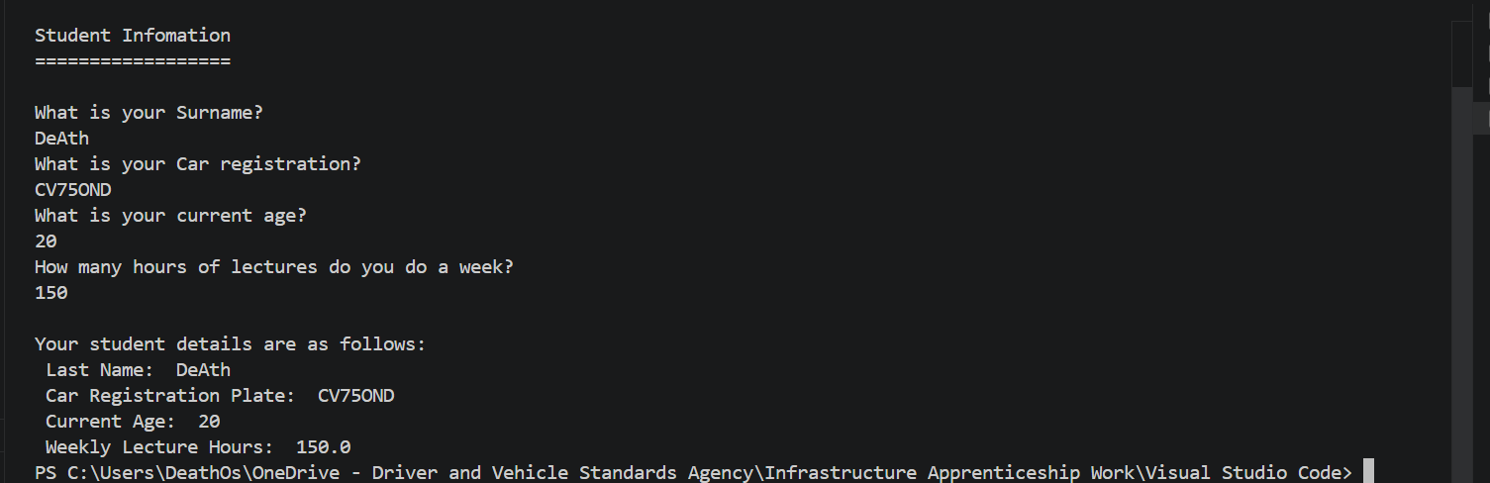
Result: Did the programme behave as expected ie syntactically and logically correct?
YES and NO
If NO, what went wrong?
Obviously, a person realistically wouldn’t be able to attend more than 112 hours of university a week due to sleeping schedules (based on getting 8 hours of sleep each night). So there needs to be some validation here to say the maximum hours a person could physically do is around 114 hours I would personally say.
If YES, comment on what happened
The values were correctly recorded, and stored. They were then printed out correctly too. Validation is just needed to stop the user from entering values which aren’t realistic.

(Copy and paste a box similar to the above for each of the rest of the tests)
- Consider the results of the above tests and revisit your original code in order to address any tests that failed. (Note: you may not be able to solve all of the problems that were encountered, but solve as many as you can.)

I think for my first issue, I need to stop users from being able to input numbers as a name and maybe increase the character letter of a name from 20 to 40 just in case as there may be some people with longer names. To stop users from entering numbers I will use the isalpha() command to check if the users are entering valid characters.

I also need to look at stopping people from entering values over/under a certain amount for the age and lecture weekly hours. I don’t believe there’s anymore validation needed here though.

Paste your full revised code here :

[Copy and paste your full revised code here – note, do not use a screenshot]

#### Making improvements to my first assignment in class.
# This work will be done to improve my python code below and be submitted as part of work sheet 1.
# The upgrades I will complete are as follows:

# 1. Validation to stop people from entering numbers as a name.
# 2. Validation to stop people from entering specific values for ages (between 0 and 100)
# 3. Validation to stop people from entering specific values for Lecture weekly hours (between 0 and 112)

# Show how varaiables can capture infomation by taking the following 4 bits of infomation.
# Student Surname
# Car registration
# Current Age
# Hours per week of lectures.

# Making it look okay.
print("Student Infomation")
print("==================")
print()

# Varaiables below - implement error handling.

studentSurname = input("What is your Surname?\n")

#Updated validation below to stop users from entering numbers as a name. Also increased name len to 40 characters.

while not studentSurname.isalpha() or len(studentSurname) >= 40 or len(studentSurname) <= 0:
print(" Surname must be less than or equal to 40 characters. \n The surname cannot contain Numbers.\n Please refrain from using special characters.")
studentSurname = input("What is your surname?\n")

carReg = input("What is your Car registration?\n")

while len(carReg) >= 8 or len(carReg) <= 0:
print("Car Reg plates must be no longer than 7 characters with no space between the characters.")
carReg = input("What is your Car registration?\n")

# Error flagging for age and number of hours per week.
# May try do something which stops user from inputting their age above a certain age
# e.g. can't be younger than 17, but can't be older than 110 for example.

# Updated validation to stop users from being older than 100 or younger than 0.

flag = 0

while flag == 0:
try:
CurrentAge = int(input("What is your current age?\n"))
while CurrentAge >= 100 or CurrentAge <= 0:
print("The age cannot exceed 100, please try again.")
CurrentAge = int(input("What is your current age?\n"))
except ValueError:
print("Not a valid Age")
else:
flag = 1

# May try do something which stops user from inputting more than 100 odd hours a week.

# Updated validation to allow for a maximum of 112 hours a week as sleeping 8 hours is needed for 7 days a week.
# Meaning max hours a user could physically do is 112. Also set there to be a minimum of 0 weekly hours of lectures.
# I set to 0 as some students may complete a course which doesn't require lectures (I think this is possible??)

flag = 0

while flag == 0:
try:
LectureHours = float(input("How many hours of lectures do you do a week?\n"))
while LectureHours >= 112 or LectureHours <= 0:
print("Th lecture hours cannot exceed 112 hours a week or be less than 0.")
LectureHours = float(input("How many hours of lectures do you do a week?\n"))
except ValueError:
print("Not a valid Age")
else:
flag = 1

# print varaiables.

print("\nYour student details are as follows:\n", "Last Name: ", studentSurname, "\n", "Car Registration Plate: ", carReg, "\n", "Current Age: ", CurrentAge, "\n", "Weekly Lecture Hours: ", LectureHours)

